🇸🇦
KINGDOM OF SAUDI ARABIA
National Artificial Intelligence Policy 2025–2030
A Comprehensive Framework for Ethical, Inclusive,
and Economically Transformative Artificial Intelligence
Prepared by:
Nafiul Ahmad Rafi
Insights Bangladesh | Policy & Governance Research Division
May 2025

Table of Contents

Executive Summary

The Kingdom of Saudi Arabia stands at a pivotal inflection point in its national development trajectory. Anchored by Vision 2030 — the Kingdom's ambitious blueprint for economic diversification — this National Artificial Intelligence Policy 2025–2030 serves as the definitive strategic framework through which Saudi Arabia will harness artificial intelligence to transform its economy, governance systems, and human capital base. As a high-income economy with a GDP exceeding USD 1.06 trillion, robust digital infrastructure, and substantial sovereign wealth, Saudi Arabia possesses extraordinary foundational assets to become not merely an AI consumer, but a global AI innovator and governance leader.
This policy document is structured around five strategic pillars: Ethical AI and Human Rights Protection; Economic Growth and Industrial AI Adoption; Education, Upskilling, and AI Workforce Development; Public Sector AI and e-Governance; and AI Research, Innovation, and the Startup Ecosystem. These pillars are grounded in rigorous analysis of Saudi Arabia's AI readiness across six dimensions — economy, education, digital infrastructure, governance, innovation capacity, and ethical frameworks — resulting in a composite readiness score of 7.6 out of 10, positioning the Kingdom among the top AI-ready nations in the Global South.
Economically, AI is projected to contribute up to USD 160 billion to Saudi GDP by 2030, equivalent to approximately 12.4% of current GDP — one of the highest AI-to-GDP ratios globally for an emerging AI economy. Priority sectors include energy and petrochemicals, healthcare, smart cities, financial services, and logistics, all of which are central to Vision 2030's diversification agenda. The policy recommends a structured national AI investment framework distributing resources across infrastructure (25%), education (20%), R&D (20%), public sector AI (20%), regulatory bodies (10%), and ethics and civil society (5%).
This policy is fully aligned with international frameworks including the UNESCO AI Ethics Recommendation (2021), OECD AI Principles (updated 2024), the EU AI Act (2024), World Bank AI Strategy, G20 AI Principles, and ITU AI for Good Guidelines. The governance architecture proposed herein — anchored by a National AI Ethics Board, a five-tier risk classification system, and an independent National AI Observatory — reflects global best practice adapted to Saudi Arabia's unique political, economic, and cultural context. Implementation unfolds across three phases: Foundation (2025), Scaling (2026–2027), and Optimization (2028–2030), with clearly defined KPIs, parliamentary oversight mechanisms, and annual public reporting obligations.

Section 1: National AI Readiness Assessment

1.1 Economic Context
Saudi Arabia is the largest economy in the Arab world and the 17th largest globally, with a nominal GDP of approximately USD 1.06 trillion (2024). The Kingdom's GDP per capita stands at approximately USD 28,000, reflecting its high-income status. The economy is in active structural transformation under Vision 2030, with non-oil revenue growing to represent over 38% of total government revenues by 2024, exceeding original targets. Key economic sectors include petroleum and petrochemicals, real estate and construction, financial services, tourism (now contributing over USD 100 billion annually), and logistics.
The digital economy is expanding rapidly, driven by NEOM, the Red Sea Project, Diriyah Gate, and other giga-projects with embedded AI and smart city mandates. Saudi Arabia ranks among the top five nations globally in government AI investment as a percentage of sovereign wealth allocations, with the Public Investment Fund (PIF) deploying billions through entities such as the Saudi Data and AI Authority (SDAIA) and the National Technology Development Program (NTDP).

1.2 Education & Human Capital
Saudi Arabia has achieved near-universal literacy (97.6%), with strong tertiary enrollment rates of approximately 67%. The country has over 30 accredited universities and numerous technical and vocational training institutions under TVTC. However, a structural STEM skills gap persists: demand for AI-specialized professionals currently outpaces domestic supply by an estimated 4:1 ratio. The government has responded with the Digital Skills Initiative and partnerships with MIT, CMU, and King Abdullah University of Science and Technology (KAUST), which serves as the Kingdom's primary AI research hub. Women's participation in the labor force has grown dramatically from 17% (2017) to over 33% (2024) — a foundational advantage for inclusive AI workforce development.

1.3 Digital Infrastructure
Saudi Arabia boasts one of the most advanced digital infrastructures in the Arab world. Fixed broadband penetration exceeds 96% of households, while 5G coverage reaches approximately 74% of the population as of 2024. Data center capacity has grown 340% since 2020, with major cloud providers (AWS, Google, Microsoft Azure) operating local zones. The national fiber backbone — managed by Saudi Telecom Company (STC) and Zain — provides latency and bandwidth comparable to G7 nations. Blockchain and IoT integration is advancing across logistics, healthcare, and smart city platforms. This robust connectivity forms a strong bedrock for AI deployment at scale.

1.4 Governance & Institutional Capacity
Saudi Arabia has established a sophisticated AI governance ecosystem ahead of most developing nations. SDAIA, established in 2019, serves as the national authority for data and AI, and has produced the National AI Strategy, the Personal Data Protection Law (PDPL, effective 2023), and the Ethical AI Framework (2020). The Council of Ministers has institutionalized digital transformation mandates across all ministries. Institutional coordination is supported by the National Transformation Program (NTP) under Vision 2030, ensuring AI policy integration across health, education, transport, and finance ministries.

1.5 Corruption Risk Assessment
Saudi Arabia scores 52 on Transparency International's 2024 Corruption Perceptions Index, ranking 58th globally — above the regional Middle East average of 41 but below the OECD average of 65. This indicates a medium-tier governance risk for AI deployment, particularly in public procurement of AI systems, algorithmic decision-making in government services, and data handling by state entities. This policy therefore mandates algorithmic accountability standards, independent AI audits for all government AI systems, and transparent procurement frameworks to mitigate corruption risk in AI adoption and protect public trust.
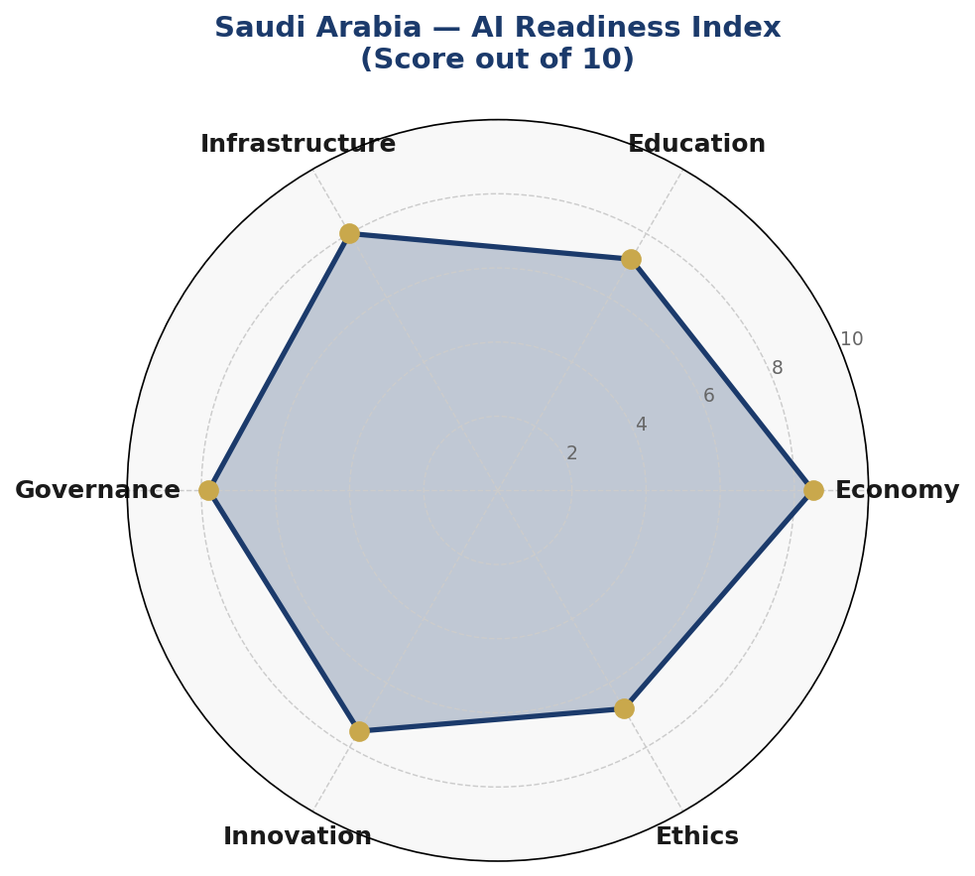
Figure 1.1: Saudi Arabia AI Readiness Index — Six-Dimensional Assessment (Score out of 10)

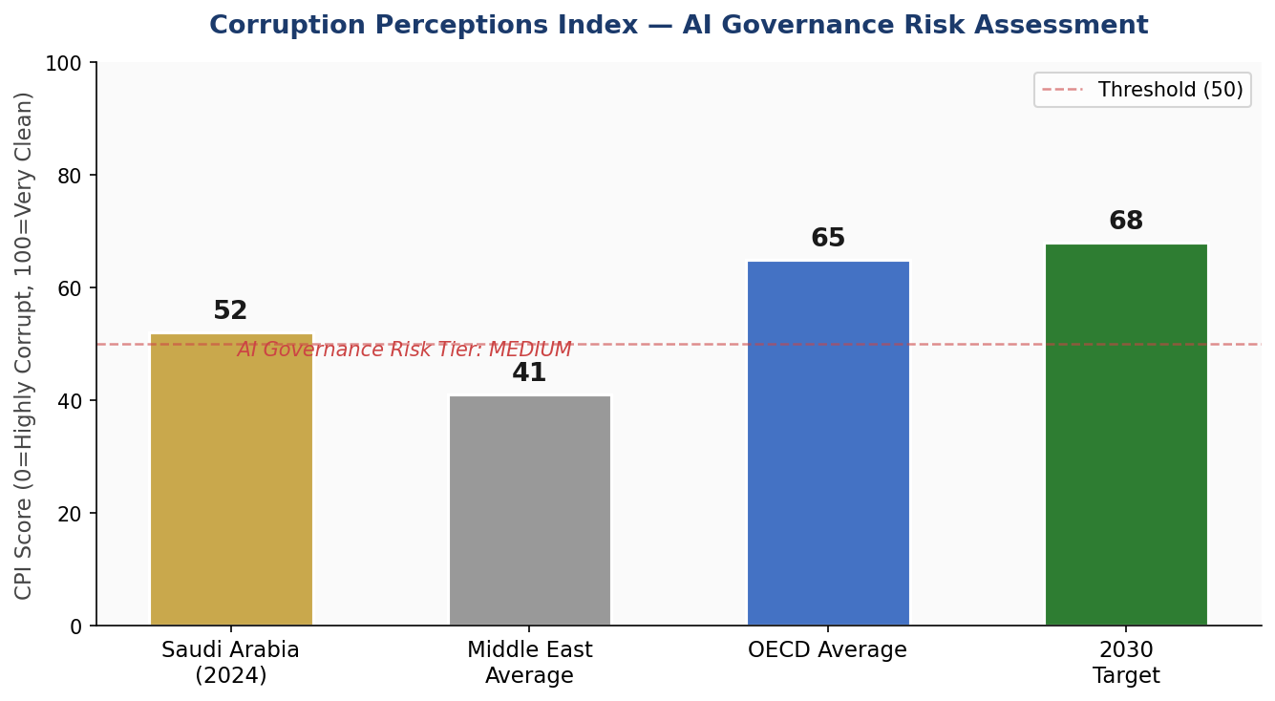
Figure 1.2: Corruption Perceptions Index — Saudi Arabia vs. Regional and OECD Benchmarks with AI Governance Risk Tier

Section 2: Policy Vision & Strategic Pillars

2.1 Vision Statement
"To establish Saudi Arabia as the Arab world's leading AI nation and a globally respected voice in ethical AI governance — leveraging artificial intelligence to diversify our economy, empower our people, and contribute to human flourishing in alignment with our values and Vision 2030."
This vision reflects three core aspirations: economic leadership through AI-driven diversification beyond hydrocarbons; human empowerment through equitable access to AI tools and education; and global governance participation through ethical frameworks that reflect both universal human rights principles and Saudi Arabia's cultural and legal traditions.

2.2 Strategic Pillar 1: Ethical AI & Human Rights Protection
Saudi Arabia affirms that artificial intelligence must serve human dignity, respect privacy, and be free from discriminatory outcomes. This pillar establishes the National AI Ethics Board (NAEB) with enforcement authority over public and private AI deployments, mandates bias audits for high-stakes AI systems, and enshrines human oversight requirements in law. All AI systems affecting citizens' rights — including welfare determinations, law enforcement applications, and credit scoring — must undergo mandatory ethics review before deployment.

2.3 Strategic Pillar 2: Economic Growth & Industrial AI Adoption
AI-driven economic diversification is central to Vision 2030. This pillar targets USD 160 billion in AI economic contribution by 2030, with priority AI adoption in: petroleum optimization and smart energy management; predictive healthcare and genomics; intelligent transportation and logistics; smart city management across NEOM and the Red Sea Project; financial services automation and Islamic fintech; and agricultural AI for food security. Public-Private Partnership (PPP) frameworks with AI companies — including negotiated technology transfer agreements — will accelerate adoption while ensuring knowledge retention in-Kingdom.

2.4 Strategic Pillar 3: Education, Upskilling & AI Workforce Development
Saudi Arabia will invest aggressively in developing a sovereign AI talent base. This pillar mandates integration of AI literacy into the national K-12 curriculum by 2026, the launch of 20 AI-specialized university programs in partnership with global institutions, and the creation of a National AI Skills Passport for workforce credentialing. Special attention is given to reducing gender disparities in AI education and creating pathways for non-traditional learners through online AI academies, including an Arabic-language AI learning platform scaled across the GCC.

2.5 Strategic Pillar 4: Public Sector AI & e-Governance
AI will fundamentally transform service delivery across all government ministries. Priority use cases include: AI-powered Hajj and Umrah crowd management and safety systems; intelligent health triage and hospital resource optimization; automated tax and customs compliance monitoring; predictive judicial case management; AI-enhanced national security threat assessment; and smart traffic and urban mobility management in Riyadh, Jeddah, and NEOM. All government AI deployments must adhere to the Citizen-First AI Charter included in this policy, ensuring transparency, explainability, and accessible grievance redressal.

2.6 Strategic Pillar 5: AI Research, Innovation & Startup Ecosystem
Saudi Arabia will establish itself as a regional hub for AI research and venture creation. This pillar creates a SAR 10 billion (USD 2.67 billion) National AI Innovation Fund administered by PIF, seed-funding 500 AI startups over five years through the Monsha'at-AI partnership. Research priorities include Arabic NLP and language models, AI for Islamic finance (halal compliance verification, sukuk optimization), climate-smart AI for the Saudi Green Initiative, and AI-enabled heritage preservation. The Saudi AI Research Council, housed at KAUST, will coordinate national research priorities and international collaboration.

Section 3: International Framework Alignment

Saudi Arabia's National AI Policy is designed from the outset as a globally-aligned framework. Rather than adopting any single international model wholesale, this policy synthesizes principles from the six most authoritative global AI governance frameworks, adapting each to the Kingdom's unique development context, legal tradition, and Vision 2030 objectives.

3.1 UNESCO AI Ethics Recommendation (2021)
The UNESCO Recommendation establishes eleven core values: respect for human rights and dignity; peace; inclusion; living together in peace; the environment and ecosystems; diversity; responsibility; privacy; rule of law; security; and data governance. Saudi Arabia's policy maps directly onto all eleven values: the National AI Ethics Board operationalizes dignity and rights protections; the Citizen-First AI Charter addresses inclusion and accountability; data governance is codified in the enhanced PDPL framework; and environmental AI applications align with the Saudi Green Initiative.

3.2 OECD AI Principles (Updated 2024)
The OECD AI Principles — covering inclusive growth, human-centered values, transparency, robustness, and accountability — are operationalized throughout this policy. The updated 2024 principles emphasizing systemic risk management and cross-border AI governance cooperation are reflected in Sections 6 and 10, including mandatory robustness standards for critical infrastructure AI and bilateral AI governance agreements with OECD member states.

3.3 EU AI Act (2024) — Risk-Based Framework
The EU AI Act's four-tier risk classification (Unacceptable, High, Limited, Minimal) is adapted in Section 6 of this policy. Saudi Arabia prohibits AI systems that manipulate human behavior against free will, enable mass surveillance of protected characteristics, and assign social credit scores. High-risk systems — including AI in education assessment, employment decisions, credit scoring, and law enforcement — require mandatory conformity assessments, independent audits, and human oversight before deployment. This alignment positions Saudi Arabia as a preferred partner for European AI enterprises operating in the region.

3.4 World Bank AI Strategy & G20 AI Principles
World Bank alignment is reflected in the policy's emphasis on AI for development outcomes: improving public service delivery, reducing inequality in access to AI tools, and ensuring AI investment generates broad-based economic gains rather than concentrated returns. G20 Principles — endorsed by Saudi Arabia as a G20 member — guide the international cooperation chapter (Section 10) and the National AI Innovation Fund's mandate to support AI startups addressing development challenges.

3.5 ITU AI for Good Guidelines & SDG Linkage
The International Telecommunication Union's AI for Good framework connects AI deployment to the Sustainable Development Goals. Saudi Arabia's policy identifies primary SDG linkages: SDG 3 (AI in healthcare), SDG 4 (AI in education), SDG 8 (AI for economic growth), SDG 9 (AI for infrastructure and innovation), SDG 11 (AI for smart cities), and SDG 13 (AI for climate action through the Saudi Green Initiative). Each major policy initiative identifies its SDG contribution in implementation plans.

3.6 Comprehensive Framework Alignment Matrix
International Framework | Core Principle Alignment | Policy Section | Monitoring | Ethics | Economy | Gov't
UNESCO AI Ethics Recommendation (2021) | Sec 6 Ethics Board, data rights, bias audits | Sec 2 Vision, Pillar 1 | Sec 5 K-12 & tertiary AI curriculum | ✅ | ✅ | ⚠️
OECD AI Principles (2019, 2024) | Transparency, accountability, robustness | Sec 6 Risk Classification | Sec 9 KPI Dashboard | ✅ | ✅ | ✅
EU AI Act (2024) | Risk-based AI regulation, prohibited uses | Sec 6 Risk tiers | Sec 9 AI Observatory | ✅ | ⚠️ | ✅
World Bank AI Strategy | Inclusive growth, digital public goods | Sec 4 PPP framework | Sec 8 Implementation | ✅ | ✅ | ⚠️
G20 AI Principles | Human-centred AI, responsible innovation | Sec 2 Pillar 2 & 5 | Sec 10 Diplomacy | ✅ | ✅ | ✅
ITU AI for Good (SDGs) | SDG alignment, AI for development | Sec 7 e-Governance | Sec 10 South-South | ✅ | ⚠️ | ✅
Table 3.1: International Framework Alignment Matrix — ✅ Full Alignment | ⚠️ Partial Alignment | 🔲 Future Roadmap

Section 4: Economic Impact & Investment Roadmap

Saudi Arabia is positioned to capture one of the highest AI economic dividends of any nation in the world. According to McKinsey Global Institute estimates for high-income Gulf states, AI could contribute between 12–14% of GDP by 2030 — for Saudi Arabia, this translates to approximately USD 135–160 billion annually. This projection is supported by the Kingdom's unique combination of massive energy sector digitization opportunities, giga-project AI integration, and sovereign wealth fund capacity to make transformative AI investments at speed and scale.

4.1 Projected AI Economic Contribution
The projected AI economic contribution follows a steep growth trajectory, expanding from USD 18 billion in 2025 (as early AI deployments begin to demonstrate productivity gains) to USD 160 billion by 2030. The steepest growth is anticipated between 2027 and 2029 as large-scale infrastructure AI systems come online across NEOM, the Red Sea Project, and national health and logistics networks. Energy sector AI optimization alone — including predictive maintenance at Aramco facilities and AI-managed grid balancing — is projected to contribute USD 35 billion annually by 2028.
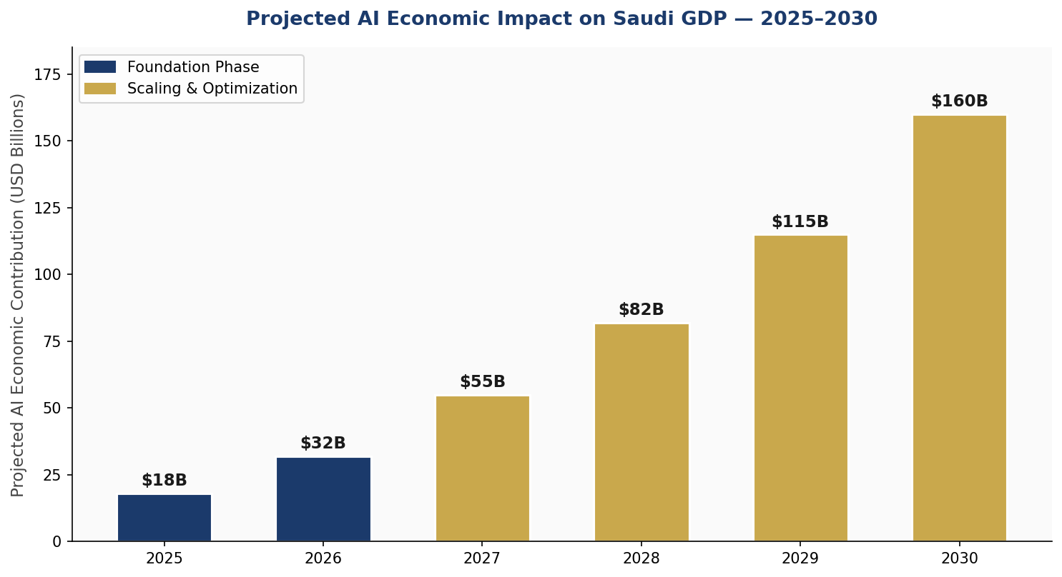
Figure 4.1: Projected AI Economic Contribution to Saudi GDP, 2025–2030 (USD Billions)

4.2 Investment Allocation Framework
This policy recommends a structured national AI investment allocation across six categories, calibrated to maximize economic return while ensuring ethical deployment, institutional capacity, and equitable access. Total recommended national AI expenditure for the 2025–2030 period is SAR 150 billion (approximately USD 40 billion), deployed through a combination of government appropriation, PIF mandate, and incentivized private sector co-investment.
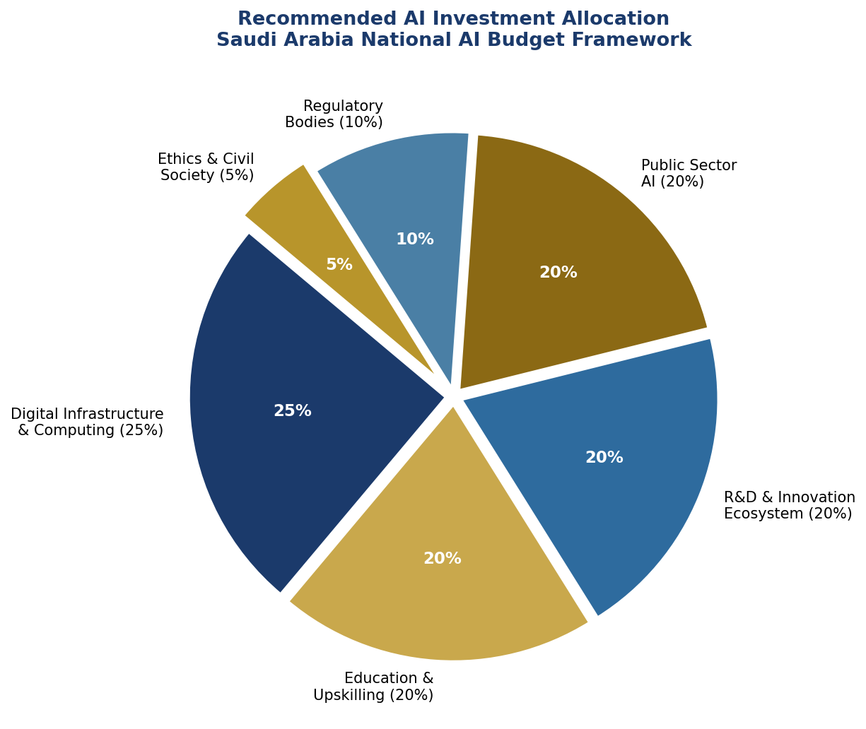
Figure 4.2: Recommended AI Investment Allocation — Saudi Arabia National AI Budget Framework (2025–2030)

4.3 Priority Sectors for AI Adoption
The following sectors are designated as Priority AI Adoption Zones, each with dedicated government support, regulatory fast-tracks, and targeted talent pipelines:
- Energy & Petrochemicals: Predictive maintenance, reservoir optimization, carbon capture AI, smart grid management (Estimated AI value-add: USD 35B by 2028)
- Healthcare & Life Sciences: AI diagnostics, genomics, hospital resource optimization, mental health AI (Estimated AI value-add: USD 22B by 2028)
- Smart Cities & Real Estate: NEOM AI systems, traffic management, urban planning AI, building energy optimization
- Financial Services & Islamic Fintech: Fraud detection, AI credit scoring within Sharia compliance, sukuk optimization, halal investment screening
- Logistics & Supply Chain: Port AI management (King Abdullah Port), customs automation, last-mile delivery optimization
- Tourism & Hospitality: AI visitor management, personalized hajj services, multilingual AI concierge systems

4.4 Public-Private Partnership Framework
The National AI PPP Framework, administered by SDAIA in coordination with the Ministry of Investment, establishes standard partnership templates for domestic and international AI companies. All major AI contracts with government entities exceeding SAR 50 million must include: mandatory technology transfer provisions ensuring in-Kingdom AI capability development; requirements to employ and train Saudi nationals at 40% of technical roles within three years; open-source data sharing agreements for non-proprietary government datasets; and participation in the national AI skills development fund.

Section 5: Education & Human Capital Development

Saudi Arabia's AI ambitions will only be realized through a sovereign talent base capable of building, deploying, and governing AI systems domestically. This section establishes the National AI Education Framework — a comprehensive, cradle-to-career pipeline transforming Saudi Arabia's education system into one of the world's premier producers of AI-literate citizens and AI-specialized professionals.

5.1 Current Skills Gap Analysis
Saudi Arabia currently has approximately 8,000 trained AI professionals against an estimated demand of 32,000 by 2027 — a gap of 24,000 professionals. University graduates with AI-related degrees number approximately 2,400 annually, while the Vision 2030 AI economy requires 6,000+ per year at full implementation. Furthermore, Arabic-language AI content and tools remain scarce, creating a language barrier that disproportionately disadvantages Saudis from less internationally-connected backgrounds. Women, while increasingly entering the workforce, remain underrepresented in STEM faculties (28% of STEM graduates) and in AI specifically (estimated 18% of AI professionals).

5.2 National AI Curriculum Framework
The Ministry of Education will implement AI education across all schooling levels:
- K-6 (Awareness Level): Introduction to computational thinking, basic robotics, age-appropriate AI ethics through storytelling and game-based learning. Integrated into existing ICT and mathematics curricula by 2026.
- Grades 7-9 (Literacy Level): Machine learning concepts, data literacy, introduction to Python programming, AI applications in everyday life. Mandatory AI elective module by 2026.
- Grades 10-12 (Applied Level): AI project development, applied data science, ethics and bias in algorithms, career pathways in AI. Optional AI specialization track leading to AI qualification examined by the National Center for Assessment.
- TVTC Vocational (Practitioner Pathways): 18-month AI technician programs covering AI tool operation, data annotation, AI systems maintenance, and domain-specific AI applications (healthcare AI technician, logistics AI specialist, etc.).
- University (Expert Pipeline): Expanded AI degree programs at all Saudi universities, mandatory AI literacy modules in all undergraduate programs regardless of major, and 10 new AI research centers at regional universities complementing KAUST's flagship role.

5.3 AI Education Pipeline — Population Targets
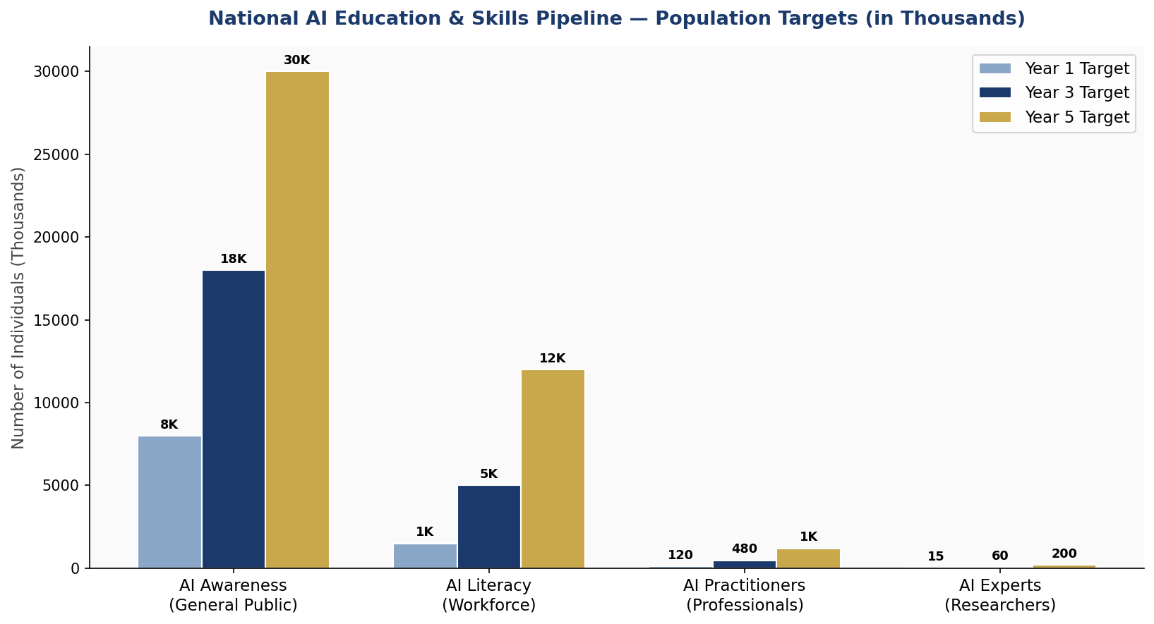
Figure 5.1: National AI Education & Skills Pipeline — Population Targets by Level and Year (in Thousands)

5.4 International Scholarship & Exchange
The Custodian of the Two Holy Mosques Scholarship Program will be expanded with an AI specialization track, funding 2,000 Saudi students annually at leading AI universities globally (MIT, Stanford, CMU, Oxford, ETH Zurich, NUS). Reciprocal agreements will bring international AI researchers and lecturers to Saudi universities on 2-5 year secondments, accelerating knowledge transfer into domestic institutions.

5.5 Inclusion & Gender Equity
All AI education programs will apply gender equity targets, aiming for 40% female participation by 2027 and 50% by 2030. The National AI Girls in Tech Initiative — modeled on successful programs at Princess Nourah bint Abdulrahman University — will be scaled nationally, with dedicated AI hackathons, mentorship programs, and scholarship funds for women pursuing AI careers. Accessibility accommodations for persons with disabilities will be mandated across all digital AI learning platforms.

Section 6: Ethical AI Governance & Regulatory Framework

Saudi Arabia's AI regulatory framework is designed to be simultaneously protective of citizens' rights and enabling of innovation — recognizing that trust is the ultimate prerequisite for AI adoption at scale. The regulatory architecture draws on the EU AI Act's risk-based approach, UNESCO's human-rights-centered principles, and Saudi Arabia's own legal traditions including the Basic Law of Governance and the Personal Data Protection Law (PDPL, 2023).

6.1 National AI Ethics Board (NAEB)
The National AI Ethics Board shall be established by Royal Decree within six months of this policy's adoption, operating as an independent statutory body under the oversight of the Shura Council. The NAEB shall comprise 15 members: three representatives from SDAIA; two from the Ministry of Justice; two AI ethics academics (including one international appointment); two representatives from the private sector AI industry; two civil society representatives including a consumer rights advocate; one representative each from the health, education, and financial services sectors; and one independent international AI governance expert. The NAEB shall hold enforcement authority to suspend AI deployments that violate this policy, impose financial penalties, and recommend criminal referrals in cases of egregious AI misuse.

6.2 AI Risk Classification System
Saudi Arabia adopts a five-tier AI risk classification adapted from the EU AI Act:
Tier 0: Prohibited AI Systems
The following AI applications are permanently prohibited in Saudi Arabia:
- AI systems that manipulate individuals through subliminal techniques to cause harm or override free will
- AI-enabled social scoring systems by government or private entities that rate citizens based on behavior across domains
- Real-time biometric surveillance of protected characteristics in public spaces without specific judicial authorization
- AI systems that exploit vulnerable persons including children, the elderly, or persons with disabilities
- AI weapons systems operating entirely without human oversight or capable of autonomous lethal force decisions
Tier 1: High-Risk AI (Mandatory Conformity Assessment)
High-risk AI systems require pre-deployment conformity assessment, ongoing monitoring, and mandatory human oversight:
- AI in educational assessment and student qualification decisions
- AI in employment recruitment, performance evaluation, and termination decisions
- AI in credit scoring, insurance underwriting, and financial services
- AI in healthcare diagnostics, treatment recommendations, and triage decisions
- AI in law enforcement, including predictive policing and evidence analysis
- AI in immigration and border management systems
- AI in critical infrastructure management (energy grid, water systems, telecommunications)
Tier 2: Limited Risk (Transparency Obligations)
AI systems interacting with citizens must clearly disclose AI involvement. Chatbots must identify themselves. AI-generated content must be watermarked. Recommendation algorithms must disclose their existence and offer opt-out mechanisms.
Tier 3: Minimal Risk (Voluntary Code of Conduct)
Low-risk AI applications — including AI in gaming, productivity software, and general recommendation systems — operate under a voluntary industry Code of Conduct administered by the NAEB, with annual self-certification requirements.

6.3 Data Protection & Algorithmic Accountability
The Personal Data Protection Law (PDPL) will be enhanced with specific AI provisions: mandatory disclosure of AI training data sources for high-risk systems; the right to human review of any algorithmic decision significantly affecting a citizen's rights; data minimization requirements for AI training datasets; and prohibition on the use of biometric data for commercial AI without explicit informed consent. An Algorithmic Accountability Unit within SDAIA will conduct random audits of deployed AI systems, with powers to order remediation, require model retraining, or mandate system decommissioning.

Section 7: Public Sector & e-Governance AI

The Saudi government will be transformed into one of the world's most AI-integrated public administrations by 2030. Guided by the Citizen-First AI Charter, all government AI deployments prioritize service quality, equity of access, transparency, and citizen empowerment. The National e-Government Center (NEC) will coordinate AI integration across ministries through a standardized Government AI Platform (GAP) that enables shared AI infrastructure, reduces duplication, and ensures interoperability.

7.1 Priority Government AI Use Cases
- Hajj & Umrah Management: AI-powered crowd flow analysis, predictive safety alerts, personalized pilgrim guidance via mobile AI assistant (Arabic/Urdu/English/Indonesian multilingual). Targeting zero crowd-crush fatalities and 30% reduction in pilgrimage management costs by 2027.
- Healthcare: National AI diagnostic assistance system at 350 primary health centers; AI-managed hospital bed allocation reducing wait times by 40%; predictive disease surveillance integrated with WHO global health monitoring.
- Judicial System: AI-assisted case classification, legal research, and scheduling optimization. Targeting 50% reduction in case backlog by 2028 while preserving human judicial authority in all determinations.
- Taxation & Customs: AI-powered ZATCA audit selection, automated customs classification, real-time VAT compliance monitoring — targeting 15% increase in non-oil tax revenue through improved compliance.
- National Security: AI-enhanced threat intelligence, cybersecurity anomaly detection across government networks (NCSC AI integration), and border management AI at all 19 land and sea ports.
- Smart Municipality Services: AI-managed traffic signals in Riyadh and Jeddah targeting 25% reduction in average commute times; AI waste management optimization; predictive infrastructure maintenance across 15 major municipalities.

7.2 Citizen-First AI Charter
All government AI systems interacting with or affecting Saudi citizens must comply with the Citizen-First AI Charter, which establishes: the right to be informed when an AI system is involved in a decision; the right to request human review of any AI-assisted administrative decision; the right to an explanation of AI decision criteria in plain Arabic; the right to lodge a complaint with the NAEB about any government AI system; and the commitment that no Saudi citizen shall be denied access to essential public services solely on the basis of an AI determination without human review.

7.3 Government AI Procurement Standards
All government procurement of AI systems exceeding SAR 5 million must comply with the National AI Procurement Standard (NAPS), including: mandatory bias testing across gender, age, region, and socioeconomic status before deployment; data sovereignty requirements ensuring sensitive government data processed only in Saudi-based infrastructure; escrow requirements for AI model source code in high-risk applications; and mandatory post-deployment monitoring with quarterly performance and ethics reports to the NAEB.

Section 8: Implementation Roadmap

The 2025–2030 National AI Policy implementation unfolds across three phases, each with defined objectives, responsible entities, resource allocations, and measurable KPIs. The phased approach recognizes that institutional capacity, public trust, and technical infrastructure must be built sequentially before ambitious scaling can succeed.

8.1 Phase 1 — Foundation (2025)
Phase 1 focuses on establishing the legal, institutional, and infrastructural foundations for national AI governance and deployment. Key deliverables include: Royal Decree establishing the NAEB and National AI Observatory; enactment of the AI Governance Act incorporating this policy's regulatory framework; launch of five government AI pilot programs in health, logistics, and municipal services; initiation of the AI K-12 curriculum design process with Ministry of Education; and launch of the National AI Innovation Fund's first cohort of 50 startups.

8.2 Phase 2 — Scaling (2026–2027)
Phase 2 operationalizes the Foundation phase investments across the national economy and public sector. Key deliverables include: full rollout of K-12 AI curriculum in all public schools; launch of 20 university AI programs; deployment of government AI Platform (GAP) across 12 priority ministries; achievement of 100 AI-enabled government services on the Absher platform; SAR 10 billion PIF AI Fund fully deployed into 500 startups; and publication of Saudi Arabia's first Annual National AI State Report.

8.3 Phase 3 — Optimization (2028–2030)
Phase 3 consolidates gains, addresses emerging risks, and positions Saudi Arabia as an exporter of AI governance knowledge and AI-trained talent to the Arab world and Global South. Key deliverables include: comprehensive policy review incorporating five years of evidence and international developments; launch of the Arab AI Governance Forum hosted in Riyadh; achievement of 1,200 AI practitioners and 200 AI researchers produced domestically per year; USD 160 billion AI economic contribution target; and Saudi Arabia joining GPAI and the Global AI Safety Network as a governing member.

8.4 Implementation Timeline
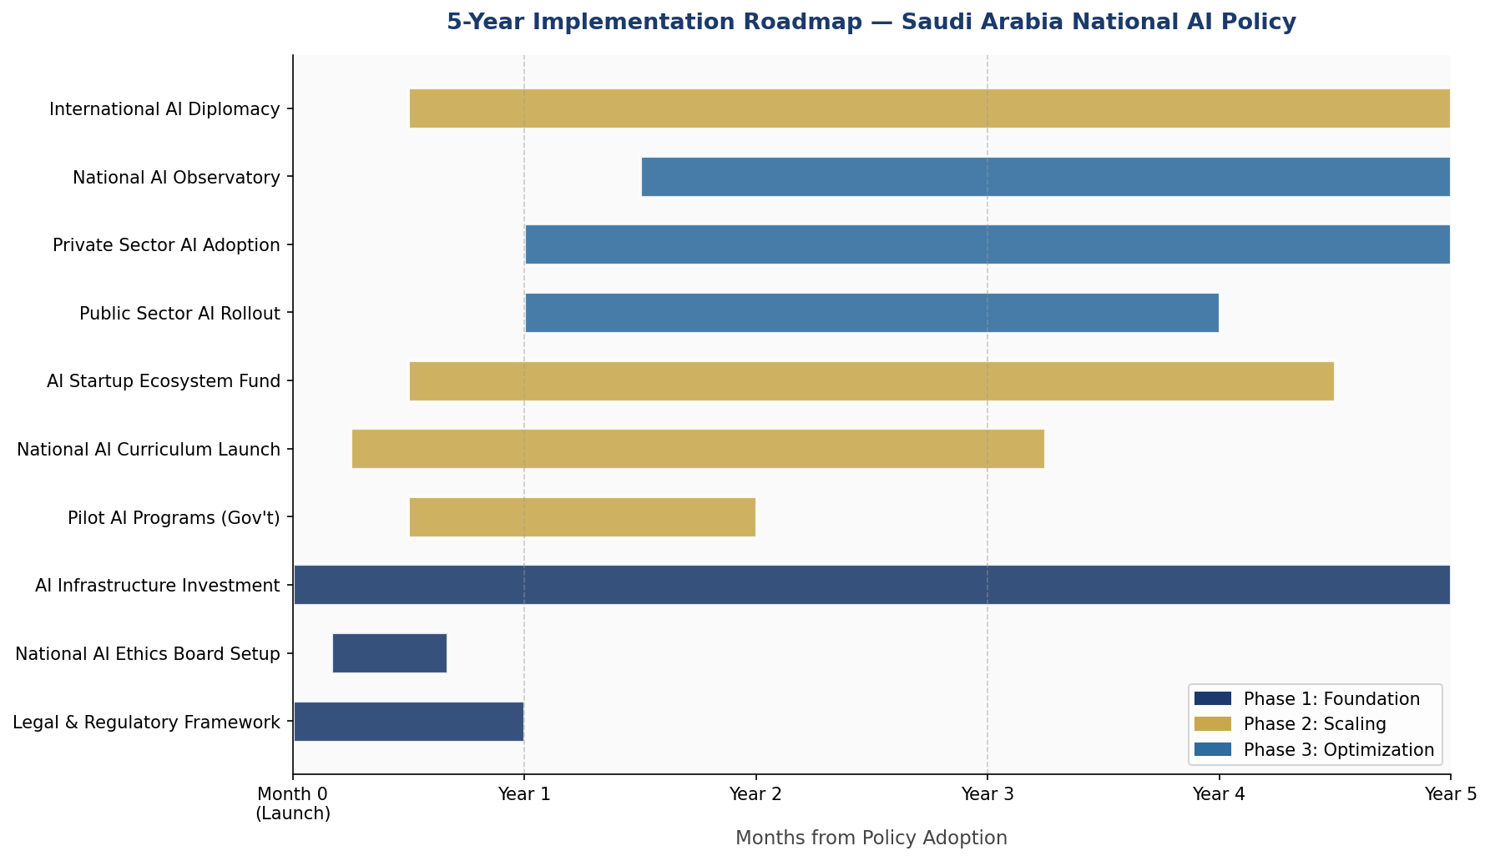
Figure 8.1: 5-Year Implementation Roadmap — Saudi Arabia National AI Policy (Gantt Timeline)

8.5 Phase KPIs Summary
KPI Area | Phase 1 (2025) | Phase 2 (2027) | Phase 3 (2030)
AI Startups Funded | 50 | 250 | 500+
Gov't AI Services Live | 5 pilots | 100 services | 300+ services
AI-Trained Graduates/yr | 2,400 | 4,500 | 6,000+
AI GDP Contribution | $18B | $55B | $160B
AI Ethics Audits Completed | 20 | 200 | 1,000+
Women in AI Workforce % | 18% | 32% | 50%

Section 9: Monitoring, Evaluation & Accountability

Robust monitoring and evaluation is essential to ensure this policy delivers its intended outcomes, adapts to the rapidly evolving AI landscape, and maintains public trust. Saudi Arabia establishes a multi-layered accountability architecture combining executive oversight, parliamentary scrutiny, independent civil society assessment, and international peer review.

9.1 National AI Observatory
The National AI Observatory (NAO), established within SDAIA but operating with independent mandate and reporting to the Shura Council, shall serve as Saudi Arabia's primary AI monitoring institution. The NAO will maintain a living registry of all AI systems deployed by government entities; conduct quarterly performance assessments of high-risk AI systems; publish an Annual National AI State Report; and operate an AI Incident Response Registry for documenting and analyzing AI-related harms. The NAO will employ a permanent staff of 80 specialists including AI engineers, ethicists, economists, and legal experts.

9.2 Annual AI State Report
The Annual National AI State Report — the first to be published in Q4 2026 — shall include: assessment of progress against all policy KPIs; independent evaluation of AI ethics compliance across government deployments; economic analysis of AI contribution to GDP and employment; an AI incident register documenting failures and corrective actions; a forward-looking risk assessment of emerging AI threats; and comparison with international AI governance benchmarks. The report must be tabled in the Shura Council and made publicly available in Arabic and English within 30 days of finalization.

9.3 KPI Dashboard
KPI Metric | Baseline (2024) | Year 1 Target | Year 3 Target | Year 5 Target (2030)
AI Readiness Index Score | 7.6/10 | 7.9/10 | 8.4/10 | 9.0/10
AI GDP Contribution (USD) | $12B | $18B | $55B | $160B
AI Professionals (Domestic) | 8,000 | 12,000 | 22,000 | 35,000
Gov't AI Services Deployed | 12 | 50 | 150 | 300+
AI Startups (Funded) | 150 | 200 | 400 | 700+
AI Ethics Audits Conducted | 0 | 50 | 300 | 1,500
CPI Score (Transparency) | 52 | 54 | 58 | 65+
Women in AI % | 18% | 22% | 35% | 50%
AI-K12 Schools Coverage | 0% | 15% | 70% | 100%
Annual AI State Reports | 0 | 1 | 3 | 5
Table 9.1: Saudi Arabia National AI Policy — KPI Monitoring Dashboard

9.4 Parliamentary & Civil Society Oversight
The Shura Council's Committee on Technology and Communication will hold biannual oversight hearings with SDAIA, the NAEB, and the NAO. Independent civil society organizations — including the Saudi Federation for Cybersecurity, Programming and Drones (SAFCSP) and university research centers — are granted standing to submit shadow reports to the NAO and present findings at parliamentary hearings. International peer review will be conducted every two years in partnership with the OECD Global Partnership on AI (GPAI).

Section 10: International Cooperation & AI Diplomacy

Saudi Arabia's scale, geographic position, and financial resources uniquely position the Kingdom to play a leadership role in shaping global AI governance — particularly for the Arab world, Muslim-majority nations, and the broader Global South. AI diplomacy is therefore a strategic priority, not merely an administrative function.

10.1 Bilateral AI Cooperation Priorities
Saudi Arabia will pursue structured bilateral AI cooperation agreements with: the United States (AI research partnership through ARAMCO-MIT collaboration; US-KSA AI Investment Framework); the European Union (alignment with EU AI Act standards; data transfer agreements; joint AI governance research); China (technology partnership in AI manufacturing, smart cities, and 5G-AI integration with appropriate sovereign safeguards); Japan and South Korea (robotics-AI integration, elderly care AI, industrial automation); India (IT workforce partnerships, AI outsourcing frameworks, and joint Arabic-Hindi NLP development); and Singapore (AI governance best practices exchange, fintech AI cooperation).

10.2 Regional AI Leadership — Arab & Islamic World
Saudi Arabia aspires to convene and lead the Arab AI Governance Forum, a biennial gathering of Arab League member states to coordinate AI policy, share data governance standards, and develop Arabic-language AI standards — including an authoritative Arabic AI Ethics Lexicon. Through the Islamic Development Bank AI Fund, Saudi Arabia will co-fund AI capacity building in OIC member states with limited AI resources, positioning the Kingdom as a responsible regional AI leader aligned with Islamic values of knowledge, justice, and stewardship.

10.3 Global AI Governance Participation
Saudi Arabia commits to active participation in: the OECD Global Partnership on AI (GPAI) as a governing member; UNESCO AI Ethics Implementation Network; ITU AI for Good Summit as a co-organizer; G20 Digital Economy Working Group; and the UN Secretary-General's AI Advisory Body. Saudi Arabia will contribute a USD 100 million voluntary contribution to UN AI Capacity Building for Least Developed Countries, administered through UNDP, over the 2025–2030 policy period.

10.4 South-South Knowledge Transfer
Saudi Arabia will establish the Saudi AI Academy for Development, offering scholarship and training programs for AI governance professionals from Arab League, OIC, and African Union member states. Annual intake: 500 international AI policy fellows from developing nations. This initiative positions Saudi Arabia as a generator rather than merely a recipient of international AI capacity building, fulfilling the Kingdom's emerging role as a major development partner.

Conclusion

The National Artificial Intelligence Policy 2025–2030 represents the Kingdom of Saudi Arabia's most ambitious and comprehensive commitment to harnessing technology for national transformation since the launch of Vision 2030 itself. Artificial intelligence is not a peripheral technological concern — it is the defining infrastructure of the 21st-century economy, the most consequential tool for public service transformation, and the arena in which Saudi Arabia can establish enduring global leadership.
This policy has been designed to be simultaneously ambitious and responsible. The economic targets — USD 160 billion in AI-driven GDP contribution by 2030 — are grounded in credible projections and the Kingdom's unique structural advantages. The governance architecture — from the National AI Ethics Board to the Citizen-First AI Charter — reflects genuine commitment to protecting the rights and dignity of every Saudi citizen in the age of algorithms. The education pipeline — from AI literacy in primary schools to world-class AI research at KAUST — recognizes that technology without talent is infrastructure without purpose.
Critically, this policy is not a document to be filed and forgotten. It is a living governance instrument, subject to annual review, parliamentary scrutiny, independent evaluation, and continuous adaptation as artificial intelligence itself evolves at unprecedented speed. The institutions it creates — the NAEB, the NAO, the Saudi AI Research Council — are designed to outlast any single policy cycle and to develop the institutional wisdom that only experience can provide.
Saudi Arabia enters the AI age not as a follower of others' frameworks, but as an active architect of its own AI destiny — one that honors its values, serves its people, advances its economy, and contributes to the responsible development of AI for all humanity. The future of artificial intelligence will, in part, be written in Riyadh. This policy ensures it is written with wisdom, justice, and ambition worthy of the Kingdom's heritage and potential.

References & Bibliography

International Frameworks & Policy Documents
- UNESCO (2021). Recommendation on the Ethics of Artificial Intelligence. United Nations Educational, Scientific and Cultural Organization, Paris.
- OECD (2024). OECD AI Principles — Updated Framework. Organisation for Economic Co-operation and Development, Paris.
- European Parliament (2024). Regulation (EU) 2024/1689 — Artificial Intelligence Act. Official Journal of the European Union.
- World Bank Group (2023). World Bank AI Strategy for Development. Washington, D.C.
- G20 (2023). G20 AI Principles and New Delhi Leaders' Declaration on AI Governance. G20 India Presidency.
- International Telecommunication Union (2023). AI for Good Global Summit Guidelines. Geneva: ITU.
- Global Partnership on AI (2024). GPAI Annual Report. Paris: OECD/GPAI Secretariat.

Saudi Arabia Policy & Data Sources
- Saudi Data and Artificial Intelligence Authority — SDAIA (2020). National AI Strategy. Riyadh: SDAIA.
- Saudi Data and Artificial Intelligence Authority (2020). AI Ethics Principles — Kingdom of Saudi Arabia. Riyadh: SDAIA.
- Council of Ministers (2023). Personal Data Protection Law (PDPL) and Implementing Regulations. Riyadh: Bureau of Experts at the Council of Ministers.
- Vision 2030 Secretariat (2024). Vision 2030 Annual Progress Report. Riyadh: General Authority for Statistics.
- Public Investment Fund (2024). PIF Annual Report 2024: Strategy and Portfolio Update. Riyadh: PIF.

Economic & AI Research
- McKinsey Global Institute (2023). The Economic Potential of Generative AI: The Next Productivity Frontier. New York: McKinsey & Company.
- World Economic Forum (2024). Future of Jobs Report 2025. Geneva: WEF.
- Oxford Insights (2023). Global AI Readiness Index 2023. Oxford: Oxford Insights.
- Transparency International (2024). Corruption Perceptions Index 2024. Berlin: Transparency International e.V.
- International Monetary Fund (2024). Saudi Arabia Article IV Consultation: Staff Report 2024. Washington, D.C.: IMF.
- PricewaterhouseCoopers (2023). Sizing the Prize: What's the Real Value of AI for Your Business and How Can You Capitalize? London: PwC.

About the Author

Nafiul Ahmad Rafi
Policy & Good Governance Researcher | BD Civic Tech Architect
Nafiul Ahmad Rafi is a civic technologist, policy researcher, author, photographer, and musician based in Dhaka, Bangladesh. He is the Founder and Director of Insights Bangladesh, a data-driven governance and policy impact analysis institution, and the Founder & Lead Architect of NagorikBD.org — a transparency-first civic platform scaled across Mymensingh Division, connecting citizens with government services across 45 Upazilas.
His work exists at the intersection of institutional reform and artificial intelligence, transforming theoretical governance into scalable, data-driven reality. Without a conventional computer science degree, he self-taught the tools of modern AI and web development to build the infrastructure that enforces the policies he once only researched.
Key Platforms & Projects
- NagorikBD.org — Civic transparency platform, Mymensingh Division
- Insights Bangladesh — Policy impact analysis institution
- FactCheck BD (factcheckbd.org) — Bangladesh's AI-powered fact-checking platform
- Political Insights BD / PIBD (pibbd.org) — Political intelligence and civic tech hub
- PeaceShield BD / National Peace Tracker — AI-powered hate speech and conflict monitoring
- PolicyLens AI (aigovbd.org) — 9-dimensional AI policy audit tool

He has published four books and maintains a personal site at ahmad-rafi.com.
Research Interests
AI Governance · Policy Research · Future of Bangladesh · Climate Policy
Contact
- 🌐 ahmad-rafi.com
- 🔗 LinkedIn: nafiul-ahmad-rafi (https://bd.linkedin.com/in/nafiul-ahmad-rafi)
- ✉️ contact@ahmad-rafi.com

"I build code to ensure transparency, and I write lyrics to inspire the courage to use it."

