🇦🇫
ISLAMIC EMIRATE OF AFGHANISTAN

National Artificial Intelligence Policy
2025 – 2030

A Comprehensive Framework for Ethical, Inclusive, and Economically Transformative AI

Prepared by:
Nafiul Ahmad Rafi
Policy & Good Governance Researcher | BD Civic Tech Architect
Insights Bangladesh

May 2025

Table of Contents

Executive Summary

Afghanistan stands at a defining intersection of crisis and opportunity. With a GDP per capita of approximately USD 358, an internet penetration rate of 18%, a literacy rate of 37%, and a Corruption Perceptions Index score of 20/100 — ranking among the most fragile governance environments globally — Afghanistan's path to stability and sustainable development demands bold, context-sensitive, and internationally aligned strategies. Artificial Intelligence (AI) represents one such transformative pathway.
This National AI Policy 2025–2030 is designed to establish a foundational framework for the responsible, inclusive, and economically productive deployment of AI technologies across Afghanistan's public and private sectors. It does not presuppose existing robust institutions or high digital literacy. Instead, it is built precisely for Afghanistan's current reality: a fragile state with extraordinary human potential, a young population hungry for economic opportunity, and a diaspora with global technical expertise that can be channeled toward national reconstruction.
The policy is structured around five strategic pillars: Ethical AI and Human Rights Protection; Economic Growth and Industrial AI Adoption; Education, Upskilling, and AI Workforce Development; Public Sector AI and e-Governance; and AI Research, Innovation, and Startup Ecosystem Development. Each pillar is calibrated to Afghanistan's specific constraints — connectivity gaps, institutional fragility, gender exclusion challenges, and acute corruption risk — while remaining aligned with global standards including the UNESCO AI Ethics Recommendation (2021), the OECD AI Principles (updated 2024), the EU AI Act framework, and the United Nations Sustainable Development Goals.
Over the five-year horizon (2025–2030), implementation is projected to contribute USD 800 million to Afghanistan's GDP by Year 5, build a national AI literacy base of over 300,000 graduates, establish 500 registered AI startups, and launch 50 public sector AI pilots spanning health, education, agriculture, and disaster response. The policy also establishes a National AI Ethics Board, a National AI Observatory, and a Parliamentary AI Oversight Mechanism — institutional anchors designed to ensure accountability, prevent AI misuse, and build public trust.
Afghanistan's participation in the global AI governance conversation is not only a sovereign right but a strategic imperative. This document positions Afghanistan as an active, principled participant in multilateral AI diplomacy — through the United Nations, the Organisation of Islamic Cooperation (OIC), and South-South cooperation networks — rather than a passive recipient of technology transfer. The ambition is clear: to build a national AI ecosystem that serves Afghan citizens, reflects Afghan values, and earns Afghanistan's rightful place in the architecture of the AI century.

Section 1: National AI Readiness Assessment

1.1 Economic Context
Afghanistan is classified as a Least Developed Country (LDC) by the United Nations. Its economy — heavily dependent on agriculture (approximately 23% of GDP), mining, and remittances — contracted sharply following the political transition of August 2021. Real GDP declined by an estimated 20–30% in 2021–2022. International aid, which historically constituted 40–75% of public expenditure, has been significantly curtailed. Per capita income stands at approximately USD 358 (World Bank, 2023 estimates), placing Afghanistan among the world's poorest nations.
Despite these constraints, several structural characteristics create an opportunity space for AI-driven recovery. Afghanistan possesses substantial untapped mineral reserves estimated at USD 1–3 trillion, including lithium deposits critical to the global AI hardware supply chain. Its demographic profile — with over 60% of the population below age 25 — constitutes a latent human capital base. The Afghan diaspora, estimated at 2.5–6 million globally, includes a technically skilled cohort concentrated in OECD countries whose knowledge transfer can be harnessed through deliberate policy incentives.

1.2 Education and Human Capital
Afghanistan's education system has faced catastrophic disruption in recent years. The overall literacy rate stands at approximately 37% (UNESCO, 2023), with female literacy significantly lower at an estimated 17–23%. Tertiary enrollment is extremely limited, with fewer than 10% of eligible youth accessing higher education. STEM capacity within higher institutions is minimal, and digital skills training programs are nascent and largely donor-dependent.
This context demands an AI education strategy that begins at the foundational digital literacy level, is inclusive of marginalized populations including women and rural communities, and leverages informal and remote learning pathways. The Afghan diaspora can serve as remote instructors and curriculum designers. Low-tech AI literacy programs — delivered via radio, offline digital devices, and community centers — can reach populations with limited internet access.

1.3 Digital Infrastructure
Internet penetration in Afghanistan stands at approximately 18% (DataReportal, 2024), concentrated in urban centers such as Kabul, Herat, Mazar-i-Sharif, and Kandahar. Mobile penetration is considerably higher, at approximately 68%, with 2G/3G being the dominant connectivity mode. 4G availability is limited and geographically uneven. Data center infrastructure is minimal, with no significant domestic cloud computing capability. Energy access — critical for AI infrastructure — remains unreliable, with approximately 30% of the population having access to electricity.
AI policy implementation must therefore prioritize edge computing solutions, low-bandwidth AI applications, offline-capable AI tools, and solar-powered community technology hubs. Satellite internet connectivity — through initiatives such as Starlink or regional partners — may provide a transformative leap in coverage.

1.4 Governance and Institutional Capacity
Afghanistan's governance environment is characterized by significant institutional fragility. The current administrative structure reflects a centralized government with limited legislative and judicial independence in the internationally recognized sense. International development partners have largely suspended direct budget support, and many institutional frameworks built under previous administrations have been discontinued. However, local administrative capacity at the provincial level — particularly in health, agriculture, and education — has shown resilience and represents a potential vehicle for public sector AI piloting.

1.5 Corruption Risk and AI Governance
Afghanistan scored 20/100 on Transparency International's Corruption Perceptions Index 2023, ranking 162nd out of 180 countries. This level of corruption risk has direct implications for AI governance. Without strong accountability mechanisms, AI systems deployed in procurement, social welfare distribution, or law enforcement risk amplifying existing corruption patterns, enabling algorithmic capture by vested interests, or creating new opacity in administrative processes.
This policy therefore embeds anti-corruption safeguards at every layer: mandatory algorithmic audits for public sector AI, transparent procurement guidelines for AI tools, civil society oversight roles, and international third-party verification for high-risk AI applications.

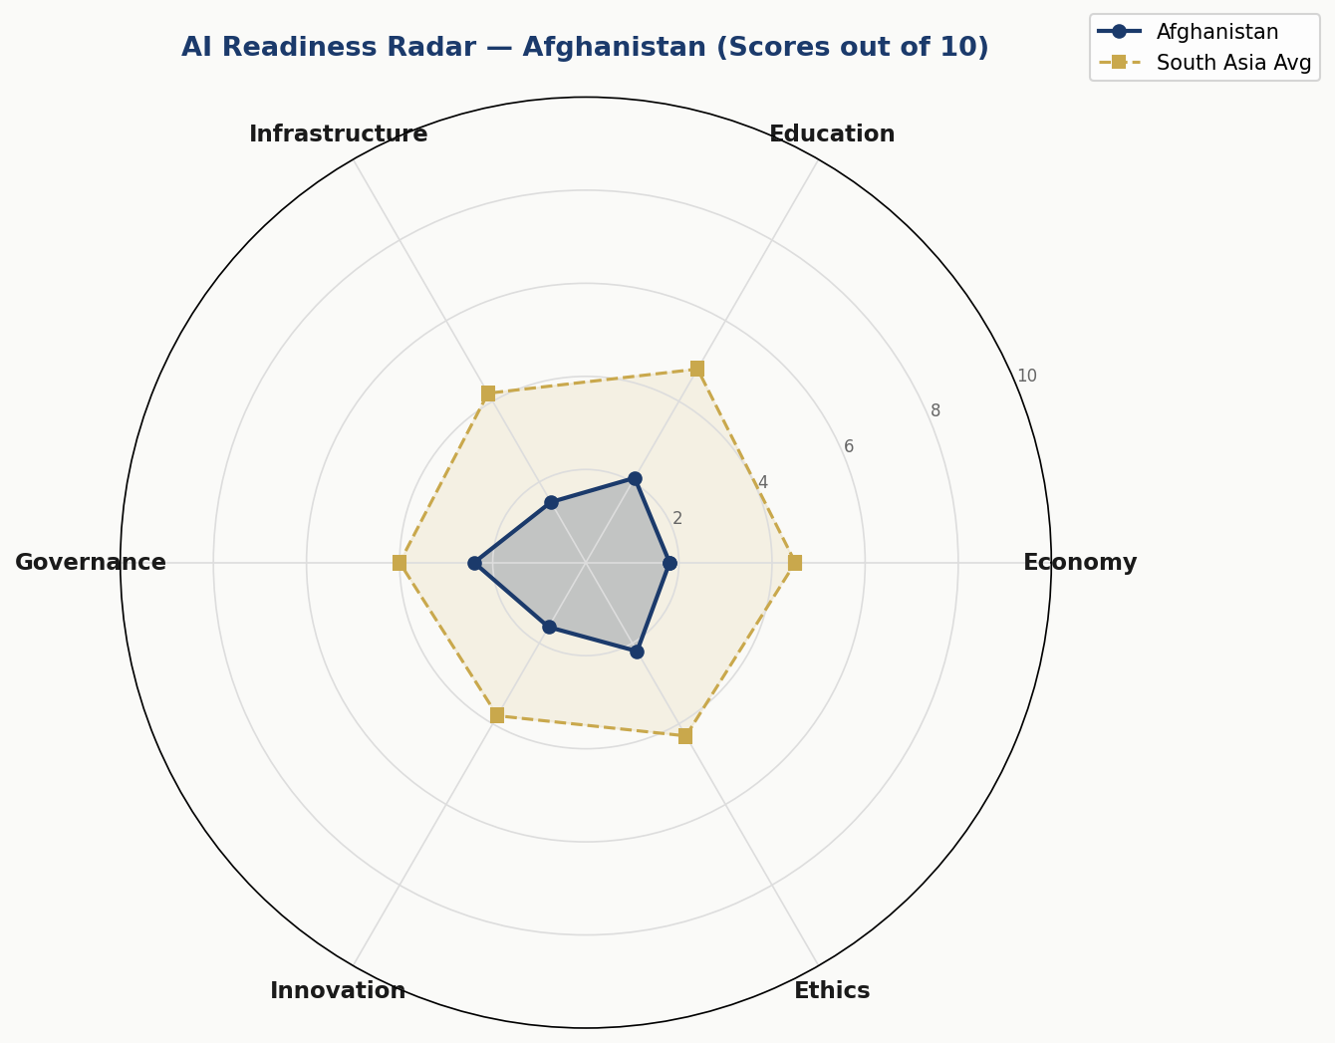
Chart 1: AI Readiness Radar — Afghanistan vs South Asia Average (Scores out of 10, 2024)
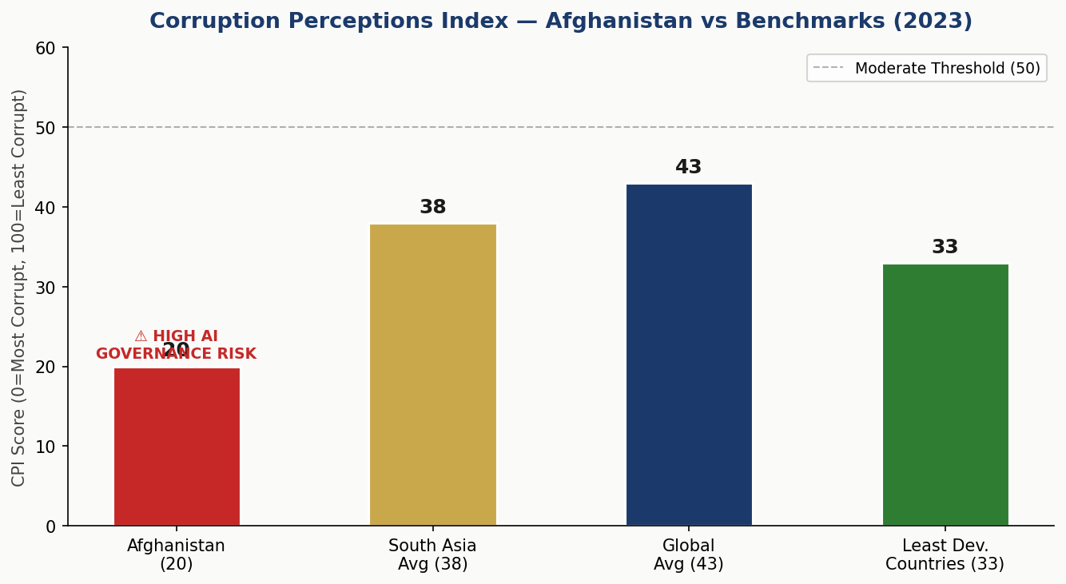
Chart 2: Corruption Perceptions Index — Afghanistan vs Regional and Global Benchmarks (TI, 2023)

Section 2: Policy Vision and Strategic Pillars

Policy Vision Statement
To harness the transformative power of Artificial Intelligence to rebuild Afghanistan's economy, empower its people, strengthen transparent governance, and enable Afghanistan to participate as a sovereign and principled actor in the global AI ecosystem — while ensuring that AI development respects Islamic values, human dignity, and the rights of all Afghans regardless of gender, ethnicity, or geography.

2.1 Pillar I — Ethical AI and Human Rights Protection
All AI systems deployed in Afghanistan must respect the fundamental dignity of every Afghan citizen. This pillar establishes the ethical red lines — uses of AI that are categorically prohibited — and the oversight architecture that ensures accountability. Key initiatives include the National AI Ethics Board, mandatory human rights impact assessments for AI procurement, and a public AI transparency register.
Given Afghanistan's complex security environment, this pillar places particular emphasis on restricting AI surveillance technologies. Mass surveillance AI, predictive policing systems without judicial oversight, and biometric data collection without informed consent are classified as unacceptable-risk applications and are prohibited under this policy.

2.2 Pillar II — Economic Growth and Industrial AI Adoption
AI offers Afghanistan a path to economic diversification and leapfrog development. Priority sectors for AI-driven growth include agriculture (precision farming, crop disease detection, weather prediction), mining (geological mapping, safety monitoring), health (telemedicine AI, diagnostics), financial inclusion (mobile AI banking, credit scoring), and disaster response (satellite imagery analysis, early warning systems).
This pillar establishes a National AI Investment Fund seeded by international donors and administered through a transparent Public-Private Partnership framework. It also creates regulatory sandboxes for AI startups and provides SME-facing AI adoption grants.

2.3 Pillar III — Education, Upskilling, and AI Workforce Development
Building a generation of AI-capable Afghans is the most consequential long-term investment this policy makes. From AI awareness programs in schools — including girls' informal education networks — through to advanced research fellowships for graduate students, this pillar maps a complete national AI education pipeline. It includes teacher training programs, curriculum development, diaspora-led remote mentoring, and partnerships with international universities.

2.4 Pillar IV — Public Sector AI and e-Governance
Government is where AI can have the fastest, most direct impact on citizen lives. Priority public sector applications include AI-powered crop advisory services for the Ministry of Agriculture, telemedicine diagnosis support for rural health clinics, automated scholarship and social welfare eligibility screening, document verification systems for civil registration, and infrastructure damage assessment using satellite imagery.
All government AI procurement must follow the open-tender guidelines established in Section 7 of this policy, with mandatory source code disclosure for high-risk applications and a civil society observer role in procurement committees.

2.5 Pillar V — AI Research, Innovation, and Startup Ecosystem
A sovereign AI capability requires indigenous research capacity. This pillar establishes the Afghan Centre for AI Research (ACAIR) as a public institution housed within Kabul University, with satellite centers in Herat and Balkh. It provides competitive research grants, facilitates diaspora research exchange programs, and creates an AI patent fund to protect Afghan intellectual property. A national AI startup incubator — the Afghanistan AI Hub — is established to provide seed funding, mentoring, and market access to AI entrepreneurs.

Section 3: International Framework Alignment

3.1 UNESCO AI Ethics Recommendation (2021)
The UNESCO Recommendation on the Ethics of AI — the first global normative instrument on AI ethics — identifies 11 core values and principles. This policy maps directly to each:
- Proportionality and Do No Harm: Section 6 establishes AI risk tiers and prohibited use cases.
- Safety and Security: Section 6 requires mandatory security auditing for high-risk AI.
- Fairness and Non-Discrimination: Section 5 includes explicit gender and ethnic inclusion targets.
- Sustainability: Section 4 prioritizes low-energy AI deployment models suited to Afghanistan's energy constraints.
- Right to Privacy: Section 6 establishes a Data Protection Act recommendation.
- Human Oversight and Determination: Section 9 mandates Parliamentary oversight and civil society audit roles.
- Transparency and Explainability: Section 7 requires AI transparency registers for public sector deployments.
- Responsibility and Accountability: National AI Ethics Board (Section 6) holds legal accountability.
- Awareness and Literacy: Section 5 outlines national AI education pipeline.
- Multi-stakeholder and Adaptive Governance: Section 9 establishes the National AI Observatory.
- International and Transboundary Cooperation: Section 10 outlines bilateral and multilateral engagement.

3.2 OECD AI Principles (2019, Updated 2024)
The OECD AI Principles — adopted by over 46 countries — provide the foundational governance architecture for this policy. Afghanistan's alignment includes: (1) Inclusive growth, sustainable development, and well-being — operationalized through Sections 4 and 7; (2) Human-centred values and fairness — embedded in Section 6's risk classification system; (3) Transparency and explainability — codified in public sector AI procurement guidelines; (4) Robustness, security, and safety — mandated for all government AI systems; (5) Accountability — enforced through the National AI Ethics Board and Parliamentary mechanism.

3.3 EU AI Act (2024) — Risk-Based Framework
The EU AI Act (fully effective 2024–2026) provides the world's most comprehensive risk-based AI regulatory model. Afghanistan adapts this framework to its context:
Unacceptable Risk (Banned): Social scoring systems by government entities; real-time biometric surveillance in public spaces without judicial warrant; AI manipulation systems targeting vulnerable groups; predictive policing without human review.
High Risk (Mandatory Audit): AI in health diagnosis and treatment; AI in educational assessment; AI in social welfare eligibility; AI in public infrastructure management; AI in border/immigration control.
Limited Risk (Transparency Obligation): Chatbots and citizen-facing AI interfaces must disclose AI identity; AI-generated content in government communications must be labeled.
Minimal Risk (Voluntary Code): Commercial AI products, entertainment AI, productivity tools — encouraged to follow voluntary code of conduct.

3.4 Comprehensive Framework Alignment Matrix

Framework | Core Principle | Ethics | Governance | Implementation | Int'l Cooperation
UNESCO AI Ethics (2021) | Proportionality & Do No Harm | Section 6 | Section 6 | Section 2, 6 | Section 3
OECD AI Principles (2024) | Inclusive Growth & Sustainability | Section 2, 4 | Section 6 | Section 8 | Section 10
EU AI Act (2024) | Risk-Based Classification | Section 6 | Section 6 | Section 7 | Section 3
World Bank AI Strategy | Development & Poverty Reduction | Section 4, 5 | Section 7 | Section 8 | Section 4
G20 AI Principles | Inclusive AI Governance | Section 2 | Section 6 | Section 10 | Section 2
ITU AI for Good | SDG Alignment | Section 4, 5 | Section 7 | Section 5 | Section 10

3.5 G20 AI Principles and ITU AI for Good
Afghanistan, while not a G20 member, aligns with G20 AI Principles through its emphasis on inclusive AI governance, human-centred development, and international cooperation. The ITU AI for Good framework provides specific SDG linkages: AI for agriculture (SDG 2 — Zero Hunger), AI for health (SDG 3 — Good Health), AI for education (SDG 4 — Quality Education), AI for economic inclusion (SDG 8 — Decent Work), and AI for transparent institutions (SDG 16 — Peace and Justice).

Section 4: Economic Impact and Investment Roadmap

4.1 Projected AI Economic Contribution
Drawing on World Bank and McKinsey Global Institute estimates for Least Developed Countries, AI adoption — even at conservative uptake rates — can contribute 0.3% of GDP in Year 1, scaling to 4.1% by Year 5 as infrastructure, skills, and regulatory confidence build. For Afghanistan, with a GDP of approximately USD 18.6 billion (2023 estimate), this represents a potential contribution of USD 55 million in Year 1, growing to USD 800 million by 2029.
These projections assume: (a) international aid and FDI resumption at modest levels; (b) diaspora remittance channels remaining open; (c) at least 3 major public sector AI implementations achieving scale; and (d) a functional National AI Ethics Board providing investor confidence.
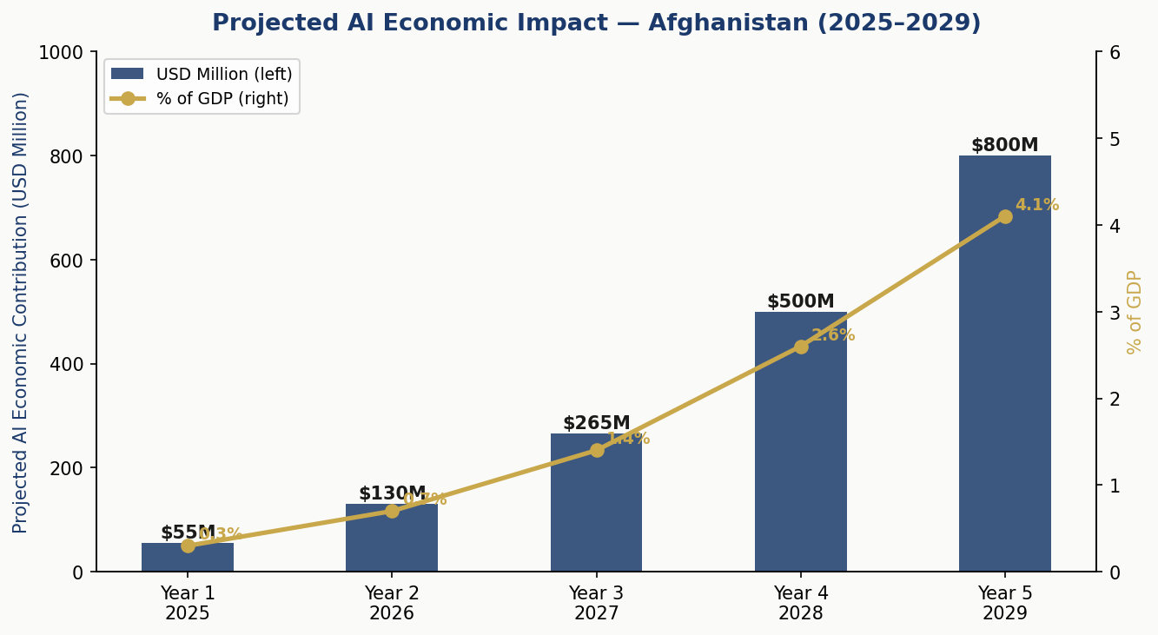
Chart 3: Projected AI Economic Impact — Afghanistan 2025–2029 (USD Million & % of GDP)

4.2 Investment Allocation Framework
The recommended investment allocation for a National AI Fund of approximately USD 150 million over 5 years — to be mobilized from international donors, diaspora investment bonds, and private sector co-financing — is as follows:
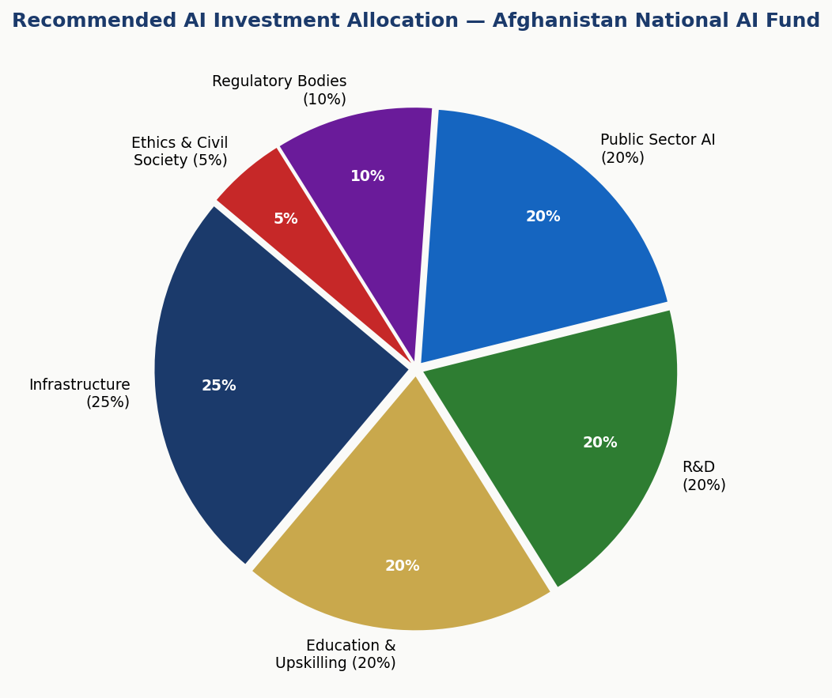
Chart 4: Recommended AI Investment Allocation — Afghanistan National AI Fund (5-Year Total)

4.3 Priority Sectors for AI Adoption
- Agriculture (highest priority): Precision farming, crop disease detection via mobile phone imagery AI, weather-responsive irrigation advisory, livestock health monitoring. Afghanistan's agricultural sector employs approximately 60% of the workforce.
- Mining and Natural Resources: AI-assisted geological mapping, mine safety monitoring, environmental impact tracking for lithium and rare earth extraction — positioning Afghanistan in the global AI hardware supply chain.
- Health and Telemedicine: AI-powered diagnostic support for rural health workers with limited formal training, TB and malaria screening, maternal health monitoring via mobile applications.
- Financial Inclusion: Mobile AI-based credit scoring for the unbanked population, fraud detection in mobile money systems, AI-powered microfinance optimization.
- Disaster Response and Climate Resilience: Earthquake early warning systems (Afghanistan sits on major fault lines), flood prediction for the Amu Darya basin, drought monitoring via satellite.

4.4 Public-Private Partnership Framework
A National AI PPP Secretariat, housed within the Ministry of Finance, will administer co-financing arrangements between the government and private sector AI investors. All PPP agreements must include: (a) mandatory technology transfer components; (b) Afghan employment quotas of minimum 70%; (c) data sovereignty provisions ensuring no Afghan citizen data is stored on foreign servers without consent; and (d) a 3% revenue contribution to the National AI Education Fund.

Section 5: Education and Human Capital Development

5.1 Current Skills Gap Analysis
Afghanistan faces a profound AI skills gap that operates at multiple levels simultaneously. At the foundational level, basic digital literacy is absent for the majority of the population. At the practitioner level, fewer than 2,000 individuals nationally have any formal AI or machine learning training. At the research level, Afghanistan has produced fewer than 50 internationally published AI researchers in the past decade. Bridging this gap requires a long-term commitment to education infrastructure, not merely training programs.
Compounding the challenge is the severe restriction on girls' and women's formal education. This policy takes a principled stance: any Afghan AI education program that excludes women excludes the majority of its potential talent pool. All education initiatives under this policy must develop parallel delivery mechanisms — community-based learning, radio-delivered AI literacy, online platforms accessible through mobile data — that can reach women outside formal school settings.

5.2 National AI Curriculum Framework
K–12 (Primary and Secondary): Digital literacy integrated into existing curricula at grades 5–12. AI awareness modules (what AI is, how it affects daily life, ethical questions) introduced at grade 8. Coding fundamentals via offline tools (Scratch, Python) for grades 10–12.
Tertiary (University Level): Dedicated AI Bachelor's programs at Kabul University, Herat University, and Balkh University by Year 2. AI minors available across all undergraduate disciplines. National AI scholarship program funding 1,000 students per year.
Vocational and Informal: 6-month AI practitioner certificates for working professionals. AI for Farmers program — a 10-day training using mobile phones and offline tools for agricultural AI applications. Community AI Centers in 10 provincial capitals providing free access and instruction.
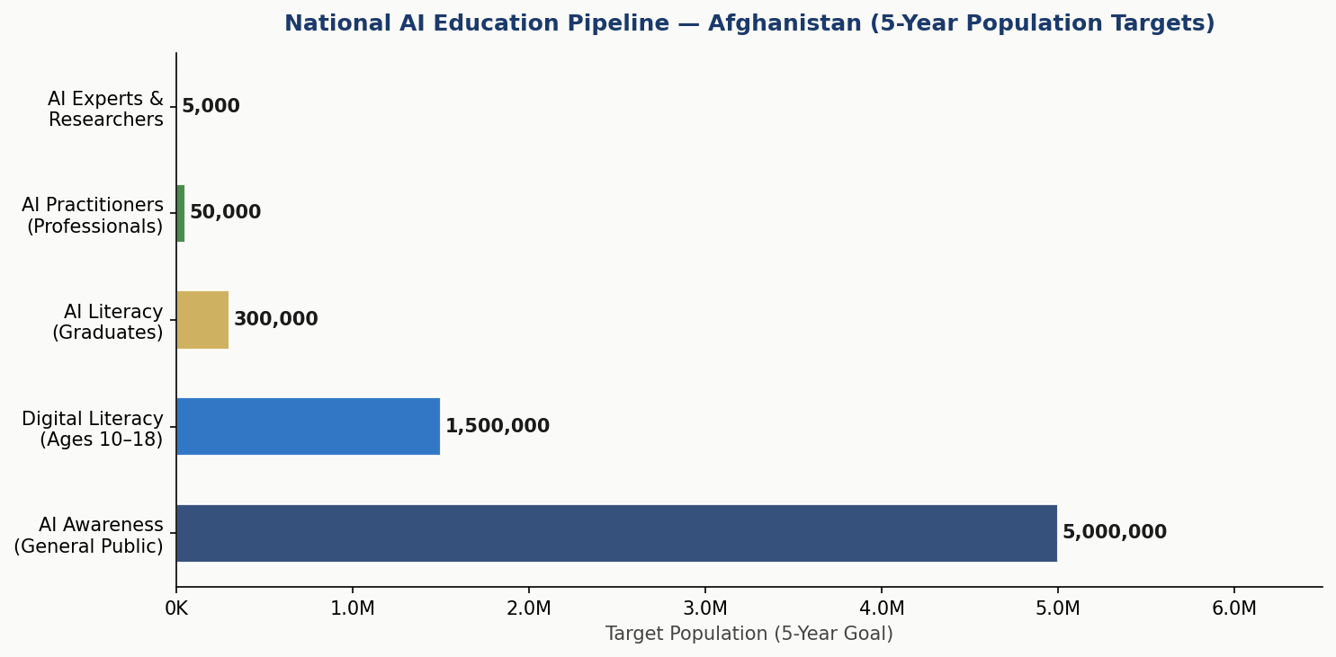
Chart 5: National AI Education Pipeline — Afghanistan 5-Year Population Targets

5.3 Diaspora Engagement Program
The Afghan diaspora — estimated at 2.5–6 million globally, with significant technical expertise concentrated in Germany, the United States, Australia, and the Gulf states — represents Afghanistan's most immediately deployable AI human capital. The Afghan AI Diaspora Network (AADN) will be established as a formal government-recognized body facilitating: remote teaching appointments; curriculum review and quality assurance; mentorship pairing with Afghan students; investment facilitation; and research collaboration.

5.4 Gender and Inclusion Targets
This policy sets explicit inclusion targets: 30% female participation in all AI education programs by Year 3; 40% by Year 5. At least 25% of National AI Scholarship recipients must be women. Community AI Centers must offer women-only sessions. All AI curriculum materials must be reviewed for gender bias. A dedicated Women in AI Afghanistan Fellowship program will fund 200 women annually for advanced AI training.

Section 6: Ethical AI Governance and Regulatory Framework

6.1 National AI Ethics Board
The National AI Ethics Board (NAEB) is established as the primary regulatory authority for AI in Afghanistan. It comprises 15 members: 5 government representatives (Ministry of Communications, Ministry of Justice, Ministry of Health, Ministry of Education, and Ministry of Finance); 4 independent technical experts (at least 2 of international standing); 3 civil society representatives (including at least 1 women's rights organization); 2 private sector representatives; and 1 international observer (nominated by UNESCO).
The Board's mandate includes: approving or prohibiting high-risk AI deployments; issuing binding AI ethical guidelines; investigating complaints of AI misuse; conducting annual public reports; and representing Afghanistan in international AI governance forums. Board members serve 4-year terms with staggered renewal to ensure institutional continuity.

6.2 AI Risk Classification System
Risk Tier | Requirements | Afghanistan-Specific Examples
Unacceptable Risk — BANNED | Prohibited under Afghan law. No exceptions. | Mass surveillance; social credit scoring; AI manipulation of religious content; autonomous lethal weapons.
High Risk — Mandatory Audit | Pre-deployment NAEB review; annual audits; human override mandatory. | Health diagnostics AI; welfare eligibility systems; educational assessment AI; border management AI.
Limited Risk — Transparency | Must disclose AI identity to users. Register with NAEB. | Government chatbots; AI-generated public information; automated social media moderation tools.
Minimal Risk — Voluntary Code | Encouraged to follow national AI Code of Conduct. | Productivity apps; AI translation tools; agricultural advisory apps; AI-assisted crafts and design.

6.3 Data Protection and Privacy Framework
Afghanistan currently lacks comprehensive data protection legislation. This policy recommends the drafting and enactment of an Afghan Personal Data Protection Act (APDPA) modeled on GDPR principles but adapted for low-connectivity environments. Key provisions include: (1) data minimization — only data strictly necessary for AI function may be collected; (2) purpose limitation — data collected for one AI application may not be repurposed without explicit consent; (3) data residency — citizen data processed by government AI must be stored on infrastructure physically located within Afghanistan or in vetted sovereign cloud environments; (4) right to explanation — any Afghan citizen subject to an automated decision affecting their rights must be able to request a plain-language explanation.

6.4 Anti-Corruption AI Guidelines
Given Afghanistan's CPI score of 20/100, special anti-corruption provisions are mandatory for all public sector AI deployments: (a) All government AI procurement must follow open competitive tender with public disclosure of evaluation criteria; (b) AI systems used in public resource allocation (land registry, customs, contracts) must maintain immutable audit logs accessible to civil society; (c) No AI system may be deployed in a government function without a Corruption Impact Assessment conducted by an independent auditor; (d) Whistleblower protections for individuals reporting AI-enabled corruption are guaranteed under this policy.

Section 7: Public Sector and e-Governance AI

7.1 Priority Government AI Use Cases
Ministry | AI Application | Expected Impact | Timeline
Agriculture | Crop disease detection via mobile photo AI | Reduce crop loss by 20% for 500K farmers | Year 1–2
Public Health | TB/Malaria screening AI for community workers | Increase diagnosis rate by 30% in rural areas | Year 1–2
Education | Adaptive learning AI for refugee/informal schools | Improve literacy outcomes for 200K students | Year 2–3
Finance | AI fraud detection in mobile money systems | Reduce financial fraud by 40% | Year 1
Disaster Response | Satellite imagery AI for earthquake damage mapping | Cut emergency response time by 50% | Year 2
Civil Registration | Document authentication AI for ID verification | Reduce fake document fraud | Year 2–3
Justice | AI-assisted legal aid information system | Expand access to legal information for rural citizens | Year 3
Infrastructure | Road and bridge condition monitoring via AI imaging | Prioritize maintenance, reduce road casualties | Year 3–4

7.2 Government AI Procurement Guidelines
All government AI procurement above USD 50,000 must: (1) be advertised via open tender on the national e-procurement portal; (2) include a mandatory Technical Ethics Assessment scoring weight of minimum 20% in evaluation criteria; (3) require vendor disclosure of training data sources, model architecture documentation, and bias testing results; (4) include contractual data sovereignty clauses; (5) mandate source code escrow for critical infrastructure AI; and (6) provide for a 12-month government performance audit with right to terminate without penalty if performance benchmarks are not met.

7.3 Citizen-Facing AI Services Roadmap
Year 1: AI-powered citizens' information portal (Dari/Pashto) covering government services, rights, and procedures. Year 2: AI agricultural advisory chatbot deployable via basic SMS and low-bandwidth mobile. Year 3: AI health triage service for telemedicine platforms. Year 4: AI-assisted civil registration and document services. Year 5: Comprehensive national AI e-governance portal integrating all citizen-facing services.

Section 8: Implementation Roadmap

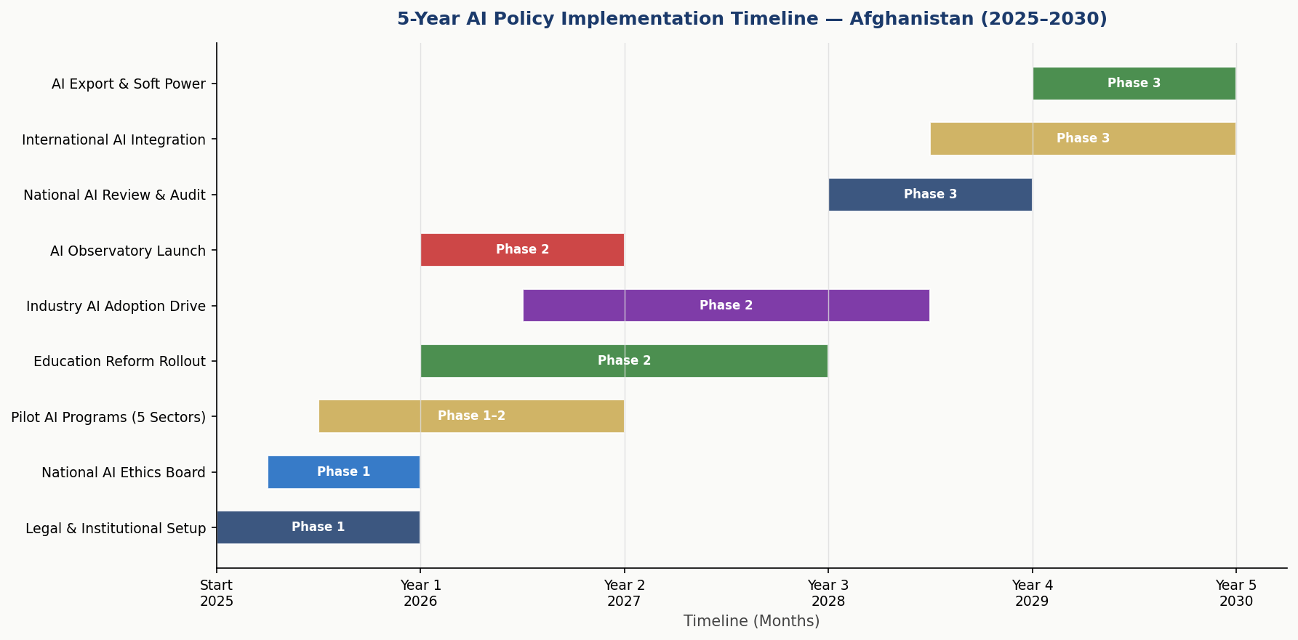
Chart 6: 5-Year AI Policy Implementation Timeline — Afghanistan (2025–2030)

8.1 Phase 1 — Foundation (2025–2026)
Legal and Institutional Setup: Draft and publish Afghan AI Policy (this document) as formal government position paper; establish legal basis for National AI Ethics Board; draft Afghan Personal Data Protection Act for stakeholder consultation; establish National AI PPP Secretariat within Ministry of Finance.
Institutional Capacity: Recruit 15-member National AI Ethics Board; establish Afghan Centre for AI Research at Kabul University; launch Women in AI Afghanistan Fellowship (200 fellowships Year 1); engage Afghan AI Diaspora Network with formal MOU.
Pilot Programs: Launch 5 high-priority public sector AI pilots (agriculture, health, disaster response, finance fraud detection, document authentication); establish 10 Community AI Centers in provincial capitals; launch National AI Scholarship Program (1,000 students Year 1).
Key Year 1 KPIs: Ethics Board operational; 5 pilots launched; 1,000 scholarships awarded; 10,000 citizens reached through AI awareness programs; AI Policy formally endorsed.

8.2 Phase 2 — Scaling (2027–2028)
Education Reform: AI literacy integrated into K–12 national curriculum; 3 universities offering AI degree programs; 50,000 vocational AI certificates awarded; Women in AI Fellowship scaled to 500 annual recipients.
Industry Adoption: Afghanistan AI Hub (startup incubator) operational with 50 resident companies; National AI Investment Fund at USD 50 million deployed; AI regulatory sandbox operational for 20 companies; 20 public sector AI applications at scale.
Governance Maturation: Afghan Personal Data Protection Act enacted; National AI Observatory publishing annual AI State Report; Parliamentary AI Oversight Committee established; first international AI cooperation agreements signed.

8.3 Phase 3 — Optimization (2029–2030)
Review and Audit: Comprehensive national AI policy review incorporating 5 years of implementation data; international peer review of AI governance framework; CPI-informed anti-corruption audit of all government AI systems; update policy for 2030–2035 cycle.
International Integration: Full engagement in UN AI governance processes; bilateral AI cooperation agreements with 5+ countries; Afghanistan positioned as South-South AI knowledge transfer hub for fragile states; AI export potential in agricultural AI and disaster response tools explored.

Section 9: Monitoring, Evaluation, and Accountability

9.1 National AI Observatory
The National AI Observatory (NAO) is established as an independent body under the National AI Ethics Board, with a mandate to: (1) conduct annual surveys of AI adoption across government, private sector, and civil society; (2) produce the Annual Afghan AI State Report — a public document covering adoption metrics, ethics incidents, investment flows, education outcomes, and international comparisons; (3) maintain a public AI registry of all AI systems deployed in government; (4) flag emerging AI risks to the NAEB and Parliament; and (5) coordinate with international AI observatories including UNESCO's AI observatory and the ITU AI for Good network.

9.2 Parliamentary Oversight Mechanism
A Parliamentary Committee on Artificial Intelligence and Digital Technology — or its functional equivalent — is established as the legislative oversight body for AI policy. It meets at minimum quarterly, receives the Annual AI State Report, and has the authority to summon the NAEB Chair, any government minister overseeing AI deployment, and private sector AI operators for testimony. It has the power to initiate independent AI audits and to recommend suspension of AI systems pending review.

9.3 KPI Dashboard

KPI | Baseline (2025) | Year 1 Target | Year 3 Target | Year 5 Target
AI Strategy Documents Adopted | 0 | 1 National Policy | 3 Sector Plans | 10 Sub-Plans
AI Ethics Board Operational | None | Established | Fully Functional | Regional Model
AI Awareness (Population %) | <1% | 5% | 20% | 40%
AI Literacy (Graduates) | <500 | 5,000 | 50,000 | 300,000
AI Startups Registered | ~10 | 50 | 200 | 500
Public Sector AI Pilots | 0 | 5 | 20 | 50
Annual AI GDP Contribution | N/A | $55M | $265M | $800M
Women in AI Programs (%) | <5% | 15% | 30% | 40%
Internet Penetration (%) | 18% | 22% | 35% | 50%
National AI Observatory Active | No | Launched | Reporting Annually | Full Audit Capacity

9.4 Civil Society and Independent Audit Role
Civil society organizations registered in Afghanistan — including diaspora-based organizations — are guaranteed observer status on the National AI Ethics Board and the National AI Observatory. They may submit formal AI ethics complaints, which NAEB must respond to within 60 days. International organizations (UN agencies, development banks) may conduct independent AI governance assessments at any time upon agreement with the NAEB. All government AI audits must have a civil society observer present.

Section 10: International Cooperation and Diplomacy

10.1 Bilateral AI Cooperation Priorities
Afghanistan's bilateral AI cooperation strategy focuses on five key partner categories: (1) Technical AI Powers — United States, China, South Korea, UAE, and Germany — for technology transfer, research collaboration, and AI infrastructure investment; (2) Regional Neighbors — Pakistan, Iran, Uzbekistan, Tajikistan — for shared AI applications in cross-border agriculture, disaster response, and trade facilitation; (3) Islamic World — Saudi Arabia, Turkey, Malaysia, and the OIC collectively — for AI governance frameworks compatible with Islamic ethical principles; (4) Fragile State Peers — Myanmar, Yemen, Sudan, DRC — for South-South AI knowledge exchange through UN-mediated platforms; (5) Diaspora Countries — Germany, USA, Australia, UK, UAE — for diaspora AI talent engagement programs.

10.2 Regional AI Governance
Afghanistan is a member of the South Asian Association for Regional Cooperation (SAARC) and the Economic Cooperation Organization (ECO). This policy mandates Afghanistan's active participation in SAARC Digital Economy Working Group, with a specific agenda item proposed for a South Asian AI Ethics Charter. Afghanistan will also seek observer status in ASEAN's AI governance forums, given ASEAN's advanced AI policy development relative to South Asia.

10.3 Global AI Governance Participation
Afghanistan commits to the following global AI governance engagements: (1) Full engagement with UNESCO's AI Ethics Recommendation implementation framework, including biennial reporting; (2) Application for membership in the OECD AI Policy Observatory's developing country partner program; (3) Active participation in ITU AI for Good annual global summit; (4) Engagement with the Global Partnership on AI (GPAI) as an associate partner; (5) Submission of national AI policy report to the UN Secretary-General's High-Level Advisory Body on AI.

10.4 Data Sovereignty and Technology Transfer Principles
All international AI cooperation agreements must include: (a) explicit recognition of Afghan data sovereignty; (b) technology transfer requirements — any AI system deployed by a foreign entity in Afghanistan must include capacity building for Afghan personnel; (c) intellectual property protections ensuring Afghan-developed AI innovations are protected under national and international IP law; (d) escrow provisions for source code of critical AI infrastructure; and (e) termination clauses allowing Afghanistan to exit agreements that prove incompatible with national interests or human rights standards.

Conclusion

Afghanistan's National AI Policy 2025–2030 is not an aspirational document written for an idealized future — it is a working framework built for the difficult present. It acknowledges the depth of Afghanistan's institutional, economic, and social challenges while refusing to let those challenges become excuses for inaction or for importing AI without governance.
The principles embedded in this policy — ethical AI, inclusive AI, accountable AI — are not Western imports or donor conditions. They reflect universal values expressed through the lens of Afghanistan's own history, culture, and faith. Islamic jurisprudence's emphasis on justice (adl), preventing harm (darar), and protecting the vulnerable (maslaha) maps precisely onto the principles of responsible AI. Afghanistan does not need to choose between AI and its values — this policy shows how they align.
The road ahead is long. A policy document does not build a data center, train a programmer, or stop a corrupt procurement. But it does something those actions cannot: it establishes the shared understanding, the legitimate authority, and the accountability architecture within which all those actions can take place with confidence and coherence. That is what this document is.
Afghanistan's young people — the most AI-ready generation in the country's history, born into a world of mobile phones and global connectivity — deserve a future in which their intelligence, creativity, and resilience are amplified by the best tools humanity has ever built. This policy is a commitment to building that future for them.

Policy Adoption Statement
This National AI Policy 2025–2030, prepared by Nafiul Ahmad Rafi (Policy & Good Governance Researcher, Insights Bangladesh), is submitted for formal adoption and endorsement by relevant national and international stakeholders as a comprehensive framework for Afghanistan's AI governance. It is designed to be living document, subject to annual review and quinquennial comprehensive revision, responsive to the evolving technology landscape and Afghanistan's changing needs.

References and Bibliography

The following international frameworks, reports, and data sources inform this policy:
- UNESCO. (2021). Recommendation on the Ethics of Artificial Intelligence. United Nations Educational, Scientific and Cultural Organization, Paris.
- OECD. (2024, updated). OECD Principles on AI. Organisation for Economic Co-operation and Development, Paris. oecd.ai/en/ai-principles.
- European Parliament. (2024). Regulation (EU) 2024/1689 — The EU Artificial Intelligence Act. Official Journal of the European Union.
- World Bank. (2023). Afghanistan Economic Monitor. World Bank Group, Washington D.C.
- Transparency International. (2023). Corruption Perceptions Index 2023. Transparency International, Berlin.
- UNESCO Institute for Statistics. (2023). Afghanistan Education Data. UIS, Montreal.
- ITU. (2024). AI for Good: Global Summit Proceedings. International Telecommunication Union, Geneva.
- Oxford Insights. (2023). Government AI Readiness Index 2023. Oxford Insights, Oxford.
- McKinsey Global Institute. (2023). The Economic Potential of Generative AI. McKinsey & Company, New York.
- DataReportal. (2024). Digital 2024: Afghanistan. DataReportal — Global Digital Insights.
- UNDP. (2023). Human Development Report 2023/24. United Nations Development Programme, New York.
- G20 AI Principles. (2019, reaffirmed 2023). G20 Ministerial Statement on Trade and Digital Economy. Osaka, Japan.
- Global Partnership on AI (GPAI). (2024). GPAI Annual Report 2024. GPAI Secretariat, Paris.
- World Bank. (2021). World Governance Indicators 2021. World Bank Group, Washington D.C.
- OCHA. (2024). Afghanistan Humanitarian Situation Report 2024. UN Office for the Coordination of Humanitarian Affairs.

About the Author

Nafiul Ahmad Rafi
Policy & Good Governance Researcher | BD Civic Tech Architect

Nafiul Ahmad Rafi is a civic technologist, policy researcher, author, photographer, and musician based in Dhaka, Bangladesh. He is the Founder and Director of Insights Bangladesh — a data-driven governance and policy impact analysis institution — and the Founder and Lead Architect of NagorikBD.org, a transparency-first civic platform scaled across Mymensingh Division, connecting citizens with government services across 45 Upazilas.
His work exists at the intersection of institutional reform and artificial intelligence, transforming theoretical governance into scalable, data-driven reality. Without a conventional computer science degree, he self-taught the tools of modern AI and web development to build the infrastructure that enforces the policies he once only researched.

Key Platforms and Projects
NagorikBD.org | Civic transparency platform for Mymensingh Division — 45 Upazilas, citizen-government interface.
Insights Bangladesh | Policy impact analysis institution — governance research, civic data, and policy advocacy.
FactCheck BD (factcheckbd.org) | Bangladesh's AI-powered fact-checking platform with multi-provider AI orchestration and Bangla/English support.
Political Insights BD / PIBD (pibbd.org) | Political intelligence and civic tech hub — election monitoring, procurement transparency, media intelligence.
PeaceShield BD / National Peace Tracker | AI-powered hate speech detection and conflict monitoring system with Bangla-BERT and national news aggregation.
PolicyLens AI (aigovbd.org) | 9-dimensional AI policy audit tool for national AI governance evaluation.

He has published four books and maintains his personal site at ahmad-rafi.com.

Research Interests: AI Governance · Policy Research · Future of Bangladesh · Climate Policy (Bangladesh Context)

Contact
🌐 | ahmad-rafi.com
🔗 | linkedin.com/in/nafiul-ahmad-rafi
✉️ | contact@ahmad-rafi.com

"I build code to ensure transparency, and I write lyrics to inspire the courage to use it."

