🇧🇩
PEOPLE'S REPUBLIC OF BANGLADESH

National Artificial Intelligence Policy
2025 – 2030

A Comprehensive Framework for Ethical, Inclusive, and Economically Transformative AI

Prepared by
Nafiul Ahmad Rafi
Policy & Good Governance Researcher | BD Civic Tech Architect
Insights Bangladesh
ahmad-rafi.com | contact@ahmad-rafi.com

May 2025

Table of Contents

Executive Summary
Bangladesh stands at a pivotal crossroads. With a GDP per capita of approximately USD 2,800, a population of 170 million, and a rapidly growing digital economy accounting for nearly 3% of GDP, the nation possesses both the scale and the ambition to emerge as a regional AI leader. This National Artificial Intelligence Policy 2025–2030 provides the foundational framework to translate that ambition into measurable, inclusive, and ethically grounded outcomes.
The policy is developed in alignment with the six leading international AI governance frameworks: the UNESCO AI Ethics Recommendation (2021), the OECD AI Principles (updated 2024), the European Union AI Act (2024), the World Bank AI Strategy, the G20 AI Principles, and ITU AI for Good Guidelines. It acknowledges Bangladesh's LDC graduation trajectory, its ambition under Vision 2041, and the structural vulnerabilities — including a Transparency International CPI score of 24, limited STEM tertiary enrollment, and early-stage AI infrastructure — that must be addressed for AI adoption to be equitable and corruption-resilient.
The policy is organized around five strategic pillars: (1) Ethical AI and Human Rights Protection, (2) Economic Growth and Industrial AI Adoption, (3) Education, Upskilling, and AI Workforce Development, (4) Public Sector AI and e-Governance, and (5) AI Research, Innovation, and Startup Ecosystem. These pillars are supported by a phased five-year implementation roadmap, a National AI Ethics Board, a National AI Observatory, and a comprehensive KPI dashboard to ensure accountability.
By 2030, this policy projects AI's direct contribution to reach 4.8% of GDP, with 10 million citizens reached through AI literacy programs, 250,000 AI practitioners trained, and Bangladesh positioned as a credible voice in global AI governance forums.

Section 1: National AI Readiness Assessment

1.1 Economic Context
Bangladesh has sustained GDP growth rates above 6% for over a decade, earning recognition as one of Asia's fastest-growing economies. The garment and textile sector (RMG) contributes approximately 84% of export earnings, creating both an urgency and an opportunity: AI-driven automation in manufacturing necessitates proactive workforce transition strategies, while the sector's global connectivity creates pathways for technology transfer.
The remittance economy (USD 21.9 billion in 2023) and a burgeoning fintech sector — led by bKash, Nagad, and Rocket — provide a foundation for AI adoption in financial services. Bangladesh's LDC graduation from 2026 onwards introduces tariff vulnerabilities that AI-driven productivity gains must offset.

1.2 Education and Human Capital
Bangladesh's adult literacy rate stands at approximately 74%. Tertiary enrollment is growing but remains low at 23%, with STEM graduates constituting less than 18% of that cohort. The national ICT Division has initiated programs such as the Learning and Earning Development Project (LEDP) and Hi-Tech Parks, but a systematic AI skills pipeline — from K–12 through postgraduate research — is absent.

1.3 Digital Infrastructure
Internet penetration has reached 44% (mobile-dominated), with 4G coverage across most Upazila towns. The national fiber backbone — under the Info-Sarker Phase III program — is expanding. However, last-mile connectivity in coastal, haor, and Chittagong Hill Tracts regions remains inadequate. Data center capacity is nascent, with growing dependence on regional cloud providers.

1.4 Governance and Institutional Capacity
Bangladesh operates under a parliamentary democracy with periodic elections. Digital governance initiatives under the a2i (Access to Information) program and the National Portal Framework have digitized significant citizen-government touchpoints across 45,000+ service points. However, institutional AI capacity within ministries is minimal, and a dedicated AI regulatory body does not yet exist.

1.5 Corruption Risk Assessment
Bangladesh's CPI score of 24 (Transparency International, 2023) places it in the high-corruption-risk category globally. This creates specific risks for AI deployment in public procurement, judicial systems, and social protection distribution. This policy mandates algorithmic accountability standards and independent audit requirements for all high-risk public AI systems precisely to address this vulnerability.
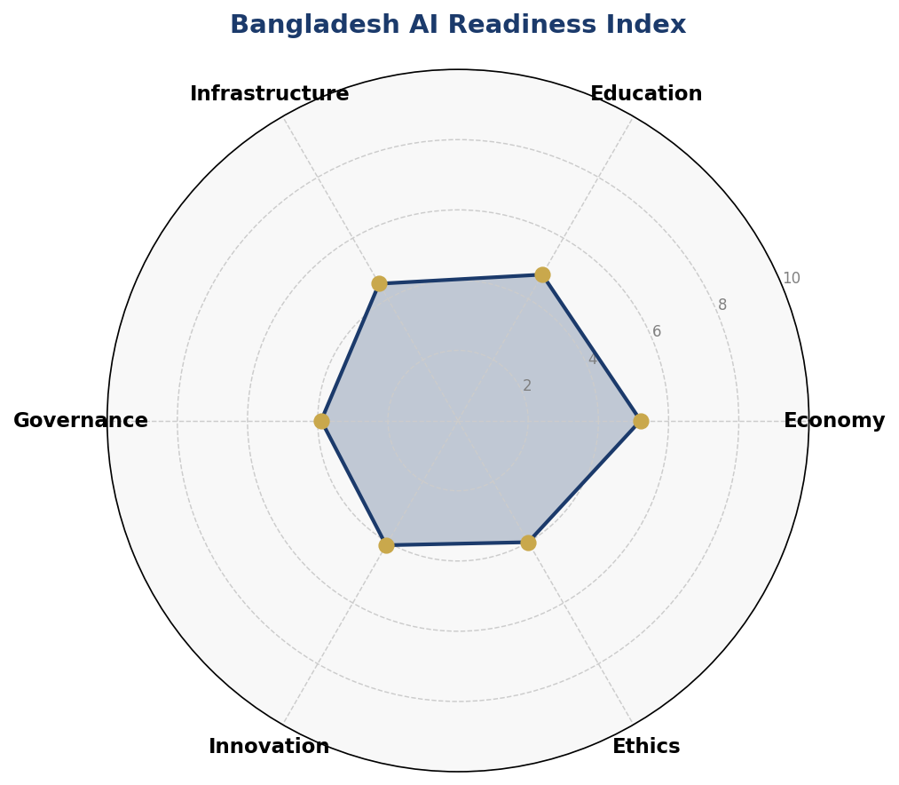
Figure 1: Bangladesh AI Readiness Index — Six-Dimensional Assessment (Scores out of 10)
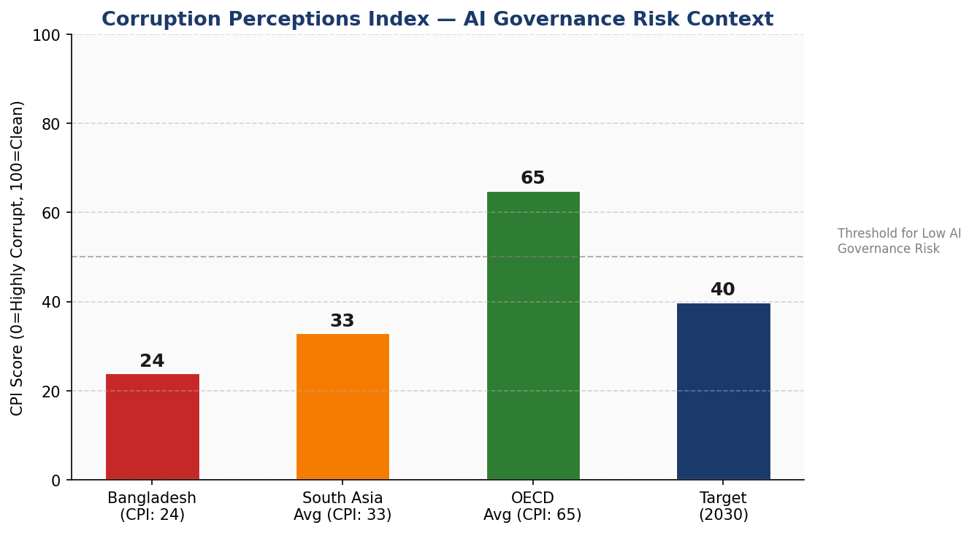
Figure 2: Corruption Perceptions Index — Bangladesh vs. Regional and OECD Benchmarks

Section 2: Policy Vision and Strategic Pillars

2.1 Vision Statement
"By 2030, Bangladesh will be a regionally recognised, ethically grounded AI nation — where artificial intelligence amplifies the dignity, productivity, and rights of every citizen, and where transparency, accountability, and inclusion are non-negotiable foundations of every intelligent system deployed in public or private life."

2.2 Strategic Pillar I — Ethical AI and Human Rights Protection
All AI systems deployed in Bangladesh — public or private — must be designed, audited, and operated in alignment with core human rights principles: non-discrimination, privacy, due process, freedom of expression, and cultural dignity. A National AI Ethics Board will enforce these standards through a mandatory registration, audit, and incident reporting regime.

2.3 Strategic Pillar II — Economic Growth and Industrial AI Adoption
AI adoption will be prioritized in Bangladesh's highest-employment and highest-growth sectors: Ready-Made Garments (smart manufacturing, quality control, export compliance AI), Financial Services (fraud detection, credit scoring for unbanked populations), Agriculture (precision farming, climate-adaptive crop AI), Healthcare (diagnostic AI for rural telemedicine), and Logistics (port and supply chain optimization).

2.4 Strategic Pillar III — Education, Upskilling, and AI Workforce Development
A national AI skills pipeline will be established across three tiers: AI Awareness (general public, K–12 integration), AI Literacy (secondary and vocational training), and AI Practitioner & Expert tracks (university curricula, postgraduate research centers, and a National AI Fellowship Program). Women's inclusion in AI education will be a mandated performance indicator, targeting 40% female participation across all programs.

2.5 Strategic Pillar IV — Public Sector AI and e-Governance
Government ministries will adopt AI to improve service delivery, reduce corruption, and enhance evidence-based policymaking. Priority applications include automated social protection targeting, AI-assisted public procurement anomaly detection, judicial case management AI, and climate early warning systems. All government AI must be procured under the National AI Procurement Standard and subjected to annual algorithmic audits.

2.6 Strategic Pillar V — AI Research, Innovation, and Startup Ecosystem
A National AI Research Fund (NAIRF) will be established with initial capitalization of BDT 500 crore, co-funded by government and private sector. Bangladesh's seven public technical universities will form a National AI Research Consortium. A dedicated AI startup support track will be integrated into the ICT Division's existing startup ecosystem programs, with fast-track regulatory sandbox access for AI companies.

Section 3: International Framework Alignment
This policy is explicitly designed for multi-framework alignment. The table below maps each international framework's core principles to specific sections of this policy document.

Framework | Core Principle | Policy Section Alignment
UNESCO AI Ethics (2021) | Proportionality & Safety | Sec. 6 (Risk Classification), Sec. 9 (Monitoring)
UNESCO AI Ethics (2021) | Fairness & Non-Discrimination | Sec. 2.2 (Ethical AI Pillar), Sec. 5 (Education Inclusion)
OECD AI Principles (2024) | Inclusive Growth & Sustainability | Sec. 2.3 (Economic Pillar), Sec. 4 (Investment Roadmap)
OECD AI Principles (2024) | Transparency & Explainability | Sec. 6 (Governance), Sec. 7 (Public Sector AI)
EU AI Act (2024) | Risk-Based Classification | Sec. 6.2 (Risk Classification System)
EU AI Act (2024) | High-Risk System Obligations | Sec. 7 (Gov. AI Procurement Standard)
World Bank AI Strategy | Development & Poverty Reduction | Sec. 4 (Economic Impact), Sec. 5 (Education Pipeline)
G20 AI Principles | Inclusive Growth & Digital Divides | Sec. 2.3, Sec. 5, Sec. 10 (Int'l Cooperation)
ITU AI for Good | SDG Linkage & Connectivity | Sec. 1.3 (Infrastructure), Sec. 2.4 (e-Governance)
Table 1: Comprehensive International Framework Alignment Matrix

Section 4: Economic Impact and Investment Roadmap
Drawing on McKinsey Global Institute estimates for lower-middle income economies and World Bank projections for South Asian AI adoption, Bangladesh's AI sector is projected to contribute between 3.5%–5% of GDP by 2030 under accelerated adoption scenarios. This policy targets the midpoint projection of 4.8% through coordinated public and private investment.
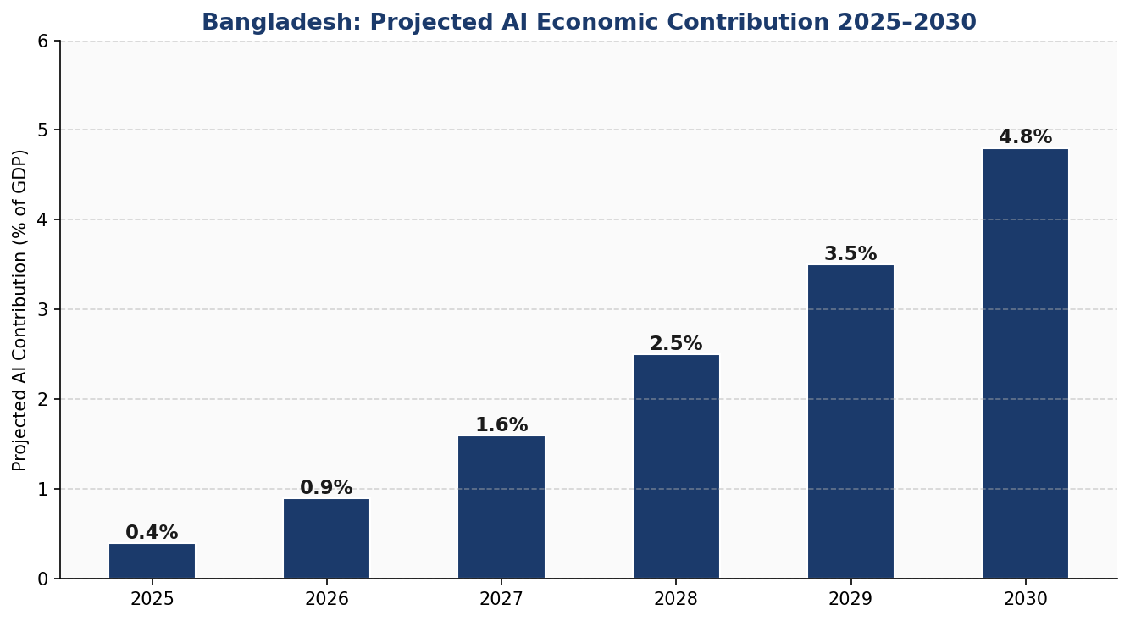
Figure 3: Bangladesh Projected AI Contribution to GDP — 2025 to 2030

Investment allocation across the five-year period is structured to prioritize foundational infrastructure in Years 1–2, with education and R&D scaling from Year 2 onwards. The recommended AI budget allocation as a share of the national ICT budget is as follows:
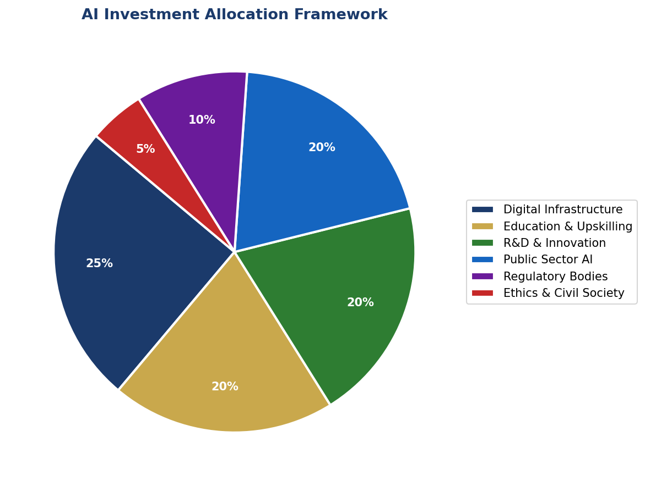
Figure 4: Recommended National AI Investment Allocation Framework

4.1 Priority Sectors for AI Adoption
The following sectors are identified as highest-priority for structured AI adoption programs based on Bangladesh's economic profile:
- Ready-Made Garments (RMG) — Quality control AI, compliance monitoring, sustainable sourcing verification
- Agriculture — Crop yield prediction, pest and flood early warning, precision input optimization
- Healthcare — Diagnostic AI for district hospitals, telemedicine triage, drug supply chain optimization
- Financial Services — MSME credit scoring, remittance fraud detection, Islamic finance AI compliance
- Education — Adaptive learning platforms, Bangla NLP tools, examination integrity systems
- Climate & Disaster Management — Cyclone track modeling, flood prediction, coastal erosion monitoring

Section 5: Education and Human Capital Development
Bangladesh's AI future will be determined by the depth and breadth of its human capital pipeline. This section establishes a National AI Curriculum Framework spanning four tiers, with specific population targets for Year 1 and Year 5, and inclusion mandates ensuring women, rural communities, and persons with disabilities are equitably represented.
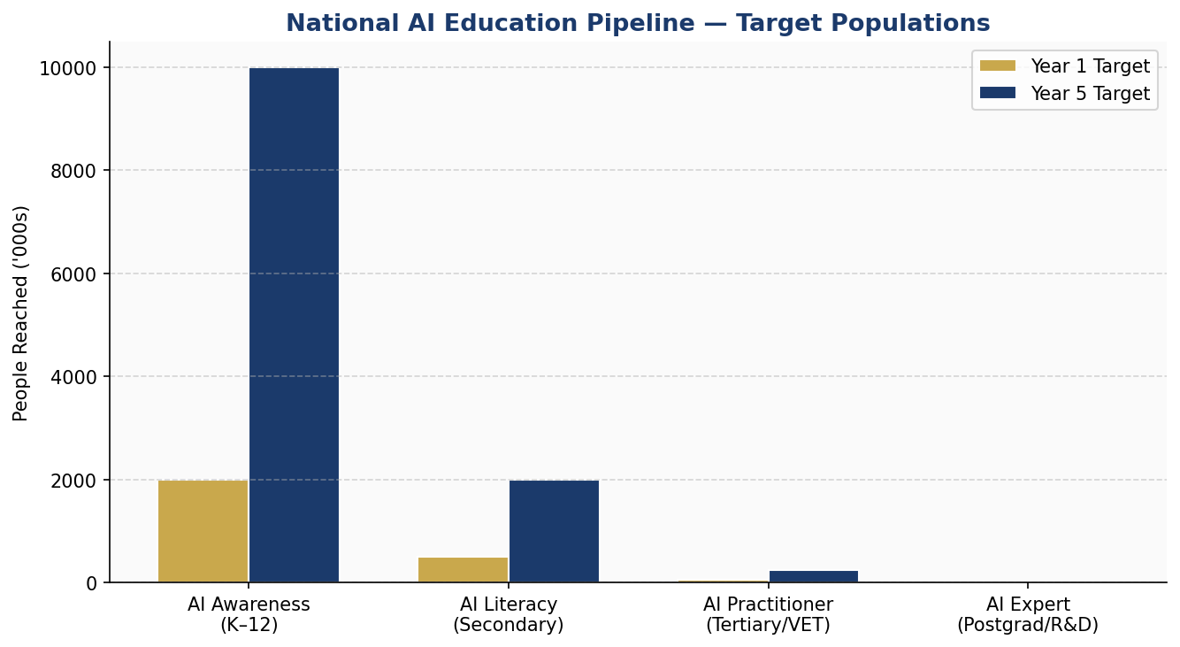
Figure 5: National AI Education Pipeline — Target Populations by Tier (Year 1 vs. Year 5)

5.1 National AI Curriculum Framework
Tier 1 — AI Awareness (K–12): Integration of computational thinking, data literacy, and AI ethics into the National Curriculum. Target: 10 million students by Year 5. Delivered through teacher training and digital content on the Muktopaath platform.
Tier 2 — AI Literacy (Secondary & Vocational): Structured AI literacy modules at SSC/HSC level and Bangladesh Technical Education Board vocational tracks. Target: 2 million young people by Year 5.
Tier 3 — AI Practitioner (University & Professional): Mandatory AI coursework in CS, EEE, Business, and Social Science undergraduate programs. Target: 250,000 practitioners by Year 5.
Tier 4 — AI Expert (Postgraduate & R&D): National AI Research Consortium across 7 technical universities. 100 annual AI PhDs funded through the National AI Research Fund. Target: 15,000 AI experts by Year 5.

5.2 Women in AI — Inclusion Mandate
All AI education programs funded under this policy must achieve and maintain 40% female participation within 24 months of inception. The Bangladesh Hi-Tech Park Authority will establish dedicated Women in AI Labs in six divisional cities.

Section 6: Ethical AI Governance and Regulatory Framework

6.1 National AI Ethics Board
A statutory National AI Ethics Board (NAEB) will be established by Parliamentary act within 18 months of policy adoption. The NAEB will comprise: 3 government nominees (ICT Division, Law Ministry, Statistics Bureau), 3 independent academics (AI, law, social science), 2 civil society representatives, 1 industry representative, and 1 international expert nominated by UNESCO.

6.2 AI Risk Classification System

Risk Tier | Definition | Examples in Bangladesh Context
Unacceptable Risk (Banned) | Systems that pose unacceptable threat to fundamental rights | Social scoring by government, subliminal manipulation systems
High Risk (Regulated) | Significant impact on fundamental rights or safety | Judicial risk scoring, social protection targeting, border control AI, medical diagnosis
Limited Risk (Transparent) | AI with transparency obligations | Chatbots in government portals, content recommendation, AI-generated media
Minimal Risk (Voluntary) | AI posing little to no risk | Spam filters, inventory forecasting, language correction tools
Table 2: Bangladesh AI Risk Classification System (Adapted from EU AI Act Framework)

6.3 Anti-Corruption AI Governance
Given Bangladesh's CPI score, all AI systems deployed in public procurement, tax administration, customs, and law enforcement must: (a) undergo mandatory third-party algorithmic audits every 12 months, (b) publish bias and decision-transparency reports, (c) maintain immutable audit logs accessible to the National AI Observatory, and (d) be open to Parliamentary scrutiny on demand.

Section 7: Public Sector and e-Governance AI

7.1 Priority Government Use Cases
- Social Protection — AI-assisted targeting for VGD, VGF, and cash transfer programs to reduce leakage
- Public Procurement — Anomaly detection on e-GP/CPTU data to flag bid-rigging and collusion
- Land Administration — AI-assisted digitization and dispute detection for land records
- Tax Administration — Automated audit selection and VAT compliance AI (NBR integration)
- Disaster Response — AI-powered flood modeling integrated with SPARRSO satellite data
- Judicial System — Case management AI for backlog reduction (with mandatory human final decision)

7.2 National AI Procurement Standard
All government ministries procuring AI systems must follow the National AI Procurement Standard (NAPS), which mandates: open tendering with AI-specific technical requirements, mandatory explainability and bias testing documentation, source code escrow for critical national infrastructure AI, and preference for locally developed solutions when technical equivalence exists.

Section 8: Five-Year Implementation Roadmap
The roadmap is organized into three overlapping phases, each building on the foundations established in prior phases. Progress will be reviewed annually by the National AI Observatory and reported to Parliament.
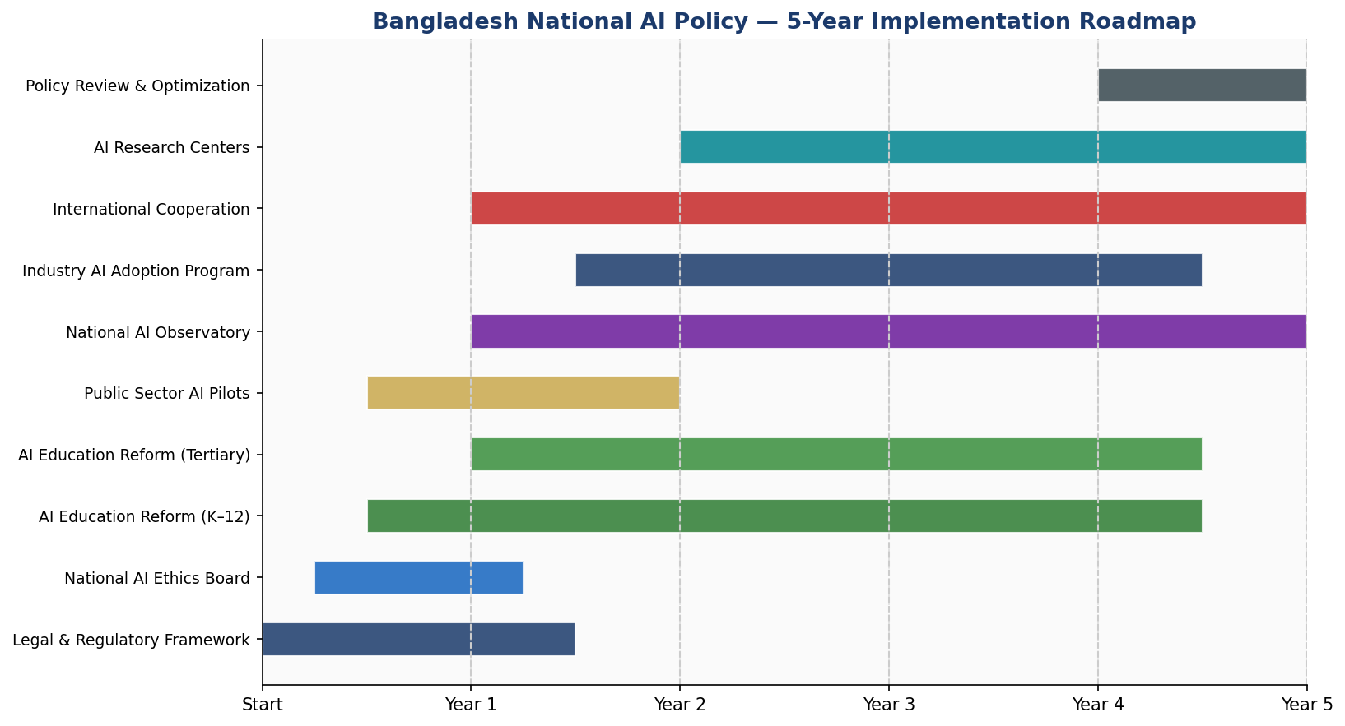
Figure 6: Bangladesh National AI Policy — 5-Year Implementation Timeline

8.1 Phase 1 — Foundation (Years 1–2)
- Enact the National AI Act establishing the NAEB and AI Observatory
- Publish National AI Risk Classification Guidelines
- Launch AI Readiness Audit of top 20 government ministries
- Establish National AI Research Consortium across 7 universities
- Launch AI literacy programs through Muktopaath — target 2 million by end of Year 2
- Pilot 3 high-impact public sector AI applications (social protection, procurement, disaster)

8.2 Phase 2 — Scaling (Years 2–4)
- Integrate AI curriculum into national SSC/HSC syllabi
- Scale government AI pilots to national rollout
- Activate National AI Research Fund — first cohort of 25 PhD fellowships
- Launch Women in AI Labs in 6 divisional cities
- Establish bilateral AI cooperation agreements with India, Japan, Singapore, EU
- Complete AI Readiness rollout to all 64 districts

8.3 Phase 3 — Optimization (Years 4–5)
- Conduct first comprehensive National AI Policy Review
- Position Bangladesh for AI export services (Bangla NLP, RMG AI, health AI for SAARC)
- Apply for full membership in Global Partnership on AI (GPAI)
- Publish first National AI State of the Nation Report

Section 9: Monitoring, Evaluation, and Accountability

9.1 National AI Observatory
The National AI Observatory (NAO) will operate under the ICT Division with functional independence. It will publish quarterly dashboards, conduct annual policy compliance audits, and submit an annual report to Parliament. Civil society organizations may apply for accreditation as Independent AI Auditors under the NAO framework.

9.2 KPI Dashboard

KPI | Baseline (2025) | Year 1 Target | Year 3 Target | Year 5 Target
AI contribution to GDP (%) | <0.5% | 1% | 2.5% | 4.8%
Citizens in AI literacy programs | ~50,000 | 2M | 6M | 10M
AI practitioners trained | ~5,000 | 20,000 | 100,000 | 250,000
Gov. AI systems audited (annual) | 0 | 5 | 30 | 60+
Women in AI programs (%) | ~15% | 25% | 35% | 40%
AI startups (registered) | ~200 | 400 | 1,200 | 3,000
CPI Score (TI) | 24 | 26 | 30 | 35
Table 3: National AI Policy KPI Dashboard — Baseline and Five-Year Targets

Section 10: International Cooperation and AI Diplomacy
Bangladesh's AI policy is designed not in isolation but as an active contribution to global AI governance. As a SAARC member, a major contributor to UN peacekeeping, and an emerging voice in LDC and climate negotiations, Bangladesh will leverage AI diplomacy to advance both national interests and global equity.

10.1 Bilateral Priorities
- India — Bangla-language NLP collaboration, cross-border AI agricultural data sharing
- Japan — AI robotics for RMG automation transition, elderly care AI research
- Singapore — Fintech AI, AI startup ecosystem linkage, talent exchange
- European Union — Regulatory alignment, research grants, AI ethics co-development
- United States — Fulbright AI fellowships, USAID digital governance programs

10.2 Multilateral Engagement
- Apply for GPAI (Global Partnership on AI) full membership by Year 3
- Lead a SAARC AI Governance Working Group
- Participate in ITU AI for Good annual summits as country presenter
- Engage in G77 AI equity caucus at UN General Assembly

10.3 South-South Knowledge Transfer
Bangladesh will share its civic AI tools — particularly the National Peace Tracker, the AI-powered procurement monitoring system, and the AI literacy curriculum — with least-developed country partners through the a2i Technology Transfer Program, positioning Bangladesh as a leading AI development cooperation provider by 2030.

Conclusion
The National Artificial Intelligence Policy 2025–2030 is not merely a technical document. It is a statement of national intent — that Bangladesh will enter the age of AI on its own terms: transparently, inclusively, and with accountability at its core.
Artificial intelligence carries within it both extraordinary promise and genuine peril. For a country of 170 million people, 35% of whom live in rural areas with limited access to government services, AI's greatest potential lies not in automation for efficiency's sake, but in access, equity, and voice. This policy's greatest success will be measured not only in GDP percentage points, but in the farmer who receives a timely flood warning, the woman who accesses a government service without paying a bribe, and the student in Mymensingh who builds an AI tool that the world uses.
The road is long. The institutional gaps are real. The corruption risks are documented. But Bangladesh has overcome extraordinary odds before — in 1971 and in the decades since. This policy provides the map. The commitment to walk the road must come from government, civil society, academia, industry, and citizens, together.

"Technology is never neutral. In whose hands it lands, and for whose benefit it runs — these are political choices. Bangladesh must choose wisely."

References and Bibliography
1. UNESCO. (2021). Recommendation on the Ethics of Artificial Intelligence. United Nations Educational, Scientific and Cultural Organization.
2. OECD. (2019, updated 2024). OECD AI Principles. Organisation for Economic Co-operation and Development.
3. European Parliament. (2024). Regulation (EU) 2024/1689 — The Artificial Intelligence Act. Official Journal of the European Union.
4. World Bank. (2023). World Development Report 2023: Migrants, Refugees, and Societies. World Bank Group.
5. G20 AI Principles. (2019). Ministerial Statement on Trade and Digital Economy. G20 Japan Presidency.
6. ITU. (2023). AI for Good Global Summit Outcomes Report. International Telecommunication Union.
7. Transparency International. (2024). Corruption Perceptions Index 2023. Berlin: Transparency International.
8. Oxford Insights. (2023). Government AI Readiness Index 2023. Oxford Insights Ltd.
9. McKinsey Global Institute. (2023). The Economic Potential of Generative AI. McKinsey & Company.
10. Government of Bangladesh, ICT Division. (2022). Bangladesh National Digital Connectivity Master Plan. Ministry of Posts, Telecommunications and Information Technology.
11. World Bank. (2023). Bangladesh Country Economic Memorandum. The World Bank Group, Dhaka Office.
12. Transparency International Bangladesh (TIB). (2024). National Household Survey on Corruption. TIB Research Division.

About the Author

Nafiul Ahmad Rafi
Policy & Good Governance Researcher | BD Civic Tech Architect
Nafiul Ahmad Rafi is a civic technologist, policy researcher, author, photographer, and musician based in Dhaka, Bangladesh. He is the Founder and Director of Insights Bangladesh — Bangladesh's first data-driven governance and policy impact analysis institution — and the Founder and Lead Architect of NagorikBD.org, a transparency-first civic platform scaled across the entire Mymensingh Division, connecting citizens with government services across 45 Upazilas.
His work exists at the intersection of institutional reform and artificial intelligence, transforming theoretical governance frameworks into scalable, data-driven systems. Self-taught in modern AI and full-stack web development, he builds the infrastructure that enforces the policies he once only researched.

Key Platforms and Projects
- NagorikBD.org — Civic transparency platform, Mymensingh Division (45 Upazilas)
- Insights Bangladesh — Data-driven policy impact analysis institution
- FactCheck BD (factcheckbd.org) — Bangladesh's AI-powered bilingual fact-checking platform
- Political Insights BD / PIBD (pibbd.org) — Political intelligence and civic tech hub
- PeaceShield BD / National Peace Tracker — AI-powered hate speech and conflict monitoring system
- PolicyLens AI (aigovbd.org) — 9-dimensional AI policy impact audit tool

Research Interests
AI Governance · Policy Research · Future of Bangladesh · Climate Policy (Bangladesh Context)

Publications
Nafiul Ahmad Rafi is the author of four published books and maintains a personal research website at ahmad-rafi.com, where he publishes long-form analysis, civic tools, and policy commentary.

🌐 ahmad-rafi.com  ✉️ contact@ahmad-rafi.com | 🔗 linkedin.com/in/nafiul-ahmad-rafi  🏛️ Insights Bangladesh | NagorikBD.org

"I build code to ensure transparency, and I write lyrics to inspire the courage to use it."
— Nafiul Ahmad Rafi

