🇲🇻

REPUBLIC OF MALDIVES
National Artificial Intelligence Policy
2026 – 2031

A Comprehensive Framework for Ethical, Inclusive, and Economically Transformative AI

Prepared by
Nafiul Ahmad Rafi
Policy & Good Governance Researcher | Insights Bangladesh
May 2026

Table of Contents

Executive Summary

Executive Summary
The Maldives stands at a pivotal crossroads in its national development trajectory. As a small island developing state (SIDS) with a GDP of approximately USD 6.2 billion, a population of just over 520,000, and an economy overwhelmingly dependent on tourism (contributing 28% of GDP) and fisheries, the Republic of Maldives faces structural vulnerabilities that artificial intelligence can uniquely address — from climate resilience modeling and blue economy management to public health optimization and digital governance reform.
This National Artificial Intelligence Policy 2026–2031 establishes a comprehensive, principled, and actionable framework for harnessing AI in service of the Maldivian people. It is grounded in the country's unique geographic reality — 1,192 low-lying coral islands across 26 atolls — and the urgent imperatives of sustainable development, climate adaptation, and economic diversification that this reality demands. The policy is aligned with global standards including UNESCO's AI Ethics Recommendation (2021), the OECD AI Principles, the EU AI Act (2024), and the ITU AI for Good Guidelines.
The policy is organized around five strategic pillars: Ethical AI & Human Rights Protection; Economic Growth & Industrial AI Adoption; Education, Upskilling & AI Workforce Development; Public Sector AI & e-Governance; and AI Research, Innovation & Startup Ecosystem. Over a five-year implementation horizon, these pillars will translate into concrete national programs — from a National AI Ethics Board and an AI Curriculum Reform Initiative, to a Blue Economy AI Lab and a Public Sector AI Deployment Roadmap covering 20 key government services.
Projections indicate that effective AI adoption could contribute up to 3.8% of GDP — approximately USD 248 million — by 2030, while creating approximately 5,500 qualified AI practitioners and upskilling more than 55,000 citizens with foundational digital literacy. The policy also acknowledges known governance challenges: a Corruption Perceptions Index score of 40 (Transparency International, 2023) places the Maldives in a medium-risk tier, necessitating robust algorithmic accountability standards and anti-corruption guardrails embedded throughout.
This policy is not merely a technical document. It is a social contract — a commitment by the Maldivian government to ensure that artificial intelligence serves every atoll, every community, and every generation with equity, transparency, and respect for human dignity.

Section 1: National AI Readiness Assessment

Section 1: National AI Readiness Assessment
A thorough assessment of the Maldives' AI readiness forms the bedrock of this policy. Using data from the World Bank, Oxford Insights AI Readiness Index, Transparency International, UNESCO, and ITU, the following subsections evaluate the country across six critical dimensions.

1.1 Economic Context
The Maldives is classified as an upper-middle-income country with a per capita GNI of approximately USD 11,890 (World Bank, 2023). The economy is dominated by tourism (directly and indirectly accounting for over 65% of GDP), with fisheries, construction, and government services as secondary contributors. Economic concentration in a single sector creates vulnerability: the COVID-19 pandemic caused a GDP contraction of 33.5% in 2020, illustrating systemic fragility. AI offers diversification opportunities in blue economy analytics, climate-smart fisheries management, and remote healthcare delivery.
The digital economy is nascent but growing. Mobile penetration stands at 164% (SIM-to-person ratio), and e-commerce has expanded following pandemic-driven digitalization. However, fintech infrastructure and digital trade policy remain underdeveloped. The Maldives Monetary Authority has begun exploring digital financial services, creating an opportunity to integrate AI-powered fraud detection and inclusive finance tools.

1.2 Education & Human Capital
Literacy stands at 99.3% — one of the highest in South Asia — and primary education completion rates exceed 95%. However, tertiary enrollment remains modest, and STEM capacity is constrained by brain drain: skilled graduates frequently emigrate to larger economies for postgraduate opportunities. The Maldives National University (MNU) and Maldives Polytechnic are the primary tertiary institutions, with limited capacity for advanced AI or computer science programs.
The digital skills gap is significant at the professional level. A 2023 UNDP skills assessment found fewer than 200 individuals in the Maldives with hands-on machine learning or data science expertise. This policy directly addresses this gap through the National AI Curriculum Framework and AI Scholarship Program detailed in Section 5.

1.3 Digital Infrastructure
Internet penetration stands at approximately 68% (ITU, 2023), with significant disparities between Malé (the capital, near-universal connectivity) and outer atolls (often below 50%). 4G LTE is available on most inhabited islands; a national broadband fiber rollout program is underway. The government's e-Government portal provides digital access to over 120 services, though interoperability between ministries remains a challenge.
Cloud infrastructure is mostly foreign-hosted, raising data sovereignty considerations. A national data center feasibility study, commissioned in 2024, is anticipated to inform a domestic cloud hosting strategy. This policy recommends accelerating that initiative as a foundational prerequisite for sovereign AI deployment.

1.4 Governance & Institutional Capacity
The Maldives operates as a presidential republic. The government has demonstrated increasing digitalization ambition, with dedicated digital economy initiatives under the Ministry of Environment, Climate Change and Technology. The country ranked 101st on the 2023 UN e-Government Development Index, with relatively strong online services but weaker human capital and telecommunications infrastructure sub-indices.
Institutional AI capacity is currently embedded across isolated pockets — the Maldives Customs Service has deployed a rudimentary risk-scoring tool; the Ministry of Health has used data analytics for disease surveillance. However, there is no cross-ministerial AI coordination body, no national AI ethics guidelines, and no dedicated AI budget line. This policy rectifies these gaps.

1.5 Corruption Risk Assessment
Transparency International's 2023 Corruption Perceptions Index assigns the Maldives a score of 40 out of 100 (rank: 116 of 180), placing it in the medium-risk tier. This score is above the South Asian average of 38 but significantly below the OECD average of 66. The primary AI governance risks associated with this level are: procurement fraud in AI system acquisitions, algorithmic bias in public sector tools, and inadequate audit trails for automated government decisions.
Section 6 of this policy mandates an Algorithmic Accountability Framework specifically designed to mitigate corruption-related AI risks, including mandatory third-party audits for all high-risk public sector AI deployments and a public AI registry for government systems.
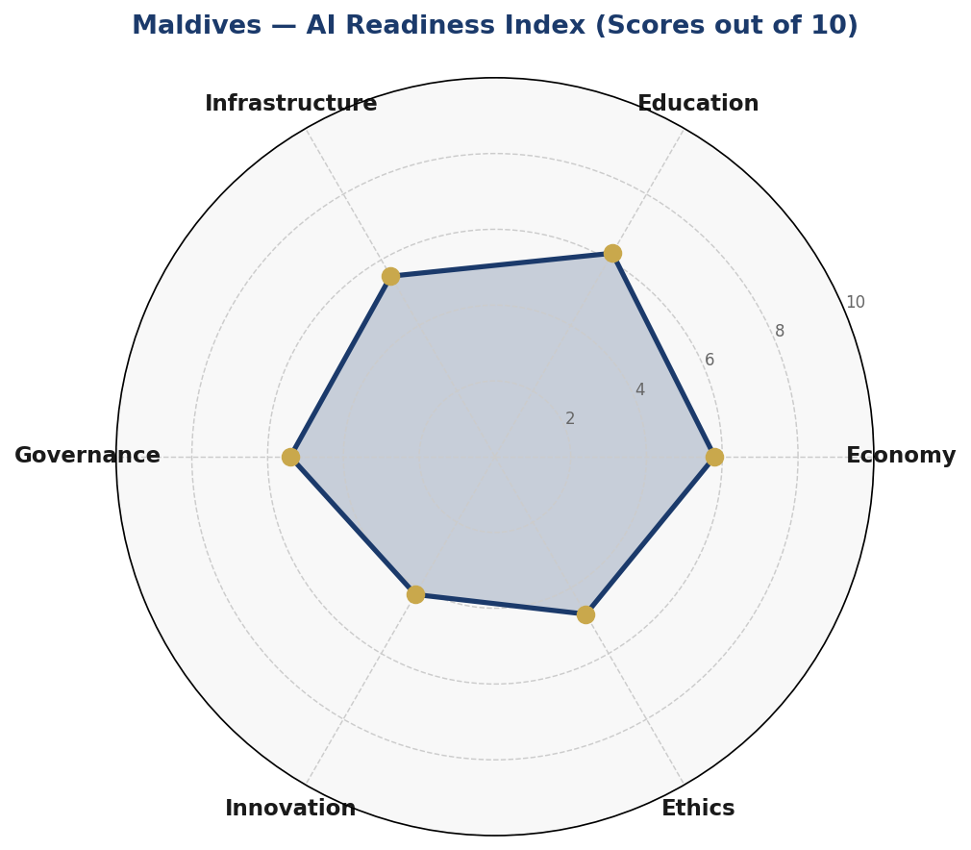
Figure 1.1: Maldives AI Readiness Index — Six-Axis Radar Assessment (Scores out of 10)
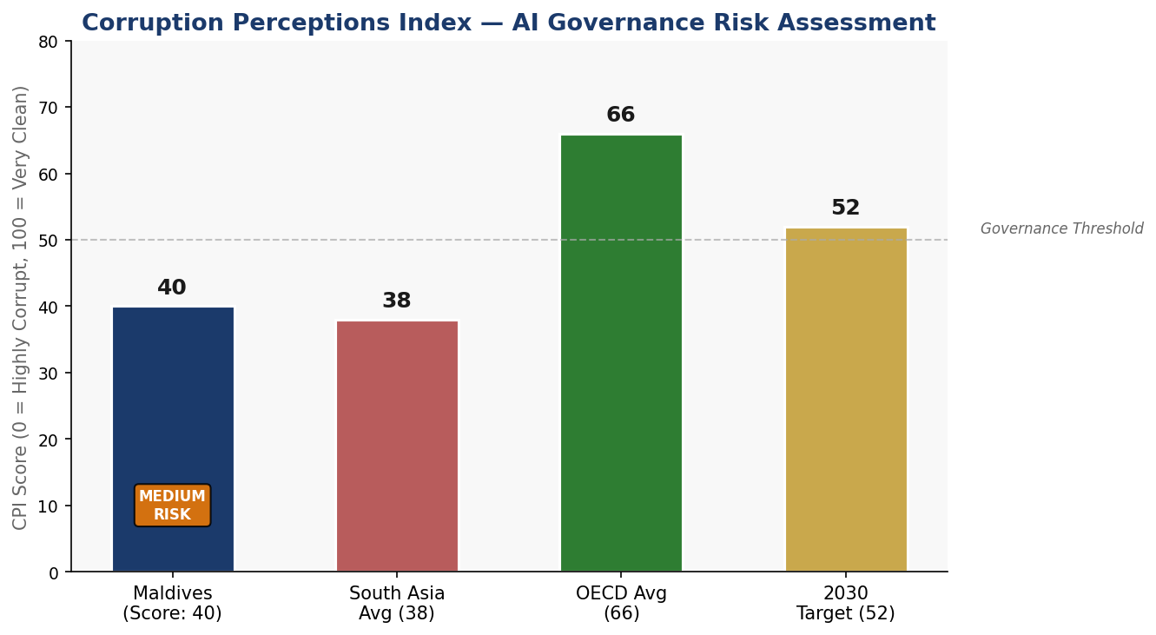
Figure 1.2: Corruption Perceptions Index — Maldives vs. Regional & OECD Benchmarks, with 2030 Target

Section 2: Policy Vision & Strategic Pillars

Section 2: Policy Vision & Strategic Pillars

2.1 National AI Vision Statement
"By 2031, the Maldives will be recognized as the Indian Ocean's most ethical, inclusive, and climate-resilient AI nation — where artificial intelligence protects our reefs, empowers our communities, and ensures that the smallest atolls receive the same quality of public services as the capital."

This vision is anchored in the Maldives' unique identity: a small island nation with an outsized global environmental footprint, deep cultural ties to the ocean, and a population that deserves world-class public services regardless of geographic remoteness. AI is not the goal — it is the instrument through which the Maldives delivers on its constitutional promise of equal dignity for all citizens.

2.2 Strategic Pillar I — Ethical AI & Human Rights Protection
All AI systems deployed in or by the Maldives — whether government, commercial, or imported — must uphold the fundamental rights enshrined in the Constitution of the Republic of Maldives. This includes the right to non-discrimination, the right to privacy, and the right to judicial redress. The government will establish a National AI Ethics Board (see Section 6) with investigative and enforcement powers, publish an annually updated AI Risk Registry, and mandate human-in-the-loop oversight for all AI decisions affecting individual rights.
Particular attention will be given to protecting the rights of women, outer island communities, migrant workers (who constitute approximately 25% of the Maldivian population), and youth. AI systems must be evaluated for differential impact across these groups before public deployment.

2.3 Strategic Pillar II — Economic Growth & Industrial AI Adoption
The Maldives will leverage AI to diversify its economy and build resilience against climate and market shocks. Priority sectors include: (i) Smart Tourism — AI-powered visitor experience personalization, crowd management, and sustainability compliance monitoring; (ii) Blue Economy — fisheries stock prediction, coral reef health monitoring, and sustainable aquaculture optimization; (iii) Climate Adaptation — sea-level rise modeling, early warning systems, and climate-smart urban planning for island reclamation projects; (iv) Financial Technology — AI-driven credit scoring for unbanked outer-island residents and fraud detection.

2.4 Strategic Pillar III — Education, Upskilling & AI Workforce Development
The Maldives' greatest asset is its young population — median age 30. This policy commits to making AI literacy a core competency for every Maldivian through a phased National AI Curriculum Framework, a National AI Scholarship Program targeting outer-island students, and targeted initiatives to bring women into AI careers (target: 40% female participation in AI programs by 2031). Partnerships with global universities, UNDP, and ITU will supplement domestic capacity.

2.5 Strategic Pillar IV — Public Sector AI & e-Governance
Government is the most powerful driver of AI adoption at scale. This policy mandates AI integration across 20 identified priority government services over five years, including health service delivery in outer atolls (AI-assisted diagnosis and telemedicine), tax compliance (automated VAT reconciliation), customs risk scoring, judicial caseload management, and disaster response coordination. All government AI deployments must comply with the Algorithmic Accountability Standards in Section 6.

2.6 Strategic Pillar V — AI Research, Innovation & Startup Ecosystem
The Maldives will establish an AI Innovation Sandbox — a regulatory-light environment for AI startups to test solutions in tourism, fisheries, and climate adaptation. A USD 5 million AI Seed Fund (co-financed by government and development partners) will be launched in Year 2. MNU will host a new Centre for AI Research in Climate & Ocean Sciences (CARICOS) in partnership with international universities, focusing on coral reef AI monitoring systems and sea-level rise predictive modeling — globally significant research anchored in local need.

Section 3: International Framework Alignment

Section 3: International Framework Alignment
This policy has been architected with deliberate alignment to six globally recognized AI governance frameworks. The alignment is substantive — each framework's core principles are mapped to specific policy sections and commitments, not merely acknowledged in passing.

3.1 UNESCO AI Ethics Recommendation (2021)
UNESCO's Recommendation on the Ethics of AI identifies 11 core values: human rights and dignity; peace; social justice; sustainability; privacy; non-maleficiation; fairness & non-discrimination; transparency & explainability; accessibility & equity; responsibility & accountability; and science & safety. This policy addresses all 11:
- Human Dignity & Rights: Section 2 (Pillar I), Section 6 (Ethics Board & Rights Audit)
- Sustainability: Section 2 (Pillar II — Climate AI), Section 4 (Blue Economy)
- Privacy: Section 6 (Data Protection Act recommendations)
- Fairness & Non-Discrimination: Section 5 (Inclusion targets), Section 6 (Bias Audit)
- Transparency & Explainability: Section 6 (Public AI Registry, Algorithmic Accountability)
- Accountability: Section 9 (National AI Observatory, Parliamentary Oversight)
- Equity & Accessibility: Section 5 (Outer Island AI Access), Section 7 (Citizen AI Services)

3.2 OECD AI Principles (2019, Updated 2024)
The OECD AI Principles comprise five value-based principles and five recommendations for policymakers. The Maldives policy maps as follows:
- Inclusive growth, sustainable development: Section 2 (Pillars II–III), Section 4 (Economic Roadmap)
- Human-centred values & fairness: Section 6 (Ethics Board, Risk Classification)
- Transparency & explainability: Section 6 (Algorithmic Accountability Standards)
- Robustness, security & safety: Section 6 (AI Risk Classification, Audit Requirements)
- Accountability: Section 9 (KPI Dashboard, Annual AI State Report)
- OECD Policymaker Rec. — Investing in AI: Section 4 (Investment Roadmap)
- OECD Policymaker Rec. — Building human capacity: Section 5 (Curriculum & Workforce)

3.3 EU AI Act (2024) — Risk-Based Framework Application
While the Maldives is not an EU member, the EU AI Act represents the most comprehensive legislative framework for AI risk governance globally. This policy adopts its four-tier risk classification system adapted to the Maldivian context (see Section 6 for full detail):
- Unacceptable Risk (Prohibited): Social scoring by government; real-time biometric surveillance in public spaces without judicial warrant; AI manipulation targeting vulnerable individuals.
- High Risk (Regulated): AI in judicial decisions, immigration screening, healthcare diagnosis, education assessment, critical infrastructure.
- Limited Risk (Transparency): Chatbots, AI-generated content, emotion recognition — must disclose AI nature.
- Minimal Risk (Voluntary CoC): Spam filters, AI gaming, recommendation engines.

3.4 World Bank AI Strategy — Development-Focused Alignment
The World Bank's AI for Development framework emphasizes that developing nations must build domestic AI capacity rather than becoming passive consumers of foreign AI systems. This policy responds through: domestic cloud infrastructure investment (Section 1.3), the CARICOS research centre (Section 2.6), the AI Startup Seed Fund (Section 2.6), and mandatory technology transfer clauses in all government AI procurement contracts (Section 7).

3.5 G20 AI Principles — Inclusive Growth Alignment
The G20 AI Principles, adopted under Japan's presidency in 2019, emphasize that AI should benefit all people and the planet. As a Small Island Developing State, the Maldives brings a distinctive perspective: inclusive growth must account for geographic dispersion. This policy's outer-island connectivity mandate (Section 7), AI-assisted telemedicine program, and atoll-level digital literacy centers directly operationalize G20 inclusive growth principles in a geographically fragmented context.

3.6 ITU AI for Good Guidelines — SDG Linkage
The Maldives' AI policy directly contributes to the following Sustainable Development Goals via the ITU AI for Good framework:
- SDG 3 (Good Health): AI-assisted telemedicine and outer-island diagnostic tools
- SDG 4 (Quality Education): National AI Curriculum, AI literacy programs
- SDG 8 (Decent Work): AI Workforce Development Program, Startup Ecosystem
- SDG 13 (Climate Action): Coral reef AI monitoring, climate modeling systems
- SDG 14 (Life Below Water): Blue Economy AI Lab, fisheries stock AI
- SDG 16 (Peace & Institutions): Anti-corruption AI guidelines, Public AI Registry
- SDG 17 (Partnerships): International AI Cooperation Framework (Section 10)

3.7 Comprehensive Framework Alignment Matrix
Policy Domain / Framework | UNESCO | OECD | EU AI Act | World Bank | G20 | ITU
Ethics & Human Rights | ✅ | ✅ | ✅ | ✅ | ✅ | ✅
Economic Development | ✅ | ✅ | ⚠️ | ✅ | ✅ | ✅
Education & Workforce | ✅ | ✅ | 🔲 | ✅ | ✅ | ✅
Risk Classification | ✅ | ✅ | ✅ | ⚠️ | ✅ | ⚠️
Data Protection & Privacy | ✅ | ✅ | ✅ | ✅ | ⚠️ | ✅
Public Sector AI | ✅ | ✅ | ✅ | ✅ | ✅ | ✅
Climate & Sustainability AI | ✅ | ✅ | 🔲 | ✅ | ✅ | ✅
International Cooperation | ✅ | ✅ | ⚠️ | ✅ | ✅ | ✅
Accountability & Monitoring | ✅ | ✅ | ✅ | ✅ | ✅ | ✅
Table 3.1: Framework Alignment Matrix — ✅ Full Alignment | ⚠️ Partial | 🔲 Not Directly Addressed

Section 4: Economic Impact & Investment Roadmap

Section 4: Economic Impact & Investment Roadmap
Drawing on methodology from McKinsey Global Institute (2023), the World Economic Forum (2024), and the World Bank's AI for Development framework, this section projects AI's economic contribution to the Maldives and sets out a five-year investment roadmap.

4.1 AI Economic Impact Projections
For upper-middle-income small island economies with high tourism concentration, conservative AI adoption scenarios project a 3.5–4.5% GDP contribution within five years, assuming adequate infrastructure investment and human capital development. For the Maldives, with a base GDP of USD 6.2 billion, this translates to USD 217–279 million in additional economic activity by 2030.
The primary pathways are: (1) Productivity gains in tourism — AI-driven personalization, dynamic pricing, and sustainability compliance monitoring could add USD 60–80 million; (2) Blue Economy optimization — AI fisheries management and coral reef tourism preservation could generate USD 40–60 million; (3) Government efficiency — public sector AI across 20 services is projected to reduce administrative costs by 18–22%, equivalent to USD 35–50 million annually; (4) New AI-native businesses in the startup ecosystem — estimated USD 25–40 million by 2030.
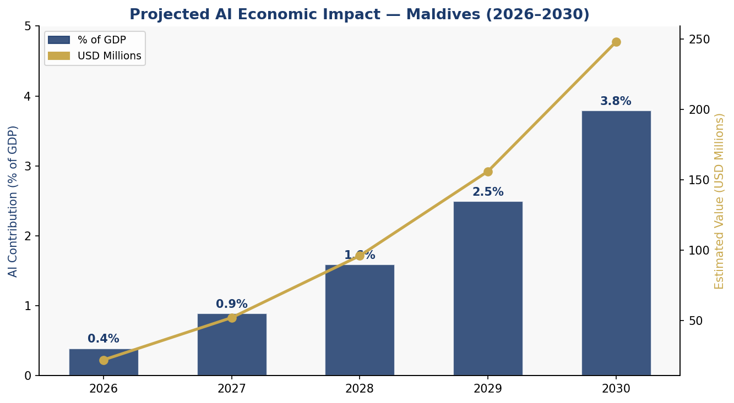
Figure 4.1: Projected AI Contribution to Maldives GDP (2026–2030), with USD Million Value Estimates

4.2 Priority Sectors for AI Adoption
- Tourism & Hospitality: Smart visitor management, AI concierge systems, sustainability scoring for resorts, dynamic reef protection scheduling based on visitor load
- Blue Economy: Tuna stock assessment AI (reducing by-catch by est. 30%), coral bleaching early warning, seabed mapping via autonomous underwater vehicles
- Climate Adaptation & Disaster Response: AI-powered sea-level rise scenario planning, cyclone trajectory modeling, automated early warning broadcast systems
- Healthcare: AI-assisted diagnosis for outer-island health posts, predictive epidemic modeling, AI-powered telehealth platforms
- Financial Services: AI credit scoring for unbanked island communities, fraud detection in government payment systems, Islamic finance AI compliance tools
- Education: Adaptive learning platforms for remote students, AI-powered Dhivehi language processing tools, automated assessment systems

4.3 Recommended National AI Investment Allocation
Total recommended government AI investment over five years: USD 48–62 million (approximately 0.8–1.0% of annual GDP). The allocation below reflects the need to build foundational infrastructure while simultaneously developing human capital and governance systems.
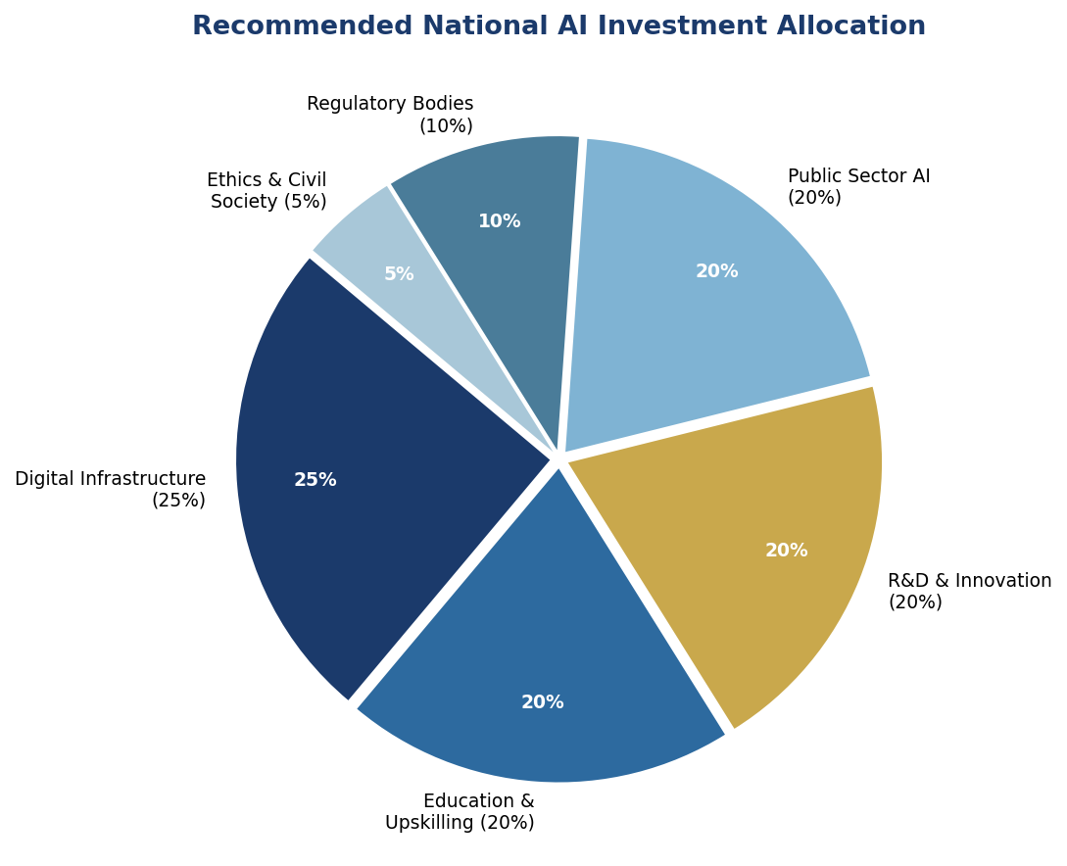
Figure 4.2: Recommended National AI Budget Allocation by Sector (2026–2031)

4.4 Public-Private Partnership Framework
Government funding alone is insufficient. This policy establishes a Public-Private AI Partnership (PPAP) mechanism with the following elements: (1) AI Procurement Partnership Agreements — requiring technology transfer and local capacity building from all foreign AI vendors; (2) Tourism Industry AI Consortium — co-investment with Maldives Association of Tourism Industry (MATI) for sector-specific AI tools; (3) Development Partner Co-financing — formal engagement with World Bank IFC, ADB, UNDP, and USAID for AI infrastructure grants; (4) Diaspora AI Investment Fund — engaging the Maldivian diaspora in tech-sector investment.

Section 5: Education & Human Capital Development

Section 5: Education & Human Capital Development

5.1 Current Skills Gap Analysis
The Maldives faces a three-layered AI skills gap: (1) Foundation Level — approximately 32% of the adult working population lacks basic digital literacy; (2) Practitioner Level — fewer than 200 individuals possess data science, ML, or AI engineering skills; (3) Expert Level — there are no PhD-level AI researchers resident in the country. Addressing this gap is not optional — it is the precondition for every other section of this policy.
The outer-island skills gap is particularly acute. Students in atolls beyond Malé face limited access to STEM teachers, computer labs, and broadband internet. This policy mandates equal AI education access across all 26 atolls through mobile AI learning labs, satellite-connected digital classrooms, and AI tutoring tools that function on low-bandwidth connections.

5.2 National AI Curriculum Framework
K–12: AI Foundations (Ages 6–18)
- Primary (Grades 1–5): Digital citizenship, basic algorithmic thinking, unplugged AI activities
- Middle (Grades 6–9): Introduction to data literacy, machine learning concepts, ethical AI discussions
- Secondary (Grades 10–12): Python fundamentals, practical ML projects, AI ethics case studies using Maldivian contexts (reef monitoring, fisheries)
Tertiary (MNU & Maldives Polytechnic)
- New Bachelor of Science in Artificial Intelligence & Data Science (MNU, launch Year 2)
- AI specialization tracks in existing engineering, business, and healthcare programs
- Joint degree programs with University of Colombo, IIT Bombay, and University of Edinburgh
Vocational & Professional (Adults)
- National AI Upskilling Program: 12-week intensive courses for government employees, SME owners, and healthcare workers
- AI Sector Certifications (in partnership with AWS, Google, and Microsoft): subsidized for Maldivian nationals

5.3 AI Education Pipeline
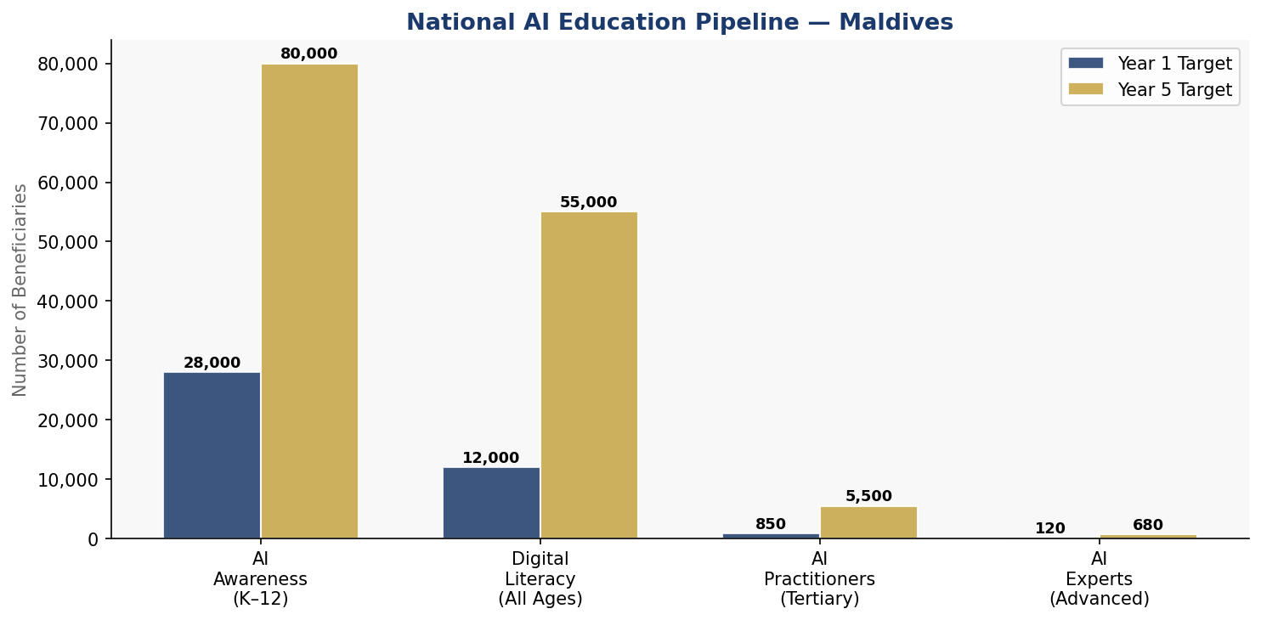
Figure 5.1: National AI Education Pipeline — Year 1 vs Year 5 Beneficiary Targets

5.4 Women & Underrepresented Groups
Gender parity in AI is a national priority. Current estimates suggest women constitute fewer than 20% of tech professionals in the Maldives. This policy targets 40% female participation in AI education programs by 2031 through: dedicated female AI scholarship awards (50 scholarships per year reserved for women); Women in AI Maldives network and mentorship program; AI entrepreneurship bootcamps specifically for women from outer islands; and mandatory gender disaggregation in all AI program outcome data.
Outer-island youth, migrant worker children, and students with disabilities will benefit from targeted AI literacy programs designed around universal design principles.

Section 6: Ethical AI Governance & Regulatory Framework

Section 6: Ethical AI Governance & Regulatory Framework
Effective AI governance requires binding legal frameworks, independent oversight bodies, and clear accountability chains. This section establishes the Maldives' AI governance architecture — designed to be proportionate to the country's size while meeting international standards.

6.1 National AI Ethics Board
The National AI Ethics Board (NAEB) will be established by Act of Parliament within 18 months of this policy's adoption. Composition: 11 members — 3 independent AI ethics experts (including at least one international), 2 civil society representatives, 2 government representatives, 1 legal expert, 1 technology industry representative, 1 academic, and 1 youth representative (under 30). At least 4 members must be women.
NAEB Mandate: Review and approve all high-risk government AI deployments; investigate public complaints regarding AI systems; publish an annual AI Ethics State of the Nation report; recommend AI legislation updates to Parliament; and maintain the National AI Risk Registry.

6.2 AI Risk Classification System
Risk Tier | Definition | Examples in Maldives Context | Regulatory Response
🚫 Unacceptable | Poses unacceptable risk to rights or safety | Government social scoring; covert biometric surveillance; AI manipulating voter behavior | PROHIBITED by law. Criminal penalty for deployment.
🔴 High Risk | Significant potential for harm; mandatory oversight required | AI in courts, immigration, hospitals, exam grading, infrastructure control | NAEB registration; third-party audit; human override mandatory; annual review
🟡 Limited Risk | Moderate risk; transparency obligations apply | Chatbots on government portals, AI-generated tourism content, emotion analysis tools | Must disclose AI nature to users; register with NAEB
🟢 Minimal Risk | Low or negligible risk; voluntary standards apply | AI spam filters, search recommendations, marine weather apps | Voluntary Code of Conduct; encouraged to adopt AI principles
Table 6.1: Maldives AI Risk Classification System (Adapted from EU AI Act, 2024)

6.3 Data Protection & Privacy Act Recommendations
The Maldives does not yet have a comprehensive Data Protection Act. This policy strongly recommends the passage of a Maldives Data Protection & Privacy Act within 24 months, aligned with the EU GDPR framework and the APEC Privacy Framework. Key provisions should include: the right to access personal data held by government AI systems; the right to explanation of automated decisions; the right to contest and appeal AI-generated decisions; mandatory data breach notification within 72 hours; and strict consent requirements for biometric data collection — particularly relevant for tourism sector identity systems.

6.4 Algorithmic Accountability Standards
All High-Risk government AI systems must meet the following accountability standards before deployment: (1) Impact Assessment — documented analysis of potential harms across demographic groups; (2) Bias Audit — third-party evaluation of training data and outputs for discriminatory patterns; (3) Explainability Requirement — ability to provide plain-language explanations for automated decisions affecting individuals; (4) Audit Trail — immutable logs of AI system inputs, decisions, and outcomes for a minimum of 5 years; (5) Human Override — a designated human officer with authority to override any AI decision.

6.5 Anti-Corruption AI Guidelines
Given the Maldives' CPI score of 40, anti-corruption safeguards are mandatory in all government AI systems. Specific requirements: all government AI procurement must go through a competitive, transparent tender process with published evaluation criteria; AI vendors must disclose beneficial ownership and any political connections; government AI procurement contracts must include technology transfer clauses; a Public AI Registry will list all government AI systems, their purpose, risk classification, vendor, cost, and performance data — accessible to citizens online; and the Anti-Corruption Commission will receive dedicated AI forensic tools to detect algorithmic manipulation in public procurement.

Section 7: Public Sector AI & e-Governance

Section 7: Public Sector AI & e-Governance

7.1 Priority Government Use Cases
The following 20 government services are prioritized for AI integration over five years, selected based on citizen impact, implementation feasibility, and alignment with national development priorities:
Service / System | Ministry / Agency | AI Application | Phase
Outer Island Telemedicine | Ministry of Health | Diagnostic AI | Phase 1
Customs Risk Scoring | Maldives Customs | Risk ML Model | Phase 1
Tourism Permit Processing | Min. of Tourism | Intelligent OCR | Phase 1
Fisheries Stock Monitoring | Min. of Fisheries | Satellite + ML | Phase 1
Coral Reef Early Warning | EPA Maldives | Sensor AI | Phase 1
VAT Compliance Automation | MIRA | Pattern Detection | Phase 1
AI Student Counseling Platform | Min. of Education | NLP Chatbot | Phase 2
Disaster Response Coordination | NDMA | Predictive Routing | Phase 2
Public Procurement AI Monitor | ACC | Anomaly Detection | Phase 2
Justice & Case Management | Judiciary | Case Analytics | Phase 2
Digital ID Fraud Prevention | DNR | Biometric AI | Phase 2
AI Weather & Sea Forecasting | MMS | Meteorological ML | Phase 2
National AI Citizen Portal | e-Gov Secretariat | AI Assistant | Phase 3
Dhivehi NLP Platform | MNU / MIT | Language AI | Phase 3
Table 7.1: Priority Government AI Deployments (2026–2031)

7.2 Government AI Procurement Guidelines
All government AI procurements exceeding MVR 500,000 (approximately USD 32,000) must comply with the following guidelines: (1) Open tender process with mandatory publication of evaluation criteria; (2) AI vendor due diligence checklist including ethics certification; (3) Mandatory local capacity building — all contracts must include training provisions for at least 3 Maldivian staff; (4) Data sovereignty clause — citizen data must remain on Maldivian servers or SAARC-partner trusted jurisdictions; (5) Performance benchmarks and exit provisions — all contracts must include measurable KPIs and a government right to exit without penalty if KPIs are unmet after 12 months.

Section 8: Implementation Roadmap

Section 8: Implementation Roadmap
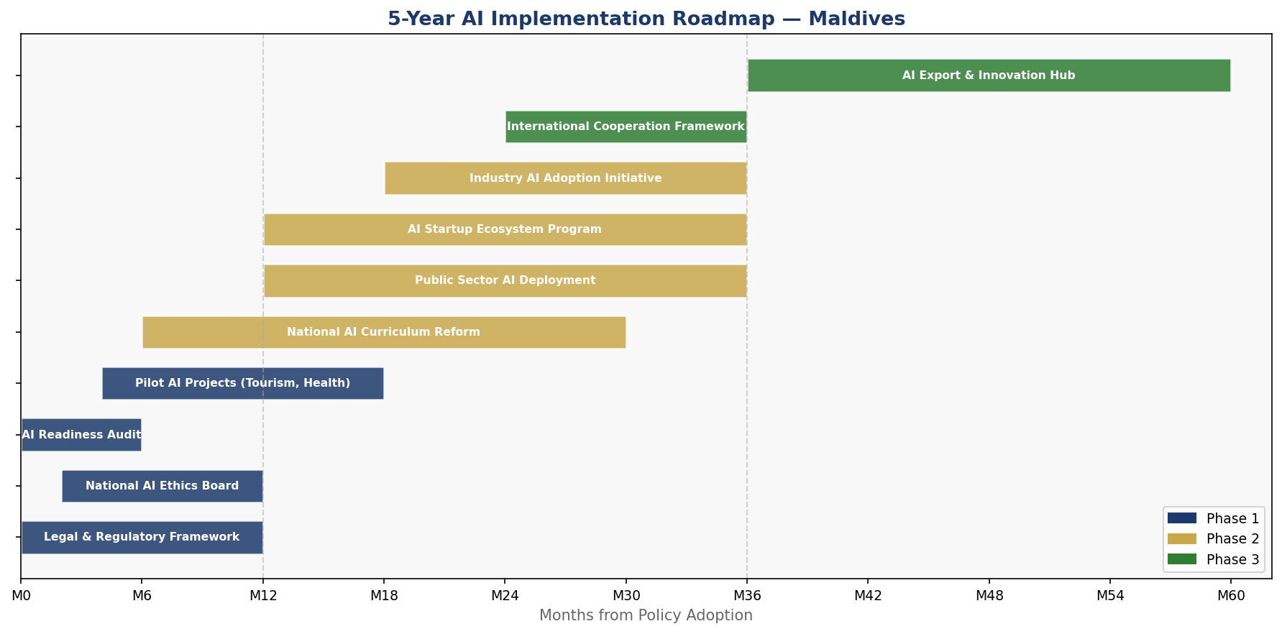
Figure 8.1: Five-Year AI Implementation Timeline — Maldives (2026–2031)

8.1 Phase 1 — Foundation (Months 1–12)
The Foundation phase establishes the legal, institutional, and data infrastructure upon which all subsequent AI activity depends. This is the most critical phase — delays here cascade through the entire roadmap.
- Pass enabling legislation: AI Policy Act, Data Protection Bill, NAEB Establishment Act
- Establish National AI Ethics Board: Appoint members, publish mandate, begin operations
- Conduct National AI Readiness Audit: Baseline assessment of all 26 atolls
- Launch 6 Priority Government AI Pilots: Telemedicine, customs, reef monitoring, fisheries, VAT, tourism permits
- Publish National AI Curriculum Framework: Begin teacher training in Malé and Addu City
- Establish AI Innovation Sandbox: Regulatory framework and first cohort of 10 startups
Phase 1 KPIs: NAEB operational by Month 9; 3 AI bills in Parliament by Month 6; 6 government AI pilots live by Month 12; 500 teachers trained in AI pedagogy by Month 12.

8.2 Phase 2 — Scaling (Months 13–36)
Phase 2 scales successful pilots nationally and extends AI education to all atolls.
- National rollout of 14 additional government AI services
- Launch BSc in AI & Data Science at MNU (Year 2)
- Deploy 26 Atoll AI Learning Centers (one per atoll capital)
- Activate USD 5 million AI Startup Seed Fund
- Establish CARICOS research center at MNU
- First annual AI State of the Nation Report to Parliament
Phase 2 KPIs: 20 government AI services operational; 2,500 AI practitioners trained; 100 startups in sandbox; first coral reef AI monitoring system live.

8.3 Phase 3 — Optimization (Months 37–60)
Phase 3 reviews and optimizes existing deployments while exploring the Maldives' potential as a regional AI knowledge exporter.
- Comprehensive policy review and update based on outcomes data
- Launch National AI Citizen Portal with multilingual AI assistant (Dhivehi + English)
- Negotiate bilateral AI cooperation agreements (India, Singapore, UAE, EU)
- Explore AI service exports — Maldives as South Asia's island AI lab
- Prepare National AI Policy 2032–2036 based on lessons learned
Phase 3 KPIs: 5,500 AI practitioners; USD 248M AI economic contribution; 40% female AI participation; Maldives ranked in top 5 SIDS on Oxford Insights AI Readiness Index.

Section 9: Monitoring, Evaluation & Accountability

Section 9: Monitoring, Evaluation & Accountability

9.1 National AI Observatory
The National AI Observatory (NAO) will be established as a semi-autonomous unit within the Ministry of Environment, Climate Change and Technology, with a dedicated budget and mandate to track AI policy implementation, collect impact data, publish annual reports, and feed evidence into policy updates. The NAO will publish quarterly progress dashboards accessible to the public at ai.gov.mv.

9.2 Annual AI State Report
The Minister responsible for technology will present an Annual AI State of the Nation Report to Parliament each year. The report will include: progress against all KPIs; new AI deployments and their outcomes; incidents, complaints, and Ethics Board investigations; budget utilization; and priority recommendations for the following year. All reports will be publicly accessible.

9.3 Parliamentary Oversight Mechanism
A dedicated Parliamentary Committee on AI & Digital Governance will be established to provide ongoing legislative oversight. The committee will hold quarterly hearings with NAEB, the NAO, and relevant ministries; review all draft AI-related legislation; commission independent audits; and publish committee reports.

9.4 KPI Dashboard
KPI Metric | 2025 Baseline | Year 1 Target | Year 3 Target | Year 5 Target
AI Practitioners Trained | ~200 | 850 | 2,800 | 5,500
AI Literacy (Adult Population %) | 12% | 22% | 45% | 72%
Govt AI Services Deployed | 2 | 8 | 16 | 20
AI Contribution to GDP (%) | ~0.1% | 0.4% | 1.6% | 3.8%
Female AI Program Participation | ~18% | 25% | 33% | 40%
AI Startups in Ecosystem | ~5 | 30 | 80 | 150
Outer Island AI Access (%) | ~25% | 45% | 70% | 90%
NAEB Complaints Resolved | N/A | 100% | 100% | 100%
Oxford AI Readiness Rank (SIDS) | Est. 8th | 6th | 4th | Top 5
Table 9.1: National AI KPI Dashboard — Baseline, Annual Targets, and 5-Year Goals

Section 10: International Cooperation & Diplomacy

Section 10: International Cooperation & Diplomacy

10.1 Bilateral AI Cooperation Priorities
The Maldives will pursue strategic bilateral AI cooperation agreements with the following partner nations, prioritizing those that offer complementary strengths:
- India: Largest trading and development partner; India's Digital India AI mission offers direct technical assistance, capacity building, and co-development of Dhivehi language AI tools. Target: AI MoU with Ministry of Electronics and IT within 18 months.
- Singapore: ASEAN's AI governance leader; offers regulatory knowledge transfer, AI ethics framework co-development, and access to Singapore's Smart Nation infrastructure partnerships.
- United Arab Emirates: AI investment partner; UAE's AI Strategy 2031 and its AI investment fund offer financing opportunities for Maldives AI infrastructure, particularly in smart tourism.
- European Union: Technical standards and regulatory alignment; EU AI Act expertise, Horizon Europe research partnerships, and GDPR implementation technical assistance.
- United States: Innovation ecosystem access; USAID digital economy programs, Fulbright AI scholarships, and Silicon Valley startup ecosystem connections.

10.2 Regional AI Governance — SAARC & IORA
The Maldives will champion AI governance within its regional blocs. Within SAARC, the Maldives will propose a South Asian AI Interoperability Framework — establishing shared data standards and cross-border AI service recognition. Within the Indian Ocean Rim Association (IORA), the Maldives will lead the Ocean AI Initiative: a consortium of Indian Ocean SIDS nations (Seychelles, Mauritius, Comoros) developing shared AI tools for coral reef monitoring, sustainable fisheries, and blue carbon sequestration measurement.

10.3 South-South Knowledge Transfer
As a SIDS that will develop genuine AI expertise in ocean-climate AI by 2031, the Maldives has an obligation to share that knowledge with other SIDS facing similar vulnerabilities — particularly in the Pacific (Tuvalu, Kiribati, Fiji) and Caribbean (Barbados, Trinidad). This policy establishes a Maldives AI for SIDS Fund, receiving 5% of the CARICOS research center budget annually for knowledge transfer activities, technical assistance missions, and joint publication programs.

10.4 Global AI Governance Participation
The Maldives will actively participate in: United Nations AI Advisory Body; ITU AI for Good Global Summit (annual participation); Global Partnership on AI (GPAI) — seek associate membership; UNESCO AI Ethics Implementation Network; and Commonwealth Digital Connectivity Agenda. In all global forums, the Maldives will advocate for a SIDS-specific track in AI governance discussions, ensuring that the unique challenges of small island nations — geographic dispersion, climate vulnerability, limited domestic markets — are represented in global AI policy frameworks.

Conclusion

Conclusion
The Maldives stands at a historic moment. Climate change threatens its very existence. Economic concentration in a single sector creates systemic risk. Geographic dispersion makes equal public service delivery a perennial challenge. Artificial intelligence does not solve these problems by itself — but deployed ethically, inclusively, and with genuine commitment to every atoll and every citizen, it can be the most powerful tool the Maldives has ever had.
This National Artificial Intelligence Policy 2026–2031 is not a technology document. It is a governance document. It answers fundamental questions about who benefits from AI in the Maldives (everyone), who oversees it (an independent Ethics Board and Parliament), who pays for it (government, private sector, and development partners together), and what it is for (a more equitable, resilient, and prosperous Maldives).
The path ahead requires political will, institutional investment, and the courage to say clearly: AI in the Maldives will be governed by the values of the Maldivian people — Islamic principles of justice and compassion, democratic accountability, and the deep Maldivian relationship with the ocean that has sustained this civilization for three thousand years.
Implementation begins now.

References & Bibliography

References & Bibliography
- UNESCO (2021). Recommendation on the Ethics of Artificial Intelligence. Paris: United Nations Educational, Scientific and Cultural Organization.
- OECD (2019, updated 2024). OECD Principles on AI. Paris: Organisation for Economic Co-operation and Development.
- European Parliament (2024). Regulation on Artificial Intelligence (EU AI Act). Brussels: European Union.
- World Bank (2023). World Development Indicators — Maldives Country Profile. Washington D.C.: World Bank Group.
- Transparency International (2023). Corruption Perceptions Index 2023. Berlin: Transparency International.
- Oxford Insights (2023). Government AI Readiness Index 2023. Oxford: Oxford Insights.
- ITU (2023). Measuring Digital Development: Facts and Figures 2023. Geneva: International Telecommunication Union.
- McKinsey Global Institute (2023). The Economic Potential of Generative AI. New York: McKinsey & Company.
- World Economic Forum (2024). Future of Jobs Report 2025. Geneva: World Economic Forum.
- UNDP (2023). Human Development Report 2023/2024. New York: United Nations Development Programme.
- Maldives Monetary Authority (2024). Annual Report 2023. Malé: MMA.
- Ministry of Environment, Climate Change and Technology, Republic of Maldives (2025). Digital Economy Roadmap 2025–2030. Malé: Government of Maldives.
- G20 (2019). G20 AI Principles. Osaka: G20 Osaka Leaders' Declaration.
- Global Partnership on AI (GPAI) (2023). GPAI Annual Report. Paris: OECD.
- IORA (2023). Indian Ocean Rim Association Blue Economy Declaration. Port Louis: IORA Secretariat.

About the Author

About the Author
Nafiul Ahmad Rafi
Policy & Good Governance Researcher | BD Civic Tech Architect | Founder, Insights Bangladesh

Nafiul Ahmad Rafi is a civic technologist, policy researcher, author, photographer, and musician based in Dhaka, Bangladesh. He is the Founder and Director of Insights Bangladesh, a data-driven governance and policy impact analysis institution, and the Founder & Lead Architect of NagorikBD.org — a transparency-first civic platform scaled across Mymensingh Division, connecting citizens with government services across 45 Upazilas.
His work exists at the intersection of institutional reform and artificial intelligence, transforming theoretical governance into scalable, data-driven reality. Without a conventional computer science degree, he self-taught the tools of modern AI and web development to build the infrastructure that enforces the policies he once only researched.

Key Platforms & Projects
- NagorikBD.org — Civic transparency platform, Mymensingh Division
- Insights Bangladesh — Policy impact analysis institution
- FactCheck BD (factcheckbd.org) — Bangladesh's AI-powered fact-checking platform
- Political Insights BD / PIBD (pibbd.org) — Political intelligence and civic tech hub
- PeaceShield BD / National Peace Tracker — AI-powered hate speech and conflict monitoring
- PolicyLens AI (aigovbd.org) — 9-dimensional AI policy audit tool

Research Interests
AI Governance · Policy Research · Future of Bangladesh · Climate Policy

Publications
Nafiul Ahmad Rafi has published four books on governance, technology, and society. His work spans academic policy analysis, investigative journalism, and civic infrastructure design.

Contact
- Website: ahmad-rafi.com
- LinkedIn: linkedin.com/in/nafiul-ahmad-rafi
- Email: contact@ahmad-rafi.com

"I build code to ensure transparency, and I write lyrics to inspire the courage to use it."

