🇳🇵
FEDERAL DEMOCRATIC REPUBLIC OF NEPAL
National Artificial Intelligence Policy
2026 – 2031

A Comprehensive Framework for Ethical, Inclusive,
and Economically Transformative AI
Prepared by:
Nafiul Ahmad Rafi
Policy & Good Governance Researcher | BD Civic Tech Architect
Insights Bangladesh
May 2026

Table of Contents

Executive Summary
Nepal stands at a pivotal juncture in its development trajectory. As a landlocked, lower-middle-income country with a population of approximately 30 million and a GDP of around USD 40 billion, Nepal faces the simultaneous challenge of accelerating economic growth, reducing poverty, and leapfrogging legacy infrastructure limitations. Artificial Intelligence offers a rare transformational opportunity — one that, if harnessed strategically and ethically, could fundamentally reposition Nepal within the global economy over the next decade.
This National AI Policy 2026–2031 is Nepal's foundational governance document for responsible AI development and deployment. It establishes a comprehensive national framework spanning regulation, education, investment, public sector modernisation, and international cooperation. The Policy is aligned with globally recognised frameworks including the UNESCO AI Ethics Recommendation (2021), the OECD AI Principles (2024 update), the EU AI Act (2024), and the United Nations Sustainable Development Goals. It reflects Nepal's unique socioeconomic context — including its mountainous topography, agricultural dependency, significant diaspora economy, federal governance structure, and rapidly expanding mobile internet penetration.
The Policy is structured around five strategic pillars: Ethical AI and Human Rights Protection; Economic Growth and Industrial AI Adoption; Education, Upskilling and AI Workforce Development; Public Sector AI and e-Governance Modernisation; and AI Research, Innovation and Startup Ecosystem Development. Each pillar is backed by specific targets, institutional mandates, and a phased implementation roadmap. Key outcomes projected by 2031 include USD 2.5–5 billion in AI-driven economic contribution (approximately 4–5% of GDP), training 2 million citizens in foundational AI literacy, establishment of a National AI Ethics Board, and deployment of AI in at least 15 federal public service domains.
This Policy calls for an inclusive, gender-responsive, and culturally sensitive approach to AI. Nepal's linguistic diversity — with over 120 languages — demands multilingual AI systems. Its geography necessitates connectivity investment as a precondition for AI deployment. And its governance history, including persistent transparency challenges (TI CPI score: 35/100), makes ethical AI governance not merely aspirational but existentially necessary. The policies outlined here are designed to be realistic, time-bound, and measurable, with a National AI Observatory mandated to publish annual progress reports.

Section 1: National AI Readiness Assessment

1.1 Economic Context
Nepal is classified as a lower-middle-income country by the World Bank, with a GDP per capita of approximately USD 1,350 (2024). The economy is heavily dependent on remittances (approximately 26% of GDP), tourism, agriculture, and hydropower exports. The services sector has grown rapidly, accounting for over 60% of GDP, driven in part by telecommunications, fintech, and e-commerce expansion. However, manufacturing and technology sectors remain underdeveloped relative to Nepal's demographic potential.
Nepal's Eighth National Plan and the country's graduation from Least Developed Country (LDC) status, anticipated by 2026, provide a governance mandate for accelerated economic diversification. AI represents a high-leverage investment opportunity: the McKinsey Global Institute estimates that AI could add 15–20% to GDP for developing economies that establish early foundational policy. For Nepal, even conservative projections suggest USD 2–5 billion in AI-attributable economic value by 2031, particularly in agriculture, tourism, financial services, and government efficiency.

1.2 Education and Human Capital
Nepal's adult literacy rate stands at approximately 76%, with significant rural-urban and gender disparities. Tertiary education enrolment is around 18%, with engineering and STEM disciplines underrepresented among women. The country has approximately 1,400 higher education institutions, including Tribhuvan University, Kathmandu University, and Pokhara University, which collectively enrol over 400,000 students annually. However, AI-specific curricula remain nascent, with only a handful of institutions offering dedicated data science or machine learning programmes.
A critical digital skills gap persists. The World Bank's Skills for a Digital Nepal assessment identifies that fewer than 5% of the current workforce possesses intermediate digital skills, and AI-proficient practitioners number fewer than 2,000 nationwide. Closing this gap is not merely an education policy matter — it is the single most important enabling condition for AI-driven economic growth.

1.3 Digital Infrastructure
Nepal has achieved approximately 72% mobile internet penetration, with 4G coverage reaching most urban and peri-urban areas. Fibre optic connectivity is expanding rapidly under the Broadband Master Plan 2022–2030. However, rural connectivity — particularly in the Himalayan and mid-hill regions — remains severely limited, with electricity access gaps compounding the problem. Data centre infrastructure is sparse, with no tier-3 or tier-4 government data centre currently operational. Nepal's cloud market is nascent, with most enterprises relying on international cloud providers. The Government Integrated Data Centre (GIDC) in Biratnagar represents the most advanced public sector facility.

1.4 Governance and Institutional Capacity
Nepal transitioned to a federal democratic republic in 2015, with governance divided across federal, provincial (7), and local (753) levels. This federal structure creates both opportunities — enabling localised AI deployment for citizen services — and challenges, including coordination complexity and capacity disparities between Kathmandu and provincial governments. The Ministry of Communication and Information Technology (MoCIT) is the primary national agency responsible for digital governance, and will serve as the lead ministry for AI policy implementation.

1.5 Corruption Risk Assessment
Nepal's Transparency International Corruption Perceptions Index (CPI) score of 35/100 (2024), ranking 108 out of 180 countries, flags a significant governance risk. Corruption in public procurement, land registration, and service delivery has historically undermined digital transformation initiatives. AI systems deployed in high-stakes public domains — procurement, land records, social welfare distribution, law enforcement — carry elevated risks of algorithmic capture and misuse if deployed without robust oversight. This Policy mandates algorithmic audits, procurement transparency standards, and civil society oversight mechanisms as non-negotiable components of all public sector AI deployments.
Chart 1: Nepal AI Readiness Assessment Radar
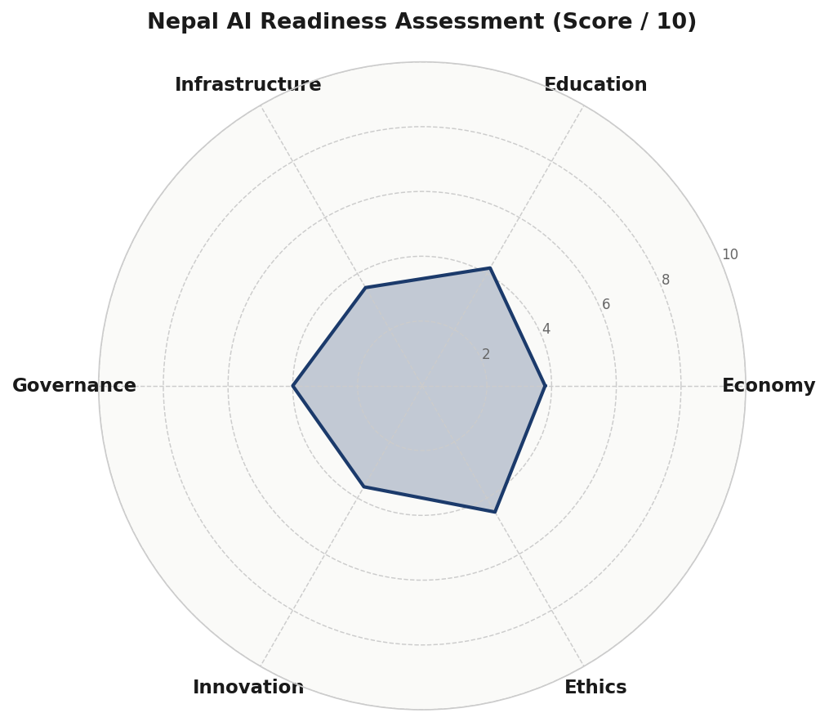
Figure 1.1 — Nepal AI Readiness Radar (6 dimensions, scored /10). Composite score: 3.93/10. Strongest dimension: Ethics (4.5); Weakest: Infrastructure (3.5).
Chart 2: Corruption Perception Index — Nepal vs Comparators
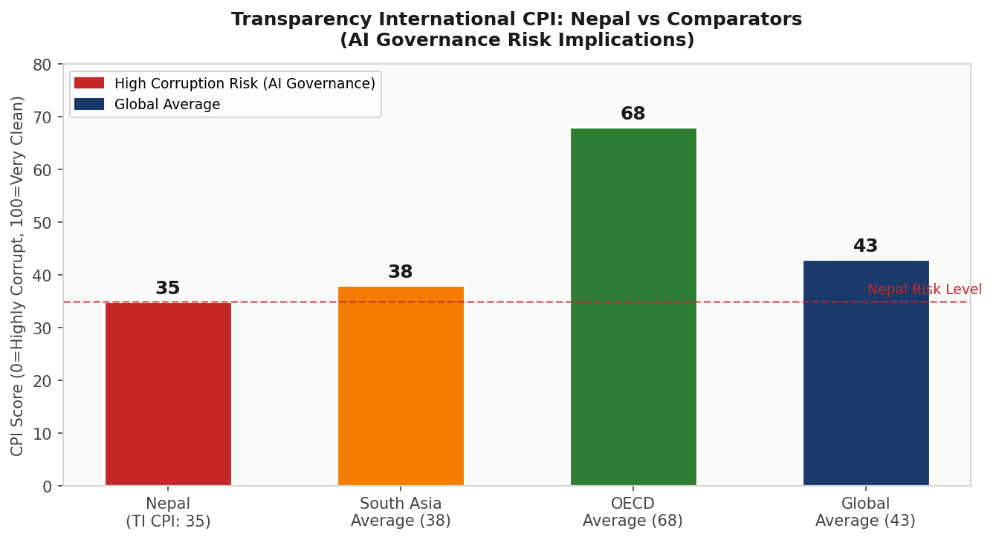
Figure 1.2 — TI CPI Score Comparison (2024). Nepal's score of 35 is below the South Asian average (38) and significantly below the OECD average (68), placing it in the High AI Governance Risk tier.

Section 2: Policy Vision and Strategic Pillars

2.1 National Vision Statement
"By 2031, Nepal shall be a digitally empowered, ethically governed, and AI-literate nation — where artificial intelligence serves as an equalising force that bridges geography, reduces poverty, modernises governance, and empowers every Nepali citizen to participate in and benefit from the Fourth Industrial Revolution."
This vision is grounded in Nepal's federal democratic values, its commitment to inclusive development as articulated in the Sustainable Development Goals, and its unique position as a developing nation with significant untapped human capital potential. AI in Nepal will not merely replicate Western models — it will be adapted to Nepali languages, geographies, governance structures, and cultural contexts.

Pillar I: Ethical AI and Human Rights Protection
Nepal commits to AI that upholds human dignity, prevents discrimination, and is transparent in its operations. This pillar establishes the National AI Ethics Board, mandates algorithmic impact assessments for all high-risk AI deployments, bans facial recognition surveillance in public spaces without judicial authorisation, and creates a grievance mechanism for AI-affected citizens. It incorporates Nepal's international human rights obligations under the ICCPR, ICESCR, and CEDAW.

Pillar II: Economic Growth and Industrial AI Adoption
AI-driven productivity gains in agriculture (precision farming, crop disease detection), tourism (personalised experience platforms, demand forecasting), financial services (credit scoring for the unbanked, fraud detection), and hydropower management represent Nepal's highest-opportunity AI investment areas. This pillar establishes sector-specific AI adoption roadmaps, a National AI Investment Fund (NPR 10 billion initial capitalisation), and regulatory sandboxes for AI-driven fintech and agritech startups.

Pillar III: Education, Upskilling and AI Workforce Development
Nepal cannot import its AI future — it must grow it. This pillar mandates integration of AI literacy into the national school curriculum by 2027, creation of 50 AI Labs in higher education institutions by 2029, and a National AI Fellows Programme that awards 500 advanced AI scholarships annually. Special quotas ensure women, Dalit, Janajati, and Madhesi communities represent at least 40% of AI training programme beneficiaries.

Pillar IV: Public Sector AI and e-Governance
Nepal's federal governance system — often hampered by procedural delays, paper-based records, and limited inter-agency data sharing — is a prime candidate for AI transformation. Priority use cases include AI-powered land record management (reducing fraud and disputes), automated social welfare eligibility verification, judicial case management, disaster early warning systems (critical given Nepal's seismic and flood risk), and multilingual citizen service chatbots in Nepali and major regional languages.

Pillar V: AI Research, Innovation and Startup Ecosystem
Nepal has a growing diaspora of AI talent in the United States, Australia, and the Gulf. This pillar creates mechanisms for diaspora knowledge transfer, establishes a National AI Research Centre at Tribhuvan University, creates a startup visa and repatriation grant programme for AI entrepreneurs, and positions Nepal within SAARC's emerging AI cooperation agenda. The goal is for Nepal to produce and export AI solutions tailored to mountainous topography, multilingual contexts, and climate resilience — addressable problems for which Nepal has comparative contextual expertise.

Section 3: International Framework Alignment

3.1 UNESCO AI Ethics Recommendation (2021)
The UNESCO Recommendation on the Ethics of AI, adopted by 193 member states including Nepal, articulates 11 core values that this Policy explicitly maps to. Nepal's alignment is as follows:
- Proportionality and Do No Harm: All AI systems must pass proportionality assessments before deployment. The National AI Ethics Board maintains a prohibited AI applications registry.
- Safety and Security: Government AI systems require third-party security audits. AI used in disaster management must meet ISO 31000 risk management standards.
- Fairness and Non-Discrimination: Algorithmic fairness testing is mandatory for AI systems affecting employment, credit, social welfare, and law enforcement.
- Sustainability: AI infrastructure procurement must assess environmental impact. Data centres must report energy consumption and achieve green certification by 2030.
- Right to Privacy: AI systems processing citizen data must comply with the proposed Personal Data Protection Act and implement privacy-by-design principles.
- Human Oversight and Determination: No fully autonomous AI decision-making is permitted in life-affecting domains (healthcare, justice, social welfare). Human review is mandatory.
- Transparency and Explainability: Citizens have the right to explanation for AI-driven decisions affecting them. Government AI must publish algorithmic impact statements.
- Responsibility and Accountability: Clear liability chains for AI harm are established in law. Developers, deployers, and procurers each bear defined legal responsibility.
- Awareness and Literacy: The National AI Literacy Programme targets 15 million citizens with basic AI awareness by 2031.
- Multi-stakeholder Governance: The National AI Ethics Board includes civil society, academia, private sector, and government representatives in equal measure.
- International and Transboundary Cooperation: Nepal commits to SAARC AI cooperation, South-South knowledge transfer, and participation in UN AI governance forums.

3.2 OECD AI Principles (2024 Update)
Although Nepal is not an OECD member, the 2024 update of the OECD AI Principles provides the most comprehensive internationally recognised AI governance benchmark. Nepal adopts these principles as implementation guidance:
- Inclusive Growth, Sustainable Development, and Well-being: AI investment prioritises rural and marginalised communities.
- Human-centred Values and Fairness: Algorithmic fairness audits are mandated for public sector AI.
- Transparency and Explainability: Explainability requirements scale with AI risk classification.
- Robustness, Security, and Safety: Government AI procurement requires documented risk assessments and adversarial testing.
- Accountability: The National AI Observatory publishes annual compliance reports.

3.3 EU AI Act (2024) — Risk-Based Framework Adaptation
Nepal adopts the EU AI Act's four-tier risk architecture, adapted for national context:
Unacceptable Risk (Prohibited)
- Real-time biometric mass surveillance in public spaces without judicial warrant
- AI systems that manipulate citizens through psychological exploitation
- Social credit scoring by government agencies
- AI-based recruitment systems that discriminate on protected characteristics
High Risk (Mandatory Regulation)
- AI in criminal justice (sentencing, risk assessment, predictive policing)
- AI in healthcare (diagnosis, treatment recommendations)
- AI in financial services (credit scoring, insurance underwriting)
- AI in education (automated student assessment, admission decisions)
- AI in critical infrastructure (hydropower management, disaster systems)
Limited Risk (Transparency Obligations)
- Chatbots and virtual assistants must disclose AI nature to users
- AI-generated content must be labelled in media and government communications
Minimal Risk (Voluntary Code of Conduct)
- AI-powered recommender systems, spam filters, AI tools for creative applications

3.4 Framework Alignment Matrix
Framework Principle | Pillar I Ethics | Pillar II Economy | Pillar III Education | Pillar IV Gov. | Pillar V Innovation
UNESCO — Safety & Security | ✅ | ⚠️ | 🔲 | ✅ | ⚠️
UNESCO — Fairness & Non-Discrimination | ✅ | ✅ | ✅ | ✅ | ⚠️
UNESCO — Privacy | ✅ | ⚠️ | 🔲 | ✅ | 🔲
UNESCO — Human Oversight | ✅ | ⚠️ | 🔲 | ✅ | ⚠️
OECD — Accountability | ✅ | ✅ | ⚠️ | ✅ | ⚠️
OECD — Transparency | ✅ | ⚠️ | ✅ | ✅ | ⚠️
OECD — Inclusive Growth | ✅ | ✅ | ✅ | ✅ | ✅
EU AI Act — Risk Classification | ✅ | ✅ | ⚠️ | ✅ | ⚠️
World Bank — Development Focus | ⚠️ | ✅ | ✅ | ✅ | ✅
G20 — Responsible AI | ✅ | ✅ | ✅ | ✅ | ✅
ITU/SDG — AI for Good | ✅ | ✅ | ✅ | ✅ | ✅
ITU — Connectivity | ⚠️ | ✅ | ⚠️ | ✅ | ⚠️
✅ Full Alignment ⚠️ Partial Alignment 🔲 Not Applicable / Future Phase

Section 4: Economic Impact and Investment Roadmap

4.1 AI's Projected Economic Contribution
Based on World Bank projections for lower-middle-income countries with comparable AI readiness profiles (Vietnam, Sri Lanka, Kenya), Nepal can realistically expect AI-attributable GDP growth of 0.3–5.1% over the policy period (2026–2031), with cumulative economic value in the USD 2.5–5 billion range. The sectors with the highest AI value potential in the Nepali context are agriculture (USD 800 million potential by 2031), financial services (USD 600 million), tourism and hospitality (USD 500 million), public administration efficiency gains (USD 400 million), and health systems (USD 300 million).
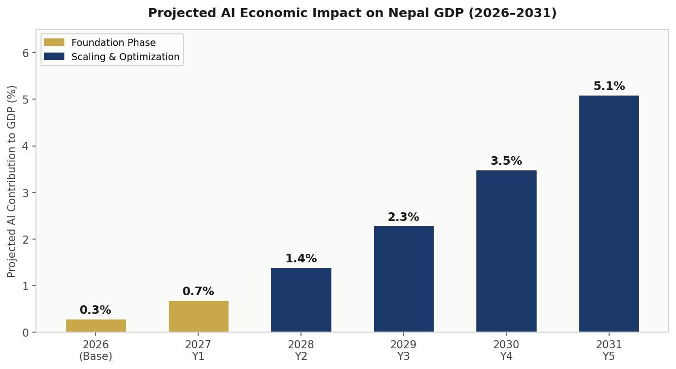
Figure 4.1 — Projected AI Contribution to Nepal GDP (%). Baseline: 0.3% (2026). Target: 5.1% (2031). Based on World Bank LMI country comparators and Nepal-specific sectoral analysis.

4.2 Investment Allocation Framework
The National AI Investment Fund will be capitalised at NPR 10 billion (approximately USD 75 million) over the five-year policy period, leveraging additional public-private partnership funding estimated at 2–3x the public allocation. The recommended allocation across investment categories is shown below:
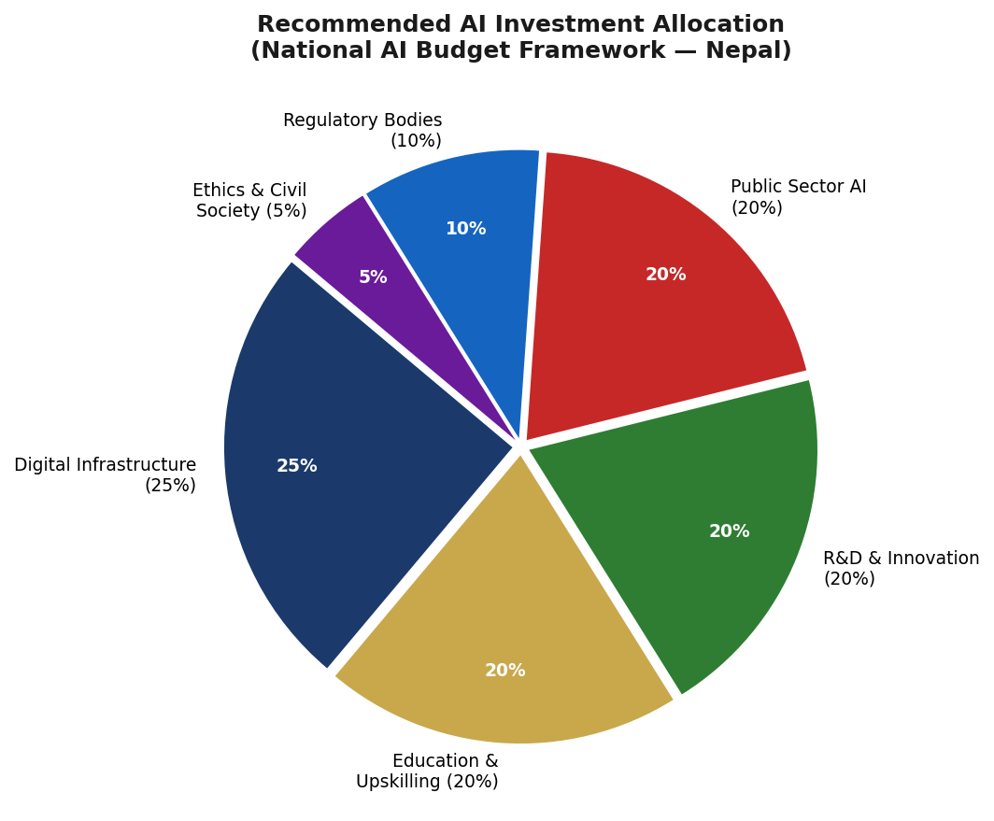
Figure 4.2 — Recommended Nepal National AI Investment Allocation. Digital infrastructure receives the largest share (25%) given Nepal's infrastructure gap as the primary AI deployment constraint.

4.3 Priority Sectors for AI Adoption
Agriculture (highest priority)
Over 65% of Nepal's population depends on agriculture. AI applications include satellite-based crop health monitoring, AI-powered pest and disease early warning systems, precision irrigation for terraced hill farming, agricultural market price forecasting for smallholders, and climate adaptation modelling for increasingly erratic monsoon patterns. Pilot programmes will be launched in 3 provinces (Lumbini, Madhesh, Karnali) in Phase 1.
Financial Inclusion
Nepal has a financial inclusion rate of approximately 60%, with significant gaps among rural women and hill communities. AI-powered alternative credit scoring using mobile transaction data, AI-enabled fraud detection for mobile banking, and multilingual AI customer service for cooperative banks represent high-impact, rapid-deployment opportunities. The Nepal Rastra Bank will issue an AI in Financial Services regulatory sandbox framework by 2027.
Disaster Risk Reduction
Nepal is among the world's most disaster-prone countries, facing annual threats from earthquakes (the 2015 earthquake killed 9,000 people), floods, landslides, and glacial lake outburst floods (GLOFs). AI-powered early warning systems, satellite imagery analysis for landslide monitoring, and AI-assisted rescue coordination are classified as national security priorities and will receive dedicated funding outside the standard AI investment envelope.

4.4 Public-Private Partnership Framework
The Nepal AI Investment Framework adopts a tiered PPP model. Tier 1 involves full government ownership and operation for high-risk, high-sovereignty AI systems (national security, law enforcement, social welfare). Tier 2 involves regulated private sector deployment under government licence and audit for financial services, health, and education AI. Tier 3 involves open market AI innovation with voluntary code of conduct compliance for commercial and consumer AI applications. Foreign direct investment in AI is welcomed with tax incentives, provided data localisation requirements are met.

Section 5: Education and Human Capital Development

5.1 Skills Gap Analysis
Nepal faces a severe AI skills deficit at every level. At the expert level (AI researchers and ML engineers capable of building and deploying custom AI systems), Nepal has an estimated 1,500–2,000 practitioners. At the practitioner level (professionals who can apply AI tools to domain problems — in healthcare, agriculture, finance, law), the number is approximately 10,000–15,000, representing less than 0.1% of the working population. At the literacy level (citizens who understand AI, can use AI tools, and can critically evaluate AI outputs), the proportion is under 5% of the adult population.
This policy aims to achieve, by 2031: 15 million citizens with basic AI awareness (40% of the adult population), 2 million AI-literate citizens capable of using AI tools productively, 150,000 AI practitioners across priority sectors, and 15,000 AI experts anchored in Nepal rather than emigrating.

5.2 National AI Curriculum Framework
Primary and Secondary (K–12)
AI concepts will be integrated into the national curriculum from Grade 6 onward as part of the Computing and Digital Literacy subject, which becomes compulsory from 2028. Grade 6–8 will focus on AI awareness (what AI is, everyday AI examples, ethical considerations). Grades 9–10 will introduce AI tools, basic data literacy, and critical thinking about algorithmic systems. Grades 11–12 (Science and Management streams) will offer elective AI modules including supervised learning concepts, AI ethics case studies, and introductory Python programming.
Tertiary Education
All undergraduate programmes in engineering, management, health sciences, and education will include a mandatory one-semester AI Literacy and Applications module by 2028. Dedicated BSc and MTech AI/Data Science programmes will be established at Tribhuvan University, Kathmandu University, and Pokhara University, targeting a combined annual intake of 3,000 students by 2030. Research collaboration agreements with IIT Delhi, MIT, and the Alan Turing Institute will be pursued for joint PhD programmes.
Vocational and Non-Formal Training
The Council for Technical Education and Vocational Training (CTEVT) will integrate AI tools into all major vocational training streams. Dedicated 3-month and 6-month certificate programmes in AI for Agriculture, AI for Tourism, AI for Financial Services, and AI for Healthcare will be developed in partnership with the private sector. These programmes will be delivered in both Nepali and English, with provisions for regional language adaptations.
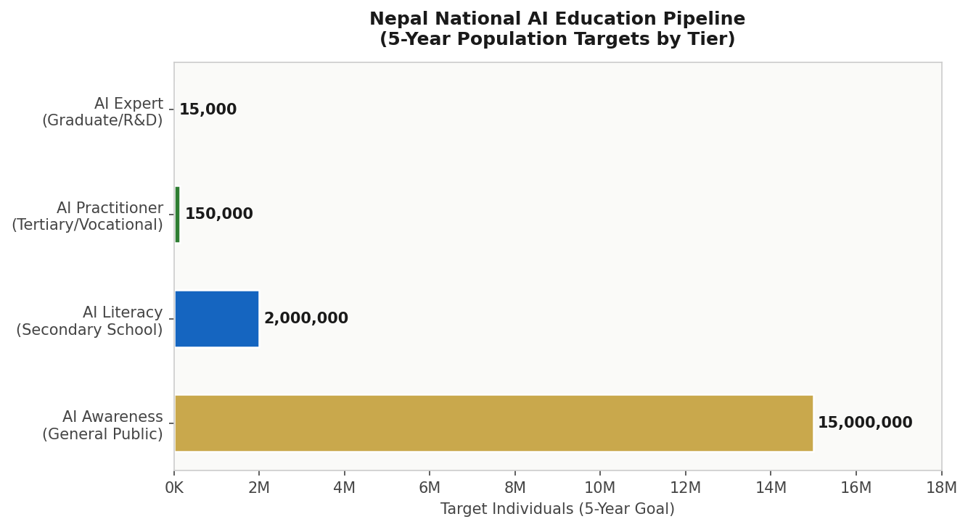
Figure 5.1 — Nepal National AI Education Pipeline (5-Year Targets). The funnel reflects a tiered approach from mass awareness to expert development, with proportional investment weighted toward the practitioner tier.

5.3 Gender and Inclusion Targets
Nepal's national gender parity index in STEM higher education stands at 0.62 (UNDP 2023), reflecting significant underrepresentation of women in technology fields. This Policy mandates gender-disaggregated tracking of all AI training programme participation, with a binding target of 40% women's participation in government-funded AI programmes. Separate targets apply for Dalit, Janajati, and Madhesi communities. Scholarships, stipends, and childcare support will be provided to address access barriers.

Section 6: Ethical AI Governance and Regulatory Framework

6.1 National AI Ethics Board
The National AI Ethics Board (NAEB) will be established by 2026 under an Act of Parliament, operating as an independent statutory authority. The NAEB will comprise 21 members serving three-year renewable terms: 5 government representatives (MoCIT, MoLaw, MoHealth, MoFinance, NRB), 4 civil society representatives, 4 academic experts in AI ethics, computer science, and social science, 3 private sector representatives, 2 representatives from marginalised communities, 2 representatives from provincial governments, and 1 independent international AI governance expert.
The NAEB's core mandates include: issuing binding AI ethics guidelines, conducting algorithmic audits of high-risk government AI systems, receiving and adjudicating citizen AI grievances, advising Parliament on AI legislation, and publishing annual State of AI Ethics reports. NAEB decisions on high-risk AI system deployment are legally binding on government agencies.

6.2 Data Protection and Privacy
Nepal's proposed Personal Data Protection Act (PDPA), currently in parliamentary review, will be aligned with GDPR principles and enacted by 2027 as a foundational prerequisite for responsible AI deployment. Key provisions include: data minimisation requirements, purpose limitation, explicit consent for personal data processing in AI systems, the right to explanation for automated decisions, mandatory data breach notification within 72 hours, and data localisation requirements for sensitive government and health data. An independent Data Protection Commissioner will be appointed with enforcement powers.

6.3 Anti-Corruption AI Standards
Given Nepal's governance transparency challenges, special AI anti-corruption standards apply to all public sector AI deployments. All AI used in procurement, land administration, social welfare, and licensing must: maintain complete audit logs for 7 years, produce decisions that are auditable by the Office of the Auditor General, be procured through an open competitive process with technical specifications published for civil society review, and be subject to mandatory post-deployment evaluation after 12 months.
AI-assisted public procurement decision systems must interface directly with the PPMO's e-GP platform and flag anomalous awarding patterns for independent review. Whistleblower protections are extended to cover reports of AI system manipulation by government officials.

6.4 Algorithmic Accountability Standards
All AI systems deployed by government agencies in high-risk categories must publish an Algorithmic Impact Assessment (AIA) before deployment. The AIA must document: the AI system's purpose and decision scope, training data sources and data governance practices, fairness metrics tested and results, identified failure modes and mitigation measures, human oversight procedures, and the grievance mechanism for affected citizens. AIA documents will be publicly accessible on a national AI transparency portal maintained by MoCIT.

Section 7: Public Sector and e-Governance AI

7.1 Priority Government AI Use Cases
The following government AI use cases are prioritised for Phase 1 deployment (2026–2028), selected based on citizen impact potential, technical feasibility, and alignment with Nepal's federal governance priorities:
- Digital Land Record Management: AI-powered OCR and data validation for Nepal's estimated 8 million paper-based land registration records, reducing fraud and processing time from weeks to days.
- Social Protection Targeting: AI-assisted eligibility verification for Karnali Province nutrition programmes, school feeding initiatives, and senior citizen allowances — reducing exclusion errors and inclusion fraud.
- Tax Administration: AI pattern recognition for the Inland Revenue Department to flag anomalous tax filings and improve VAT compliance, targeting a 15% increase in domestic revenue collection.
- Disaster Early Warning: AI integration with the National Seismological Centre and Department of Hydrology for real-time earthquake and flood early warning, with multilingual SMS alert systems.
- Judicial Case Management: AI-powered case classification, backlog prioritisation, and legal precedent search for the Supreme Court and High Courts, targeting 20% reduction in case backlog by 2030.
- Agricultural Advisory Services: Multilingual AI chatbot (in Nepali, Maithili, Tamang, Awadhi) delivering crop advisory, weather alerts, and market price information to 500,000 smallholder farmers by 2028.

7.2 Government AI Procurement Guidelines
All government AI procurement must follow the National AI Procurement Framework (NAIPF), to be published by MoCIT by Q2 2027. Key procurement principles include: open architecture preference (avoiding proprietary lock-in), mandatory source code audit rights for government, algorithmic impact assessment submission before contract award, training data provenance disclosure, explainability requirements commensurate with risk tier, and mandatory post-deployment performance evaluation clauses. Foreign AI vendors must establish a local legal entity and data residency for government contracts above NPR 50 million.

7.3 Interoperability Standards
Nepal's federal governance structure requires AI systems across federal and provincial governments to be interoperable. MoCIT will adopt and mandate the Government Interoperability Framework (GIF) standards for all public sector AI data exchange. A National Digital Identity platform (building on the existing National ID Card system) will serve as the common citizen identity layer for all government AI services, with privacy-preserving authentication mechanisms.

Section 8: Five-Year Implementation Roadmap

8.1 Overview
The Nepal National AI Policy 2026–2031 is implemented in three overlapping phases: Foundation (2026–2027), Scaling (2027–2029), and Optimisation (2029–2031). Each phase has defined milestones, responsible agencies, and budget allocations. Phase transitions are conditional on milestone achievement, with the National AI Observatory empowered to flag phase delays and recommend corrective action to Parliament.
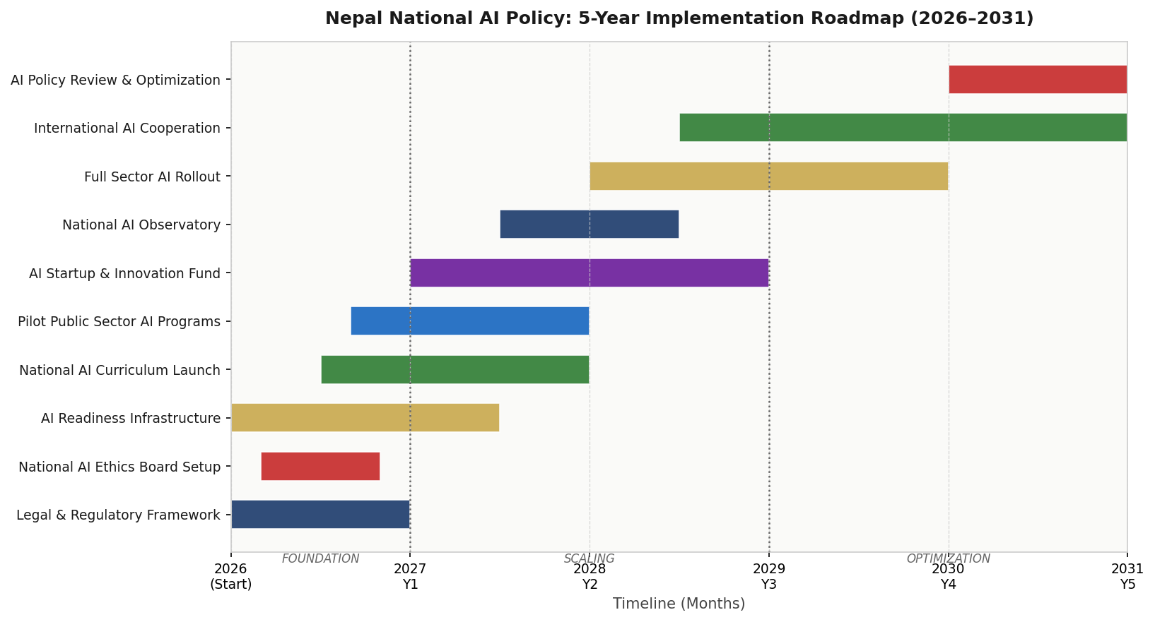
Figure 8.1 — Nepal National AI Policy: 5-Year Implementation Gantt (2026–2031). Phases overlap to allow continuous progress while establishing foundational systems.

8.2 Phase 1: Foundation (2026–2027)
Key Milestones
- Q4 2026: National AI Ethics Board established by Act of Parliament
- Q4 2026: National AI Strategy Unit created within MoCIT
- Q1 2027: Personal Data Protection Act enacted
- Q2 2027: National AI Procurement Framework published
- Q2 2027: AI Literacy Module integrated into 200 pilot secondary schools
- Q3 2027: First 5 government AI pilot deployments launched (land records, tax, disaster)
- Q4 2027: National AI Observatory operational, first baseline report published
Phase 1 Budget Allocation
Estimated NPR 1.8 billion (USD 13.5 million) from the National AI Investment Fund. Priority: institutional setup, legal framework, infrastructure baseline assessment, and pilot programmes.

8.3 Phase 2: Scaling (2027–2029)
Key Milestones
- 2027–2028: AI literacy curriculum rolled out nationally across all Grade 6–10 schools
- 2028: Dedicated AI degree programmes launched at 3 national universities
- 2028: 15 government AI services operational across federal and provincial levels
- 2028: National AI Research Centre established at Tribhuvan University
- 2029: 150,000 AI practitioners reached through government-funded training programmes
- 2029: National AI Startup Fund operational with first cohort of 50 startups funded
Phase 2 Budget Allocation
Estimated NPR 4.5 billion (USD 33.5 million). Priority: education system integration, public sector AI scaling, startup ecosystem, and infrastructure investment.

8.4 Phase 3: Optimisation (2029–2031)
Key Milestones
- 2029–2031: Full national AI literacy programme reaching 15 million citizens
- 2030: Comprehensive Policy review and update based on National AI Observatory findings
- 2030: Nepal achieves SAARC AI Hub status, hosting first regional AI governance forum
- 2031: National AI Policy 2031–2036 development begins based on evaluation findings
- 2031: Target — 5% AI contribution to GDP, 150,000 AI practitioners, 15M AI-aware citizens
Phase 3 Budget Allocation
Estimated NPR 3.7 billion (USD 27.5 million). Priority: optimisation, international integration, second-generation AI infrastructure, and policy renewal.

Section 9: Monitoring, Evaluation and Accountability

9.1 National AI Observatory
The National AI Observatory (NAO) will be established as a unit within the National Planning Commission by Q4 2027, with operational independence guaranteed by statute. The NAO will publish an Annual State of AI in Nepal Report, conduct biennial impact evaluations of major AI programmes, maintain the national AI transparency portal, and submit findings to Parliament's Technology Committee.

9.2 KPI Dashboard
KPI Metric | Baseline (2026) | Year 1 Target | Year 3 Target | Year 5 Target
AI contribution to GDP (%) | 0.3% | 0.7% | 2.3% | 5.1%
AI-literate citizens (millions) | ~0.5M | 1M | 5M | 15M
AI practitioners trained | ~2,000 | 10,000 | 80,000 | 150,000
AI expert researchers | ~500 | 800 | 5,000 | 15,000
Govt AI services deployed | 0 | 5 | 20 | 40+
Women in AI programmes (%) | ~15% | 25% | 35% | 40%+
AI startups funded | ~10 | 30 | 150 | 400+
CPI Score (TI) | 35 | 36 | 40 | 48
AI Ethics Board cases resolved | N/A | 100% | 95%+ | 98%+
Rural AI service access (%) | 5% | 15% | 35% | 60%

9.3 Parliamentary Oversight
Nepal's Parliament Technology Committee will receive bi-annual briefings from the National AI Ethics Board and the National AI Observatory. A dedicated Parliamentary AI Accountability Debate will be held annually, with all government agencies required to submit AI implementation progress reports. The Auditor General's Office is mandated to conduct performance audits of AI investment programmes every two years.

9.4 Civil Society Role
Civil society organisations, academic institutions, and the media are recognised as essential accountability actors. The National AI Observatory will publish all data in open, machine-readable formats. An annual National AI Civil Society Forum will be convened, with findings formally considered by the National AI Ethics Board. Investigative journalism covering AI systems failures or harms will be facilitated through mandatory public disclosure of algorithmic impact assessments.

Section 10: International Cooperation and AI Diplomacy

10.1 Bilateral AI Cooperation Priorities
Nepal will prioritise bilateral AI cooperation agreements with India, China, the United States, Japan, and the European Union — representing Nepal's five most significant development and trade partners. Priority areas for bilateral cooperation include: AI research joint ventures, digital infrastructure co-financing, AI ethics regulatory dialogue, and talent exchange programmes. India, as Nepal's primary economic partner, will be the focus of the first bilateral AI Cooperation MoU, targeting collaboration on agricultural AI, disaster management systems, and digital payment infrastructure.

10.2 SAARC Regional AI Governance
Nepal advocates for a dedicated SAARC AI Working Group under the SAARC Secretariat, with Nepal volunteering to host the inaugural SAARC AI Governance Forum in Kathmandu in 2028. Key regional cooperation priorities include: shared data standards for cross-border disaster management AI, harmonised AI ethics guidelines for SAARC member states, a regional AI startup acceleration fund, and mutual recognition of AI certification programmes.

10.3 South-South Knowledge Transfer
Nepal will actively engage in South-South AI knowledge transfer with AI-advancing developing nations in Africa and Southeast Asia. Memoranda of Understanding with Rwanda (recognised for its proactive AI governance), Kenya (for its AI in financial inclusion experience), and Vietnam (for its AI industrialisation model) will be pursued. Nepal's unique expertise in mountain-terrain AI, multilingual NLP for low-resource languages, and community-based digital inclusion will be offered as knowledge contributions to partner countries.

10.4 Global AI Governance Participation
Nepal commits to active participation in: the UN Secretary-General's AI Advisory Body (as an Asia-Pacific developing nation voice), the ITU AI for Good programme, the Global Partnership on Artificial Intelligence (GPAI), and UNESCO AI Ethics implementation working groups. Nepal will submit its first Voluntary National Review on AI Governance to the UN in 2028, aligned with the SDG review process.

Conclusion
Nepal's National AI Policy 2026–2031 is not merely a technology strategy — it is a development vision, a governance commitment, and a democratic mandate. It reflects Nepal's determination to navigate the opportunities and risks of the AI era in a manner consistent with its federal democratic values, its rich cultural heritage, and its obligations to every Nepali citizen, from the Terai plains to the Himalayan highlands.
The challenge is real and well-documented: Nepal's AI readiness composite score of 3.93/10 reflects genuine infrastructure gaps, skills deficits, and governance challenges. But the opportunity is equally real: a young demographic, rapidly expanding digital connectivity, a highly educated diaspora willing to contribute, and a tradition of community-based resilience that AI can amplify rather than replace.
This Policy is deliberately ambitious on outcomes and honest about constraints. It does not pretend that AI will solve corruption overnight, or that every rural school will have AI teachers by 2027. What it commits to is a phased, evidence-based, and accountable implementation process — one where progress is transparently measured, failures are acknowledged and corrected, and citizens remain the ultimate beneficiaries and judges of Nepal's AI journey.
Nepal's path to AI-powered development will be distinctly Nepali: multilingual, mountainous, federal, and community-centred. This Policy provides the framework. Implementation is the shared responsibility of government, private sector, civil society, academia, and every Nepali who understands that the future will be shaped by those who are prepared to shape it.
जय नेपाल — Long Live Nepal

References and Bibliography

International Frameworks
- UNESCO Recommendation on the Ethics of Artificial Intelligence (2021). Paris: UNESCO.
- OECD Principles on AI (2019, updated 2024). Paris: OECD Publishing.
- European Parliament and Council. (2024). Regulation on Artificial Intelligence (EU AI Act). Brussels: Official Journal of the European Union.
- World Bank Group. (2023). World Development Report 2021: Data for Better Lives. Washington DC: World Bank.
- G20 AI Principles (2019). Osaka: G20 Leaders' Declaration.
- ITU. (2023). AI for Good Global Summit Report. Geneva: International Telecommunication Union.
- United Nations. (2023). Secretary-General's Advisory Body on AI: Interim Report. New York: UN.

Nepal Country Data
- Central Bureau of Statistics, Nepal. (2024). National Population and Housing Census 2021: Key Findings. Kathmandu: CBS.
- Nepal Rastra Bank. (2024). Annual Report 2023/24. Kathmandu: NRB.
- Ministry of Communication and Information Technology. (2022). Broadband Master Plan 2022–2030. Kathmandu: MoCIT.
- Transparency International. (2024). Corruption Perceptions Index 2024. Berlin: TI.
- Oxford Insights. (2023). Government AI Readiness Index 2023. Oxford: Oxford Insights.
- UNDP Nepal. (2023). Human Development Report 2023: Nepal Country Profile. Kathmandu: UNDP.
- World Bank. (2024). Nepal Country Overview. Washington DC: World Bank.

AI Economic Impact
- McKinsey Global Institute. (2023). The Economic Potential of Generative AI: The Next Productivity Frontier. New York: McKinsey.
- World Economic Forum. (2023). Future of Jobs Report 2023. Geneva: WEF.
- Asian Development Bank. (2023). Asia's Digital Future: From Now to 2025 and Beyond. Manila: ADB.

About the Author
Nafiul Ahmad Rafi
Policy & Good Governance Researcher | BD Civic Tech Architect

Nafiul Ahmad Rafi is a civic technologist, policy researcher, author, photographer, and musician based in Dhaka, Bangladesh. He is the Founder and Director of Insights Bangladesh, a data-driven governance and policy impact analysis institution, and the Founder & Lead Architect of NagorikBD.org — a transparency-first civic platform scaled across Mymensingh Division, connecting citizens with government services across 45 Upazilas.
His work exists at the intersection of institutional reform and artificial intelligence, transforming theoretical governance into scalable, data-driven reality. Without a conventional computer science degree, he self-taught the tools of modern AI and web development to build the infrastructure that enforces the policies he once only researched.

Key Platforms and Projects
- NagorikBD.org — Civic transparency platform, Mymensingh Division
- Insights Bangladesh — Policy impact analysis institution
- FactCheck BD (factcheckbd.org) — Bangladesh's AI-powered fact-checking platform
- Political Insights BD / PIBD (pibbd.org) — Political intelligence and civic tech hub
- PeaceShield BD / National Peace Tracker — AI-powered hate speech and conflict monitoring
- PolicyLens AI (aigovbd.org) — 9-dimensional AI policy audit tool
He has published four books and maintains a personal website at ahmad-rafi.com.

Research Interests
AI Governance · Policy Research · Future of Bangladesh · Climate Policy

Contact
- Website: ahmad-rafi.com
- LinkedIn: linkedin.com/in/nafiul-ahmad-rafi
- Email: contact@ahmad-rafi.com

"I build code to ensure transparency, and I write lyrics to inspire the courage to use it."

