🇵🇰 ISLAMIC REPUBLIC OF PAKISTAN

National Artificial Intelligence Policy
2026 – 2031

A Comprehensive Framework for Ethical, Inclusive, and
Economically Transformative Artificial Intelligence

Prepared by:
Nafiul Ahmad Rafi
Insights Bangladesh | Policy & Good Governance Research
May 2026

Executive Summary

Pakistan stands at a pivotal juncture in its developmental trajectory. With a population exceeding 230 million — the fifth largest in the world — a median age of 22 years, and a rapidly expanding digital economy, the country possesses the demographic and economic preconditions to become a significant AI-driven economy within the next decade. Yet realizing this potential demands deliberate, evidence-based, and ethically grounded policy action at the national level. This National Artificial Intelligence Policy 2026–2031 provides that foundation.
This policy emerges at a moment of global AI transformation. Governments from Washington to Beijing to Riyadh are racing to position their economies for an AI-augmented future. Pakistan cannot afford complacency. The country's Oxford Insights AI Readiness Index score of approximately 30 out of 100 reflects real gaps in digital infrastructure, AI talent, and institutional capacity — but also signals enormous potential for accelerated progress given targeted investment and political will.
The policy is organized around five strategic pillars: Ethical AI and Human Rights Protection; Economic Growth and Industrial AI Adoption; Education, Upskilling, and AI Workforce Development; Public Sector AI and e-Governance; and AI Research, Innovation, and Startup Ecosystem Development. These pillars are designed to be mutually reinforcing, ensuring that Pakistan's AI journey creates broad-based prosperity rather than concentrating gains among already-privileged groups.
Implementation is envisioned in three phases over a 60-month horizon. Phase 1 (Foundation, Year 1) establishes the legal, institutional, and infrastructural bedrock. Phase 2 (Scaling, Years 2–3) deploys AI capabilities across government services, education, and priority industries. Phase 3 (Optimization, Years 4–5) reviews, refines, and positions Pakistan as a regional AI leader with growing export potential. Projected economic benefits, modelled on World Bank and McKinsey estimates for comparable lower-middle-income economies, suggest AI could contribute 9.5% of GDP — approximately USD 38 billion — by 2030.
This policy is explicitly aligned with seven major international frameworks: UNESCO's AI Ethics Recommendation, OECD AI Principles (2024 update), the EU AI Act, World Bank AI Strategy, G20 AI Principles, ITU AI for Good Guidelines, and the Global Partnership on AI (GPAI). Alignment is not merely rhetorical; it is structural, with each framework's core requirements mapped to specific policy sections and implementation mechanisms.

Section 1: National AI Readiness Assessment

1.1 Economic Context
Pakistan's GDP stood at approximately USD 340 billion in 2024 (nominal), with a per capita income of around USD 1,500, classifying it as a lower-middle-income country. Key economic sectors include agriculture (24% of GDP), manufacturing (19%), services (57%), and a growing IT/BPO sector generating over USD 2.6 billion in annual exports. The informal economy represents an estimated 35–40% of total economic activity, presenting both a challenge and an opportunity for AI-enabled formalization and productivity enhancement.
Pakistan's fiscal constraints are significant — public debt exceeds 75% of GDP and the IMF remains an active lender of last resort — making the case for efficient, targeted AI public investment particularly compelling. AI adoption in agriculture, tax administration, and public service delivery could yield substantial fiscal dividends while improving citizen outcomes.

1.2 Education & Human Capital
Pakistan's adult literacy rate stands at approximately 58%, among the lower in South Asia. Gross tertiary enrollment is around 9–10%, and STEM graduates number roughly 100,000 per year. The country has a nascent but growing technology talent base, with emerging AI and data science programs at institutions including LUMS, NUST, IBA Karachi, and FAST-NUCES. However, demand for AI talent dramatically outpaces supply, and gender disparities are severe — women constitute fewer than 15% of the technology workforce.
Pakistan produces approximately 500 computer science PhDs and a few hundred AI-specialist master's graduates annually. This must scale tenfold within the policy horizon. The National AI Curriculum Framework outlined in Section 5 provides the pathway.

1.3 Digital Infrastructure
Internet penetration in Pakistan reached approximately 36% in 2024, with significant urban-rural and gender divides. Mobile penetration is considerably higher at around 78%, making mobile-first AI service delivery essential. The national fibre optic backbone (PTCL infrastructure) covers major urban centres but remains thin in rural areas. Cloud computing adoption is nascent; Pakistan relies heavily on international data centres, creating latency, sovereignty, and cost challenges that a domestic AI compute strategy must address.

1.4 Governance & Institutional Capacity
Pakistan operates as a federal parliamentary democracy with significant provincial autonomy. The Ministry of IT & Telecommunication (MoITT) is the primary government actor in the digital space, alongside the National Information Technology Board (NITB) and the Pakistan Telecommunication Authority (PTA). Institutional capacity for technology regulation is growing but remains limited relative to the scale of the AI policy challenge. Coordination across federal and provincial tiers is essential and historically challenging.

1.5 Corruption Risk Assessment
Transparency International's 2023 Corruption Perception Index ranks Pakistan at 27 out of 100 (rank 133/180 globally), significantly below the South Asian average of approximately 35 and the OECD average of 68. This elevated corruption risk has direct implications for AI governance: procurement corruption could compromise AI system quality; algorithmic bias could be exacerbated by corrupt data collection; and AI surveillance tools could be misused by bad actors within the state apparatus. The National AI Ethics Board must include explicit anti-corruption mandates and independent oversight mechanisms.
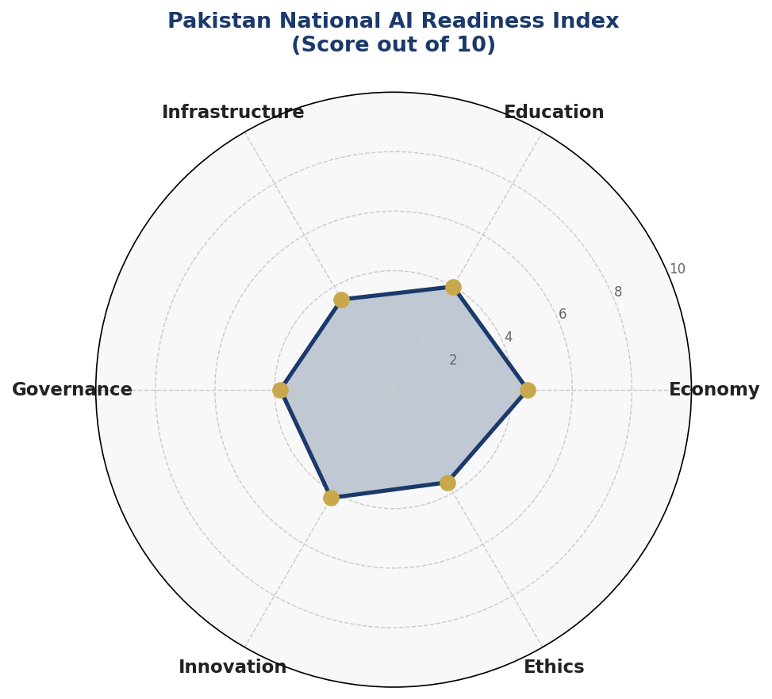
Figure 1: Pakistan National AI Readiness Index — Six-Dimension Radar Analysis (Scores out of 10)
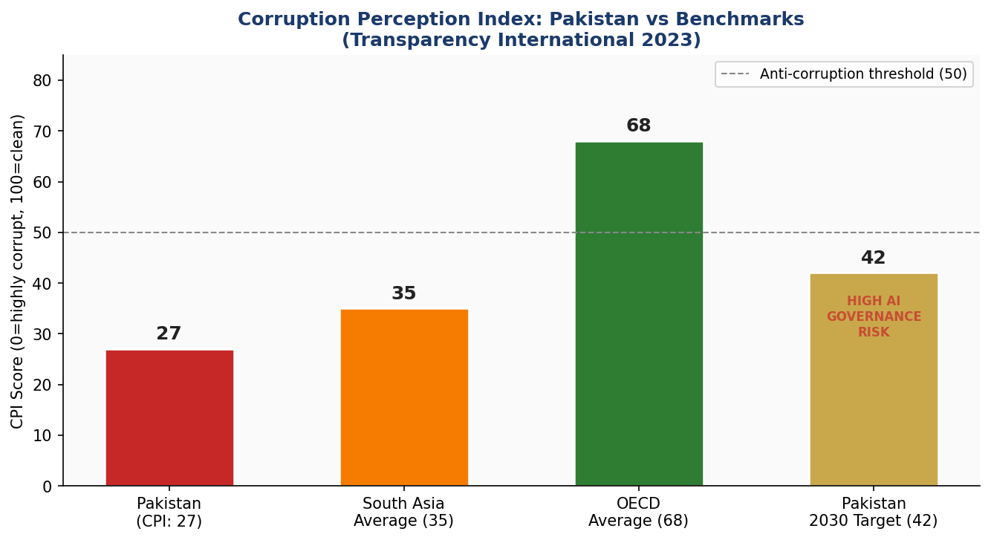
Figure 2: Corruption Perception Index — Pakistan vs Regional and Global Benchmarks (Transparency International 2023)

Section 2: Policy Vision & Strategic Pillars

2.1 National Vision Statement
"By 2031, Pakistan will be a digitally sovereign, ethically grounded AI nation — harnessing the power of artificial intelligence to eradicate poverty, accelerate industrialization, empower its youth, and deliver transparent, citizen-centred governance — while becoming South Asia's leading voice in global AI ethics and governance."

2.2 Strategic Pillar I — Ethical AI & Human Rights Protection
Pakistan commits to ensuring that every AI system deployed within its borders respects fundamental human rights, protects personal data, and operates transparently. This pillar establishes a National AI Ethics Board with legal authority to audit, approve, and sanction AI deployments across sectors. It mandates algorithmic impact assessments for high-risk applications and establishes redress mechanisms for citizens harmed by AI-driven decisions.
Specific focus is given to protecting vulnerable populations — women, minorities, persons with disabilities, and rural communities — from algorithmic discrimination. All public-sector AI must undergo quarterly ethics reviews. Private-sector AI in high-risk categories (health, finance, law enforcement) must be registered with the Ethics Board and subject to annual audits.

2.3 Strategic Pillar II — Economic Growth & Industrial AI Adoption
AI presents Pakistan with a historic opportunity to accelerate industrial transformation. Priority sectors for AI adoption include agriculture and food security (precision farming, crop yield prediction, pest control), textile and manufacturing (quality control, predictive maintenance, export optimization), financial services (credit scoring for the unbanked, fraud detection), healthcare (diagnostic AI, telemedicine), and the burgeoning IT/BPO export sector which has natural AI augmentation potential.
A National AI Industrial Adoption Accelerator will provide matching grants, tax incentives, and technical assistance to SMEs integrating AI into their operations. A dedicated AI Export Promotion Initiative will support Pakistani AI firms in entering global markets, building on existing diaspora networks in Silicon Valley, London, and the Gulf.

2.4 Strategic Pillar III — Education, Upskilling & AI Workforce Development
Pakistan's 230 million population — with 64% under age 30 — is simultaneously its greatest AI challenge and its most powerful asset. The National AI Curriculum Framework (detailed in Section 5) will systematically build AI literacy from primary school through to postdoctoral research. Particular emphasis is placed on closing the gender gap: all AI education programmes will carry mandatory female participation targets, initially 35% rising to 50% by 2031.

2.5 Strategic Pillar IV — Public Sector AI & e-Governance
Government transformation through AI is both the most impactful and the most risk-laden application domain. Pakistan's priority use cases include: tax compliance and revenue optimization (FBR AI systems); land records digitization and fraud prevention (provincial revenue authorities); judicial case management and backlog reduction; social protection beneficiary identification (BISP); and health system optimization (Ministry of National Health Services).
All government AI procurement will follow a Citizens-First Standard: systems must demonstrably improve service quality, reduce corruption risk, and be explainable to the citizens they affect. A Government AI Procurement Framework (GAIF) will be developed by the Ministry of IT within the first 12 months.

2.6 Strategic Pillar V — AI Research, Innovation & Startup Ecosystem
Pakistan's AI research output is growing but remains below potential. The National AI Research Initiative will establish five Centre of Excellence nodes — at LUMS, NUST, IBA Karachi, University of Peshawar, and University of Balochistan — ensuring geographic and disciplinary diversity. A Pakistan AI Venture Fund, capitalized at PKR 50 billion over five years through a public-private partnership, will provide seed and Series A funding to AI startups.
International research partnerships will be pursued with leading AI institutions globally, including the Alan Turing Institute (UK), MBZUAI (UAE), Indian Institutes of Technology (subject to bilateral arrangements), and KAIST (South Korea). The Pakistani diaspora — especially in North America and the UK — will be actively engaged as mentors, investors, and return entrepreneurs.

Section 3: International Framework Alignment

3.1 UNESCO AI Ethics Recommendation (2021)
The UNESCO Recommendation on the Ethics of AI, adopted unanimously by 193 member states, establishes 11 core values: respect for human rights and dignity; environmental flourishing; diversity and inclusiveness; peaceful societies; protection of privacy and data; rule of law; transparency and explainability; responsibility and accountability; data governance; education and awareness; and multi-stakeholder governance. This policy maps directly to all 11 values across its ten sections.

3.2 OECD AI Principles (Updated 2024)
The OECD's five AI principles — inclusive growth and well-being; human-centred values and fairness; transparency and explainability; robustness, security and safety; and accountability — are embedded throughout this policy's governance architecture. Pakistan, while not an OECD member, recognizes the global standard-setting authority of these principles and commits to substantive alignment, including participation in the OECD AI Policy Observatory.

3.3 EU AI Act (2024)
The EU AI Act's risk-based classification system has been adapted for Pakistan's specific legal, economic, and institutional context in Section 6 of this policy. The four-tier risk framework (Unacceptable, High, Limited, and Minimal Risk) provides a practical regulatory scaffold that Pakistan can implement with domestic legislative modifications. Key adaptations for Pakistan's context include heightened attention to surveillance technology misuse and a more graduated approach to high-risk AI given current institutional capacity constraints.

3.4 World Bank, G20, ITU & GPAI Alignment
The World Bank's AI for Development framework emphasizes AI as a tool for poverty reduction and public service delivery — priorities that are central to this policy. The G20 AI Principles, developed under the 2019 Osaka Track, focus on responsible stewardship of trustworthy AI, with Pakistan committing to full alignment as a G20 dialogue partner. ITU's AI for Good framework provides SDG linkages that connect every policy pillar to specific Sustainable Development Goals. GPAI membership is a Year 1 objective, providing access to international expertise and peer learning.

Table 1: International Framework Alignment Matrix
Framework / Principle | Ethics &  Human Rights | Economic  Growth | Education &  Workforce | Public Sector  AI | Research &  Innovation
UNESCO AI Ethics (2021)  11 Core Values | ✅ | ✅ | ✅ | ✅ | ✅
OECD AI Principles (2024)  5 Principles | ✅ | ✅ | ⚠️ | ✅ | ✅
EU AI Act (2024)  Risk-Based Framework | ✅ | ⚠️ | ✅ | ✅ | ⚠️
World Bank AI Strategy  Development Focus | ⚠️ | ✅ | ✅ | ✅ | ✅
G20 AI Principles  Inclusive Growth | ✅ | ✅ | ✅ | ⚠️ | ✅
ITU AI for Good  SDG Alignment | ✅ | ✅ | ✅ | ✅ | ⚠️
GPAI Responsible AI  Multistakeholder | ✅ | ⚠️ | ✅ | ✅ | ✅
✅ Full Alignment ⚠️ Partial Alignment (requires additional measures) 🔲 Future alignment target

Section 4: Economic Impact & Investment Roadmap

4.1 Projected Economic Contribution of AI
Based on McKinsey Global Institute estimates for lower-middle-income economies and World Bank AI productivity models, AI is projected to contribute between 9–12% of GDP to Pakistan's economy by 2030 under an active adoption scenario. For Pakistan's current GDP base of approximately USD 340 billion, this represents a potential AI-attributable economic increment of USD 30–40 billion by 2030 — effectively adding the economic equivalent of a new province to national output.
Near-term gains (Years 1–2) will concentrate in AI-augmented exports (IT/BPO, textile quality), agricultural productivity, and public revenue collection efficiency. Medium-term gains (Years 3–4) will emerge from healthcare system optimization and financial inclusion. Long-term gains (Year 5+) will reflect AI-driven industrial upgrading and export competitiveness.
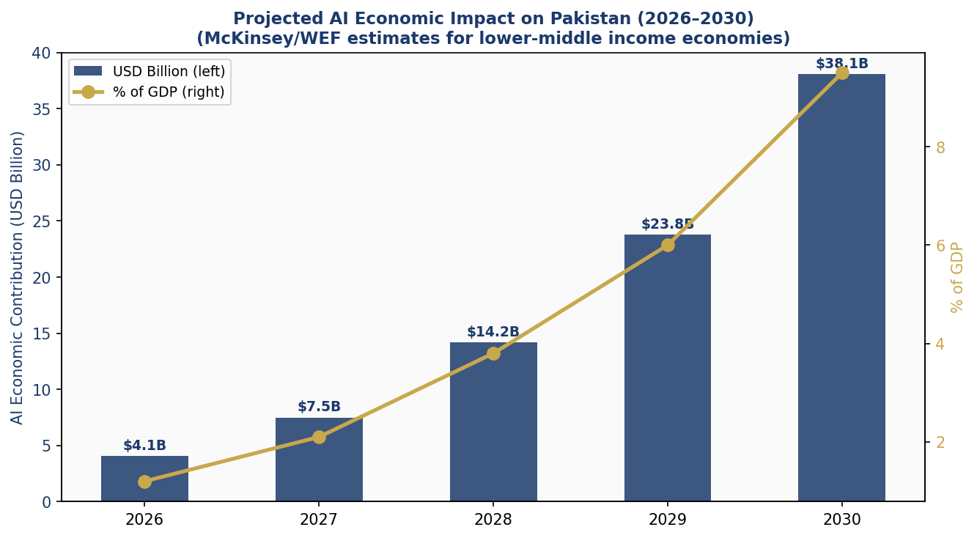
Figure 3: Projected AI Economic Impact on Pakistan 2026–2030 (USD Billions & % of GDP)

4.2 National AI Investment Framework
Pakistan commits to a dedicated National AI Investment Fund of PKR 250 billion (approximately USD 900 million) over the five-year policy period. This combines federal government allocation (50%), provincial government contributions (20%), international development finance (15%), and private sector mobilization (15%). The investment allocation across categories is as follows:
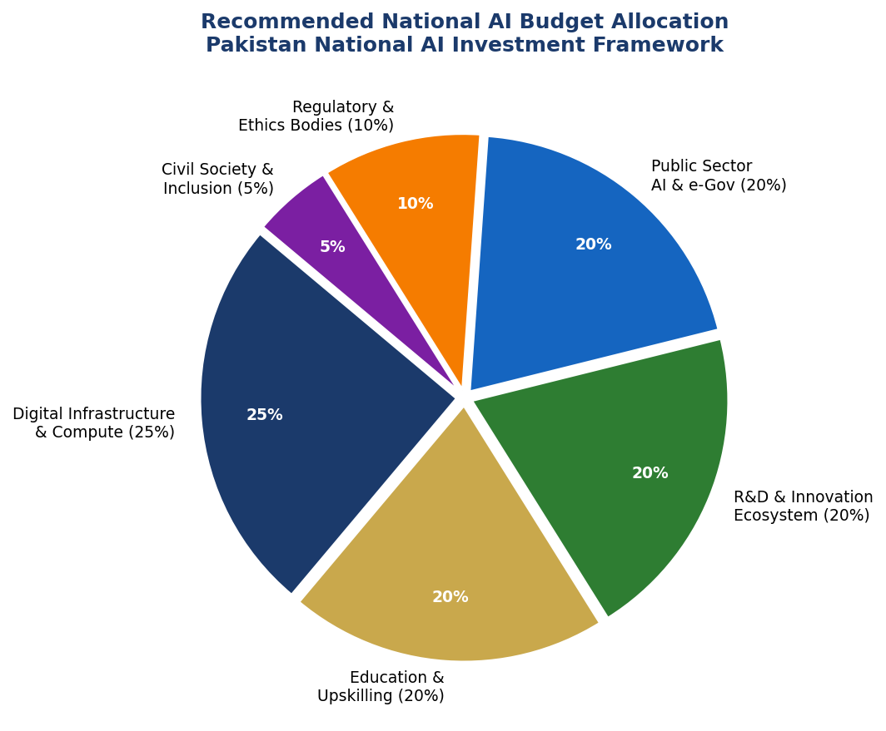
Figure 4: Recommended National AI Budget Allocation — Pakistan AI Investment Framework 2026–2031

4.3 Priority Sectors for AI Adoption
Agriculture & Food Security: Pakistan's agricultural sector employs 38% of the labour force and contributes 24% of GDP. AI applications in precision irrigation, satellite-based crop monitoring, pest and disease early warning, and supply chain optimization could increase agricultural productivity by 15–20% within five years. The Ministry of National Food Security and Research will lead a National Agricultural AI Program in partnership with provincial agriculture departments.
Manufacturing & Textiles: The textile sector (66% of Pakistan's exports) faces intensifying global competition. AI-powered quality control, predictive maintenance, demand forecasting, and automated logistics could enhance competitiveness significantly. A Textile AI Adoption Incentive Scheme will provide matched funding and technical assistance to medium and large manufacturers.
Financial Services: Pakistan's financial inclusion rate stands at approximately 21% for adults (2021 Findex data). AI-powered credit scoring using alternative data (mobile usage, utility payments, supply chain records) can extend formal financial access to tens of millions of currently unbanked Pakistanis. The State Bank of Pakistan will develop a Regulatory Sandbox for AI-driven fintech applications.
Healthcare: The doctor-to-patient ratio in Pakistan (approximately 1:1,000) makes AI-augmented diagnostics, telemedicine triage, and drug supply chain management critical policy priorities. AI diagnostic tools for tuberculosis, dengue, maternal health, and chronic disease management will be piloted in 10 districts in Year 1, with national rollout in Years 2–3.

4.4 Public-Private Partnership Framework
Government cannot bear the full burden of AI investment, nor should it. A National AI PPP Framework will be established under the Board of Investment, providing standardized templates for AI joint ventures, data sharing agreements, and outcome-based contracts. The framework will include robust safeguards against data monopolization and ensure that public-sector AI investments generate publicly accessible benefits rather than exclusively private returns.

Section 5: Education & Human Capital Development

5.1 Current Skills Gap Analysis
Pakistan currently produces an estimated 100,000 STEM graduates annually, of whom fewer than 2,000 have meaningful AI or data science specialization. The national demand for AI-capable professionals — from data annotators and machine learning engineers to AI ethicists and policy analysts — is estimated at 250,000+ roles by 2030. The current gap of approximately 248,000 skilled professionals represents both an urgent challenge and a compelling opportunity.
Gender disparity is acute: women constitute approximately 12–15% of Pakistan's technology workforce despite comprising 49% of the population. Addressing this gap is not merely an equity imperative — it is an economic necessity. Fully including women in Pakistan's AI workforce could increase national AI output by an estimated 35–40%.

5.2 National AI Curriculum Framework
Primary Education (Grade 1–8): Age-appropriate computational thinking, algorithmic reasoning, and data literacy will be integrated into the national curriculum. All primary school teachers will receive a 40-hour AI Literacy Certification through the Allama Iqbal Open University distance education platform.
Secondary Education (Grade 9–12): Dedicated AI and Data Science elective streams, practical project-based learning using open-source tools, and national AI olympiads to identify and nurture exceptional talent. Coordination with provincial education boards for curriculum standardization.
Tertiary Education: All public universities will offer AI/data science minors across all faculties by Year 2. Twenty universities will launch full AI degree programmes by Year 3. The Higher Education Commission will establish an AI Curriculum Standards Board and fast-track accreditation for AI programmes.
Vocational & Continuing Education: A National AI Upskilling Programme targeting 5 million working adults by Year 5, delivered through TVET authorities, mobile learning platforms, and industry partnerships. Focus on practical AI application skills relevant to Pakistan's key industries.
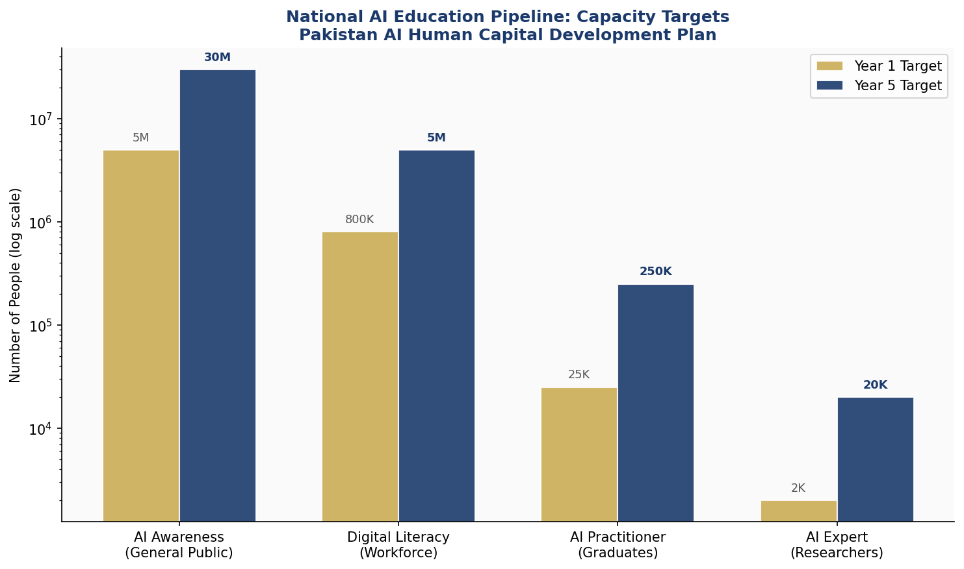
Figure 5: National AI Education Pipeline — Capacity Targets Year 1 vs Year 5 (Log Scale)

5.3 Women & Inclusion Targets
All AI education programmes funded under this policy will carry mandatory minimum female participation targets: 35% in Year 1, rising to 50% by Year 5. The National AI Girls Scholarship Programme will provide 10,000 merit-based scholarships annually for women pursuing AI-related tertiary education. Provincial Women AI Hubs — 10 established in Year 1 — will provide safe, supportive learning environments in secondary cities and underserved areas.

5.4 International Scholarship & Exchange
Pakistan will negotiate AI scholarship agreements with leading AI nations including the UK (Alan Turing Institute partnership), Germany (DAAD programme expansion), South Korea (KAIST collaboration), UAE (MBZUAI partnerships), and Canada (CIFAR AI Chairs programme). A target of 500 outbound AI scholarship recipients annually is established, with reciprocal obligations to contribute to Pakistan's AI ecosystem upon return.

Section 6: Ethical AI Governance & Regulatory Framework

6.1 National AI Ethics Board
The National AI Ethics Board (NAEB) will be established as an independent statutory body under the Ministry of IT & Telecommunication, with a mandate to regulate, audit, and enforce AI ethics standards across all sectors. The Board will comprise 15 members: 3 senior judiciary representatives, 3 technologists (nominated by HEC), 2 civil society leaders, 2 representatives of marginalized communities, 2 industry representatives (non-voting on enforcement matters), 2 independent international AI ethicists, and 1 representative of the National Commission on the Status of Women.
NAEB will publish an Annual State of AI Ethics Report, maintain a public registry of all High-Risk AI systems, conduct mandatory audits of government AI deployments, and operate a citizen complaint portal. Enforcement powers include: mandatory system suspension; financial penalties up to PKR 500 million; criminal referrals for deliberate deception; and mandatory public disclosure of violations.

6.2 AI Risk Classification System
Table 2: Pakistan National AI Risk Classification Framework
Risk Tier | Regulatory Response | Example Applications in Pakistan Context
UNACCEPTABLE  RISK | BANNED | Social scoring by government; AI-powered mass surveillance without judicial oversight; subliminal manipulation systems; AI that exploits vulnerabilities of minors
HIGH RISK | MANDATORY AUDIT  & REGISTRATION | AI in criminal justice & law enforcement; medical diagnosis AI; AI-based recruitment & credit scoring; biometric identification in public spaces; AI in education assessment
LIMITED RISK | TRANSPARENCY  OBLIGATIONS | Chatbots & virtual assistants; deepfake content generation; emotion recognition tools; AI-generated text in journalism or public communications
MINIMAL RISK | VOLUNTARY CODE  OF CONDUCT | AI-powered spam filters; recommendation systems; AI in gaming; predictive analytics for business operations; content moderation tools
AI Risk Classification adapted from EU AI Act (2024) for Pakistan's legal and institutional context

6.3 Data Protection & Privacy Framework
Pakistan's Personal Data Protection Act (under development as of 2025) must be enacted and operationalized in Year 1 of this policy. The AI Policy requires that the PDPA include: explicit provisions for AI-specific data processing; mandatory data minimization for AI training datasets; the right to explanation for automated decisions; data localization requirements for sensitive categories; and a dedicated Data Protection Authority with investigative powers.

6.4 Algorithmic Accountability Standards
All AI systems making decisions that affect citizens' rights, access to public services, or economic opportunities must comply with Pakistan's Algorithmic Accountability Standards (AAS), to be developed by NAEB in Year 1. AAS requirements include: documentation of training data sources and potential biases; regular fairness audits disaggregated by gender, province, urban/rural, and minority status; public-facing explanations of how automated decisions are made; and annual third-party audits for High Risk systems.

6.5 Anti-Corruption AI Use Guidelines
Given Pakistan's elevated corruption risk environment, specific guidelines govern AI use in anti-corruption contexts. AI may be used to enhance FBR tax compliance monitoring, BISP beneficiary verification, procurement anomaly detection, and land record fraud prevention. However, all such uses must be approved by NAEB, subject to judicial oversight, operated transparently, and evaluated for algorithmic fairness to ensure they do not disproportionately target vulnerable populations while shielding politically connected actors.

Section 7: Public Sector & e-Governance AI

7.1 Priority Government Use Cases
Tax Administration: The Federal Board of Revenue (FBR) will deploy AI-powered tax gap analysis, return cross-referencing, and taxpayer risk scoring systems in Year 1. Conservative estimates suggest AI-enhanced tax administration could increase annual tax collection by PKR 200–400 billion within three years, significantly improving Pakistan's chronically low tax-to-GDP ratio of approximately 9%.
Social Protection: The Benazir Income Support Programme (BISP) serves 9 million families. AI-enhanced beneficiary targeting — using satellite imagery, mobile data, and administrative records — can improve targeting accuracy, reduce ghost beneficiaries, and identify uncovered deserving families. A BISP AI Targeting Pilot will be launched in Balochistan and Khyber Pakhtunkhwa in Year 1.
Justice System: Pakistan's courts carry backlogs exceeding 2 million pending cases. AI-assisted case categorization, scheduling optimization, legal research assistance, and judgment drafting support (for routine matters) can significantly reduce judicial backlogs without compromising judicial independence. The Law and Justice Commission will develop AI adoption guidelines for the judiciary.
Health System: District Health Information System (DHIS2) data, combined with AI analytics, will power a National Disease Surveillance AI Platform capable of detecting outbreak signals weeks before traditional reporting chains. Maternal and child health AI interventions will target Pakistan's highest-priority health outcomes — neonatal mortality and stunting — in Year 2.

7.2 Government AI Procurement Framework
All government AI procurement above PKR 50 million must comply with the Government AI Procurement Framework (GAIF), to be developed by MoITT in Year 1. GAIF requirements include: mandatory algorithmic impact assessment before procurement; preference for open-source and locally-developed solutions; data sovereignty clauses in all vendor contracts; prohibition on vendor lock-in architectures; mandatory source code escrow; and a Citizens' Technology Audit right enabling civil society review of government AI deployments.

7.3 Interoperability & Data Standards
All government AI systems must comply with Pakistan's National Data Interoperability Standards (NDIS), to be published by NITB in Year 1. NDIS will ensure that AI systems across federal and provincial governments can share data securely, that citizen data is portable, and that AI models developed with public funding can be reused across agencies without duplicative development costs.

Section 8: Implementation Roadmap

8.1 Phase 1 — Foundation (Year 1: Months 1–12)
The foundation phase establishes the institutional, legal, and infrastructural bedrock without which subsequent phases cannot succeed. Key deliverables include: enactment of the Personal Data Protection Act; establishment of the National AI Ethics Board; launch of the Government AI Procurement Framework; initiation of 5 major agricultural and health AI pilots; launch of the National AI Curriculum Reform process; Pakistan's application for GPAI membership; and a National AI State of the Nation Report establishing baselines for all KPIs.
Responsibility: MoITT leads with coordination from Ministry of Finance, Ministry of Education, Ministry of National Health Services, HEC, State Bank of Pakistan, and FBR. A Prime Minister's AI Task Force provides cross-ministerial coordination and quarterly review.

8.2 Phase 2 — Scaling (Years 2–3: Months 13–36)
The scaling phase deploys proven approaches nationally and expands the institutional ecosystem. Key milestones include: national rollout of agricultural AI across all four provinces; launch of 20 AI degree programmes at public universities; deployment of the FBR AI tax compliance system nationally; BISP AI targeting rollout in all provinces; establishment of 5 AI Centres of Excellence; Pakistan AI Venture Fund first cohort investments; and the first Annual State of AI Ethics Report.

8.3 Phase 3 — Optimization (Years 4–5: Months 37–60)
The optimization phase consolidates gains, addresses implementation lessons, and begins positioning Pakistan as a regional AI leader. Key milestones include: comprehensive mid-term policy review with parliamentary oversight; launch of AI export promotion strategy; regional AI governance leadership initiative (SAARC AI Council proposal); establishment of Pakistan AI international research collaboration portal; and achievement of Year 5 KPI targets including USD 38 billion AI economic contribution and 65/100 AI Readiness Index score.
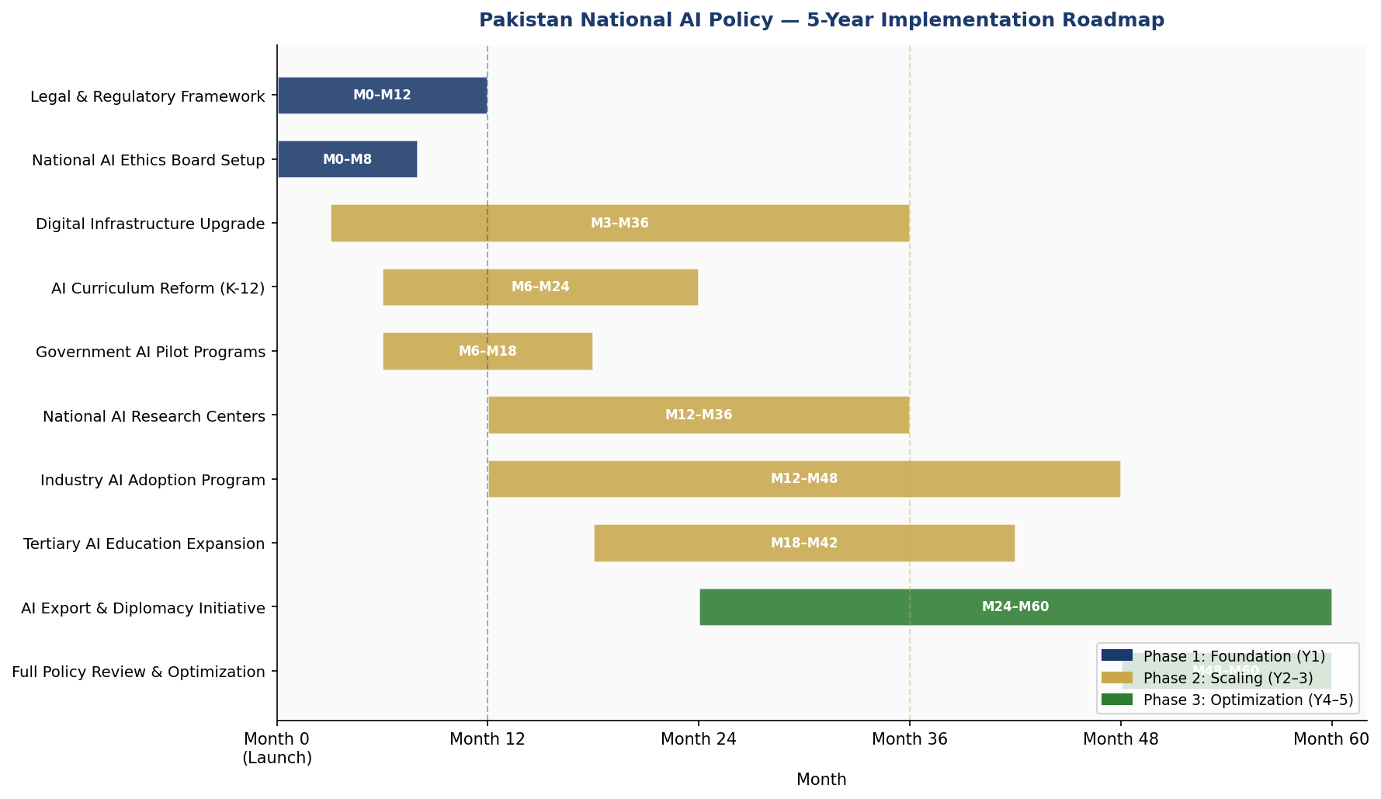
Figure 6: Pakistan National AI Policy — 5-Year Implementation Roadmap (Gantt Chart)

Section 9: Monitoring, Evaluation & Accountability

9.1 National AI Observatory
A National AI Observatory (NAIO), housed within the Pakistan Institute of Development Economics (PIDE) for institutional independence, will monitor AI adoption, measure policy outcomes, and publish quarterly progress reports. The Observatory will maintain the Pakistan AI Dashboard — a public-facing real-time data portal tracking all KPIs defined in this policy.

9.2 Parliamentary Oversight
A dedicated Parliamentary Standing Committee on AI Governance will be established in the National Assembly and Senate. The committee will receive quarterly briefings from NAEB, NAIO, and MoITT; conduct annual public hearings on AI policy performance; and have authority to call for emergency reviews in cases of significant AI-related harm or ethical violations. The committee's proceedings will be publicly live-streamed and transcripts published within 72 hours.

9.3 KPI Dashboard
Table 3: National AI Policy KPI Dashboard — Pakistan 2026–2031
KPI Metric | Baseline  (2025) | Year 1  (2026) | Year 3  (2028) | Year 5  (2030)
AI Readiness Index Score | 30/100 | 38/100 | 52/100 | 65/100
AI PhD/MSc Graduates Annually | ~500 | 2,000 | 8,000 | 20,000
Public Sector AI Use Cases | 3 | 15 | 45 | 80
National AI Ethics Board Rulings | N/A | 12 | 40+ | 100+
AI Startup Ecosystem (active firms) | ~200 | 600 | 2,500 | 6,000
Women in AI Workforce (%) | ~12% | 18% | 28% | 38%
AI Contribution to GDP (%) | <0.5% | 1.2% | 3.8% | 9.5%
Government Data Portals (open) | 8 | 30 | 80 | 200+
Internet Penetration (%) | 36% | 45% | 58% | 70%
Annual National AI Audit Reports | 0 | 1 | 3 | 5
Source: Baseline data from Oxford Insights, TI, World Bank, HEC, NITB. Targets set by MoITT in consultation with line ministries.

9.4 Civil Society & Independent Audit
Civil society organizations play an irreplaceable role in ensuring AI governance accountability. This policy mandates that at least 15% of the National AI Ethics Board consists of civil society representatives, and that an annual Independent AI Audit — conducted by organizations with no government funding — be published and presented to Parliament. A Pakistan AI Civil Society Forum will be formally recognized and provided with secretariat support (non-monetary) by MoITT.

Section 10: International Cooperation & Diplomacy

10.1 Bilateral AI Cooperation Priorities
Pakistan will pursue structured AI cooperation agreements with: China (BRI digital component, AI joint research); Saudi Arabia and UAE (Gulf digital economy integration, AI talent exchange); United Kingdom (Alan Turing Institute partnership, FCDO AI development funding); United States (USAID digital development initiatives, university partnerships); and Germany (GIZ digital transformation support, Industry 4.0 collaboration).
Each bilateral agreement will include four standard components: research and innovation exchange; AI talent mobility; AI ethics and governance knowledge sharing; and commercial AI market access reciprocity.

10.2 Regional AI Governance — SAARC
Pakistan will champion the establishment of a SAARC AI Governance Dialogue, building on the 2024 SAARC Digital Connectivity Framework. A regional approach to AI ethics standards, cross-border data flows, and shared AI research infrastructure can yield significant cost efficiencies for all South Asian nations, particularly in agriculture, health, and disaster risk reduction — sectors where AI applications have transboundary relevance.

10.3 Global AI Governance Participation
Pakistan commits to active participation in: the Global Partnership on AI (GPAI) — membership application Year 1; UN Secretary-General's High-Level Advisory Body on AI; ITU AI for Good Global Summit; UNESCO AI Ethics implementation review process; and G20 AI dialogue as a partner nation. Pakistan will seek a seat on the GPAI Steering Committee within the five-year policy horizon.

10.4 South-South Knowledge Transfer
Pakistan has much to learn from — and contribute to — peer developing countries navigating AI adoption. Priority South-South partnerships include Rwanda (governance innovation), India (AI research scale, pending bilateral relations normalization), Kenya (mobile AI deployment), Indonesia (AI education at scale), and Bangladesh (AI in financial inclusion and RMG sector). Pakistan will host a biennial South Asian AI Development Forum starting in 2027.

Conclusion

Pakistan's National AI Policy 2026–2031 is both an aspiration and a commitment — a detailed blueprint for transforming the country's significant AI potential into tangible prosperity, equity, and global competitiveness. The policy does not pretend that Pakistan's challenges — fiscal constraints, infrastructure gaps, institutional capacity limitations, and corruption risks — are trivial. They are real, and they are acknowledged throughout this document.
But equally real are Pakistan's assets: a youthful and growing population hungry for opportunity; a substantial and globally distributed diaspora with AI talent and capital; an agricultural base ripe for productivity enhancement; and a political and civil society increasingly attuned to the urgency of digital transformation. AI, deployed wisely and ethically, can be the accelerant that turns these assets into achievement.
The policy's success will be measured not in strategy documents or institutional launches, but in concrete outcomes: farmers with better yields; children with world-class AI education; citizens accessing transparent, responsive government services; entrepreneurs building AI companies from Karachi to Gilgit; and a Pakistan that speaks with authority at the tables where global AI governance is shaped.
This policy provides the framework. Implementation requires sustained political will, adequate resourcing, genuine multi-stakeholder collaboration, and the courage to be held accountable. Pakistan is ready.

References & Bibliography

1. UNESCO. (2021). Recommendation on the Ethics of Artificial Intelligence. United Nations Educational, Scientific and Cultural Organization, Paris.
2. OECD. (2024). OECD AI Principles (Updated). Organisation for Economic Cooperation and Development, Paris.
3. European Parliament. (2024). EU Artificial Intelligence Act. Official Journal of the European Union.
4. World Bank. (2023). World Development Report 2023: Migrants, Refugees, and Societies. World Bank Group, Washington DC.
5. Oxford Insights. (2023). Government AI Readiness Index 2023. Oxford Insights, Oxford.
6. Transparency International. (2023). Corruption Perceptions Index 2023. Transparency International, Berlin.
7. McKinsey Global Institute. (2023). The Economic Potential of Generative AI. McKinsey & Company.
8. World Economic Forum. (2023). Future of Jobs Report 2023. World Economic Forum, Geneva.
9. Government of Pakistan, Ministry of IT & Telecommunication. (2023). Pakistan Digital Policy Framework 2023–2030. MoITT, Islamabad.
10. State Bank of Pakistan. (2024). National Financial Inclusion Strategy 2024–2028. SBP, Karachi.
11. Higher Education Commission Pakistan. (2024). HEC Digital Pakistan Initiative. HEC, Islamabad.
12. ITU. (2023). Global ICT Regulatory Outlook 2023. International Telecommunication Union, Geneva.
13. GPAI. (2023). Responsible AI Principles. Global Partnership on Artificial Intelligence.
14. Pakistan Bureau of Statistics. (2024). Pakistan Economic Survey 2023-24. PBS, Islamabad.
15. World Bank. (2024). Pakistan Development Update April 2024. World Bank Group.

About the Author

Nafiul Ahmad Rafi
Policy & Good Governance Researcher | BD Civic Tech Architect

Nafiul Ahmad Rafi is a civic technologist, policy researcher, author, photographer, and musician based in Dhaka, Bangladesh. He is the Founder and Director of Insights Bangladesh, a data-driven governance and policy impact analysis institution, and the Founder & Lead Architect of NagorikBD.org — a transparency-first civic platform scaled across Mymensingh Division, connecting citizens with government services across 45 Upazilas.
His work exists at the intersection of institutional reform and artificial intelligence, transforming theoretical governance into scalable, data-driven reality. Without a conventional computer science degree, he self-taught the tools of modern AI and web development to build the infrastructure that enforces the policies he once only researched.

Key Platforms & Projects:
- NagorikBD.org — Civic transparency platform, Mymensingh Division
- Insights Bangladesh — Policy impact analysis institution
- FactCheck BD (factcheckbd.org) — Bangladesh's AI-powered fact-checking platform
- Political Insights BD / PIBD (pibbd.org) — Political intelligence and civic tech hub
- PeaceShield BD / National Peace Tracker — AI-powered hate speech and conflict monitoring
- PolicyLens AI (aigovbd.org) — 9-dimensional AI policy audit tool

He has published four books and maintains a personal site at ahmad-rafi.com.

Research Interests: AI Governance · Policy Research · Future of Bangladesh · Climate Policy

Contact:
🌐 ahmad-rafi.com
🔗 linkedin.com/in/nafiul-ahmad-rafi
✉️ contact@ahmad-rafi.com

"I build code to ensure transparency, and I write lyrics to inspire the courage to use it."

