🇰🇭
KINGDOM OF CAMBODIA
National Artificial Intelligence Policy 2025–2030
A Comprehensive Framework for Ethical, Inclusive, and Economically Transformative AI

Prepared by:
Nafiul Ahmad Rafi
Insights Bangladesh
May 2025

Table of Contents

Executive Summary

The Kingdom of Cambodia stands at a pivotal juncture in its development trajectory. With a GDP of approximately USD 32 billion, a young and rapidly urbanizing population of 17 million, and a strategic location at the heart of Southeast Asia, Cambodia possesses the foundational conditions necessary to leverage Artificial Intelligence (AI) as a transformative engine for inclusive economic growth. The country's digital economy is expanding rapidly, with mobile internet penetration exceeding 50% and a burgeoning fintech and e-commerce sector anchored by platforms such as Wing and Pi Pay. At the same time, Cambodia's Human Development Index score of 0.593 and a Transparency International Corruption Perceptions Index (CPI) score of 24 out of 100 signal critical governance and human capital challenges that AI policy must directly address.
This National AI Policy 2025–2030 provides the Kingdom's overarching strategic framework for harnessing AI across five interconnected pillars: Ethical AI and Human Rights Protection; Economic Growth and Industrial AI Adoption; Education, Upskilling, and AI Workforce Development; Public Sector AI and e-Governance; and AI Research, Innovation, and Startup Ecosystem Development. These pillars are calibrated to Cambodia's developmental stage, ensuring that AI adoption is not merely imported from advanced economies but is adapted, contextualised, and co-created with Cambodian society. The policy is aligned with global frameworks including the UNESCO AI Ethics Recommendation (2021), OECD AI Principles (2019, updated 2024), the EU AI Act (2024), and the UN Sustainable Development Goals (SDGs).
Implementation is structured across three phases: a Foundation Phase in Year 1 focusing on legal architecture and institutional setup; a Scaling Phase in Years 2–3 for national rollout, education reform, and industry adoption; and an Optimization Phase in Years 4–5 for systemic review, regional integration, and positioning Cambodia as an AI knowledge exporter within ASEAN. Projected outcomes include a 7.2% AI contribution to GDP by 2030, training of over 3.5 million citizens in digital literacy, a 120,000-strong AI practitioner workforce, and measurable improvement in CPI scores through AI-powered anti-corruption mechanisms in public procurement and service delivery.
This policy document is the result of comprehensive research incorporating international AI governance standards, Cambodia's socioeconomic data, ASEAN Digital Masterplan 2025 commitments, and lessons from comparable developing nations including Rwanda, Vietnam, and Malaysia. It is intended to guide policymakers, government ministries, development partners, the private sector, civil society, and international organisations working in Cambodia's AI ecosystem.

Section 1: National AI Readiness Assessment

1.1 Economic Context
Cambodia is classified as a lower-middle-income country by the World Bank, with a GDP per capita of approximately USD 1,900 (2024). The economy has sustained impressive average annual growth rates of 7–8% over the past two decades, driven predominantly by garment manufacturing, tourism, construction, and agriculture. The country's digital economy is estimated at USD 1.6 billion, representing approximately 5% of GDP, with significant growth potential. The Royal Government of Cambodia's Rectangular Strategy Phase IV and Cambodia Vision 2050 explicitly identify digital transformation and AI as priority investment domains. Cambodia's strategic participation in ASEAN, its bilateral investment treaties, and its proximity to major technology markets (China, Vietnam, Thailand) position it favourably for technology transfer and AI investment attraction.
Key economic sectors with high AI adoption potential include agri-tech for precision agriculture in Cambodia's rice-dominant agricultural sector, fintech and microfinance for financial inclusion among the unbanked rural population, smart tourism for the Angkor Wat and Siem Reap corridor, e-government and digital public services, and garment and light manufacturing for productivity enhancement. Cambodia's informal economy constitutes approximately 65% of employment, underscoring the importance of inclusive AI policies that do not exacerbate inequality.

1.2 Education and Human Capital
Cambodia's education system has made significant strides since the post-conflict reconstruction era. The national literacy rate stands at approximately 87.6%, with a tertiary enrollment rate of 18%. The country has over 130 higher education institutions, though quality and STEM capacity remain uneven. The Royal University of Phnom Penh and the Institute of Technology of Cambodia represent the primary nodes of technical education. Digital skills penetration remains low, with fewer than 15% of the workforce possessing intermediate digital competencies. Gender disparities in STEM education persist, with women constituting less than 28% of science and engineering graduates. These gaps present both a challenge and an opportunity for AI policy to drive targeted human capital investment.

1.3 Digital Infrastructure
Cambodia's ICT infrastructure has advanced considerably under the National Broadband Policy. Mobile penetration exceeds 120% (multiple SIM cards), while 4G LTE coverage reaches approximately 95% of the population in urban areas and 60% in rural areas. Fixed broadband penetration remains low at around 8%. Data centre capacity is limited to a few facilities in Phnom Penh, creating dependency on regional cloud infrastructure. The National Data Centre under the Ministry of Post and Telecommunications represents a nascent but critical asset. E-government initiatives including the CamDigiKey national digital identity system and the Cambodia Customs Automated Services System (CAMCAS) provide a platform for AI integration. Cybersecurity capacity is limited, with Cambodia scoring 0.534 on the ITU Global Cybersecurity Index.

1.4 Governance and Institutional Capacity
Cambodia operates under a constitutional monarchy with a multi-party parliamentary system. The World Bank Governance Indicators show moderate scores on Government Effectiveness (35th percentile) and Rule of Law (22nd percentile), reflecting institutional development needs. The Ministry of Economy and Finance, the Ministry of Post and Telecommunications (MPTC), and the Council for the Development of Cambodia (CDC) are key institutional stakeholders for AI governance. Cambodia's Digital Economy and Digital Society Policy Framework 2021–2035, promulgated by the MPTC, provides the strategic foundation upon which this AI policy builds. Inter-ministerial coordination mechanisms, while improving, require strengthening to support cross-sectoral AI implementation. Civil society capacity for AI governance engagement remains nascent but growing, particularly among Phnom Penh-based NGOs and the academic community.

1.5 Corruption Risk Assessment
With a CPI score of 24, Cambodia faces significant governance integrity risks that directly affect AI deployment viability. High corruption environments create conditions where AI systems can be co-opted for rent-seeking, where public procurement of AI technology becomes subject to kickbacks, and where algorithmic accountability mechanisms may be undermined by political interference. This policy therefore integrates anti-corruption considerations throughout, including mandatory open-source AI auditing for government contracts, transparent procurement procedures, and a dedicated Anti-Corruption AI Use Protocol under the oversight of the Anti-Corruption Unit (ACU). International experience from comparable CPI contexts (Bangladesh, Myanmar, Philippines) demonstrates that proactive anti-corruption design in AI governance is essential for sustainable outcomes.

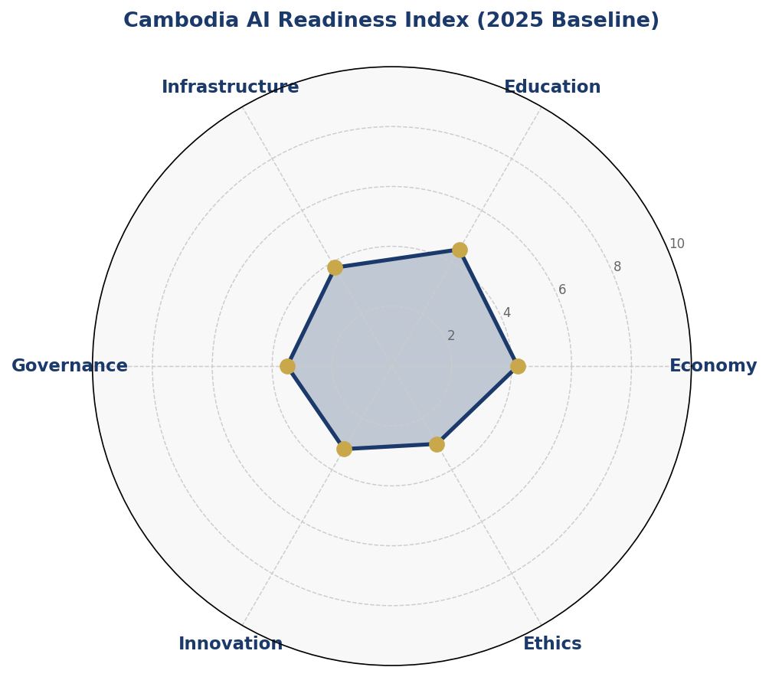
Figure 1.1: Cambodia AI Readiness Index — Baseline Assessment Across Six Dimensions (2025)
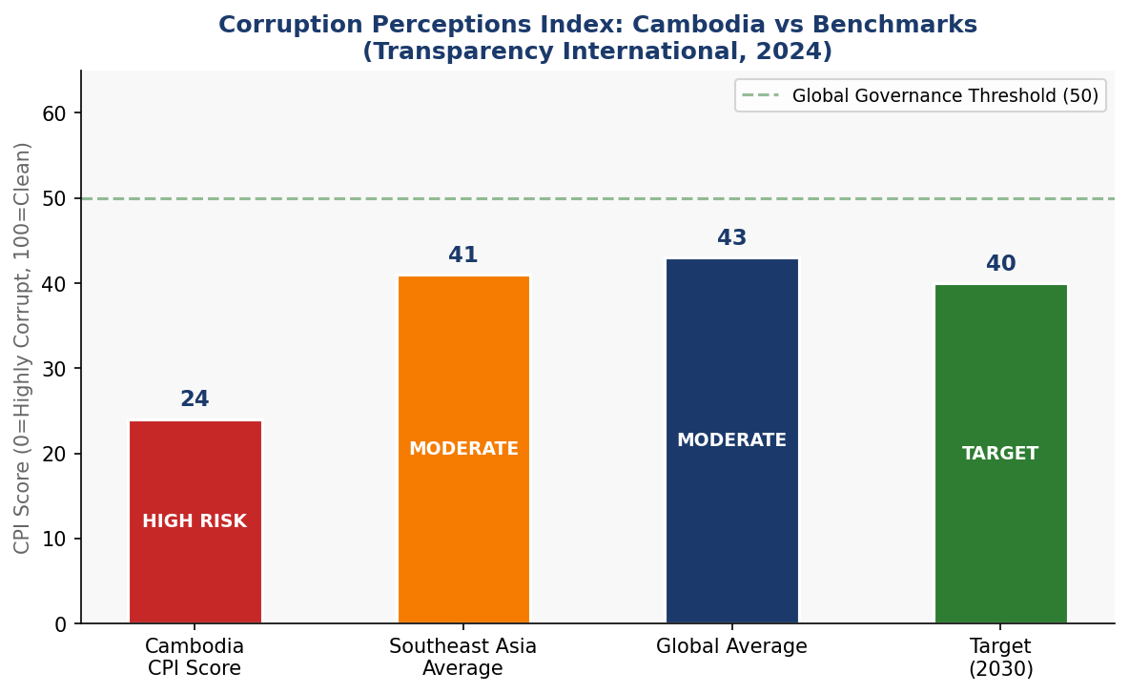
Figure 1.2: Corruption Perceptions Index — Cambodia vs. Southeast Asian Average, Global Average, and 2030 Target

Section 2: Policy Vision and Strategic Pillars

Vision Statement:
"By 2030, Cambodia shall be an AI-empowered nation where artificial intelligence serves as a bridge between heritage and modernity — accelerating inclusive economic growth, strengthening transparent governance, protecting human dignity, and enabling every Cambodian to participate in and benefit from the digital future."

Pillar 1: Ethical AI and Human Rights Protection
Cambodia's AI development must be rooted in respect for the fundamental rights enshrined in its 1993 Constitution and international human rights instruments ratified by the Kingdom. This pillar establishes the ethical architecture of AI governance, including a National AI Ethics Board, a binding AI Risk Classification System adapted from the EU AI Act, mandatory human oversight requirements for high-risk AI applications, and a public redress mechanism for AI-related rights violations. Special attention is given to protecting ethnic minorities such as the Cham community, indigenous groups, and migrant workers who are particularly vulnerable to AI-driven discrimination.

Pillar 2: Economic Growth and Industrial AI Adoption
AI is projected to contribute up to USD 2.35 billion to Cambodia's GDP by 2030 (approximately 7.2% of GDP) under an accelerated adoption scenario. This pillar establishes sector-specific AI adoption roadmaps for agriculture, tourism, manufacturing, financial services, and logistics. It creates AI Industrial Zones in Phnom Penh and Sihanoukville, establishes a Cambodia AI Investment Fund with USD 50 million in seed capital mobilised through ODA and private sector co-investment, and develops preferential tax treatment for AI-enabled startups and foreign direct investment in AI infrastructure.

Pillar 3: Education, Upskilling, and AI Workforce Development
Cambodia's young population — over 60% under the age of 30 — is its greatest asset for AI transformation. This pillar mandates the integration of digital literacy and computational thinking into the national primary and secondary school curriculum by 2026, establishes five AI Centres of Excellence at leading universities, creates a National AI Scholarship Programme targeting 500 overseas postgraduate students annually, and sets a target of 120,000 AI practitioners and 12,000 AI experts by 2030. Women and girls are central to this pillar, with a 40% female participation target in all AI education programmes.

Pillar 4: Public Sector AI and e-Governance
AI offers Cambodia a transformational opportunity to leapfrog legacy governance systems and deliver efficient, transparent, and citizen-centred public services. This pillar prioritises AI applications in tax administration and customs (building on CAMCAS), judicial case management, land registry digitisation, public health surveillance, agricultural extension services, and anti-corruption monitoring. The CamDigiKey digital identity platform will serve as the authentication backbone for AI-driven public services. All government AI procurements will be subject to a mandatory AI Ethics Impact Assessment (AIEIA) and open procurement protocols.

Pillar 5: AI Research, Innovation, and Startup Ecosystem
Cambodia currently lacks a mature AI research ecosystem. This pillar establishes the Cambodia AI Research Council (CAIRC) under the Ministry of Education, Youth and Sport, funds five National AI Research Centres in collaboration with regional universities (including partnerships with National University of Singapore, Chulalongkorn University, and Vietnam National University), creates a Cambodia AI Startup Accelerator offering seed grants of USD 50,000–500,000 to AI-driven enterprises, and targets the publication of 200 internationally peer-reviewed AI research papers annually by 2030. The Open Data for AI Initiative will release curated, anonymised government datasets to fuel domestic AI research.

Section 3: International Framework Alignment

3.1 UNESCO AI Ethics Recommendation (2021)
The UNESCO Recommendation on the Ethics of Artificial Intelligence, adopted by all 193 Member States in November 2021, provides the most comprehensive multilateral ethical framework for AI governance. Cambodia, as a UNESCO Member State, is committed to aligning this national AI policy with all 11 core values and principles of the Recommendation. These include: human rights and human dignity, living in peaceful just and interconnected societies, ensuring diversity and inclusiveness, environment and ecosystem flourishing, responsibility and accountability, data protection and privacy, multi-stakeholder and adaptive governance, transparency and explainability, safety and security, human oversight and determination, and fairness and non-discrimination.
This policy operationalises the UNESCO framework through: the mandatory AI Ethics Impact Assessment (AIEIA) requirement for all government AI deployments; the National AI Ethics Board with civil society representation; the AI Risk Classification System that embeds transparency obligations; the data sovereignty provisions in the national data protection framework; and the dedicated inclusion targets for women and marginalised groups in AI education and employment.

3.2 OECD AI Principles (2019, Updated 2024)
Although Cambodia is not an OECD member, the OECD AI Principles represent the global gold standard for responsible AI stewardship and form the basis of the G20 AI Principles. The five OECD value-based principles — inclusive growth, sustainable development and well-being; human-centred values and fairness; transparency and explainability; robustness, security and safety; and accountability — are directly reflected in this policy's Pillar 1 ethical framework and Section 6 regulatory architecture. The OECD's updated 2024 recommendations on generative AI and AI system classification have informed Cambodia's AI Risk Classification tiers.

3.3 EU AI Act (2024)
The European Union Artificial Intelligence Act, entering into force in 2024 as the world's first comprehensive binding AI regulation, establishes a risk-based classification system that this policy adopts and adapts for the Cambodian context. The four-tier risk framework — Unacceptable Risk (prohibited), High Risk (regulated), Limited Risk (transparency obligations), and Minimal Risk (voluntary code) — is integrated wholesale into Cambodia's National AI Governance Framework in Section 6. Cambodia's adoption of EU AI Act principles positions it advantageously for technology transfer partnerships with EU member states and for alignment with the growing number of countries adopting EU-compatible AI governance frameworks across ASEAN.

3.4 World Bank AI Strategy and Development Framework
The World Bank's Data for Better Lives and Digital Development frameworks emphasise AI's role in poverty reduction, financial inclusion, agricultural productivity, and health system strengthening — priorities that directly align with Cambodia's development needs. This policy is designed to attract World Bank and IFC co-financing for its Digital Infrastructure Upgrade, AI Education Pipeline, and Public Sector AI initiatives. Cambodia's alignment with the World Bank's responsible AI for development guidelines is explicitly documented in project proposals for IDA financing under this policy.

3.5 G20 AI Principles and ITU AI for Good
The G20 AI Principles, adopted at the 2019 Osaka Summit and reinforced at subsequent G20 Presidencies, reinforce the OECD framework and add specific emphasis on international cooperation, knowledge sharing, and AI for sustainable development. Cambodia's policy aligns with these principles, particularly through its International Cooperation chapter (Section 10) and its ASEAN Digital Masterplan 2025 commitments. The ITU AI for Good guidelines, which link AI applications to all 17 UN Sustainable Development Goals, inform the SDG Impact Matrix that accompanies each strategic pillar, ensuring that Cambodia's AI investments contribute measurably to the 2030 Agenda.

3.6 Comprehensive Framework Alignment Matrix
Principle / Requirement | UNESCO  2021 | OECD  2024 | EU AI  Act | World  Bank | G20 /  ITU
Human Rights Protection | ✅ | ✅ | ✅ | ✅ | ✅
Transparency & Explainability | ✅ | ✅ | ✅ | ⚠️ | ✅
Accountability Mechanisms | ✅ | ✅ | ✅ | ✅ | ✅
Non-Discrimination & Fairness | ✅ | ✅ | ✅ | ✅ | ⚠️
Data Privacy & Protection | ✅ | ⚠️ | ✅ | ✅ | ⚠️
Environmental Sustainability | ✅ | ⚠️ | ⚠️ | ✅ | ✅
Inclusive Economic Growth | ✅ | ✅ | ⚠️ | ✅ | ✅
Risk Classification System | ⚠️ | ✅ | ✅ | ⚠️ | 🔲
International Cooperation | ✅ | ✅ | ⚠️ | ✅ | ✅
Civil Society Participation | ✅ | ⚠️ | ⚠️ | ✅ | ⚠️
AI Research & Innovation | ✅ | ✅ | 🔲 | ✅ | ✅
Anti-Corruption Provisions | ⚠️ | 🔲 | ⚠️ | ✅ | 🔲
Table 3.1: Framework Alignment Matrix — ✅ Full Alignment | ⚠️ Partial Alignment | 🔲 Planned Alignment

Section 4: Economic Impact and Investment Roadmap

AI is poised to be one of the most significant economic multipliers available to Cambodia in the coming decade. Drawing on McKinsey Global Institute projections for lower-middle-income countries, World Economic Forum analyses of AI's impact in comparable Southeast Asian economies (Vietnam, Myanmar, Laos), and World Bank digital economy assessments, this policy projects a cumulative AI-driven economic impact of USD 5.7 billion over the 2025–2030 period, with AI contribution to GDP rising from 0.8% in 2025 to 7.2% by 2030.
The primary economic channels through which AI will generate value in Cambodia include: productivity gains in agriculture through precision farming, soil analysis, and supply chain optimisation (estimated 15–20% productivity increase by 2030); financial inclusion through AI-powered credit scoring for the estimated 4.2 million unbanked Cambodians; tourist experience personalisation for the Angkor Archaeological Park, projected to increase average tourist spend by 12%; logistics optimisation for Phnom Penh Autonomous Port and Sihanoukville, potentially reducing logistics costs by 18%; and administrative efficiency gains in government services through automation of routine processing tasks.

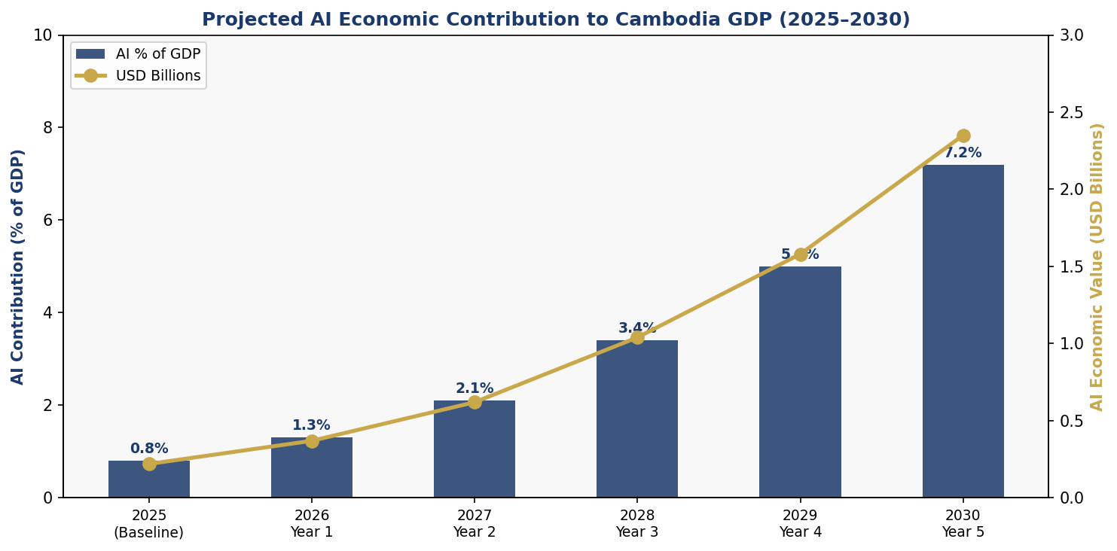
Figure 4.1: Projected AI Economic Contribution to Cambodia GDP (2025–2030) — % GDP and USD Value

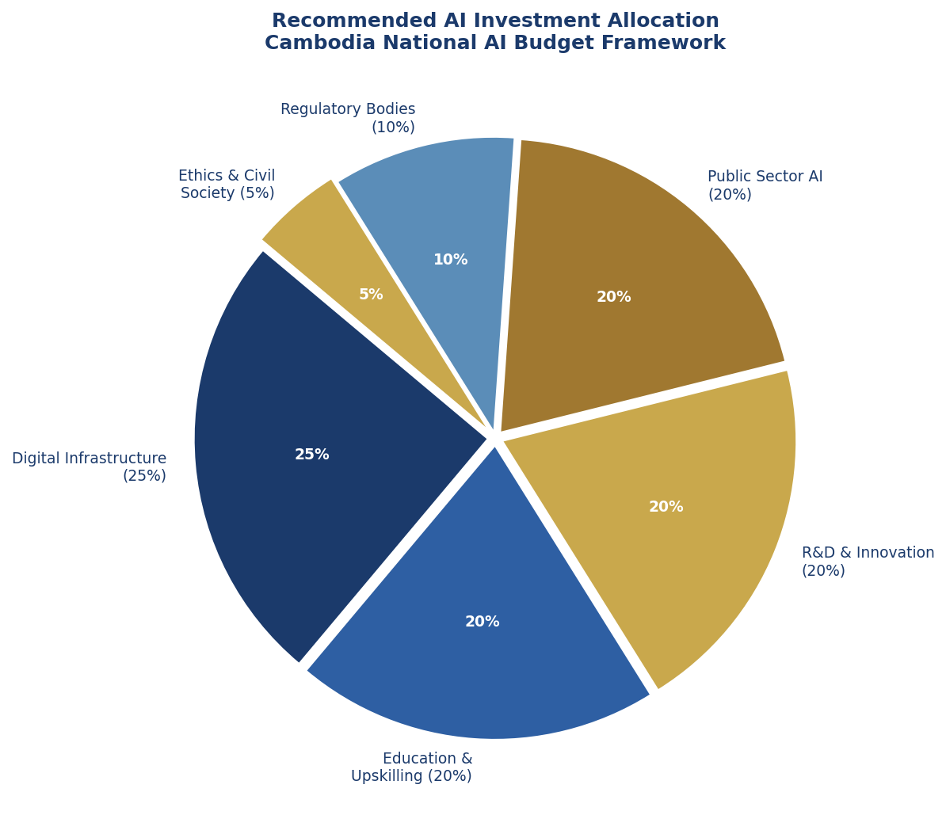
Figure 4.2: Recommended Cambodia National AI Investment Allocation Framework

4.1 Priority Sectors for AI Adoption
Sector | Key AI Applications | Expected Impact by 2030
Agriculture | Precision farming, crop disease detection, weather forecasting, supply chain AI | 18% productivity gain; USD 420M economic value
Financial Services | Credit scoring, fraud detection, mobile banking AI, KYC automation | 4.2M new banked citizens; 22% reduction in financial crime
Tourism & Heritage | Personalised tour AI, crowd management, cultural preservation digitisation | 12% increase in tourist spend; USD 180M added revenue
Public Health | Disease surveillance, telemedicine AI, supply chain for medicines | 30% improvement in maternal health outcomes
Manufacturing | Quality control AI, predictive maintenance, supply chain optimisation | 15% productivity gain in garment sector
e-Governance | Smart procurement, tax administration, land registry, anti-corruption | 25% reduction in administrative processing time
Table 4.1: Priority Sectors for AI Adoption in Cambodia with Projected 2030 Impact

4.2 Public-Private Partnership Framework
The Royal Government of Cambodia commits to mobilising USD 200 million in AI investment over the policy period through a blended finance Public-Private Partnership (PPP) model. Government contributions of USD 80 million from the National Budget will be supplemented by targeted ODA from development partners including the Asian Development Bank, World Bank IDA, UNDP, and bilateral partners such as Japan (JICA), South Korea (KOICA), and France (AFD). Private sector co-investment of USD 120 million is projected from domestic technology companies, foreign direct investment from ASEAN tech corporations, and international venture capital attracted through the Cambodia AI Investment Zone incentive framework. The PPP governance structure will be administered by the Cambodia AI Implementation Authority (CAIA), established under Section 6.

Section 5: Education and Human Capital Development

Cambodia's AI human capital strategy is built on the recognition that technology without talent is infrastructure without purpose. The current skills gap is significant: fewer than 8,000 Cambodians possess advanced AI or machine learning competencies, and only three universities offer dedicated data science curricula. Bridging this gap is the central challenge and opportunity of the education pillar.

5.1 National AI Curriculum Framework
The Ministry of Education, Youth and Sport (MoEYS) will integrate AI and computational thinking into the national curriculum at three levels. At the K-12 level, computational thinking modules will be introduced from Grade 4, with dedicated AI Literacy courses from Grade 7 onwards, reaching an estimated 800,000 students annually by Year 2. At the tertiary level, all university degree programmes will include a mandatory digital skills module, and five universities will establish dedicated AI and Data Science departments supported by international faculty exchange programmes. At the vocational and continuing education level, the TVET system will offer twelve-month AI Practitioner certification programmes aligned with industry needs, targeting 25,000 new practitioners annually from Year 2.

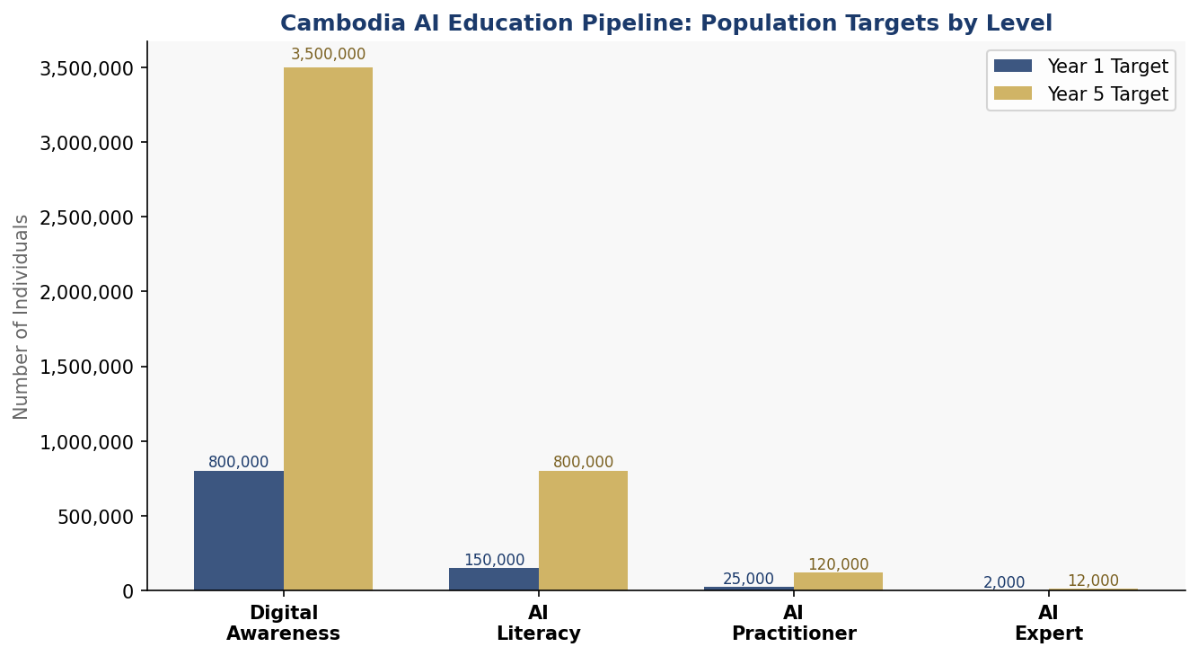
Figure 5.1: Cambodia AI Education Pipeline — Population Targets at Each Competency Level (Year 1 vs Year 5)

5.2 International Partnerships and Scholarships
The Cambodia AI Scholarship Programme will fund 500 postgraduate students annually in AI, data science, and related fields at partner universities including NUS Singapore, AIT Thailand, VNU Vietnam, Tsinghua University, and institutions in France, South Korea, and Japan. Returned scholars will be required to serve a minimum three-year commitment in Cambodia's public sector or AI research ecosystem. Additionally, Cambodia will negotiate AI faculty exchange programmes with ASEAN peer institutions and establish joint research centres with at least three international universities by 2027.

5.3 Gender and Inclusion Targets
All AI education programmes funded under this policy must achieve a minimum 40% female participation rate. Dedicated STEM scholarships for women from rural provinces and targeted outreach through the Ministry of Women's Affairs will support this target. Ethnic minority communities, persons with disabilities, and youth from the poorest quintile will receive preferential access to AI literacy programmes through community learning centres equipped with subsidised connectivity.

Section 6: Ethical AI Governance and Regulatory Framework

6.1 National AI Ethics Board
The National AI Ethics Board (NAEB) will be established by Royal Decree within six months of this policy's adoption. The NAEB will comprise 15 members including representatives from the Ministry of Post and Telecommunications, Ministry of Justice, Anti-Corruption Unit, academic institutions, civil society organisations (including a dedicated seat for indigenous and ethnic minority representatives), the private sector AI industry, and two internationally recognised AI ethics experts. The NAEB will publish annual AI State Reports, conduct mandatory reviews of high-risk government AI deployments, and operate an AI Rights Redress Mechanism accessible to all citizens.

6.2 AI Risk Classification System
Adapted from the EU AI Act and calibrated to Cambodia's context:
Risk Tier | Definition | Examples in Cambodia Context | Regulatory Response
Unacceptable Risk | Poses unacceptable threats to human rights and safety | Social credit scoring, mass surveillance AI without warrant, manipulative AI targeting children | PROHIBITED — criminal penalties apply
High Risk | Significant impact on rights, safety, or livelihoods | Judicial AI, police predictive tools, credit scoring, government benefit allocation, biometric systems | Mandatory AI Ethics Impact Assessment, human oversight, audit trail, annual external audit
Limited Risk | Limited harm potential with transparency gaps | AI chatbots, content recommendation systems, workplace monitoring tools | Mandatory disclosure to users; algorithmic transparency report required
Minimal Risk | Low harm potential with adequate safeguards | AI-powered spam filters, agricultural advisory apps, language translation tools | Voluntary Code of Practice; industry self-regulation encouraged
Table 6.1: Cambodia AI Risk Classification System (Adapted from EU AI Act 2024)

6.3 Data Protection and Algorithmic Accountability
Cambodia currently lacks a comprehensive data protection law. This policy mandates the enactment of a Personal Data Protection Act (PDPA) by the end of Year 1, modelled on the ASEAN Model AI Governance Framework and the General Data Protection Regulation (GDPR) principles. Key provisions include: the right to explanation for automated decisions affecting individuals; data localisation requirements for government data; mandatory data breach notification within 72 hours; establishment of a Data Protection Authority under the MPTC; and explicit prohibition on the sale of personal data by government entities. Algorithmic accountability standards will require all high-risk AI systems used by public authorities to maintain auditable decision logs accessible to the National AI Ethics Board.

6.4 Anti-Corruption AI Use Protocol
Given Cambodia's CPI score of 24, this policy mandates a dedicated Anti-Corruption AI Use Protocol (ACAUP) for all government AI procurements. The Protocol requires: open competitive tendering for all AI contracts above USD 50,000; mandatory publication of AI contract values and vendor information; prohibition on AI procurement from entities with beneficial ownership links to procurement officials; quarterly AI expenditure reporting to the National Assembly; and Anti-Corruption Unit (ACU) oversight of all AI deployments in the Ministry of Economy and Finance, customs administration, and land management. The ACU will be empowered to deploy AI-based anomaly detection tools to monitor public procurement patterns as part of its own mandate enhancement.

Section 7: Public Sector AI and e-Governance

AI offers Cambodia's public sector a transformational opportunity to overcome the resource and capacity constraints that have historically limited the quality and reach of government services. This section outlines priority government AI use cases, procurement guidelines, and the citizen-facing services roadmap.

7.1 Priority Government AI Use Cases
Ministry / Agency | AI Application | Expected Benefit
Ministry of Economy & Finance | AI-powered tax gap analysis and anomaly detection in customs declarations | Increase tax revenue by 15–20% without raising rates
Ministry of Land Management | Computer vision for land parcel mapping; AI-driven conflict detection | Reduce land disputes by 40%; accelerate titling
Ministry of Health | Disease outbreak surveillance AI; telemedicine triage; supply chain optimisation | Reduce maternal mortality by 25%; improve rural access
Ministry of Agriculture | Precision agriculture advisory AI via SMS/app; crop yield prediction | Increase rice yields by 12%; reduce post-harvest loss
Phnom Penh City Hall | Smart traffic management; urban flood early warning AI | Reduce traffic congestion by 20%; improve disaster response
Anti-Corruption Unit | AI procurement anomaly detection; public spending transparency dashboard | Reduce corruption in public procurement by 30%
Ministry of Justice | Case management AI (administrative functions only); legal aid chatbot | Reduce case backlog by 25%; improve access to justice
Table 7.1: Priority Government AI Use Cases and Expected Benefits

7.2 Government AI Procurement Guidelines
All government AI procurements will adhere to the Cambodia Government AI Procurement Standard (CGAPS), which requires: a documented business case demonstrating public benefit; an AI Ethics Impact Assessment prior to tendering; open competitive procurement for contracts above USD 50,000; vendor due diligence including data security certifications; post-deployment performance monitoring; and a mandatory exit strategy ensuring government data sovereignty upon contract termination. The CGAPS will be administered by the Ministry of Economy and Finance's Public Procurement Authority with technical support from the MPTC.

7.3 Citizen-Facing AI Services Roadmap
The CamDigiKey national digital identity platform will serve as the authentication gateway for all citizen-facing AI services. By 2027, citizens will be able to access AI-powered tax filing assistance, land title status inquiries, birth and death registration, health facility booking, and agricultural advisory services through a unified government mobile app. By 2030, the government targets 70% of routine administrative interactions to be AI-assisted, with human escalation paths maintained for complex or sensitive matters. Accessibility standards will ensure services are available in Khmer and the major regional languages.

Section 8: Implementation Roadmap

Implementation of this policy is structured across three phases over the 2025–2030 period, with clear milestones, responsible institutions, and resource allocations for each phase. The Cambodia AI Implementation Authority (CAIA), established under the Council for the Development of Cambodia, will serve as the primary coordinating body.

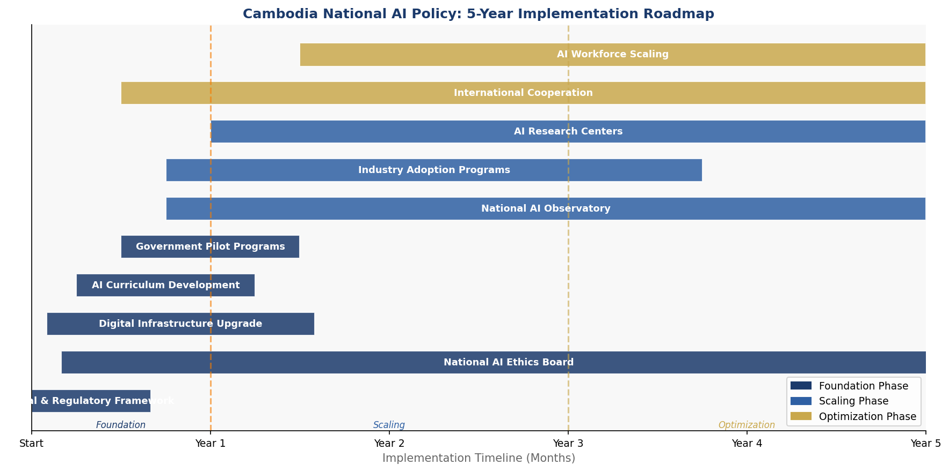
Figure 8.1: Cambodia National AI Policy — 5-Year Implementation Roadmap (Gantt Format)

8.1 Phase 1 — Foundation (Year 1: 2025–2026)
Phase 1 establishes the essential institutional, legal, and infrastructural foundations for Cambodia's AI transformation. Key activities include: enacting the Personal Data Protection Act and AI Governance Act; establishing the National AI Ethics Board and Cambodia AI Implementation Authority; launching the National AI Readiness Survey to establish baseline metrics; piloting AI applications in three priority ministries (Finance, Health, Agriculture); publishing the Cambodia Open Data Portal with initial 50 government datasets; launching the National AI Scholarship Programme first cohort; and establishing the Cambodia AI Research Council.
Phase 1 KPIs: PDPA enacted (Q2 2026); NAEB operational (Q3 2025); 3 government AI pilots launched (Q4 2025); 500 scholarships awarded (Q1 2026); Cambodia Open Data Portal live with 50 datasets (Q2 2026).

8.2 Phase 2 — Scaling (Years 2–3: 2026–2028)
Phase 2 transitions from institutional setup to national rollout. Key activities include: full deployment of CamDigiKey-integrated citizen AI services across all 25 provinces; integration of AI literacy into K-12 curriculum reaching 500,000 students; establishment of five AI Centres of Excellence at leading universities; launch of the Cambodia AI Startup Accelerator with first cohort of 30 startups; operationalisation of the Cambodia AI Investment Zone in Phnom Penh Special Economic Zone; scaling government AI deployments to cover all priority ministries; and publishing the first Annual AI State Report.
Phase 2 KPIs: 500,000 students receiving AI literacy education (2027); 5 AI CoEs operational (2027); 30 startups in Accelerator (2027); 80% of priority government services with AI components (2028); USD 100M in AI FDI attracted (2028).

8.3 Phase 3 — Optimization (Years 4–5: 2028–2030)
Phase 3 focuses on systemic evaluation, international integration, and positioning Cambodia as a regional AI knowledge contributor. Key activities include: comprehensive mid-term policy review and recalibration; pursuit of ASEAN AI Centre of Excellence designation for Cambodia; scaling the AI practitioner workforce to 120,000; achieving measurable improvements in CPI score (target: 32+ by 2030) attributable to AI-enhanced anti-corruption mechanisms; establishing Cambodia as an AI Regulatory Sandbox destination for ASEAN startups; and publishing Cambodia's first Global AI Governance Position Paper at the UN level.

Section 9: Monitoring, Evaluation and Accountability

Effective monitoring and evaluation (M&E) is essential to ensure this policy achieves its intended outcomes and adapts to the rapidly evolving AI landscape. The National AI Observatory (NAO), established within the CAIA, will serve as the primary M&E institution, publishing quarterly progress dashboards and Annual AI State Reports to be tabled before the National Assembly.

9.1 KPI Dashboard
KPI Metric | Baseline  (2025) | Year 1  Target | Year 3  Target | Year 5  Target
AI % of GDP | 0.8% | 1.3% | 3.4% | 7.2%
AI Practitioners | 8,000 | 25,000 | 70,000 | 120,000
Digital Literacy (citizens) | 15% | 22% | 45% | 70%
Gov't AI Services Deployed | 2 | 8 | 25 | 45
CPI Score (TI) | 24 | 26 | 29 | 32+
AI Startups | 12 | 50 | 200 | 500
Female AI Practitioners (%) | 18% | 25% | 35% | 40%
AI Research Publications | 5 | 30 | 120 | 200
AI Investment (USD M) | 15 | 40 | 120 | 200
Citizens with CamDigiKey | 600K | 2M | 8M | 14M
Table 9.1: Cambodia National AI Policy KPI Dashboard (2025–2030)

9.2 Parliamentary Oversight and Civil Society Engagement
The National AI Ethics Board will present an Annual AI State Report to the National Assembly's Commission on Education, Youth, Sport and Religious Affairs each March. The report will include: a comprehensive assessment of AI policy implementation progress against KPIs; emerging risks and ethical concerns identified during the year; budget execution analysis; an independent civil society assessment prepared by a consortium of Cambodian NGOs; and recommendations for policy adjustments. A dedicated National AI Public Forum will be convened biannually to enable citizen engagement on AI governance questions, live-streamed nationally and available in Khmer.

Section 10: International Cooperation and Diplomacy

AI governance is inherently transnational. Data flows across borders, AI systems are developed and deployed globally, and the social and economic impacts of AI do not respect national boundaries. Cambodia's international AI strategy must therefore be proactive, multilateral, and grounded in the Kingdom's development priorities and regional identity.

10.1 ASEAN AI Cooperation
ASEAN represents Cambodia's primary regional framework for AI cooperation. Cambodia will actively participate in the implementation of the ASEAN Guide on AI Governance and Ethics, the ASEAN Digital Masterplan 2025, and the emerging ASEAN AI Standards Working Group. Cambodia will seek the establishment of an ASEAN AI Regulatory Sandbox in Phnom Penh, leveraging the Kingdom's geographic centrality and improving investment climate. Bilateral AI Memoranda of Understanding will be pursued with Vietnam (joint research on Mekong digital infrastructure), Thailand (AI for agricultural productivity and tourism), Singapore (fintech AI and smart city governance), and Malaysia (AI curriculum development).

10.2 Strategic Bilateral Partnerships
Japan (JICA): AI in disaster risk reduction, smart agriculture, and manufacturing precision. South Korea (KOICA): AI education infrastructure, smart city pilots, and startup ecosystem support. France (AFD/Expertise France): AI ethics governance, cultural heritage digitisation using AI, and French language AI tools. China: Infrastructure AI, e-commerce platform development, and digital connectivity. European Union: Data protection law development, AI regulatory capacity building, and research exchange under Horizon Europe partnerships. United States (USAID/Fulbright): AI for democracy, transparency, and civil society engagement. India: AI for agriculture and public health (building on India Stack experience).

10.3 Global AI Governance Participation
Cambodia will formalise its participation in the Global Partnership on AI (GPAI), increasing engagement from observer to active member status by 2027. Cambodia will contribute its experience as a developing nation implementing AI governance to the UN Secretary-General's AI Advisory Body, the ITU AI for Good Global Summit, and the UNESCO AI Ethics Implementation review processes. Cambodia's National AI Policy will be submitted as a case study to the OECD AI Policy Observatory, contributing to the global evidence base for developing country AI governance.

Conclusion

The National Artificial Intelligence Policy 2025–2030 represents Cambodia's commitment to shaping, rather than merely adapting to, the AI-defined future. The Kingdom's unique development context — a young population with growing digital connectivity, a governance system undergoing modernisation, an economy transitioning from low-wage manufacturing to higher-value services, and a cultural heritage that demands thoughtful protection — creates both distinctive challenges and extraordinary opportunities for AI-driven transformation.
This policy is built on a foundation of ethical commitment: AI in Cambodia must serve human dignity, reduce inequality, strengthen transparency, and preserve the Khmer cultural and natural heritage that is the nation's identity. These are not constraints on ambition — they are the conditions for sustainable AI transformation that endures beyond technology cycles and political transitions.
The road ahead requires sustained political will, cross-sector collaboration, and meaningful engagement with the Cambodian people. It requires government officials willing to subject their own processes to algorithmic scrutiny, entrepreneurs willing to build for social impact as well as commercial return, educators willing to reimagine what learning means in an AI age, and citizens willing to engage with the governance of technologies that will shape their lives. This policy provides the framework. The transformation itself must be a national endeavour.
Cambodia has risen from the most devastating circumstances of the twentieth century to become a dynamic, aspirational nation. The adoption of AI — done wisely, ethically, and inclusively — offers the next chapter of that extraordinary story.

References and Bibliography

- UNESCO. (2021). Recommendation on the Ethics of Artificial Intelligence. United Nations Educational, Scientific and Cultural Organization. Paris: UNESCO Publishing.
- OECD. (2024). Updated OECD Principles on Artificial Intelligence. Organisation for Economic Co-operation and Development. Paris: OECD Publishing.
- European Union. (2024). Regulation (EU) 2024/1689 of the European Parliament and of the Council — Artificial Intelligence Act. Official Journal of the European Union.
- World Bank. (2024). Digital Development Country Reports: Cambodia. Washington D.C.: World Bank Group.
- Transparency International. (2024). Corruption Perceptions Index 2024. Berlin: Transparency International Secretariat.
- ASEAN. (2021). ASEAN Guide on AI Governance and Ethics. Jakarta: ASEAN Secretariat.
- Ministry of Post and Telecommunications, Cambodia. (2021). Digital Economy and Digital Society Policy Framework 2021–2035. Phnom Penh: Royal Government of Cambodia.
- McKinsey Global Institute. (2023). The Economic Potential of Generative AI: The Next Productivity Frontier. New York: McKinsey & Company.
- ITU. (2023). Global Cybersecurity Index 2023. Geneva: International Telecommunication Union.
- Oxford Insights. (2023). AI Readiness Index 2023. Oxford: Oxford Insights.
- World Economic Forum. (2023). The Future of Jobs Report 2023. Geneva: World Economic Forum.
- G20. (2023). G20 New Delhi Leaders' Declaration — AI Governance Annex. New Delhi: G20 Presidency.
- UNDP. (2024). Human Development Report 2024. New York: United Nations Development Programme.
- Asian Development Bank. (2023). Asian Development Outlook: Cambodia Country Report. Manila: ADB.
- Global Partnership on AI (GPAI). (2024). GPAI Annual Report: AI for Global Development. Paris: OECD-hosted GPAI Secretariat.
- National Institute of Statistics Cambodia. (2024). Cambodia Socio-Economic Survey 2024. Phnom Penh: Royal Government of Cambodia.
- ASEAN. (2021). ASEAN Digital Masterplan 2025. Jakarta: ASEAN Secretariat.

About the Author

Nafiul Ahmad Rafi
Policy & Good Governance Researcher | BD Civic Tech Architect

Nafiul Ahmad Rafi is a civic technologist, policy researcher, author, photographer, and musician based in Dhaka, Bangladesh. He is the Founder and Director of Insights Bangladesh, a data-driven governance and policy impact analysis institution, and the Founder & Lead Architect of NagorikBD.org — a transparency-first civic platform scaled across Mymensingh Division, connecting citizens with government services across 45 Upazilas.
His work exists at the intersection of institutional reform and artificial intelligence, transforming theoretical governance into scalable, data-driven reality. Without a conventional computer science degree, he self-taught the tools of modern AI and web development to build the infrastructure that enforces the policies he once only researched.

Key Platforms and Projects:
- NagorikBD.org — Civic transparency platform, Mymensingh Division
- Insights Bangladesh — Policy impact analysis institution
- FactCheck BD (factcheckbd.org) — Bangladesh's AI-powered fact-checking platform
- Political Insights BD / PIBD (pibbd.org) — Political intelligence and civic tech hub
- PeaceShield BD / National Peace Tracker — AI-powered hate speech and conflict monitoring
- PolicyLens AI (aigovbd.org) — 9-dimensional AI policy audit tool

He has published four books and maintains a personal site at ahmad-rafi.com.

Research Interests: AI Governance · Policy Research · Future of Bangladesh · Climate Policy

Contact:
Website: ahmad-rafi.com
LinkedIn: linkedin.com/in/nafiul-ahmad-rafi
Email: contact@ahmad-rafi.com

"I build code to ensure transparency, and I write lyrics to inspire the courage to use it."

