🇫🇯
REPUBLIC OF FIJI
National Artificial Intelligence Policy
2026 – 2031

A Comprehensive Framework for Ethical, Inclusive, and Economically Transformative AI
Prepared by:
Nafiul Ahmad Rafi
Policy & Good Governance Researcher | Insights Bangladesh
May 2026

Table of Contents

Executive Summary
Fiji stands at a pivotal juncture in its development trajectory. As a small island developing state (SIDS) in the South Pacific, Fiji faces unique structural challenges — geographic remoteness, climate vulnerability, economic dependence on tourism and sugar production, and a relatively small domestic market. Yet these same constraints create urgent imperatives and distinctive opportunities for Artificial Intelligence adoption. AI offers Fiji a rare technological leapfrog: the ability to expand public service delivery, diversify economic productivity, and strengthen climate resilience without replicating the costly infrastructure development pathways followed by larger nations.
This National Artificial Intelligence Policy (2026–2031) establishes a comprehensive, evidence-based framework governing how Fiji will develop, deploy, and regulate AI systems across government, industry, civil society, and education. Grounded in Fiji's national development priorities — as articulated in the 5-Year and 20-Year National Development Plans — and aligned with internationally recognised frameworks including the UNESCO AI Ethics Recommendation (2021), OECD AI Principles, EU AI Act, and G20 AI Principles, this policy seeks to ensure that AI development in Fiji is ethical, inclusive, locally relevant, and globally competitive.
The policy is organised around five strategic pillars: (1) Ethical AI and Human Rights Protection; (2) Economic Growth and Industrial AI Adoption; (3) Education, Upskilling, and AI Workforce Development; (4) Public Sector AI and e-Governance; and (5) AI Research, Innovation, and Startup Ecosystem. Across these pillars, the policy establishes clear institutional mandates, regulatory frameworks, investment priorities, and a phased 5-year implementation roadmap with measurable KPIs and accountability mechanisms.
If implemented effectively, this policy is projected to contribute up to 3.8% of GDP by 2030 through direct AI economic activity, generate over 6,500 new AI-linked jobs, deliver digital government services to all 900-plus inhabited islands, and position Fiji as the leading AI governance hub in the Pacific Islands region. The policy explicitly addresses the risks of algorithmic bias, data sovereignty, and the exacerbation of existing inequalities — ensuring that Fiji's AI journey reflects and reinforces its national values of inclusion, cultural diversity, and democratic accountability.

Section 1: National AI Readiness Assessment

1.1 Economic Context
Fiji is an upper-middle income country with a GDP of approximately USD 5.0 billion (2023), representing a GDP per capita of around USD 5,600. The economy is heavily concentrated in tourism (approximately 25–30% of GDP), sugar production, remittances, and garment manufacturing — all sectors with significant AI transformation potential. Fiji experienced significant economic contraction during the COVID-19 pandemic (an estimated 19% GDP decline in 2020) and has been on a recovery trajectory since 2022. The government's economic diversification agenda identifies the digital economy, renewable energy, and blue economy sectors as priority growth areas, all of which are highly amenable to AI integration.
Fiji's digital economy remains nascent but growing. Internet penetration stands at approximately 63%, mobile penetration exceeds 90%, and the government has made significant investments in fibre optic undersea cable connectivity through the FINTEL infrastructure. The Fijian Competition and Consumer Commission (FCCC) oversees the telecommunications sector, though regulatory capacity for emerging digital technologies remains limited. The country's fiscal space for large technology investments is constrained, making Public-Private Partnership (PPP) models and development finance institution engagement critical components of this policy's investment strategy.

1.2 Education and Human Capital
Fiji maintains a literacy rate of approximately 99% and has a well-established tertiary education sector, anchored by the University of the South Pacific (USP) — the premier higher education institution for the Pacific Islands — and Fiji National University (FNU). However, STEM participation rates at tertiary level remain low relative to regional peers, and digital skills gaps are pronounced in rural communities and among older workers. The gender gap in STEM education is narrowing but remains a policy concern. This policy identifies human capital development as the single most critical determinant of Fiji's AI readiness trajectory.

1.3 Digital Infrastructure
Fiji's digital infrastructure presents both opportunities and constraints for AI adoption. Suva, Ba, Lautoka, and Nadi benefit from relatively modern fibre broadband infrastructure. However, the outer islands — particularly in the Lomaiviti, Lau, and Rotuma groups — remain significantly underserved, relying on satellite connectivity with high latency and limited bandwidth. The government's Digital Fiji initiative, in partnership with the World Bank and Asian Development Bank, has made progress in extending connectivity, but the digital divide between urban and rural communities remains a critical equity challenge that this policy must directly address.

1.4 Governance and Institutional Capacity
Fiji scored 57 on the Transparency International Corruption Perceptions Index (2023), placing it above the regional Pacific average and in the "medium risk" tier for AI governance. The country operates as a parliamentary democracy following the restoration of civilian rule in 2014 and the democratic elections of 2022. The independent judiciary, functioning parliament, and established civil society organisations provide a reasonable institutional foundation for AI governance. However, institutional capacity for technology regulation is limited, and inter-agency coordination mechanisms require strengthening. The policy proposes the establishment of a dedicated National AI Authority with a clear mandate, budget, and enforcement powers.

1.5 Corruption Risk Assessment for AI Governance
A CPI score of 57, while above the Pacific regional average, indicates meaningful residual corruption risk that must be factored into AI governance design. In particular, algorithmic procurement processes, automated benefit eligibility systems, and AI-driven law enforcement tools present elevated corruption and abuse risks if not accompanied by robust transparency, audit trails, and civil society oversight. This policy mandates mandatory algorithmic impact assessments for all public sector AI applications, open-source or auditable algorithms for high-stakes government decisions, and an independent ombudsman function within the National AI Ethics Board.
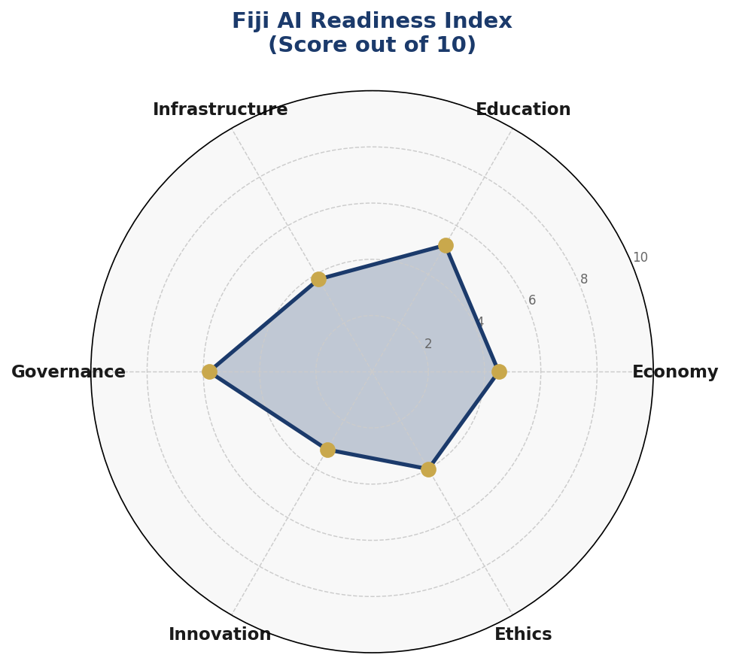
Figure 1.1 — Fiji AI Readiness Radar: Six-dimension assessment (Economy, Education, Infrastructure, Governance, Innovation, Ethics) scored out of 10, derived from Fiji-specific data and international benchmarks.

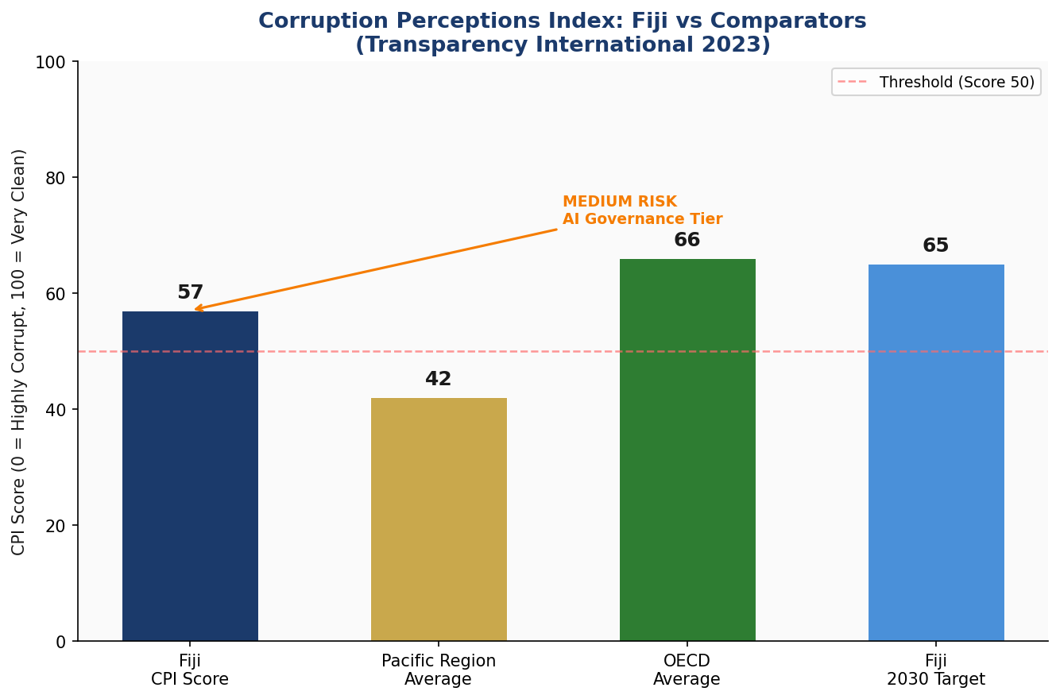
Figure 1.2 — Corruption Perceptions Index Comparison: Fiji (2023) vs Pacific Regional Average, OECD Average, and Fiji's 2030 Target. Source: Transparency International, World Bank WGI.

Section 2: Policy Vision and Strategic Pillars

2.1 Vision Statement
"To make Fiji a Pacific leader in ethical, inclusive, and sustainable Artificial Intelligence — where AI empowers every citizen, strengthens democratic governance, preserves cultural identity, and drives climate-resilient economic prosperity across all 300-plus islands."

2.2 Mission
To establish Fiji as a model small island developing state for responsible AI governance — demonstrating that ethical AI adoption is achievable, beneficial, and sustainable even within resource-constrained contexts, and sharing these lessons through active Pacific regional cooperation.

2.3 Strategic Pillars

Pillar 1 — Ethical AI and Human Rights Protection
AI systems deployed in Fiji must respect fundamental human rights, cultural values, and democratic principles. This pillar establishes the legal and institutional framework governing AI ethics, privacy, bias prevention, and accountability. It creates the National AI Ethics Board, mandates algorithmic impact assessments, and establishes Fiji's AI risk classification system. Special attention is paid to the rights of indigenous Fijian communities (iTaukei), Pacific Islander cultural heritage, and the protection of vulnerable groups including women, children, and people with disabilities.

Pillar 2 — Economic Growth and Industrial AI Adoption
AI offers Fiji's economy transformative potential across its priority sectors: smart tourism experiences, precision agriculture for sugarcane and other crops, AI-driven fisheries management in Fiji's vast Exclusive Economic Zone, and climate risk modelling for the blue economy. This pillar establishes sector-specific AI adoption roadmaps, incentive frameworks for AI-driven business investment, and a National AI Investment Fund to catalyse both domestic and foreign direct investment in AI-enabled industries.

Pillar 3 — Education, Upskilling, and AI Workforce Development
Human capital is Fiji's most critical AI asset. This pillar mandates integration of AI literacy into the national curriculum from primary level, establishes a National AI Skills Certification programme in partnership with USP and FNU, and creates targeted reskilling programmes for workers in sectors facing AI-driven disruption — particularly garment manufacturing and lower-skilled tourism roles. Gender equity targets ensure women represent at least 50% of AI programme beneficiaries.

Pillar 4 — Public Sector AI and e-Governance
Government is both a regulator and a leading adopter of AI in Fiji. This pillar establishes priority government AI use cases including AI-powered disaster early warning systems (critical for Fiji's cyclone and flood exposure), intelligent agricultural advisory services for smallholder farmers, automated document processing for visa and permit services, and AI-driven disease surveillance for the Ministry of Health. It also establishes procurement standards for government AI systems and citizen-facing service quality standards.

Pillar 5 — AI Research, Innovation, and Startup Ecosystem
Fiji's long-term AI competitiveness depends on domestic research and innovation capacity. This pillar funds a National Centre for Pacific AI Research at USP, establishes an AI Startup Incubator in Suva and Lautoka, creates a Pacific AI Data Commons for shared research datasets, and establishes Fiji as a hub for Pacific-regional AI governance research — leveraging Fiji's unique position as a multiethnic, multilingual, small island democracy with deep Pacific regional networks.

Section 3: International Framework Alignment
Fiji's National AI Policy has been designed with explicit alignment to the leading international AI governance frameworks. Rather than treating international standards as external impositions, this policy treats them as a common global foundation upon which Fiji's distinctive Pacific context, values, and priorities are built. The following subsections detail how each major framework has informed specific policy provisions.

3.1 UNESCO AI Ethics Recommendation (2021)
The UNESCO AI Ethics Recommendation — adopted by 193 member states including Fiji — establishes 11 core values and principles: respect for human rights, social justice, non-maleficence, privacy and data protection, multiple stakeholder participation, transparency, accountability, safety, oversight, sustainability, and human dignity. Fiji's National AI Ethics Board structure (Section 6) directly implements UNESCO's multi-stakeholder governance model. The Risk Classification System mirrors UNESCO's guidance on proportionate regulation. Fiji's particular emphasis on iTaukei cultural heritage protection reflects UNESCO's recognition of cultural diversity as a core AI ethics value.

3.2 OECD AI Principles (2019, Updated 2024)
The OECD AI Principles — human-centred values, fairness, transparency, robustness and security, accountability, and inclusive growth — underpin Fiji's Vision Statement and five Strategic Pillars. The 2024 updates on generative AI and frontier AI systems are incorporated in Section 6's risk classification framework. Fiji joins the OECD AI Policy Observatory as an associate member to ensure ongoing alignment with evolving international standards.

3.3 EU AI Act (2024) — Risk-Based Categorisation
The EU AI Act's four-tier risk classification — Unacceptable Risk (prohibited), High Risk (regulated), Limited Risk (transparency obligations), and Minimal Risk (voluntary code) — has been adapted for Fiji's context in Section 6. While Fiji is not an EU member and the Act does not apply directly, the risk-based regulatory approach is adopted as international best practice. Systems banned under EU classification (social scoring, real-time biometric surveillance in public spaces for law enforcement) are also classified as Unacceptable Risk under Fiji's framework.

3.4 World Bank AI Strategy and Development Focus
The World Bank's emphasis on AI for development outcomes — strengthening institutional capacity, expanding data ecosystems, and ensuring AI benefits reach marginalised communities — directly shapes Sections 4 and 5 of this policy. Fiji's close partnership with the World Bank on digital infrastructure financing makes alignment with World Bank AI standards a practical necessity as well as a normative commitment.

3.5 G20 AI Principles and ITU AI for Good
G20 AI Principles on inclusive growth, innovation promotion, and international cooperation inform Section 10's international diplomacy framework. ITU AI for Good guidelines, particularly on SDG linkage and digital inclusion, inform the AI Education Pipeline (Section 5) and the Public Sector AI roadmap (Section 7). Fiji commits to reporting annually to ITU on its AI for Good progress.

3.6 Comprehensive Framework Alignment Matrix
Framework | Key Principles | Policy Section Alignment | Pillar 1  Ethics | Pillar 2-4  Economy/Gov | Pillar 5  Innovation
UNESCO AI Ethics Recommendation (2021) | Human dignity, privacy, fairness, safety | S1 Ethics Board, S6 Risk Classification, S9 Accountability | ✅ | ✅ | ⚠️
OECD AI Principles (2019/2024) | Inclusive growth, human-centred values, transparency, robustness | S2 Vision, S6 Governance, S9 Monitoring | ✅ | ✅ | ✅
EU AI Act (2024) | Risk-based regulation, prohibited uses, conformity assessment | S6 Risk Classification, S7 Gov AI Procurement | ✅ | ⚠️ | 🔲
World Bank AI Strategy | Development outcomes, institutional capacity, data ecosystems | S1 Readiness, S4 Economy, S5 Education | ✅ | ✅ | ✅
G20 AI Principles | Inclusive growth, innovation, international cooperation | S2 Pillars, S10 Cooperation | ✅ | ✅ | ⚠️
ITU AI for Good / SDG Guidelines | SDG alignment, digital inclusion, climate action | S4 Economy, S5 Education, S8 Roadmap | ✅ | ✅ | ✅
GPAI (Global Partnership on AI) | Responsible AI, multi-stakeholder governance | S6 Ethics, S10 Diplomacy | ⚠️ | ✅ | ⚠️
Table 3.1 — International Framework Alignment Matrix. ✅ = Full alignment | ⚠️ = Partial alignment / in progress | 🔲 = Planned for Phase 2

Section 4: Economic Impact and Investment Roadmap

4.1 Projected AI Economic Contribution
Drawing on World Economic Forum, McKinsey Global Institute, and World Bank projections for small island developing states and upper-middle income economies, AI adoption is projected to contribute between 0.4% of GDP in Year 1 (2026) and 3.8% of GDP by 2030, as AI-enabled productivity gains compound across tourism, agriculture, fisheries, and government services. This projection is conservative relative to larger economies' projections and accounts for Fiji's infrastructure constraints and talent pipeline build-up period.
Tourism — which accounted for approximately 34% of GDP pre-pandemic — represents the single largest near-term opportunity. AI-personalised visitor experiences, dynamic pricing, AI-powered resort management, and predictive demand forecasting could increase tourism revenue by an estimated 12–18% by 2030. Smart agriculture applications for sugarcane disease detection and precision irrigation could increase agricultural productivity by 15–20%. AI-assisted fisheries management across Fiji's 1.3 million square kilometre EEZ could add an estimated FJD 85 million annually to the blue economy.
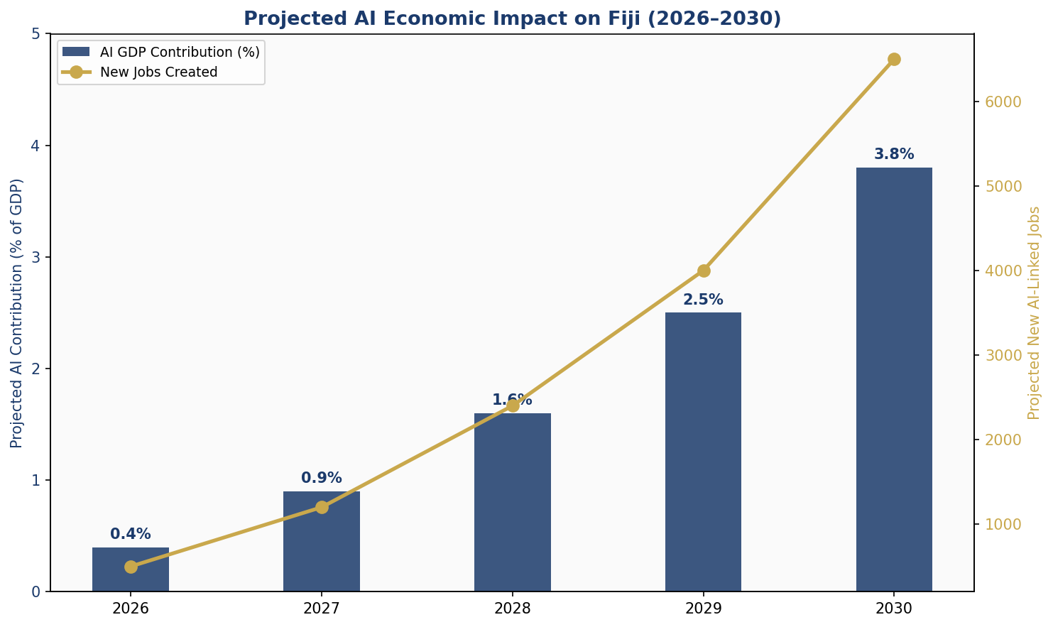
Figure 4.1 — Projected AI Economic Impact on Fiji (2026–2030): GDP contribution (%) and new AI-linked jobs created. Sources: WEF, McKinsey, World Bank SIDS projections, adapted for Fiji context.

4.2 National AI Investment Fund
The Government of Fiji will establish a National AI Investment Fund (NAIF) with an initial capitalisation of FJD 50 million over 5 years, supported by concessional financing from the Asian Development Bank, World Bank IDA, and bilateral development partners including Australia, Japan, and New Zealand. The Fund will operate through the Ministry of Finance with an independent Investment Committee including private sector, civil society, and academic representation.
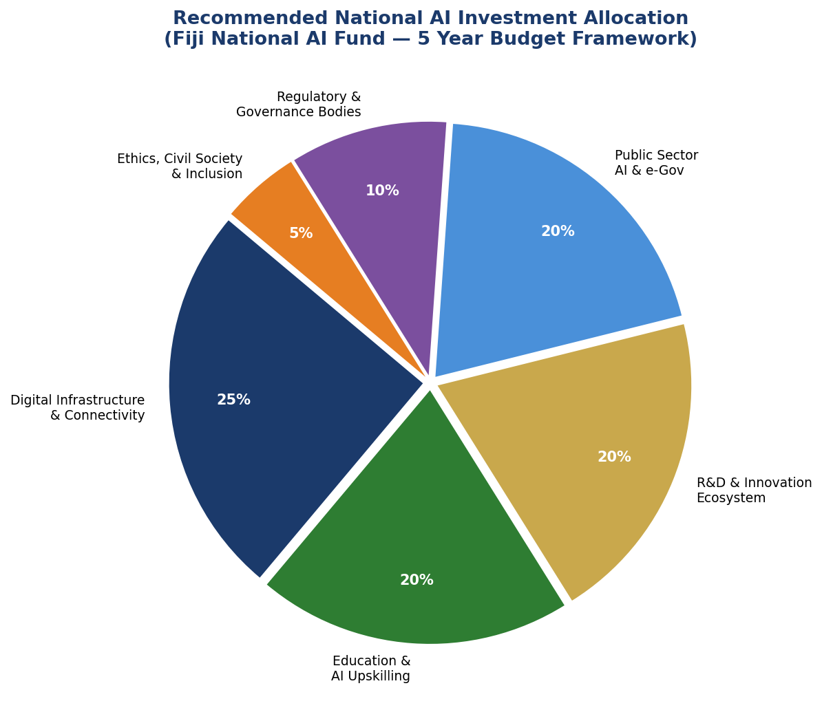
Figure 4.2 — Recommended National AI Investment Allocation: Five-Year Budget Framework across six priority categories. Total Fund: FJD 50 million (2026–2031).

4.3 Priority Sectors for AI Adoption
The following sectors have been identified as priority areas for AI investment and adoption, based on their economic weight, AI applicability, and alignment with Fiji's national development priorities:
- Tourism and Hospitality: AI-personalised visitor experiences, smart resort management, predictive maintenance, language translation services for visitors
- Agriculture and Food Security: Drone-based crop monitoring, disease early detection, precision irrigation, supply chain optimisation for sugarcane and root crops
- Blue Economy and Fisheries: AI-powered vessel monitoring, illegal fishing detection, fish stock assessment, aquaculture optimisation
- Climate Resilience and Disaster Management: Cyclone track prediction, flood early warning systems, climate risk mapping for infrastructure planning
- Health Services: AI-assisted diagnostics for remote health posts, disease surveillance, telemedicine triage for outer islands
- Financial Services: Inclusive fintech AI for rural financial access, credit scoring for unbanked populations, anti-money laundering systems

4.4 Public-Private Partnership Framework
The NAIF will operate on a co-investment model: for every dollar of public investment in eligible AI projects, the government aims to catalyse two dollars of private and development partner investment. PPP contracts for AI infrastructure will require technology transfer provisions, Fijian employee training commitments, and open data contribution to the Pacific AI Data Commons. Foreign technology companies wishing to access Fiji's AI market must demonstrate a local capacity-building plan approved by the National AI Authority.

Section 5: Education, Upskilling, and Human Capital Development

5.1 Current Skills Gap Analysis
Fiji's 2025 National Digital Skills Survey (conducted by the Ministry of Education in partnership with USP) identifies significant gaps across the AI competency spectrum. While general digital literacy has improved markedly (smartphone penetration exceeds 85%), advanced data literacy, programming skills, and AI-specific competencies remain rare outside a small urban professional cohort. Less than 0.5% of Fiji's workforce currently holds any AI-related qualification. Women represent only 28% of ICT sector workers. Rural and outer island communities face compounded disadvantages from infrastructure limitations and fewer tertiary education options.

5.2 National AI Curriculum Framework
The Ministry of Education will integrate AI literacy across all schooling levels through a staged curriculum reform:
- Primary Level (Years 1–8): AI awareness, computational thinking, data concepts, ethical technology use — integrated into existing Digital Literacy and Mathematics curricula
- Secondary Level (Years 9–13): AI literacy, basic programming, data analysis, digital ethics, and critical evaluation of AI outputs — as standalone elective and integrated components
- Tertiary Level: Specialised AI and Data Science programmes at USP and FNU; mandatory AI ethics modules for all Engineering, Business, Law, and Health programmes
- Vocational and Technical: AI applications in trade and technical contexts through Fiji National University's polytechnic programmes — covering AI tools relevant to construction, agriculture, maritime, and healthcare support roles
The curriculum framework will be reviewed and updated annually by a National AI Education Committee comprising representatives from the Ministry of Education, USP, FNU, the private sector, and civil society. iTaukei and Fiji Hindi language learning materials will be developed to ensure cultural and linguistic accessibility.

5.3 AI Education Pipeline — Population Targets
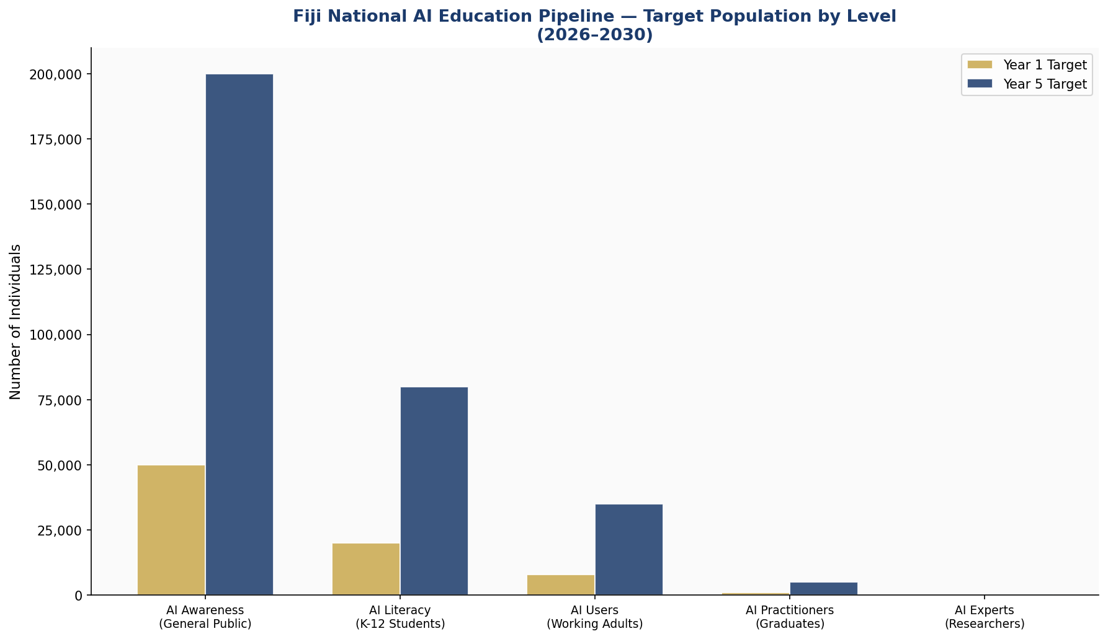
Figure 5.1 — Fiji National AI Education Pipeline: Target population at each competency level, comparing Year 1 (2026) and Year 5 (2030) targets. The pipeline spans from general AI Awareness to specialist AI Expert level.

5.4 National AI Skills Certification Programme
The Ministry of Employment and Labour, in partnership with USP and FNU, will establish a nationally recognised AI Skills Certification Programme at three levels — Foundation, Practitioner, and Expert. Certifications will be mutually recognised under bilateral agreements with Australia and New Zealand, facilitating labour mobility for Fijian AI professionals in both directions. The programme will include specific pathways for retraining workers displaced from AI-affected industries.

5.5 Gender and Inclusion Targets
By 2031, Fiji commits to achieving the following inclusion benchmarks: women represent at least 50% of AI scholarship recipients; female-led AI startups receive at least 40% of incubator funding; iTaukei Fijians represent at least 40% of AI public sector trainees; and outer island communities receive no less than 20% of total AI education investment.

Section 6: Ethical AI Governance and Regulatory Framework

6.1 National AI Ethics Board
The National AI Ethics Board (NAEB) will be established under the National AI Act within 12 months of policy adoption. The NAEB will be an independent statutory body with the following composition: three independent ethicists appointed by Parliament; two representatives from civil society and human rights organisations; two representatives from the private sector AI industry; one representative each from the University of the South Pacific and Fiji National University; one representative from the iTaukei Land Trust Board (representing indigenous communities); one representative from the Fiji Human Rights and Anti-Discrimination Commission; and the Director of the National AI Authority (ex officio, non-voting).
The NAEB's mandate includes: issuing binding guidance on AI ethics standards; reviewing and approving High Risk AI system deployments in the public sector; investigating complaints of AI-related harm; publishing an annual State of AI Ethics report; and representing Fiji in international AI ethics forums including UNESCO and the Global Partnership on AI.

6.2 AI Risk Classification System
Fiji adopts a four-tier risk classification system adapted from the EU AI Act and UNESCO guidance, tailored to Fiji's institutional capacity and context:

UNACCEPTABLE  (Prohibited) | Government social scoring systems that determine citizen rights based on behaviour profiles; Real-time mass biometric surveillance in public spaces; AI systems designed to manipulate political opinion through deceptive means; Child exploitation content generation; AI weapons of mass casualty potential

HIGH RISK  (Regulated) | AI in criminal justice (risk assessment, bail decisions); AI in government benefit eligibility determination; Biometric identification in law enforcement; AI-driven credit scoring for individuals; Medical diagnosis AI in public health facilities; AI in educational assessment/grading

LIMITED RISK  (Transparency) | Chatbots and virtual assistants interacting with citizens; AI-generated content in media and government communications; Emotion recognition applications; Deepfake content (must be labelled); AI recruitment screening tools

MINIMAL RISK  (Voluntary) | AI-powered spam filters; Personalised product recommendations; AI in entertainment; Automated manufacturing and logistics optimisation; AI-assisted scientific research tools

6.3 Data Protection and Privacy Framework
Fiji will enact a comprehensive Data Protection Act within 18 months of policy adoption, establishing: data subject rights (access, correction, deletion, portability); mandatory data breach notification within 72 hours; data localisation requirements for sensitive government data; cross-border data transfer standards aligned with international best practice; and special protections for biometric, health, and children's data. A Privacy Commissioner with enforcement powers will be established within the Fiji Human Rights and Anti-Discrimination Commission.

6.4 Algorithmic Accountability Standards
All high-risk AI systems deployed by government agencies must undergo mandatory Algorithmic Impact Assessment (AIA) before deployment, reviewed by the NAEB. AIAs must document: the system's purpose, training data sources, performance metrics, potential for discriminatory outcomes, human oversight mechanisms, and redress procedures for affected individuals. AIA reports for public-sector systems will be published in full on the National AI Observatory website.

Section 7: Public Sector and e-Governance AI

7.1 Priority Government AI Use Cases
The Government of Fiji will lead by example in responsible AI adoption. The following use cases have been prioritised based on citizen impact, feasibility, and alignment with the national development agenda:

7.1.1 Disaster Early Warning and Climate Resilience
Fiji faces an average of two to three cyclones per year, along with significant flood and drought risk. AI-powered meteorological modelling, integrated with existing Pacific climate networks, will provide earlier, more precise early warning to communities. The National Disaster Management Office will deploy AI systems for real-time damage assessment using satellite imagery, enabling faster response prioritisation. This initiative will be developed in partnership with UNDP, the Pacific Community (SPC), and Australia's Bureau of Meteorology.

7.1.2 Agricultural Advisory Services
The Ministry of Agriculture will deploy an AI-powered advisory service accessible via SMS and WhatsApp to Fiji's approximately 14,000 registered smallholder farmers. The system will provide personalised advice on sugarcane disease management, planting timing, pest identification (via image recognition), and market price information. The service will be available in English, iTaukei Fijian, and Fiji Hindi.

7.1.3 Health Surveillance and Telemedicine
The Ministry of Health will deploy AI-assisted diagnostic support tools at all 87 health centres and 1,100 health posts across Fiji, enabling rural health workers to access AI-assisted triage guidance via tablet. An AI-powered disease surveillance system will analyse anonymised patient data across the health network to detect potential outbreak patterns, complementing the existing Pacific Syndromic Surveillance System.

7.1.4 Document Processing and Citizen Services
The Ministry of Economy and Land Transport will pilot AI-powered processing for land title applications, business licensing, and permit renewals — reducing average processing times from 14 days to under 48 hours. AI-powered chatbot services in three languages will be deployed on the Fiji Government Online portal.

7.2 AI Procurement Guidelines for Government
All government AI system procurement must adhere to the National AI Procurement Framework, which requires: mandatory Algorithmic Impact Assessment; preference for systems with explainable AI (XAI) capabilities; mandatory data localisation or approved cross-border transfer agreements; vendor technology transfer and local staff training commitments; open standards and interoperability requirements; and mandatory independent security audits prior to deployment.

7.3 Interoperability Standards
The Government's Chief Digital Officer (within the Ministry of Finance) will publish and enforce national AI interoperability standards, ensuring that AI systems procured by different agencies can share data and functionality where appropriate, avoiding costly siloing and duplication. Fiji will adopt the Linked Data standards of the W3C and contribute to the Pacific regional digital government interoperability framework coordinated through the Pacific Islands Forum Secretariat.

Section 8: Implementation Roadmap
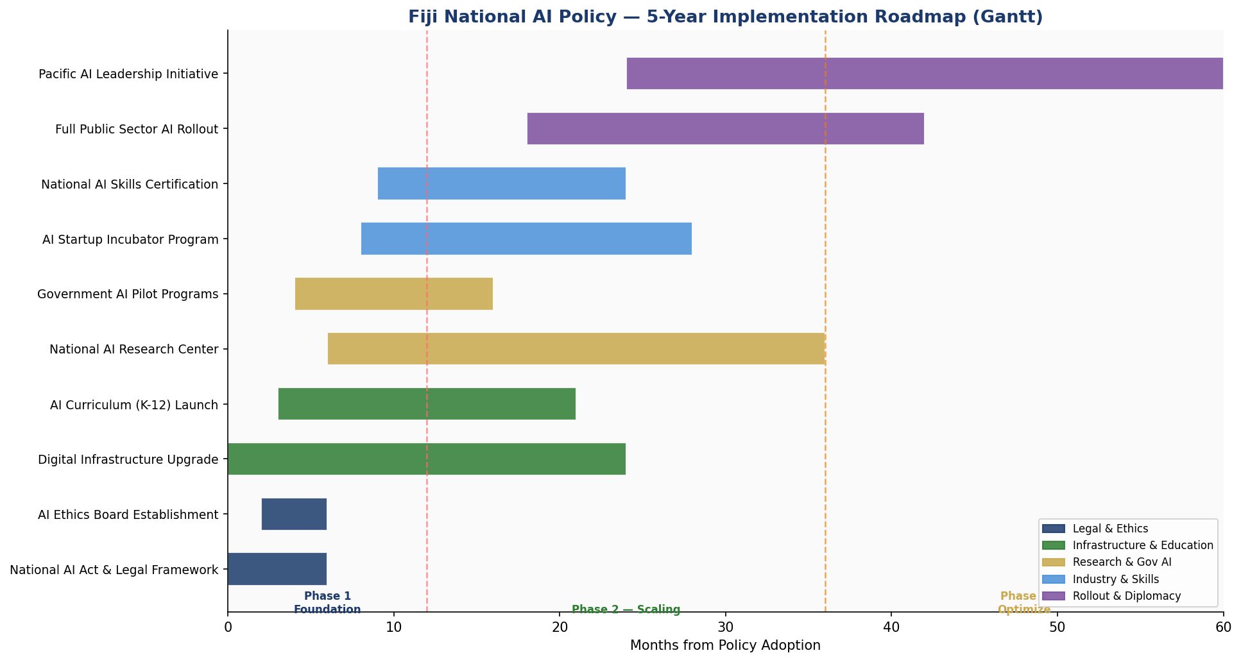
Figure 8.1 — Fiji National AI Policy: Five-Year Implementation Roadmap (Gantt). Three phases: Foundation (Months 1–12), Scaling (Months 13–36), and Optimisation (Months 37–60).

8.1 Phase 1: Foundation (2026 — Months 1–12)
The Foundation phase focuses on establishing the legal, institutional, and infrastructural prerequisites for responsible AI adoption.
- Draft and enact the National AI Act through Parliament
- Establish the National AI Authority (secretariat, budget, staffing)
- Appoint the National AI Ethics Board
- Publish AI Risk Classification Guidance and Algorithmic Impact Assessment templates
- Launch the National AI Investment Fund with initial capitalisation
- Begin Digital Infrastructure Extension programme to underserved islands
- Integrate AI literacy into Years 9–13 secondary curriculum
- Pilot three government AI applications (agricultural advisory, health triage, document processing)

8.2 Phase 2: Scaling (2027–2028 — Months 13–36)
The Scaling phase rolls out programmes nationally, expanding from pilots to full deployment and building momentum in the private sector and tertiary education system.
- Full deployment of 8+ government AI services across all major agencies
- National AI Skills Certification Programme operational at USP and FNU
- Pacific AI Research Centre established at USP, first research cohort enrolled
- AI Startup Incubator operational in Suva and Lautoka
- Tourism sector AI adoption incentive programme launched
- Data Protection Act enacted and Privacy Commissioner appointed
- Bilateral AI cooperation agreements signed with Australia, New Zealand, Japan

8.3 Phase 3: Optimisation (2029–2030 — Months 37–60)
The Optimisation phase focuses on review, refinement, international integration, and positioning Fiji as a Pacific AI leadership hub.
- Comprehensive policy mid-term review (Month 36) informing Phase 3 priorities
- Pacific AI Governance Framework developed with Forum member states
- Full public sector AI rollout — 15+ citizen-facing AI services
- Fiji joins Global Partnership on AI (GPAI) as full member
- National AI Observatory annual report series published
- AI industry export potential assessment and strategy development

8.4 KPI Dashboard — Targets by Phase
KPI Indicator | Baseline (2025) | Year 1 (2026) | Year 3 (2028) | Year 5 (2030)
National AI Act enacted | None | Enacted | Operational | Reviewed/Updated
AI Ethics Board operational | None | Established | Full capacity | Expanded mandate
AI workforce (practitioners) | ~50 | 1,000 | 3,000 | 5,000+
AI literacy (public) | <1% | 15% | 40% | 65%
Women in AI programmes | 28% | 40% | 48% | 50%+
Gov AI services deployed | 0 | 3 pilots | 8 services | 15+ services
AI GDP contribution | ~0% | 0.4% | 1.6% | 3.8%
New AI-linked jobs | 0 | 500 | 2,400 | 6,500+
AI startups funded | 0 | 5 | 20 | 50
Pacific AI cooperation MoUs | 0 | 3 | 8 | 12
Table 8.1 — KPI Dashboard: National AI Policy Implementation Targets (2026–2030).

Section 9: Monitoring, Evaluation, and Accountability

9.1 National AI Observatory
The National AI Observatory (NAO) — a unit within the National AI Authority — will serve as Fiji's primary mechanism for tracking, analysing, and publicly reporting on AI policy implementation and societal AI impacts. The NAO will: publish an Annual State of AI in Fiji report; maintain a live public dashboard of KPI progress; commission independent evaluation studies at Years 2 and 4; host a biennial National AI Forum bringing together government, industry, academia, and civil society; and coordinate data collection for Fiji's international AI governance reporting obligations.

9.2 Parliamentary Oversight
The Parliament of Fiji will receive an Annual AI Report from the Minister responsible for Technology, tabled within 3 months of each financial year end. A Joint Parliamentary Select Committee on AI and Digital Technology will be established with the mandate to scrutinise government AI procurement, review NAEB reports, hold public hearings on AI impacts, and recommend legislative updates. Parliamentary oversight is a cornerstone of democratic accountability for AI governance.

9.3 Civil Society and Independent Audit
Civil society organisations registered under the Fiji Charitable Trusts Act will have formal standing to request Algorithmic Impact Assessment reviews from the NAEB. The Office of the Auditor General will conduct annual performance audits of the National AI Authority and the National AI Investment Fund. An independent AI Red Team will be contracted biennially to test government AI systems for vulnerabilities, biases, and performance degradation.

9.4 Citizen Redress Mechanism
Any Fijian citizen who believes they have been adversely affected by an AI-driven government decision has the right to: request a human review of that decision within 10 working days; receive a plain-language explanation of how the AI system contributed to the decision; lodge a formal complaint with the NAEB; and pursue legal remedy through the Fiji courts. The National AI Act will establish clear liability provisions for AI-related harms caused by both government and private sector actors.

Section 10: International Cooperation and Diplomacy

10.1 Pacific Regional AI Governance
Fiji is committed to leading the development of a Pacific Regional AI Governance Framework under the auspices of the Pacific Islands Forum (PIF). Fiji's unique combination of stable democratic governance, relatively advanced digital infrastructure (by Pacific standards), a world-class regional research university (USP) on its territory, and an established diplomatic tradition positions it as the natural convener of Pacific AI governance dialogue. Fiji will host the inaugural Pacific AI Governance Summit in 2027, bringing together all 18 PIF member states.

10.2 Bilateral AI Cooperation Priorities
Fiji will pursue bilateral AI cooperation agreements with its key development and trade partners:
- Australia and New Zealand: AI research collaboration, skills recognition, cybersecurity cooperation, joint climate AI modelling
- Japan: Smart city technology transfer, disaster risk AI cooperation, maritime AI for fisheries management
- India: Digital public infrastructure expertise, AI for healthcare delivery in resource-constrained settings, English-language AI tools
- United States: Data privacy standards alignment, AI for democracy and governance integrity, startup ecosystem linkages
- European Union: EU AI Act compliance support, research collaboration, digital rights framework alignment

10.3 South-South Knowledge Transfer
Fiji actively seeks to learn from and share with other small island developing states and Pacific neighbours navigating similar AI challenges. Formal knowledge exchange partnerships will be established with Barbados (Caribbean SIDS AI governance leader), Rwanda (AI-enabled public services model for developing countries), and Estonia (digital government excellence). Fiji will contribute its own learnings — particularly around multilingual AI deployment, outer island connectivity solutions, and climate AI applications — through ITU's Digital Development Sector and the Commonwealth Digital Economy Programme.

10.4 Global AI Governance Participation
Fiji will actively engage in global AI governance forums, including the United Nations AI Advisory Body, the ITU AI for Good Summit, UNESCO's AI Ethics Recommendation implementation monitoring, and the Global Partnership on AI. Fiji's voice in these forums will consistently advocate for: equitable representation of small and developing states in AI governance; mandatory AI impact assessment requirements in development assistance AI projects; AI technology transfer obligations in trade agreements; and the recognition of cultural and ecological diversity as core AI ethics values.

Conclusion
Fiji's National Artificial Intelligence Policy 2026–2031 is both an aspiration and an action plan. It aspires to a Fiji where every citizen — from a farmer in Nadroga to a student in Vanua Levu, from a nurse in a Lau health post to an entrepreneur in Suva — benefits from AI's potential to improve lives, expand opportunities, and strengthen the institutions and ecosystems upon which Fijian wellbeing depends.
The action plan is grounded in realism. Fiji is a small state with real resource constraints, real governance challenges, and real vulnerabilities — to economic shocks, to climate change, and to the risks that accompany new and powerful technologies. This policy does not promise to eliminate these risks. It commits Fiji to managing them with transparency, accountability, and a genuine commitment to human rights.
The five-year journey this policy sets out — from legal foundation-building in 2026 to Pacific regional AI leadership by 2031 — is ambitious but achievable. It requires sustained political will, adequate resourcing, genuine multi-stakeholder partnership, and the kind of adaptive learning that comes from honest evaluation and willingness to change course when evidence demands it.
Above all, Fiji's AI journey must be Fijian. It must reflect the country's values of inclusivity, respect for cultural diversity, democratic accountability, and the Pacific way of community and collective wellbeing. AI is a tool. What matters is what we choose to build with it. This policy is Fiji's answer to that question.

Bula Vinaka — Welcome to Fiji's AI future.

References and Bibliography
[1] UNESCO. (2021). Recommendation on the Ethics of Artificial Intelligence. United Nations Educational, Scientific and Cultural Organization, Paris.
[2] OECD. (2024, updated). OECD AI Principles and AI Policy Observatory. Organisation for Economic Co-operation and Development, Paris.
[3] European Parliament. (2024). Regulation (EU) 2024/1689 — Artificial Intelligence Act. Official Journal of the European Union.
[4] World Bank Group. (2021). World Development Report 2021: Data for Better Lives. International Bank for Reconstruction and Development.
[5] G20. (2019, reaffirmed 2023). G20 AI Principles. G20 Japan Presidency.
[6] ITU. (2024). AI for Good: SDG Impact Assessment Framework. International Telecommunication Union, Geneva.
[7] Transparency International. (2024). Corruption Perceptions Index 2023. Transparency International, Berlin.
[8] Oxford Insights. (2023). AI Readiness Index. Oxford Insights.
[9] Government of Fiji. (2017). 5-Year and 20-Year National Development Plan. Ministry of Economy, Suva.
[10] Pacific Islands Forum Secretariat. (2024). Blue Pacific 2050 Strategy Digital Annex. PIFS, Suva.
[11] McKinsey Global Institute. (2023). The Economic Potential of Generative AI. McKinsey & Company.
[12] World Economic Forum. (2024). Future of Jobs Report 2025. WEF, Geneva.
[13] Asian Development Bank. (2023). Digital Connectivity in Pacific Small Island Developing States. ADB, Manila.
[14] University of the South Pacific. (2024). Pacific AI Research Landscape Assessment. USP Institute for Research Extension and Training, Suva.
[15] Global Partnership on AI (GPAI). (2024). Responsible AI in the Global South: Principles and Practice. GPAI.

About the Author

Nafiul Ahmad Rafi
Policy & Good Governance Researcher | BD Civic Tech Architect

Nafiul Ahmad Rafi is a civic technologist, policy researcher, author, photographer, and musician based in Dhaka, Bangladesh. He is the Founder and Director of Insights Bangladesh, a data-driven governance and policy impact analysis institution, and the Founder & Lead Architect of NagorikBD.org — a transparency-first civic platform scaled across Mymensingh Division, connecting citizens with government services across 45 Upazilas.
His work exists at the intersection of institutional reform and artificial intelligence, transforming theoretical governance into scalable, data-driven reality. Without a conventional computer science degree, he self-taught the tools of modern AI and web development to build the infrastructure that enforces the policies he once only researched.

Key Platforms and Projects
- NagorikBD.org — Civic transparency platform, Mymensingh Division
- Insights Bangladesh — Policy impact analysis institution
- FactCheck BD (factcheckbd.org) — Bangladesh's AI-powered fact-checking platform
- Political Insights BD / PIBD (pibbd.org) — Political intelligence and civic tech hub
- PeaceShield BD / National Peace Tracker — AI-powered hate speech and conflict monitoring
- PolicyLens AI (aigovbd.org) — 9-dimensional AI policy audit tool

He has published four books and maintains a personal site at ahmad-rafi.com.

Research Interests
AI Governance · Policy Research · Future of Bangladesh · Climate Policy

Contact
🌐 ahmad-rafi.com
🔗 LinkedIn: nafiul-ahmad-rafi
✉️ contact@ahmad-rafi.com

"I build code to ensure transparency, and I write lyrics to inspire the courage to use it."

