🇻🇳 SOCIALIST REPUBLIC OF VIETNAM
National Artificial Intelligence Policy 2026–2031
A Comprehensive Framework for Ethical, Inclusive, and Economically Transformative AI

Prepared by:
Nafiul Ahmad Rafi
Insights Bangladesh
May 2026

Table of Contents

Executive Summary
Vietnam stands at a pivotal moment in its technological evolution. With a GDP growth rate averaging 6–7% annually, a young and digitally engaged population of over 97 million, and a government increasingly committed to digital transformation, Vietnam possesses the foundational prerequisites for becoming a regional leader in Artificial Intelligence (AI) adoption. However, unlocking this potential requires a coherent, rights-respecting, and internationally aligned national AI policy framework.
This National AI Policy 2026–2031 charts a five-year course for the responsible and economically transformative deployment of AI across all sectors of Vietnamese society. The policy is anchored in five strategic pillars: (1) Ethical AI and Human Rights Protection; (2) Economic Growth and Industrial AI Adoption; (3) Education, Upskilling, and AI Workforce Development; (4) Public Sector AI and e-Governance; and (5) AI Research, Innovation, and Startup Ecosystem. Together, these pillars form a coherent vision for a Vietnam that leads in AI innovation while safeguarding the rights and dignity of every citizen.
Vietnam's Oxford Insights AI Readiness Index score and rapidly expanding digital economy indicate meaningful capacity for AI uptake. The manufacturing, agriculture, healthcare, and financial services sectors represent particularly high-impact areas for early AI integration. Yet, challenges remain: a Transparency International CPI score of 40 signals governance risks that must be proactively mitigated through robust AI accountability structures, and infrastructure gaps in rural provinces call for inclusive deployment strategies.
This policy has been developed with full alignment to UNESCO's AI Ethics Recommendation (2021), the OECD AI Principles (2019/2024), the EU AI Act's risk-based regulatory model (2024), the World Bank AI Strategy for Development, and G20 AI Principles. It establishes a National AI Ethics Board, a tiered AI risk classification system, a National AI Observatory for monitoring and evaluation, and a structured five-year implementation roadmap with measurable KPIs. By 2031, Vietnam is projected to add up to 4.2% of incremental GDP from AI-driven productivity gains — equivalent to tens of billions of USD in economic value — while simultaneously expanding digital inclusion and strengthening democratic governance.

Section 1: National AI Readiness Assessment

1.1 Economic Context
Vietnam is classified as a lower-middle-income economy by the World Bank, with a nominal GDP of approximately USD 430 billion (2025 est.) and a GDP per capita of around USD 4,400. The economy has demonstrated remarkable resilience, maintaining 6–7% annual growth driven by manufacturing exports (electronics, textiles, footwear), a burgeoning services sector, and remittances. The digital economy accounts for approximately 14.5% of GDP, with e-commerce, fintech, and digital platforms growing rapidly. Vietnam ranks among the fastest-growing digital economies in Southeast Asia, providing a robust foundation for AI adoption across strategic sectors.
Vietnam is a member of ASEAN, CPTPP, and the RCEP trade bloc, giving it significant exposure to international trade dynamics and technology transfer channels. The government's 'Vietnam Digital Economy Strategy 2025' and the National Digital Transformation Programme (Decision 749/QD-TTg) signal strong political will for digitalization, creating an enabling environment for AI policy integration.

1.2 Education & Human Capital
Vietnam has a literacy rate of over 95% and a tertiary education enrollment rate of approximately 40%. The country produces around 80,000 STEM graduates annually, with a growing number specializing in computer science, data science, and software engineering. However, a significant digital skills gap persists at the practitioner and specialist levels. The Vietnamese Ministry of Education and Training has begun piloting computational thinking curricula in secondary schools, but AI-specific pedagogy remains limited outside elite universities such as VNU, HUST, and RMIT Vietnam.
Women represent approximately 48% of tertiary STEM enrollment in Vietnam, an exceptional figure by regional standards, creating a strong gender-parity baseline for inclusive AI workforce development. Vocational training (TVET) institutions, however, have not yet systematically incorporated AI and data literacy into their curricula, representing a high-leverage intervention point for rapid workforce upskilling.

1.3 Digital Infrastructure
Vietnam's internet penetration stands at approximately 79% of the population, with mobile penetration exceeding 130% (SIM cards per capita). The country has a robust 4G network covering most urban and peri-urban areas, and 5G pilots are underway in Hanoi, Ho Chi Minh City, and Da Nang. However, rural provinces — particularly in the Central Highlands, Northwest, and Mekong Delta regions — face persistent connectivity gaps, limiting equitable AI service delivery. Data center capacity is growing rapidly, with international cloud providers (AWS, Google Cloud, Microsoft Azure) establishing local infrastructure in recent years.

1.4 Governance & Institutional Capacity
Vietnam operates as a single-party socialist state under the Communist Party of Vietnam (CPV). The government has demonstrated capacity for rapid policy implementation, as evidenced by the speed of digital transformation programs. Key AI-relevant institutions include the Ministry of Science and Technology (MOST), the Ministry of Information and Communications (MIC), the National Agency for Science and Technology Information (NASATI), and the Vietnam Academy of Science and Technology (VAST). Interagency coordination on AI remains nascent, and dedicated AI governance institutions are yet to be formally established, creating an institutional gap this policy directly addresses.

1.5 Corruption Risk Assessment
Vietnam scores 40 out of 100 on Transparency International's Corruption Perceptions Index (2024), ranking 83rd globally. This places Vietnam in the 'High AI Governance Risk' tier in this policy's framework. The most relevant AI-specific corruption risks include: algorithmic procurement manipulation (using AI systems to bias government tender processes), surveillance AI misuse for targeted repression, data manipulation in social scoring systems, and opacity in state-deployed AI decision-making. This policy mandates independent algorithmic audits for all government AI systems and prohibits specific high-risk use cases to mitigate these structural vulnerabilities.
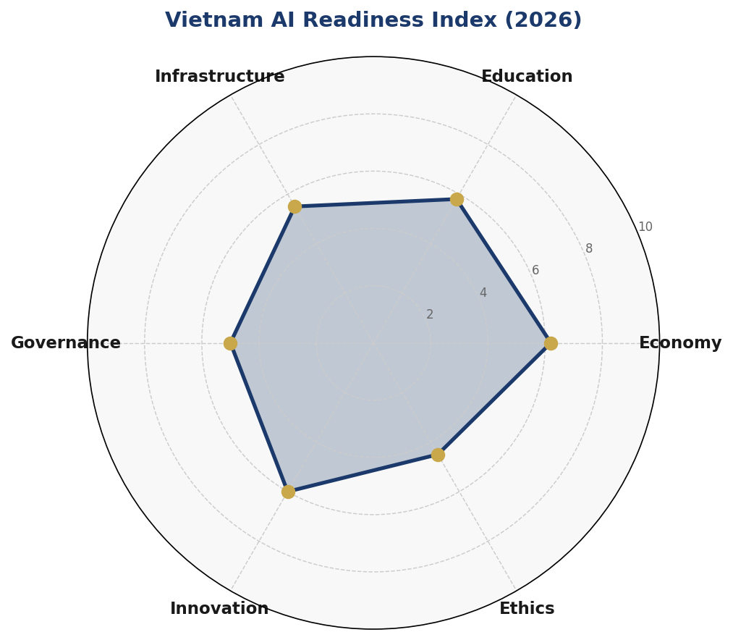
Figure 1.1: Vietnam AI Readiness Index — 6-Axis Assessment (2026)
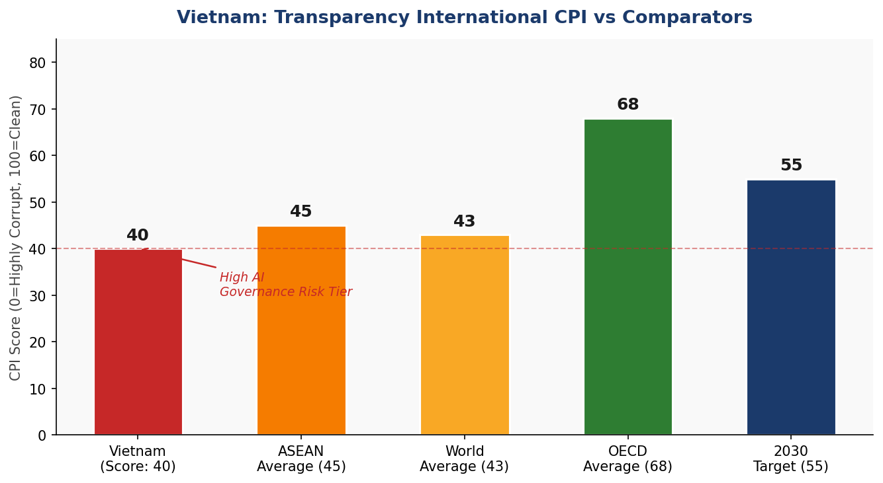
Figure 1.2: Vietnam CPI Score vs Comparators and AI Governance Risk Tier

Section 2: Policy Vision & Strategic Pillars

2.1 Vision Statement
By 2031, Vietnam is a digitally sovereign, AI-empowered nation — one in which artificial intelligence enhances the productivity of every worker, improves the quality of every public service, protects the rights of every citizen, and accelerates Vietnam's journey to high-income status, all while reflecting the cultural values and national aspirations of the Vietnamese people.

2.2 Strategic Pillar 1 — Ethical AI & Human Rights Protection
Vietnam commits to deploying AI in a manner that fully respects human dignity, the rule of law, and the rights of all persons within its jurisdiction. This pillar establishes the National AI Ethics Board, a tiered risk classification system, mandatory algorithmic impact assessments for high-risk applications, and explicit prohibitions on AI uses that violate fundamental freedoms. Transparency, explainability, and contestability are non-negotiable design requirements for all government AI systems.
- Establish the National AI Ethics Board (NAEB) by Q2 2026
- Publish national Algorithmic Accountability Standards by Q4 2026
- Mandate AI Impact Assessments for all government-facing AI by Q2 2027
- Prohibit social scoring, predictive policing without oversight, and real-time mass biometric surveillance of public spaces except under judicial warrant

2.3 Strategic Pillar 2 — Economic Growth & Industrial AI Adoption
Vietnam's AI policy places economic transformation at its core. AI is expected to add up to 4.2% incremental GDP contribution by 2031, primarily through productivity gains in manufacturing (smart factories, predictive maintenance), agriculture (precision farming, crop disease detection), healthcare (diagnostics, drug discovery), financial services (fraud detection, credit scoring), and logistics. The government will provide targeted investment incentives, regulatory sandboxes, and public-private partnership frameworks to accelerate responsible industrial AI adoption.
- Launch AI-Ready Industry Program targeting 500 SMEs by 2028
- Establish 3 AI Industrial Parks in Hanoi, Ho Chi Minh City, and Da Nang by 2029
- Create a USD 500M National AI Investment Fund (public-private) by Q3 2026

2.4 Strategic Pillar 3 — Education, Upskilling & AI Workforce Development
Vietnam must build a nationally distributed AI talent pipeline spanning general awareness, digital literacy, practitioner-level skills, and world-class specialization. This requires integrated reform across the K-12 curriculum, tertiary education, vocational training, and continuous professional development. Gender equity and regional inclusion are core design principles; rural and ethnic minority communities must have equitable access to AI education pathways.
- Integrate AI and computational thinking into K-12 national curriculum by 2028
- Establish AI Centers of Excellence in 5 leading universities by 2027
- Train 1 million AI practitioners through public upskilling programs by 2030
- Achieve 40% women's representation in AI specialist roles by 2031

2.5 Strategic Pillar 4 — Public Sector AI & e-Governance
Government AI deployment represents the highest-leverage and highest-risk application domain. This pillar mandates rigorous procurement standards, mandatory transparency disclosures, and public accountability mechanisms for all state AI systems. Priority use cases include public health surveillance, tax compliance analytics, infrastructure maintenance prediction, citizen service automation, and anti-corruption analytics — all subject to strict ethical guardrails.
- Deploy AI-assisted citizen service platforms in all 63 provinces by 2029
- Establish national Government AI Procurement Guidelines by Q4 2026
- Launch AI-powered anti-corruption analytics pilot in public procurement by Q2 2027

2.6 Strategic Pillar 5 — AI Research, Innovation & Startup Ecosystem
Vietnam must cultivate indigenous AI research capacity and a vibrant startup ecosystem to avoid perpetual technology dependence on foreign providers. This pillar supports the establishment of national AI research institutes, competitive grant programs, technology transfer partnerships with leading global universities, and a structured startup acceleration framework with regulatory sandbox provisions.
- Fund 50 AI research grants annually through MOST/VAST from 2027
- Launch Vietnam AI Startup Accelerator with annual cohorts of 30 companies
- Establish bilateral AI research agreements with at least 10 international partners by 2028

Section 3: International Framework Alignment

3.1 UNESCO AI Ethics Recommendation (2021)
Vietnam's AI Policy aligns with all eleven core values of the UNESCO Recommendation on the Ethics of AI: proportionality and do no harm; safety and security; fairness and non-discrimination; sustainability; right to privacy and data protection; human oversight and determination; transparency and explainability; responsibility and accountability; awareness and literacy; multi-stakeholder and adaptive governance; and international cooperation. The National AI Ethics Board is mandated to publish annual UNESCO alignment reports, and all AI systems deployed in education and healthcare are subject to mandatory rights-impact assessments.

3.2 OECD AI Principles (2019/2024 Update)
The OECD AI Principles emphasize inclusive growth, human-centred values, transparency, robustness, and accountability. Vietnam's policy incorporates these through: mandatory explainability requirements for high-impact AI decisions; algorithmic accountability standards for public sector AI; a National AI Observatory modelled on OECD recommendations; and active participation in the OECD AI Policy Observatory peer review process. The 2024 updates on advanced AI systems are reflected in Vietnam's classification of generative AI under 'Limited Risk' with mandatory transparency disclosures.

3.3 EU AI Act (2024) — Risk-Based Framework Adaptation
Vietnam adopts the EU AI Act's four-tier risk classification as the backbone of its domestic regulatory architecture, adapted to the Vietnamese legal context. Unacceptable risk uses are prohibited by statute. High-risk applications in critical infrastructure, justice, employment, and education require mandatory conformity assessments and registration in a national AI database. Limited-risk AI must disclose AI-generated content and automated decision-making to affected persons. Minimal-risk AI is subject only to voluntary codes of conduct.

3.4 World Bank AI Strategy for Development
Aligning with the World Bank's emphasis on AI for poverty reduction, inclusive growth, and human capital development, Vietnam's policy targets AI deployment in underserved provinces, prioritizes AI applications in agriculture and rural health services, and mandates digital inclusion provisions in all national AI programs. World Bank collaboration is sought for the National AI Skills Program financing and independent governance capacity-building.

3.5 G20 AI Principles & ITU AI for Good Guidelines
Vietnam endorses the G20 AI Principles' emphasis on trustworthy AI, innovation-enabling governance, and international interoperability. Through active engagement with the ITU AI for Good framework, Vietnam commits to deploying AI toward SDG achievement — particularly SDG 3 (Good Health), SDG 4 (Quality Education), SDG 8 (Decent Work), SDG 9 (Industry and Innovation), and SDG 16 (Peace and Strong Institutions).

3.6 Framework Alignment Matrix
The following table maps each international framework's core principles to the corresponding sections of this policy:
Framework Principle | S2 Vision | S4 Ethics | S5 Economy | S6 Education | S7 Public AI | S8 Roadmap
UNESCO: Non-discrimination & Fairness | ✅ | ✅ | ✅ | ✅ | ✅ | ✅
UNESCO: Transparency & Explainability | ⚠️ | ✅ | ✅ | ⚠️ | ✅ | ✅
UNESCO: Accountability & Responsibility | ✅ | ✅ | ✅ | ✅ | ✅ | ✅
OECD: Inclusive Growth | ✅ | ✅ | ✅ | ✅ | ✅ | ✅
OECD: Human-centred Values | ✅ | ✅ | ⚠️ | ✅ | ✅ | ⚠️
OECD: Robustness & Security | ⚠️ | ✅ | ✅ | ⚠️ | ✅ | ✅
EU AI Act: Risk Classification | 🔲 | ✅ | ✅ | 🔲 | ✅ | ✅
EU AI Act: Fundamental Rights Impact | ⚠️ | ✅ | ⚠️ | ✅ | ✅ | ⚠️
G20: Innovation Enablement | ✅ | ⚠️ | ✅ | ✅ | ⚠️ | ✅
ITU: SDG Alignment | ✅ | ✅ | ✅ | ✅ | ✅ | ✅
World Bank: Development-AI Nexus | ✅ | ✅ | ✅ | ✅ | ✅ | ✅
Legend: ✅ Full Alignment ⚠️ Partial Alignment 🔲 Planned by Year 3

Section 4: Economic Impact & Investment Roadmap

4.1 Projected Economic Contribution of AI
According to McKinsey Global Institute estimates for lower-middle-income economies in Southeast Asia, widespread AI adoption could contribute between 3.5% and 5.5% of incremental GDP over a five-year horizon through productivity enhancements in manufacturing, services automation, and agricultural optimization. For Vietnam, with its export-driven manufacturing base and rapidly growing digital services sector, a conservative estimate of 4.2% incremental GDP contribution by 2031 is achievable under this policy's investment framework, representing approximately USD 18–22 billion in additional economic output.
Priority sectors for AI-driven economic transformation include: advanced manufacturing (smart factories, quality control AI), agri-tech (precision farming, supply chain traceability), healthcare (AI-assisted diagnostics, hospital management), fintech (credit scoring, fraud detection, insurance), and logistics/transportation (route optimization, autonomous port operations). Each of these sectors has demonstrated AI-readiness signals including digital infrastructure, data availability, and existing industry capacity.
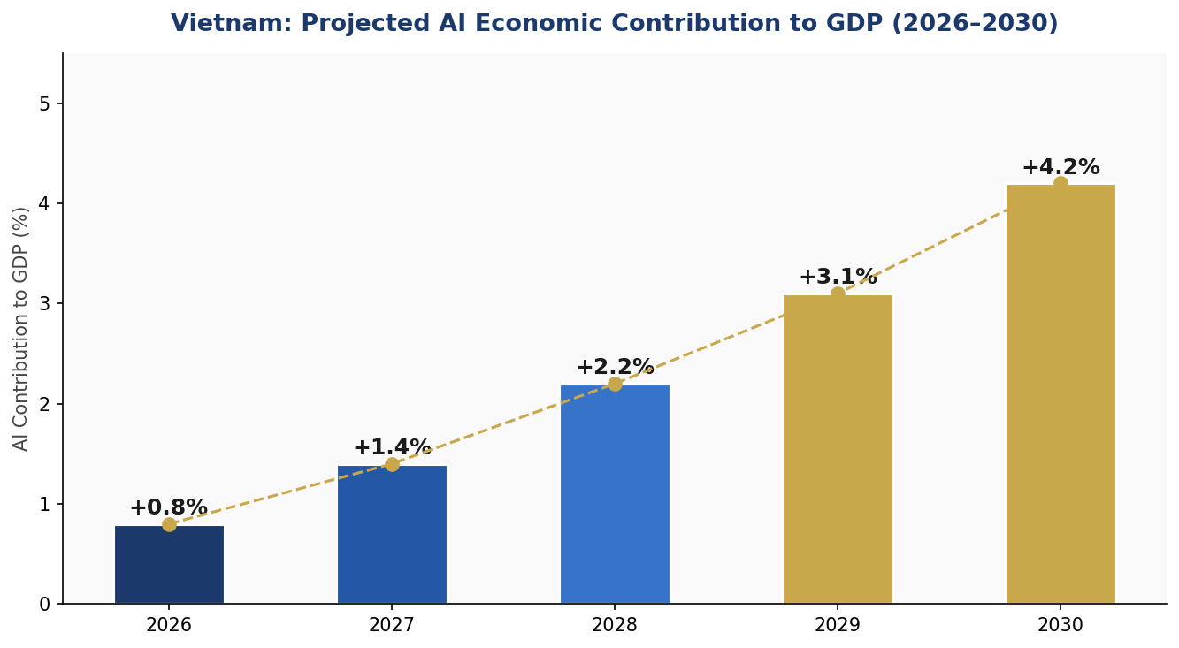
Figure 4.1: Projected AI Contribution to Vietnam's GDP — Year 1 to Year 5

4.2 National AI Investment Allocation
Total recommended public AI investment over the policy period: USD 1.2–1.8 billion (public sector contribution), with an additional USD 2–3 billion expected from private sector co-investment through the PPP framework. Investment allocation follows a balanced portfolio approach across six categories:
- Infrastructure (25%) — Data centers, 5G expansion, cloud sovereign infrastructure, AI compute access
- Education & Upskilling (20%) — K-12 curriculum reform, tertiary AI programs, national skills platform
- R&D (20%) — University AI research grants, national AI research institute, technology transfer
- Public Sector AI (20%) — e-Governance AI systems, citizen service platforms, anti-corruption tools
- Regulatory Bodies (10%) — National AI Ethics Board, AI Observatory, conformity assessment labs
- Ethics & Civil Society (5%) — Public awareness, independent auditors, civil society capacity
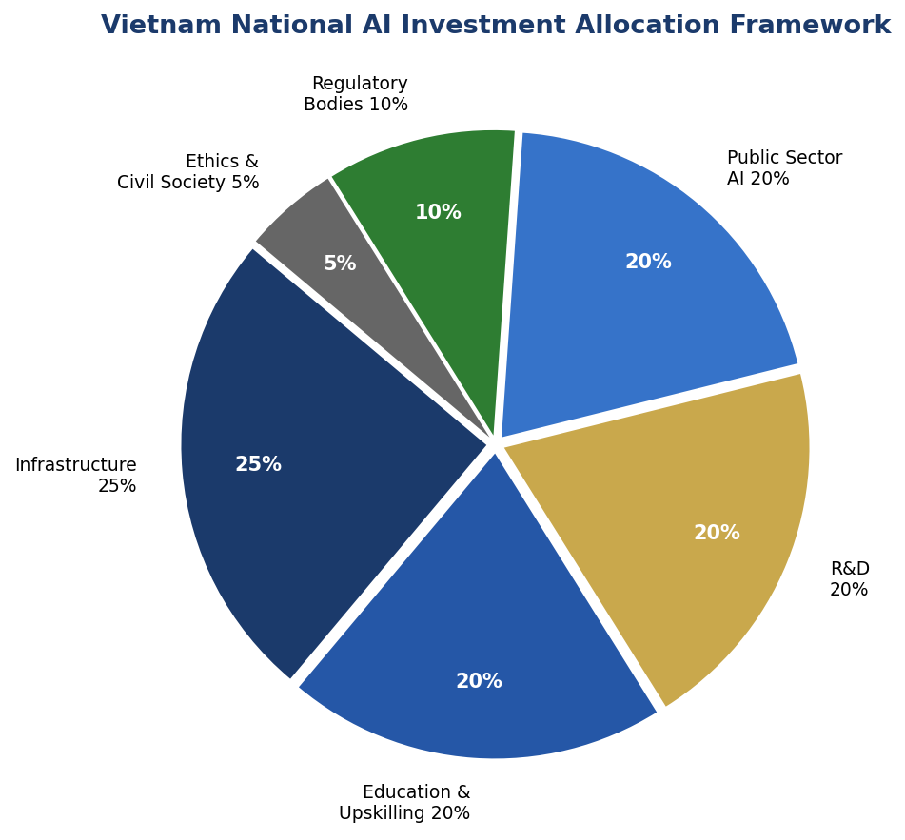
Figure 4.2: Vietnam National AI Investment Allocation Framework

4.3 Public-Private Partnership Framework
Vietnam will establish a National AI Investment Council (NAIC) co-chaired by the Ministry of Planning and Investment and a leading private sector representative. The NAIC will govern the USD 500M National AI Fund, structured as a blended finance vehicle combining sovereign funds, development bank financing (ADB, World Bank IFC), and private capital. Investment criteria prioritize: Vietnamese-founded AI companies, solutions addressing domestic development challenges, export-potential AI products, and companies with demonstrated responsible AI practices.

Section 5: Education & Human Capital Development

5.1 Skills Gap Analysis
Vietnam's AI talent ecosystem currently comprises approximately 3,000–5,000 AI specialists (researchers and senior engineers), 80,000–120,000 technology practitioners with adjacent AI skills, and approximately 15–20 million digitally literate workers. Against these figures, industry demand projections by 2030 call for 500,000 AI practitioners and 50,000 specialists — a gap requiring systematic, nationally coordinated intervention at every level of the education pipeline.
Rural and ethnic minority communities are significantly underrepresented in current AI talent pools, reflecting a structural equity challenge. Women, while well-represented in general STEM fields, remain underrepresented at the specialist and leadership levels in AI, a gap this policy actively targets through dedicated scholarship programs and mentorship networks.

5.2 National AI Curriculum Framework
The Ministry of Education and Training (MOET), in collaboration with the Ministry of Information and Communications (MIC), will develop and deploy a tiered National AI Curriculum Framework spanning four educational levels:
K-12 Level: AI Awareness and Computational Thinking will be integrated into the national curriculum from Grade 5 onward. Students will develop foundational understanding of algorithms, data, and automated decision-making, with age-appropriate emphasis on critical digital citizenship and ethical AI use.
Tertiary Level: All universities offering STEM degrees will incorporate an AI and Data Science minor as a general education requirement by 2028. Five Centers of AI Excellence (CoAIE) will be established at leading universities with dedicated research infrastructure, international faculty exchange programs, and industry partnership requirements.
Vocational Training (TVET): The Vietnam General Directorate of Vocational Education and Training (GDVT) will develop AI-focused modules for all major vocational sectors — manufacturing, healthcare, agriculture, and services — with a target of 200,000 upskilled TVET graduates by 2031.
Continuous Professional Development: A National AI Skills Platform (online and blended) will provide accessible, multilingual, and free-of-charge AI learning resources for working professionals, with targeted outreach to rural provinces and ethnic minority communities.
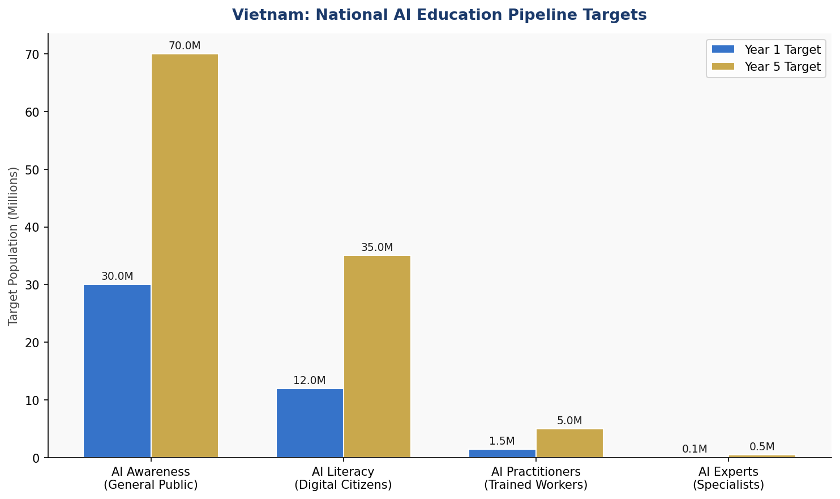
Figure 5.1: Vietnam AI Education Pipeline — Year 1 vs Year 5 Population Targets (Millions)

5.3 Inclusion Targets
- 50% of AI scholarship recipients from rural provinces or ethnic minority backgrounds by 2029
- 40% women's representation in AI specialist roles by 2031
- AI literacy programs in 25+ languages/dialects spoken in Vietnam by 2029
- Mobile-first AI skills content accessible without broadband by 2027

Section 6: Ethical AI Governance & Regulatory Framework

6.1 National AI Ethics Board (NAEB)
The National AI Ethics Board (NAEB) will be established by executive decree by Q2 2026. It will consist of 15 members drawn from government (5), civil society and human rights organizations (4), academia and research (3), and private sector (3), with a mandatory gender balance requirement (minimum 40% women). The NAEB will be operationally independent from any line ministry, reporting directly to the National Assembly. Its mandate covers: issuing binding ethical guidelines for government AI, approving high-risk AI use cases, overseeing algorithmic impact assessments, and publishing annual National AI Ethics Reports.

6.2 AI Risk Classification System
Vietnam adopts a four-tier AI risk classification framework adapted from the EU AI Act, calibrated to Vietnam's socio-political context:
Unacceptable Risk (Prohibited): Social scoring systems by government or quasi-government entities; predictive policing systems without judicial oversight and human decision-making; real-time biometric surveillance of public spaces except under specific judicial warrant; AI systems that manipulate persons through subliminal techniques; AI-generated disinformation systems; autonomous lethal weapons without human control.
High Risk (Strictly Regulated): AI in critical infrastructure control; AI in employment recruitment and performance assessment at scale; AI in educational assessment with binding outcomes; AI in judicial or quasi-judicial decision-making; AI in healthcare diagnostics used as sole determinant; AI in immigration processing. High-risk systems require mandatory conformity assessment, registration in the National AI Database, ongoing monitoring, and human override mechanisms.
Limited Risk (Transparency Required): General-purpose AI assistants, chatbots, and customer service AI; AI-generated content (text, image, video, audio); AI-assisted recommendation systems. Limited-risk AI must disclose its AI nature to users and provide opt-out mechanisms where feasible.
Minimal Risk (Voluntary Code): All other AI applications. Providers are encouraged to adopt the national Responsible AI Code of Conduct.

6.3 Data Protection & Privacy
Vietnam will enact a comprehensive Personal Data Protection Law by 2027, consistent with GDPR principles and ASEAN Data Management Framework. The law will establish: rights to access, rectification, erasure, and portability of personal data; mandatory data protection impact assessments for AI systems processing sensitive data; explicit consent requirements for training data collection; cross-border data transfer restrictions with adequacy determination processes; and a dedicated Data Protection Authority with enforcement powers.

6.4 Anti-Corruption AI Guidelines
Given Vietnam's elevated CPI-indicated governance risks, this policy mandates specific anti-corruption measures for government AI: all AI systems used in public procurement, benefits distribution, licensing, and law enforcement must be subject to independent algorithmic audits every 18 months; AI procurement processes must be published in the national transparency register; civil society organizations have statutory rights to request algorithmic impact information; and whistleblower protections apply specifically to reporting AI-related corruption.

Section 7: Public Sector & e-Governance AI

7.1 Priority Government AI Use Cases
Vietnam's government will prioritize AI deployment in areas of highest citizen impact and institutional capacity, subject to rigorous ethical safeguards:
- Healthcare: AI-assisted diagnostic support in district hospitals, disease surveillance and epidemic early warning, drug supply chain optimization
- Agriculture: Crop disease detection and yield prediction for smallholder farmers via mobile platform, climate adaptation advisory systems
- Tax & Revenue: AI-enhanced tax compliance analytics and fraud detection (non-punitive, with human review requirement)
- Infrastructure: Predictive maintenance for roads, bridges, and public utilities; AI-assisted urban planning and flood modeling
- Education: Personalized learning platforms for rural students, automated administrative processing for scholarship allocation
- Public Safety: AI-assisted traffic management and road safety analytics (aggregated, non-surveillance-based)
- Anti-Corruption: AI monitoring of procurement anomalies and conflict-of-interest patterns in government contracting

7.2 Government AI Procurement Guidelines
All government AI procurement above VND 5 billion (approx. USD 200,000) must comply with the National Government AI Procurement Framework (NGAPF), to be published by Q4 2026. The NGAPF mandates: open competition with transparency in evaluation criteria; mandatory algorithmic explainability requirements; data sovereignty and localization provisions; post-deployment monitoring plans; and vendor code of conduct obligations aligned with this policy's ethical AI standards.

7.3 Citizen-Facing AI Services Roadmap
Vietnam commits to deploying AI-enhanced citizen services across all 63 provinces through the National Public Service Portal (dichvucong.gov.vn) by 2029. Priority services for AI enhancement include: birth registration and vital records processing; land title management; tax filing assistance; social welfare eligibility determination (with mandatory human review of negative determinations); and multilingual government information chatbots in Vietnamese, English, and major ethnic minority languages.

7.4 Interoperability Standards
All government AI systems must comply with the National AI Interoperability Standards Framework (NAIST), ensuring data portability, API standardization, and cross-agency AI-sharing protocols. NAIST will be developed in alignment with ASEAN Digital Data Governance Framework standards, positioning Vietnam as a regional interoperability leader.

Section 8: Implementation Roadmap

8.1 Five-Year Implementation Architecture
The policy is structured in three overlapping phases, reflecting the realities of institutional capacity-building, technology deployment cycles, and policy learning:
Phase 1 — Foundation (Year 1, 2026): This phase establishes the institutional, legal, and human capital foundations without which subsequent phases cannot succeed. The National AI Ethics Board is constituted, the National AI Strategy is formally launched, foundational legal frameworks are drafted, and pilot programs are initiated in healthcare and agriculture.
Phase 2 — Scaling (Years 2–3, 2027–2028): Building on validated foundations, Phase 2 deploys AI at national scale across priority sectors. The AI education curriculum reform reaches national implementation, the National AI Skills Platform launches, industrial AI adoption programs begin supporting hundreds of companies, and the first cohort of the Vietnam AI Startup Accelerator graduates.
Phase 3 — Optimization (Years 4–5, 2029–2031): Vietnam consolidates its AI gains, reviews and strengthens regulatory frameworks based on real-world evidence, deepens international AI cooperation, and positions itself as a regional AI governance model and potential AI capability exporter.
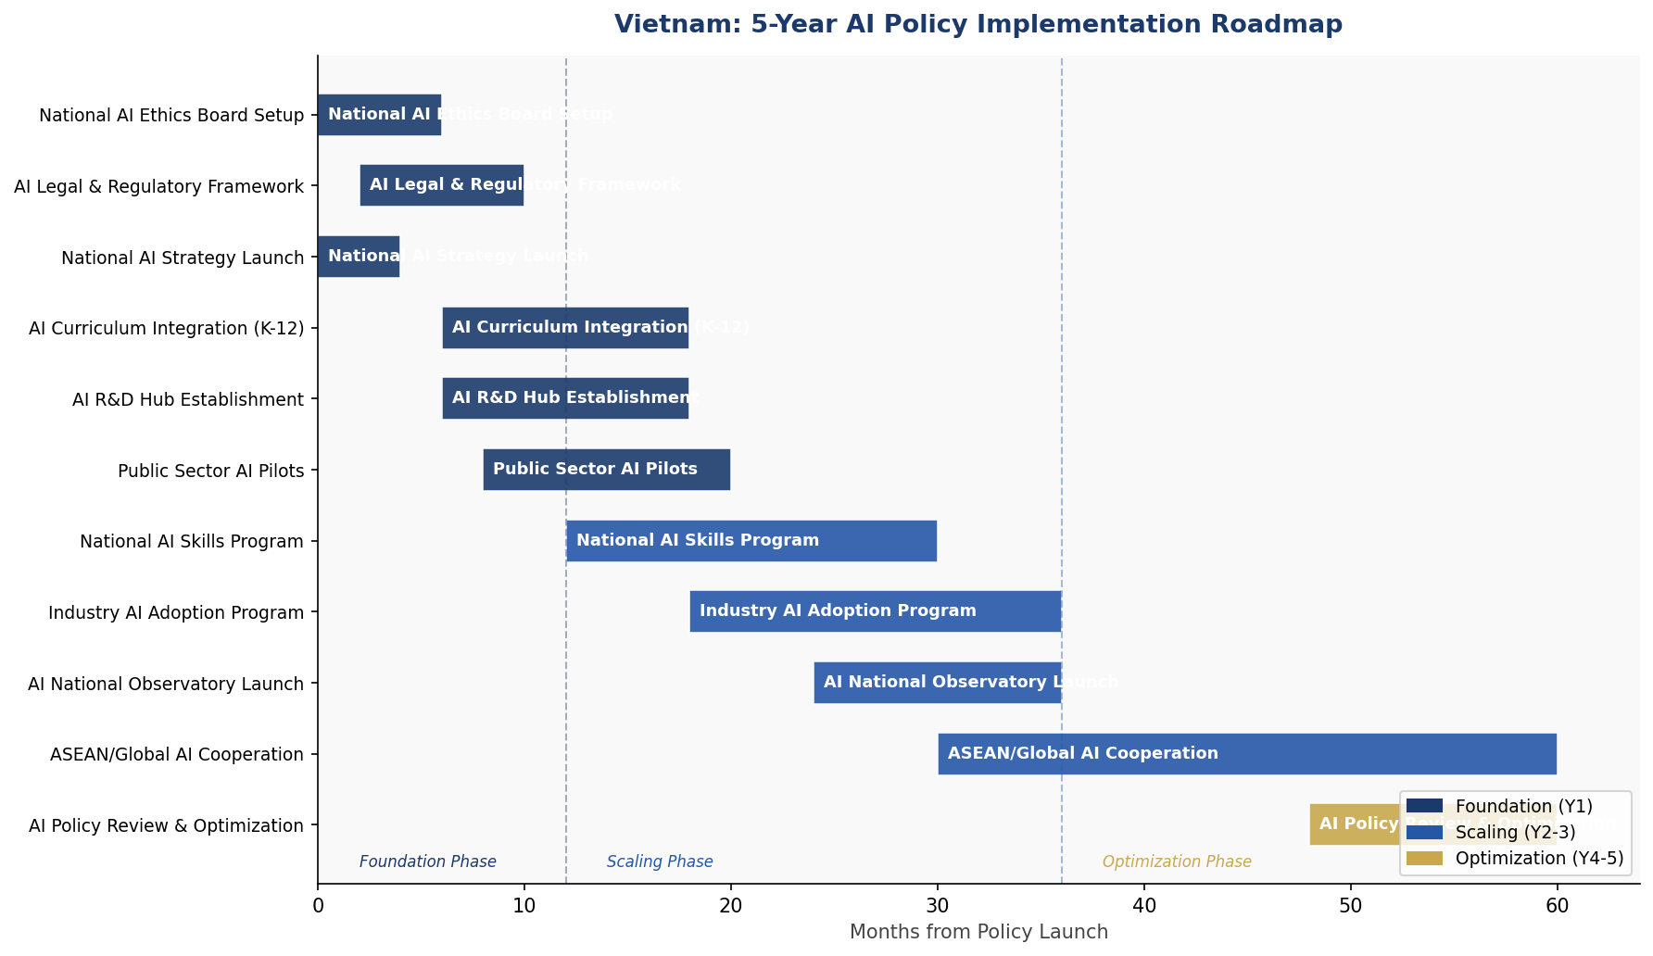
Figure 8.1: Vietnam AI Policy Implementation Roadmap — 5-Year Gantt Timeline

8.2 Phase KPIs
KPI | Phase 1 (Y1) | Phase 2 (Y2-3) | Phase 3 (Y4-5)
AI Ethics Board Operational | Yes | Active | Enhanced Mandate
Legal AI Framework Enacted | Draft | Law Enacted | Reviewed & Updated
AI Practitioners Trained | 50,000 | 300,000 | 1,000,000
Government AI Systems Audited | 10 pilots | 100 systems | All systems
AI Startups Supported | 30 | 90 | 200+
GDP AI Contribution | +0.8% | +2.2% | +4.2%
AI Literacy Rate (Adults) | 20% | 45% | 70%
UNESCO Alignment Score | Partial | Substantial | Full

Section 9: Monitoring, Evaluation & Accountability

9.1 National AI Observatory
The National AI Observatory (NAOB) will be established within the Vietnam Academy of Science and Technology (VAST) by Q4 2026, with operational independence guaranteed by statute. The NAOB's mandate encompasses: continuous monitoring of AI deployment across public and private sectors; annual publication of the Vietnam AI State Report; international benchmarking against OECD and Oxford Insights metrics; maintaining the National AI Database (a registry of all high-risk and government AI systems); and providing technical support to the National AI Ethics Board.

9.2 Annual AI State Report
The NAOB will publish an Annual Vietnam AI State Report every November, covering: AI adoption metrics by sector; ethical AI compliance rates; education and workforce progress indicators; economic impact estimates; governance quality assessments; international framework alignment scores; and civil society feedback integration. The report will be publicly available in Vietnamese and English and will be subject to parliamentary review.

9.3 KPI Dashboard
Metric | Baseline (2026) | Year 1 Target | Year 3 Target | Year 5 Target
AI Practitioners (M) | 0.12M | 0.17M | 0.4M | 1.0M
AI Literacy Adults (%) | 15% | 20% | 45% | 70%
Govt AI Systems Audited | 0 | 10 | 100 | All
CPI Score | 40 | 41 | 44 | 55 (target)
AI GDP Contribution (%) | 0.3% | 0.8% | 2.2% | 4.2%
Women in AI Specialist Roles | 22% | 25% | 33% | 40%
AI Startups (active) | ~300 | 400 | 700 | 1,200+
Provinces w/ AI Services | 5 | 20 | 45 | 63
Oxford AI Readiness Rank | ~62 | 58 | 50 | 40
UNESCO Alignment Score | 30% | 55% | 80% | 95%

9.4 Parliamentary Oversight
The National Assembly's Committee on Science, Technology and Environment will convene semi-annual hearings on AI policy implementation progress. The Minister of Science and Technology and the NAEB Chair will provide mandatory briefings. The National Assembly has statutory authority to amend AI legislation, override ministerial AI regulations inconsistent with this policy, and commission independent reviews of AI governance performance.

9.5 Civil Society & Independent Audit
Registered civil society organizations have statutory rights to: access the National AI Database; submit formal objections to high-risk AI deployment approvals; request independent algorithmic audits of government AI; and present findings to NAEB hearings. An independent AI Auditor function will be created, staffed by professionals certified under the national AI Audit Certification Program, to provide third-party conformity assessments of high-risk AI systems.

Section 10: International Cooperation & Diplomacy

10.1 Bilateral AI Cooperation Priorities
Vietnam will pursue strategic AI cooperation agreements with key technology partners and development allies, prioritizing: knowledge transfer and joint research programs; technology access arrangements that preserve Vietnamese data sovereignty; capacity-building programs for Vietnamese AI governance institutions; and investment facilitation for responsible foreign AI companies operating in Vietnam.
Priority bilateral partners include: Japan (manufacturing AI, robotics), South Korea (AI hardware, fintech AI), Singapore (AI governance standards, financial sector AI), France (AI ethics and regulation, GDPR-alignment), Germany (industrial AI, automotive), United States (AI research, startup ecosystem), China (manufacturing AI — with enhanced data governance safeguards), India (IT services, AI education), and Australia (agri-tech AI, governance capacity-building).

10.2 ASEAN AI Governance
As a core ASEAN member, Vietnam is positioned to contribute significantly to regional AI governance architecture. Vietnam will champion the full implementation of the ASEAN Guide on AI Governance and Ethics, advocate for ASEAN-wide AI interoperability standards, and host the ASEAN AI Governance Forum in 2028. Vietnam will seek to align its domestic AI risk classification with ASEAN regional frameworks to facilitate cross-border AI service deployment while maintaining national sovereignty over data and critical systems.

10.3 South-South Knowledge Transfer
Vietnam recognizes its responsibility as a relatively advanced developing nation to share AI governance knowledge with less-resourced countries. Through the Mekong Institute and bilateral development programs, Vietnam will offer AI policy advisory support to Laos, Cambodia, and Myanmar. Vietnam will also engage actively in the G77 AI Working Group at the UN to advance developing country perspectives in global AI governance negotiations.

10.4 Global AI Governance Participation
Vietnam will maintain active representation in: the UN High-Level Advisory Body on AI (as it evolves); the ITU AI for Good platform; the UNESCO Global AI Observatory; the GPAI (Global Partnership on AI); the ISO/IEC JTC 1/SC 42 AI standards working group; and relevant OECD AI policy working parties. Vietnam will submit its national AI governance report to the UN Secretary-General's AI Advisory Body as part of global governance accountability.

Conclusion
Vietnam's National AI Policy 2026–2031 represents a comprehensive, rights-respecting, and economically ambitious framework for harnessing the transformative potential of artificial intelligence. In a global landscape where AI is simultaneously reshaping economies, altering the nature of work, and challenging democratic governance, Vietnam has an extraordinary opportunity — and a profound responsibility — to chart a path that delivers AI's benefits to all 97 million of its citizens while safeguarding the values and freedoms they deserve.
This policy does not promise easy success. Vietnam's AI journey will require sustained political will, significant public investment, genuine accountability mechanisms, and the active participation of civil society, academia, industry, and citizens themselves. The governance risks inherent in Vietnam's institutional context — including the CPI-indicated corruption vulnerabilities — are acknowledged directly and addressed with specific structural safeguards, rather than papered over with optimistic rhetoric.
But the trajectory is clear and compelling. A Vietnam that builds its AI ecosystem on solid ethical foundations — where government AI is transparent and accountable, where workers are upskilled rather than displaced, where the benefits of automation reach rural provinces and ethnic minority communities, and where Vietnam's voice is heard in global AI governance — is a Vietnam positioned for sustained high-income status, regional leadership, and global respect.
The implementation clock starts now. Every month of delay is a month in which other nations consolidate AI advantages, workers accumulate skills gaps, and governance vacuums invite misuse. Vietnam's AI future begins with the decisions made in 2026.

References & Bibliography

International Frameworks & Standards
- UNESCO Recommendation on the Ethics of AI (2021). United Nations Educational, Scientific and Cultural Organization.
- OECD Principles on Artificial Intelligence (2019, updated 2024). Organisation for Economic Co-operation and Development.
- Regulation (EU) 2024/1689 of the European Parliament and of the Council on Artificial Intelligence (EU AI Act). Official Journal of the European Union, 12 July 2024.
- World Bank AI Strategy for Development (2023). International Bank for Reconstruction and Development.
- G20 AI Principles (2019). G20 Osaka Summit Digital Economy Task Force.
- ITU AI for Good Global Summit — AI and the SDGs Framework (2024). International Telecommunication Union.
- ASEAN Guide on AI Governance and Ethics (2023). ASEAN Digital Ministers' Meeting.
- Global Partnership on AI (GPAI) — Responsible AI Working Group Reports (2023–2025).

Vietnam National Sources
- Socialist Republic of Vietnam — National Digital Transformation Programme to 2025, Orientation to 2030 (Decision 749/QD-TTg, 2020). Prime Minister's Office, Hanoi.
- Ministry of Science and Technology, Vietnam — National Strategy for Research, Development and Application of Artificial Intelligence to 2030 (Decision 127/QD-TTg, 2021). Hanoi.
- Ministry of Information and Communications — Vietnam ICT White Paper 2024. MIC, Hanoi.
- Vietnam General Statistics Office — Statistical Yearbook 2024. GSO, Hanoi.

Research & Data Sources
- Oxford Insights — Government AI Readiness Index 2024. Oxford Insights Ltd, Oxford.
- Transparency International — Corruption Perceptions Index 2024. Transparency International, Berlin.
- McKinsey Global Institute — The Economic Potential of Generative AI: The Next Productivity Frontier (2023). McKinsey & Company.
- World Economic Forum — Future of Jobs Report 2025. WEF, Davos.
- ITU — Measuring Digital Development: Facts and Figures 2024. International Telecommunication Union, Geneva.
- World Bank — World Development Indicators 2024. World Bank, Washington DC.
- GSMA — Mobile Economy Asia Pacific 2024. GSMAi, London.

About the Author

Nafiul Ahmad Rafi
Policy & Good Governance Researcher | BD Civic Tech Architect
Nafiul Ahmad Rafi is a civic technologist, policy researcher, author, photographer, and musician based in Dhaka, Bangladesh. He is the Founder and Director of Insights Bangladesh, a data-driven governance and policy impact analysis institution, and the Founder & Lead Architect of NagorikBD.org — a transparency-first civic platform scaled across Mymensingh Division, connecting citizens with government services across 45 Upazilas.
His work exists at the intersection of institutional reform and artificial intelligence, transforming theoretical governance into scalable, data-driven reality. Without a conventional computer science degree, he self-taught the tools of modern AI and web development to build the infrastructure that enforces the policies he once only researched.

Key Platforms & Projects:
- NagorikBD.org — Civic transparency platform, Mymensingh Division
- Insights Bangladesh — Policy impact analysis institution
- FactCheck BD (factcheckbd.org) — Bangladesh's AI-powered fact-checking platform
- Political Insights BD / PIBD (pibbd.org) — Political intelligence and civic tech hub
- PeaceShield BD / National Peace Tracker — AI-powered hate speech and conflict monitoring
- PolicyLens AI (aigovbd.org) — 9-dimensional AI policy audit tool

He has published four books and maintains a personal site at ahmad-rafi.com.

Research Interests:
AI Governance · Policy Research · Future of Bangladesh · Climate Policy

Contact:
- Website: ahmad-rafi.com
- LinkedIn: linkedin.com/in/nafiul-ahmad-rafi
- Email: contact@ahmad-rafi.com

“I build code to ensure transparency, and I write lyrics to inspire the courage to use it.”

