*Heaven’s Light is Our Guide*

**Rajshahi University of Engineering & Technology**



**Department of Electrical & Computer Engineering**

Course No: ECE 3118

Course Title: Software Engineering & Information System Design Sessional

|  |
| --- |
| **System Analysis and Design on Directorate General of Family Planning** |

|  |  |
| --- | --- |
| **Submitted by:** | |
| Name: **Md. Zayed Al Masud**  Roll: **1810016** | Name: **Faria Afrin Tisha**  Roll: **1810017** |
| Name: **Abdullah Al Rafi**  Roll: **1810018** | Name: **Md. Rakibul Islam**  Roll: **1810019** |
| Name: **Md. Turag Islam**  Roll: **1810020** | |
| **Date of Submission:** 15. 11. 2022 | |

|  |
| --- |
| **Submitted to:** |
| Rakibul Hassan  Assistant Professor,  Department of Electrical & Computer Engineering, RUET |

**CONTENTS**

|  |  |  |
| --- | --- | --- |
|  | **Title** | **Page No** |
|  | **CONTENTS** | **02 – 04** |
|  | **List of Figures** | **04** |
|  | **List of Tables** | **04** |
|  |  |  |
| **Chapter** | **Contents** | **Pages No** |
| **Chapter 01** | **Recognition of Need** | **05 – 07** |
|  | 1.1 Introduction | 05 |
|  | 1.2 Objectives | 05 |
|  | 1.3 Vision and Mission of the Organization | 05 |
|  | 1.4 Problem Identification | 06 |
|  | 1.4.1 Logistics Allotments are delayed | 06 |
|  | 1.4.2 The entire system is not digitized | 06 |
|  | 1.4.3 There is no adequate infrastructure at the district and upazila levels | 06 |
|  | 1.4.4 Fast Paced training is not effective | 06 |
|  | 1.4.5 E-nothi System is not being implied properly | 06 |
|  | 1.4.6 There is no personal datasheet or database | 06 |
|  | 1.4.7 Not enough positions or promotions in the structure | 06 |
|  | 1.4.8 The post of Family Welfare Officer is vacant | 06 |
|  | 1.4.9 Not proper monitoring system during recruitment | 07 |
|  | 1.5 Conclusions | 07 |
| **Chapter 02** | **Initial Feasibility Study** | **08 – 09** |
|  | 2.1 Introduction | 08 |
|  | 2.2 Initial Feasibility Study | 08 |
|  | 2.2.1 Logistics Allotments are delayed | 08 |
|  | 2.2.2 The entire system is not digitized | 08 |
|  | 2.2.3 There is not adequate infrastructure at the district and upazila levels | 08 |
|  | 2.2.4 Fast Paced training is not effective | 09 |
|  | 2.2.5 E-nothi System is not being implied properly | 09 |
|  | 2.2.6 There is no personal datasheet or database | 09 |
|  | 2.2.7 Not enough positions or promotions in the structure | 09 |
|  | 2.2.8 Not proper monitoring system during recruitment | 09 |
|  | 2.3 Conclusion | 09 |
| **Chapter 03** | **Information Gathering** | **10 – 16** |
|  | 3.1 Introduction | 10 |
|  | 3.2 Information Gathering using Different Tools | 10 |
|  | 3.2.1 Forms and Documents | 10 |
|  | 3.2.1.1 Distribution of Service-related Form (Upazila to Division) | 11 |
|  | 3.2.1.2 Food and Nutrition Tracking Form | 12 |
|  | 3.2.1.3 Mother and Child Health Tracking Form | 13 |
| **Chapter** | **Contents** | **Pages No** |
| **Chapter 03** | 3.2.2 On-site Observation | 15 |
|  | 3.2.3 Interview | 15 |
| **Chapter 04** | **Feasibility Study** | **17 – 21** |
|  | 4.1 Introduction | 17 |
|  | 4.2 Feasibility analysis | 17 |
|  | 4.2.1 Logistics Allotments are delayed | 17 |
|  | 4.2.2 The entire system is not digitized | 18 |
|  | 4.2.3 Fast Paced training is not effective | 18 |
|  | 4.2.4 E-nothi System is not being implied properly | 18 |
|  | 4.2.5 There is no personal datasheet or database | 18 |
|  | 4.2.6 Not enough positions or promotions in the structure | 19 |
|  | 4.2.7 Not proper monitoring system during the recruitment | 19 |
|  | 4.3 Conclusion | 21 |
| **Chapter 05** | **Database Design** | **22 – 32** |
|  | 5.1 Introduction | 22 |
|  | 5.2 Database for human resource | 22 |
|  | 5.2.1 Entity relationship diagram for human resource | 23 |
|  | 5.2.2 Structure of tables in human resource | 24 |
|  | 5.3 Database for Recruitment Management System | 28 |
|  | 5.3.1 Entity relationship diagram for recruitment management system | 29 |
|  | 5.3.2 Structure of tables in recruitment management system | 29 |
|  | 5.4 Conclusion | 32 |
| **Chapter 06** | **Summary of System Analysis and Design on Directorate General of Family Planning** | **33 – 35** |

**List of Figures**

|  |  |  |
| --- | --- | --- |
| **Serial No** | **Title** | **Page No** |
| 4.1 | The Data flow diagram for promotion level in the proposed system | 19 |
| 4.2 | Data flow diagram for (RMAT) Recruitment management and Applicant Tracking | 21 |

**List of Tables**

|  |  |  |
| --- | --- | --- |
| **Serial No** | **Title** | **Page No** |
| 4.1 | Weighted Candidate System Evaluation Matrix for Increasing Numbers of Manpower versus a RMAT (Recruitment Management and Applicant Tracking) System. | 20 |
| 5.1 | Tables of Human Resource Database | 22 |
| 5.2 | Entity Relationship diagram of Human Resource Database | 23 |
| 5.3 | Person information Table | 24 |
| 5.4 | Person Information Table 2 | 24 |
| 5.5 | Present address Table | 24 |
| 5.6 | Permanent address Table | 25 |
| 5.7 | Family info Table | 25 |
| 5.8 | Educational qualification Table | 25 |
| 5.9 | Professional information Table | 26 |
| 5.10 | Posting info Table | 26 |
| 5.11 | Salary structure Table | 26 |
| 5.12 | Employee job status Table | 27 |
| 5.13 | Training Table | 27 |
| 5.14 | Person trained Table | 27 |
| 5.15 | Reward Table | 27 |
| 5.16 | Questioner Table | 28 |
| 5.17 | Tables of Recruitment Management Database | 28 |
| 5.18 | Entity Relationship diagram of Recruitment Management Database | 29 |
| 5.19 | Application Table | 28 |
| 5.20 | Applicant Table | 30 |
| 5.21 | Document Table | 30 |
| 5.22 | Criteria Table | 30 |
| 5.23 | Job category Table | 30 |
| 5.24 | Job position Table | 31 |
| 5.25 | Job Table | 31 |
| 5.26 | Steps Table | 31 |
| 5.27 | Process Table | 31 |
| 5.28 | Interview Table | 32 |
| 5.29 | Exam & interview result Table | 32 |
| 5.30 | Recruitment Table | 32 |
| 5.31 | Hiring manager Table | 32 |

**Chapter 01**

**Recognition of Need**

* 1. ***Introduction***

Directorate General of Family Planning is a government agency responsible for family planning in Bangladesh. Family Planning Board and Family Planning Council was established in 1972. In August 1975, the Directorate of Family Planning was established under Division of Population Control and Family Planning under the Ministry of Health and Family Welfare. The family planning council was upgraded to the National Council for Population Control.

Bangladesh Family Planning Program evolved through a series of development phases that took place during the last 52 years. Family planning efforts in this country began in the early 1950s with voluntary efforts of a group of social and medical workers. Categorical FP program emerged during 1965-95 with the objective to control population growth as a strategy of economic development.

* 1. ***Objectives***
* The objective is to ensure quality and equitable health care for all citizens in Bangladesh
* Improving access to and utilization of health, population and nutrition services for people of Bangladesh.
* Improving Maternal, Child, Reproductive and Adolescent Health benefits.
* Planning, Monitoring and Evaluation of Family Planning.
* Addressing issues like violence against women and children, Gender equity, and Adolescent Reproductive Health
* Improving the services status in the hard to reach and low performing areas.
* A number of development activities in other key sectors implemented throughout Bangladesh will contribute to achievement of this goal.
  1. ***Vision and Mission of the Organization***
* The vision is to see the people the healthiest.
* An important vision is to see people happier and economically productive.
* The mission is to create conditions where the people of Bangladesh have the opportunity to reach and maintain the highest attainable level of health.
* The Organization envisions a nation where all people can access high-quality, affordable, and comprehensive family planning and health care services.
* Improving the quality of lives of individuals, especially the poor and vulnerable people, by campaigning.
  1. ***Problem Identification***
     1. **Logistics Allotments are delayed**

Due to bureaucratic complications logistics allotments are delayed. So, day to activity is hampered a lot.

**1.4.2 The entire system is not digitized**

The whole system is not fully digitized. As a result, the organization is unable to effectively provide quality service

**1.4.3 There is no adequate infrastructure at the district and upazila levels**

The district level offices are located in rented houses and the upazila level offices are located in the upazila health complex under the Directorate of Health. Some offices of upazila parishad are being operated in two rooms, so space is not adequate.

**1.4.4 Fast Paced training is not effective**

Senior officials are not agile. So, first paced and short-termed training session proves to ineffective.

**1.4.5 E-nothi System is not being implied properly**

E-Nothi (e-filing) is one of the flagship programmes of the Digital Bangladesh initiative, and serves as a single online platform for conducting official file management. But it lacks proper monitoring and also the senior officials find it difficult to use as their slow to adapt with modern technology.

**1.4.6 There is no personal datasheet or database**

A proper database will provide useful information about Recruitment, promotion and transfer. Recruitment and promotion can be conducted effectively.

**1.4.7 Not enough positions or promotions in the structure**

Although there is a provision for promotion of officers and employees, the promotion is not visible or inadequate.

**1.4.8 The post of Family Welfare Officer is vacant**

Due to vacancy of post, maternal and child health services and family planning services are being disrupted.

**1.4.9 Not proper monitoring system during recruitment**

Due to negligence of duty while recruitment properly skilled manpower cannot be hired. Also causes imperfect persons to be recruited which later causes legal problems.

* 1. ***Conclusion***

The Family Planning Department of Bangladesh is a well-established organization. They have very clear mission and vision. The existing system has some problem that hinders the proper functioning of the organization which were found during initial investigation. There is a lot of considerations to be made to find the solutions.

**Chapter 02**

**Initial Feasibility Study**

***2.1 Introduction***

A feasibility study is test of system proposal according to its workability, impact on the organization, ability to meet user needs and effective use of resources. The objective of feasibility study is not to solve the problem but to acquire a sense of its scope. Feasibility Study helps to take decision about whether study of system should be feasible for development or not. It identifies the possibility of improving an existing system, developing a new system, and produce refined estimates for further development of system. It is used to obtain the outline of the problem and decide whether feasible or appropriate solution exists or not. The output of a feasibility study is a formal system proposal act as decision document which includes the complete nature and scope of the proposed system.

***2.2 Initial Feasibility Study***

**2.2.1 Logistics Allotments are delayed**

Due to bureaucratic complications logistics allotments are not supplied in time. So, day to activity is hampered a lot. As a result, the organization cannot provide quality services. It takes a lot of time to solve mechanical or technical error. It also slows down the proper functioning of the organization.

**2.2.2 The entire system is not digitized**

The whole system is not fully digitized. As a result, the organization is unable to effectively provide quality service. A proper digitized system can increase communication speed among different sections. Ease of access of information in a digitized system will surely increase the overall effectiveness of the organization.

**2.2.3 There is not adequate infrastructure at the district and upazila levels**

The district level offices are located in rented houses and the upazila level offices are located in the upazila health complex under the Directorate of Health. Some offices of upazila parishad are being operated in two rooms, so space is not adequate. Adequate infrastructure can boost the operation of the organization.

**2.2.4 Fast Paced training is not effective**

Senior officials are not agile. So, first paced and short-termed training session proves to ineffective. So, there needs to be different categories for different types of people.

**2.2.5 E-nothi System is not being implied properly**

E-Nothi (e-filing) is one of the flagship programmes of the Digital Bangladesh initiative, and serves as a single online platform for conducting official file management. But it lacks proper monitoring and also the senior officials find it difficult to use as their slow to adapt with modern technology. E-nothi related training is not enough. Training should be descriptive and detail.

**2.2.6 There is no personal datasheet or database**

A proper database will provide useful information about Recruitment, promotion and transfer. Recruitment and promotion can be conducted effectively. This can remove corruption in providing salary, allowance, bonuses.

**2.2.7 Not enough positions or promotions in the structure**

Although there is a provision for promotion of officers and employees, the promotion is not visible or inadequate. There is not enough positions or promotions in the structure. There is a necessary for more positions in the organizations structure.

**2.2.8 Not proper monitoring system during recruitment**

Due to negligence of duty while recruitment properly skilled manpower cannot be hired. Also causes imperfect persons to be recruited which later causes legal problems. There is a lack of manpower for monitoring system, also recruit examinations are not taken in time.

***2.3 Conclusion***

The problems that were identified before we have tried to established why these problems need to be solved. A lot of consideration to be taken into account to find out the solutions of these problems as this is a government organization. To solve these problems, the organization needs sufficient budget, time, manpower and technical support. More analysis is necessary to ensure whether these problems can be solved or not

**Chapter 3**

**Information Gathering**

***3.1 Introduction***

Information gathering is an art and a science. The approach and manner, in which information is gathered, require persons with sensitivity, common sense and knowledge of what and when to gather and the channels used to secure information. Before one determines where to go for information or what tools to use, the first requirement is to figure out what information to gather. Much of the information we need to analyze relates to the organization in general, the user staff, and the workflow. Information about the organization’s policies, goals, objectives, and structure explain the kind of environment that promotes the introduction of computer-based systems. Company policies are guidelines that determine the conduct of business. Policies are translated into rules and procedures for achieving goals. Another kind of information for analysis is knowledge about the people who run the present system, their job functions and information requirements, the relationships of their jobs to the existing system and the interpersonal network that holds the user group together. The main focus is on the roles of the people, authority relationships and inters personnel relations. The workflow focuses on what happens to the data through various points in a system. This can be shown by a data flow diagram or a system flow chart. A data flow diagram represents the information generated at each processing point in the system and the direction it takes from source to destination. A system flowchart describes the physical system. The information available from such charts explains the procedures used for performing tasks and work schedules.

***3.2 Information Gathering using Different Tools***

In this section we have presented the information we have collected from the respective organization.

***3.2.1 Forms and Documents***

Review of existing documents and forms helps to seek insight into a system which describes the current system capabilities, its operations, or activities.

**3.2.1.1 Distribution of Service-related Form (Upazila to Division)**

District wise/Upazila wise

Distribution & Performed Division

Reporting Month:

|  |  |  |  |  |  |  |  |  |  |  |  |  |
| --- | --- | --- | --- | --- | --- | --- | --- | --- | --- | --- | --- | --- |
| **Sl. No** | **District**  **Upazila** |  | | | | | | **Distribution** | | | | |
| **Oral Pill (Cycle)** | | **(Pieces)** | **Injectable** | | **IUD** | | | **Implant** | | |
|
| **Shukhi** | **Apon** | **Vial** | **Syringe** | **Distribution** | | **Remove** | **Implanon** | **Jadel** | **Remove** |
| **Division /District**  **Total** | |  |  |  |  |  |  | |  |  |  |  |

|  |  |  |  |  |  |  |  |  |  |  |  |  |
| --- | --- | --- | --- | --- | --- | --- | --- | --- | --- | --- | --- | --- |
| **Distribution** | | | | | | | | | | | | |
| **ECP** | **Misoprostol (Dose)** | **MRM**  **Pack** | **7.1% Chlorhexidine** | **Inj**  **MgS04** | **Inj**  **Oxytocin**  **(Dose)** | **MNP**  **(Sachet)** | **Kit**  **Number** | **MR**  **(MVA)**  **Kit** | **Kit**  **Number** | **DDS**  **Kit**  **Number** | **Inj**  **Antennal**  **Corticosteroid** | **Inj**  **Gentamicin** |
|
|
|  |  |  |  |  |  |  |  |  |  |  |  |  |

|  |  |  |  |
| --- | --- | --- | --- |
| **Performed** | | | |
| **Permanent Method** | | | |
| **Male (Number)** | **Female (Number)** | | |
| **Normal** | **Post-partum** | **Total** |
|  |  |  |  |

**3.2.1.2 Food and Nutrition Tracking Form**

Division wise / District wise Consolidated Nutrition Services

Reporting Period: from, To,

|  |  |  |  |  |  |  |  |  |  |
| --- | --- | --- | --- | --- | --- | --- | --- | --- | --- |
| **Sl No** | **Division**  **/District**  **Upazila**  **/Thana** | **Nutrition Services (Woman & Mother of 0–23-month age Children** | | | | | | | |
| **Counseling on IYCF, IFA,**  **Vitamin-A & Hand washing** | **No. of pregnant mother Received**  **IFA &**  **Calcium Tablet** | **No. of mother (0-23Months) Received IFA**  **& Calcium**  **Tablet** | **No. of children Exclusive feeding up to 6 months** | **No. of children (6-23Month) feeding complementary foods** | **No. of children (24-59Month) feeding complementary foods** | **No. of children**  **Received**  **MNP Sachet**  **(6-23Months)** | **No. of children**  **Received**  **MNP Sachet**  **(24-59Month)** |
| **Total** | |  |  |  |  |  |  |  |  |

|  |  |  |  |  |  |  |
| --- | --- | --- | --- | --- | --- | --- |
|  | | | | | | |
| **No. of children Feeding**  **Zink pill**  **with ORS suffering from Diarrhea** | **No. of children (6-59Month)**  **conducted**  **GMP** | **No. of children (6-59Month)**  **Identifying Suffering**  **from MAM** | **No. of children (6-59Month) Suffering from SAM & Referred** | **No. of children (6-59Month)**  **Identifying**  **Child**  **Stunting** | **No. of children (6-59Month)**  **Identifying**  **Child**  **Wasting** | **No. of children (6-59 Month)**  **Identifying Child Under weight** |
|  |  |  |  |  |  |  |

**3.2.1.3 Mother and Child Health Tracking Form**

Division wise Maternal & Child Health, Reproductive health Services

Reporting Period: From, To,

|  |  |  |  |  |  |  |  |  |  |  |
| --- | --- | --- | --- | --- | --- | --- | --- | --- | --- | --- |
| **Sl**  **No.** | **Division** |  |  |  |  |  | | |  | |
|  |  |  |  | **Reproductive Health Services** | | |  | |  |
|  |  |  |  | **ANC Services** | | |  | |  |
|  |
| **ANC-1** | **ANC-2** |  | **ANC-3** | **ANC-4** | **Counseling on**  **FP method after Post**  **Partum** | **Receive Misoprostol** | **7.1%**  **chlorhexidine gluconate**  **for umbilical cord care** | **No. of mother**  **Suffering from APH** | **No. of mother**  **receive**  **Inj.antenatal carotid**  **steroids**  **in (24-34 weeks)** |
| **1** | **Column No.** | **91** | **92** |  | **93** | **94** | **95** | **96** | **97** | **98** | **99** |
| **Total** | |  |  |  |  |  |  |  |  |  |  |

|  |  |  |  |  |  |  |  |  |  |  |
| --- | --- | --- | --- | --- | --- | --- | --- | --- | --- | --- |
|  | | | **Reproductive Health Services** | | | | | | |  |
|  | | | **Delivery Services** | | | | | | **No. of services post**  **abortion**  **care** | **No. of pre-**  **eclampsia patient** |
| **Home** | |  | **Hospital/Clinic** | | | | | **No. of mother**  **feeding**  **Misoprostol** |
| **Trained Person** | **Nontrained**  **Person** | **Normal** | **C-Section** | **Others**  **(Forceps/**  **Vacuum/**  **Breech** | **No. of delivery follow**  **(AMTSL)** | **No. of uses**  **Partograph** | **No. of mother Suffering from IPH** |
| **100** | **101** | **102** | **103** | **104** | **105** | **106** | **107** | **108** | **109** | **110** |
|  |  |  |  |  |  |  |  |  |  |  |

|  |  |  |  |  |  |  |  |  |  |  |  |  |  |  |  |  |  |  |  |  |
| --- | --- | --- | --- | --- | --- | --- | --- | --- | --- | --- | --- | --- | --- | --- | --- | --- | --- | --- | --- | --- |
| **Sl.**  **No** | **Division** |  | | **Child Services (0-5 Years)** | | | | | | | | | | |  | |  | | | |
| **No. of**  **Newborn received**  **KMC**  **Services** |  | **No. of Immunized Child (0-15Months)** | | | | | | | | | | |  | | **No. of referred child** | | | |
| **BCG** | **OPV &**  **Pentavalent**  **(DPT, Hep-B, Hib)** | | | **PCV** | | | **BOPV** | | | **IPV**  **(Fractional)** | | **MR** | |
| **1** | **2** | **3** | **1** | **2** | **3** | **1** | **2** | **3** | **1** | **2** | **1** | **2** | **Disease** | **Pneumonia** | **Diarrheal** |
|  | **Column No.** | **158** | **159** | **160** | **161** | **162** | **163** | **164** | **165** | **166** | **167** | **168** | **169** | **170** | **171** | **172** | **173** | **174** | **175** |
| **Total** | |  |  |  |  |  |  |  |  |  |  |  |  |  |  |  |  |  |  |

|  |  |  |  |  |  |  |  |  |  |  |  |  |
| --- | --- | --- | --- | --- | --- | --- | --- | --- | --- | --- | --- | --- |
| **Total**  **Live**  **Birth** | **Low birth weight**  **Newborn**  **(Weight**  **<2500gm)** | **Low birth weight**  **Newborn**  **(Weight**  **<2000gm)** | **Immature**  **Newborn (Before**  **37 weeks)** | **Still**  **birth** | **No. of Death** | | | | | | | |
| **No. of death childbirth (<1 year)** | | | | **No. of death**  **Childbirth**  **(1-5Year)** | **Maternal Death** | **Others Death** | **Total**  **Death** |
| **0-7 Days** | **8-28 Days** | **29Days to**  **below**  **1Year** | **Total** |
| **176** | **177** | **178** | **179** | **180** | **181** | **182** | **183** | **184** | **185** | **186** | **187** | **188** |
|  |  |  |  |  |  |  |  |  |  |  |  |  |

***3.2.2 On-site Observation***

A fact-finding method used by the systems analyst is on-site or direct observation. It is the process of recognizing and noting people, objects and occurrences to obtain information. The major objective of on-site observation is to get as close as possible to the “real” system being studied. For this reason, it is important that the analyst is knowledgeable about the general makeup and activities of the system. The analyst’s role is that of an information seeker.

During our on-site observation, we visited different sectors of the organization. Every sector was performing specific tasks that were assigned to them. There was enough presence of the modern technology. Every sector had their dedicated computer, printer, scanner and other necessary peripherals. Although enough technology was present, not all sectors were seen to use them. Some sector preferred working without the help of computers.

***3.2.3 Interview***

On-site observation is less effective for learning about people’s perceptions, feelings and motivations. The alternative is the personal interview and the questionnaire. In both the methods heavy reliance is placed on the interviewees report for information about the job, the present system, or experience. The quality of the response is judged in terms of its reliability and validity.

The interview is a face-to-face interpersonal role situation in which a person called the interviewer asks a person being interviewed questions designed to gather information about a problem area. The interview is the oldest and most often used device for gathering information in system work. It can be used for two main purposes

* As an exploratory device to identify relations or verify information
* To capture information, as it exists.

Systems analyst collects information from individuals or groups by interviewing. The analyst can be formal, legalistic, play politics, or be informal; as the success of an interview depends on the skill of analyst as interviewer.

To analyse the system of Family Planning Department, we Interviewed the Upper Quality Assistant. He was very polite and helpful to provide the information that we were looking for.

**Interview with the Upper Quality Assistant:**

1. **Interviewer:** What is the main function of the organization?

**Interviewee:** The organization sends the directives that are to be implemented selected by the central authority to the field workers. It then reports back to authority the result of the field work done. It works as a mediation between field works and central authority.

1. **Interviewer:** What problems does the organization face in its day-to-day activities?

**Interviewee:** Due to bureaucratic complications logistics allotments are not supplied in time. If there is any technology related problem, it takes a lot of time to solve.

1. **Interviewer:** Is the whole working system of the organization digitized? If not, why?

**Interviewee:** There is presence of digital technology in all sectors. But some sectors are unable to implement them due to lack of training or ineffective training. Also, the senior officials find it uncomfortable using digital techniques.

1. **Interviewer:** Do you have enough infrastructure for effectively provide your service across the country?

**Interviewee:** The district level offices are located in rented houses and the upazila level offices are located in the upazila health complex under the Directorate of Health. Some offices of upazila parishad are being operated in two rooms, so space is not adequate. Adequate infrastructure can boost the operation of the organization

1. **Interviewer:** How effectively do this organization implements the use of E-nothi?

**Interviewee:** The E-nothi system is not being used properly.

1. **Interviewer:** What is the obstacle for not using e-nothi ?

**Interviewee:** E-nothi related training is not enough. The training needs to be more descriptive.

1. **Interviewer:** Do you have your own dedicated database?

**Interviewee:** The process of creating database is ongoing. It will be implemented soon.

1. **Interviewer:** How does promotions take place in the organization?

**Interviewee: T**here is a provision for promotion of officers and employees, but the promotion is not visible or inadequatedue to bureaucratic complications.

1. **Interviewer:** How do you recruit new people?

**Interviewee:** New people are employed through examination.

1. **Interviewer:** Is the present recruitment process effective?

**Interviewee:** Due to lack of manpower, recruitment process is delayed, exams are being held rarely. Also, proper scrutiny of skilled people cannot be conducted.

1. **Interviewer:** What do you think your contribution to the overall development of Bangladesh?

**Interviewee:** We work mainly on population control. And mother and child health care. We have lessened mother’s death during child birth. We work to ensure every child to be healthy and happy.

**Chapter 4**

**Feasibility Study**

***4.1 Introduction***

Many feasibility studies are disillusioning for both users and analysis. It tells us whether a project is worth the investment—in some cases, a project may not be doable. There can be many reasons for this, including requiring too many resources, which not only prevents those resources from performing other tasks but also may cost more than an organization would earn back by taking on a project that isn’t profitable. Each candidate’s system performance is evaluated against the system performance requirements set prior to the feasibility study. Whatever the criteria, there has to be as close a match as predictable, although tradeoffs are often necessary to select the best system.

In some cases, the performance and cost data for each candidate system show which system is the best choice. This outcome terminates the feasibility study.

*4.2 Feasibility analysis*

In feasibility analysis, the solution of the problems that is feasible to solved are identified. In some problem we evaluate the proposed system with existing system by weighted candidate system evaluation matrix. We have selected some criteria based on the problem and give them weighting factor from 1 to 5. And we also given rating from 1 to 5 on different criteria of the proposed system and the exiting system. 5,4,3,2,1 refers for excellent, very good, fair, poor and very poor respectively. For some problem we also create DFD for proposed system.

**4.2.1 Logistics Allotments are delayed**

We have seen that logistics allotments are delayed in the different sub-branch of the Family Planning system. Since all the decisions are taken from the central office so there is some time taken for logistics allotments. So, if we decentralize the power then it requires less time. Decentralization refers to a specific form of organizational structure where the top management delegates decision-making responsibilities and daily operations to middle and lower subordinates. The top management can thus concentrate on making major decisions with greater time abundance. Decision-making becomes quicker and better at the same time, by pushing down the power to make a decision to the operational level, which is nearest to the situation.

**4.2.2 The entire system is not digitized**

The entire Family Planning system is not digitalized. Because today’s worlds are digital world. Technology is improving day by day. So, for giving quality service the system must be digitalized. If the entire system is digitalized then it can increase the efficiency of the system. There need adequate digital devices like computers, scanners, printer, Fax, etc. And also, there needs proper training for the employee to use these devices.

**4.2.3 Fast Paced training is not effective**

To increase the efficiency of the employee and also for adapting to new technology training must be a crucial part of a system. The exiting system of Family Planning has been arranged training for the employee but it is not enough for the employee since it is short termed i.e. 1-3 days. In our proposed system we suggest changes the structure of the training and also increases the time length of the training.

**4.2.4 E-nothi System is not being implied properly**

The Bangladesh government has been declared that everything i.e., every offline file must also have softcopy version that is E-Nothi. E-Nothi (e-filing) is one of the flagship programmes of the Digital Bangladesh initiative, and serves as a single online platform for conducting official file management. But E-Nothi is not completely applied on the whole system. There are several problems with appling E-Nothi system such as the Family Planning system has many senior employees whose are not familiar with the use of computer although there are some employees whose have some basic knowledge about computer but they are not comfortable with it. To solve those problem training about computer technology required and also the training should be descriptive and detail. But only training is not enough to applied the E-Nothi system. There must be proper monitoring from the higher officers and also authority must strict about applied E-Nothi system.

**4.2.5 There is no personal datasheet or database**

The Family Planning System has no database. From a database the official staffs may find useful information such as promotion, salary, bonus and also it is useful for those who want to apply application on a vacant post. So, in keeping those advantage in mind it is feasible to build a database for Family Planning system. At chapter 5, we have been showed the database structure for Family Planning system.

**4.2.6 Not enough positions or promotions in the structure**

In Family Planning system there are few numbers of positions in the existing system. For this reason, there are not adequate promotion for the employee the system. As the employee are not promoted to higher level their efficiency of work is reduced. Our Proposed system we create a DFD (Data Flow Diagram) for the promotion of the employee. The DFD are shown below.

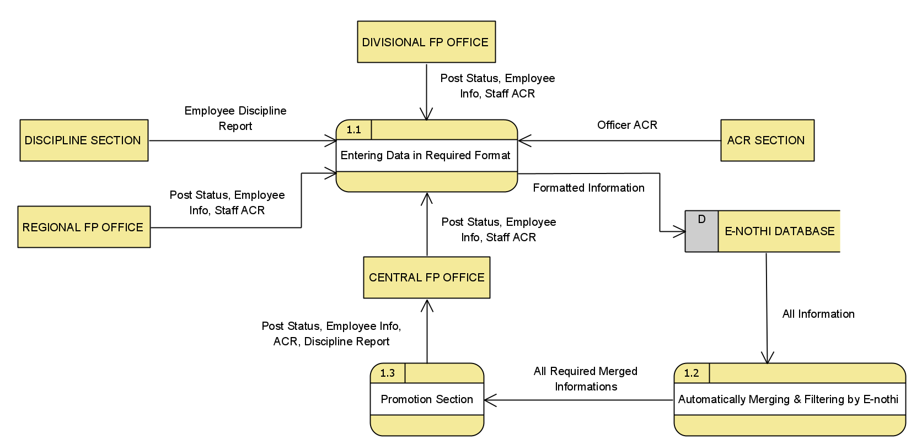

Fig. 4.1: The Data flow diagram for promotion level in the proposed system

**4.2.7 Not proper monitoring system during the recruitment**

In new recruitment, there are some problems in the existing system. Such as the recruitment system is not digitalized and also there is no proper monitoring during the recruitment so proper manpower cannot be hired. In our proposed system, we create a database for digitalized recruitment and also, we create a DFD for the recruitment system. At chapter 5, the database for recruitment system is shown.

|  |  |  |  |  |  |
| --- | --- | --- | --- | --- | --- |
| **Evaluation Criteria** | **Weighting factor** | **By increasing manpower in the existing system** | | **By creating recruitment management system** | |
| **Rating** | **Score** | **Rating** | **Score** |
| **Performance**  Merit justification  Integration  Hiring process  Tracking  User interface  Processing Speed  Security  **Cost**  Salary  Training  Maintainance | 2  4  3  4  3  5  3  4  3  5 | 4  2  2  2  3  2  3  2  4  4 | 8  8  6  8  9  10  9  8  12  20 | 5  5  4  5  4  5  5  5  3  3 | 10  20  12  20  12  25  15  20  9  15 |
| Total score |  | 98 | | 158 | |

Table 4.1 weighted candidate system evaluation matrix for increasing numbers of manpower versus a RMAT (Recruitment management and applicant tracking) system.

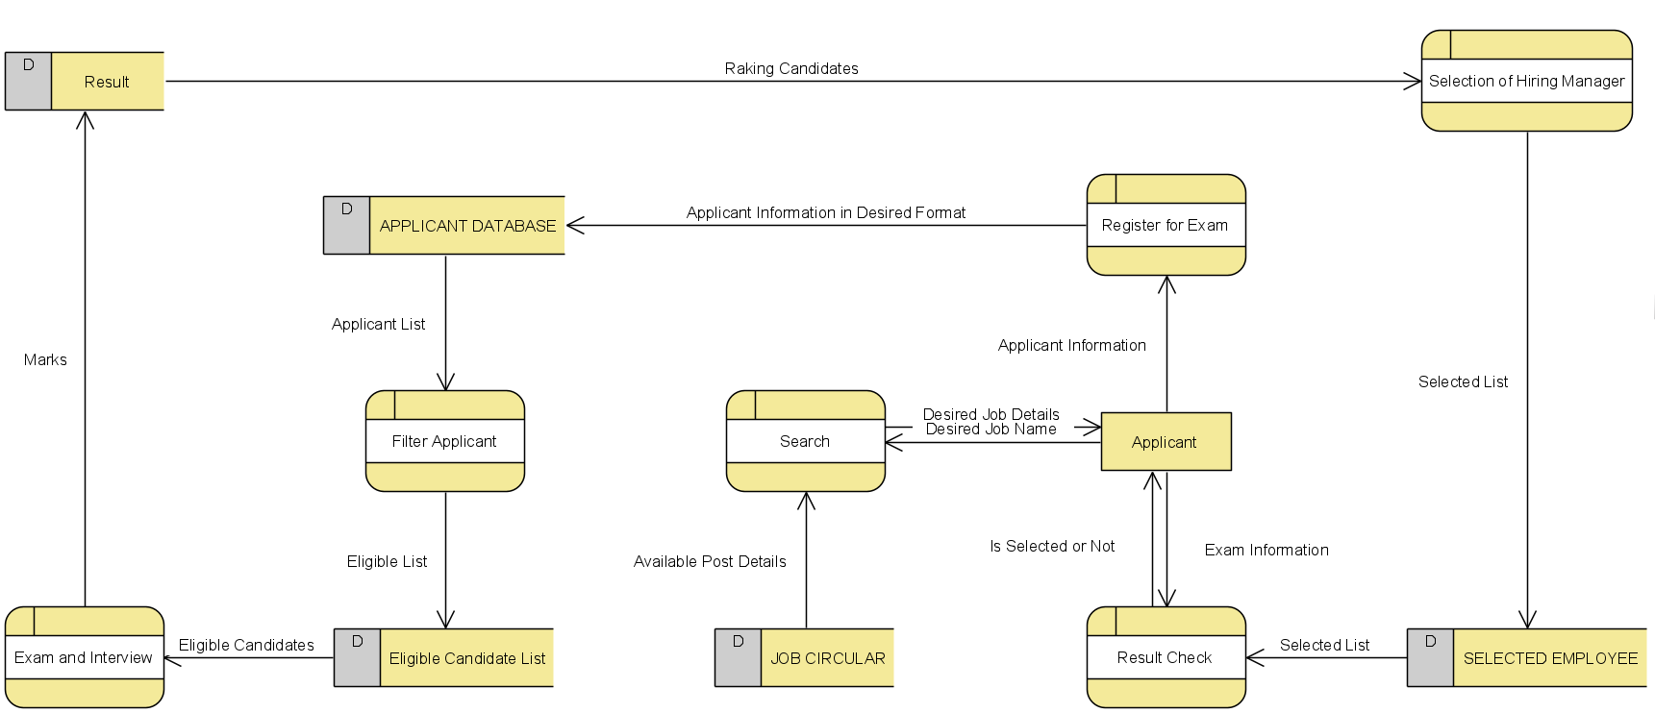

Fig. 4.2: Data flow diagram for (RMAT) Recruitment management and Applicant Tracking

***4.3 Conclusion***

In this chapter we have tried to give the feasible solution of the problems that are identified before and also give the reasons why these problems need to be solved. There are many considerations are taken into account to find out the feasible solutions of these problems.

**Chapter 5**

**Database Design**

***5.1 Introduction***

Databases are used for storing, maintaining and accessing any sort of data. They collect information on people, places or things. That information is gathered in one place so that it can be observed and analyzed. Databases can be thought of as an organized collection of information.

The purpose of database design for the Family Planning Office is to create efficient way of handling large amounts and multiple types of data, easy access of information, categorizing data and to create an organized working environment.

***5.2 Database for human resource***

To gather all information related to human resources, several types of data is needed. These are categorized into several tables in our proposed database for human resource. This makes collecting, accessing and querying very easy. Name of the tables are given in *figure 5.1*.

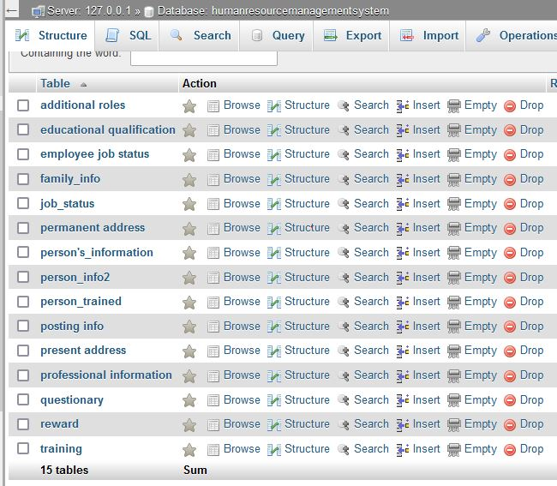

*Figure 5.1 Tables of Human Resource Database*

**5.2.1 Entity relationship diagram for human resource**

An Entity Relationship (ER) Diagram is a type of flowchart that illustrates how entities relate to each other within a system.

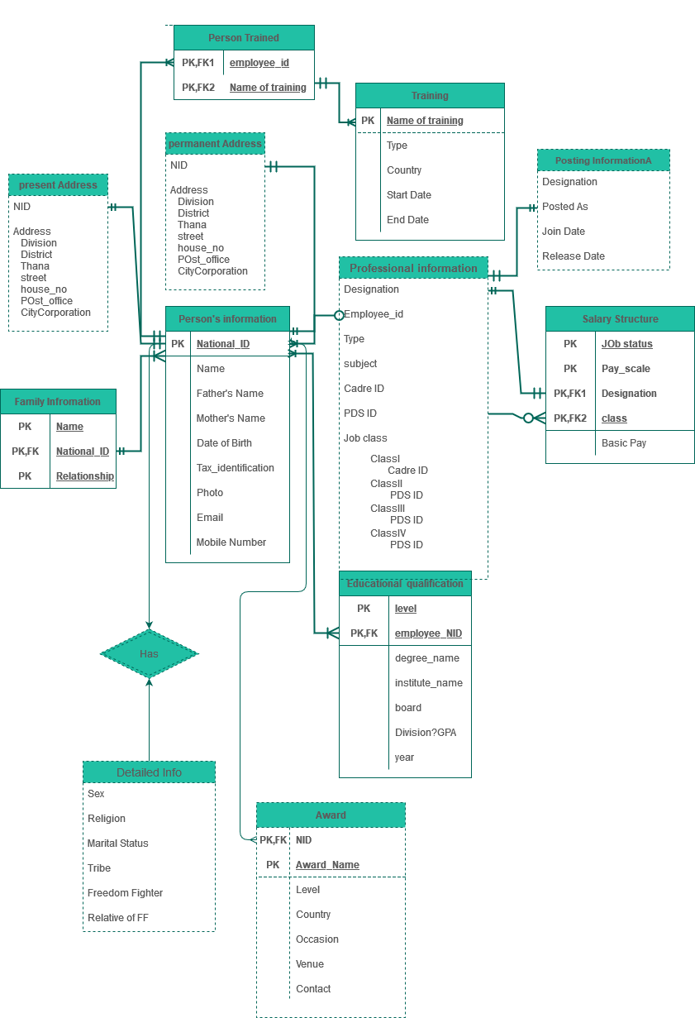

*Figure 5.2 Entity Relationship diagram of Human Resource Database*

**5.2.2 Structure of tables in human resource**

The structure of each table of the human resource database are shown in the figures below.

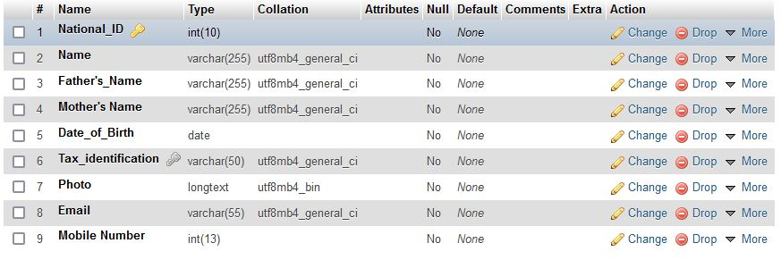

*Figure 5.3 Person’s information Table*

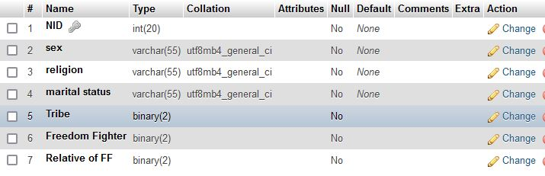

*Figure 5.4 Person Information Table 2*

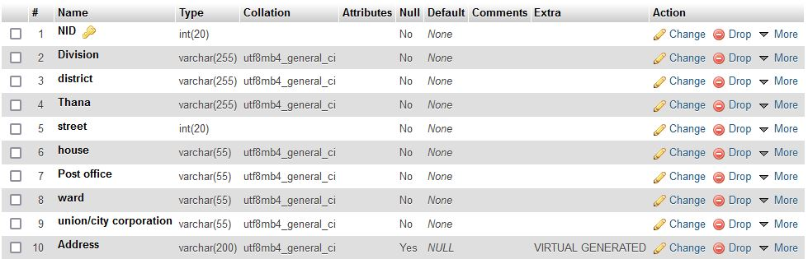

*Figure 5.5 present address Table*

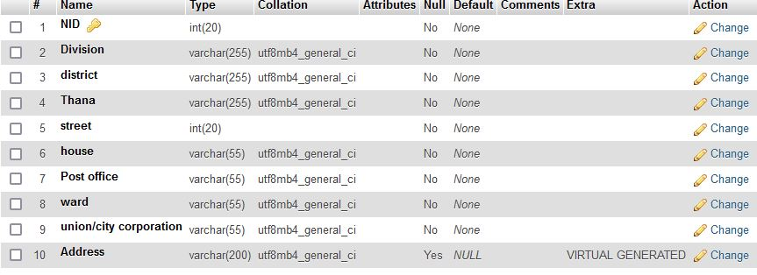

*Figure 5.6 permanent address Table*

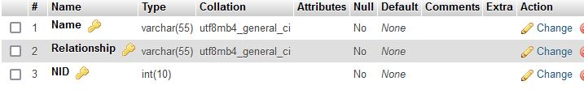

*Figure 5.7 family_info Table*

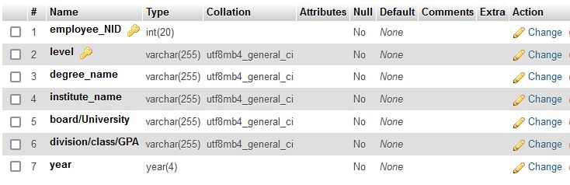

*Figure 5.8 educational qualification Table*

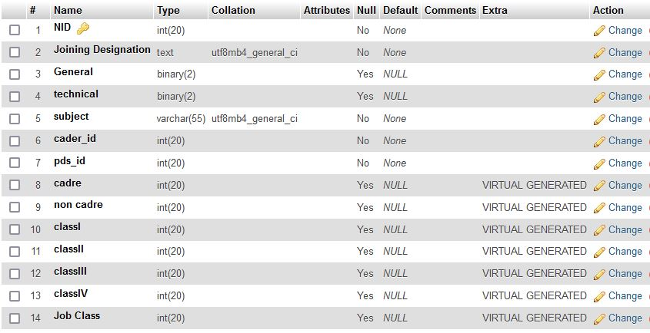

*Figure 5.9 professional information Table*

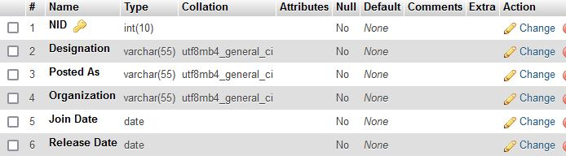

*Figure 5.10 posting info Table*

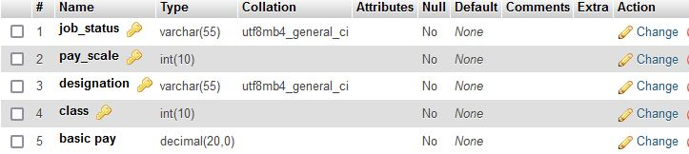

*Figure 5.11 salary structure Table*

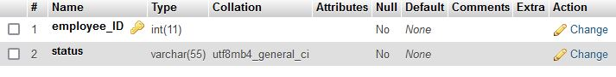

*Figure 5.12 employee job status Table*

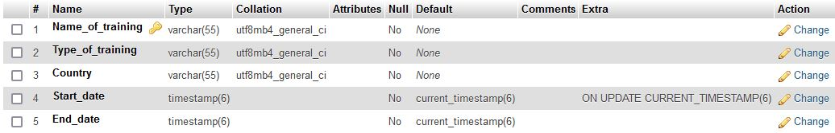

*Figure 5.13 training Table*

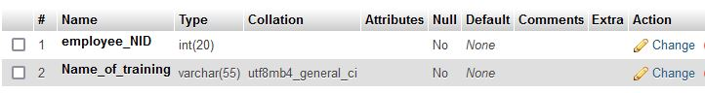

*Figure 5.14 person_trained Table*

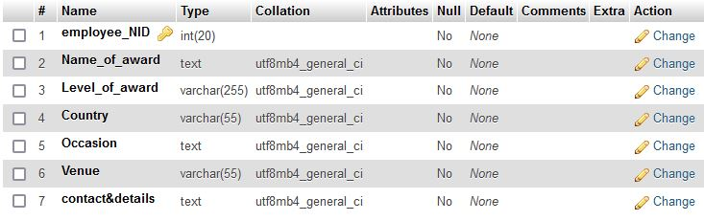

*Figure 5.15 reward Table*

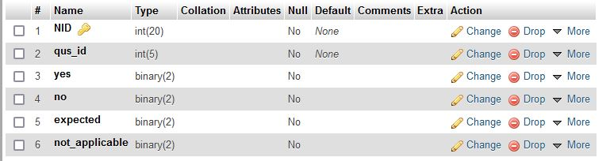

*Figure 5.16 questionary Table*

***5.3 Database for recruitment management system***

To successfully execute recruitment process, monitor them and store information efficiently, several types of data is needed. For collecting, accessing and querying efficiently, there are several tables in this database. Name of the tables are given in *figure 5.17*.

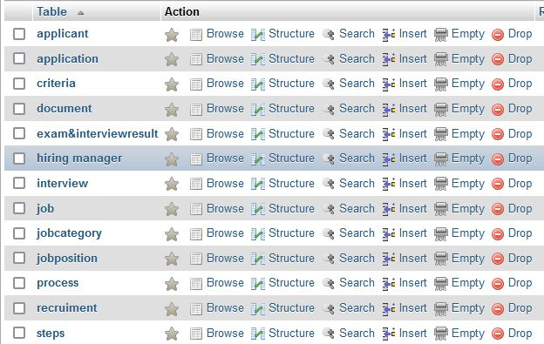

*Figure 5.17 Tables of Recruitment Management Database*

**5.3.1 Entity relationship diagram for recruitment management system**

An Entity Relationship (ER) Diagram is a type of flowchart that illustrates how entities relate to each other within a system.

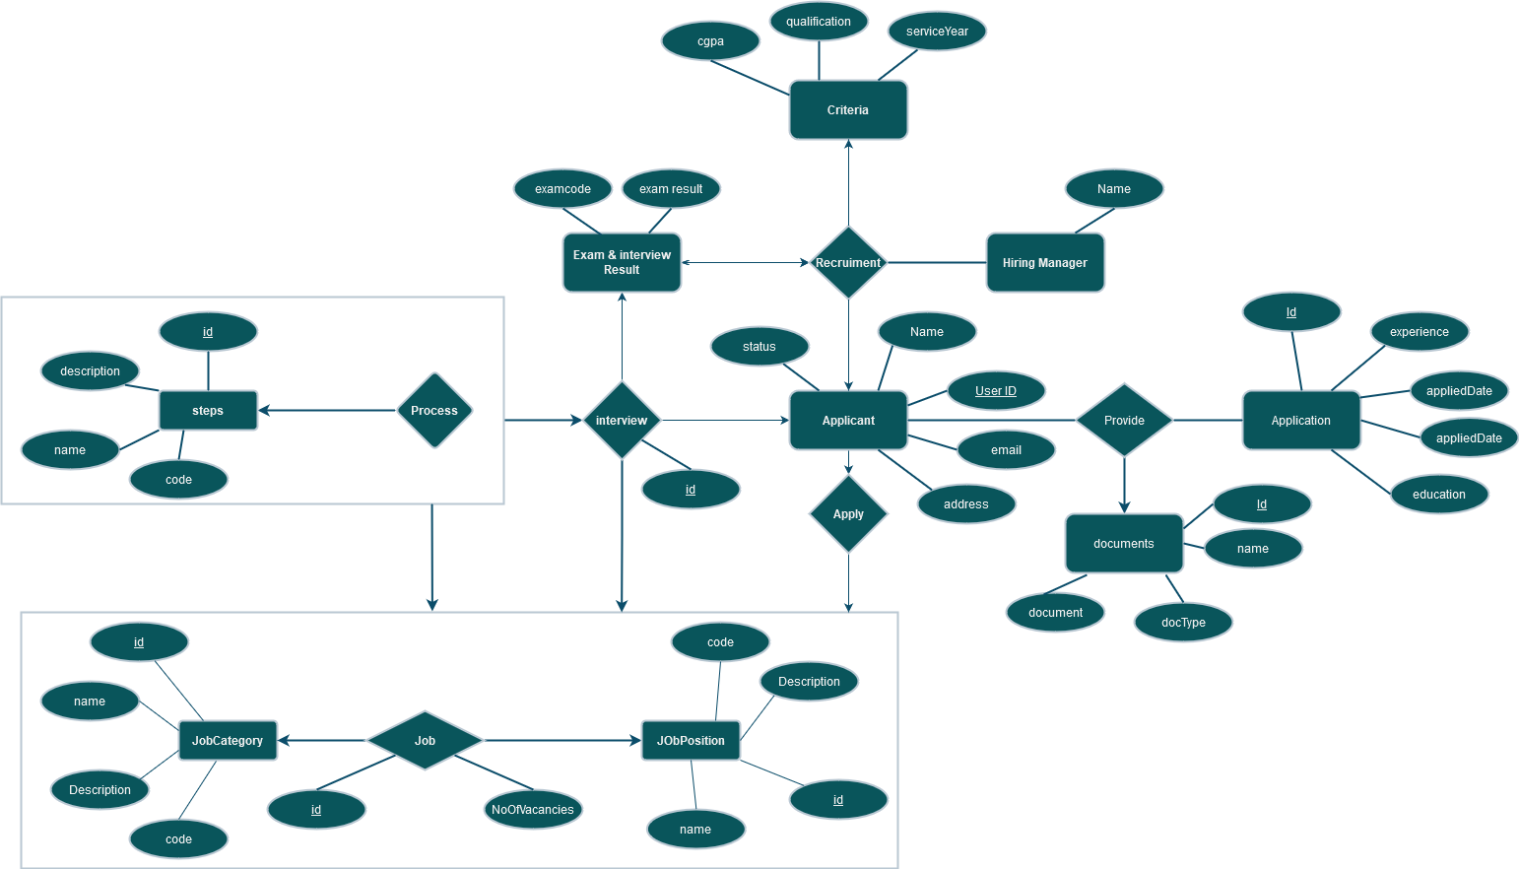

*Figure 5.18 Entity Relationship diagram of Recruitment Management Database*

**5.3.2 Structure of tables in recruitment management system**

The structure of each table of the recruitment management system database are shown in the figures below.

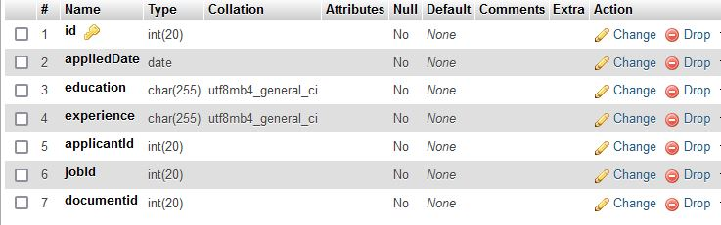

*Figure 5.19 application Table*

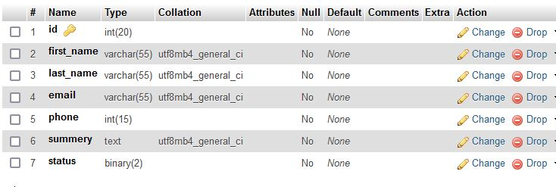

*Figure 5.20 applicant Table*

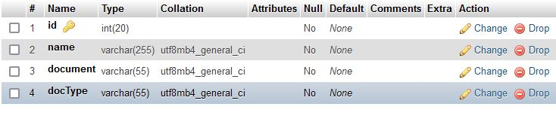

*Figure 5.21 document Table*

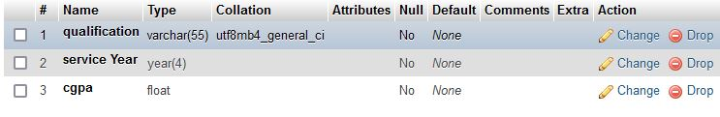

*Figure 5.22 criteria Table*

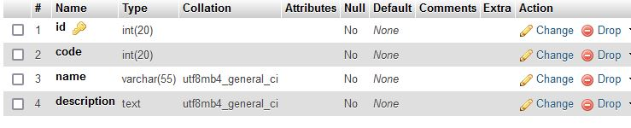

*Figure 5.23 jobcategory Table*

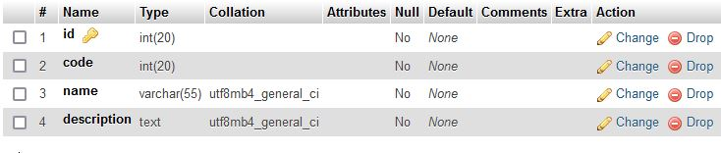

*Figure 5.24 jobposition Table*

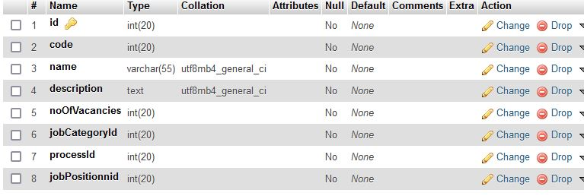

*Figure 5.25 job Table*

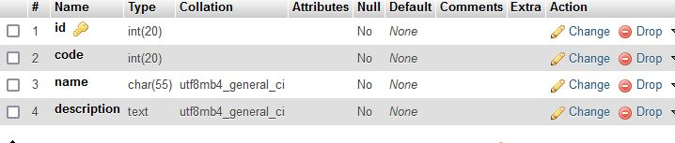

*Figure 5.26 steps Table*

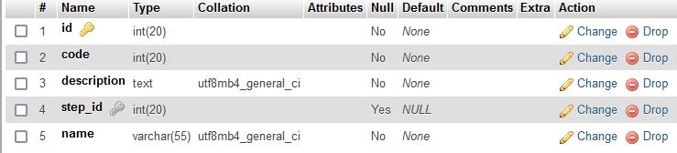

*Figure 5.27 process Table*

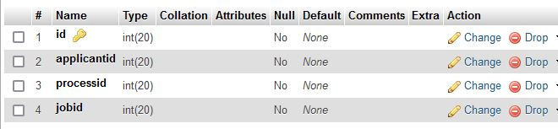

*Figure 5.28 interview Table*

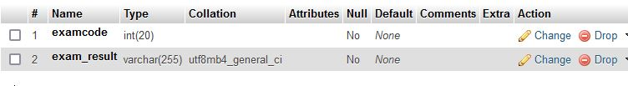

*Figure 5.29 exam&interviewresult Table*

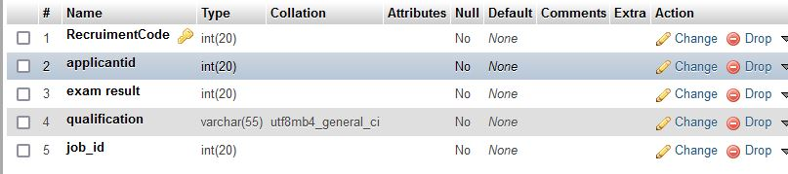

*Figure 5.30 recruitment Table*

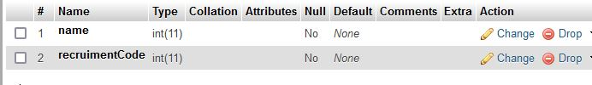

*Figure 5.31 hiring manager Table*

***5.4 Conclusion***

The proposed databases will improve data sharing and data security. This will minimize data inconsistency, faster data access. This will also reduce data entry, storage, and retrieval costs. It will make the Family Planning office more efficient, effective.

**Chapter 6**

**Summary of System Analysis and Design on Directorate General of Family Planning**

In this paper, we have made an analysis on the prevailing system Directorate General of Family Planning, Rajshahi branch.

This is a government agency responsible for family planning in Bangladesh. Family Planning Board and Family Planning Council was established in 1972. Since then this agency is working to ensure quality and equitable health care for all citizens in Bangladesh.

In achieving their goals, they are quite rigid. They are eager to improve the calibre of their offerings. They constantly give maternity and child health special attention. The files and documents are appropriately kept confidential by this organization. Actually, what we learned from examining their system was how meticulous and accountable they are with regard to every little detail.

They also have their own missions and visions. The goal is to establish circumstances that will allow Bangladeshis to achieve and retain the highest possible level of health. The Organization wants to see a country where everyone has access to comprehensive, high-quality family planning and healthcare services.

In our analysis previously we have identified ten problems apparently. We have found that the logistics allotments are delayed. So, day to day activity is hampered a lot. The whole system is not fully digitized. As a result, the organization is unable to effectively provide quality service. There is no adequate infrastructure at the district and upazila levels.

We also found that that the senior officials are not agile. So, first paced and short-termed training session proves to ineffective. E-nothi (e-filing) system lacks proper monitoring and also the senior officials find it difficult to use as their slow to adapt with modern technology.

There is no personal datasheet or database. As a result, useful information about Recruitment, promotion and transfer cannot be processed effectively.

We also found out that although there is a provision for promotion of officers and employees, the promotion is not visible or inadequate. Due to vacancy of post, maternal and child health services and family planning services are being disrupted. Due to negligence of duty while recruitment properly skilled manpower cannot be hired. Also causes imperfect persons to be recruited which later causes legal problems.

We have used a variety of ways to acquire data from the board. We gathered all of their paperwork, documents, and forms. We have seen how they operate on onsite. Then, we scheduled an interview with the upper quality assistant. These details facilitated our work and improved our understanding of the organization's internal workings.

We have created a data flow diagram for the current system so that anyone can quickly comprehend how the entire business operates. We created another data flow diagram with a few tweaks after considering the viability of resolving the difficulties at hand. Actually, this suggested data flow diagram serves our aim to the fullest extent. Anyone may understand what we wanted to change by looking at the proposed system's data flow diagram for the organization that was being studied.

We have also proposed optimised database concept for the proposed system.

**1. HUMAN RESOURSE MANAGEMENT SYSTEM (HRMS):**

Human resource management system is one of the most efficient way of handling and accessing all important information of employees in a disciplined and organized way. A large organization need to handle different human resource functions on a day to day basis for example, employee payroll, benefits, promotions, training etc. The Directorate General of Family Planning is a government agency which has similar functions. There by we are proposing a personal database that would have access to all necessary information of each person working in that organization. To elaborate how it is going to help this organization, let’s assume the authority needs to know the following information i.e, employee’s name, educational qualification, and joining designation, join date, job status, pay scale etc. for promotion purpose. We have provided all these attributes under different entities (personal information, posting info, educational qualification, professional information, salary structure etc.). By querying these entities using primary and foreign keys, would easily provide us a list of qualified employees for promotion. Our proposed HRMS database contained about 15 entities within which some are weak entities that does not contain any primary key (i.e. person trained). Each entity contained relevant attributes and corresponding primary key (i.e. NID). All this information provides a sustainable information regarding how many employees are getting training services? Who are qualified for reward or promotions? Weather any employee is freedom fighter or relative of any freedom fighter? Etc.

We can conclude that our HRMS system undoubtedly increase the performance and remove any kind of uncertainties to perform any human resource functions.

**2. RECRUITMENT MANAGEMENT SYSTEM (RMS):**

We have proposed a second database system to create fully automated system for recruitment management. This system is very useful to collaborate between candidates and hiring committee. Then recruiters can post vacancies, add candidates and schedule and conduct interviews for candidates. Candidates can add a number of skills to their profiles, check for available vacancies and communicate with recruiters, etc. The first phase of the interviews are conducted through the system and the post first phase are announced via the system which is a special feature of RMS system. This system has an attractive and user-friendly interface, so that it is easy for the users to use for the first time. We are able to demonstrate that our proposed RMS system significantly improves the efficiency and effectiveness of recruitment of candidates in the organization. So that it will provide a good service by contributing a tremendous number of features to the recruitment management section of this organization.

In our whole analysis we discovered that the staff members and employees were quite friendly and helpful during the entire investigation and design phase. They have been completely cooperative with us. We sought to alter those systems so that the organization would profit more from them than it did from the previous one while incurring no additional costs as a result of the change. We offered seven modifications they may make to their system. Other issues can be resolved as well, but most of them are not economically viable. In order to keep up with the current world, we expect that this organization will implement further modifications and digitize the entire system in the future.