1. **Explain the applications of Mobile Computing?**

Wireless networks have a wide range of applications in today's life, making communication and data transfer more efficient and accessible. Here are some key applications:

1. Mobile Communication :

- Cellular Networks (4G/5G) : Provide mobile voice and data services, enabling smartphones and other mobile devices to stay connected to the internet.

- Wi-Fi : Enables wireless internet access at home, offices, cafes, airports, etc.

**1. Business Applications**

* **Remote Work**: Enables employees to access corporate networks, collaborate, and work efficiently from anywhere.
* **Field Services**: Mobile devices help service technicians update work orders, access manuals, and track progress.
* **Sales and Marketing**: Sales teams use mobile devices for client presentations, product demonstrations, and order processing.

**2. Healthcare**

* **Telemedicine**: Doctors can diagnose and monitor patients remotely via mobile apps and devices.
* **Electronic Health Records (EHRs)**: Healthcare professionals access patient records on mobile devices for better treatment.
* **Mobile Health Apps**: Track fitness, monitor vital signs, and manage medications for patients.

**3. Education**

* **E-Learning**: Students and teachers access educational content and interact through mobile apps and platforms.
* **Distance Learning**: Mobile computing enables learning from remote locations via video conferencing and online courses.
* **Digital Libraries**: Accessing academic resources, eBooks, and research articles on-the-go.

**4. Banking and Finance**

* **Mobile Banking**: Users perform transactions, check balances, and pay bills through banking apps.
* **Stock Trading**: Investors monitor market trends and trade stocks using mobile platforms.
* **E-Wallets**: Digital payment systems like Google Pay and PayPal enable seamless transactions.

**5. Transportation and Logistics**

* **Navigation and GPS**: Real-time maps and route planning for efficient transportation.
* **Fleet Management**: Companies track and manage vehicles, monitor fuel consumption, and optimize routes.
* **Ride-Sharing Services**: Apps like Uber and Lyft rely on mobile computing for seamless user experiences.

**6. Entertainment**

* **Streaming Services**: Access to movies, music, and games on mobile devices anytime, anywhere.
* **Social Media**: Platforms like Instagram, Twitter, and Facebook allow users to connect and share content on the go.
* **Gaming**: Mobile computing powers online and augmented reality (AR) gaming.

**7. Retail and E-Commerce**

* **Online Shopping**: Users browse and purchase products via apps like Amazon and Flipkart.
* **Mobile Point of Sale (mPOS)**: Retailers use mobile devices to accept payments and manage inventory.
* **Customer Engagement**: Personalized marketing and notifications via mobile apps.

**8. Government Services**

* **E-Governance**: Citizens access services like tax filing, bill payments, and document verification through mobile apps.
* **Emergency Services**: Real-time alerts and communication during natural disasters or emergencies.
* **Surveillance and Monitoring**: Law enforcement uses mobile systems for on-field data collection and communication.

**9. Agriculture**

* **Precision Farming**: Farmers use mobile apps to monitor weather, soil conditions, and crop health.
* **Market Access**: Mobile computing connects farmers to markets, enabling them to get fair prices for their produce.
* **Smart Irrigation**: Control irrigation systems remotely using mobile devices.

**10. Personal Use**

* **Communication**: Mobile computing supports texting, voice calls, and video calls via apps like WhatsApp and Zoom.
* **Fitness Tracking**: Wearables like smartwatches sync with mobile apps to monitor health metrics.
* **Smart Home Control**: Control home devices like lights, thermostats, and security systems remotely.

**Conclusion**

Mobile computing has revolutionized industries and everyday life by enhancing connectivity, productivity, and convenience. Its applications continue to expand with advancements in mobile technology, such as 5G, IoT, and AI.

1. **Explain Limitations of Mobile Computing?**

**Limitations of Mobile Computing**

Mobile computing has revolutionized the way we interact with technology, enabling portability and convenience. However, despite its numerous advantages, there are several limitations and challenges associated with mobile computing. These limitations can impact the overall performance, reliability, and usability of mobile systems.

Here are some of the main limitations:

**1. Limited Battery Life**

* **Problem**: Mobile devices such as smartphones, tablets, and laptops rely on batteries for power, which limits their operation time.
* **Impact**: Frequent charging is required, and long usage periods can drain the battery quickly, leading to decreased productivity and user inconvenience.
* **Solutions**: Advances in battery technology, energy-efficient hardware, and software optimization can help mitigate this issue.

**2. Network Connectivity Issues**

* **Problem**: Mobile computing heavily depends on wireless networks (e.g., Wi-Fi, cellular, Bluetooth). The strength and availability of network signals can vary greatly depending on the environment.
* **Impact**: Users may experience poor signal strength, dropped connections, or slow internet speeds, especially in rural or crowded areas or when moving between different locations.
* **Solutions**: Use of 5G networks, improved coverage, and Wi-Fi hotspots can help, but challenges like network congestion and signal interference remain.

**3. Security and Privacy Concerns**

* **Problem**: Mobile devices are more vulnerable to attacks such as hacking, malware, data theft, and unauthorized access due to their portability and frequent connection to public networks.
* **Impact**: Security breaches can lead to loss of sensitive data, identity theft, or exposure to malicious software.
* **Solutions**: Implementing strong encryption, multi-factor authentication (MFA), regular security updates, and device-level security (e.g., biometric authentication) can enhance protection.

**4. Limited Processing Power**

* **Problem**: Mobile devices typically have less processing power compared to desktops or servers due to their compact form factor and focus on battery efficiency.
* **Impact**: This limitation can hinder the performance of resource-intensive applications such as high-definition video streaming, gaming, or large-scale data analysis.
* **Solutions**: Cloud computing and edge computing can offload some of the processing demands to more powerful remote servers, allowing mobile devices to access heavy computational resources.

**5. Limited Storage Capacity**

* **Problem**: The storage capacity of mobile devices is often smaller compared to desktops or servers due to the need for portability and space constraints.
* **Impact**: This limitation can affect the ability to store large files, applications, or media, and can result in slower device performance when storage is nearly full.
* **Solutions**: Use of cloud storage, external storage devices, or storage optimization techniques can help address this issue.

**6. High Cost of Mobile Devices and Connectivity**

* **Problem**: Mobile computing devices, especially smartphones, laptops, and tablets with advanced features, can be expensive. Additionally, mobile data plans for internet access can also add to the costs.
* **Impact**: The high initial cost and ongoing costs of data usage can be a barrier to adoption, particularly in regions with lower economic conditions.
* **Solutions**: Reduced prices for affordable devices, cheaper data plans, and the use of free or low-cost public Wi-Fi networks can help mitigate this limitation.

**7. Limited User Interface and Interaction**

* **Problem**: Mobile devices often have small screens, limited input methods (e.g., touchscreen, virtual keyboard), and less ergonomic designs compared to traditional desktops.
* **Impact**: This can make tasks like typing, navigating through apps, or editing documents less efficient and more challenging, especially for users with larger hands or those needing precise control.
* **Solutions**: Advances in voice recognition, gesture control, and virtual reality interfaces may help enhance user interaction. However, certain tasks still benefit from larger screens and physical keyboards.

**8. Limited Multitasking Capabilities**

* **Problem**: While mobile operating systems have improved multitasking features, mobile devices often struggle with running multiple resource-intensive applications simultaneously.
* **Impact**: Running many applications at once can slow down the device, affect battery life, and increase the chance of crashes or unresponsiveness.
* **Solutions**: Mobile devices with more powerful processors and increased RAM can handle multitasking better, but users may still face limitations compared to traditional computers.

**9. Environmental Factors**

* **Problem**: Mobile devices are more susceptible to environmental factors such as extreme temperatures, humidity, dust, and physical impacts (e.g., drops or water damage).
* **Impact**: Exposure to these elements can reduce the lifespan of mobile devices and even lead to device failure or data loss.
* **Solutions**: Protective cases, rugged devices, and waterproofing technologies can help mitigate environmental risks.

**10. Dependency on External Infrastructure**

* **Problem**: Mobile computing often relies on external infrastructure, such as cellular networks, Wi-Fi, and cloud services. These services may not always be available or reliable.
* **Impact**: In areas with poor infrastructure, such as remote or rural locations, mobile computing can be severely limited, affecting access to services and productivity.
* **Solutions**: Offline modes for certain applications, use of satellite communication, and expanding network infrastructure can improve the situation.

**11. Limited Software and Application Availability**

* **Problem**: While mobile app ecosystems have grown significantly, there are still some applications or software packages that are not fully optimized for mobile platforms or do not exist in mobile versions.
* **Impact**: Users may experience difficulty performing certain tasks that are easily done on traditional desktops or laptops, such as heavy content creation or specialized professional work.
* **Solutions**: The development of more mobile-friendly software and cloud-based applications that can be accessed across devices may help bridge this gap.

**12. Regulatory and Legal Issues**

* **Problem**: Mobile computing often involves roaming across different geographic regions and networks, each with different laws, regulations, and standards regarding data privacy, security, and usage.
* **Impact**: Users and organizations may face legal challenges when operating mobile devices in different regions, particularly related to data protection laws.
* **Solutions**: Awareness of local regulations and adopting best practices for global compliance can help mitigate legal risks.

**Conclusion**

Despite the many advantages of mobile computing, it faces several limitations that affect its efficiency, security, and overall user experience. Overcoming these challenges requires ongoing technological advancements, innovative solutions, and improvements in infrastructure. As mobile technology continues to evolve, many of these limitations will likely be addressed, leading to even greater benefits for users in the future.

1. **Differentiate guided and unguided media transmission?**

**Comparison of Guided and Unguided Media Transmission**

**Guided and unguided media are two primary types of communication channels used in networking. Below is a detailed differentiation based on various factors:**

| **Aspect** | **Guided Media** | **Unguided Media** |
| --- | --- | --- |
| **Definition** | **Uses physical pathways (cables) to transmit signals.** | **Transmits signals through the air or space without a physical medium.** |
| **Examples** | **Twisted pair cables, coaxial cables, optical fiber.** | **Radio waves, microwaves, infrared signals.** |
| **Medium** | **Physical (solid medium like cables or optical fibers).** | **Wireless (air, space, or vacuum).** |
| **Signal Propagation** | **Signals are confined to the physical medium.** | **Signals propagate freely in all directions.** |
| **Bandwidth** | **Higher bandwidth in certain cases (e.g., optical fiber).** | **Typically lower bandwidth compared to guided media.** |
| **Interference** | **Less prone to external interference due to shielding.** | **More susceptible to environmental interference and noise.** |
| **Installation** | **Requires laying cables; involves more effort and cost.** | **Easier to install; no physical infrastructure needed.** |
| **Mobility** | **Limited to fixed locations; physical connections required.** | **Allows for mobility; suitable for mobile communication.** |
| **Maintenance** | **Complex and costly due to physical wear and tear.** | **Easier, but interference issues may require adjustments.** |
| **Security** | **Offers higher security since signals are confined to the medium.** | **Less secure as signals can be intercepted more easily.** |
| **Cost** | **Higher initial setup cost (cable installation).** | **Lower initial cost but may involve higher ongoing operational costs.** |
| **Applications** | **LANs, telephone networks, cable TV.** | **Mobile networks, satellite communication, Wi-Fi.** |

**Key Points**

1. **Guided Media is suitable for fixed and secure connections where high bandwidth is required, such as in LANs or data centers.**
2. **Unguided Media is ideal for applications that demand mobility, such as wireless communication systems and satellite links.**

**Conclusion**

**Both guided and unguided media have their advantages and are chosen based on the specific requirements of the application, such as cost, mobility, security, and bandwidth.**

1. **Explain the Limitations of Handheld devices?**

**Limitations of Handheld Devices**

**Handheld devices, such as smartphones, tablets, and PDAs, are designed for portability and convenience. However, they come with several limitations that can affect performance, usability, and functionality.**

**1. Hardware Limitations**

**a. Processing Power:**

* **Handheld devices typically have less powerful processors compared to laptops or desktops, limiting their ability to handle resource-intensive applications like high-end gaming or complex computations.**

**b. Limited Memory:**

* **RAM and storage capacity are often limited, which can affect multitasking and the storage of large files or applications.**

**c. Small Battery Life:**

* **Due to compact size, battery capacity is limited, leading to shorter usage times and frequent recharging requirements.**

**d. Small Screen Size:**

* **The compact screen can make reading, typing, and editing tasks more challenging, particularly for professional or educational purposes.**

**e. Restricted Peripheral Support:**

* **Lack of extensive ports limits connectivity with external devices like monitors, keyboards, or printers.**

**2. Software Limitations**

**a. Simplified Operating Systems:**

* **Mobile operating systems like Android or iOS are optimized for handheld devices but lack some features of full-fledged OS like Windows or macOS.**

**b. App Compatibility:**

* **Some software applications are not available for handheld devices, or they may offer limited functionality compared to their desktop versions.**

**3. Connectivity Challenges**

**a. Network Dependence:**

* **Handheld devices rely heavily on wireless networks (Wi-Fi, mobile data) for internet access, and poor connectivity can degrade their functionality.**

**b. Lower Bandwidth:**

* **Wireless connections may not always provide the high-speed internet required for seamless performance in data-heavy applications.**

**4. Ergonomic and Usability Issues**

**a. Input Constraints:**

* **Virtual keyboards and touch screens can be less efficient and accurate compared to physical keyboards and mice for input-intensive tasks.**

**b. Strain on Users:**

* **Prolonged use can lead to eye strain, neck strain, or repetitive stress injuries due to awkward handling or small displays.**

**5. Security Concerns**

**a. Vulnerability:**

* **Handheld devices are more prone to theft or loss due to their compact and portable nature.**

**b. Data Protection:**

* **Limited support for advanced security features, such as firewalls or encryption, increases the risk of data breaches.**

**c. Malware Risks:**

* **Mobile devices are increasingly targeted by malware and phishing attacks, especially when connected to public networks.**

**6. Environmental Factors**

**a. Fragility:**

* **Handheld devices are more susceptible to damage from drops, spills, and other physical impacts.**

**b. Performance in Extreme Conditions:**

* **Extreme temperatures, dust, or moisture can adversely affect their performance and lifespan.**

**7. Cost Implications**

**a. High Cost of Ownership:**

* **Frequent upgrades are often required to keep up with advancing technology, increasing the total cost of ownership.**

**b. Repair and Replacement:**

* **Repairs can be expensive, and in some cases, replacement may be the only option.**

**Conclusion**

**While handheld devices offer unparalleled portability and convenience, their limitations in hardware, software, and usability can restrict their effectiveness for certain tasks. Understanding these constraints helps users choose appropriate devices based on their specific needs and applications.**

**5. With a neat diagram, explain the functional architecture of a GSM system**?

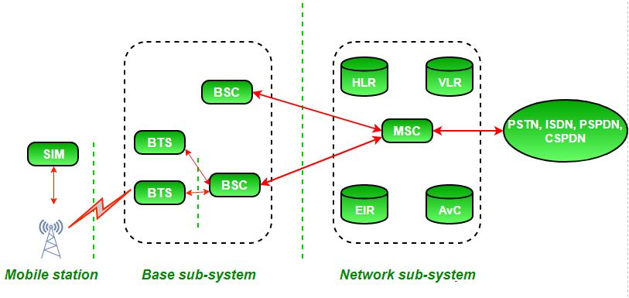

**Functional Architecture of a GSM System**

The **Global System for Mobile Communications (GSM)** is a cellular network system widely used for mobile communication. It provides services like voice communication, text messaging (SMS), and data transmission. The functional architecture of a GSM system is structured to manage both the mobile terminals (phones) and the network infrastructure. Below is an explanation of the main components involved in GSM architecture, along with a diagram for better understanding.

**Key Components of the GSM System:**

1. **Mobile Station (MS):**
   * The mobile station is the end-user device, i.e., the mobile phone or device that connects to the GSM network.
   * It consists of two parts:
     + **Mobile Equipment (ME):** The hardware part, i.e., the mobile phone itself.
     + **Subscriber Identity Module (SIM):** A smart card containing the subscriber's information, including their identity, authentication data, and local storage for contact numbers.
2. **Base Station Subsystem (BSS):**
   * The BSS is responsible for handling communication between mobile stations and the network.
   * It consists of two main components:
     + **Base Transceiver Station (BTS):** This component handles the radio communication with the mobile station (MS). It manages the radio resources, such as channel allocation and handovers, and communicates directly with MSs within its coverage area.
     + **Base Station Controller (BSC):** The BSC manages multiple BTSs and coordinates their operation. It handles functions like handover (transferring calls between BTSs), power control, and resource management.
3. **Network Subsystem (NSS):**
   * The NSS is the core of the GSM network that manages all the network-related tasks such as call setup, routing, and maintenance of the subscriber database. Key components include:
     + **Mobile Switching Center (MSC):** The MSC is responsible for call routing, switching between different BTSs and BSCs, managing mobility, and ensuring proper connection during a call.
     + **Home Location Register (HLR):** The HLR is a central database that stores information about subscribers, including their profile, service subscriptions, and current location.
     + **Visitor Location Register (VLR):** The VLR is a temporary database that stores information about subscribers who are currently within a certain area or visiting a particular MSC's service area. It helps the MSC in handling mobile subscribers on the move.
     + **Authentication Center (AUC):** The AUC ensures security in the network by authenticating the user’s identity. It generates encryption keys and checks the legitimacy of the subscriber.
     + **Equipment Identity Register (EIR):** The EIR is a database that maintains information about mobile equipment (IMEI numbers). It helps identify stolen or fraudulent devices.
4. **Operation and Support Subsystem (OSS):**
   * The OSS is responsible for the overall monitoring and management of the GSM network. It ensures the network operates optimally, performs maintenance, and troubleshoots issues. OSS is used by network operators to configure, maintain, and monitor all components in the GSM system.

**Functional Diagram of GSM Architecture:**

Here is a simplified diagram representing the GSM system's functional architecture:

+--------------------+ +------------------+

| Mobile Station | | Mobile Station|

| (MS) |<--Radio--> | (MS) |

+--------------------+ +------------------+

| |

| |

+--------------------+ +-------------------+

| Base Station |<--> | Base Station |

| Controller (BSC) | | Transceiver (BTS) |

+--------------------+ +-------------------+

| |

| |

+-------------------------+ +-------------------------+

| Mobile Switching |<-----> | Home Location Register|

| Center (MSC) | | (HLR) |

+-------------------------+ +-------------------------+

| |

| |

+-------------------------+ +-------------------------+

| Authentication Center |<-----> | Equipment Identity |

| (AUC) | | Register (EIR) |

+-------------------------+ +-------------------------+

**Explanation of the Diagram:**

1. **Mobile Station (MS):** The mobile phones interact with the network via Base Transceiver Stations (BTS) through radio signals.
2. **BTS (Base Transceiver Station):** Each BTS covers a specific geographic area and manages radio communication with the mobile phones.
3. **BSC (Base Station Controller):** The BSC manages several BTSs, allocating resources and handling handovers between base stations.
4. **MSC (Mobile Switching Center):** The MSC handles the core switching functions, routing calls, and managing connections between different parts of the network.
5. **HLR (Home Location Register):** Stores the subscriber's details, including service subscriptions and current location.
6. **VLR (Visitor Location Register):** Temporary database that stores subscriber details while they are in a specific area.
7. **AUC (Authentication Center):** Responsible for verifying the subscriber’s identity and security.
8. **EIR (Equipment Identity Register):** A database that stores the IMEI numbers of mobile devices, used for tracking and preventing fraudulent devices.

**GSM System Functions:**

* **Call Setup and Routing:** When a call is initiated, the call request is sent through the BTS, BSC, and MSC for routing.
* **Authentication:** The AUC verifies the subscriber's credentials before call establishment.
* **Mobility Management:** The system tracks the location of users via the HLR, VLR, and MSC, ensuring seamless communication as the user moves.
* **Handover:** When a mobile user moves from one cell to another, the BSC handles the handover process to ensure uninterrupted communication.

**Conclusion:**

The GSM architecture is a layered system consisting of different subsystems that work together to ensure efficient mobile communication. The functional components handle everything from radio communication to call routing, subscriber management, and security. Each subsystem performs a crucial role in providing services like voice, SMS, and data in a mobile network.

**6.Discuss the protocol architecture of GSM?**

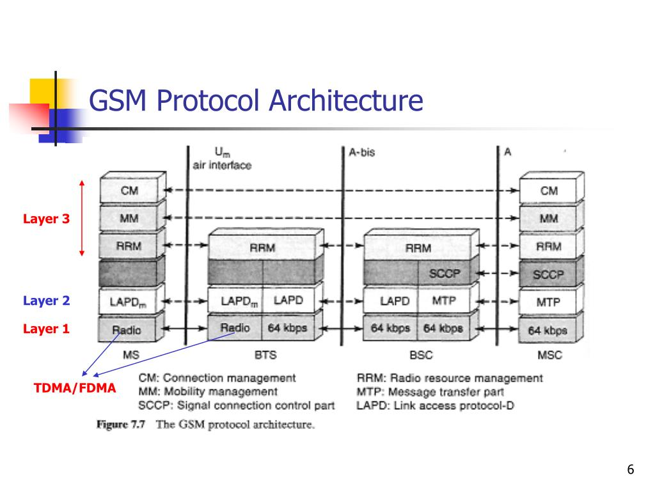

**Protocol Architecture of GSM**

**The GSM protocol architecture is a hierarchical set of protocols that governs the communication between mobile stations (MS), base stations (BTS), and the network infrastructure in a GSM system. The protocol layers are designed to handle different aspects of the communication process, such as radio communication, call management, authentication, and mobility management. These layers operate in parallel and enable a seamless user experience, ensuring both user and system functionality.**

**The GSM protocol architecture follows a layered structure and can be divided into several levels based on their functionality. These layers are organized into three main groups:**

1. **The Mobile Station (MS) Layers**
2. **The Base Station Subsystem (BSS) Layers**
3. **The Network Subsystem (NSS) Layers**

**Each group corresponds to the respective layers in the GSM system.**

**Overview of GSM Protocol Architecture**

**1. Mobile Station (MS) Protocols**

**At the Mobile Station (MS) level, the protocols are responsible for managing the interactions between the mobile device (such as a mobile phone) and the network. The MS consists of two key functional blocks:**

* **Mobile Equipment (ME): The physical device (phone) responsible for communication.**
* **Subscriber Identity Module (SIM): The card that stores subscriber information and ensures secure communication.**

**The MS protocol layers are grouped as follows:**

1. **Radio Resource Control (RRC) Layer:**
   * **Manages the connection between the mobile station and the network, including the establishment, maintenance, and release of radio resources.**
   * **Handles the setup and release of connections between the MS and the Base Station (BTS).**
2. **LLC (Logical Link Control) Layer:**
   * **Responsible for the logical link between the mobile station and the base station. It provides reliable data delivery over the radio link by using error detection, correction, and flow control mechanisms.**
   * **Ensures that the MS can transmit and receive data reliably.**
3. **MAC (Medium Access Control) Layer:**
   * **Coordinates access to the radio channel by managing time slots, frequency resources, and addressing. It ensures that multiple users can share the radio medium without interference.**
   * **The MAC layer performs the necessary handshakes and scheduling for data transmission.**
4. **RLC (Radio Link Control) Layer:**
   * **Provides error recovery services, retransmission, and flow control in both uplink and downlink communications.**
   * **Ensures data is transmitted correctly by the network by retransmitting any lost or corrupted data.**

**2. Base Station Subsystem (BSS) Protocols**

**The BSS is composed of Base Station Controllers (BSCs) and Base Transceiver Stations (BTSs), which control the radio resources and manage communication with the mobile stations. The BSS protocol layers are responsible for controlling radio resources, handovers, and communication with the network infrastructure. The BSS protocols include:**

1. **BSSAP (Base Station Subsystem Application Protocol):**
   * **BSSAP is responsible for managing the signaling between the mobile station and the BSC, ensuring that mobile station requests are appropriately handled, and call setup and handovers are carried out seamlessly.**
   * **BSSAP handles tasks such as the routing of mobile station calls to the MSC, and handover requests to ensure that users are seamlessly transferred between cells as they move.**
2. **RSL (Radio Signaling Link) Protocol:**
   * **The RSL protocol manages the signaling between the BSC and BTS. It is responsible for the control of radio channels, frequency allocations, and other signaling aspects of the radio interface.**

**3. Network Subsystem (NSS) Protocols**

**The Network Subsystem (NSS) contains the core network elements, including the Mobile Switching Center (MSC), Home Location Register (HLR), Visitor Location Register (VLR), Authentication Center (AUC), and Equipment Identity Register (EIR). The protocols at the NSS level manage call routing, mobility management, authentication, subscriber data management, and network security.**

**The NSS protocol layers include:**

1. **MAP (Mobile Application Part) Protocol:**
   * **MAP is one of the most important protocols in GSM, responsible for handling the signaling related to call setup, mobile station location management, authentication, and SMS.**
   * **MAP provides communication between different elements of the NSS, such as the MSC, VLR, and HLR, enabling mobile number portability, call routing, and subscriber database updates.**
2. **ISUP (ISDN User Part) Protocol:**
   * **ISUP is responsible for managing signaling between two MSCs when setting up a voice call. It is part of the signaling system for inter-network call setup and management.**
   * **ISUP handles the exchange of information required for establishing, maintaining, and clearing calls between different switching centers.**
3. **CAP (CAMEL Application Part) Protocol:**
   * **The CAMEL protocol is used to support value-added services such as prepaid billing, call forwarding, and other advanced features. It enables interaction with intelligent network (IN) services.**
   * **CAMEL allows for network operators to implement charging mechanisms, monitoring, and control of mobile calls in real time.**

**Protocol Stack Overview**

**Here’s a simplified view of the GSM protocol architecture across the different layers, showing how the protocols fit together in the system:**

**-----------------------------------------------------------**

**| **Layer** | **Protocol** |**

**-----------------------------------------------------------**

**| **Application Layer** | MAP, CAMEL, ISUP, BSSAP |**

**-----------------------------------------------------------**

**| **Transport Layer** | X.25, TCP/IP |**

**-----------------------------------------------------------**

**| **Network Layer** | Frame Relay, ATM, GPRS |**

**-----------------------------------------------------------**

**| **Data Link Layer** | LLC, RLC, MAC |**

**-----------------------------------------------------------**

**| **Physical Layer** | GSM Radio Interface (air interface) |**

**-----------------------------------------------------------**

**Explanation of Protocol Layers:**

1. **Physical Layer (Layer 1):**
   * **This layer deals with the radio transmission and reception. It defines the physical characteristics of the GSM air interface, such as frequency, time slots, modulation, and transmission power.**
2. **Data Link Layer (Layer 2):**
   * **The data link layer includes MAC (Medium Access Control), RLC (Radio Link Control), and LLC (Logical Link Control). These protocols ensure reliable communication over the radio link, including error detection and retransmission.**
3. **Network Layer (Layer 3):**
   * **The network layer consists of protocols like MAP (Mobile Application Part), which manages signaling between mobile stations, MSCs, and HLRs for mobility and call management.**
   * **It also includes ISUP for call signaling and routing between MSCs and CAP for intelligent network services like prepaid billing.**
4. **Transport Layer:**
   * **Provides end-to-end communication between network nodes, often using transport protocols like X.25 or TCP/IP to ensure data is delivered reliably across different parts of the network.**
5. **Application Layer:**
   * **This layer includes various GSM services like SMS, call setup, authentication, and roaming services. The protocols like BSSAP, MAP, and CAMEL handle application-level functions like mobile call setup, location updates, and network service control.**

**Conclusion**

**The GSM protocol architecture is a complex, multi-layered structure that ensures efficient and reliable mobile communication. It handles everything from radio resource management at the physical layer to call setup, authentication, and mobility management at the higher layers. The protocols are designed to ensure interoperability between different network elements (MS, BTS, BSC, MSC, etc.), provide security features, and support a wide range of services. Each layer in the protocol stack works together to provide a seamless experience for the end-user, from initial connection establishment to secure and uninterrupted communication.**

**7.Illustrate GSM Radio Interfaces?**

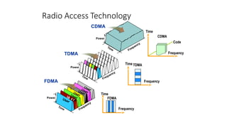

**GSM Radio Interfaces:**

**The GSM radio interface (also known as the air interface) is the part of the GSM network that handles the wireless communication between the mobile station (MS) and the base station (BTS), which is part of the Base Station Subsystem (BSS). The radio interface is defined by the physical and data link layers in the GSM protocol stack, and it provides the connection between mobile devices and the network infrastructure.**

**In GSM, the radio interface uses a combination of frequency division and time division to allow multiple mobile stations to share the same radio resources without interference. This is referred to as Frequency Division Multiple Access (FDMA) and Time Division Multiple Access (TDMA).**

**The radio interface consists of several key components:**

1. **Radio Channels**
2. **Frequency Allocation**
3. **Time Slots (TDMA)**
4. **Air Interface Protocols**
5. **Physical Layer**

**Below is a detailed explanation of each of these components, followed by a diagram illustrating the GSM radio interface.**

**1. Radio Channels:**

**The GSM radio interface is divided into various types of channels, each with a specific purpose. These channels can be divided into two categories:**

* **Traffic Channels (TCH):** 
  + **Used for carrying user data (voice, SMS, etc.).**
  + **Each traffic channel typically has a bandwidth of 13 kbps for speech data.**
* **Control Channels (CCH):** 
  + **Used for signaling and control purposes.**
  + **These include:** 
    - **BCCH (Broadcast Control Channel): Used by the BTS to broadcast system information (e.g., frequency, cell identity).**
    - **CCCH (Common Control Channel): Used for random access by the mobile station when it tries to connect to the network.**
    - **AGCH (Access Grant Channel): Used for allocating a traffic channel for a mobile station after a request.**
    - **PCH (Paging Channel): Used by the network to page a mobile station when there is an incoming call or message.**
    - **RACH (Random Access Channel): Used by the MS to initiate a request for access to the network.**
    - **SDCCH (Stand-alone Dedicated Control Channel): Used for signaling and authentication between the MS and network during call setup and registration.**

**2. Frequency Allocation:**

**GSM operates in specific frequency bands that vary by region. The key GSM frequency bands are:**

* **GSM 900 MHz: This band is the primary frequency band used for GSM networks in most parts of the world.**
  + **Uplink (Mobile to BTS): 890 MHz to 915 MHz**
  + **Downlink (BTS to Mobile): 935 MHz to 960 MHz**
* **GSM 1800 MHz (DCS 1800): This band is used in some regions, particularly in Europe and Asia.**
  + **Uplink: 1710 MHz to 1785 MHz**
  + **Downlink: 1805 MHz to 1880 MHz**
* **GSM 1900 MHz: Used primarily in North America.**
  + **Uplink: 1850 MHz to 1910 MHz**
  + **Downlink: 1930 MHz to 1990 MHz**

**Within these frequency bands, the available spectrum is divided into 200 kHz channels, each of which can carry a communication stream. These frequency channels are assigned to different cells within a given area, and multiple cells can operate in the same region by using different frequencies.**

**3. Time Division Multiple Access (TDMA):**

**In GSM, the radio channels are further divided into time slots, allowing multiple users to share the same frequency channel by transmitting in different time intervals. This technique is called Time Division Multiple Access (TDMA).**

**Each 200 kHz frequency channel is divided into 8 time slots, with each time slot allocated to a different user. The mobile station and the base station alternately transmit and receive during these time slots, making it possible for multiple users to share the same frequency channel.**

* **Each TDMA frame consists of 8 time slots, and each time slot lasts 577 microseconds.**
* **The duration of a single TDMA frame is therefore 4.615 milliseconds.**

**This combination of FDMA (frequency division) and TDMA (time division) allows 8 simultaneous calls to occur within the same 200 kHz channel.**

**4. Air Interface Protocols:**

**At the physical layer, the GSM radio interface involves several key protocols that ensure reliable communication between the mobile station and the base station. These protocols include:**

* **Logical Link Control (LLC): Handles the logical link between the mobile station and the base station. It ensures that data is correctly transmitted over the air interface.**
* **Medium Access Control (MAC): Manages access to the radio channel, scheduling which mobile station can transmit or receive at a given time.**
* **Radio Link Control (RLC): Provides error recovery and ensures data integrity by retransmitting lost or corrupted data packets.**
* **Physical Layer: Defines the actual physical characteristics of the radio transmission, including the modulation scheme (GMSK) and the data rate.**

**5. Physical Layer:**

**The physical layer defines the fundamental characteristics of the radio interface. In GSM, the following characteristics are important:**

* **Modulation: GSM uses Gaussian Minimum Shift Keying (GMSK) modulation for the transmission of data. GMSK is a type of continuous-phase frequency shift keying (FSK), which allows for efficient use of the available bandwidth while minimizing interference.**
* **Channel Bandwidth: Each GSM radio channel is 200 kHz wide, and each channel can carry up to 8 time slots for TDMA-based communication.**
* **Frequency Hopping: GSM also supports frequency hopping, a technique where the frequency used for transmission changes rapidly in a pseudo-random pattern, helping to avoid interference and eavesdropping. This helps improve call quality and security.**

**Illustrative Diagram of GSM Radio Interface:**

**Here’s a simplified diagram illustrating the GSM radio interface:**

**+-------------------------------+**

**| Mobile Station (MS) |**

**| |**

**| Mobile Equipment (ME) |**

**| Subscriber Identity Module |**

**| |**

**+-------------------------------+**

**| (Radio Interface)**

**|**

**+--------------------------------------+**

**| Base Transceiver Station (BTS) |**

**| |**

**| - Handles the radio communication|**

**| - Manages time slots, frequencies |**

**+--------------------------------------+**

**|**

**+---------------------------------------+**

**| Base Station Controller (BSC) |**

**| - Manages multiple BTSs and handovers|**

**| - Allocates channels and power |**

**+---------------------------------------+**

**|**

**+---------------------------------------+**

**| Mobile Switching Center (MSC) |**

**| - Connects calls, manages roaming |**

**| - Handles mobility management |**

**+---------------------------------------+**

**Radio Resource Management in GSM:**

**The GSM radio interface also includes radio resource management (RRM), which ensures optimal use of the radio spectrum and quality of service. The key tasks of RRM include:**

* **Frequency Planning: Assigning frequencies to cells to avoid interference.**
* **Power Control: Adjusting the transmission power to reduce interference and conserve battery life.**
* **Handover Management: Ensuring a seamless transition of calls when a mobile user moves from one cell to another.**
* **Channel Allocation: Efficiently allocating radio channels to users and managing channel reuse to optimize capacity.**

**Conclusion:**

**The GSM radio interface is a critical component of the GSM network, enabling communication between the mobile station (MS) and the network through the base station (BTS). The radio interface combines FDMA and TDMA to allocate frequencies and time slots to different users, supporting multiple simultaneous users per channel. The system uses advanced modulation techniques (GMSK), frequency hopping, and various protocols (LLC, MAC, RLC) to ensure reliable and efficient communication over the air. Through careful resource management and planning, the GSM radio interface is able to support widespread mobile communication across the globe.**

**8.Discuss the architecture of GPRS architecture?**

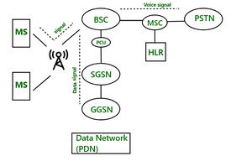

**Architecture of GPRS (General Packet Radio Service)**

**General Packet Radio Service (GPRS) is a packet-switched data service for mobile networks, and it extends the capabilities of GSM (Global System for Mobile Communications) by enabling higher-speed data transmission. GPRS allows mobile users to send and receive data (such as internet browsing, email, and multimedia messages) over the same radio interface used for voice communication.**

**The architecture of GPRS is built upon the existing GSM network infrastructure, with several enhancements to support packet-switched data transmission. The GPRS architecture consists of mobile stations, base station subsystems, and core network elements, each with specific functions and responsibilities.**

**Key Components of GPRS Architecture**

1. **Mobile Station (MS)**
2. **Base Station Subsystem (BSS)**
3. **GPRS Core Network** 
   * **Serving GPRS Support Node (SGSN)**
   * **Gateway GPRS Support Node (GGSN)**
4. **GPRS Support Systems** 
   * **Home Location Register (HLR)**
   * **Authentication Center (AUC)**
   * **Equipment Identity Register (EIR)**

**1. Mobile Station (MS)**

**The Mobile Station (MS) in GPRS refers to the user’s device (e.g., mobile phone, tablet, or other GPRS-enabled devices) that connects to the GPRS network. It consists of:**

* **Mobile Equipment (ME): The actual mobile device hardware, such as a smartphone or tablet.**
* **Subscriber Identity Module (SIM): A smart card that stores the subscriber's identity, authentication information, and other necessary data.**

**In the context of GPRS, the MS is responsible for:**

* **Sending and receiving packet-switched data over the GPRS network.**
* **Managing mobile IP addresses to communicate with the internet and external data services.**
* **Establishing and maintaining connections with the Serving GPRS Support Node (SGSN).**

**2. Base Station Subsystem (BSS)**

**The Base Station Subsystem (BSS) in a GPRS network is responsible for managing radio communication between the mobile station and the core network. The BSS consists of two primary components:**

* **Base Transceiver Station (BTS): The BTS provides the radio interface to the mobile station (MS). It handles the radio transmission and reception of data and voice signals over the air interface. In GPRS, the BTS still handles voice communication as well as data.**
* **Base Station Controller (BSC): The BSC manages multiple BTSs, allocating resources and controlling handovers between cells in the network. It is responsible for managing the radio resources, including the configuration of packet-switched data channels for GPRS.**

**In GPRS, the BSS is responsible for the following key tasks:**

* **Establishing and managing packet-switched data connections.**
* **Relaying GPRS data between the mobile station (MS) and the core network components (SGSN and GGSN).**

**3. GPRS Core Network**

**The GPRS Core Network is the backbone that handles all the packet-switched data traffic. It consists of two main elements:**

* **Serving GPRS Support Node (SGSN)**
* **Gateway GPRS Support Node (GGSN)**

**Serving GPRS Support Node (SGSN):**

**The SGSN is responsible for the management and routing of packet-switched data to and from the mobile station (MS). The SGSN handles key functions such as:**

* **Packet Routing and Forwarding: The SGSN receives data packets from the mobile station and forwards them to the appropriate destination or service. It also routes incoming packets from the GGSN to the mobile station.**
* **Session Management: The SGSN is responsible for maintaining the GPRS session between the MS and the GPRS network. It manages IP address assignment, the establishment of connections, and handover management as the mobile station moves between different cells or SGSNs.**
* **Authentication: The SGSN communicates with the HLR to authenticate users and ensure that only valid subscribers can access the GPRS network.**
* **Mobility Management: The SGSN keeps track of the location of mobile stations, enabling mobility management (tracking the MS's location, ensuring seamless handovers between SGSNs, etc.).**

**Gateway GPRS Support Node (GGSN):**

**The GGSN is the interface between the GPRS network and external data networks, such as the internet or corporate intranets. It performs the following functions:**

* **Data Packet Forwarding: The GGSN receives data packets from the internet (or other external networks) and forwards them to the appropriate SGSN. It also forwards data packets from the SGSN to the internet.**
* **IP Address Allocation: The GGSN allocates IP addresses to the mobile station (MS) for data sessions. This allows the MS to communicate over IP-based networks like the internet.**
* **Gateway Functions: The GGSN serves as a gateway between the GPRS network and external packet-switched networks (like the internet or private corporate networks). It handles address translation, routing, and ensures that the MS can communicate with external servers or websites.**

**4. GPRS Support Systems**

**In addition to the core network components (SGSN and GGSN), GPRS also relies on other network elements to manage user data, authentication, and security.**

**Home Location Register (HLR):**

**The HLR is a central database that stores all subscriber information for GPRS users, including:**

* **Subscriber profiles and service subscriptions.**
* **Current location information (such as the SGSN the user is connected to).**
* **Authentication information for secure network access.**

**The HLR is consulted by both the SGSN and GGSN when establishing connections and managing user sessions.**

**Authentication Center (AUC):**

**The AUC is responsible for verifying the identity of subscribers. It communicates with the HLR to authenticate users before allowing them to access the GPRS network, ensuring secure communication.**

**Equipment Identity Register (EIR):**

**The EIR stores information about mobile equipment, such as the IMEI (International Mobile Equipment Identity) number, and can be used to block stolen or unauthorized devices from accessing the network.**

**GPRS Architecture Diagram**

**Below is a simplified diagram of the GPRS architecture, illustrating the key components and how they interact:**

**+------------------------+**

**| Mobile Station (MS) |**

**| (Mobile Phone / Device) |**

**+------------------------+**

**|**

**| (Radio Interface)**

**|**

**+------------------------+**

**| Base Station Subsystem |**

**| (BSS) |**

**| +------------------+ |**

**| | Base Station | |**

**| | Transceiver (BTS)| |**

**| +------------------+ |**

**| | Base Station | |**

**| | Controller (BSC) | |**

**| +------------------+ |**

**+------------------------+**

**|**

**|**

**+-------------------------+**

**| Serving GPRS Support |**

**| Node (SGSN) |**

**+-------------------------+**

**|**

**| (Data Forwarding)**

**|**

**+-------------------------+**

**| Gateway GPRS Support |**

**| Node (GGSN) |**

**+-------------------------+**

**|**

**| (Internet / External Network)**

**|**

**+-------------------------+**

**| External Data Networks |**

**| (e.g., Internet) |**

**+-------------------------+**

**Key Functionalities in GPRS Architecture**

1. **Session Management: The SGSN and GGSN work together to set up and maintain sessions for GPRS users. The SGSN handles the session management tasks such as context creation, handover management, and IP address assignment, while the GGSN forwards data between the mobile station and external networks.**
2. **Data Delivery: When a mobile station requests data (e.g., browsing the internet), the SGSN routes the request through the GGSN, which forwards the data packets to the appropriate external network. Conversely, when external data needs to reach the MS, the GGSN forwards it to the SGSN, which then delivers it over the air interface.**
3. **Mobility Management: As the mobile station moves between different geographic areas (or cells), the SGSN tracks the location and ensures that the user remains connected. If a mobile user moves from one SGSN's coverage area to another, the session is transferred seamlessly between SGSNs.**
4. **Security and Authentication: The AUC and HLR provide the necessary authentication and authorization for user access. The EIR ensures that only authorized devices can access the network.**

**Conclusion**

**The GPRS architecture enhances GSM's capabilities by enabling packet-switched data communication, allowing mobile users to access internet services, email, and multimedia messaging. It builds upon the existing GSM network by introducing key elements like the SGSN and GGSN to handle data routing and session management. GPRS enables always-on, efficient, and cost-effective mobile data services by using shared radio resources for both voice and data. The combination of these elements makes GPRS an essential technology for mobile data communications in the 2.5G era, serving as a foundation for further advancements like EDGE (Enhanced Data rates for GSM Evolution) and 3G technologies.**

**9.Explain the working of SDMA, FDMA, TDMA, CDMA for multiple access?**

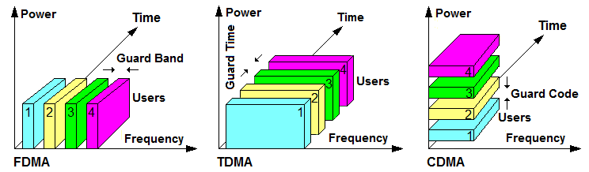

**Multiple Access Techniques in Wireless Communication**

**In wireless communication, multiple access techniques are used to allow multiple users to share the same communication channel or spectrum efficiently. These techniques determine how the available bandwidth is divided and allocated to different users to avoid interference and optimize the use of radio resources.**

**The four main multiple access techniques used in cellular networks are:**

1. **Space Division Multiple Access (SDMA)**
2. **Frequency Division Multiple Access (FDMA)**
3. **Time Division Multiple Access (TDMA)**
4. **Code Division Multiple Access (CDMA)**

**Each of these techniques uses a different method to allocate resources such as frequency, time, or space to users in a wireless communication system. Let's explore each of these techniques in detail:**

**1. Space Division Multiple Access (SDMA)**

**Space Division Multiple Access (SDMA) is a technique where multiple users are assigned the same frequency channel but are distinguished by their spatial separation (i.e., different locations or directions). This technique relies on the use of directional antennas and beamforming to create "virtual" channels in space. Users are spatially separated, so their signals do not interfere with one another.**

* **How SDMA works:**
  + **SDMA uses beamforming to focus energy in specific directions toward individual users. This allows multiple users to transmit and receive at the same time without interfering with each other, even if they share the same frequency.**
  + **The signal is directed to a specific user using smart antennas or MIMO (Multiple Input, Multiple Output) techniques. The antenna array is used to adjust the beam's direction so that it focuses energy on the intended user.**
  + **This technique is especially useful in cellular networks and Wi-Fi systems where users are located at different positions within the coverage area of a base station.**
* **Key advantage:**
  + **Efficient use of available spectrum by reusing the same frequency in different spatial locations, thus increasing the capacity of the network.**
* **Limitation:**
  + **Requires complex beamforming technology and advanced antenna systems, which may increase the cost and complexity of implementation.**

**2. Frequency Division Multiple Access (FDMA)**

**Frequency Division Multiple Access (FDMA) is a technique where the available frequency spectrum is divided into smaller frequency bands or channels, and each user is allocated a specific frequency band for communication. In FDMA, each user is assigned a unique frequency channel, and the users transmit simultaneously but on different frequencies.**

* **How FDMA works:** 
  + **The total bandwidth is divided into multiple narrow frequency bands (or channels), and each user is allocated a specific frequency band.**
  + **The users transmit in parallel, but their signals do not interfere because they operate at different frequencies.**
  + **Guard bands (unused frequencies between channels) are often used to avoid interference between adjacent channels.**
* **Key advantage:** 
  + **Simple to implement and suitable for systems with low data rates and low capacity.**
* **Limitation:** 
  + **Not bandwidth-efficient. Since FDMA allocates a fixed frequency band to each user, the channel cannot be shared dynamically, leading to underutilization of bandwidth when users are inactive or using low data rates.**

**3. Time Division Multiple Access (TDMA)**

**Time Division Multiple Access (TDMA) is a technique where multiple users share the same frequency channel by dividing time into discrete time slots. Each user is allocated a time slot within which they can transmit or receive data. Users transmit in time-division intervals, so only one user can transmit at any given time in a specific time slot.**

* **How TDMA works:**
  + **The available frequency spectrum is shared among multiple users by dividing the transmission time into multiple time slots.**
  + **Each user is assigned a specific time slot within a recurring frame. The number of slots in a frame depends on the data rate and the number of users.**
  + **Users transmit during their assigned time slots. Since time slots are non-overlapping, users' signals do not interfere with each other.**
  + **A TDMA frame typically consists of multiple time slots, and all users in the system share the same frequency at different times.**
* **Key advantage:**
  + **Higher capacity than FDMA because users are allocated time slots rather than frequency bands, leading to more efficient use of the available spectrum.**
  + **Suitable for digital communication systems, such as GSM and IS-136.**
* **Limitation:**
  + **Synchronization of time slots is critical; any drift in timing can cause interference.**
  + **Since users share the same frequency, delay may occur if many users are transmitting, especially in systems with many users.**

**4. Code Division Multiple Access (CDMA)**

**Code Division Multiple Access (CDMA) is a technique where users share the same frequency spectrum, but each user’s data is encoded with a unique code. CDMA is based on the principle of spread spectrum, where the signal is spread over a wide bandwidth, making it less susceptible to interference.**

* **How CDMA works:**
  + **CDMA uses unique spreading codes for each user. The data of each user is spread across a wide frequency band by multiplying the data signal by a unique spreading code (also called a PN sequence or pseudo-random sequence).**
  + **The spreading codes are orthogonal (non-interfering), so users can transmit simultaneously on the same frequency. The receiver decodes the signal by correlating the received signal with the unique code of the intended user.**
  + **Power control is essential in CDMA to ensure that users' signals do not interfere with each other due to their simultaneous transmission on the same frequency.**
* **Key advantage:**
  + **High capacity: Multiple users can share the same frequency band, increasing the efficiency of spectrum use. CDMA also offers better resistance to interference and fading.**
  + **Users can communicate simultaneously without requiring strict time or frequency synchronization.**
* **Limitation:**
  + **Requires more complex signal processing and power control mechanisms.**
  + **Near-far effect: Users that are closer to the base station can overpower the signals of users farther away unless the transmission power is carefully controlled.**

**Comparison of SDMA, FDMA, TDMA, and CDMA**

| **Technique** | **Basic Concept** | **Usage** | **Key Advantage** | **Key Limitation** |
| --- | --- | --- | --- | --- |
| **SDMA** | **Spatial separation using directional antennas** | **Cell-based communication (e.g., cellular networks)** | **Efficient use of spectrum by reusing frequencies in different spatial locations** | **Requires complex beamforming and smart antenna systems** |
| **FDMA** | **Dividing the available frequency spectrum into smaller frequency bands** | **Analog cellular systems, early digital systems** | **Simple to implement, low complexity** | **Low bandwidth efficiency, not ideal for high-capacity systems** |
| **TDMA** | **Dividing the time into slots, each user uses one slot** | **GSM, IS-136 (2G systems)** | **More efficient than FDMA, higher capacity** | **Timing synchronization is critical, potential for delay** |
| **CDMA** | **Spreading data over a wide frequency band with unique codes for each user** | **3G networks (e.g., IS-2000, WCDMA), CDMA2000** | **High capacity, robust against interference, simultaneous communication** | **Requires complex signal processing, power control issues** |

**Conclusion**

**Each multiple access technique has its own strengths and weaknesses and is suitable for different types of wireless communication systems.**

* **SDMA focuses on spatial separation and beamforming, making it ideal for scenarios where users are physically located in different areas.**
* **FDMA and TDMA are simpler and were commonly used in earlier cellular networks (such as GSM), with FDMA dividing the spectrum into frequency bands, and TDMA dividing time.**
* **CDMA, with its use of unique codes for users, offers high capacity and is widely used in modern 3G and 4G systems due to its ability to handle high user density and resistance to interference.**

**In modern wireless systems, TDMA and CDMA are more widely used, particularly in cellular networks and data transmission systems, while SDMA is becoming more prevalent with the advent of technologies like MIMO (Multiple Input Multiple Output).**

**10.Explain the major differences between SDMA, FDMA, TDMA, CDMA?**

SDMA, FDMA, TDMA, and CDMA are all multiple access techniques used in communication systems to allow multiple users to share the same communication channel efficiently. Here’s a breakdown of their major differences:

**1. Space Division Multiple Access (SDMA)**

* **Concept**: Allocates separate spatial resources (antenna beams or physical space) to users.
* **Key Principle**: Differentiates users based on their spatial location using advanced antenna techniques.
* **Usage**: Often used in satellite communications and advanced cellular systems (e.g., MIMO in 4G/5G).
* **Advantages**: Increases capacity by reusing the same frequency in different spatial directions.
* **Challenges**: Requires sophisticated antenna systems and signal processing.

**2. Frequency Division Multiple Access (FDMA)**

* **Concept**: Divides the available bandwidth into distinct frequency bands assigned to different users.
* **Key Principle**: Each user gets a unique frequency band during the communication session.
* **Usage**: Analog systems like AMPS (1G) and some satellite communication systems.
* **Advantages**: Simple to implement, with minimal interference between users on separate frequencies.
* **Challenges**: Limited spectrum resources and inefficient for bursty data traffic.

**3. Time Division Multiple Access (TDMA)**

* **Concept**: Allocates separate time slots within the same frequency band for different users.
* **Key Principle**: Users transmit data sequentially in their assigned time slots.
* **Usage**: Digital systems like GSM (2G).
* **Advantages**: Efficient use of bandwidth, suitable for digital data transmission.
* **Challenges**: Synchronization is critical; delays can occur in high-traffic scenarios.

**4. Code Division Multiple Access (CDMA)**

* **Concept**: All users share the same frequency band and time but are differentiated using unique codes.
* **Key Principle**: Employs spread-spectrum technology, where each user’s signal is encoded with a unique pseudorandom sequence.
* **Usage**: 3G systems like WCDMA, GPS.
* **Advantages**: High spectrum efficiency, resistance to interference and eavesdropping.
* **Challenges**: Complex implementation, requires robust signal processing and power control.

**Summary Table**

| **Feature** | **SDMA** | **FDMA** | **TDMA** | **CDMA** |
| --- | --- | --- | --- | --- |
| **Resource Allocation** | Space (spatial beams) | Frequency | Time | Code |
| **Differentiation** | Spatial location | Frequency bands | Time slots | Unique codes |
| **Used In** | Satellites, 4G/5G (MIMO) | 1G, Satellite Systems | 2G (GSM), some 3G systems | 3G (WCDMA), GPS |
| **Advantages** | High capacity, spatial reuse | Simple implementation | Efficient for digital data | High efficiency, robust |
| **Challenges** | Expensive, complex hardware | Limited spectrum reuse | Synchronization issues | Complex, requires control |

Each technique is chosen based on the specific needs of the communication system, such as available bandwidth, number of users, and system complexity.

**11. Explain the IEEE 802.11 MAC Frame structure**

IEEE 802.11 Mac Frame - GeeksforGeeks

**IEEE 802.11 MAC Frame Structure**

The **IEEE 802.11 MAC frame** is a standardized format used for communication in wireless local area networks (WLANs). It ensures that data is transmitted and received correctly between wireless devices. The structure of the MAC frame is divided into multiple fields, each serving a specific purpose.

**General Structure of IEEE 802.11 MAC Frame**

The IEEE 802.11 MAC frame consists of the following fields:

1. **Frame Control**
2. **Duration/ID**
3. **Addresses (up to 4)**
4. **Sequence Control**
5. **Frame Body (Data)**
6. **Frame Check Sequence (FCS)**

Here’s a detailed breakdown of each field:

**1. Frame Control Field (2 Bytes)**

The frame control field contains information about the frame type and control information.

* **Protocol Version (2 bits)**: Indicates the protocol version (usually set to 00 for current 802.11 versions).
* **Type (2 bits)**: Specifies the type of the frame:
  + **00**: Management (e.g., beacon, probe request)
  + **01**: Control (e.g., RTS/CTS, ACK)
  + **10**: Data
* **Subtype (4 bits)**: Provides further details about the frame type (e.g., beacon, association request).
* **To DS/From DS (1 bit each)**: Indicates if the frame is going to or from a distribution system.
* **More Fragments (1 bit)**: Indicates if more fragments follow.
* **Retry (1 bit)**: Shows whether the frame is a retransmission.
* **Power Management (1 bit)**: Indicates if the device is in power-saving mode.
* **More Data (1 bit)**: Tells the receiver that more data is buffered for it.
* **Protected Frame (1 bit)**: Indicates if the frame is encrypted.
* **Order (1 bit)**: Used for strict ordering of frames.

**2. Duration/ID Field (2 Bytes)**

* **Purpose**: Indicates the duration the medium will be reserved for this transmission.
* **Special Use**: In power-save mode, it may contain an ID for the station.

**3. Address Fields (4 × 6 Bytes)**

The frame can have up to **4 addresses**, each serving a specific role:

* **Address 1**: Destination address (receiver).
* **Address 2**: Source address (sender).
* **Address 3**: BSSID (Basic Service Set Identifier) or the address of the access point in infrastructure mode.
* **Address 4**: Only used in Wireless Distribution System (WDS) for mesh or relay networks.

**4. Sequence Control Field (2 Bytes)**

* **Fragment Number (4 bits)**: Identifies the fragment number if the data is fragmented.
* **Sequence Number (12 bits)**: Indicates the sequence number of the frame to detect duplicates.

**5. Frame Body (Variable Length)**

* **Purpose**: Contains the actual payload (data or management/control information).
* **Length**: Varies depending on the type of frame (e.g., data, acknowledgment, beacon).
* **Maximum Length**: Up to **2312 bytes** for data frames.

**6. Frame Check Sequence (FCS) (4 Bytes)**

* **Purpose**: Ensures integrity by using a cyclic redundancy check (CRC).
* **How It Works**: The receiver calculates the CRC and compares it with the FCS to detect transmission errors.

**Frame Types in IEEE 802.11**

1. **Management Frames**:
   * Used for connection establishment, maintenance, and termination.
   * Examples: Beacon, Authentication, Association Request, Probe Request.
2. **Control Frames**:
   * Facilitate reliable data transfer and medium access control.
   * Examples: Request to Send (RTS), Clear to Send (CTS), Acknowledgment (ACK).
3. **Data Frames**:
   * Carry user data or payload.
   * Examples: Data, Null Function (power management), QoS Data.

**Diagram of IEEE 802.11 MAC Frame**

Below is a high-level diagram representing the structure of the MAC frame:

| Frame Control | Duration/ID | Address 1 | Address 2 | Address 3 | Sequence Control |

| Address 4 (optional) | Frame Body (Data) | Frame Check Sequence (FCS) |

**Key Features of IEEE 802.11 MAC Frame**

1. **Support for Mobility**: The multiple address fields accommodate devices moving between access points.
2. **Error Detection**: The FCS ensures that any errors in the transmission are identified.
3. **Fragmentation**: The sequence control field allows large packets to be fragmented for efficient transmission.
4. **Power-Saving Features**: The power management bits enable energy efficiency in mobile devices.
5. **Security**: The protected frame bit indicates encryption for secure communication.

**Conclusion**

The IEEE 802.11 MAC frame structure is fundamental to wireless communication in WLANs. Its flexible design ensures reliable data delivery, supports mobility, and provides essential control mechanisms to manage the shared wireless medium efficiently.

**12. With a neat sketch explain the Wireless LAN IEEE 802.11 architecture.**

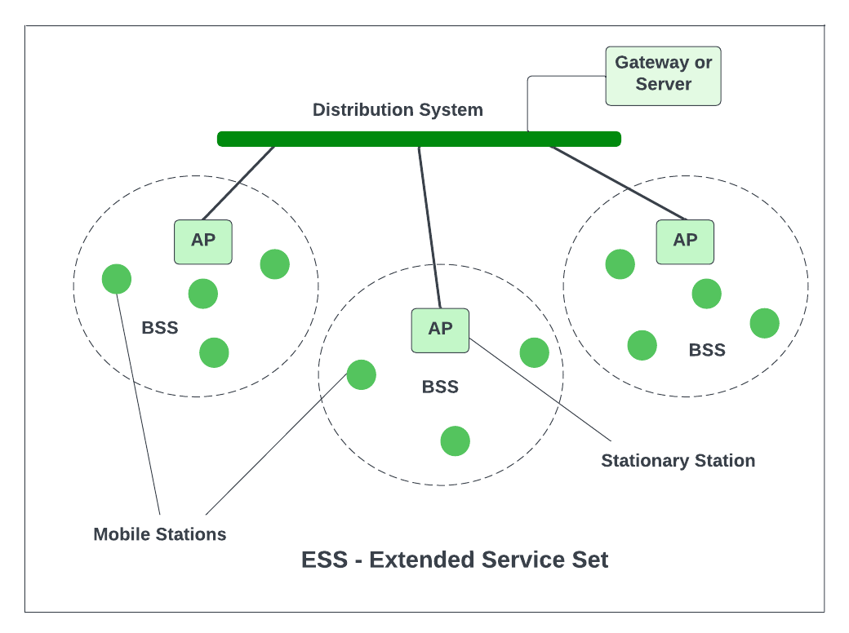

**Wireless LAN IEEE 802.11 Architecture**

The IEEE 802.11 architecture provides the framework for wireless local area networks (WLANs). It ensures reliable data transmission, mobility, and connectivity between devices using wireless communication. The architecture consists of several components, which work together to provide network functionality.

**Key Components of IEEE 802.11 Architecture**

1. **Stations (STAs)**:
   * Devices with a wireless interface (e.g., laptops, smartphones, IoT devices).
   * Each station has a wireless network interface card (NIC) to communicate with the WLAN.
2. **Access Point (AP)**:
   * Acts as a central communication hub for stations in a wireless network.
   * Provides connectivity between the wireless and wired networks.
3. **Basic Service Set (BSS)**:
   * The fundamental building block of the WLAN.
   * It consists of a group of stations communicating with each other.
   * Two types of BSS:
     + **Independent BSS (IBSS)**: Stations communicate directly without an access point (ad hoc mode).
     + **Infrastructure BSS**: Stations communicate through an access point.
4. **Extended Service Set (ESS)**:
   * A collection of multiple BSSs interconnected via a **Distribution System (DS)**.
   * Allows seamless roaming between access points while maintaining network connectivity.
5. **Distribution System (DS)**:
   * Facilitates communication between access points within the same ESS.
   * Connects the wireless network to a wired backbone (e.g., Ethernet).
6. **Portal**:
   * Acts as a gateway to connect the WLAN to other networks (e.g., the internet or another LAN).
7. **Medium Access Control (MAC) Layer**:
   * Ensures fair access to the wireless medium for all devices using techniques like CSMA/CA (Carrier Sense Multiple Access with Collision Avoidance).

**Diagram of IEEE 802.11 Architecture**

Below is a textual representation of the architecture:

----------- Wired Network ------------

|

+------------+

| Portal |

+------------+

|

+-------------------+

| Distribution |

| System |

+-------------------+

/ \

/ \

+----------+ +----------+

| Access | | Access |

| Point | | Point |

+----------+ +----------+

| |

+---------+ +---------+

| STA1 | | STA2 |

+---------+ +---------+

**Features of IEEE 802.11 Architecture**

1. **Flexibility**:
   * Supports both infrastructure (via access points) and ad hoc (peer-to-peer) modes.
2. **Mobility**:
   * Allows devices to move between BSSs within the same ESS without disconnecting.
3. **Scalability**:
   * Easily extendable by adding more access points to the ESS.
4. **Interoperability**:
   * Compatible with wired networks through the portal and distribution system.

**Key Points of Operation**

1. **Communication in IBSS**:
   * Stations communicate directly without relying on an access point.
   * Suitable for small or temporary networks.
2. **Communication in Infrastructure Mode**:
   * Stations connect through an access point, which handles packet forwarding.
   * Ensures better control, coverage, and scalability.
3. **Roaming**:
   * Stations can seamlessly move between access points within an ESS.
   * Handoff mechanisms ensure uninterrupted communication.
4. **Access Control**:
   * The MAC layer manages access to the shared wireless medium using protocols like CSMA/CA.

**Applications of IEEE 802.11**

* Home networks
* Enterprise WLANs
* Public hotspots
* Industrial IoT networks

**Conclusion**

The IEEE 802.11 architecture provides a robust and flexible framework for implementing WLANs. With its components like BSS, ESS, and DS, it supports reliable communication, seamless mobility, and easy scalability, making it a widely adopted standard for wireless networking.

**13.Explain the Indirect TCP, Snooping TCP, Mobile TCP?**

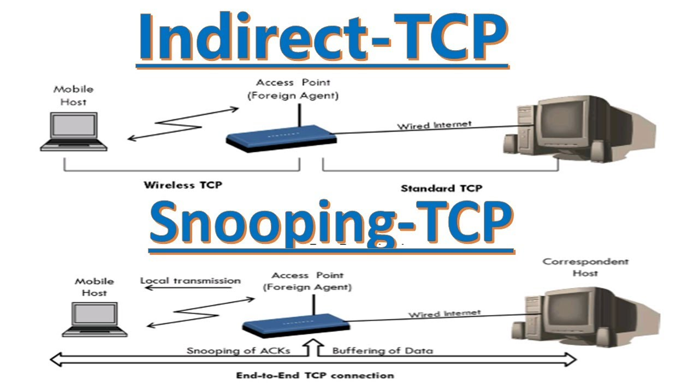

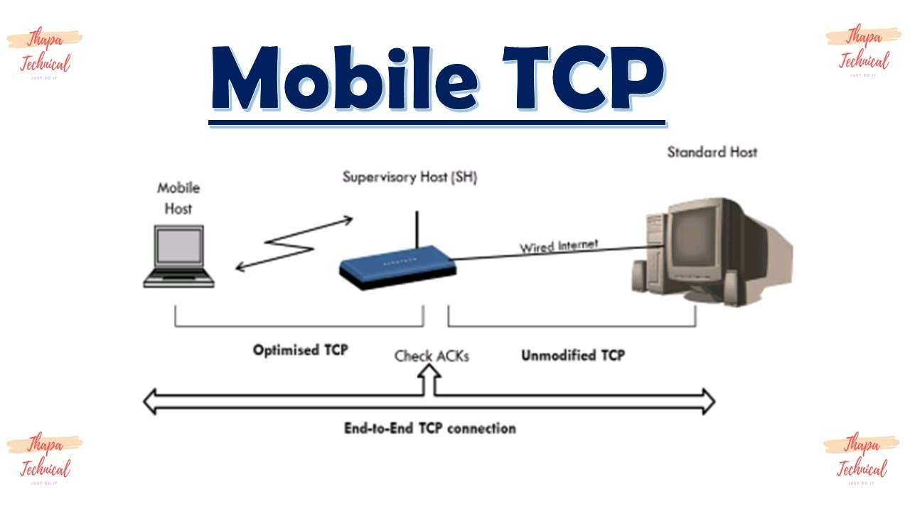

1. **Indirect TCP (I-TCP)**

**Indirect TCP** is a modification of the standard TCP protocol designed to optimize the performance of mobile networks. It aims to address the challenges that arise due to the variable and often unreliable nature of mobile networks, especially the high latency and frequent handoffs in mobile environments.

**How Indirect TCP Works:**

* **Splitting the Connection**: In I-TCP, the connection is split into two parts: one between the **mobile host** and the **base station (BS)**, and the other between the **base station** and the **correspondent host (CH)**.
  + The mobile node uses a **local connection** with the base station (BS), which is responsible for dealing with the unreliable wireless link.
  + The base station handles the TCP connection with the correspondent host.
* **Advantages**:
  + The wireless network and TCP connection between the base station and correspondent host are isolated from each other.
  + This allows the mobile host to handle errors locally without affecting the global TCP connection.
* **Disadvantages**:
  + This model introduces an extra layer of complexity, as the base station has to manage the split connection and the state of the TCP connection.
  + Handover between base stations can cause disruptions.

**Use Cases:**

Indirect TCP is commonly used in scenarios where mobile devices are connected to networks with intermittent connectivity, such as in rural areas or moving vehicles.

1. **Snooping TCP**

**Snooping TCP** is a variant of the TCP protocol that optimizes performance in wireless networks, particularly in environments with high latency and frequent packet losses.

**How Snooping TCP Works:**

* **Local Cache in the Base Station**: The key feature of Snooping TCP is that the **base station** in the mobile network **“snoops”** on the TCP packets between the mobile host and the correspondent host.
  + The base station monitors the TCP packets and locally stores a **cache** of the packets that are transmitted to the mobile host.
  + It can **detect** lost packets (due to wireless link issues) and can **retransmit** them locally to the mobile host without needing to go back to the correspondent host.
* **Advantages**:
  + **Reduced Latency**: Packet retransmission can be done locally without involving the long round-trip time to the correspondent host, which reduces latency.
  + **Improved Performance**: The base station can proactively retransmit lost packets, leading to better throughput and reliability in wireless networks.
* **Disadvantages**:
  + **Complexity in Managing Buffers**: The base station needs to maintain and manage the cache, which could be computationally expensive and difficult to scale.
  + **Packet Duplication**: If the base station misinterprets network conditions, there might be duplicate packets, which may lead to unnecessary retransmissions.

**Use Cases:**

Snooping TCP is suitable for environments with high packet loss and latency, such as mobile or satellite communications.

1. **Mobile TCP (M-TCP)**

**Mobile TCP** (also known as **M-TCP**) is a specialized version of TCP that is specifically designed for use in mobile networks. Its goal is to enhance the performance of TCP in the context of frequent handoffs, high mobility, and unreliable wireless communication.

**How Mobile TCP Works:**

* **Handling Handoffs**: Mobile TCP introduces special mechanisms to handle the mobility of the mobile node. One of the key features is its ability to handle **handoffs** between different base stations or access points without disrupting the ongoing TCP session.
  + When the mobile host moves from one network to another, it informs the correspondent host (or uses a mobility management protocol) to maintain the continuity of the TCP connection.
* **Transparent Handover**: During the handoff process, Mobile TCP aims to ensure that the data transfer is transparent to the upper layers (such as application layer), so there is minimal disruption to the ongoing communication.
* **Retransmission Mechanism**: In the case of lost packets due to handoffs or mobility-related issues, Mobile TCP allows the **mobile node** to request retransmission of lost data from the correspondent host, reducing packet loss and improving communication reliability.
* **Improved Congestion Control**: Mobile TCP can modify the congestion window mechanism to adapt to the changing conditions in the mobile network (like varying signal strength and network delays), helping improve data flow control.

**Advantages:**

* **Seamless Mobility**: Mobile TCP provides a better mechanism for managing mobile nodes in an active communication session, reducing the impact of handoffs on TCP performance.
* **Higher Throughput and Lower Latency**: By optimizing packet loss handling and reducing the impact of mobility, Mobile TCP can achieve higher throughput and lower latency.

**Disadvantages:**

* **Complexity**: Mobile TCP introduces added complexity in managing connections, particularly during handoffs, which could lead to challenges in implementation.
* **Signaling Overhead**: The process of informing the correspondent host about the mobile node's new location or handling lost packets might introduce signaling overhead, which can reduce overall efficiency.

**Use Cases:**

Mobile TCP is useful in environments where the user is highly mobile, such as in vehicular networks, or in cellular networks where handoffs between access points or base stations are frequent.

**Comparison of I-TCP, Snooping TCP, and M-TCP**

| **Feature/Protocol** | **Indirect TCP (I-TCP)** | **Snooping TCP** | **Mobile TCP (M-TCP)** |
| --- | --- | --- | --- |
| **Connection Split** | Yes, splits the connection into two parts | No | No |
| **Mobility Handling** | Base station handles local mobility | Base station retransmits lost packets | Handles mobility through handoffs |
| **Packet Retransmission** | Handled by the base station | Handled by the base station locally | Handled by the mobile node and correspondent host |
| **Latency** | High latency due to splitting | Low latency due to local retransmissions | Moderate latency with handoff management |
| **Complexity** | High due to connection splitting | Moderate due to snooping mechanism | High due to mobility management |

**Conclusion**

Each of these variants of TCP (Indirect TCP, Snooping TCP, and Mobile TCP) addresses the challenges posed by mobile networks in different ways. Indirect TCP focuses on splitting connections to localize issues, Snooping TCP uses local caching to handle packet loss, and Mobile TCP aims to manage mobility more effectively. The choice of which protocol to use depends on the specific requirements and conditions of the mobile network.

**14.What is encapsulation? Explain various encapsulation techniques in mobile IP?**

**Encapsulation in Mobile IP :**

Encapsulation is the process of enclosing data (such as packets or messages) within another data structure or format before transmitting it over a network. In the context of **Mobile IP**, encapsulation allows the original IP packet (destined for a mobile node) to be enclosed within another IP packet, enabling it to be forwarded to the mobile node's current location via the foreign agent (FA).

Encapsulation is critical in **Mobile IP** because it ensures that a mobile node (MN) can continue to receive data even when it changes its point of attachment to the network.

**Purpose of Encapsulation in Mobile IP**

1. **Packet Delivery to Mobile Node**:
   * When a mobile node moves to a new network, its home agent (HA) uses encapsulation to send packets to the foreign agent (FA) or directly to the mobile node.
2. **Hiding Mobility from Correspondent Node (CN)**:
   * Encapsulation makes the mobility of the mobile node transparent to the correspondent node, as it continues sending packets to the mobile node's home address.
3. **Routing Support**:
   * The encapsulated packet allows the mobile node to receive data at its care-of address (CoA) instead of its home address.

**Encapsulation Techniques in Mobile IP**

**1. IP-in-IP Encapsulation (RFC 2003)**

This is the most common encapsulation technique used in Mobile IP.

* **How It Works**:
  + The entire original IP packet is **encapsulated** within a new IP header.
  + The new IP header contains:
    - **Source Address**: Home agent's IP address.
    - **Destination Address**: Care-of address (CoA) of the mobile node.
  + The original IP packet remains intact as the payload of the new packet.
* **Advantages**:
  + Simple and efficient for forwarding packets.
  + Preserves the original IP packet, which allows for easy decapsulation.
* **Disadvantages**:
  + Overhead: Adds an extra 20-byte IP header, increasing packet size.
* **Use Case**:
  + Used when the home agent forwards packets to the foreign agent or directly to the mobile node.

**2. Minimal Encapsulation (RFC 2004)**

This is a lightweight encapsulation technique that reduces overhead compared to IP-in-IP encapsulation.

* **How It Works**:
  + Instead of adding a full IP header, only a minimal encapsulation header is added.
  + The header includes:
    - **Source Address**: Home agent's IP address.
    - **Destination Address**: Care-of address.
    - Fields for protocol and checksum.
  + Some fields from the original IP header are reused to reduce redundancy.
* **Advantages**:
  + Reduces overhead compared to IP-in-IP encapsulation, as fewer fields are added.
  + Efficient in bandwidth-constrained environments.
* **Disadvantages**:
  + Slightly more complex to implement due to reuse of fields.
* **Use Case**:
  + Used in networks where bandwidth efficiency is critical.

**3. Generic Routing Encapsulation (GRE)**

GRE is a tunneling protocol that can encapsulate a variety of network layer protocols, including IP.

* **How It Works**:
  + GRE encapsulates the original IP packet in a new GRE header and then encapsulates this inside a new IP header.
  + The GRE header contains:
    - Protocol type of the payload.
    - Checksum and sequence numbers (optional).
* **Advantages**:
  + Supports encapsulation of multiple protocols (not limited to IP).
  + Allows for additional features like checksum verification and sequencing.
* **Disadvantages**:
  + More overhead compared to IP-in-IP encapsulation due to the additional GRE header.
  + Increased complexity in decapsulation.
* **Use Case**:
  + Used in scenarios requiring encapsulation of non-IP protocols or additional features like checksum validation.

**Comparison of Encapsulation Techniques**

| **Feature** | **IP-in-IP Encapsulation** | **Minimal Encapsulation** | **GRE** |
| --- | --- | --- | --- |
| **Overhead** | High (20-byte IP header) | Low | High (GRE + IP header) |
| **Complexity** | Low | Medium | High |
| **Flexibility** | Limited to IP packets | Limited to IP packets | Supports multiple protocols |
| **Efficiency** | Moderate | High | Moderate |
| **Use Case** | General Mobile IP use | Bandwidth-constrained networks | Multi-protocol support |

**Decapsulation Process**

At the foreign agent (or mobile node):

1. The encapsulated packet is received.
2. The outer header (added during encapsulation) is removed.
3. The original IP packet is extracted and forwarded to the mobile node.

**Conclusion**

Encapsulation is essential in Mobile IP for enabling seamless packet delivery to mobile nodes, even when they change their point of attachment to the network. The choice of encapsulation technique (IP-in-IP, Minimal Encapsulation, or GRE) depends on factors such as overhead, efficiency, and protocol support. Each technique has its own advantages and limitations, making them suitable for different mobile networking scenarios.

**15.Discuss TCP/IP and Mobile IP Network Layers?**

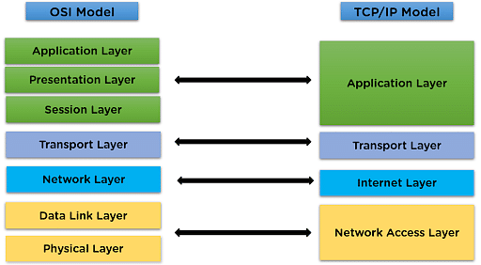

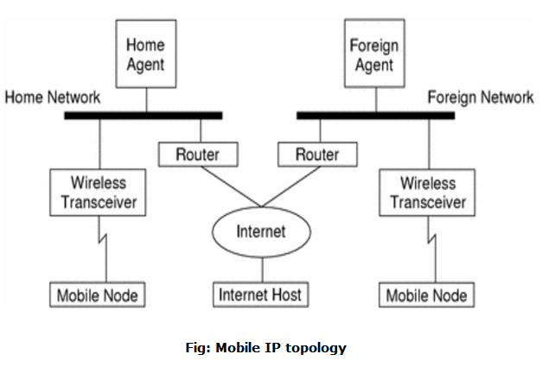

**TCP/IP and Mobile IP Network Layers**

The **TCP/IP** and **Mobile IP** protocols are key components in enabling communication over networks, especially in the context of the **internet** and mobile environments. They provide a robust framework for data transmission, addressing, routing, and mobility. Let’s break down these protocols and their respective network layers.

**1. TCP/IP Protocol Stack**

The **TCP/IP protocol suite** is a set of communication protocols used for connecting devices on the internet and local networks. It consists of **four layers**:

**a) Application Layer**

* The **Application Layer** is responsible for providing communication services directly to end-users or applications.
* It includes high-level protocols such as:
  + **HTTP** (Hypertext Transfer Protocol) for web browsing.
  + **FTP** (File Transfer Protocol) for file transfers.
  + **SMTP** (Simple Mail Transfer Protocol) for email.
  + **DNS** (Domain Name System) for name resolution.

**b) Transport Layer**

* The **Transport Layer** ensures reliable data transmission between devices on a network. It manages end-to-end communication, flow control, and error correction.
* The two primary protocols in this layer are:
  + **TCP (Transmission Control Protocol):** Provides reliable, connection-oriented communication. It handles packet sequencing, error detection, retransmission, and flow control.
  + **UDP (User Datagram Protocol):** Provides connectionless, unreliable communication, often used in real-time applications like video streaming.

**c) Internet Layer**

* The **Internet Layer** is responsible for logical addressing, routing, and forwarding of data packets. The key protocol in this layer is **IP (Internet Protocol)**.
  + **IPv4 (Internet Protocol version 4):** Uses 32-bit addresses to route packets across networks.
  + **IPv6 (Internet Protocol version 6):** A newer version with 128-bit addresses, designed to address the limitations of IPv4, such as address space exhaustion.
* Other protocols in this layer include **ICMP** (Internet Control Message Protocol) for error reporting and **ARP** (Address Resolution Protocol) for mapping IP addresses to MAC addresses.

**d) Link Layer (Network Interface Layer)**

* The **Link Layer** is responsible for data transfer between devices on the same network. It handles how data is physically transmitted through the network.
* It includes protocols like:
  + **Ethernet** for wired LANs.
  + **Wi-Fi** for wireless networks.
  + **PPP (Point-to-Point Protocol)** for dial-up connections.

**2. Mobile IP Protocol Stack**

**Mobile IP** is an extension of the traditional IP that allows mobile devices to maintain a constant IP address while moving between different networks. It ensures seamless communication for users as they roam between networks without losing connectivity.

Mobile IP operates at the **Network Layer** of the TCP/IP stack but introduces additional features to handle mobility.

**a) Mobile Node (MN)**

* The **Mobile Node** (MN) is a device (e.g., smartphone, laptop, tablet) that moves between different networks.
* It maintains a **Home Address** (HA) that remains constant, regardless of the device’s location.

**b) Home Agent (HA)**

* The **Home Agent** is a router located in the mobile node’s home network (where the MN is originally registered).
* The HA maintains a **binding table** that maps the MN's home address to its **Care-of Address** (CoA), which changes as the MN moves to different networks.
* The HA is responsible for forwarding packets destined for the MN’s home address to the correct location.

**c) Foreign Agent (FA)**

* The **Foreign Agent** is a router in the network that the mobile node is currently visiting.
* The FA provides the MN with a **Care-of Address (CoA)**, which is used to forward packets to the mobile node while it is away from its home network.
* The FA may also assist with routing packets between the MN and the HA.

**d) Correspondent Node (CN)**

* A **Correspondent Node** (CN) is any device or system that communicates with the mobile node.
* From the CN’s perspective, the MN appears to have the same IP address even when it moves between networks.

**Key Components and Process of Mobile IP**

1. **Binding Update Process:**
   * When a mobile node moves to a new network, it sends a **Binding Update** message to its Home Agent (HA) and the Foreign Agent (FA) to notify them of its new location (Care-of Address, CoA).
   * This update helps ensure that packets destined for the MN’s home address are routed to its current CoA.
2. **Packet Delivery Process:**
   * When a Correspondent Node (CN) sends packets to the MN's **Home Address**, the HA intercepts them and tunnels the packets to the CoA of the MN (via the FA or directly).
   * Once the MN receives the packet at its CoA, it can respond to the CN using its original home address.
3. **Tunneling Mechanism:**
   * Mobile IP uses **tunneling** to send packets from the HA to the mobile node’s CoA. Tunneling encapsulates the original data packets within a new packet that contains the necessary routing information.

**Advantages of Mobile IP**

1. **Seamless Mobility:**
   * Mobile IP allows a device to maintain continuous network connectivity while moving between different networks without changing its IP address.
2. **No Need for Reconfiguration:**
   * Unlike traditional IP, where a new IP address would be required when a device changes networks, Mobile IP allows the device to maintain the same IP address regardless of its location.
3. **Support for Real-Time Applications:**
   * Mobile IP ensures that real-time applications such as voice calls and video conferencing are not disrupted when a mobile node moves across different networks.

**TCP/IP vs. Mobile IP Network Layers**

| **TCP/IP Network Layers** | **Mobile IP Network Layers** |
| --- | --- |
| **Application Layer**: Deals with protocols such as HTTP, FTP, SMTP, etc. | **Mobile Node (MN)**: The mobile device maintaining its home address. |
| **Transport Layer**: Handles reliable data transfer with protocols like TCP, UDP. | **Home Agent (HA)**: Manages the mobile node's location and forwards data packets. |
| **Internet Layer**: Handles routing, addressing, and packet forwarding with protocols like IP, ICMP. | **Foreign Agent (FA)**: Assists with routing packets to and from the mobile node when visiting another network. |
| **Link Layer**: Handles communication between devices within the same local network (Ethernet, Wi-Fi). | **Correspondent Node (CN)**: A node that communicates with the mobile node, unaware of its movement. |

**Layers in Mobile IP:**

1. **Network Layer (Mobile IP Specific)**
   * The **Network Layer** in Mobile IP is responsible for addressing, routing, and forwarding packets. It handles the communication between the mobile node (MN), home agent (HA), foreign agent (FA), and correspondent node (CN). This layer enables mobility and ensures that the MN can maintain its communication session when moving between different networks.
   * Key components of this layer include:
     + **Home Agent (HA)**
     + **Foreign Agent (FA)**
     + **Mobile Node (MN)**
     + **Care-of Address (CoA)**
2. **Link Layer**
   * The **Link Layer** is responsible for data link operations such as managing communication between the mobile node and the routers (Home Agent and Foreign Agent). It deals with how packets are physically transmitted between nodes in a network (e.g., Ethernet, Wi-Fi, etc.).
   * This layer is part of the standard IP protocol stack but plays a more specific role in Mobile IP for devices moving between different wireless or wired networks.
3. **Transport Layer**
   * The **Transport Layer** (e.g., TCP, UDP) manages the transport of data between two devices. In the context of Mobile IP, it ensures reliable data transfer between the mobile node (MN) and the correspondent node (CN) even when the MN changes networks.
   * The **Transport Layer** operates independently of Mobile IP’s mobility mechanisms but plays a crucial role in ensuring that data is transmitted correctly and efficiently.

**Key Components in Mobile IP:**

* **Home Address (HA)**: A permanent address assigned to the mobile node.
* **Care-of Address (CoA)**: A temporary address assigned to the mobile node while it is visiting a foreign network.
* **Tunneling**: The encapsulation of packets to route them from the home network to the mobile node’s current location.

**16.How is a Packet Delivery and Handover Management?**

**Packet Delivery and Handover Management in Mobile Networks**

Packet delivery and handover management are two critical processes in mobile networks that ensure seamless communication when a mobile node (MN) moves between different network locations or base stations. Here is a detailed explanation of these processes:

**1. Packet Delivery**

Packet delivery refers to the process of routing data packets from a source (correspondent node) to a destination (mobile node) in a mobile environment.

**Key Steps in Packet Delivery:**

1. **Correspondent Node Sends a Packet**:
   * The **correspondent node (CN)** sends packets to the mobile node's **home address** (the permanent IP address).
   * The packets are routed to the mobile node's **home network**.
2. **Home Agent Intercepts Packets**:
   * The **home agent (HA)** intercepts the packets destined for the mobile node.
   * This is because the mobile node is not present in the home network and has moved to a foreign network.
3. **Encapsulation and Tunneling**:
   * The home agent encapsulates the original packets and tunnels them to the **care-of address (CoA)** of the mobile node, typically managed by the **foreign agent (FA)** in the foreign network.
4. **Decapsulation by Foreign Agent**:
   * The foreign agent decapsulates the packets and delivers the original packets to the mobile node.
   * If the mobile node is using a **co-located care-of address**, it decapsulates the packets itself.

**Challenges in Packet Delivery:**

* **Increased Latency**: The tunneling process may increase latency as packets have to traverse through the home agent.
* **Triangular Routing**: Packets travel from the CN to the HA and then to the MN, instead of a direct route.
* **Packet Loss**: Mobile environments often experience packet loss due to dynamic network changes.

**2. Handover Management**

Handover (or handoff) management ensures that the mobile node maintains its ongoing communication when it moves from one network to another.

**Types of Handover:**

1. **Horizontal Handover**:
   * Occurs between access points or base stations within the same type of network (e.g., between two Wi-Fi access points or two cellular base stations).
2. **Vertical Handover**:
   * Occurs between different types of networks (e.g., transitioning from a Wi-Fi network to a cellular network).

**Phases of Handover Management:**

1. **Handover Initiation**:
   * The process starts when the signal strength of the current connection degrades or a better network becomes available.
   * The mobile node (or the network) detects the need for a handover based on parameters like **signal strength**, **quality of service (QoS)**, or **network congestion**.
2. **Handover Decision**:
   * The network or mobile node decides which new base station or network to connect to.
   * Decision factors include:
     + Signal strength from nearby networks.
     + Available bandwidth.
     + Network compatibility and QoS requirements.
3. **Handover Execution**:
   * The mobile node disconnects from the current base station or network and establishes a connection with the new one.
   * IP address management plays a critical role here:
     + The mobile node may acquire a new **care-of address (CoA)** in the foreign network.
     + The home agent updates its binding table with the new CoA.
4. **Binding Update**:
   * The mobile node updates the home agent about its new location (new care-of address).
   * The home agent modifies its routing table to tunnel packets to the new CoA.

**Challenges in Handover Management:**

* **Latency**: The handover process introduces delays, especially when acquiring a new care-of address or updating bindings.
* **Packet Loss**: Packets may be lost during the transition from one network to another.
* **Interference**: Signal degradation or interference during handover can disrupt communication.

**Protocol Support for Packet Delivery and Handover**

**1. Mobile IP (MIP):**

* **Packet Delivery**:
  + Uses tunneling (e.g., IP-in-IP encapsulation) to deliver packets from the home agent to the mobile node's current location.
* **Handover Management**:
  + Mobile IP manages handover by updating the care-of address and routing packets accordingly.
  + Binding updates ensure seamless packet delivery to the new location.

**2. Fast Handover for Mobile IP (FMIP):**

* Reduces the delay caused by standard Mobile IP handovers.
* Prepares the new care-of address before the handover is initiated.

**3. Hierarchical Mobile IP (HMIP):**

* Introduces regional foreign agents to reduce the signaling load on the home agent and correspondent node during handovers.

**4. Proxy Mobile IP (PMIP):**

* Eliminates the need for the mobile node to participate in mobility-related signaling, simplifying handover management.

**Comparison of Packet Delivery and Handover Management**

| **Feature** | **Packet Delivery** | **Handover Management** |
| --- | --- | --- |
| **Objective** | Deliver packets to a mobile node's current location | Maintain ongoing communication during mobility |
| **Key Elements** | Home agent, foreign agent, tunneling, care-of address | Signal strength, QoS, new base station/network |
| **Challenges** | Triangular routing, latency, packet loss | Latency, packet loss, interference |
| **Protocol Support** | Mobile IP, encapsulation methods | Fast MIP, HMIP, PMIP |

**Conclusion**

Packet delivery and handover management are essential components of mobile communication systems. Packet delivery ensures that data reaches the mobile node irrespective of its location, while handover management maintains uninterrupted communication during mobility. Together, they enable seamless and reliable communication in dynamic mobile environments, ensuring that users remain connected even as they move between networks or base stations.

**18.Discuss the problems with Traditional TCP in wireless environments.**

Traditional **TCP (Transmission Control Protocol)** was designed primarily for wired networks, where packet losses are usually due to **network congestion** rather than other factors. However, when used in **wireless environments**, it faces several issues due to the unique characteristics of wireless networks:

**1. High Error Rates**

* **Cause:** Wireless links are prone to bit errors, interference, and fading due to environmental factors.
* **Problem:** TCP interprets these errors as congestion, reducing the transmission rate unnecessarily, which lowers performance.

**2. Variable Bandwidth and Latency**

* **Cause:** Wireless links often have fluctuating bandwidth and higher latencies compared to wired links.
* **Problem:** TCP assumes a relatively stable network, so these fluctuations can lead to suboptimal congestion window adjustments and retransmissions.

**3. Frequent Disconnections**

* **Cause:** Mobile devices may lose connectivity due to handoffs between cells, signal loss, or energy-saving states.
* **Problem:** TCP interprets these temporary disconnections as severe congestion, causing retransmission timeouts and connection resets.

**4. Handoff Issues in Mobility**

* **Cause:** When a mobile device switches between base stations (handoff), there can be delays or packet loss.
* **Problem:** TCP treats this as congestion, triggering slow-start and reducing throughput unnecessarily.

**5. Lack of Differentiation Between Loss Types**

* **Cause:** In wireless networks, packet loss can occur due to bit errors, fading, or signal interference rather than congestion.
* **Problem:** TCP cannot distinguish between congestion losses (which require slowing down) and wireless losses (which do not). This results in inappropriate congestion control mechanisms.

**6. Energy Constraints on Mobile Devices**

* **Cause:** Wireless devices often have limited battery life.
* **Problem:** TCP retransmissions and unnecessary congestion control mechanisms increase energy consumption.

**7. Hidden Terminal Problem**

* **Cause:** In wireless networks, devices that are out of range of each other but share a common access point may cause collisions when transmitting data.
* **Problem:** Collisions lead to packet loss, which TCP misinterprets as congestion.

**8. Inefficient Use of Wireless Bandwidth**

* **Cause:** TCP retransmissions and congestion control mechanisms reduce the effective use of available bandwidth.
* **Problem:** This results in lower throughput, especially in networks with high propagation delays or frequent packet loss.

**Summary of Problems**

| **Issue** | **Cause in Wireless Environment** | **TCP Misinterpretation** |
| --- | --- | --- |
| High error rates | Bit errors, interference | Congestion |
| Variable bandwidth | Link fluctuations | Inefficient congestion control |
| Disconnections | Signal loss, handoffs | Connection timeout or reset |
| Mobility (handoffs) | Base station switching | Throughput drop |
| Loss type confusion | Wireless losses vs. congestion losses | Unnecessary retransmissions |
| Energy constraints | Limited battery | High energy consumption |

**Solutions**

To address these issues, protocols like **Indirect TCP**, **Snooping TCP**, and **Mobile TCP** have been developed, along with enhancements like **TCP Westwood**, **Explicit Loss Notification (ELN)**, and **Split-TCP architecture**. These modifications aim to adapt TCP for the challenges of wireless networks.