Data Structure & Algorithm 2 (Theory part)

- Every connected directed acyclic graph (DAG) has exactly one topological ordering" - is it true or false? Explain your answer briefly by designing a graph G with exactly 4 vertices that justify your reasoning.

Answer:

The statement "Every connected directed acyclic graph (DAG) has exactly one topological ordering" is false. A directed acyclic graph (DAG) is a graph that is directed and acyclic, meaning that it has no directed cycles. A topological ordering of a DAG is a linear ordering of its vertices such that for every directed edge (u, v), vertex u comes before vertex v in the ordering.

To show that not every connected DAG has exactly one topological ordering, we can design a graph G with exactly 4 vertices as follows:
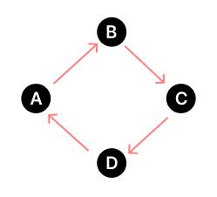

This graph is a connected DAG with 4 vertices and 4 edges. It has two possible topological orderings:

A, D, B, C, and A, D, C, B.

In general, a DAG can have multiple topological orderings if there are vertices that are not related to each other. In the example above, vertices B and C are not related to each other, so they can be ordered in different ways without affecting the topological ordering of the other vertices.

- What is the advantage of using the union-by-rank heuristic in a disjoint set? Explain your answer with an example.

Answer:

Here are three advantages of using the union-by-rank heuristic in a disjoint set:

  - Minimizes the depth of the resulting tree: The union-by-rank heuristic ensures that the depth of the resulting tree is minimized during the union operation. This improves the time complexity of the find operation, which is used to determine which set a given element belongs to.

  - Improves the overall performance: The union-by-rank heuristic improves the overall performance of the disjoint set data structure by reducing the time complexity of the find operation. This makes the data structure more efficient and scalable for large datasets.

  - Easy to implement: The union-by-rank heuristic is easy to implement and can be used in a wide range of applications. It is a simple heuristic that can be combined with other heuristics to improve the performance of the disjoint set data structure.

In general, the union-by-rank heuristic is more effective than the union-by-size heuristic because it ensures that the depth of the resulting tree is minimized, which improves the time complexity of the find operation.

For example,
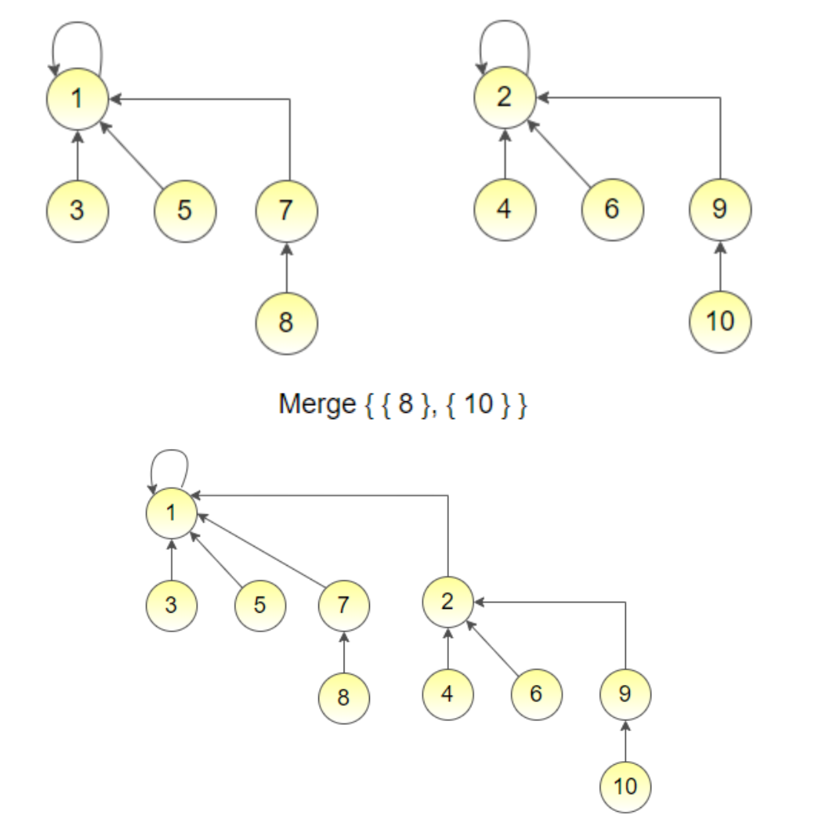

- Suppose you are given a weighted graph where multiple edges have the same weight. You are asked to apply Kruskal’s algorithm to find MST from that given graph. You have chosen the merge sort algorithm to sort the edges in ascending order. “Depending on the sequence of the sorted edges, you may have different MSTs”. Is the statement True or False? Justify your answer.

Answer:

The statement "Depending on the sequence of the sorted edges, you may have different MSTs" is true. This is because Kruskal's algorithm selects edges in ascending order of weight and adds them to the minimum spanning tree (MST) if they do not create a cycle. If there are multiple edges with the same weight, the order in which they are sorted can affect the resulting MST.
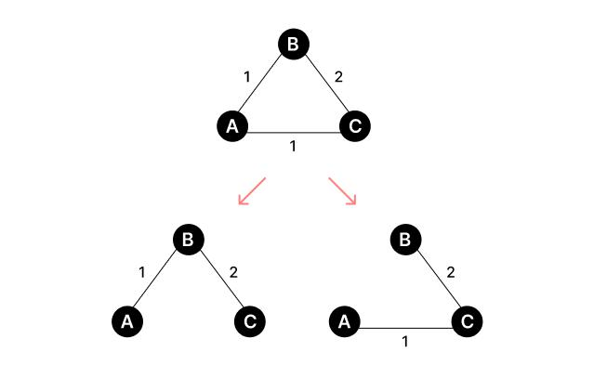

For example, suppose we have a weighted graph with three edges: (A, B) with weight 1, (B, C) with weight 2, and (A, C) with weight 1. If we sort the edges in ascending order of weight, we would get (A, B), (A, C), and (B, C). In this case, the MST would be {(A, B), (B, C)}.

However, if we sort the edges in a different order, such as (A, C), (A, B), and (B, C), we would get a different MST: {(A, C), (A, B)}.

- What will be the runtime complexity of Kruskal’s algorithm if we use bubble sort to sort edges (Sorting elements with bubble sort takes time ( ^2 ))?

Answer:

If we use bubble sort to sort edges in Kruskal's algorithm, the runtime complexity of the algorithm would be O(e^2 log e), where e is the number of edges in the graph.

Bubble sort has a time complexity of O(n^2), where n is the number of elements to be sorted. In Kruskal's algorithm, we need to sort the edges in ascending order of weight, which takes O(e^2) time using bubble sort.

In addition to the sorting time, Kruskal's algorithm also requires O(e log v) time for the disjoint-set operations, where v is the number of vertices in the graph. Therefore, the overall time complexity of Kruskal's algorithm with bubble sort would be O(e^2 log e + e log v). And e^2 log e is bigger than e log v, so we can neglect e log v.

Therefore, the runtime complexity of the algorithm will be O(e^2 log e), where e is the number of edges in the graph.

- A graph contains the vertices {1, 2, 3, 4, 5, 6, 7} and the shortest path from 1 to 7 is 1→3→2→4→5→7→6. Is it possible to find the shortest path from 2 to 7 from the given data? Justify your answer.

Answer:

No, it is not possible to find the shortest path from 2 to 7 from the given data. The fact that the shortest path from 1 to 7 is 1→3→2→4→5→7→6 does not provide enough information to determine the shortest path from 2 to 7.

To find the shortest path from 2 to 7, we need to know the weights of the edges between vertices 2, 4, 5, 6, and 7. Without this information, we cannot determine the shortest path from 2 to 7.

So, we can just say that the only way to find the shortest path from 2 to 7 will be,

2→4→5→7

In general, the shortest path between two vertices in a graph depends on the weights of the edges between them. To find the shortest path between two vertices, we need to use algorithms such as Dijkstra's algorithm or the Bellman-Ford algorithm, which take into account the weights of the edges and compute the shortest path based on that information.

- Explain why a priority queue instead of a regular queue (FIFO) is used in Dijkstra’s algorithm.

Answer:

Dijkstra's algorithm is a shortest path algorithm that uses a priority queue instead of a regular queue (FIFO) to find the next node to explore. The reason for using a priority queue is that it allows the algorithm to explore nodes in order of increasing distance from the source node.

In Dijkstra's algorithm, each node is assigned a tentative distance value, which is the shortest distance from the source node to that node that has been found so far. The algorithm starts at the source node and explores its neighbors, updating their tentative distance values if a shorter path is found. The next node to explore is the one with the smallest tentative distance value, which is why a priority queue is used.

A priority queue is a data structure that allows elements to be inserted with a priority value, and the element with the highest priority is always removed first. In Dijkstra's algorithm, the priority value is the tentative distance value of each node. By using a priority queue, the algorithm can efficiently find the node with the smallest tentative distance value and explore its neighbors.

Using a regular queue instead of a priority queue would not work for Dijkstra's algorithm because it would not guarantee that the nodes are explored in order of increasing distance from the source node. This could result in the algorithm exploring nodes that are farther away from the source node before exploring nodes that are closer, which would not necessarily result in finding the shortest path.

- What are the advantages of open addressing vs chaining for collision resolution?

Answer:

Open addressing and chaining are two methods used for collision resolution in hash tables. Here are the advantages of open addressing over chaining:

  - Space efficiency: Open addressing does not require additional space for pointers to store the keys outside the hash table, unlike chaining. This makes it more space-efficient, especially for small hash tables.

  - Cache performance: Open addressing has better cache performance than chaining because it stores all the elements in a contiguous block of memory. This reduces the number of cache misses and improves the overall performance of the hash table.

  - Low load factor: Open addressing is faster than chaining when the load factor is low because it does not require following pointers between list nodes. This makes it more efficient for hash tables with a low number of collisions.

In general, open addressing is more space-efficient and has better cache performance than chaining. However, chaining may be more efficient for hash tables with a high number of collisions or when worst-case performance is a concern.

- Provide an example to demonstrate that the worst case of the Rabin Karp Algorithm can be O((n-m+1) * m ).

Answer:

The Rabin-Karp algorithm is a string-searching algorithm that uses hashing to find patterns in strings. The worst-case running time of the Rabin-Karp algorithm is O(nm), where n is the length of the text and m is the length of the pattern. This worst-case scenario occurs when all the characters in the text and pattern are the same as the hash values of all the substrings of the text.

For example, suppose we have a text "aaaaa..." of length n and a pattern "aaa..." of length m, where all the characters in the text and pattern are 'a'. In this case, the Rabin-Karp algorithm would need to calculate the hash values for all the substrings of the text of length m, which is O(n-m+1). Since the hash values of all the substrings of the text are the same as the hash value of the pattern, the algorithm would need to compare the pattern with each of these substrings, which takes O(m) time. Therefore, the worst-case running time of the Rabin-Karp algorithm, in this case, would be O((n-m+1) * m).

In general, the worst-case running time of the Rabin-Karp algorithm occurs when all the characters in the text and pattern are the same as the hash values of all the substrings of the text. This can happen when the hash function used by the algorithm is not good enough to avoid hash collisions.

- “Breadth-First Search” can create a minimum spanning tree for unweighted graphs. Explain why this statement is true.

Answer:

The statement "Breadth-First Search can create a minimum spanning tree for unweighted graphs" is true. Breadth-First Search (BFS) is a graph traversal algorithm that starts at a source node and explores all the nodes at the current level before moving to the next level. If we tweak this algorithm by selectively removing edges, then it can convert the graph into the minimum spanning tree.

In an unweighted graph, all the edges have the same weight. Therefore, we can use BFS to find the minimum spanning tree of the graph. To do this, we start at any vertex and perform BFS to explore the graph. As we explore the graph, we keep track of the edges that we have traversed. We only add an edge to the minimum spanning tree if it connects a vertex that has not been visited before. This ensures that the minimum spanning tree is a tree and does not contain any cycles.

Since BFS visits each vertex and edge at most once, the time complexity of this algorithm is O(|V| + |E|), where |V| is the number of vertices and |E| is the number of edges in the graph. In an unweighted graph, |E| is proportional to |V|, so the time complexity of the algorithm is O(|V|). Therefore, BFS can create a minimum spanning tree for unweighted graphs in linear time.

- What is union-by-rank in the Disjoint-Set Union data structure? Why do we need this heuristic? Justify your answer.

Answer:

Union-by-rank is a heuristic used in the Disjoint-Set Union data structure that helps to keep the trees generated during the union operation as balanced as possible. We need this heuristic to reduce the time complexity of the find operation, which involves traversing the tree from a node to its root to find the set that the node belongs to.

The union-by-rank heuristic is important because it minimizes the depth of the resulting tree and makes subsequent operations faster. By using the union-by-rank heuristic, we can ensure that the height of the trees is at most logarithmic in the number of nodes, which means that the time complexity of the find operation is also logarithmic in the number of nodes.

For example,
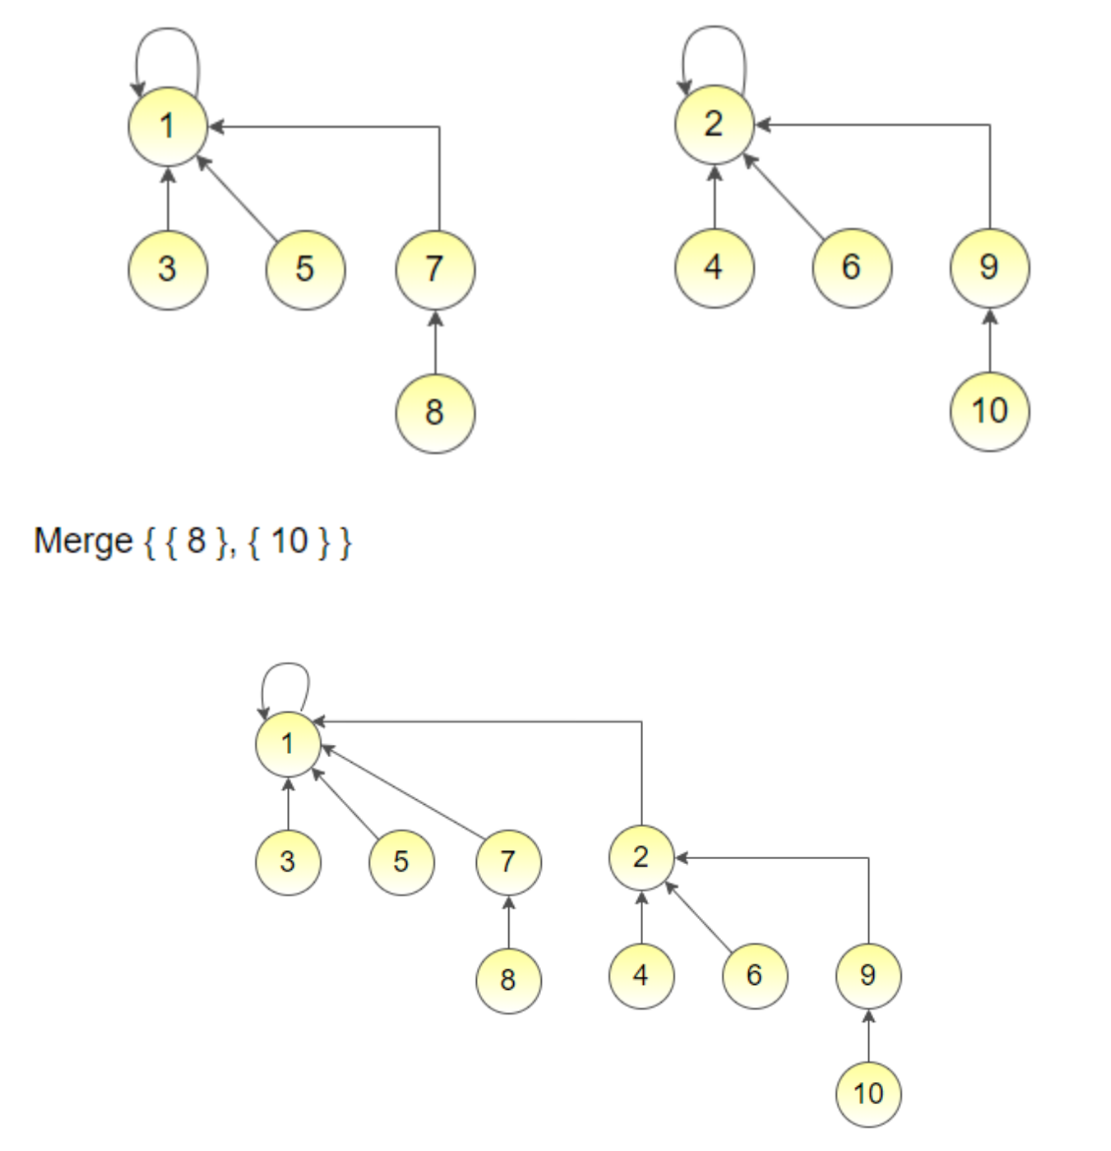

- Write the pseudocode of Union Sets and Find Sets operation of the Disjoint-Set Union data structure, assuming the path compression and union-by-rank heuristics.

Answer:

Here is the pseudocode for the Union Sets and Find Sets operations of the Disjoint-Set Union data structure, assuming the path-compression and union-by-rank heuristics:
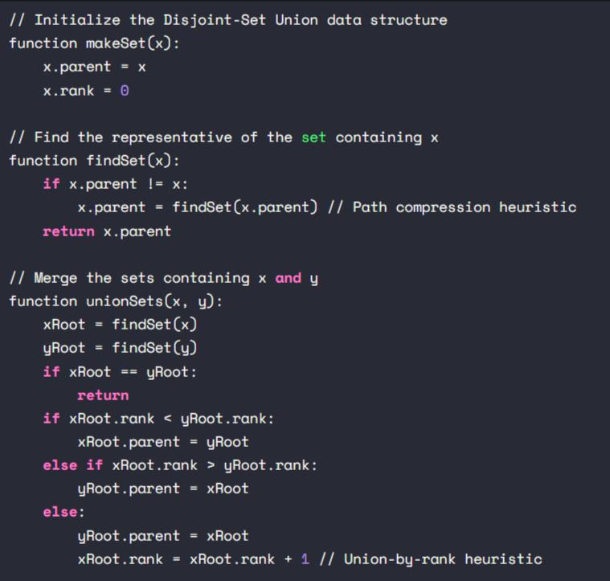

- “Kruskal's algorithm grows a forest of trees and eventually forms the MST.” - Explain this statement with an example

Answer:

Kruskal's algorithm is a greedy algorithm that finds the minimum spanning tree (MST) of a weighted graph by growing a forest of trees and adding edges that do not form a cycle. The algorithm sorts the edges in ascending order of weight and repeatedly adds the smallest edge until all vertices are connected.
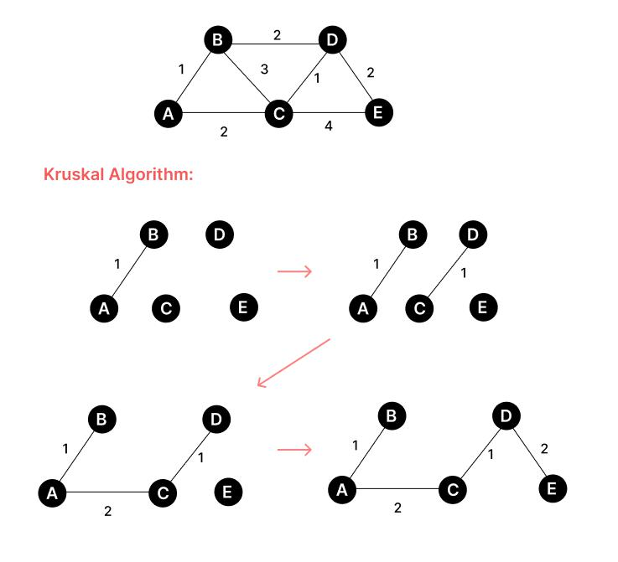

In general, Kruskal's algorithm grows a forest of trees and gradually merges them together until there is only one tree left, which represents the minimum spanning tree of the graph.

13. What are the benefits of a good Hash Function?

Answer:

A good hash function has several benefits, which are as follows:

- Speed: A good hash function should be very fast to compute.

- Minimal duplication of output values: A good hash function should minimize duplication of output values (collisions).

- Uniform distribution: A good hash function should uniformly distribute the data across the entire set of possible hash values.

- Deterministic: A hash function must always generate the same hash value for a given input.

- Bijective: A good hash function should be bijective to not lose information, where possible.

- Secure access and retrieval of data: Hashing provides secure access and retrieval of the data.

- Constant time for searching, insertion, and deletion operations: Hash tables are more efficient than search trees or other data structures.

- Applicability: A hash function is applicable in a variety of situations, such as databases for indexing, disk-based data structures, cache mapping for fast access of the data, password verification, and cryptography as a message digest.

A good hash function ensures that the hash function application will behave as well as if it were using a random function, for any distribution of the input data. It will, however, have more collisions than perfect hashing and may require more operations than a special-purpose hash function.

- Which data structure is best suited for implementing Chaining in a HashTable: Binary Search Tree or Linked List? Explain with time complexity comparisons between the both for operations such as Insertion, Search, and Deletion.

Answer:

Linked List is the best-suited data structure for implementing Chaining in a HashTable. In Chaining, each slot of the HashTable contains a linked list of elements that have the same hash value. When a new element is inserted, it is added to the linked list at the corresponding slot. When an element is searched or deleted, the linked list is traversed until the element is found or the end of the list is reached.

The time complexity of insertion, search, and deletion in a HashTable with Chaining using a linked list is O(1) on average, assuming a good hash function. In the worst case, when all elements have the same hash value and are stored in the same slot, the time complexity becomes O(n), where n is the number of elements in the linked list.

Binary Search Tree (BST) is not well-suited for implementing Chaining in a HashTable because it requires more memory and has a higher time complexity than a linked list. The time complexity of insertion, search, and deletion in a BST is O(log n) on average, where n is the number of elements in the tree. In the worst case, when the tree is unbalanced, the time complexity becomes O(n), where n is the number of elements in the tree. Therefore, using a BST for Chaining in a HashTable is not efficient.

- Explain the working of the Rolling Hash Function in the Rabin-Karp algorithm using a suitable numerical example.

Answer:

The Rabin-Karp algorithm uses a hash function and the rolling hash technique to find a pattern string in a text. The hash function converts every string into a numeric value, called its hash value. The Rabin-Karp algorithm proceeds by computing, at each position of the text, the hash value of the substring of the text that starts at that position and has the same length as the pattern string. If the hash value of the substring matches the hash value of the pattern string, then the algorithm performs an exact comparison of the substring and the pattern string.

The rolling hash technique is used to compute the hash value of the next substring efficiently by reusing the hash value of the previous substring. The rolling hash function is a function that maps a string of length k to a numeric value. The Rabin-Karp Rolling Hash H = c1a^(k-1) + c2a^(k-2) + c3a^(k-3) + ... + cka^0, where a is a constant, c1...ck are the input characters, and k is the number of characters in the string we are comparing.

For example, suppose we want to find the pattern string "abc" in the text "abcbab". We choose a prime number p, say 101, and a constant a, say 256. We compute the hash value of the pattern string as follows:
H("abc") = 97 x 256^2 + 98 x 256^1 + 99 x 256^0 = 2,503,683

We then compute the hash value of the first substring of the text, which is "abc", as follows: H("abc") = 97 x 256^2 + 98 x 256^1 + 99 x 256^0 = 2,503,683
Since the hash values match, we perform an exact comparison of the substring and the pattern string. We then compute the hash value of the next substring, which is "bcb", by reusing the hash value of the previous substring as follows:
H("bcb") = (H("abc") - 97 x 256^2) x 256 + 99 x 256^0 = 2,503,683 - 97 x 256^2 x 256 + 99 x 256^0 = 2,502,339
We continue this process until we find a match or reach the end of the text. The Rabin-Karp algorithm uses only simple multiplications and additions in its rolling hash implementation, and all the operations are done modulo a prime number p to avoid dealing with large numbers.

- What do you understand by edge relaxation? Let d(v) be the shortest path estimate from node s to node v and δ(s,v) be the shortest path value from node s to node v. When does it happen that d[v] = δ(s, v)?

Answer:

Edge relaxation is a process used in shortest-path algorithms, such as Dijkstra's algorithm, to update the shortest path estimate of a vertex by considering its adjacent vertices. The process involves checking if the shortest path estimate of the adjacent vertex can be improved by going through the current vertex. If so, the shortest path estimate of the adjacent vertex is updated to the new, shorter path estimate.

Let d(v) be the shortest path estimate from node s to node v, and δ(s,v) be the shortest path value from node s to node v. The condition d[v] = δ(s, v) holds when the shortest path estimate of vertex v is equal to the actual shortest path value from s to v. This condition is satisfied when all the edges in the shortest path from s to v have been relaxed. In other words, the shortest path estimate of v is updated to the actual shortest path value when all the edges in the shortest path have been considered and relaxed.

- Why do we use the heuristics: union-by-rank and path compression in the Disjoint-Set data structure?

Answer:

Union-by-rank and path compression are two heuristics used in the Disjoint-Set data structure to improve its time complexity. The Disjoint-Set data structure is used to maintain a collection of disjoint sets and supports two operations: union and find. The union operation merges two sets, and the find operation determines which set a given element belongs to.

Union-by-rank is a heuristic that attaches the smaller tree to the root of the larger tree during the union operation. This heuristic ensures that the depth of the resulting tree is minimized, which improves the time complexity of the find operation. The rank of a tree is an upper bound on its height, and it is updated during the union operation to reflect the new height of the merged tree.

Path compression is a heuristic that flattens the tree during the find operation by making every node on the path from the element to the root point directly to the root. This heuristic ensures that the depth of the tree is minimized, which improves the time complexity of the find operation. Path compression can be combined with union-by-rank to achieve an amortized time complexity of O(alpha(n)), where alpha(n) is the inverse Ackermann function, which grows very slowly and is practically constant for all practical values of n.

For example,
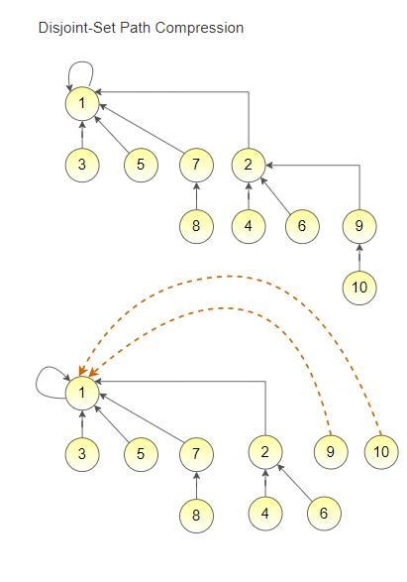

- What is Secondary Clustering? When might a hash table face this suffering?

Answer:

Secondary clustering is the tendency for a collision resolution scheme such as quadratic probing to create long runs of filled slots away from the hash position of keys. This results in long probing chains of the same color, where the keys all start at the same place, and the chain gets really long. Secondary clustering is a problem of collision resolution schemes such as quadratic probing, which can create long runs of filled slots away from the hash position.

Secondary clustering can occur when the hash function is not well-designed, or when the load factor of the hash table is high. The load factor is the ratio of the number of elements in the hash table to the size of the hash table. When the load factor is high, the probability of collisions increases, and the length of the probing chains also increases, leading to secondary clustering.

To avoid secondary clustering, a probe function that depends on the key can be used. This ensures that different keys that hash to the same location follow different probing sequences, which reduces the length of the probing chains and avoids secondary clustering. Other collision resolution schemes, such as separate chaining, can also be used to avoid secondary clustering.

Primary clustering is the tendency for a collision resolution scheme such as linear probing to create long runs of filled slots near the hash position of keys.
- Write a pseudocode for the Disjoint set data structure that prints all the elements that are present in the set where an element E is present. You can assume that the disjoint set has N elements from 1 to N and Make-set, Find-set and Union operations are already implemented.

Answer:

Here is the pseudocode for the Disjoint set data structure that prints all the elements that are present in the set where an element E is present:
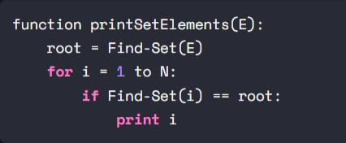

The function takes an element E as input and finds the root of the set where E is present using the Find-Set operation. It then iterates over all the elements from 1 to N and checks if the root of the current element is the same as the root of E. If so, it prints the element. This prints all the elements that are present in the set where E is present.

- Suppose using some unknown algorithm, you have obtained the following shortest path from a source s to a destination t: s, d, f, g, h, j, k, f, r, t. The graph contains all positive edge weights. Even though you do not know what algorithm has been used, mention why this shortest path is incorrect.

Answer:

The shortest path s, d, f, g, h, j, k, f, r, t is incorrect because it contains a cycle. The shortest path in a graph cannot contain a cycle because the length of the path can be reduced by removing the cycle. This contradicts the definition of the shortest path, which is the path with the minimum total weight.

The presence of a cycle in the shortest path suggests that an algorithm that does not detect cycles, such as Dijkstra's algorithm, may have been used to obtain the path. Dijkstra's algorithm assumes that the graph is acyclic and does not work correctly on graphs with cycles.

To obtain the correct shortest path, an algorithm that can handle cycles, such as the Bellman-Ford algorithm, can be used. The Bellman-Ford algorithm can handle graphs with negative edge weights as well, which Dijkstra's algorithm cannot.

- What is Primary Clustering? Which Collision Resolution technique resolves this suffering?

Answer: Primary clustering is the tendency for a collision resolution scheme such as linear probing to create long runs of filled slots near the hash position of keys.

Primary clustering is a problem that can occur in hash tables when keys that hash to nearby locations collide and form clusters. This results in long probing chains near the hash position of the keys, which slows down the performance of the hash table. Primary clustering is a problem of collision resolution schemes such as linear probing, which probes the next location in the table if the current location is occupied.

To resolve primary clustering, collision resolution techniques such as quadratic probing can be used. Quadratic probing is a collision resolution technique that resolves both primary and secondary clustering. Secondary clustering is a problem that can occur when keys that hash to different locations collide and form clusters away from their hash positions. This results in long probing chains away from the hash positions of the keys, which also slows down the performance of the hash table. Quadratic probing resolves secondary clustering by probing more widely separated cells, which reduces the length of the probing chains and avoids forming clusters.

