
United International University (UIU)
Dept. of Computer Science & Engineering (CSE)

Final Exam. : : Trimester: Spring- 2019

Course Code: CSI 217, Course Title: Data Structure
Total Marks: 40 Duration: 2 hours

Answer all three questions. Figures in the right-hand margin indicate full marks.

- The node of a doubly linked list is given as follows: [3+2=5]
struct node{
int element;
struct node* prev;
struct node* next;
};
struct node *head, *tail;
- Write a C program/pseudocode that reverses the given linked list.
- Will your code work if the given linked list is circular? Justify your answer.
- Insert the following keys into a hash table of size 10. The hash function is given here. For conflict resolution, use (i) chaining, (ii) linear probing. [3+3=6]
Keys: 37, 65, 15, 46, 75, 3
Hash function: H(x) = (x+15) MOD 10
- Convert the following infix expression into a postfix expression. [3]
((2+5)*3-4/2*(5-3))+1
OR
Design two functions QUEUE_PUSH and QUEUE_POP for pop and push operation of Queue using linked list [write all necessary codes].

- Suppose, we printed the values of the nodes of a binary search tree using inorder traversal. Will the printed values be in sorted order? Justify your answer. [2]
- Suppose we created a binary search tree by inserting the following values in the given order: 100, 110, 79, 55, 65, 220, 108, 86, 109, 5, 167.
Answer the following questions: [2+3=5]
i) Construct a binary search tree (BST) using those values
ii) Show the tree after deleting the values: 79, 110, 100 (each deletion is applied on the successive resultant tree)
- Answer the following questions [2+2=4]
- Build a complete binary tree using the value: 55, 100, 20, 23, 5, 60, 65, 30, 15, 28
- Write the pre-order and post-order traversal for the tree in question c(I).
- Write a recursive function to print the nodes of a binary tree whose values are divisible by 5. For example your code should print 55, 100, 20, 5, 60, 65, 30, 15 for the binary tree in question c(I). [3]

- The summation of degrees of all the vertices in a simple UNDIRECTED graph G=(V,E) is 14. Is it possible to draw such a graph if |V|=5? If it is possible, how many edges will there be in G? [2]
- If G=(V,E) is a simple DIRECTED Graph such that V={1,2,3,4,5,6} and E={(1,2),(2,3),(2,4),(2,5),(4,5),(4,6),(6,3)}, then draw G. Also draw the adjacency matrix and the adjacency list for G. [1+1=2]
- Apply BFS in the following Graph. Start with vertex 0 as source. Prepare d[u] and π[u] arrays in the following. d[u] means distance from the source vertex and π[u] means the parent of the vertex u in the BFS tree. [1.5+1.5=3]
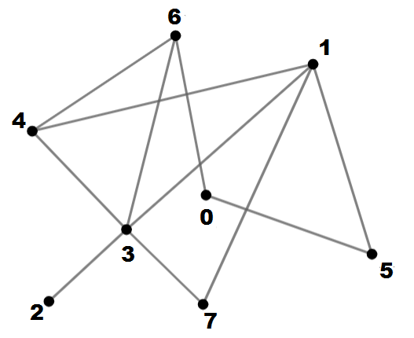
- Topologically sort/order the following Graph. After sorting, draw the graph in the sorted form. If there was an edge from 4 to 7 in this graph, could the graph be topologically sorted? If yes, explain why. If no, explain why not. [1.5+1.5=3]
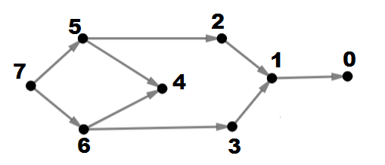
- Apply DFS in the following graph and draw the DFS tree. Next, mark which are the tree edges, back edges, forward edges and cross edges in the graph. Start DFS with vertex 1.
[2]
