
United International University (UIU)
Dept. of Computer Science & Engineering (CSE)
Final Exam Year: 2019 Trimester: Summer
Course: CSI 217 Data Structures
Marks: 40 Time: 2 hours
There are FIVE questions. Answer all of them. Figures in the right-hand margin indicate full marks.

1. | a) | What are the merits of doubly linked list over linear linked list?  OR  What are the merits of a circular queue over a normal one? | [1]
 | b) | Suppose you have a double linked list which starting node is pointed by a pointer named “head” and ending node is pointed by another pointer named “tail”. Now develop an algorithm that finds the middle node of the list.  OR  Discuss a case where Binary Search Tree searching and insertion will take O(n) time | [2]
 | c) | Design an algorithm to display the contents of a QUEUE implemented by an array. | [2]
 | d) | Assume some people are waiting for bus tickets in a line, where special people will get more priority. Now answer the following questions:  - Which data structure you suggest to implement it?  - Design it using your data structure?  - Write algorithms to provide service for the people? | [3]
2. | a) | Show the simulation (Recursive call sequences and corresponding output) of Tower of Hanoi for the number of disks, n = 4 and the starting peg A, destination peg B and auxiliary peg X.  OR  Given an adjacency matrix of a graph, write a code to find out the maximum number of neighbours/adjacent nodes that any vertex has in that graph. Your function will return the maximum value. | [4]
 | b) | Convert the infix expression: (a+b-c*d)/a*(e-f/b*e)-f*g into corresponding postfix expression using stack. Evaluate the expression for the given value: a = 5, b = 7, c = 2, d = 1, e = 5, f = 20, and g = 2.  OR  Suppose you have a student database containing name, id and marks of the students. How would you sort the database according to the marks of the students? | [4]
3. | a) | Draw the following graphs  - Weighted and Unweighted  - Cyclic and Acyclic  - Directed and Undirected  - Complete binary tree and Balanced binary tree | [2]
 | b) | Suggest data structures for representing a binary tree. Show relation of left and right children with respect to father. | [2]
 | c) | Construct the binary search tree for the following traversal sequence.  Preorder: ABDEFCGH  In-order: DBFEACHG | [2]
 | d) | Write an algorithm to determine the level of each of the nodes in a binary tree | [2]
4. | Consider the values: 500, 20, 1, 50, 2, 60, 60, 60, 0, 10.
 | a) | Now develop a binary search tree (BST) using those values. | [1]
 | b) | Write the pre-order, in-order and post-order traversal for the BST in question 4(a). | [3]
 | c) | Show the tree after deleting the value: 500, 50 and 10 (each deletion is applied on successive resultant tree). | [2]
 | d) | Construct an algorithm that search a particular value in BST. | [2]
5. | a) | Insert the values: 26, 51, 24, 15, 33, 18, 17, 79 into a hash table of eleven slots using following hash function:  h(k) = (Rev(k + 1) mod 11)  Here, function Rev(k) reverses the decimal digits of k, for example, Rev(37) = 73 | [2]
 | b) | If any conflict is occurred during the construction of hash table in 5(a), resolve it by the separate chaining method. | [1]
 | c) | Answer the following questions for the graph given below  A  D  C  E  B  - Show adjacency list and matrix for the above graph.  - Simulate the graph above for BFS algorithm.  - Find a topological order from the graph above.  OR  Find the shortest path in the following graph and just mark it in the graph. You don’t have to write any code.  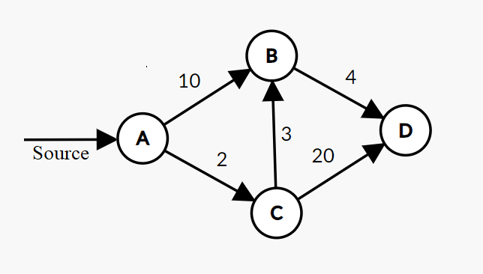 | [1]  [2]  [2]

