CSE 2215: Data Structure and Algorithms-I
Graph Chapter:
- What is a graph?
- Show the following Graphs with diagrams.
- Connected and Disconnected graph
- Cyclic and Acyclic graph
- Directed and Undirected graph
- Weighted and Unweighted graph
- a) Show Adjacency Structures using Array and Linked list for the following graph

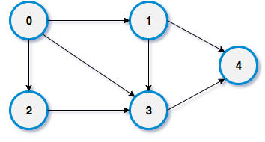
b) Show the required memory for Adjacency Matrix and Adjacency List.

- Find the degree of all the vertices of the given graph

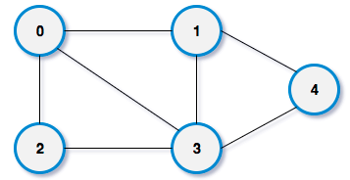

- Draw a Sparse and a Dense graph. Write applications of them

- Show the simulation of BFS and DFS from the graph given below assuming 0 (Zero) is the starting vertex


7. Show the simulation of topological order algorithm using the following directed acyclic graph

Tree Traversal:

1.Show the preorder, inorder, postorder and level order sequences from the following binary tree
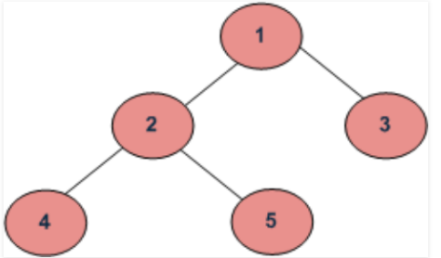

2. Draw a binary tree using the given preorder and inorder sequences
Preorder:ABDEFCG
Inorder:DBFEACG

3. Draw a binary tree using the given inorder and postorder sequences
Inorder:DBEFAGC
Postorder:DFEBGCA

4. Show the simulation of Recursive and Non-Recursive Preorder, Inorder and Postorder algorithms using the following tree



5. Show the simulation of Level order algorithm for the following tree using a Queue


6. Show array and linked list representation of the following binary tree

- Show examples full binary tree, complete binary tree, and balanced binary tree
- Prove that the maximum number of nodes in a perfect binary tree is 2^{h+1}-1
- Find the height of a perfect binary tree
- Prove that the total number of non-leaf nodes in a perfect binary tree is 2^{h}-1
Priority Queue, Heap and Heap Sort:

1.What are the differences and similarities between a QUEUE and a Priority QUEUE?

2. Applications of a Priority Queue

3. Show the status of a QUEUE and a Priority QUEUE (Data in Ascending Order) for the following operations assuming the QUEUE size, m=3, where the QUEUE is implemented by an array.
Insert(30), Insert(20), Delete(), Insert(25), Insert(40), Delete(), Insert(10) Delete(), Delete()
4. Draw a max-heap and min-heap trees from the following data where ID=last two digits of your student ID.

10 40 20 8 99 ID 15 17
5. Sort the data in ascending order and descending order using heapsort for the data given below
10 40 20 8 99 16 15 17
6. Discuss the time complexity of Max-Heapify(A, i, n) or Adjust (A, i. n) procedure in HeapSort(A, n) algorithm
7. Discuss the time complexity of HeapSort(A, n) algorithm
8. How can you find the indices of left and right child in array with respect to father in a max heap tree?

Binary Search Tree:

1.Draw a binary search tree for the following data
10 40 20 8 99 16 15 17

2. Find internal and external path lengths from Ques-I

3. Find average number of successful and unsuccessful comparisons from Ques-I

4. Show the simulation of Recursive algorithm of height calculation for the following tree


5.For binary search tree prove that E(T)-I(T)=2n, where E(T) and I(T) are external and internal path lengths respectively.

6.Insert 11 in the following Binary Search Tree

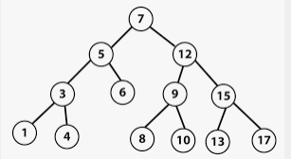

7.Delete 12 from the following Binary Search Tree


8.Write an algorithm to insert/delete an element in/from a binary search tree

Set Operation
- what is Disjoint sets?
- What are the purposes of Union and Find Operation? Show examples for each case.
- Write algorithms for Find and Union Operations.
- Show Father pointer representation using union and find operations for the tree given below
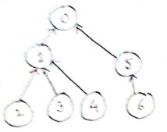
- Show the simulation of Kruskal's algorithm using Find and Union Operations

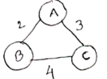

- Write an algorithm for Union by Ranking. Show the simulation of the algorithm for Union(1, 7)

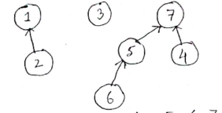
- Write an algorithm for Path Compression. Show simulation for PC_Find (3).

