1.Calculator:
import java.awt.*;
import java.awt.event.*;
public class My_Calculator implements WindowListener, ActionListener{
public int check;
public double number;
public String str1,str2,str3,str4,str5;
public Frame fra;
public Button butt0, butt1, butt2, butt3, butt4, butt5, butt6, butt7, butt8, butt9, butt_add, butt_sub, butt_mul, butt_div, butt_equal, butt_clear;
public Panel p;
public TextField tf;
My_Calculator(){
fra = new Frame("Calculator");
p = new Panel();
butt0 = new Button("0");
butt1 = new Button("1");
butt2 = new Button("2");
butt3 = new Button("3");
butt4 = new Button("4");
butt5 = new Button("5");
butt6 = new Button("6");
butt7 = new Button("7");
butt8 = new Button("8");
butt9 = new Button("9");
butt_add = new Button("+");
butt_sub = new Button("-");
butt_mul = new Button("*");
butt_div = new Button("/");
butt_equal = new Button("=");
butt_clear = new Button("Clear");
}
public void launchframe(){
fra.setSize(200,180);
fra.setVisible(true);
fra.setBackground(Color.WHITE);
fra.addWindowListener(this);
fra.setLayout(new FlowLayout());
butt0.addActionListener(this);
butt1.addActionListener(this);
butt2.addActionListener(this);
butt3.addActionListener(this);
butt4.addActionListener(this);
butt5.addActionListener(this);
butt6.addActionListener(this);
butt7.addActionListener(this);
butt8.addActionListener(this);
butt9.addActionListener(this);
butt_add.addActionListener(this);
butt_sub.addActionListener(this);
butt_mul.addActionListener(this);
butt_div.addActionListener(this);
butt_equal.addActionListener(this);
butt_clear.addActionListener(this);
tf = new TextField(10);
fra.add(tf);
p.add(butt0);
p.add(butt1);
p.add(butt2);
p.add(butt3);
p.add(butt4);
p.add(butt5);
p.add(butt6);
p.add(butt7);
p.add(butt8);
p.add(butt9);
p.add(butt_add);
p.add(butt_sub);
p.add(butt_mul);
p.add(butt_div);
p.add(butt_equal);
p.add(butt_clear);
p.setLayout(new GridLayout(4,4));
fra.add(p);
}
public void actionPerformed(ActionEvent e) {
if(e.getSource()==butt0){
str3 = "0";
tf.setText(str3);
}
if(e.getSource()==butt1){
str3 = "1";
tf.setText(str3);
}
if(e.getSource()==butt2){
str3 = "2";
tf.setText(str3);
}
if(e.getSource()==butt3){
str3 = "3";
tf.setText(str3);
}
if(e.getSource()==butt4){
str3 = "4";
tf.setText(str3);
}
if(e.getSource()==butt5){
str3 = "5";
tf.setText(str3);
}
if(e.getSource()==butt6){
str3 = "6";
tf.setText(str3);
}
if(e.getSource()==butt7){
str3 = "7";
tf.setText(str3);
}
if(e.getSource()==butt8){
str3 = "8";
tf.setText(str3);
}
if(e.getSource()==butt9){
str3 = "9";
tf.setText(str3);
}
if(e.getSource()==butt_add){
str4 = tf.getText();
tf.setText("");
check = 1;
}
if(e.getSource()==butt_sub){
str4 = tf.getText();
tf.setText("");
check = 2;
}
if(e.getSource()==butt_mul){
str4 = tf.getText();
tf.setText("");
check = 3;
}
if(e.getSource()==butt_div){
str4 = tf.getText();
tf.setText("");
check = 4;
}
if(e.getSource()==butt_equal){
str5 = tf.getText();
if(check==1){
number = Double.parseDouble(str4) + Double.parseDouble(str5);
String.valueOf(number);
tf.setText(str4 +"+" +str5 +"=" +number);
}
if(check==2){
number = Double.parseDouble(str4) - Double.parseDouble(str5);
String.valueOf(number);
tf.setText(str4 +"-" +str5 +"=" +number);
}
if(check==3){
number = Double.parseDouble(str4) * Double.parseDouble(str5);
String.valueOf(number);
tf.setText(str4 +"*" +str5 +"=" +number);
}
if(check==4){
number = Double.parseDouble(str4) / Double.parseDouble(str5);
String.valueOf(number);
tf.setText(str4 +"/" +str5 +"=" +number);
}
}
if(e.getSource()==butt_clear){
tf.setText("");
}
}
public static void main(String[] args) {
My_Calculator cal = new My_Calculator();
cal.launchframe();
}
public void windowClosing(WindowEvent e) {
System.exit(0);
}
public void windowOpened(WindowEvent e) {
}
public void windowClosed(WindowEvent e) {
}
public void windowIconified(WindowEvent e) {
}
public void windowDeiconified(WindowEvent e) {
}
public void windowActivated(WindowEvent e) {
}
public void windowDeactivated(WindowEvent e) {}

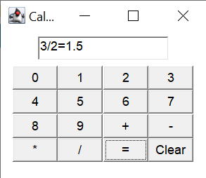
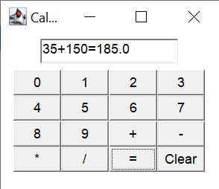
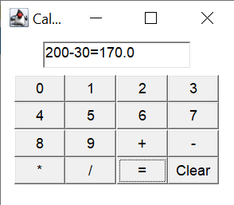



Assignment 1
Name:Rafi Abrar Kabir
Section:A
Student Id:011212012
Object Oriented Programming Language

