2.TicTacToe(Player1VsPlayer2):
import java.awt.*;
import java.awt.event.*;
public class TicTacToeOne implements WindowListener, ActionListener{
public Frame fra;
public Panel p;
public TextField tf = new TextField(10);
public Button butt[] = new Button[9];
int number=0;
public TicTacToeOne(){
fra = new Frame("TicTacToe");
p=new Panel();
}
public void launchframe(){
fra.setSize(200,180);
fra.setVisible(true);
fra.setBackground(Color.WHITE);
fra.addWindowListener(this);
fra.setLayout(new FlowLayout());
fra.add(tf);
p.setLayout(new GridLayout(3,3));
fra.add(p);
}
public void buttoninitialization(){
for(int i = 0; i <= 8; i++)
{
butt[i] = new Button();
butt[i].setLabel("");
butt[i].addActionListener(this);
p.add(butt[i]);
}
}
public boolean checkAdj(int a, int b)
{
if (!butt[a].getLabel().equals("")) {
if (butt[a].getLabel().equals(butt[b].getLabel())) {
return true;
} else return false;
} else {
return false;
}
}
public void actionPerformed(ActionEvent e) {
Button buttonClicked = (Button)e.getSource(); //get the particular button that was clicked
if(number%2 == 0)
buttonClicked.setLabel("X");
else
buttonClicked.setLabel("O");
if(checkForWin() == true)
{
if(number%2 == 0){
tf.setText("Player 1 wins");
}
else{
tf.setText("Player 2 wins");
}
}
number++;
}
private boolean checkForWin() {
if( checkAdj(0,1) && checkAdj(1,2) )
return true;
else if( checkAdj(3,4) && checkAdj(4,5) )
return true;
else if ( checkAdj(6,7) && checkAdj(7,8))
return true;
else if ( checkAdj(0,3) && checkAdj(3,6))
return true;
else if ( checkAdj(1,4) && checkAdj(4,7))
return true;
else if ( checkAdj(2,5) && checkAdj(5,8))
return true;
else if ( checkAdj(0,4) && checkAdj(4,8))
return true;
else if ( checkAdj(2,4) && checkAdj(4,6))
return true;
else
return false;
}
public static void main(String[] args) {
TicTacToeOne ttto = new TicTacToeOne();
ttto.launchframe();
ttto.buttoninitialization();
}
public void windowClosing(WindowEvent e) {
System.exit(0);
}
public void windowOpened(WindowEvent e) {
}
public void windowClosed(WindowEvent e) {
}
public void windowIconified(WindowEvent e) {
}
public void windowDeiconified(WindowEvent e) {
}
public void windowActivated(WindowEvent e) {
}
public void windowDeactivated(WindowEvent e) {
}
}

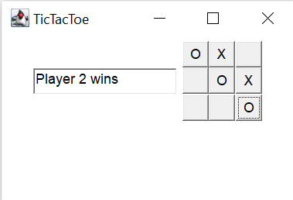
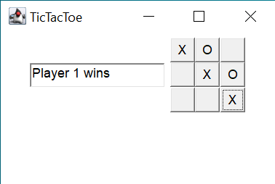



Assignment 2
Name:Rafi Abrar Kabir
Section:A
Student ID:011212012
Object Oriented Programming Language

