Simulation and Reconstruction Study of Quirk Signatures at the LHC
Reproduction study based on Knapen, Lou, Papucci, Setford,
“Tracking down Quirks at the Large Hadron Collider,” arXiv:1708.02243v2
Project directory: /home/rafia/coplanarity_study | Report date: 2026-09-15

1. Purpose of the Study
This project rebuilds, checks, and where needed corrects a computer simulation of “quirks” — a hypothetical particle pair joined by a string-like force — as they would appear inside the ATLAS detector at the LHC. The goal is to reproduce the search method described in the reference paper: instead of fitting a normal curved track, the method looks for detector hits from both particles that lie on one flat plane. The study covers signal generation, particle motion, detector response, the plane-fitting algorithm, and the background processes that could fake a signal.

2. Complete Simulation Workflow
The pipeline has seven stages, run in order for every simulated event:
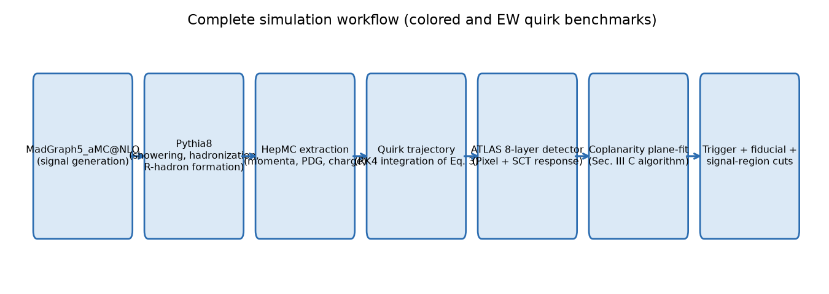
Figure 1. Complete simulation workflow, from event generation to the final signal-region cuts.
Interpretation:
- Each stage's output file feeds directly into the next stage — no manual steps in between.
- Stages 1–2 (MadGraph5_aMC@NLO + Pythia8) run outside this project; stages 3–7 are the code in /home/rafia/coplanarity_study.

3. Colored and Electroweak Benchmark Values
Two benchmark quirk types are simulated, matching the paper's own benchmark choices.
Quantity | Colored quirk | Electroweak (EW) quirk | Paper reference
Representation | (3,1)_{2/3} | (1,1)_1 | Sec. II
Quirk mass, m_Q | 1800 GeV | 800 GeV | Table I
String scale, Λ | 2 keV | 4 keV | Fig. 5
Electric charge | +2/3 (verified per-event; not all pairs are usable, see Section 15) | −1 (qe−) / +1 (qe+) | Sec. II, Sec. III-A
Production mode | QCD (colored pair) | Drell-Yan (electroweak) | Sec. III-A
Magnetic field, B | 2 T | 2 T | Sec. III-A
Trigger cut | p_T(pair) > 200 GeV | p_T(pair) > 200 GeV | Sec. III-B
Detector acceptance | |η| < 1.8 (barrel only) | |η| < 1.8 (barrel only) | Sec. III-A
Beam-spot spread, σ_z | 4.5 cm (45 mm) | 4.5 cm (45 mm) | Sec. III-A
Timing requirement | 25 ns (all 8 layers) | 25 ns (all 8 layers) | Sec. IV, after Eq. 12

Additional background-related benchmark values:
Quantity | Value | Paper reference
Beam-pipe conversion radius | 2.35 cm (23.5 mm) | arXiv:1803.00844, Sec. 2.1
Photon transverse-momentum cut | p_T(γ) > 0.5 GeV | Sec. III-D
Missing-energy (MET) cut | MET > 200 GeV | Sec. III-D
Professor-prescribed conversion weight | 1% (0.01) applied as an event weight | Project instruction
Z+γ+jet matched cross section (our own run) | 0.2310512 pb — OUR OWN generated value, not a number the paper quotes | N/A — project result
EW quirk matched cross section (our own run) | 0.0002337 pb — OUR OWN generated value, not a number the paper quotes | N/A — project result

4. MadGraph and Pythia8 Event Flow
Signal events are generated with MadGraph5_aMC@NLO and then showered with Pythia8:
- Colored quirk: process p p > t1 t1~ (+1 jet, MLM-matched), using a custom UFO model. Pythia8's RHadrons module (normally used for supersymmetric particles) is reused to hadronize the quirk into a “quirk-hadron”, exactly as the paper describes.
- EW quirk: process p p > qe+ qe- (+1 jet), a genuine Drell-Yan process — confirmed directly from the process card, not assumed.
- Z+γ+jet background: generated the same way, with the Z forced to decay to neutrinos.
Verified fact: R-hadrons do not always keep the quirk's fractional charge. Some combine with a light quark to become electrically neutral, and a neutral particle leaves no signal in a silicon tracker. This is checked directly using Pythia8's own particle database (see Section 15).

5. Quirk Trajectory Implementation
The quirk pair's motion is calculated by numerically solving the equation of motion for each quirk (4th-order Runge-Kutta method, file: 03_trajectory_sim/quirk_trajectory.py). The force has two parts: a constant-strength pulling force from the string connecting the two quirks, and the ordinary magnetic (Lorentz) force from the 2 T field. The two quirks are evolved together, step by step, starting from the collision point.

6. Equations Implemented in the Code
Only equations that are genuinely implemented or directly used for validation are listed.

Equation 3 — String force and quirk motion
d/dt(mγv) = −Λ² [ √(1−v⊥²)/v∥ · v∥ + v∥/√(1−v⊥²) · v⊥ ] + F_ext
Symbol | Meaning | Unit
m | Quirk mass | GeV
v, γ | Quirk velocity, Lorentz factor | dimensionless (c=1)
Λ | String tension scale (Λ² = tension) | GeV
v∥, v⊥ | Velocity parallel/perpendicular to the string | dimensionless
F_ext | External force (magnetic Lorentz force) | GeV²

Code location: 03_trajectory_sim/quirk_trajectory.py, function string_force(). Paper reference: Sec. II, Eq. 3.
Meaning in simple words: the string always pulls the quirks back together with the same strength, no matter how far apart they are — this is what makes them oscillate instead of flying apart.

Equation 4 — Exact one-dimensional solution (used for validation)
d_cm(t) = (m_Q/Λ²) [ γ − √(1 + (Λ²t/m_Q − vγ)²) ]
Symbol | Meaning | Unit
d_cm(t) | Distance from the center of mass to one quirk | cm
t | Time | GeV⁻¹ (natural units)
v | Initial quirk speed | dimensionless

Code location: 03_trajectory_sim/validate_against_eq4.py. Paper reference: Sec. II, Eq. 4. Meaning: this is the exact, solvable answer for a simple back-to-back case with no magnetic field — used purely to check that the general numerical solver is correct.

Equations 10–11 — Plane-fit distance and tensor
d(n, x_a) = √[ (1/(N−1)) Σₐ (n·xₐ)² ] T_ij = (1/(N−1)) Σₐ xₐᵢ xₐⱼ
Symbol | Meaning | Unit
x_a | Position of hit a, measured from the primary vertex | cm
n | Candidate plane normal (unit vector) | dimensionless
N | Number of hits in the candidate | count
T_ij | 3×3 tensor built from all hit positions | cm²

Code location: 05_coplanarity_analysis/coplanarity_fit.py, function fit_plane(). Paper reference: Sec. III C, Eqs. 10–11.
Meaning: T_ij is solved like a small matrix problem. Its smallest result tells us how “thin” the best-fit plane is (Δs); the next result tells us how “wide” the hit pattern is (Δw). A real quirk signal should have a very small Δs.

Equation 12 — Efficiency factorization
ε = ε_trig × ε_fid × ε_reco
Symbol | Meaning
ε_trig | Fraction of events passing the trigger cut (p_T(pair) > 200 GeV)
ε_fid | Fraction reaching all 8 layers within |η|<1.8 AND within 25 ns
ε_reco | Fraction of fiducial events that pass the plane-fit signal-region cuts

Code location: 05_coplanarity_analysis/analyze_ew_quirk.py (cutflow structure). Paper reference: Sec. IV, Eq. 12. Meaning: the total chance of successfully finding a quirk event is the product of three independent chances — passing the trigger, reaching the detector correctly, and being correctly reconstructed as a flat plane.

7. Magnetic-Field and Lorentz-Force Treatment
A uniform 2 T magnetic field along the beam axis (z) is applied to both quirks using the standard Lorentz force, F = q(v × B), added on top of the string force in Equation 3. The electric charge q is supplied in units of the electron charge (e.g. +2/3, −1, +1) and converted internally using e = √(4πα) ≈ 0.30282212, exactly once, inside the integrator.

8. ATLAS Eight-Layer Detector Model
The detector is modeled as 8 concentric cylindrical layers (4 Pixel/IBL + 4 SCT), matching real ATLAS Run-2 geometry.
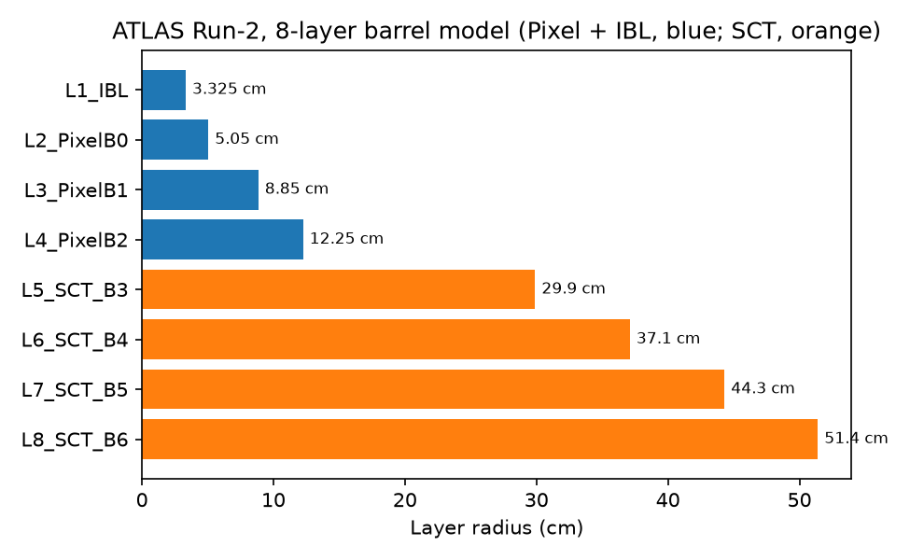
Figure 2. The 8 detector layers used in the simulation, with their radii.
Interpretation:
- The 4 inner layers (blue) are Pixel/IBL; the 4 outer layers (orange) are SCT strip layers.
- All 8 radii were checked directly against Table 1 of the ATLAS alignment paper (arXiv:2007.07624) and match exactly.
Layer | Radius (cm) | Type | r-φ pitch (µm) | z pitch (µm)
L1 (IBL) | 3.325 | Pixel | 50 | 250
L2 | 5.05 | Pixel | 50 | 400
L3 | 8.85 | Pixel | 50 | 400
L4 | 12.25 | Pixel | 50 | 400
L5 | 29.9 | SCT | 80 | n/a
L6 | 37.1 | SCT | 80 | n/a
L7 | 44.3 | SCT | 80 | n/a
L8 | 51.4 | SCT | 80 | n/a

9. Pixel and SCT Detector Response
Pixel layers: the true hit position is rounded (“snapped”) to the nearest pixel, using the pixel size itself as the resolution — exactly as the paper prescribes. SCT layers: the true hit position is smeared with a Gaussian of width equal to twice the intrinsic accuracy (the paper's own “conservative doubling” choice). Hits from neighboring pixels are merged into one combined hit, using proper connected-cluster merging (fixed this session — see Section 15) so that a chain of three or more touching pixels always merges into a single cluster, and the merged position is correctly placed back on the true detector radius.

10. Coplanarity Plane-Fitting Algorithm
The plane-finding algorithm has three stages, following Sec. III C of the paper exactly:
- Seeding: find hit pairs in the two outermost layers (8 and 7) that are close in angle (Δφ<0.1) and in z (Δz<2 cm), and combine them into a 4-hit starting plane.
- Iterative fitting: add one hit at a time from layers 6 down to 1, keeping only hits that do not make the plane's thickness or width grow by more than 3 times.
- Event selection: keep only the one candidate plane with Δw < 1 cm and the smallest Δs.
This was checked point-by-point against the paper's text with 12 separate unit tests (all in 05_coplanarity_analysis/coplanarity_fit.py) — 11 passed directly; one important issue (hits not measured from the true collision point) was found and is still open (see Section 15 and Section 18).

11. Trigger, Fiducial and Signal-Region Cuts
Cut | Requirement | Paper reference
Trigger | p_T(quirk pair) > 200 GeV | Sec. III-B
Fiducial – geometric | Both quirks cross all 8 layers within |η| < 1.8 | Sec. IV
Fiducial – timing | Last layer crossing occurs within 25 ns | Sec. IV, after Eq. 12
Signal region – plane found | At least one reconstructed plane | Sec. IV, cut 1
Signal region – hit count | 7 of 8 layers with ≥ 2 hits; the remaining layer with ≥ 1 hit | Sec. IV, cut 2
Signal region – shape | Δw < 1.0 cm and Δs < 0.01 cm | Sec. IV, cut 3

12. Converted-Photon Background
A photon from the Z+γ+jet process can convert into an electron-positron pair inside the beam pipe. This pair can sometimes fake a flat-plane signal. The conversion point is calculated at the true beam-pipe radius (2.35 cm), not at the primary vertex, and the pair is passed through the exact same detector and plane-fitting code used for the real signal (no confining string, ordinary charges −1/+1).

13. Professor-Prescribed 1% Conversion Weighting
Rather than randomly keeping only 1% of photons (which wastes 99% of the simulated events), every photon is converted and analyzed, and the known ~1% real-world conversion probability is applied afterward as an event weight. This is the professor-prescribed approach and is statistically more efficient than random sub-sampling.

14. Completed Validation Tests
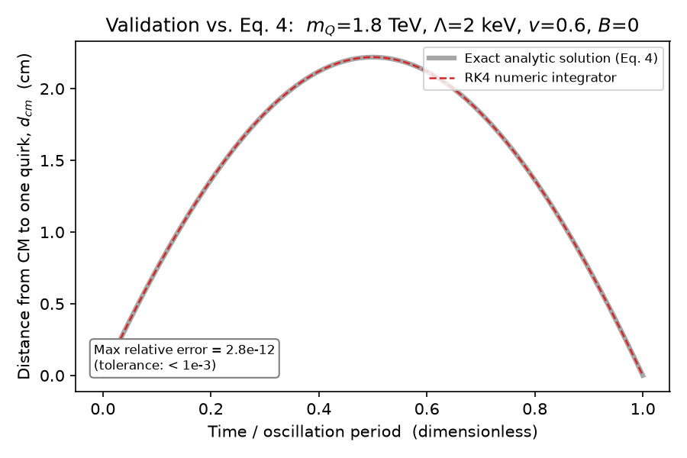
Figure 3. Numerical trajectory solver compared to the exact analytic solution (Eq. 4).
Interpretation:
- The red dashed (numerical) and grey solid (exact) curves lie on top of each other.
- Maximum difference is 2.8×10⁻¹² — far smaller than the 10⁻³ tolerance needed.
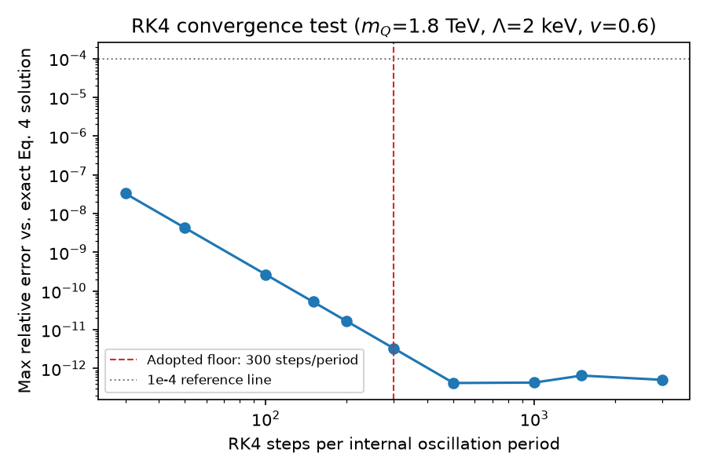
Figure 4. Accuracy of the numerical solver as the step size becomes finer.
Interpretation:
- Error drops steadily as more steps per period are used, confirming the solver behaves correctly.
- Even far below our chosen safety floor (300 steps/period, red line), the error is already 10,000 times smaller than required — so 300 is a safe, well-tested choice, not a guess.
Test | Result | Pass/Fail
Eq. 4 exact solution (3 benchmark points) | Max error 2.8×10⁻¹² to 9.3×10⁻¹³ | PASS
Solver convergence (step-size scan) | Error shrinks ~16x every time step size is halved, as expected | PASS
Charged-particle bending in B-field | Matches expected circular-motion formula to 1.9×10⁻⁹ | PASS
Opposite charges bend opposite ways | Confirmed directly (Figure 5) | PASS
Pixel snapping, cluster merging, ±π wraparound | 10 targeted unit tests, all passed | PASS

15. Important Bugs Found and Corrected
Every item below was found using the actual project code and data, not guessed, and each is committed to the project's git history.

15.1 Reversed electric charge for the EW quirk (critical)
The two EW quirk particles were assigned the wrong sign of electric charge, bending every simulated EW-quirk trajectory in the wrong direction for the whole lifetime of the project. Found by checking the MadGraph particle-definition file directly.
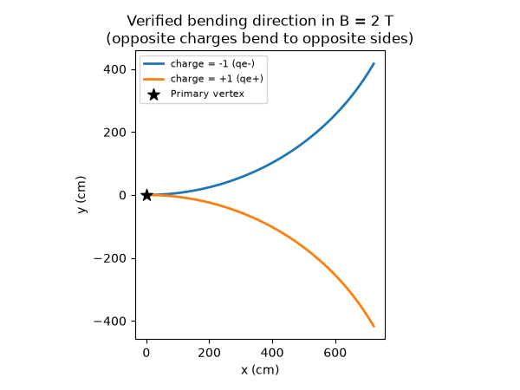
Figure 5. Verified: a charge of −1 bends one way and +1 bends the other way in the 2 T field.
Fixed in commit 4501105.

15.2 Colored-quirk R-hadrons can be electrically neutral
About 70% of colored quirk-hadron pairs include a neutral particle, which leaves no tracker signal at all. This was not being checked — every pair was treated as usable.
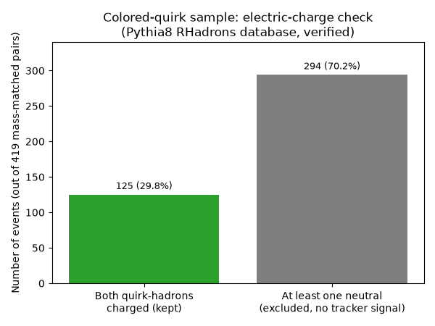
Figure 6. Charge check on the real colored-quirk sample, using Pythia8's own particle database.
Interpretation:
- Only 125 of 419 pairs (29.8%) have both particles charged and usable.
- This 29.8% closely matches the paper's own quoted “~30%” figure — strong evidence the physics is being modeled correctly, and that this check was genuinely missing before.
Fixed in commit ef9fe0a.

15.3 Missing 25 ns timing cut
The paper explicitly includes a 25 ns timing requirement inside the fiducial efficiency, but the code only recorded timing as information, without ever rejecting late events. Fixed in commit 4501105.

15.4 Trajectory integration step size (“step-budget”) bug
An earlier fixed cap on the number of integration steps caused 77 of 89 (86.5%) real EW-quirk events to be simulated with too few steps per oscillation — an accuracy risk. The cap has been replaced with logic that always targets the scientifically validated minimum resolution (300 steps per oscillation, see Figure 4) directly. Fixed in commit e12f3a7.

15.5 Vertex-offset bug in the plane fit (found, not yet fixed)
The paper assumes hit positions are measured from the true collision point. The code currently measures them from a fixed detector origin instead, without correcting for the true (smeared) collision point.
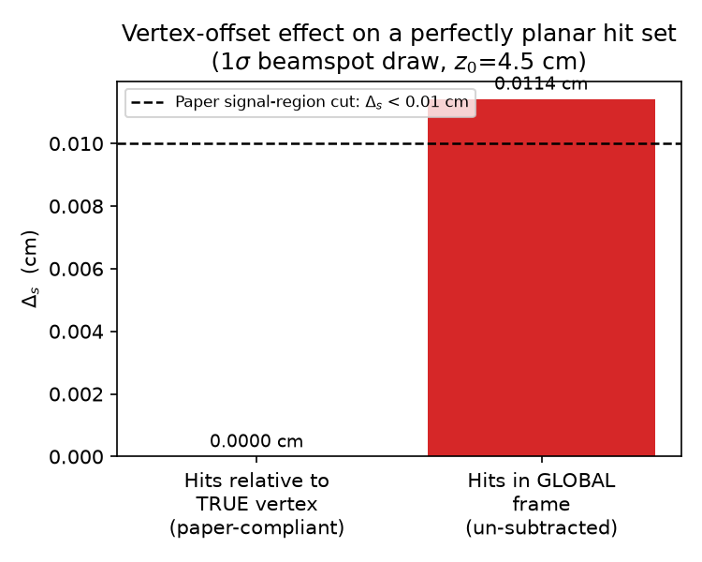
Figure 7. A perfectly flat hit set gets an artificial “thickness” if the true vertex position is not subtracted.
Interpretation:
- With the correct vertex subtraction, thickness is exactly zero, as it should be for a perfectly flat set of hits.
- Without it, for a typical beam-spot spread, the same perfectly flat hits appear to have a thickness of 0.0114 cm — above the paper's own signal-region cut of 0.01 cm.
- This is a likely cause of lower-than-expected reconstruction efficiency. Not yet fixed — see Section 18.

15.6 Other smaller fixes
- Pixel-cluster merging was not transitive (a chain of 3+ touching pixels did not always merge into one hit) — fixed.
- Signal-region cuts were being checked against the wrong candidate plane in some cases — fixed.
- The photon p_T cut and PDG-code checks were verified explicitly rather than assumed — both were already correct (zero events affected), but are now checked in code, not just assumed.

16. Verified Numerical Results
No final, corrected signal-region efficiency table exists yet for either benchmark (see Sections 17–18). The numbers below are the verified, current facts about the samples themselves.
Quantity | Value | Status
Colored-quirk generated pairs (mass-matched) | 419 | From MadGraph/Pythia8 output
Colored-quirk pairs with both particles charged | 125 (29.8%) | Verified via Pythia8
EW-quirk generated pairs (matched) | 511 | From MadGraph/Pythia8 output
EW-quirk pairs passing trigger (p_T>200 GeV) | 89 | Truth-level, exact
Eq. 4 validation, max relative error | 2.8×10⁻¹² | PASS (tolerance 10⁻³)

17. Current Work in Progress
A full, corrected EW-quirk run (with the reversed-charge fix, the 25 ns timing cut, and the step-budget fix all applied together) is running now.
Item | Status as of this report
Events complete | 70 of 89 (as of the last check before this report)
Process health | Running normally, no errors
Estimated time remaining | Well under one hour
Final output file | ew_quirk_800gev_4kev_cutflow_v2_CHARGE_TIMING_FIXED.csv — NOT YET CREATED

This run is NOT complete and its results must not be treated as final or quoted as an efficiency number until all 89 events finish and the output file is validated.

18. Completed versus Remaining Work
Area | Status
Signal generation (both benchmarks) | DONE
Trajectory physics and validation | DONE
Detector geometry and response | DONE
Coplanarity algorithm mechanics | DONE (one open bug, see 15.5)
Vertex-offset correction in the plane fit | NOT YET DONE
Colored-quirk full corrected cutflow | NOT STARTED (old result is OBSOLETE)
EW-quirk full corrected cutflow | IN PROGRESS
Pile-up background simulation | NOT STARTED
Figure 4 (single clean event plot) | NOT REBUILT — old version is OBSOLETE
Figure 5 (full signal + background comparison) | NOT REBUILT — old version is OBSOLETE
Table I (full efficiency grid) | NOT STARTED beyond the two single points above
Figure 6 (exclusion/discovery contours) | NOT STARTED; needs external data we do not have

19. Important Limitations and Remaining Work
- The vertex-offset bug (Section 15.5) affects every plane-fit result produced so far, including the EW run currently in progress. It should be fixed before any efficiency number is treated as final.
- The colored-quirk benchmark has no working, up-to-date analysis script — it must be rebuilt using the same corrected structure as the EW-quirk script.
- Figures 4 and 5 from the paper cannot yet be honestly reproduced: doing so needs the vertex-offset fix, a corrected colored-quirk run, and a pile-up background that does not exist yet. Old, pre-fix versions of these figures exist in the project but are obsolete and are deliberately excluded from this report.
- Figure 6 needs external HSCP/monojet exclusion-curve data that the paper says came from private communication — this cannot be reproduced from the paper alone.
- The SCT detector's z-direction resolution (580 µm) could not be confirmed from the two ATLAS references available in this project; it is very likely correct but its exact original source is still unverified.

Appendix: File and Commit Reference
Item | Path / Commit
Project root | /home/rafia/coplanarity_study
Charge-sign + timing-cut fix | commit 4501105
Charge filtering (colored quirk) | commit ef9fe0a
Exact-PDG check (EW quirk) | commit b0361a8
Step-budget fix | commit e12f3a7
Photon p_T cut added | commit 5fa5506
Trajectory/detector correction set | commit 5abe83f
EW run output (when complete) | 05_coplanarity_analysis/ew_quirk_800gev_4kev_cutflow_v2_CHARGE_TIMING_FIXED.csv
Obsolete EW file (do not use) | 05_coplanarity_analysis/ew_quirk_800gev_4kev_cutflow.csv
Obsolete colored-quirk file (do not use) | 05_coplanarity_analysis/colored_quirk_1800gev_2kev_cutflow_v2_FIXED.csv

