Energy Efficient Rectifier with Regeneration Capabilities for Electric Locomotives

*1 Author Name, 2Author Name, 3Author Name*

*1 Author Affiliation (to include Designation, Dpt, Name of the organization, city, Country, Pin code)*

*2 Author Affiliation (to include Designation, Dpt, Name of the organization, city, Country, Pin code)*

*3 Author Affiliation(to include Designation, Dpt, Name of the organization, city, Country, Pin code)*

*E-mail: 1 Author Mail id, 2Author Mail id , 3Author Mail id*

**Abstract:** This paper presents the design and simulation of a high power quality regenerative PWM rectifier system for electric locomotives rated at 1 M. The demand for efficient use of energy sources and high power quality requirements mandate the use of PWM rectifiers when interfacing the traction converters to the railway power system. The paper first develops the simulation models of the converter power stage and the controller. Then, a design procedure, which determines the critical design parameters, is presented. In addition, a controller that achieves unity power factor and a sinusoidal current that has a total harmonic distortion (THD) less than 2% at the worst case without employing a passive filter is developed. The significant reduction in the switching frequency ripple and the harmonics that enables the filter less design is realized by the interleaved operation of the parallel-connected rectifier units. In conclusion, the concept and the proposed design are verified through simulation studies.

***Keywords-***Electric locomotives; high power quality rectifiers; interleaving; regenerative PWM rectifiers; switch mode rectifiers

**I. INTRODUCTION**

In modern grid connected power electronic systems, high power quality and regenerative features have become the major and incontrovertible part of specifications in most designs. It is because of the significant benefits of these features to the overall system performance: the efficient use of energy sources, the lower cost, better waveform quality at the point of common coupling, managing and minimization of harmonics; and thus compliance to the governmental regulations [1]. The electric locomotive manufacturers demand these features to be included in their new productions [2]. In addition, the ability to manage the harmonics may allow handling or eliminating the undesired oscillations in the railway power system. The harmonic oscillations are signified especially when the catenary line inductance is varying depending on the distance of the locomotive with respect to the source central [3]. Consequently, the solution is to use PWM controlled rectifiers since they can realize high power quality and regenerative features effectively [4]. The classical diode rectifiers only allow unidirectional power ﬂow from ac source side to dc load side. Therefore, they are not suitable for the regenerative operation.

Moreover, the power quality is very poor. The back-to back connected thyristor controlled rectifier system is one of the solutions at high power regenerative applications. However, it is not practical to operate thyristors at high PWM switching frequency. Similarly, the gate tum-off thyristor (GTO) controlled rectifiers cannot be operated at high PWM switching frequency, as well. Additionally, the gate control of these devices needs complex and costly gate drive circuits [5]. Nevertheless, advances in semiconductor power device technology have produced a hybrid transistor called insulated gate bipolar transistors (IGBT). Today, the IGBTs are available with voltage ratings up to 6.5 kV and the current ratings up to 2.4 kA [6]. They are fully controllable, requiring a very simple gate drive, and achieving switching speeds less than one micro-second. The TGBTs that can be used up to 4 kHz switching frequency efficiently at the Megawatt level are available. With the availability of such devices, realization of the high power quality regenerative PWM rectifiers at 1 MW and above rated electric locomotives has become practical. The ability to switch the IGBTs quickly also allows interleaved operation of several parallel connected rectifiers inside one switching period. Simply, the interleaving means operation of several converter units in parallel, but the switching function generated for each unit is equally phase shifted with respect to each other [7]-[8]. The major advantage of the interleaving technique is that the frequency of the ripple at the voltage or the current as well as the frequency of the harmonics created by switching is increased depending on the number of interleaved units. So, this means that the ripple (harmonics) can be easily filtered and the waveform quality is significantly improved. In addition, the ripple magnitude at the common coupling point is reduced because of the equal phase shifting, which also contributes to better waveform quality and easy filtering. It will be shown later that this technique will significantly lessen the requirement for passive filtering in order to eliminate the harmonic currents at the source side. The following sections describe the topology of the converter, explain the control system architecture, define the design steps, and finally verify the concept and the proposed design through simulation studies. Figure 1. Shows the block diagram of electric traction system

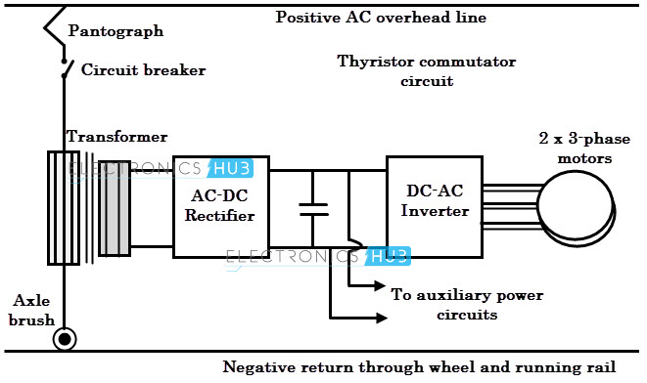

Fig.1. Block diagram of electric traction system

**II. SYSTEM DESCRIPTION**

This section describes the high power quality regenerative PWM rectifier system in detail. The Simulink block diagram of the system is shown in Fig. 2. The block named "Regenerative PWM rectifier" incorporates the power circuit of the rectifier units and the load. The content of this block will be described in the next paragraph. The catenary voltage, which is a single phase ac grid, is represented by an ideal sinusoidal voltage source at 23 k V (nominal voltage), but it is expected to vary between 17 k V and 29 k V as shown in Fig. 2. The given range is likely to be the practical maximum range. The catenary voltage is stepped down to an appropriate level before the rectification.

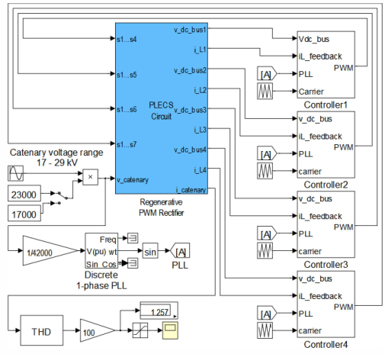

Fig.2. The Simulink model of the high power quality regenerative PWM rectifier system including the controller blocks for each parallel connected rectifier unit and the THO measurement block.

**A. Power Circuit**

Figure 2 shows the power circuit model of the rectifier system, the load, and the main transformer. The model is constructed using piecewise linear electrical circuit simulation (PLECS) tool, which is a Simulink toolbox for system-level simulations of electrical circuits developed by Plexim. The model includes four regenerative PWM rectifiers each connected to the secondary of the main transformer through an inductor. The main transformer is a single-phase transformer with four secondary windings and used to step down the catenary voltage to a low voltage and provide isolated input for each rectifier unit. The inductors shown in Fig. 3 are used to shape the input currents and can be embedded into the main transformer as part of the leakage inductance. This technique provides easy cooling, smaller size, and lower cost for the whole system. The regenerative PWM rectifiers are based on a full bridge topology. The topology uses four fully controllable bipolar switches constructed using a TGBT with an antiparallel diode. Since the input to the converter is an effective current source, the output must be a voltage source. To achieve this, a capacitor is placed at the output of each rectifier. This capacitor also provides filtering of the variations at the voltage caused by the switching frequency and the low frequency (100 Hz) components of the rectified current. The sizing of this capacitor is done in the design section. As shown in Fig. 3, the traction inverters are represented by the resistive loads that are sized to the draw the nominal power of 250 kW. The traction motors will absorb this power at the nominal speed of the locomotive. The full bridge topology shown in Fig. 3 is also known as four-quadrant converter because it can operate both as a rectifier and as an inverter when needed. During the motoring mode, they provide rectification from ac to dc and the power goes from ac side to the dc side. Conversely, during braking or downhill travelling, the motors operate as generators and actually generate electricity. During the generator mode, the converters operate as inverters and convert dc into ac transferring the power from dc side to the ac side (to the catenary). The four-quadrant operation is realized using the fully controllable bipolar switches and the proper control.

**B. Control System**

The system in Fig. 2 shows the controllers for each rectifier unit. Each controller takes four inputs: the conditioned catenary voltage, the instantaneous boost inductor current, dc bus voltage, and the triangular carrier waveform. Signal conditioning of the catenary voltage is provided by a single-phase phase lock loop (PLL) as shown in Fig. 1. The output of the PLL is a sinusoidal signal synchronized to the catenary voltage with 1.0 per unit magnitude. This signal is used by the controllers to shape the input current of the rectifiers to achieve high power quality: low THD and unity power factor. The control system consists of two control loops compensated by the proportional plus integral (PT) and the proportional plus resonant (PR) regulators. The PR regulator provides a high gain only at the fundamental frequency of the ac grid and therefore very effective in correcting the steady-state error and obtaining a good tracking of the reference signal [9]-[12].

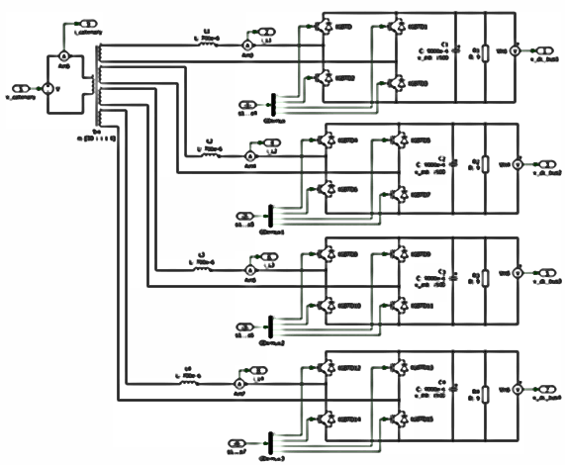

Fig. 3. The PLECS model of the four high power quality regenerative PWM rectifiers connected to the catenary voltage source through a boost inductor and the main transformer.

**III. CONVERTER DESIGN**

This section presents the design of the power circuit and determines the control system parameters based on the specifications given in Table L The nominal power of the electric locomotive is 1 MW. However, the total power is distributed to each traction motor independently through four rectifiers, each rated at 250 kW. The rectifiers are responsible for regulating a constant dc voltage at 1500 V. This voltage is the input to the voltage source inverter (VSI) that drives the traction motors of the locomotive. The main transformer has four isolated secondary windings to supply each rectifier. At the primary of the transformer, the rectifier input currents are summed and drawn from the catenary line.

**A. Design of the Control System**

The control system is a two loop average current mode controller. The scaling of the signals is done assuming an analog controller. The parameters of the PI and the PR compensators are determined via trial error method since the simulation models of the system includes all the major dynamics. The content of each controller for each rectifier is the same except the phasing of the triangular carrier waveforms. As shown in Fig. 4, there are four carrier waveforms with 2 kHz frequency. The optimum phase shift that provides the lowest THD of the input current was determined from the simulations. According to Fig. 4, the phase of the carrier waveforms applied to the second (green), the third (red), and the fourth (light blue) rectifiers are delayed with respect to the first carrier (dark blue) by an angle of 45°, 90°, and 135°, respectively. Although 2 kHz may seem a low switching frequency, the effective ripple frequency will become four times this at the input current due to phase shifting of carriers. Interleaving allows operation at a low switching frequency with no sacrifice to the waveform quality. The benefit of this is the higher efficiency.

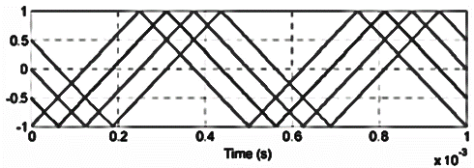

Fig. 4. The waveforms of the triangular carriers

**B. Design of the Power Circuit**

The first step is to determine the main transformer turns ratio. In order to achieve high power quality at the input, the PWM rectifier has to boost the secondary voltage to a level greater than its peak, which is similar to the operation of a conventional boost converter. Therefore, the criterion is to select the turs ratio of the transformer such that the peak of the secondary voltage at the worst case must always be less than the desired minimum dc bus voltage. The following finds the minimum value of the turs ratio

(1)

Where V1 and V2 are the main transformer primary and secondary voltages, respectively. If we assume a worst case minimum of 1400 V dc bus voltage and 29 kV maximum catenary voltage in (1), the turs ratio of the transformer is found as 30. The next step is the sizing of the current shaping (boost) inductor. Generally, there are two criteria in selecting the inductance. One is the desired ripple requirement at the current, and the second is the dynamic response. The low ripple, which needs a larger inductance, is preferred to yield better efficiency and better waveform quality. On the other hand, a low inductance is desired for faster dynamic response. This design selects an inductance that optimizes the both criteria, which corresponds to approximately 20% ripple at the current when the maximum ripple voltage is present across the inductor. The maximum ripple voltage is present across the inductor when the peak of the rectifier input voltage (V2) is half of the dc output, which is when the duty ratio (D) is 50% [5].

**IV. SIMULATION RESULTS**

The simulation studies are performed using Matlab/Simulink and PLECS tools. Fig. 5 shows the waveforms of the inductor current for each rectifier (upper trace) and the catenary current (transformer primary winding current) (lower trace) for the case when there is no phase shift among the carrier waveforms. This result is included here for comparison purposes so that the advantage of interleaving method is verified. As shown in the upper trace of Fig. 5, the switching frequency ripple at the inductor currents is 20% of 50 Hz component of the current as designed. The same amount of ripple is also reﬂected to the catenary current since interleaved operation is not active. This ripple results in 9.934% THD of the current and a slightly low power factor (0.995) at the source. In this case, the only way to reduce THD and improve the power factor at the source side is to use an LC low pass filter with a corer frequency of around 400 Hz. Since placing a filter at the high voltage side may not be practical, a separate filter placed at each rectifier input should be used. However, the interleaving operation will eliminate the need for these filters. The following figures will show the benefit of the interleaving. Figure 6 shows the same waveforms given in Fig. 5, but this time, they are obtained for the case where the carrier waveforms are phase shifted. The inductor currents (upper trace) still have the same amount of ripple as in Fig. 5. Comparison of Fig. 6 with Fig. 5 reveals the benefit of interleaved operation. Figure 8 shows the catenary voltage (blue) and the current (green). The waveforms indicate that the catenary current is perfectly sinusoidal and in phase with voltage resulting unity power factor. The THD of the current is 1.257%, which is well below the specifications. The results verify that the proposed rectifier design achieves high power quality without needing any filtering effort.

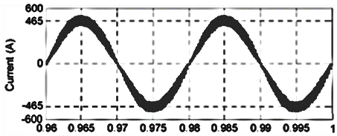

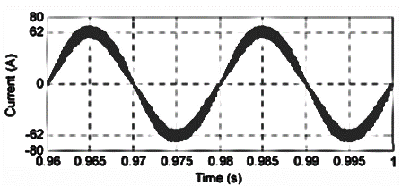

Fig. 5. The waveforms of the inductor current for each rectifier (upper trace) and the catenary current (lower trace) for the case when there is no phase shift among the carrier waveforms (non-interleaved case).

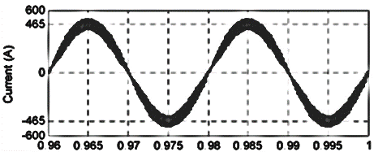

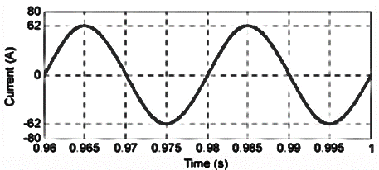

Fig. 6. The waveforms of the inductor current for each rectifier (upper trace) and the catenary current (lower trace) for the case when there is a phase shift among the carrier waveforms (interleaved case).

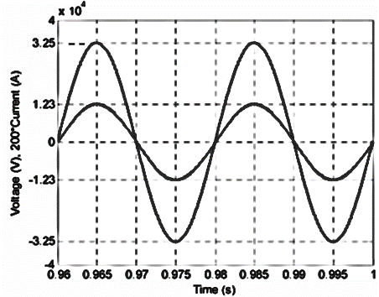

Fig. 8. The waveforms of the catenary voltage (blue) and the current (green). The current waveform is multiplied by 200 for easy viewing

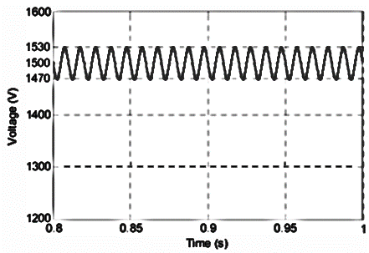

Fig. 9. The output voltage (dc bus voltage) in steady-state.

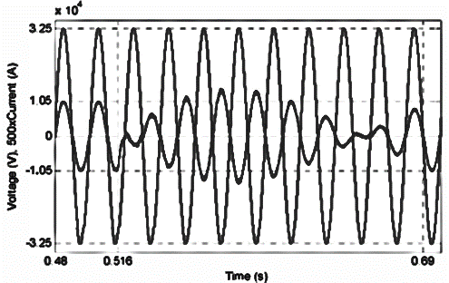

Fig.10. The waveform of the catenary voltage (blue) and the current (red) during a regenerative operation.

Moreover, Fig. 9 shows the waveform of the output voltage. The result shows that the control achieves an average voltage constant at 1 500 V. The ripple is 60 V as designed. The switching frequency ripple is very small compared to 1 00-Hz ripple. Finally, Fig. 10 shows the waveform of the catenary voltage and the current during a regenerative operation. At time t = 0.516 s, a charged capacitor is switched in and a large amount of energy is dumped into the dc bus of each rectifier. As shown in Fig. 10, the converter successfully goes into regenerative mode and transfers the excess energy back to the source. The system goes back to normal at t = 0.69 s.

**V. CONCLUSION**

The demand for efficient use of energy sources and the high power quality requirements mandate the use of PWM rectifiers when interfacing the traction converters to the railway power system. In this study, the design and the simulation of high power quality regenerative PWM rectifier system that realizes these objectives for electric locomotives rated at 1 MW have been presented. The paper gives the details of a design that specifies a unity power factor and a current total harmonic distortion less than 5% without using a passive filter. The filter less operation is realized by interleaved operation of the parallel connected rectifier units. In conclusion, the concept and the design are verified through simulation studies. The results show that proposed rectifier system satisfies the high power quality and regenerative operating needs of modern electric locomotives.

**REFERENCES**

[1] IEEE Recommended Practices and Requirements for Harmonic Control in Electric Power Systems, IEEE Std. 519,1992.

[2] A Steimel,"Electric Traction - Motive Power and Energy Supply," Oldenbourg Industrieverlag,Munich,2008.

[3] c. Heising,R. Bartelt,M. Oetmeier, V. Staudt, and A Steimel, "Improvement of Low-Frequency System Stability in 50-Hz Railway-Power Grids by Multivariable Line Converter Control in a Distance-Variation Scenario," Elect. Systems for Aircraft,

Railway and Ship Prop., 2010,pp. 1-5.

[4] 1. R. Rodriguez, 1. W. Dixon, 1. R. Espinoza, 1. Pont, and P. Lezana, "PWM Regenerative Rectifiers: State of the Art," IEEE Tran. on Power Elect., v.52,no. l,pp.5-22,Feb. 2005.

[5] N. Mohan, T. M Undelad, W. P. Robbins, "Power Electronics: Converters,Applications,ad Design," John Wiley and Sons,NY, USA,1995.

[6] HVIGBT modules, (2013, June 15). Available: http://www.mitsubishielectric.com/semiconductors/products/power mod/hvigbtmodl.

[7] 1. Wen,T . .in and K. Smedley,"A new interleaved isolated boost converter for high power applications," IEEE App. Power Elect. Con] and Exp., voL 3,2006,pp. 79-84.

[8] B. Tamyurek ad D. A Torrey,"A three-phase unity power factor single-stage ac-dc converter based on an interleaved ﬂyback topology," IEEE Trans. Power Electron., vol. 26,no. I, pp. 308- 318,Ja. 2011.

[9] H.-S. Song,R. Keil,P. Mutschler,1. van der Weem,and K. Nam, "Advanced control scheme for a single-phase PWM rectifer in traction applications," Industry Applications Conference, voL3. 2003,pp. 1558 - 1565.

[10] R. Teodorescu, F. Blaabjerg, M. Liserre, and P. C. Loh, "Proportional resonat controllers ad filters for grid-connected voltage-source converters," in Proc. Ins!. Electr. Eng (lEE), Electric Power App/., vol. 153,no. 5,pp. 750-762,Sep. 2006.

[11] G. Gy. Balazs, M. Horvath,L Schmidt, P. Kiss, "Examination of New Current Control Methods for Modern PWM Controlled AC Electric Locomotives," 6th lET Power Electronics, Machines and Drives Conference, Paper c. 2.4 (0276),2012,pp. 1-5.

[12] M. X. Xu, D. Xu, P. Lin, M. Chen, 1. Ni, and T. Zhang, "Understanding repetitive control and resonant control," 3rd IEEE Inter. Sym. on Power Electronics for Distributed Generation Systems (PEDG), pp. 621- 627,2012.