

OptiFlow – Smart Business Optimizer for West African SMEs
Department of Computer Science and Information Systems
CS443 – Mobile Application Development – Section A
Faculty: Mr. David A. Sampah
Faculty Intern: Mr. Daniel Byiringiro
Spring 2026: Final Individual Project Report
Prepared by: Rafiatou Malam Ali
Date: April 20, 2026

1. Problem Statement
The West African Business Challenge
Small and medium-sized manufacturing and distribution businesses across West Africa face three critical operational inefficiencies that directly impact on their profitability and sustainability:
Problem 1: Production Inefficiency (Profit Loss)
Many manufacturing businesses determine production quantities based on intuition or historical data without considering current resource constraints. This leads to:
- Overproduction: Excess inventory that expires or goes unsold, wasting raw materials
- Underproduction: Stockouts when demand exceeds supply, resulting in lost sales
- Resource waste: Raw materials, labor hours, and machine capacity are poorly utilized
Impact: Businesses lose an estimated 15-20% of potential profit due to suboptimal production planning.
Problem 2: High Transportation Costs
Logistics managers plan delivery routes manually using paper maps or driver memory. This results in:
- Excess fuel consumption: Trucks travel longer distances than necessary
- Inefficient vehicle utilization: Trucks return empty or travel half-full
- Cross-border inefficiencies: Poor coordination for deliveries between countries
Impact: Transportation costs account for 30-40% of product prices due to inefficient routing.
Problem 3: Inefficient Delivery Routes
Drivers serving rural and urban locations navigate without GPS optimization, leading to:
- Missed deliveries: Rural locations are skipped due to navigation difficulty
- Driver overtime: Unpredictable routes cause excessive working hours
- Fuel waste: Average 20-35% excess fuel consumption compared to optimized routes
Impact: Delivery times are 30-50% longer than necessary, increasing operational costs.
The Solution: OptiFlow
OptiFlow is a mobile application that uses mathematical optimization techniques (Linear Programming, Network Flow, and Python OR-Tools) to solve these three problems. The app provides:
- Product Mix Optimization Tells businesses exactly how many units of each product to produce to maximize profit given their resource constraints.
- Transport Cost Minimization Tells logistics managers exactly how many units to ship from each supply point to each demand point to minimize total transportation cost.
- Route Optimization Calculates the shortest possible delivery route visiting all locations and displays it on a map with turn-by-turn navigation.

Module | Functionality | Description
Product Mix | Maximize Profit | User adds products (name, profit per unit) and resources (name,  available quantity). For each product, user defines resource  consumption per unit. App uses Linear Programming (Simplex method) to calculate optimal production quantities that maximize total profit.
Transport Cost | Minimize Cost | User adds supply points (name, available quantity), demand points (name, required quantity), and cost matrix (shipping cost per unit). App uses Network Flow optimization to calculate minimum total transportation cost and optimal shipping plan.
Route Optimization | Shorten Path | User adds delivery locations by tapping on an interactive Google Map. App captures GPS coordinates and uses Traveling Salesman Problem algorithm to find the shortest route visiting all locations. Displays green line on map with numbered stops.
Budget Optimization | Allocate Resources | User sets total budget and department constraints. App calculates optimal budget allocation to maximize expected ROI.
User Authentication | Phone OTP + Email/Password | First-time users verify via SMS OTP. Returning users login with email and password. Role-based access (Admin, Manager, Driver).
Offline Storage | SQLite Database | Optimization results and user data are stored locally. App works without internet connection (critical for rural West Africa).
Proof of Delivery | Camera + GPS | Drivers capture photo of delivered goods. App stamps photo with GPS coordinates and timestamp. Serves as verifiable proof.
Export & Share | PDF + WhatsApp | Users export optimization results as PDF reports and share via WhatsApp or email.
2. App Operations, Functionalities, and Capabilities
OptiFlow integrates multiple local device resources, including GPS/geolocation, offline storage, camera, push notifications, SMS, and background task execution.
a. Core Application Functionalities
Requirement | Description
Performance | Optimization calculations complete within 15 seconds for typical data sizes (≤20 products, ≤50 locations)
Usability | Simple data entry with validation; multi-language support (English, French, Hausa)
Reliability | Offline access to saved results; automatic sync when connectivity restored
Security | Role-based access control; secure API communication
Regional Adaptability | Multi-currency support (XOF, NGN, GHS); offline-first design for rural areas
b. Non-Functional Requirements
c. Assumptions and Constraints
Assumptions
- Users own smartphones with basic device permissions enabled (GPS, camera, storage)
- Users have basic understanding of their business data (product costs, resource limits)
- Internet connectivity is available for initial setup and real-time optimization
Constraints
- Limited development time (academic schedule)
- Dependence on Google Maps API for route optimization (API key required)

3. Prototyping, Specification, Architecture & Design
3.1 High-Level Application Overview
OptiFlow is a cross-platform mobile application that solves three business optimization problems using mathematical programming:
Problem | Technique | User Question Answered
Maximize Profit | Linear Programming (Simplex) | "How many units of each product to produce?"
Minimize Cost | Transportation Problem (Network Flow) | "How many units to ship from where to where?"
Shorten Path | Traveling Salesman Problem | "What order to visit stops to drive the fewest km?"
3.2 System Architecture diagram
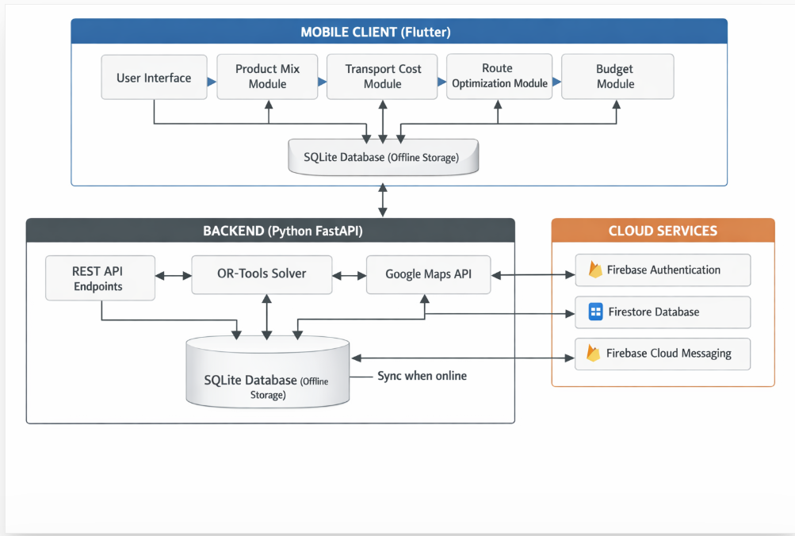Flow Explanation:
- User interacts with Flutter mobile interface
- User enters business data (products, resources, locations)
- App stores data locally in SQLite for offline access
- When online, app sends optimization requests to FastAPI backend
- Backend uses OR-Tools solver to calculate optimal solution
- Results returned to mobile app in plain business language
- User can save, export, or share results
3.3 Application Layers
Presentation Layer (UI)
- Built with Flutter (Dart)
- Screens: Onboarding, Phone Auth, Login, Role Selection, Business Setup, Dashboard, Product Mix, Transport, Route, Budget, Results, Profile
Business Logic Layer
- Optimization calculations using Linear Programming
- Transportation problem solving (Network Flow)
- Route optimization (Traveling Salesman Problem)
- Role-based access control
Data Layer
- Firebase Authentication (Phone + Email/Password)
- Cloud Firestore (User data, business data, optimization results)
- SQLite (Offline storage for rural areas)
Entity Relationship Diagram:
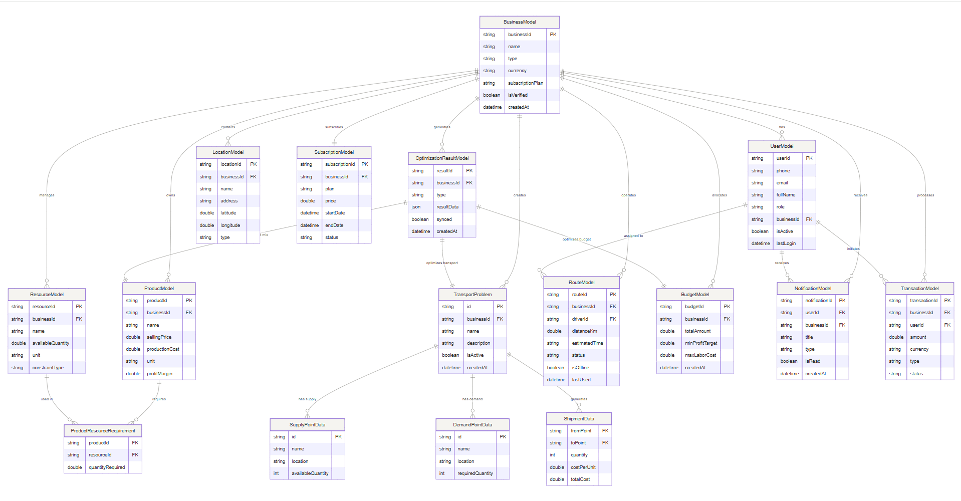
Use case diagram:
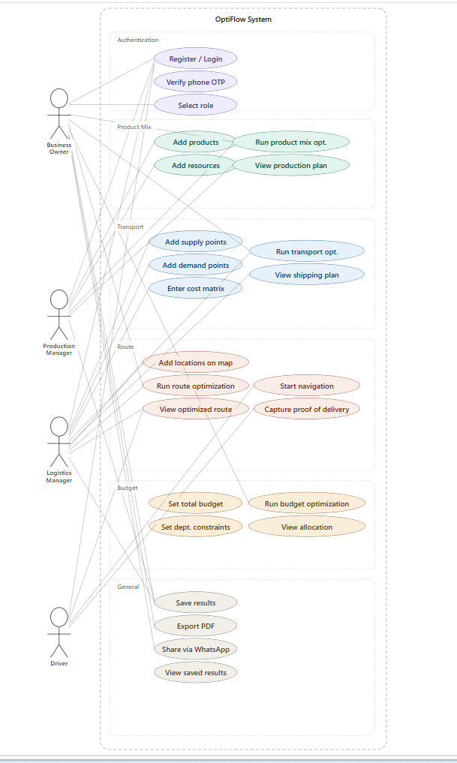

Navigation flow diagram:
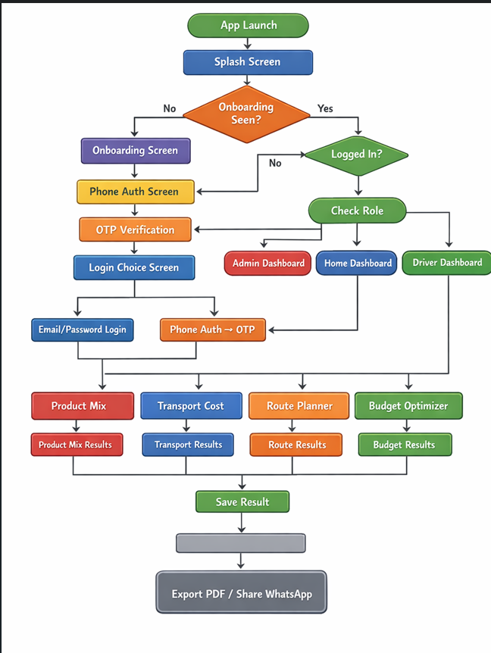
Authentication flow
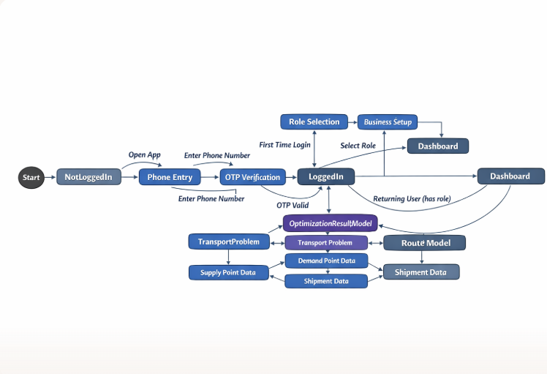

Feature | Implementation | Purpose
GPS/Geolocation | geolocator package | Driver tracking, location capture
Camera | image_picker package | Proof of delivery photos
Offline Storage | SQLite (sqflite) | Rural area functionality
Push Notifications | Firebase Cloud Messaging | Optimization complete alerts
Device Features Integration
3.5 Application Prototype
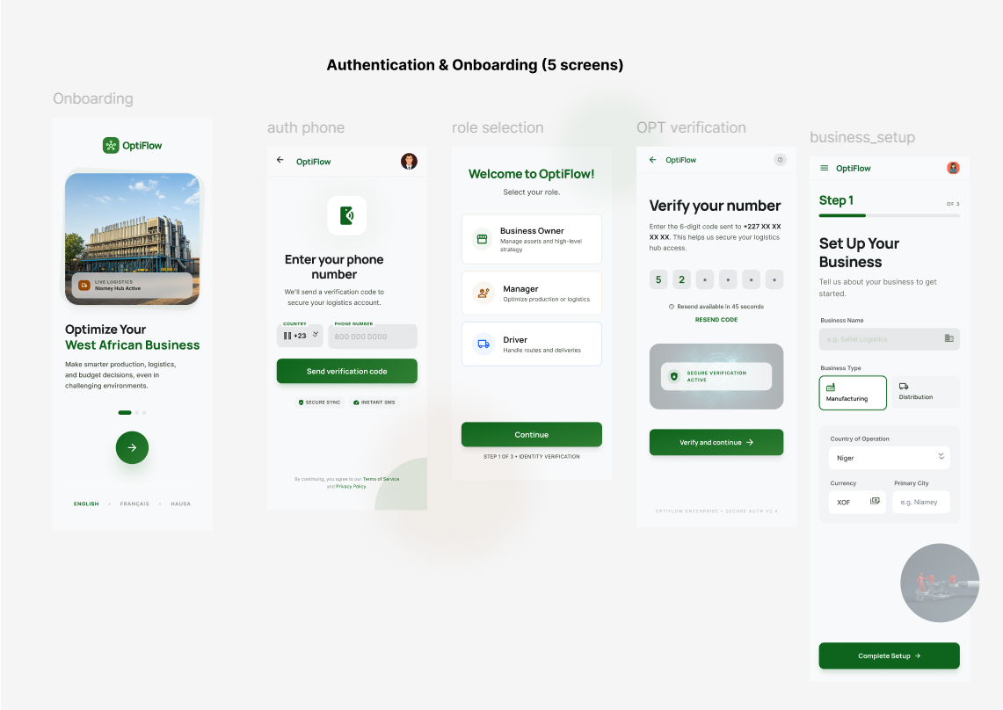
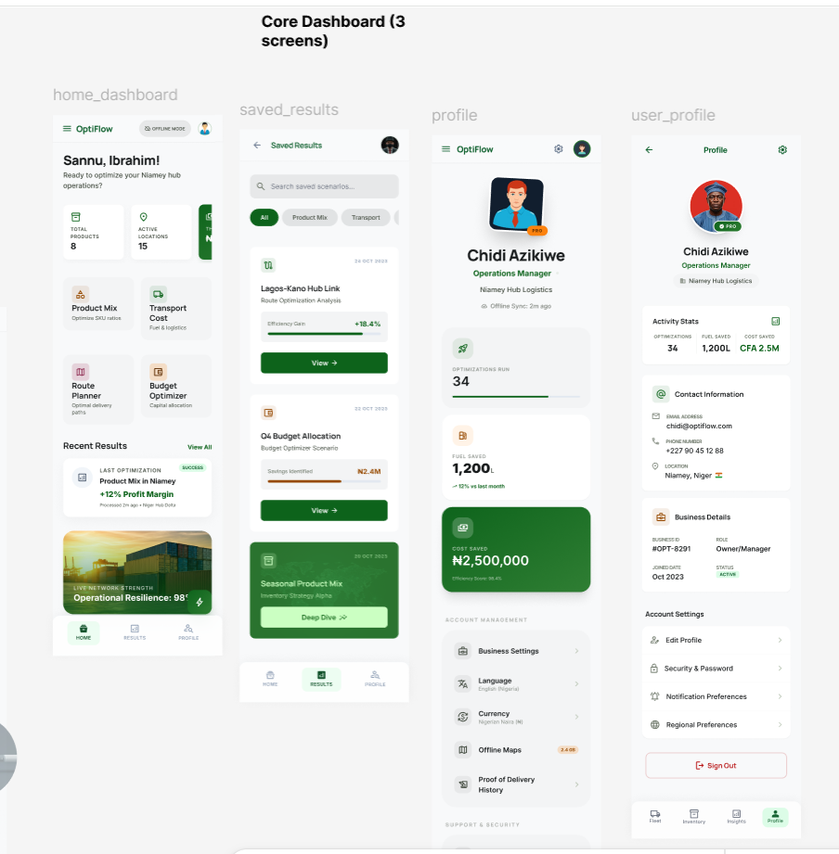
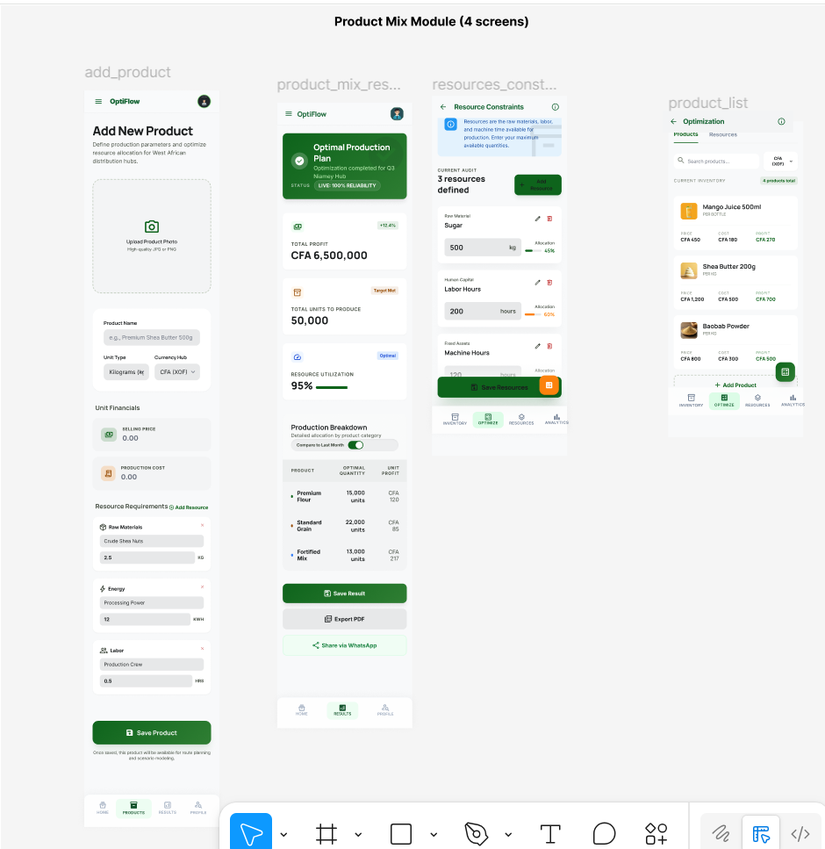
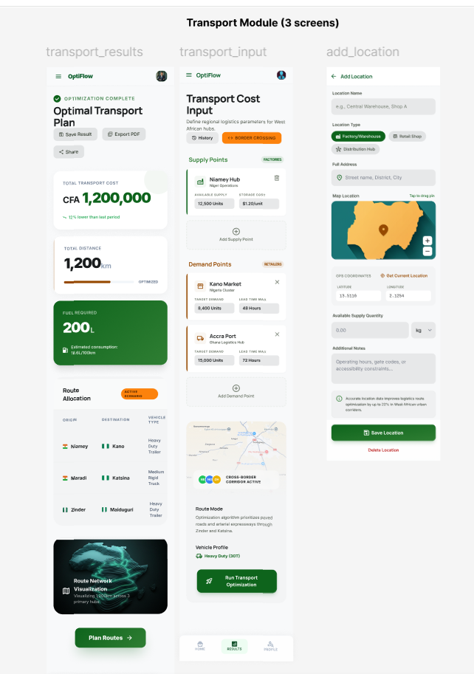
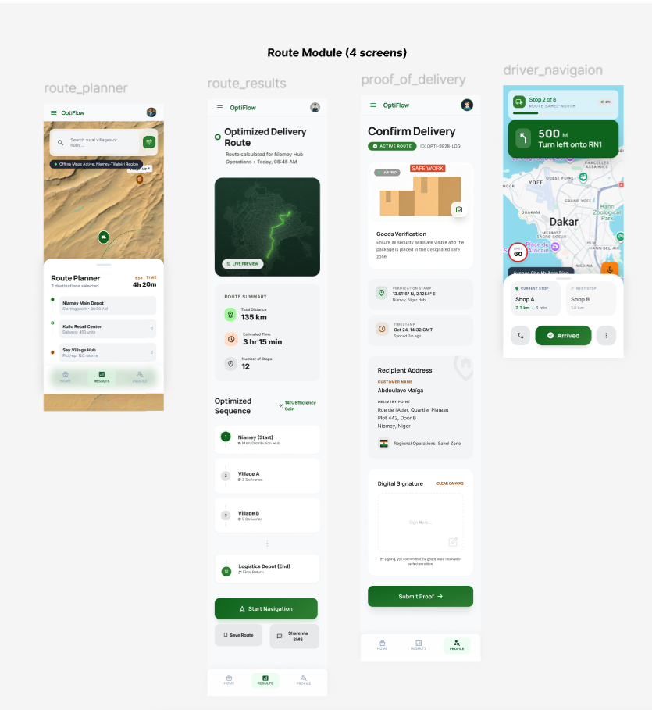
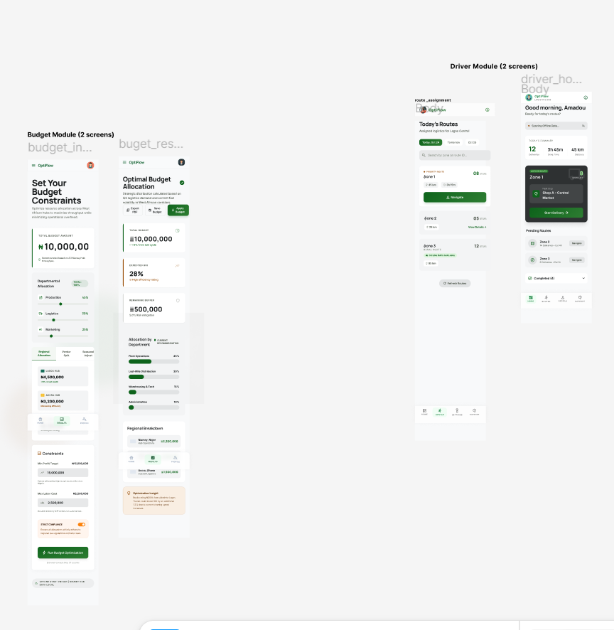
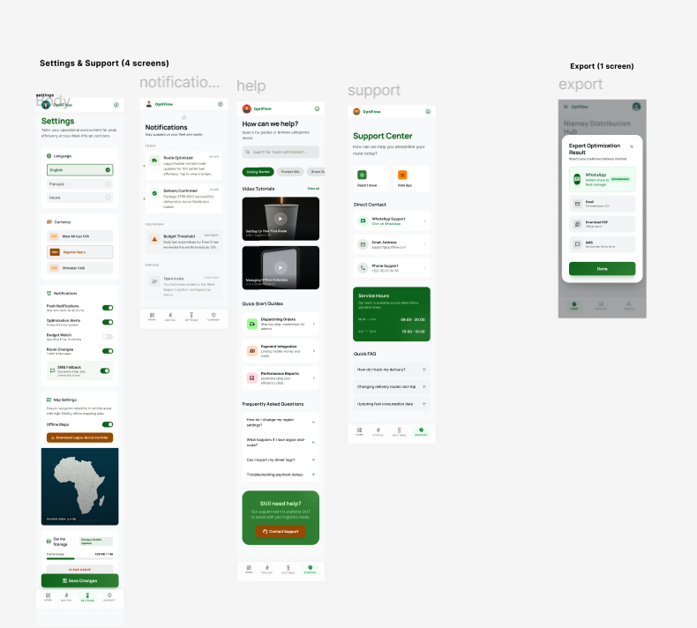
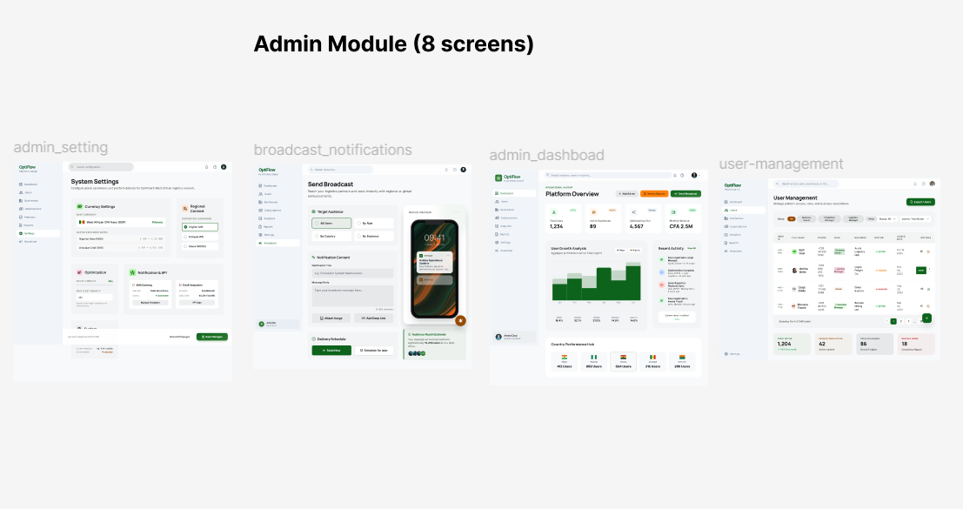
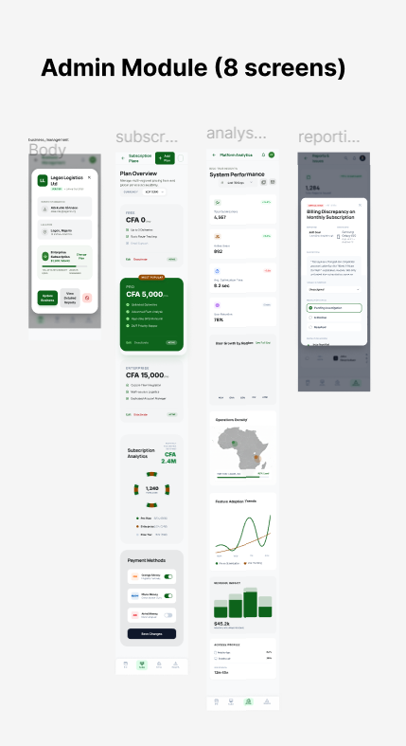
The OptiFlow prototype demonstrates a professional business optimization interface designed for West African SME managers. The interface emphasizes simplicity, clear data entry, and actionable results.

References
- Ragsdale, C.T. (2011). Spreadsheet Modelling and Decision Analysis, 8th Ed. Canada: South-Western, Cengage Learning.
- Google OR-Tools Documentation. (2026). Linear Optimization. Retrieved from https://developers.google.com/optimization
- Flutter Documentation. (2026). Cross-platform UI framework. Retrieved from https://flutter.dev
- Firebase Documentation. (2026). Authentication and Firestore. Retrieved from https://firebase.google.com

