ESP32 is capable of functioning reliably in industrial environments, with an operating temperature ranging from –40°C to +125°C. ESP32 has ultra-low power consumption with a combination of several types of proprietary software. ESP32 also includes state-of-the-art features, such as fine-grained clock gating, various power modes and dynamic power scaling. ESP32 can perform as a complete standalone system or as a slave device to a host MCU, reducing communication stack overhead on the main application processor. ESP32 can interface with other systems to provide Wi-Fi and Bluetooth functionality through its SPI / SDIO or I2C / UART interfaces.

ESP32-DevKitC:

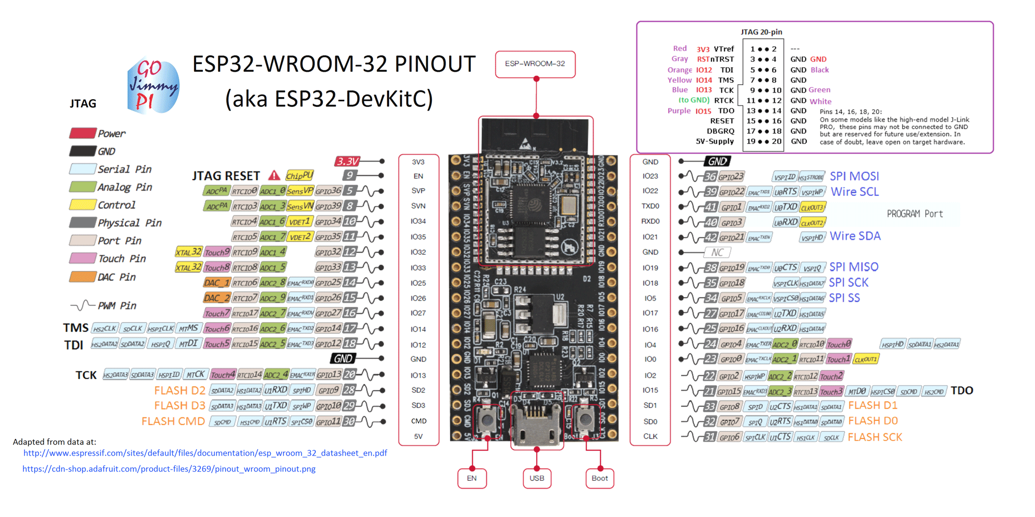

**Flame Sensor Setup**

MCP3008: The MCP3008 10-bit Analog-to-Digital Converter (ADC) combines high performance and low power consumption in a small package, making it ideal for embedded control applications. The MCP3008 features a successive approximation register (SAR) architecture and an industry-standard SPI serial interface, allowing 10-bit ADC capability to be added to any PIC® microcontroller. The MCP3008 features 200k samples/second, 8 input channels, low power consumption.

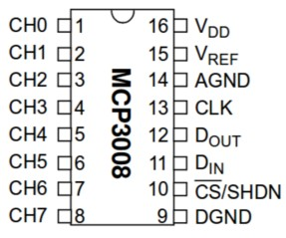

We connect two MCPs with ESP32 to get data from 12 IR sensors as show in Fig.

MCP1 connection:

VDD and VREF -> 3.3V

AGND and DGND -> GND

CLK -> G14 (HSPICLK)

Dout/MISO -> G12 (HSPIQ)

Din/MOSI -> G13 (HSPIID)

CS/SS -> G15 (HSPICS0)

Channel 0-6 -> flame sensor 8-2

MCP2 connection:

VDD and VREF -> 3.3V

AGND and DGND -> GND

CLK -> G18 (VSPICLK)

Dout/MISO -> G19 (VSPIQ)

Din/MOSI -> G23 (VSPIID)

CS/SS -> G5 (VSPICS0)

Channel 3-7 -> flame sensor 1, 12-9

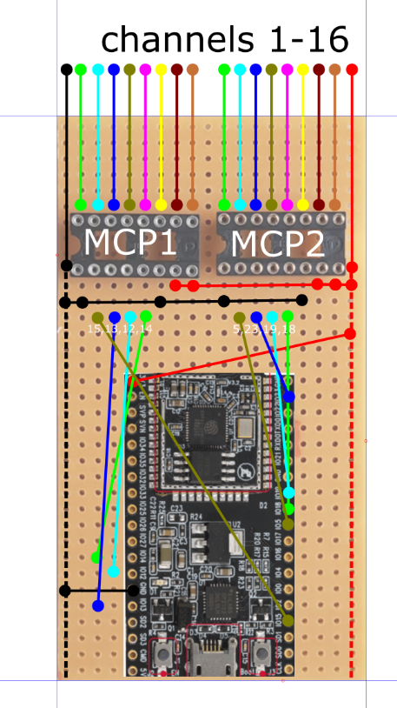

Piezo Buzzer:

VDD -> G21

GND -> GND

433 MHz Transmitter:

VDD -> 5V

GND -> GND

DATA -> G17

Current Sensor Setup

Components Required:

1 x CT sensor YHDC SCT-013-000  
1 x Burden resistor 33 Ohms for 5V supply voltage  
2 x 10k Ohm resistors  
1 x 10uF capacitor

The circuit diagram of the current sensor is shown in Fig.

<https://learn.openenergymonitor.org/electricity-monitoring/ct-sensors/files/Arduino_AC_current_input_A.png>

The setup of the current sensor is shown in Fig.

<https://learn.openenergymonitor.org/electricity-monitoring/ct-sensors/files/currentOnly_bb.png>

We connect the output (yellow wire in Fig) to G33 pin of ESP32