
AMERICAN INTERNATIONAL UNIVERSITY–BANGLADESH (AIUB)
Dept. of Computer Science
Faculty of Science and Technology
CSC2210: OBJECT ORIENTED PROGRAMMING 2
Spring 2024–2025
Section: K
Group No: 03
PROJECT REPORT ON
EMPLOYEE MANAGEMENT SYSTEM
Supervised By
Zahiduddin Ahmed
Submitted By:
Name | ID
MD. Rafid Hossain | 23-54787-3
Izar Hossain Adit | 23-52721-2
Tamim Siraj | 23-51855-2

CO2: Display and verify the mean of a real-life Project using the concepts of C# Graphical User Interface based environment with database integration to depict a desktop-based application.
Assessment  Criteria | Not Attended/ Incorrect (0) | Inadequate  (1-2) | Average  (3) | Good  (4) | Excellent  (5)
Evaluation Criteria | Evaluation Definition |  |  |  | Total =
Requirement fulfillment | Properly demonstrate a real-life scenario-based project with proper functional requirement identification for the Object-Oriented Programming project development activities.
Validation | Ensuring the ability of students’ proper demonstration on validation forms in their system in terms of dealing with the data.
Verification | Identifying if the students can verify the system data along with proper functional requirements in terms of data flow.

Chapter 1: Introduction
In a software development company, many employees work together, and organizing and managing them is challenging without a proper database and user interface. The objective of our Employee Management System is to help a company run smoothly.
An Employee Management System is a central tool to solve these problems. It combines a reliable database with an easy-to-use interface to handle all employee information in one place. This system helps track details, work hours, and tasks efficiently. It reduces manual work and paperwork, cuts down on errors, and keeps data safe and organized. With everything in order, managers can make better decisions, and the company can run more smoothly. This allows everyone to focus on their real work instead of getting stuck in daily admin tasks.

System Objectives
- Streamline employee data management
- Automate leave and promotion request workflows
- Enable efficient task assignment and tracking
- Provide role-based access control
- Ensure data security and integrity

Chapter 2: User Stories & Use Cases

User Registration and Login
A user can log in if they already have an account. If not, they can register by providing general information. During registration, the user selects their role and department and sets a username and password. By default, their account status is set to inactive.

HR Permissions and Use Cases
Recruit: HR can recruit an employee or manager from the recruit page. Based on registration, the user becomes HR, Employee, or Manager, and their status becomes active.
Terminate: HR can terminate any user by searching their username. The system displays the user's data for confirmation.
Promote: HR can finalize promotion of an employee to a manager position.
Update Information: HR can update user information by searching their username.
Leave Request Finalization: HR can finalize leave requests from employees or managers.

Manager Permissions and Use Cases
Review Leave Requests: A manager reviews leave requests from employees working under them. If approved, the request goes to HR.
Review Promotion Requests: A manager reviews promotion requests from employees working under them. Approved requests go to HR.
Apply for Leave: A manager can apply for leave directly to HR.
Assign Tasks: A manager assigns tasks with instructions and time limits to employees under them.

Employee Permissions and Use Cases
Apply for Leave: An employee applies for leave. The request is sent to their manager. If approved, it moves to HR.
Apply for Promotion: An employee applies for promotion to Manager. The request goes to their manager and then to HR if approved.
Complete Tasks: After accepting a task, its status becomes In Progress. When finished, the employee marks it Complete.

Chapter 3: Database Design

3.1 Entity-Relationship Diagram
The following ER diagram represents the relationships between the User, Employee, Task, Leave Application, and Promotion Application entities, including the self-referencing Manager relationship on Employee:

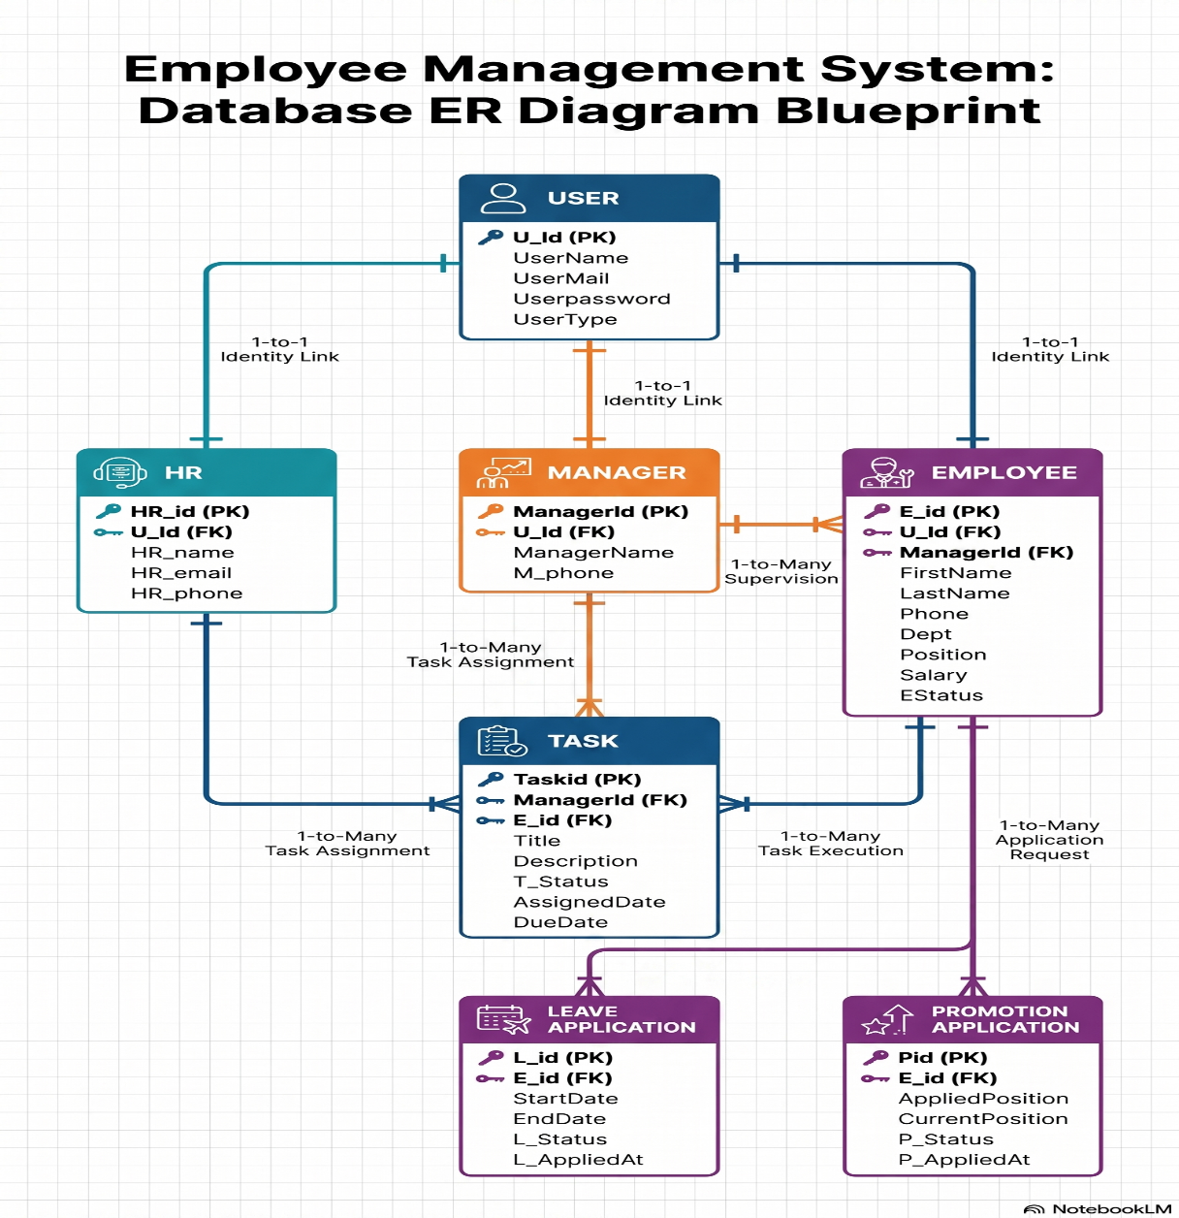
Figure 3.1 — Entity-relationship diagram of the Employee Management System

3.2 Data Dictionary

User Entity
Key | Attribute Name | Data Type | Length | Nullable
PK | U_Id | VARCHAR | 10 | No
 | UserName | VARCHAR | 50 | No
 | UserMail | VARCHAR | 50 | No
 | UserPassword | VARCHAR | 50 | No
 | UserType | VARCHAR | 20 | No

Employee Entity
Key | Attribute Name | Data Type | Length | Nullable
PK | E_id | VARCHAR | 10 | No
FK | U_Id | VARCHAR | 10 | No
FK | ManagerId | VARCHAR | 10 | No
 | FirstName | VARCHAR | 50 | No
 | LastName | VARCHAR | 50 | No
 | Phone | VARCHAR | 15 | No
 | Address | VARCHAR | 100 | No
 | DOB | DATE | — | No
 | Gender | VARCHAR | 10 | No
 | Dept | VARCHAR | 30 | No
 | Position | VARCHAR | 30 | No
 | Salary | VARCHAR | 20 | No
 | EStatus | VARCHAR | 20 | No
 | HireDate | DATE | — | No
 | TerminationDate | DATE | — | No

Task Entity
Key | Attribute Name | Data Type | Length | Nullable
PK | TaskId | VARCHAR | 10 | No
FK | ManagerId | VARCHAR | 10 | No
FK | E_id | VARCHAR | 10 | No
 | Title | VARCHAR | 50 | No
 | Description | VARCHAR | 150 | No
 | T_Status | VARCHAR | 20 | No
 | AssignedDate | DATE | — | No
 | DueDate | DATE | — | No

Leave Application Entity
Key | Attribute Name | Data Type | Length | Nullable
PK | L_id | VARCHAR | 10 | No
FK | E_id | VARCHAR | 10 | No
 | StartDate | DATE | — | No
 | EndDate | DATE | — | No
 | L_Status | VARCHAR | 20 | No
 | L_AppliedAt | DATE | — | No

Promotion Application Entity
Key | Attribute Name | Data Type | Length | Nullable
PK | Pid | VARCHAR | 10 | No
FK | E_id | VARCHAR | 10 | No
 | AppliedPosition | VARCHAR | 50 | No
 | CurrentPosition | VARCHAR | 50 | No
 | P_Status | VARCHAR | 20 | No
 | P_AppliedAt | DATE | — | No

3.3 Database Normalization

Unnormalized Form (UNF)
Username, Status, Password, Role, Dept, Salary, FirstName, LastName, DOB, Gender, Phone, Address, JoinDate, Email, HR_ID, EmployeeID, TaskID, AssignedDate, DueDate, TaskDate, Instruction, LeaveID, LeaveDate, Reason

First Normal Form (1NF)
All attribute values are atomic and there are no repeating groups. The data is decomposed into individual entities.

Second Normal Form (2NF)
- User: Username [PK], Password, Role, Dept, Salary, Status, FirstName, LastName, DOB, Gender, Email, Phone, Address, JoinDate
- HR: HR_ID [PK], Username [FK]
- Manager: ManagerID [PK], Username [FK]
- Employee: EmployeeID [PK], Username [FK], ManagerID [FK]
- Task: TaskID [PK], EmployeeID [FK], AssignedDate, DueDate, Status, Instruction
- Leave: LeaveID [PK], Username [FK], StartDate, EndDate, Reason, Status

Third Normal Form (3NF) — Final Design
All tables follow 3NF with no transitive dependencies and are ready for implementation.

Chapter 4: Screenshot of forms with figure names:

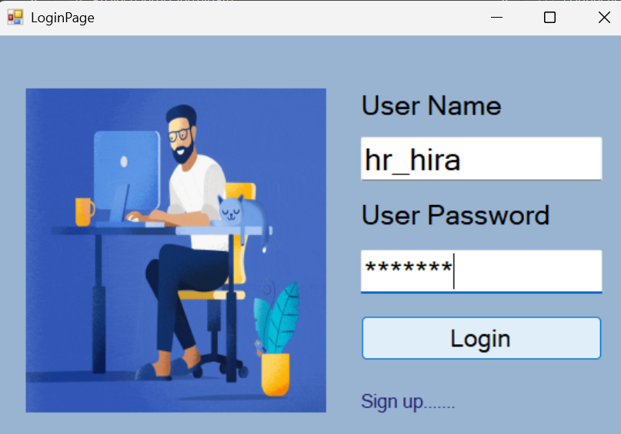  Figure 4.1: Login Form | 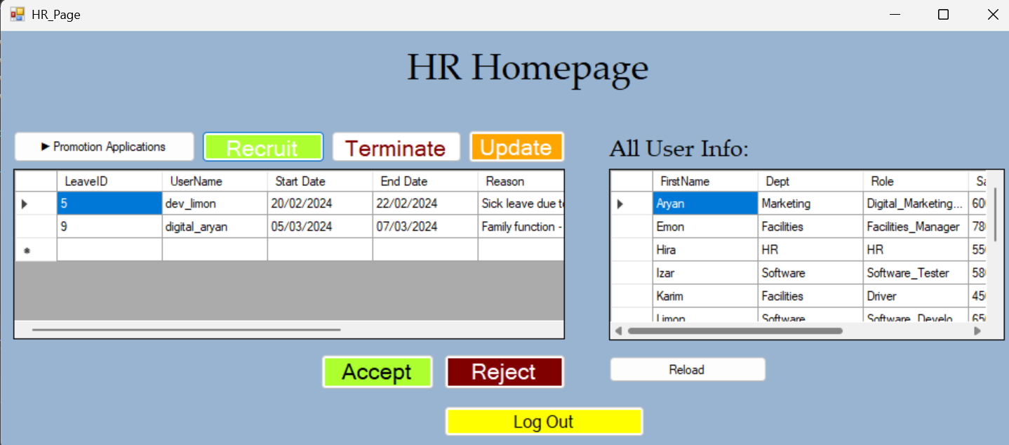  Figure 4.2: Registration Form
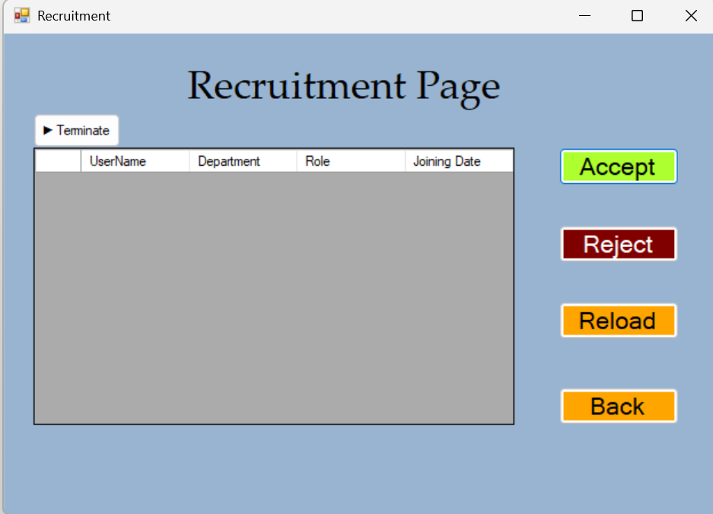  Figure 4.3: HR Dashboard | 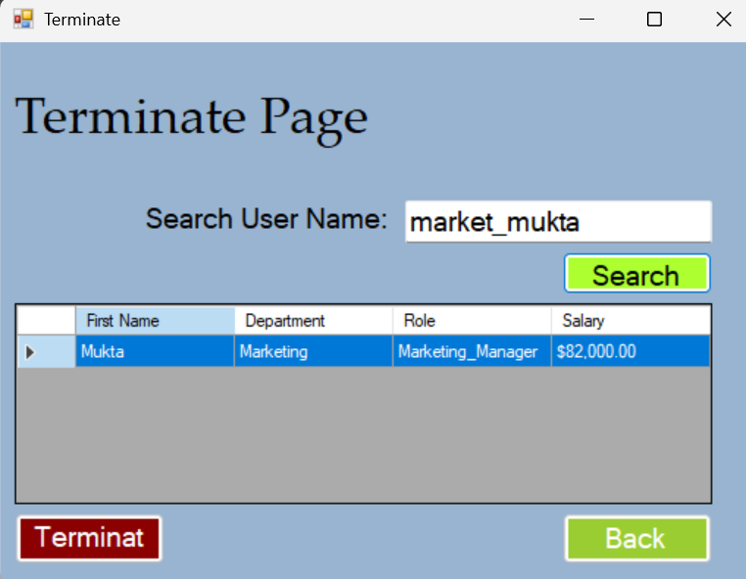  Figure 4.4: Recruit Employee/Manager Form
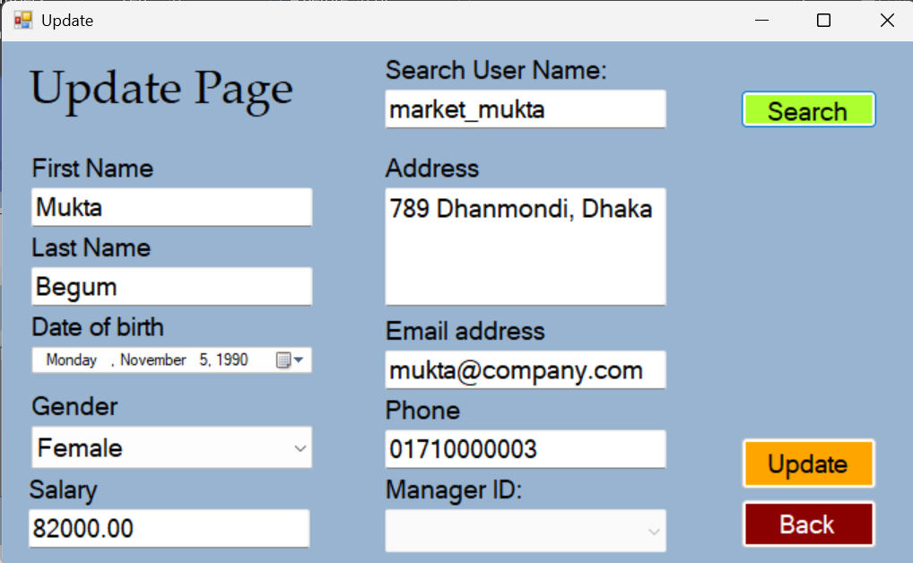  Figure 4.5: Terminate Employee Form | 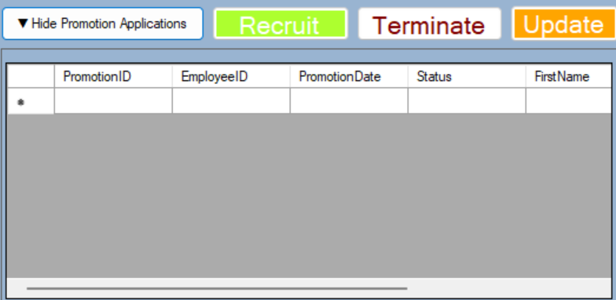  Figure 4.6: Promote Employee Form
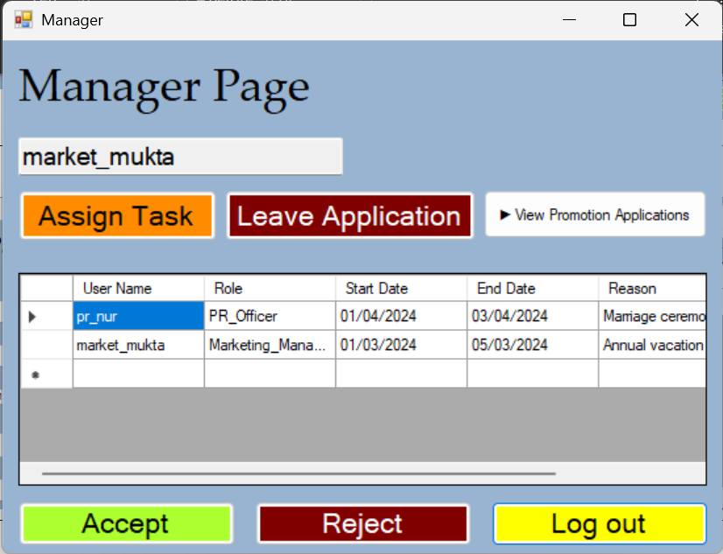  Figure 4.7: Manager Dashboard | 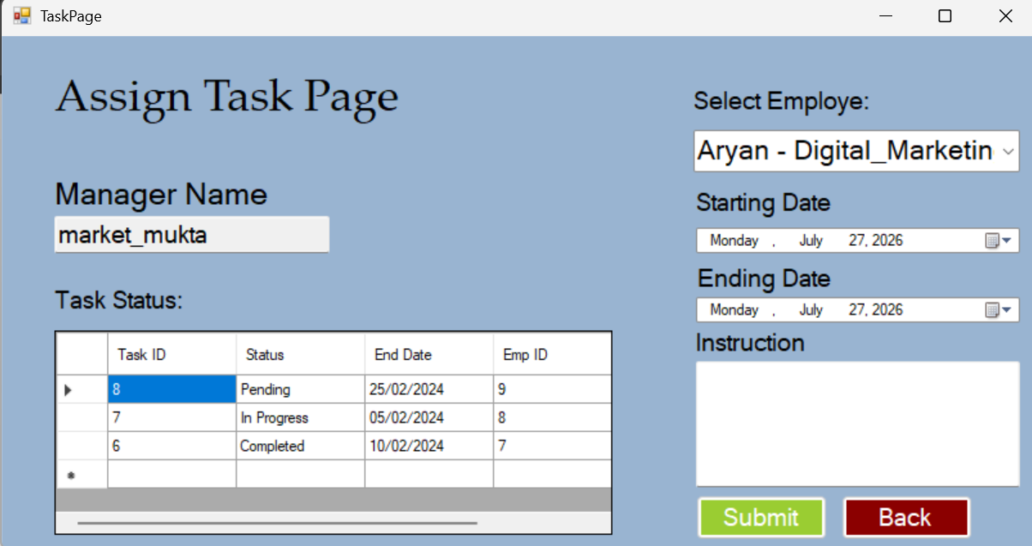  Figure 4.8: Assign Task Dashboard
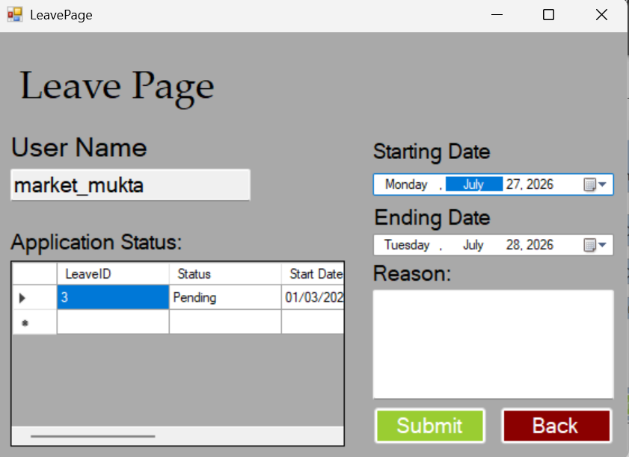  Figure 4.9: Leave Dashboard | 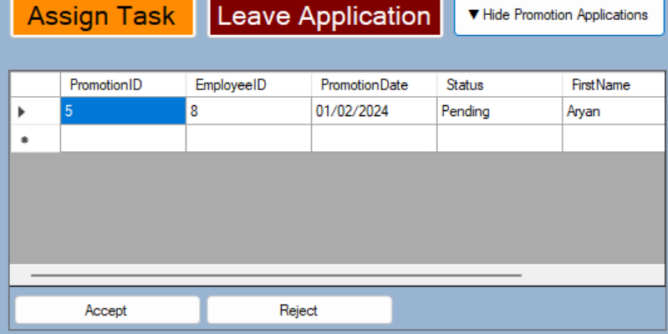  Figure 4.10: Review Promotion Request Form
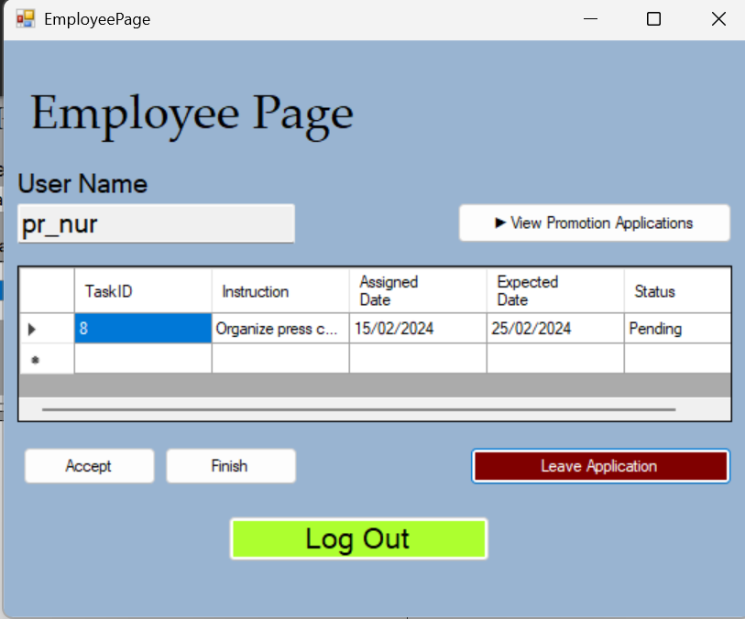  Figure 4.11: Employee Dashboard | 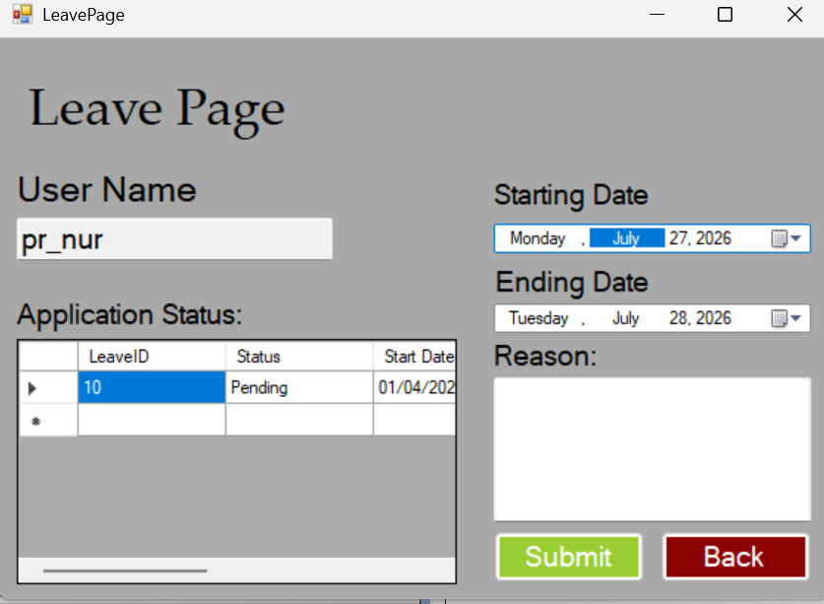  Figure 4.12: Leave Application Dashboard
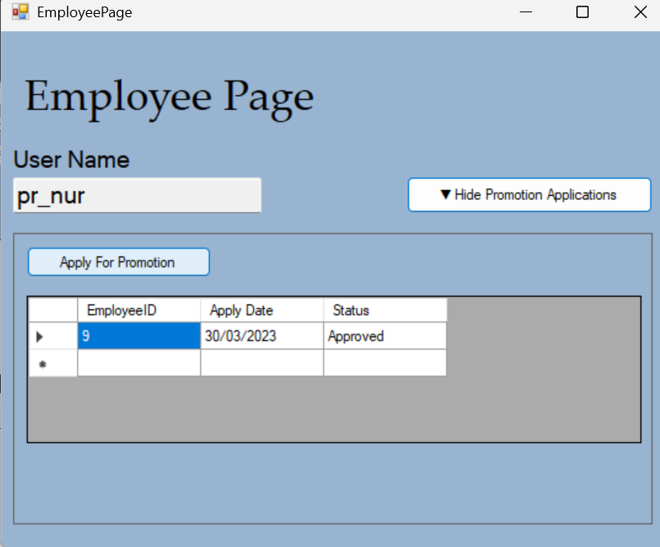  Figure 4.13: Promotion Application Dashboard | 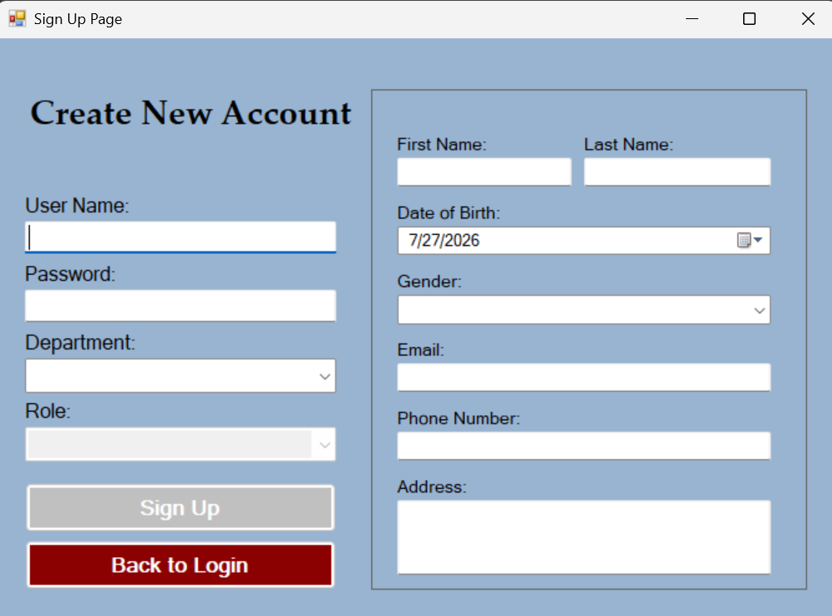  Figure 4.14: Create New Account

Conclusion
The Employee Management System is a comprehensive solution designed to automate and streamline employee-related processes within an organization. By implementing proper database design principles, role-based access control, and efficient workflow management, this system will significantly improve operational efficiency and data management.
The system provides a secure platform for employees, managers, and HR personnel to collaborate effectively while maintaining data integrity and security. Through this implementation, organizations can expect reduced administrative overhead, improved decision-making capabilities, and enhanced employee satisfaction.

