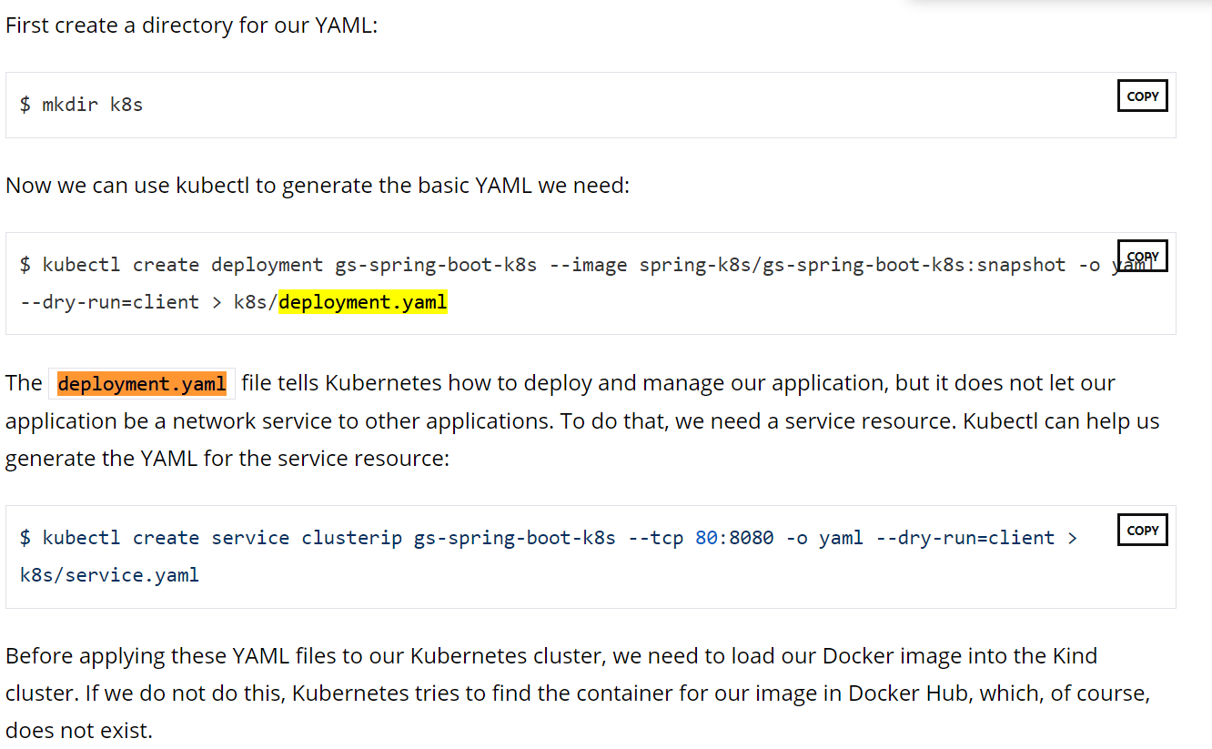

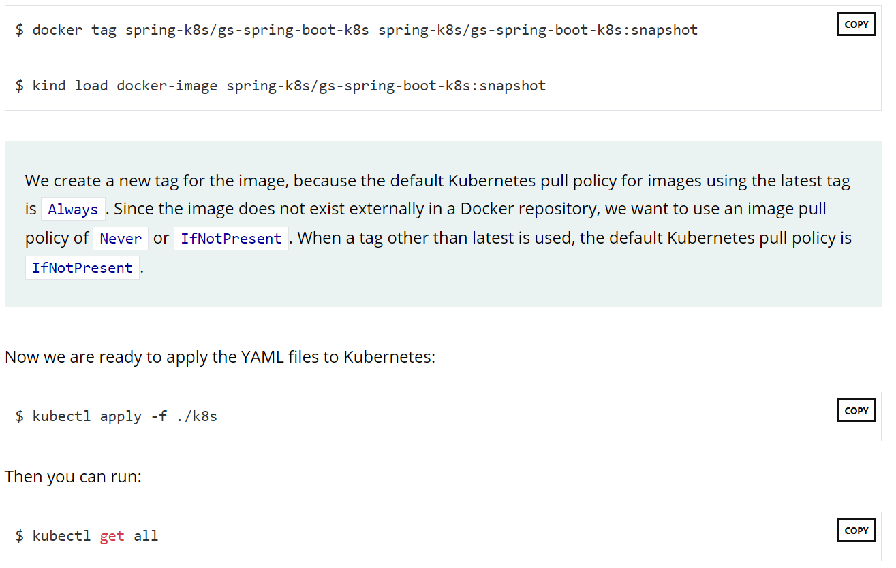

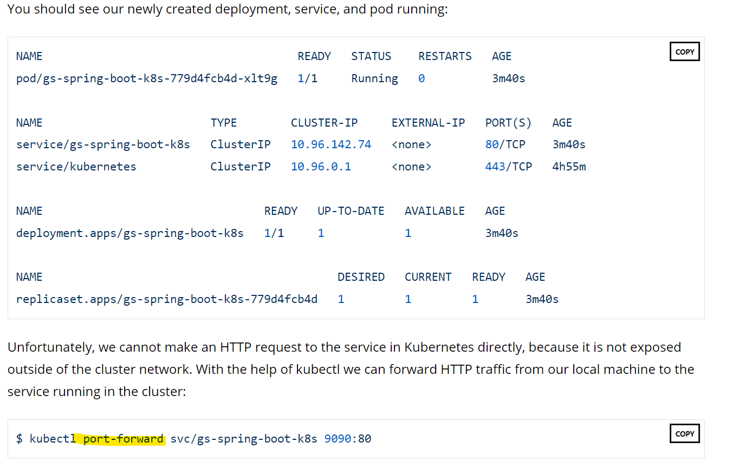

With the port-forward command running, we can now make an HTTP request to localhost:9090, and it is forwarded to the service running in Kubernetes:

Open k8s/deployment.yaml in a text editor and add the readiness, liveness, and lifecycle properties to your file:

k8s/deployment.yaml

**apiVersion: apps/v1**

**kind: Deployment**

**metadata:**

**creationTimestamp: null**

**labels:**

**app: gs-spring-boot-k8s**

**name: gs-spring-boot-k8s**

**spec:**

**replicas: 1**

**selector:**

**matchLabels:**

**app: gs-spring-boot-k8s**

**strategy: {}**

**template:**

**metadata:**

**creationTimestamp: null**

**labels:**

**app: gs-spring-boot-k8s**

**spec:**

**containers:**

**- image: spring-k8s/gs-spring-boot-k8s:snapshot**

**name: gs-spring-boot-k8s**

**resources: {}**

**livenessProbe:**

**httpGet:**

**path: /actuator/health/liveness**

**port: 8080**

**readinessProbe:**

**httpGet:**

**path: /actuator/health/readiness**

**port: 8080**

**lifecycle:**

**preStop:**

**exec:**

**command: ["sh", "-c", "sleep 10"]**

**status: {}**