Attention-Enhanced Dual Autoencoder Clustering for Liver Histopathological Images

Lailil Muflikhah¹, Dzaki Rafif Malik¹, Novanto Yudistira¹, Sri Widyarti², Sherry Arisyanti³
¹Department of Informatics Engineering, Faculty of Computer Science, Universitas Brawijaya, Malang, Indonesia
E-mail: lailil@ub.ac.id
²Department of Biology, Faculty of Mathematics and Natural Sciences, Universitas Brawijaya, Malang, Indonesia
³Institut Molekul Indonesia, Malang, Indonesia

Abstract— Histopathology image analysis plays a central role in understanding tissue morphology and evaluating treatment-induced changes, yet conventional methods struggle with the complexity, heterogeneity, and high dimensionality of histopathology data, and manual inspection remains time-consuming and subject to inter-observer variability. This study proposes an attention-enhanced dual autoencoder (DAE) framework that learns compact, biologically meaningful latent representations from liver histopathological images in a fully unsupervised manner. The framework integrates a Kolmogorov-Arnold Network (KAN) convolution block to model nonlinear intensity transitions, an Efficient Channel Attention (ECA) module to emphasize informative feature channels, and a Bottleneck Attention Module (BAM) to refine spatial-channel relationships, together with ELU activation for stable training. The model is pre-trained on multi-organ PANNUKE patches and adapted through transfer learning to IMI liver samples under different treatment conditions. Latent features are clustered using KMeans, Bisecting KMeans, and Gaussian Mixture Model (GMM) and evaluated with the Xie-Beni, Davies-Bouldin, Calinski-Harabasz, and Hartigan indices. Results show that GMM produces the most compact and well-separated clusters, achieving the lowest Davies-Bouldin Index of 3.633, while an ablation study confirms that the full DAE-KAN+ECA+BAM configuration yields the strongest feature separability compared with baseline and reduced-module variants. UMAP visualization and cluster sample inspection indicate that the learned representations capture biologically coherent morphological phenotypes, including variation in nuclear density and tissue organization. The proposed approach offers a robust, scalable, and computationally feasible unsupervised solution for discovering treatment-related morphological phenotypes in liver histopathology and lays a foundation for future integration with clinical, genomic, and treatment-response data in computational pathology systems.

Keywords— dual autoencoder; clustering; efficient channel attention; Gaussian mixture model; histopathology; KAN convolution

I. INTRODUCTION
Histopathological image analysis is essential for understanding disease mechanisms, evaluating treatment responses, and supporting clinical decision-making because it reveals microscopic tissue structures associated with pathological alterations [1], [2]. Nevertheless, manual assessment by pathologists remains time-consuming, subjective, and vulnerable to inter-observer variability, especially when large numbers of high-resolution whole-slide images must be examined [3], [4]. The growth of digital pathology has therefore created a need for computational methods that are automated, scalable, and able to capture subtle visual phenotypes, although translating such methods into routine clinical use remains an ongoing challenge [23].
Despite the success of deep learning in medical image analysis [7], automated interpretation of histopathology images remains difficult because the data are heterogeneous, high dimensional, and nonlinear. Conventional feature engineering and shallow clustering methods often fail to capture fine morphological variations such as nuclear density, cytoplasmic texture, and sinusoidal organization. These characteristics are especially important when the objective is to identify treatment-induced changes rather than classify images into predefined diagnostic labels.
Supervised approaches require large quantities of annotated data, yet expert annotations are expensive and not always available in histopathology. In treatment-response studies, the morphological patterns of interest may also be unknown in advance. Consequently, unsupervised representation learning and clustering become important for phenotype discovery in label-scarce scenarios. The main challenge is to learn latent representations that preserve biologically meaningful structures while reducing noise and redundancy.
To address these limitations, this work proposes an attention-enhanced dual autoencoder framework for liver histopathological image clustering. The model integrates KAN convolution to model nonlinear intensity transitions [8], [9], ECA to emphasize informative channels [10], and BAM to refine spatial-channel attention [11]. Cross-domain transfer learning is used by pre-training on the multi-organ PANNUKE dataset [12] and fine-tuning on IMI liver patches, enabling the model to benefit from diverse nuclear morphologies while adapting to liver-specific tissue patterns, consistent with the growing use of deep learning for quantifying liver histopathology in fatty liver disease [27].
The main contributions of this study are threefold. First, it introduces a unified unsupervised framework that combines dual autoencoder learning, nonlinear KAN convolution, and hierarchical attention mechanisms for histopathology feature extraction. Second, it compares hard, hierarchical, and probabilistic clustering approaches, namely KMeans, Bisecting KMeans, and GMM, using several validity indices. Third, it provides ablation, visualization, and runtime analyses to show how each architectural component contributes to cluster compactness, separation, and interpretability.
A. Related Work and Research Gap
Digital pathology has become an important foundation for computer-assisted tissue analysis, enabling large-scale acquisition and analysis of histological images [1], [2]. Early reviews emphasized the potential of computational histopathology but also highlighted key challenges such as image variability, limited annotation, and difficulty in extracting robust tissue descriptors [3], [5]. Deep learning has improved medical image representation learning [7], including computational histopathology specifically [24], yet many supervised models remain dependent on labeled datasets and do not directly address exploratory phenotype discovery.
Recent architectural developments provide opportunities to improve unsupervised histopathology representation learning. KAN-based modeling offers a nonlinear function-learning perspective that can help represent complex intensity transitions and tissue boundaries [8], [9], and has recently been incorporated into medical image segmentation backbones [29]. ECA provides lightweight channel attention that improves feature selectivity with minimal computational overhead [10], while BAM refines both channel and spatial information [11], consistent with broader trends surveyed across channel and spatial attention mechanisms in computer vision [25]. These components are promising for histopathology because relevant visual patterns may appear as subtle combinations of color, texture, and spatial organization.
Clustering methods also differ in their assumptions. KMeans is efficient but tends to assume compact spherical clusters [18]. Bisecting KMeans introduces a hierarchical splitting strategy that may capture some structural variation [19]. GMM, in contrast, uses probabilistic soft assignments and can better represent overlapping or non-spherical distributions [20]. Prior work on histological image clustering and autoencoder-based representations has shown that learned embeddings can reveal meaningful tissue patterns [13]-[16]. However, despite recent progress in transfer learning strategies for medical imaging [26] and the emergence of large-scale pathology foundation models [28], few studies integrate nonlinear convolution, dual autoencoder learning, channel attention, spatial attention, and transfer learning in a single unsupervised framework. This gap motivates the proposed method.
II. MATERIAL AND METHOD
The methodology follows a multi-stage pipeline that includes data preparation, pre-training, transfer learning, feature extraction, clustering, and evaluation. The overall workflow is shown in Fig. 1. The model first learns general histopathological representations from PANNUKE image patches and then adapts the learned representation to IMI liver samples. The resulting latent features are clustered and evaluated quantitatively and qualitatively.

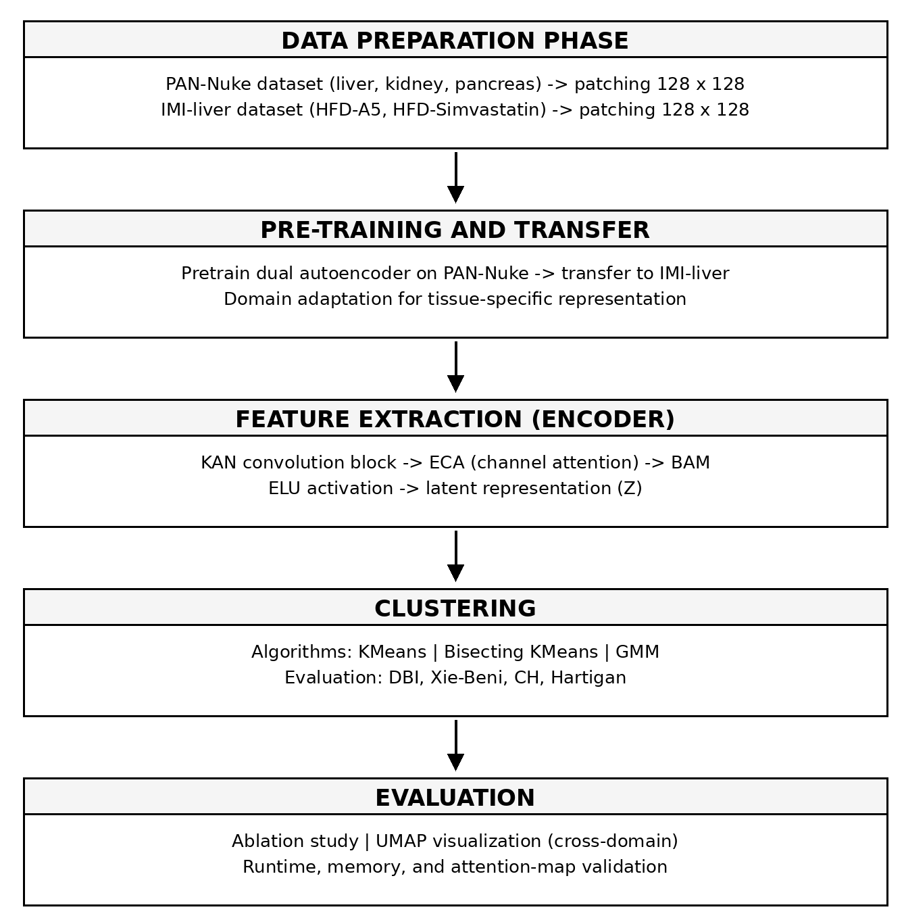
Fig. 1 The Proposed Framework Overview

A. Data Preparation
The PANNUKE dataset contains multi-organ histology patches with diverse nuclear morphologies, including liver, kidney, and pancreas tissues. The IMI dataset contains liver samples under different treatment conditions, including HFD-A5 and HFD-Simvastatin. All images were processed in RGB mode and normalized per channel to reduce variation. Image patches were extracted at 128 x 128 pixels, a size selected to balance morphological detail and computational efficiency. Data augmentation included rotations, horizontal and vertical flips, and color normalization, following established practice for improving robustness in limited medical imaging datasets [22]. The data were split into 70% training, 15% validation, and 15% testing sets to support reproducible experiments.

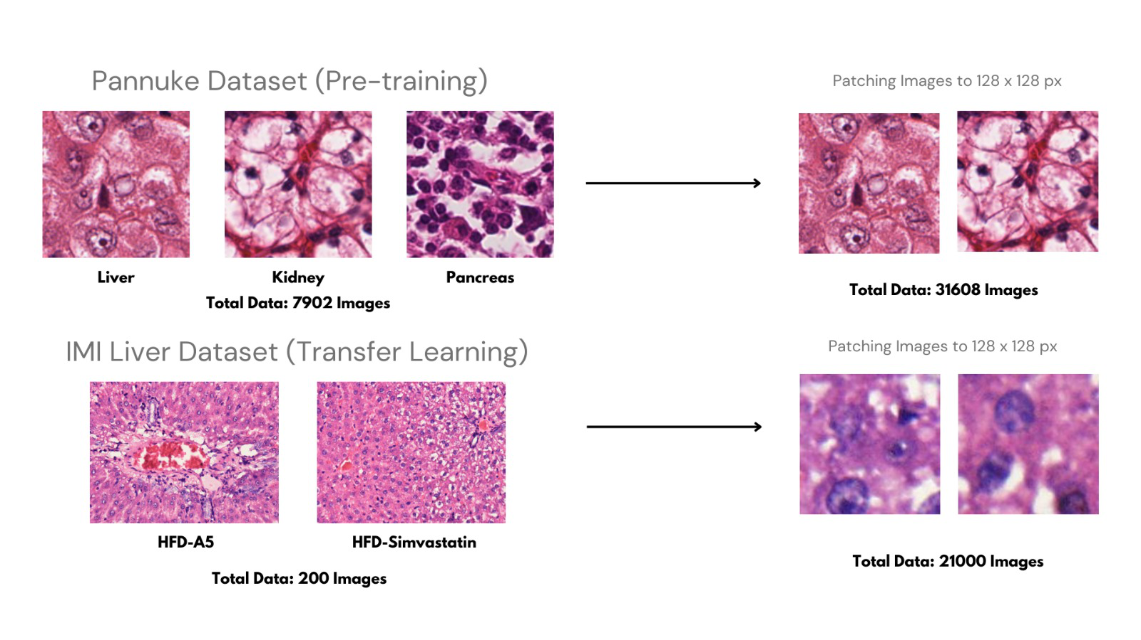
Fig. 2 Data Preparation Through Image Patching

B. Proposed Attention-Enhanced Dual Autoencoder
The core of the proposed framework is a dual autoencoder designed to learn compact latent representations from high-dimensional histopathological image patches. The architecture combines nonlinear convolution, channel attention, spatial-channel attention, and ELU activation so that the model can preserve relevant morphological signals while reducing redundant information.
1) KAN Convolution Block: Unlike standard convolution, which computes a linear weighted sum over local pixel neighborhoods, the KAN convolution block introduces learnable nonlinear functions for kernel elements. This design allows the network to model complex intensity transitions and tissue boundaries, which are important for subtle histological patterns [8], [9].
2) Efficient Channel Attention Layer: After feature extraction, the ECA layer dynamically emphasizes informative channels through a lightweight one-dimensional convolution. This mechanism improves the model's ability to focus on diagnostically relevant feature channels without the high computational cost of heavier attention modules [10].

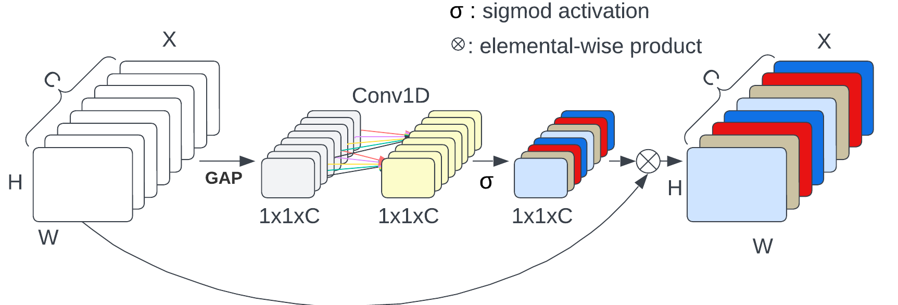
Fig. 3 Efficient Channel Attention (ECA) Layer

3) Bottleneck Attention Module: BAM is applied near the latent representation to refine both spatial and channel relationships. By highlighting relevant image regions and feature channels, BAM helps preserve localized histological patterns such as nuclear prominence and tissue organization [11].

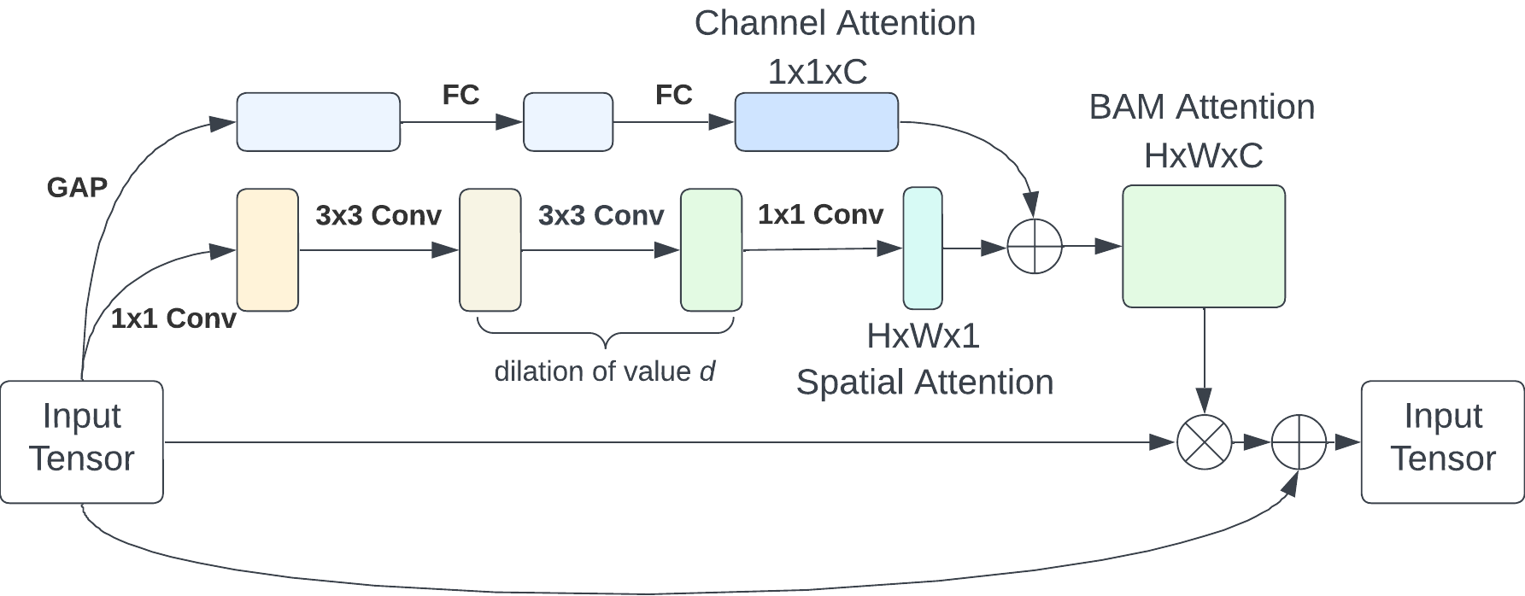
Fig. 4 Bottleneck Attention Module (BAM)

4) ELU Activation: The Exponential Linear Unit (ELU) activation is used to improve gradient flow and reduce the dying-neuron problem. ELU allows negative outputs and supports more stable convergence in complex image-based representation learning as 1[17].

$$ELU(x)=\left\{\begin{aligned}x for x≥0 \\ {\left(e\right.}^{x}-1) for x <0\end{aligned}\right.$$ | (1)
The complete architecture is illustrated in Fig. 5. The framework produces refined latent features that are subsequently used as inputs to clustering algorithms.

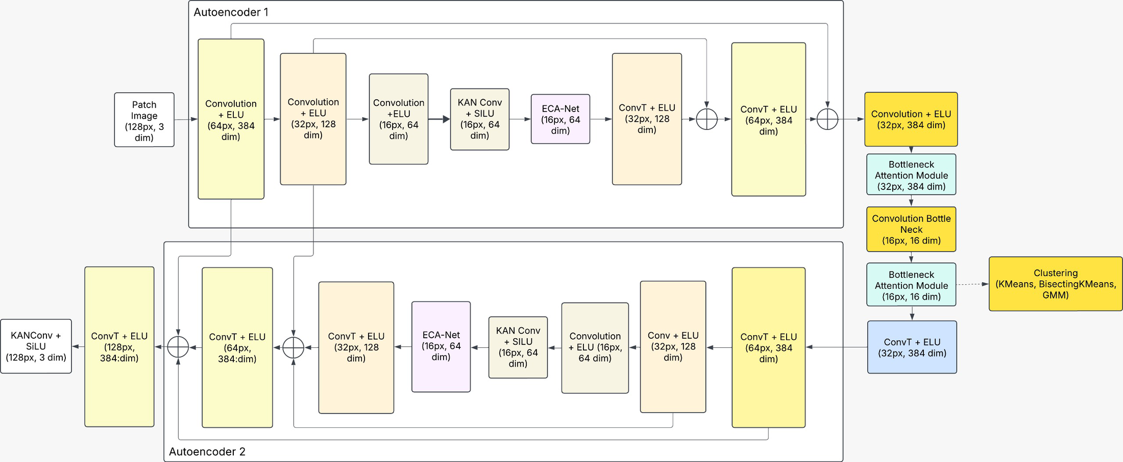
Fig. 5 Architecture of the Attention-Enhanced Dual Autoencoder Framework

C. Clustering Strategy and Evaluation Metrics
After latent feature extraction, three clustering algorithms are applied: KMeans, Bisecting KMeans, and GMM, reflecting the broader trend of coupling deep representation learning with partitional clustering objectives [21]. KMeans is used as a hard-partitioning baseline, Bisecting KMeans represents a hierarchical partitioning strategy, and GMM represents a probabilistic soft-clustering approach. This comparison evaluates how the learned feature space responds to different assumptions about cluster shape and overlap.
1) KMeans: KMeans partitions feature vectors by minimizing within-cluster variance. It is simple and efficient but can be less suitable when histopathological features form non-spherical or overlapping clusters [18].
2) Bisecting KMeans: Bisecting KMeans combines hierarchical splitting with partitional clustering. It can reveal hierarchical structures but may still be limited when tissue phenotypes vary continuously [19].
3) Gaussian Mixture Model: GMM models each cluster as a Gaussian distribution and assigns data points probabilistically. This makes it more flexible for overlapping and heteroscedastic histopathological feature distributions [20].
Cluster quality is evaluated using the Xie-Beni Index, Davies-Bouldin Index (DBI), Calinski-Harabasz Index, and Hartigan Index as 2-5, which are among the most widely adopted internal validity measures for unsupervised clustering [30]. Lower Xie-Beni and DBI values indicate better compactness and separation, whereas the Calinski-Harabasz Index reflects the ratio between between-cluster and within-cluster dispersion.
$$Xie-Beni Index=\frac{\sum_{i=1}^{k}{\left(\sum_{xϵC_{i}}{{\left\|x-c_{i}\right\|}^{2}}\right)}}{n∙\min_{i≠j}{\left\|c_{i}-c_{j}\right\|}^{2}}$$ | (2)

$$DBI=\frac{1}{k}\sum_{i=1}^{k}{\max_{j≠i}\left(\frac{S_{i}+S_{j}}{\left\|c_{i}-c_{j}\right\|}\right)}$$ | (3)
$$Calinski-Harabaz= \frac{Tr\left(B_{k}\right)}{Tr\left(W_{k}\right)}∙\frac{n-k}{k-1}$$ |  | (4)
$$Hartigan Index= \left(\frac{W_{k}}{W_{k+1}}-1\right)∙\left(n-k-1\right)$$ |  | (5)

III. RESULTS AND DISCUSSION
A. Training Behavior
The training process was first analyzed to evaluate whether the proposed network learned stable latent representations. Fig. 6 shows the step-wise training loss trend, while Fig. 7 summarizes the loss progression over epochs. The loss generally decreases as training proceeds, indicating that the model successfully optimizes the reconstruction objective. Early stopping is used to prevent overfitting when additional training no longer provides meaningful improvement.

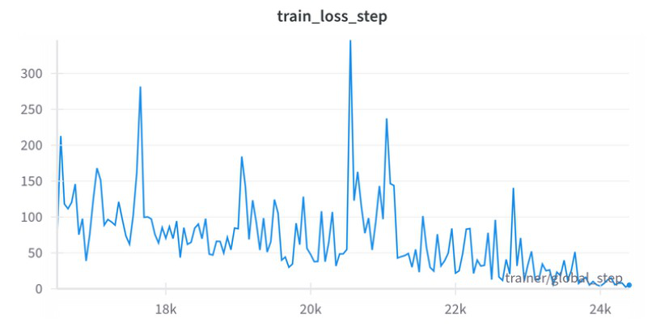
Fig. 6 Early Stopping During Training

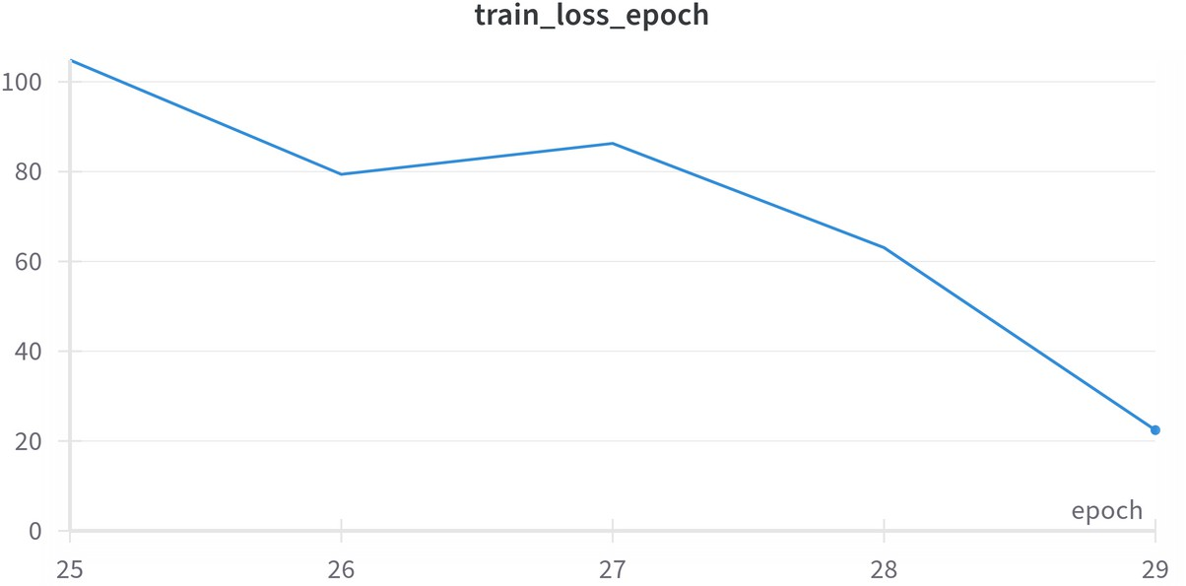
Fig. 7 Training Loss Over Epochs

B. Clustering Performance
The learned latent representations were clustered using KMeans, Bisecting KMeans, and GMM. Fig. 8 compares the clustering quality across different numbers of clusters using Xie-Beni, Calinski-Harabasz, Davies-Bouldin, and Hartigan indices. GMM achieves the lowest Davies-Bouldin Index of 3.633 in the main evaluation, indicating stronger compactness and separation. KMeans provides a competitive Xie-Beni value at a smaller number of clusters but is less stable as the cluster number increases. Bisecting KMeans performs moderately but shows reduced robustness when the latent space contains more complex cluster structures.

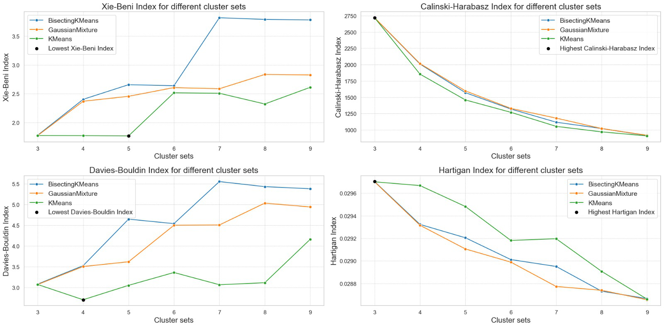
Fig. 8 Comparison of Clustering Performance Metrics for KMeans, Bisecting KMeans, and GMM

The overall evaluation workflow is presented in Fig. 9. The latent features generated by the autoencoder are assessed by applying different clustering algorithms and then computing objective cluster validity measures. This procedure enables a fair comparison of how each clustering assumption fits the attention-enhanced latent space.

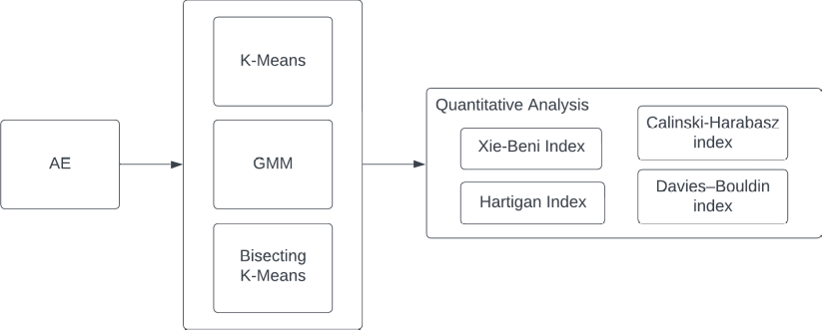
Fig. 9 Various Evaluation on Several Clustering Algorithms

UMAP visualization provides qualitative support for the quantitative findings. As shown in Fig. 10, GMM yields more compact and distinct groupings compared with KMeans and Bisecting KMeans. This result suggests that the feature space contains overlapping nonlinear distributions that are better captured by probabilistic soft clustering.

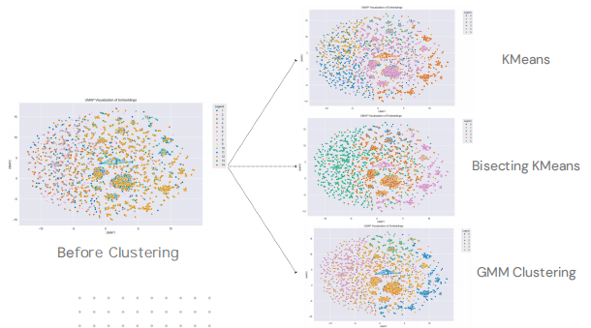
Fig. 10 UMAP Visualization of Embeddings Showing Clustering Results

Representative patch samples from GMM clusters are shown in Fig. 11. The clusters demonstrate clear morphological variation, including differences in nuclear density, texture, and tissue organization. The visual coherence within clusters indicates that the proposed latent representation captures biologically meaningful histological patterns rather than arbitrary visual groupings.

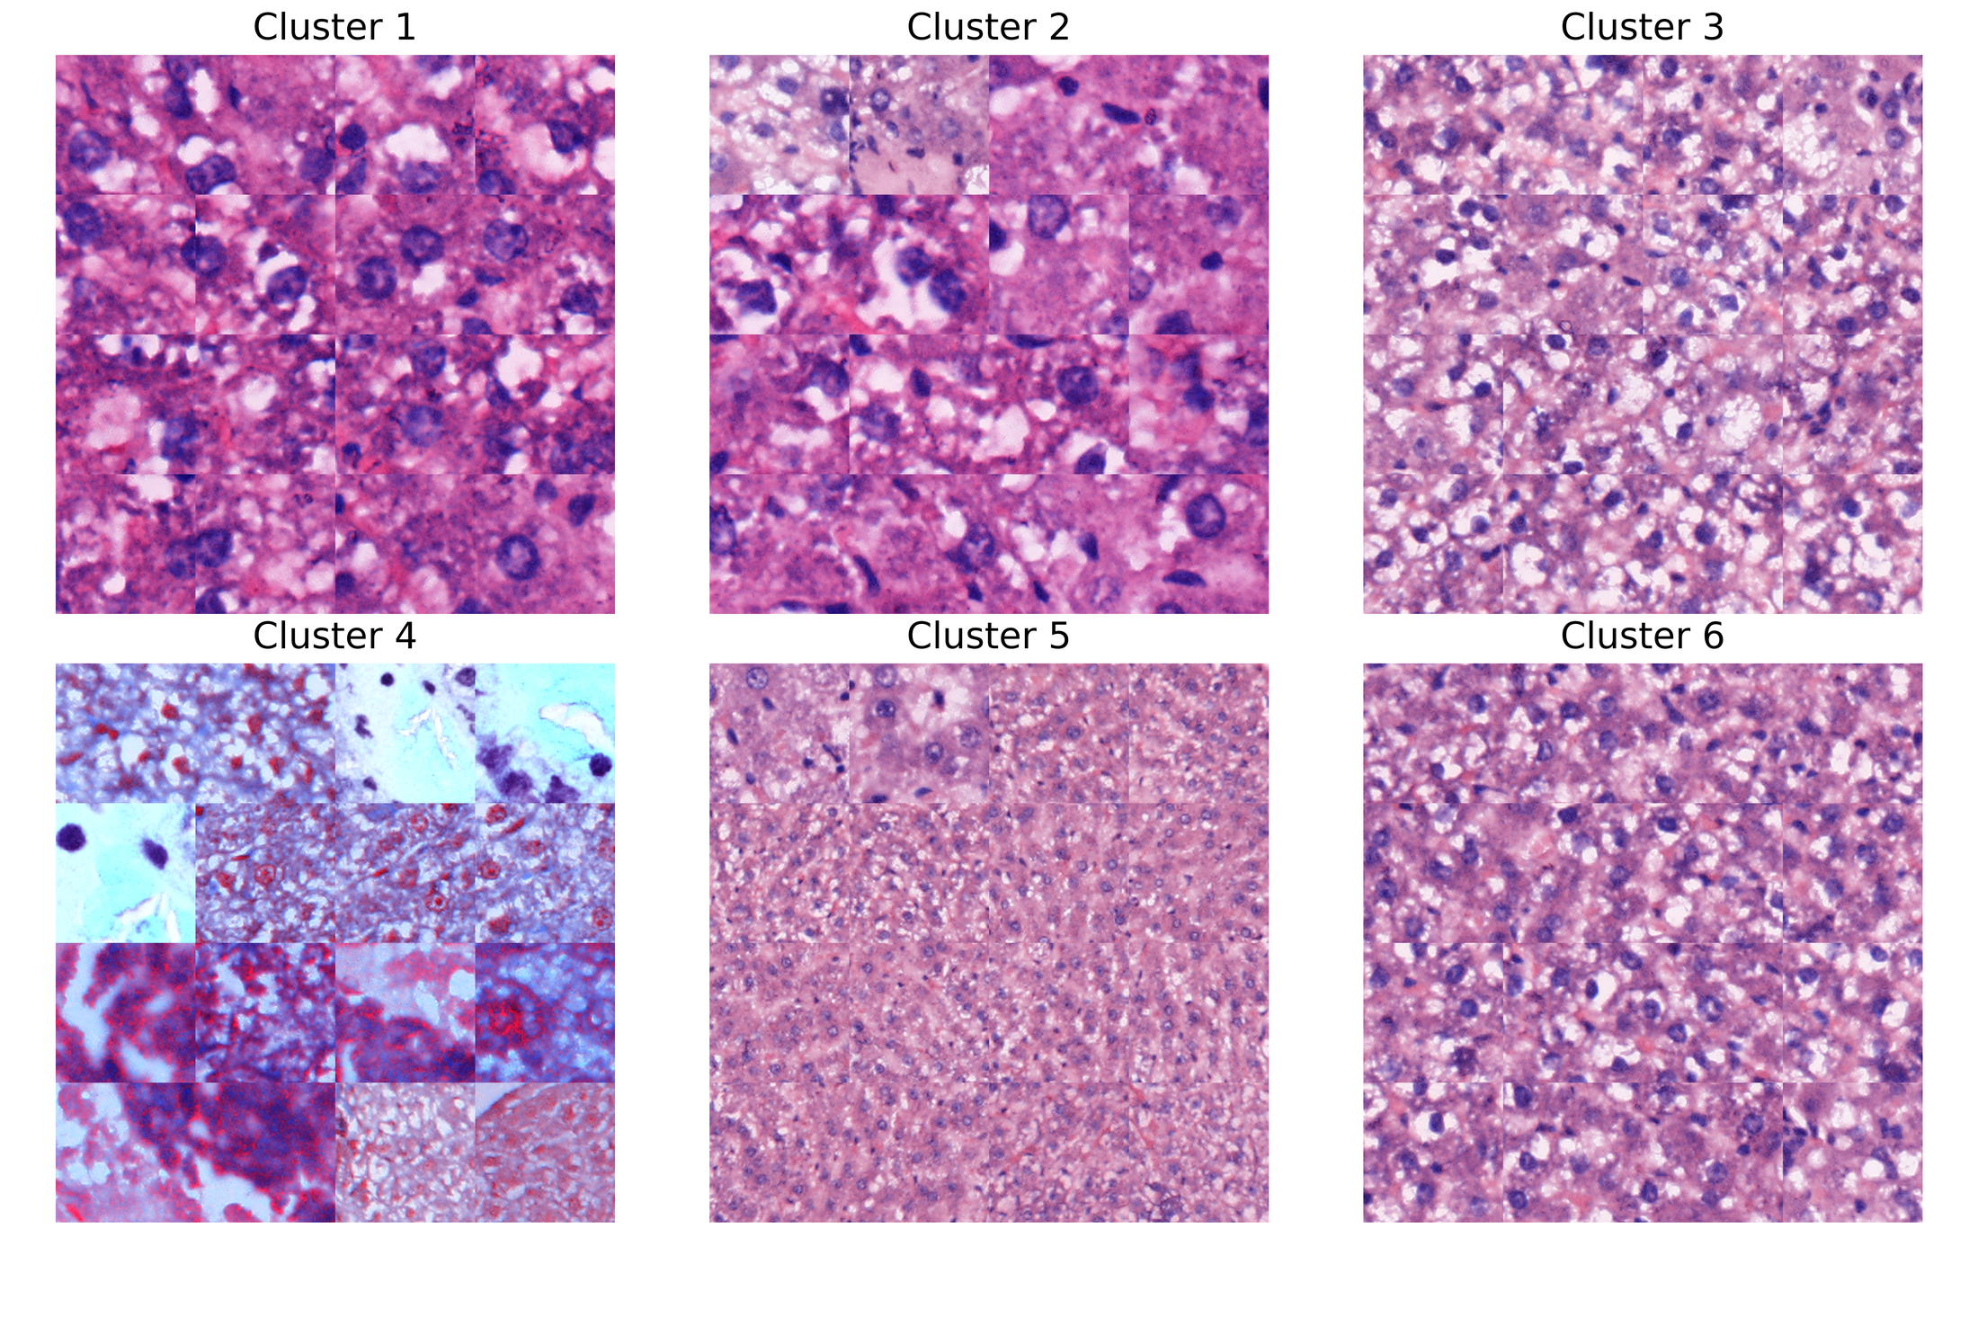
Fig. 11 Samples for Each Cluster Obtained from GMM

C. Ablation Study
A systematic ablation study was conducted to quantify the contribution of each architectural component. The baseline autoencoder was compared with variants that remove or add KAN, ECA, and BAM under matched training settings. Table I summarizes the ablation results. The baseline model produces the weakest cluster compactness, while the full DAE-KAN+ECA+BAM model achieves the best DBI and Xie-Beni values.

TABLE I ABLATION ANALYSIS
Model Variant | DBI | Xie-Beni | Observation
Baseline AE | 4.62 | 0.049 | Weak compactness
No KAN | 4.27 | 0.045 | Reduced nonlinearity
No BAM | 3.95 | 0.041 | Less spatial focus
DAE-KAN+ECA+BAM | 3.63 | 0.036 | Strongest separation

The reconstruction and attention analyses support the numerical results. Fig. 12 shows that the proposed model better preserves relevant visual structures, while Fig. 13 indicates stable training behavior and improving structural similarity. Fig. 14 further illustrates that attention maps become more concentrated and interpretable, especially when BAM is included.

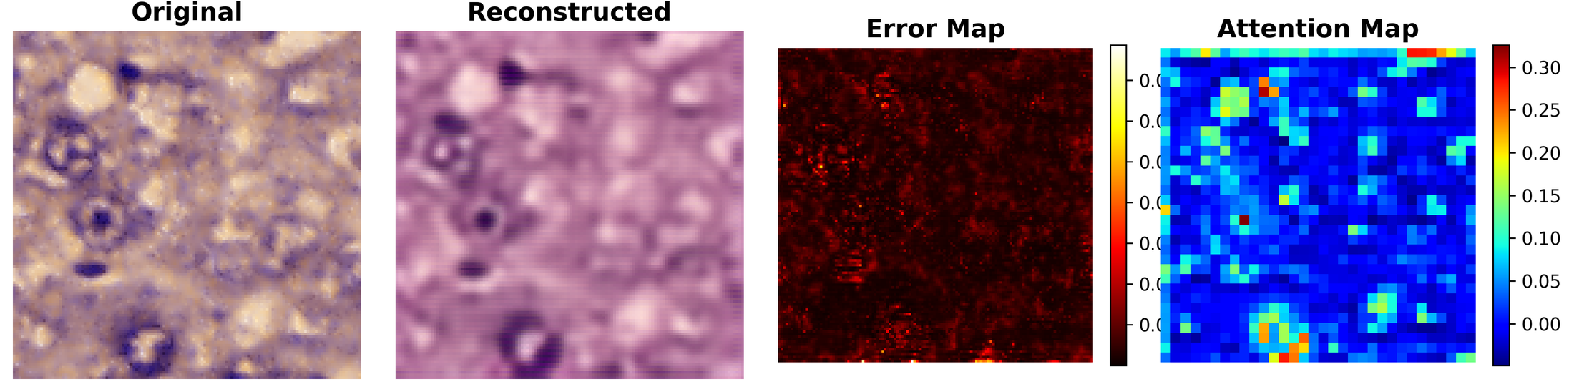
Fig. 12 DAE-KAN Reconstruction Quality Analysis

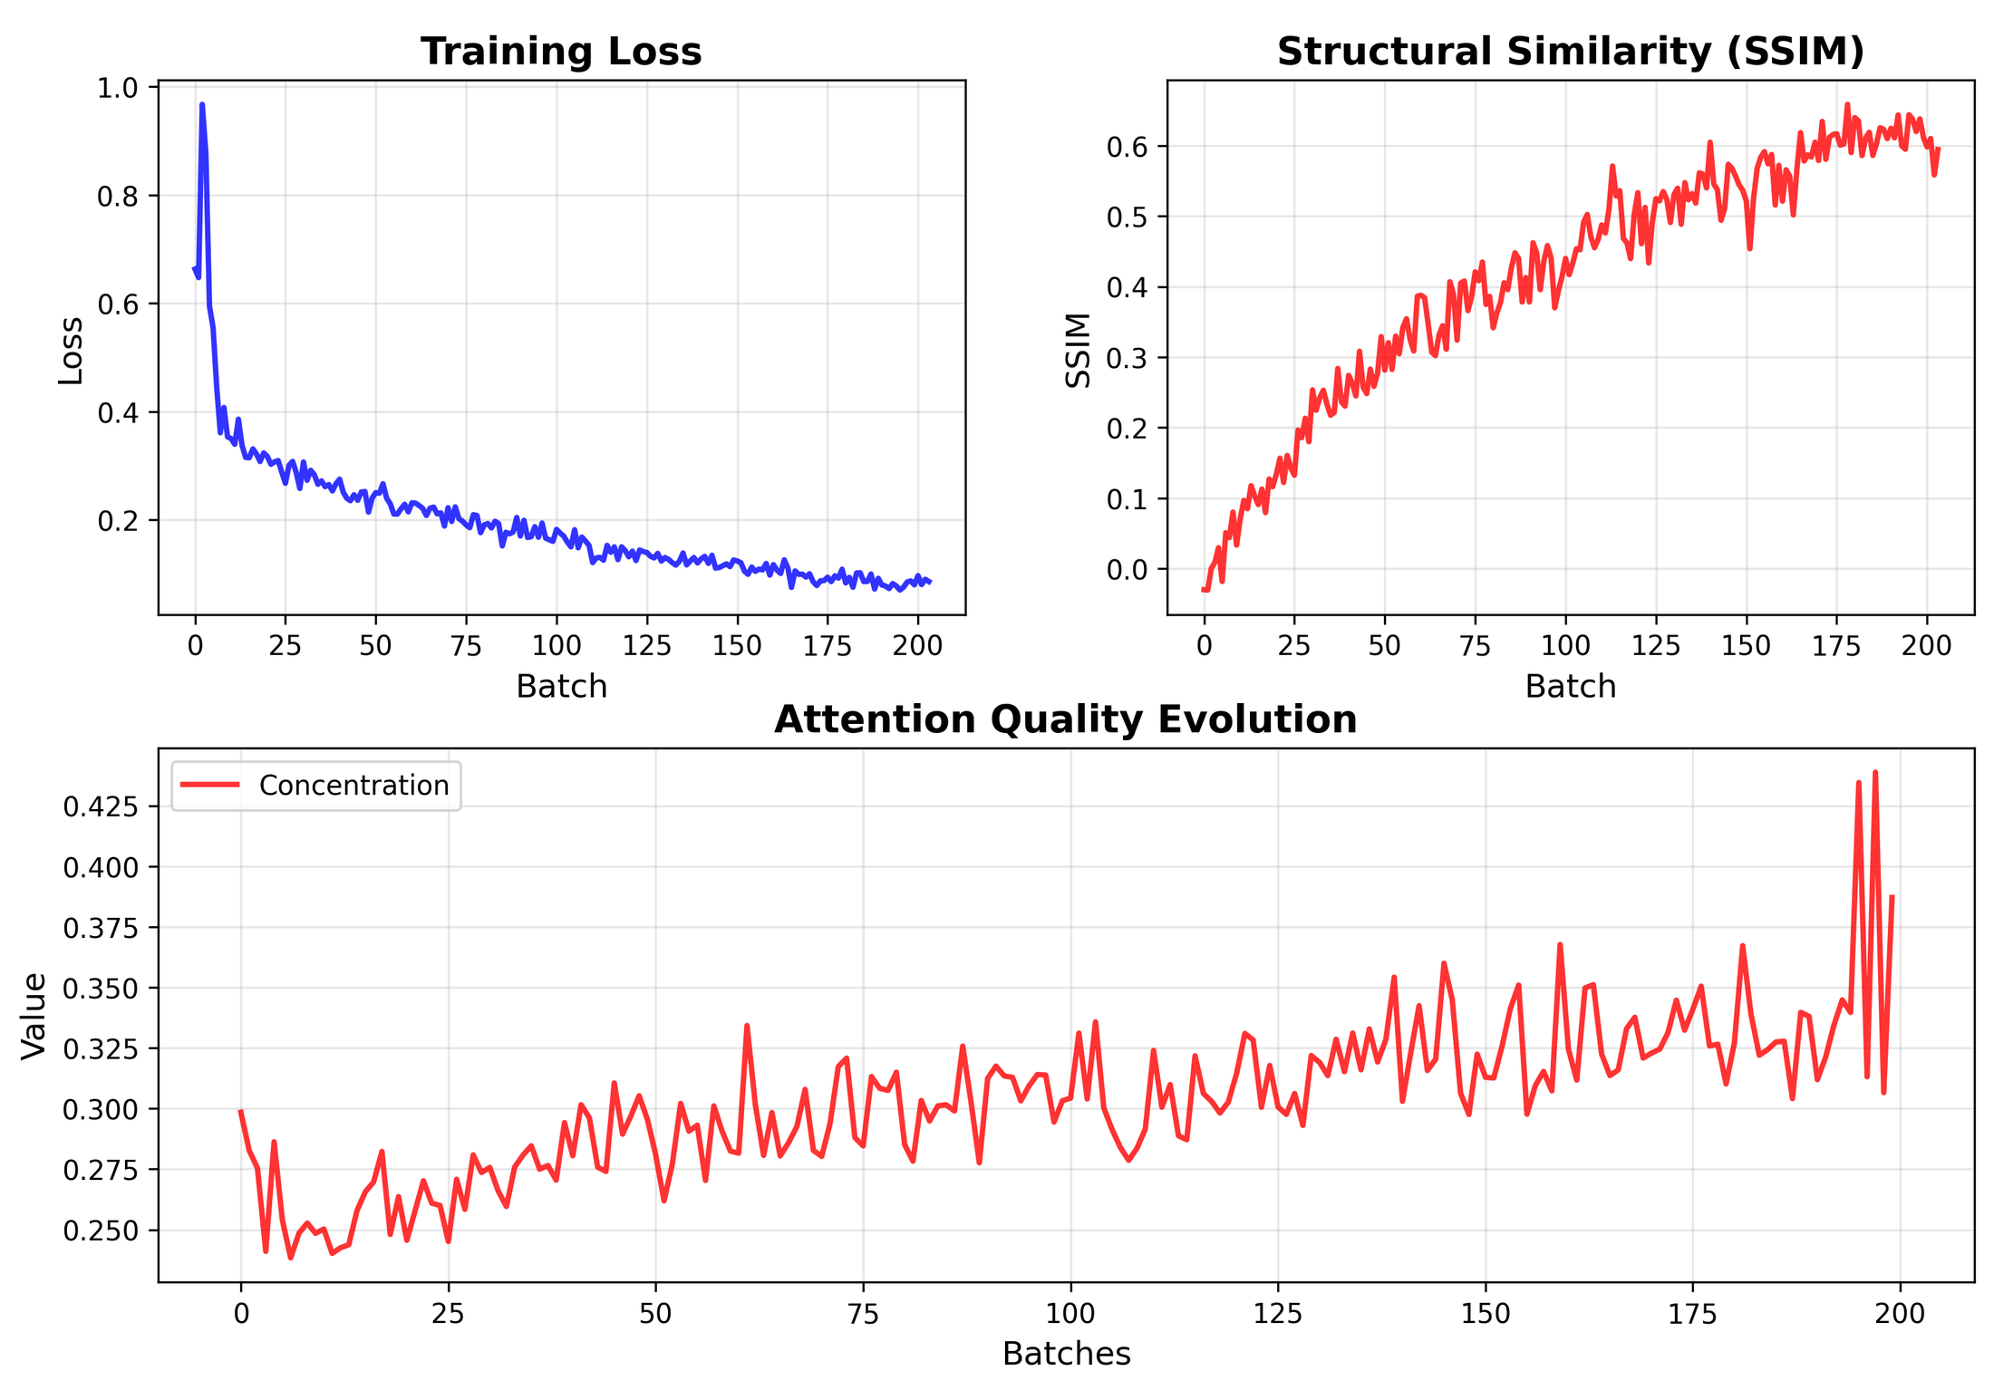
Fig. 13 DAE-KAN Training Progress Analysis

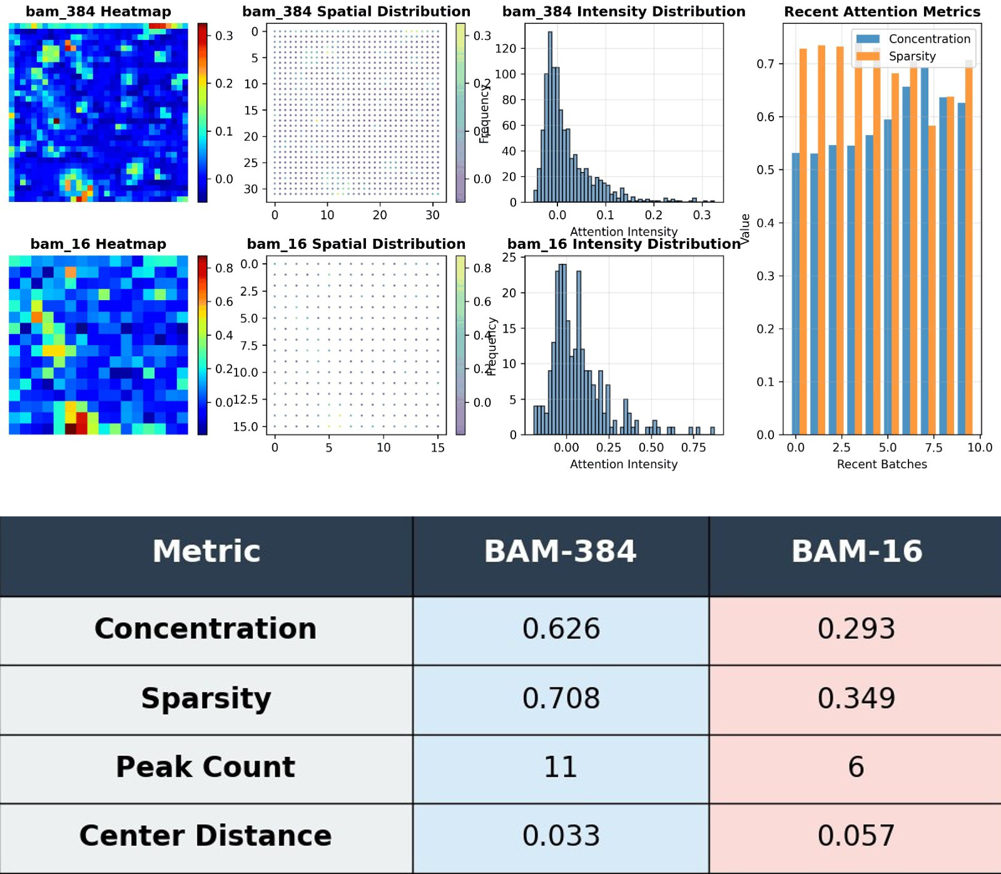
Fig. 14 DAE-KAN Attention Mechanism Analysis

Fig. 15 illustrates cluster distribution and compactness during the training cluster analysis. The GMM-based clustering result forms denser and more uniform cluster cores, whereas KMeans-based models tend to produce more dispersed and elongated regions. This pattern reinforces the suitability of probabilistic modeling for heterogeneous liver histopathology.

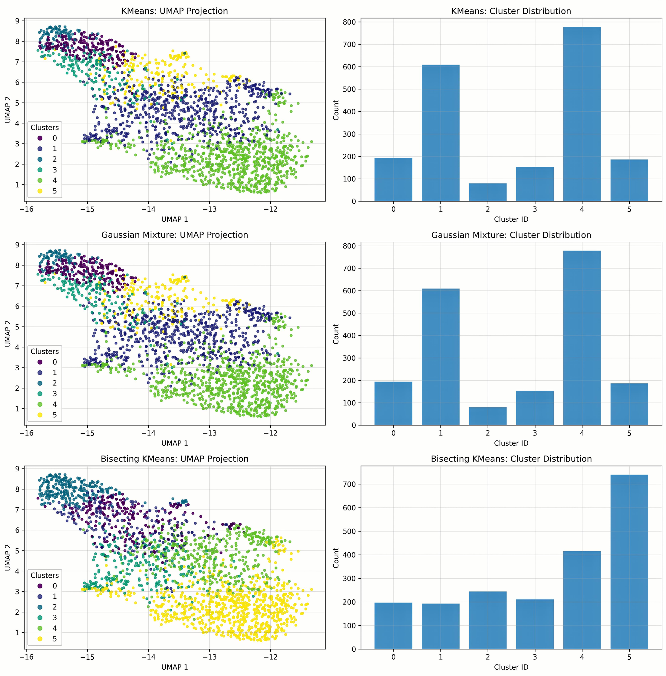
Fig. 15 Training Cluster Analysis

D. Computational Performance
The computational performance of the framework was evaluated using training time, inference time, throughput, memory use, number of parameters, and execution speed. As shown in Table II, the proposed model increases training and inference time relative to the baseline, but the overhead remains moderate. The full configuration requires 44.23 ms training time per image, 43.75 ms inference time per image, and 3577.8 MB average memory use. This trade-off is acceptable because the full model yields better latent feature separability and more interpretable clustering results.

TABLE II TRAINING AND INFERENCE TIME ANALYSIS FOR DIFFERENT ARCHITECTURAL CONFIGURATIONS
Configuration | Avg Train Time (ms) | Avg Infer Time (ms) | Throughput (images/s) | Avg Memory Usage (MB)
Baseline | 35.60 | 35.07 | 28.5 | 2753.7
Proposed model | 44.23 | 43.75 | 22.9 | 3577.8
No BAM | 43.42 | 42.92 | 23.3 | 3579.2
No ECA layer | 36.61 | 36.09 | 27.7 | 2742.0
No KAN layer | 36.01 | 35.49 | 28.2 | 2737.0

Table III reports the complexity of model variants. The baseline autoencoder has 8.1 million parameters, while the full DAE-KAN+ECA+BAM model has 11.5 million parameters. The full model requires 65.2 seconds per epoch and 4.9 seconds per 1000 patches during inference. These values indicate that the proposed architecture remains feasible for practical high-throughput histopathology analysis.

TABLE III TRAINING AND INFERENCE TIME FOR DIFFERENT MODEL VARIANTS
Model Variant | Params (M) | Training Time (s/epoch) | Inference (s/1000 patches)
Baseline AE | 8.1 | 52.3 | 4.1
DAE-KAN | 10.7 | 61.4 | 4.6
DAE-KAN+ECA | 11.1 | 63.9 | 4.8
DAE-KAN+ECA+BAM | 11.5 | 65.2 | 4.9

E. Performance on Large Datasets
The framework was further evaluated on PANNUKE and IMI datasets to examine scalability and generalizability. Table IV presents the performance comparison between baseline and proposed configurations. The proposed model improves performance on both datasets, showing higher accuracy, precision, recall, and F1-score, along with lower Davies-Bouldin Index values. These results indicate stronger feature compactness and separation under large-scale and heterogeneous histopathology conditions.

TABLE IV PERFORMANCE COMPARISON ON PANNUKE AND IMI DATASETS
Metric | PANNUKE Baseline | PANNUKE Proposed | IMI Baseline | IMI Proposed | Observation
Accuracy (%) | 84.32 | 91.57 | 82.47 | 89.83 | Consistent improvement
Precision (%) | 82.68 | 90.24 | 80.31 | 87.76 | Reduction of false positives
Recall (%) | 83.11 | 91.09 | 81.22 | 88.59 | Better sensitivity
F1-Score (%) | 82.89 | 90.66 | 80.76 | 88.17 | Stronger balance
Davies-Bouldin Index | 0.621 | 0.398 | 0.574 | 0.406 | Enhanced compactness and separability

The qualitative results also show that GMM preserves morphological coherence across thousands of patches. Compared with hard clustering methods, GMM is more capable of representing gradual transitions and mixed morphological patterns, which are common in liver tissue. This supports the interpretation that probabilistic modeling is better suited for treatment-induced phenotype discovery in heterogeneous histopathology images.
IV. CONCLUSION
This study introduced an attention-enhanced dual autoencoder framework for unsupervised clustering of liver histopathological images. By integrating KAN convolution, ECA, and BAM, the proposed model produced latent representations that were more compact, discriminative, and biologically coherent than baseline or reduced-module variants. The ablation study confirmed that each component contributes to feature expressiveness and that their integration provides the strongest cluster separability.
Among the evaluated clustering algorithms, GMM consistently delivered the best performance because its probabilistic soft-assignment strategy is better aligned with the heterogeneous and overlapping distributions found in liver histology. Quantitative indices, UMAP visualization, and cluster sample inspection all support the conclusion that the proposed representation enables meaningful morphological phenotype discovery.
The framework also demonstrated scalability on large datasets and remained computationally feasible despite a moderate increase in runtime and memory use. These findings establish the proposed method as a reliable approach for unsupervised computational pathology and provide a foundation for future integration with clinical, genomic, or treatment-response data. Future work should include validation by hepatopathology experts, external datasets, and exploration of self-supervised or contrastive objectives to further improve representation quality.
ACKNOWLEDGMENT
This research was funded by Universitas Brawijaya through the grant program "Applied Research and Artificial Intelligence Development in 2024" under contract number [00067.10/UN10.A0507/B/KS/2024].
REFERENCES
[1] J. Pallua, A. Brunner, B. Zelger, M. Schirmer, and J. Haybaeck, "The future of pathology is digital," Pathology - Research and Practice, vol. 216, no. 9, p. 153040, 2020, doi: 10.1016/j.prp.2020.153040.
[2] S. Al-Janabi, A. Huisman, and P. J. Van Diest, "Digital pathology: current status and future perspectives," Histopathology, vol. 61, no. 1, pp. 1-9, 2012, doi: 10.1111/j.1365-2559.2011.03814.x.
[3] M. N. Gurcan, L. E. Boucheron, A. Can, A. Madabhushi, N. M. Rajpoot, and B. Yener, "Histopathological image analysis: A review," IEEE Reviews in Biomedical Engineering, vol. 2, pp. 147-171, 2009, doi: 10.1109/RBME.2009.2034865.
[4] J. M. Bueno-de Mesquita, D. Nuyten, J. Wesseling, H. Van Tinteren, S. Linn, and M. van De Vijver, "The impact of inter-observer variation in pathological assessment of node-negative breast cancer on clinical risk assessment and patient selection for adjuvant systemic treatment," Annals of Oncology, vol. 21, no. 1, pp. 40-47, 2010, doi: 10.1093/annonc/mdp273.
[5] M. Veta, J. P. Pluim, P. J. Van Diest, and M. A. Viergever, "Breast cancer histopathology image analysis: A review," IEEE Transactions on Biomedical Engineering, vol. 61, no. 5, pp. 1400-1411, 2014, doi: 10.1109/TBME.2014.2303852.
[6] A. K. Jain, "Data clustering: 50 years beyond k-means," Pattern Recognition Letters, vol. 31, no. 8, pp. 651-666, 2010, doi: 10.1016/j.patrec.2009.09.011.
[7] G. Litjens et al., "A survey on deep learning in medical image analysis," Medical Image Analysis, vol. 42, pp. 60-88, 2017, doi: 10.1016/j.media.2017.07.005.
[8] B. C. Koenig, S. Kim, and S. Deng, "KAN-ODEs: Kolmogorov-Arnold network ordinary differential equations for learning dynamical systems and hidden physics," Computer Methods in Applied Mechanics and Engineering, vol. 432, p. 117397, 2024, doi: 10.1016/j.cma.2024.117397.
[9] S. Somvanshi, S. A. Javed, M. M. Islam, D. Pandit, and S. Das, "A survey on Kolmogorov-Arnold network," ACM Computing Surveys, vol. 58, no. 2, pp. 1-35, 2025, doi: 10.1145/3743128.
[10] Q. Wang, B. Wu, P. Zhu, P. Li, W. Zuo, and Q. Hu, "ECA-Net: Efficient channel attention for deep convolutional neural networks," in Proceedings of the IEEE/CVF Conference on Computer Vision and Pattern Recognition (CVPR), 2020, pp. 11531-11539, doi: 10.1109/CVPR42600.2020.01155.
[11] F. Wang, H. Hu, C. Shen, T. Feng, and Y. Guo, "BAM: a balanced attention mechanism to optimize single image super-resolution," Journal of Real-Time Image Processing, vol. 19, no. 5, pp. 941-955, 2022, doi: 10.1007/s11554-022-01235-x.
[12] J. Gamper, N. Alemi Koohbanani, K. Benet, A. Khuram, and N. Rajpoot, "PANNUKE: an open pan-cancer histology dataset for nuclei instance segmentation and classification," in European Congress on Digital Pathology. Springer, 2019, pp. 11-19, doi: 10.1007/978-3-030-23937-4_2.
[13] S. Vijh, P. Gaurav, and H. M. Pandey, "New bag-of-feature for histopathology image classification using reinforced cat swarm algorithm and weighted Gaussian mixture modelling," Complex & Intelligent Systems, vol. 8, no. 6, pp. 5027-5046, 2022, doi: 10.1007/s40747-022-00726-5.
[14] M. I. Rumman, N. Ono, K. Ohuchida, M. Altaf-Ul-Amin, M. Huang, and S. Kanaya, "Information maximization-based clustering of histopathology images using deep learning," PLOS Digital Health, vol. 2, no. 12, p. e0000391, 2023, doi: 10.1371/journal.pdig.0000391.
[15] H. Qu, C. D. Minacapelli, C. Tait, K. Gupta, A. Bhurwal, C. Catalano, R. Dafalla, D. Metaxas, and V. K. Rustgi, "Training of computational algorithms to predict NAFLD activity score and fibrosis stage from liver histopathology slides," Computer Methods and Programs in Biomedicine, vol. 207, p. 106153, 2021, doi: 10.1016/j.cmpb.2021.106153.
[16] B. Liu et al., "Self-supervised learning reveals clinically relevant histomorphological patterns for therapeutic strategies in colon cancer," Nature Communications, vol. 16, no. 1, p. 2328, 2025, doi: 10.1038/s41467-025-57541-y.
[17] L. Trottier, P. Giguere, and B. Chaib-Draa, "Parametric exponential linear unit for deep convolutional neural networks," in 2017 16th IEEE International Conference on Machine Learning and Applications (ICMLA). IEEE, 2017, pp. 207-214, doi: 10.1109/ICMLA.2017.00038.
[18] A. M. Ikotun, A. E. Ezugwu, L. Abualigah, B. Abuhaija, and J. Heming, "K-means clustering algorithms: A comprehensive review, variants analysis, and advances in the era of big data," Information Sciences, vol. 622, pp. 178-210, 2023, doi: 10.1016/j.ins.2022.11.139.
[19] V. Rohilla, M. S. S. Kumar, S. Chakraborty, and M. S. Singh, "Data clustering using bisecting k-means," in 2019 International Conference on Computing, Communication, and Intelligent Systems (ICCCIS), 2019, pp. 80-83, doi: 10.1109/ICCCIS48478.2019.8974537.
[20] M. Gogebakan, "A novel approach for Gaussian mixture model clustering based on soft computing method," IEEE Access, vol. 9, pp. 159987-160003, 2021, doi: 10.1109/ACCESS.2021.3130066.
[21] M. M. Fard, T. Thonet, and E. Gaussier, "Deep k-Means: Jointly clustering with k-Means and learning representations," Pattern Recognition Letters, vol. 138, pp. 185-192, 2020, doi: 10.1016/j.patrec.2020.07.028.
[22] S. Motamed, P. Rogalla, and F. Khalvati, "Data augmentation using Generative Adversarial Networks (GANs) for GAN-based detection of Pneumonia and COVID-19 in chest X-ray images," Informatics in Medicine Unlocked, vol. 27, p. 100779, 2021, doi: 10.1016/j.imu.2021.100779.
[23] J. van der Laak, G. Litjens, and F. Ciompi, "Deep learning in histopathology: the path to the clinic," Nature Medicine, vol. 27, no. 5, pp. 775-784, 2021, doi: 10.1038/s41591-021-01343-4.
[24] C. L. Srinidhi, O. Ciga, and A. L. Martel, "Deep neural network models for computational histopathology: A survey," Medical Image Analysis, vol. 67, p. 101813, 2021, doi: 10.1016/j.media.2020.101813.
[25] M.-H. Guo, T.-X. Xu, J.-J. Liu, Z.-N. Liu, P.-T. Jiang, T.-J. Mu, S.-H. Zhang, R. R. Martin, M.-M. Cheng, and S.-M. Hu, "Attention mechanisms in computer vision: A survey," Computational Visual Media, vol. 8, no. 3, pp. 331-368, 2022, doi: 10.1007/s41095-022-0271-y.
[26] H. E. Kim, A. Cosa-Linan, N. Santhanam, M. Jannesari, M. E. Maros, and T. Ganslandt, "Transfer learning for medical image classification: a literature review," BMC Medical Imaging, vol. 22, p. 69, 2022, doi: 10.1186/s12880-022-00793-7.
[27] F. Heinemann, P. Gross, S. Zeveleva, H. S. Qian, J. Hill, A. Höfer, D. Jonigk, A. M. Diehl, M. Abdelmalek, M. C. Lenter, S. S. Pullen, P. Guarnieri, and B. Stierstorfer, "Deep learning-based quantification of NAFLD/NASH progression in human liver biopsies," Scientific Reports, vol. 12, p. 19236, 2022, doi: 10.1038/s41598-022-23905-3.
[28] R. J. Chen, T. Ding, M. Y. Lu, D. F. K. Williamson, G. Jaume, A. H. Song, B. Chen, A. Zhang, D. Shao, M. Shaban, and F. Mahmood, "Towards a general-purpose foundation model for computational pathology," Nature Medicine, vol. 30, no. 3, pp. 850-862, 2024, doi: 10.1038/s41591-024-02857-3.
[29] C. Li, X. Liu, W. Li, C. Wang, H. Liu, Y. Liu, Z. Chen, and Y. Yuan, "U-KAN makes strong backbone for medical image segmentation and generation," Proceedings of the AAAI Conference on Artificial Intelligence, vol. 39, no. 5, pp. 4652-4660, 2025, doi: 10.1609/aaai.v39i5.32491.
[30] A. M. Ikotun, F. Habyarimana, and A. E. Ezugwu, "Cluster validity indices for automatic clustering: A comprehensive review," Heliyon, vol. 11, no. 2, p. e41953, 2025, doi: 10.1016/j.heliyon.2025.e41953.

