**The Adult Race Results and the Kids/Youth Race Records shown in Events**

**In the back-end of the Event**

Within MANAGE – RUNNING EVENT LIST-EDIT to an event.

Within #6 Media there should be two editable Race Records Image

1 for Adult Race Records and 1 for Kids/Youth Race Records

Therefore allowing for a picture of the Kids/Youth Race Results to also be put here.

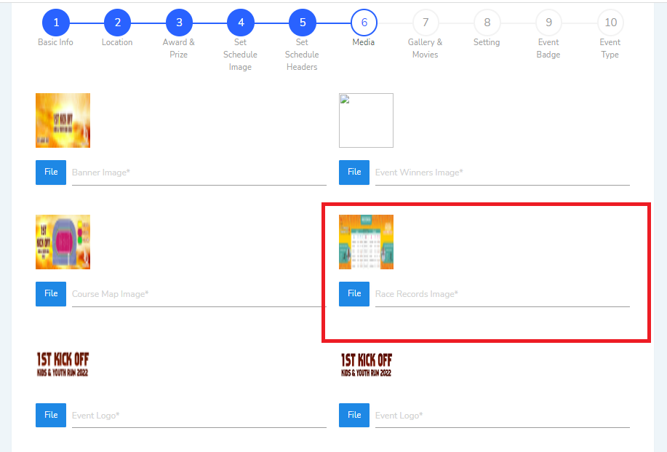

Within #8 Settings there should be 2 race records boxes

One for Adult Race Records one for Kids/Youth Race Records

Therefore making it possible to hide/unhide which of these records or both of them is currently needed to be shown for that particular event.

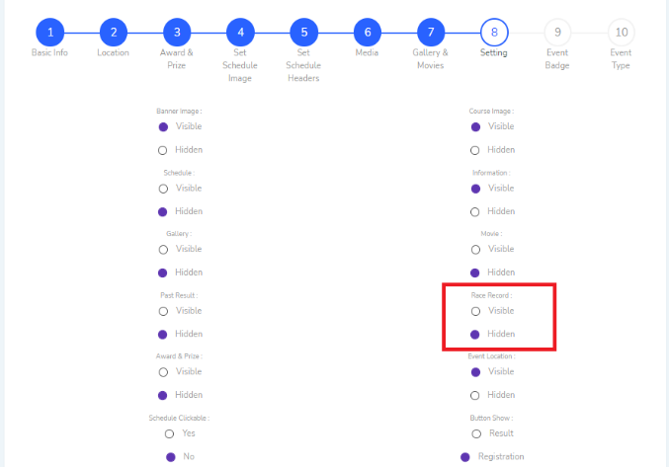

**IN the front-end of the event**

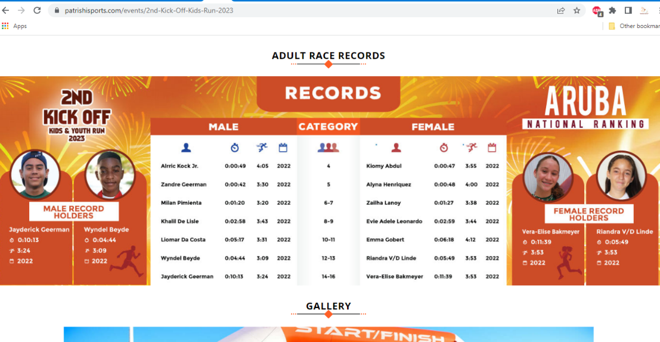

There needs to be two images shown. One for Adult Race Records which is already there and one for Kids/Youth Race Records which needs to be put in.