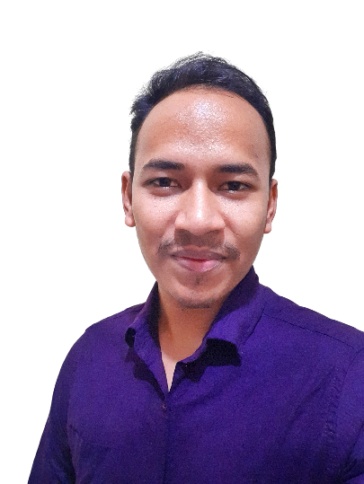Nurul Amin Khandaker

House#149, Road: Bawnia main Road,Ward#52 Uttara, Dhaka-1230

**Mobile:** 01951189383 **e-mail:** khandaker3047@gmail.com

About Me

Seeking an entry level opportunity with an esteemed organization where I can utilize my skills and enhance learning in the field of work. Capable for mastering new technologies.

Skills

**Technical Skills**

* **Programming Language:** C, C++, Java & Php. In-depth understanding of all design pattern and applications especially C, C++
* **Competitive Programming:** Have a sound knowledge of algorithm, and data structure also good at problem solving
* **Database:** Worked with distributed database using Oracle also experienced with MYSQL
* **OOP:** Capable of writing, testing, and debugging Object Oriented Programming (C++)

**Microsoft Office Skills**

* **Microsoft Word Skills:** Page setup, Text formatting, Editing, creating templates, Textboxes, SmartArt, Quick Access, Title and ribbon bar, Spellcheck, Grammar checks etc.
* **Microsoft Excel Skills:** Spreadsheets, Workbooks, Formulas, Data Linking, Pivot Tables, Charts, Data Analysis, Macros and Automatization (VBA), IF Statements, Data Validation etc.
* **Microsoft Power point Skills:** Presentation design, Templates Custom slides, Animation, Manuscripts, creating graphs and charts, Presentations troubleshooting

Education

**B.Sc. in Computer Science and Engineering**

Bangladesh University of Business and Technology (BUBT) || 2020

Mirpur-2,Dhaka-1216

CGPA: 3.48



**Higher Secondary School Certificate (H.S.C)**

Uttara High School and College || 2015

Uttara,Dhaka-1230

Background: Science

Score: 4.83

**Secondary School Certificate (S.S.C)**

B A F Shaheen Colege,Kurmitola || 2013

Dhaka Cantonment, Dhaka 1206

Background: Science

Score: 5.00

**Strengths:**

* **Quick learner**
* **Excellent Communication Skills**
* **Positive attitude**
* **Self-Motivated**
* **Able to work within tight schedules**

**Academic Projects:**

* **Online Judge Problem Solved**

[**https://www.stopstalk.com/user/profile/tushar20**](https://www.stopstalk.com/user/profile/tushar20)

* **Library Management using C**

[**https://github.com/tkhandaker101/Library-Management-using-C**](https://github.com/tkhandaker101/Library-Management-using-C)

* **Distributed Database using Java and Oracle**

[**https://github.com/tkhandaker101/tkhandaker101-Student-Managment-Oracle-and-Java-using-Distributed-Database-**](https://github.com/tkhandaker101/tkhandaker101-Student-Managment-Oracle-and-Java-using-Distributed-Database-)

* **e-Krishi Sheba with PHP and MYSQL**

**(Final Year Project)**

[**https://github.com/tkhandaker101/Krishi-Unnayan**](https://github.com/tkhandaker101/Krishi-Unnayan)

References

|  |  |
| --- | --- |
| Suman Saha  *Assistant Professor*  Dept. of CSE Bangladesh University of Business and Technology (BUBT) 01912127578  sumancsecu04@gmail.com | Md Rukon Shekh  *SR Software Developer*  NIAMA International  01733435951  rukon.info@gmail.com |