|  |  |  |  |  |  |  |  |  |
| --- | --- | --- | --- | --- | --- | --- | --- | --- |
|  | |  |  | | |  |  | |
|  | |  |  | | |  |  | |
|  | | | | | | | | |
| http://4.bp.blogspot.com/-SotLIkzmscA/UqQLE9BjdPI/AAAAAAAAARc/-SF46qFfVE0/s1600/daffodil-international-university-logo.png  Course Project | | | | | | | | |
|  | | | | | | | | |
| ROOM MANAGEMENT APPLIANCE SYSTEM | | | | | | | | |
|  | NAME: Md.Rafikul Islam | | |  | ID: 151-35-1016 | | |  |
| NAME: | | |  | ID: | | |
| Supervisor Name | | | ： | Md. Alamgir Kabir | | |
| Department: | | | ： | Software Engineering | | |
| Faculty of Science and Information Technology | | | | | | |
|  | | |  |  | | |
| December 2017 | | | | | | | | |

**Project in Brief**

Project Title: Room Management Appliance System

Completed By: Name: Md. Rafikul Islam ID: 151-35-1016

Supervised by: Md. Alamgir Kabir

Date Started: 01-10-2017

Date Completed: 06-12-2017 Operating System: Microso

Table of Contents

Chapter 1 1

1. Introduction 2

1.1 About the System 2

1.2 Purpose 2

1.3 Scope 2

1.4 Vision 2

1.5 Why this system is necessary? 2

1.6 Proposed Solution 2

Chapter 2 3

2. System Analysis 4

2.1 Use Case Model 5

2.2 Actor Goal List 5

2.2.1 Assumptions 5

2.3 Use Case Description (Brief) 5

2.4.1 Register Accounts (Example) 5

2.4 Use Case Description (Detailed) 6

2.5.1 Register Account (Example) 6

2.5 System Sequence Diagrams 6

2.6.1 Register Account 6

2.6 Domain/Conceptual Model 7

2.7 Activity diagram 8

Chapter 3 9

3. System Design 10

3.1 Sequence Diagrams 10

3.1.1 Register Account 10

3.2 Class Diagram 11

3.3 Entity Relationship Diagram 13

Chapter 4 15

4. Implementation 15

4.1 Tools &Technologies 16

4.2 Project Link 16

Chapter 5 17

5. System Testing 19

5.1 Why Software Testing is Essential? 19

5.1.1 Black box testing 19

5.1.2 White box testing 19

5.2 Test Cases 19

5.2.1 Test case: Sign up 19

Chapter 6 20

6. Conclusion 21

6.1 Good Features of the System 21

6.2 Limitations of the System 21

6.3 Future Enhancements 21

Appendices 22

7. User Manual 23

7.1 Log in Screen of Federal Shariat Court Case Flow Automation System. 23

8. References 24

Chapter 1

Introduction

# **Introduction**

The name of the system is Room Management Appliance System (RMA), where web users can reserve their meeting or class or conference room for their purpose through the networked system.

## About the System

Room Management Appliance System is created for managing the office or class room or meeting room or conference room. A network display is situated outside the room which will have been shown the information like as the room availability and who is using this room for which period. By this network display any registered person can book or canceled the room reservation.

## Purpose

Room Management Appliance System is created for managing the office or class room or meeting room or conference room. The office employee’s or any registered user for this system can book or canceled the meeting room reservation by the system. No collision will occurred for room reservation.

## Scope

It is a RMA system which helps the registered user for confirmation about their meeting room reservation with time. They can reserve the existing room for their purpose by maintaining the system. They have to login by their account and they can also cancel their reservation. It is a big opportunity for them to minimize the tension about to get the meeting room schedule.

## Vision

For room reservation we have to go to the coordinator for get a time schedule for getting a room for meeting or teaching. But by maintaining this system we have not to manage any meeting room through the coordinator. The system will manage this section.

## Why this system is necessary?

The system is necessary for minimize the collision of room time schedule or reservation of the meeting room for meeting.

## Proposed Solution

Room Management Appliance System is created for managing the office or class room or meeting room or conference room. A network display is situated outside the room which will have been shown the information like as the room availability and who is using this room for which period. By this network display any registered person can book or canceled the room reservation.

Chapter 2

**System Analysis**

# System Analysis

## Use Case Model

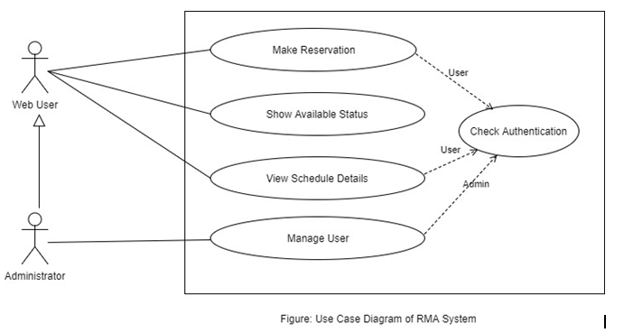

## Actor Goal List

|  |  |
| --- | --- |
| Actor | Goal |
| Registered User | Search for availability of meeting or teaching room.  Reserve the available room for meeting or conference.  Cancel the reserved room. |
| Administrator | Provide the account for login to the registered user.  Manage the room availability. |

## Use Case Description (Brief)

### Make a Reservation:

Admin and the register user can reserve any room for meeting or conference through their account. So they will have to login this website for any reservation after valid login they can do anything like make, update, release, cancel reservation.

### Show Available Status:

The web interface will display the status of the room to the user. Who is using this room, when the meeting will be finish this type of all information will be show in web display. The display will also show the availability signal by showing green or red.

### View Schedule Details:

Admin and the register user are allowed to view any room schedule through valid login.

### Manage User:

Admin create the web user and provide user ID and Password to them, also can edit their profile, and delete any web user in this section.

## Use Case Description (Detailed)

2.4.1. Make Reservation:

|  |  |
| --- | --- |
| Use Case ID | 1 |
| Name | Make Reservation |
| Primary Actor | Web User |
| Secondary Actor | Admin |
| Goal | Here registered user will reserve or cancel their meeting room. |
| Precondition | Must have to an authorized User. |
| Post Condition | Cancel/release reservation. |
| Main Success Scenario | * 1. User must have an account for become a register user or login.   2. User needs to check the room availability and choose room with time schedule.   3. User needs to fill up all the required filed properly for reservation and click to reserve. |
| Scenario Extensions | * 1. If admin/user is not an authorized for this website so they can’t entered into the website for any reservation.   2. Since they can make any reservation through their account so they can’t make any reservation if they failed to choose any available room.   3. Since they can’t make any reservation completed if they don’t fill up the required filed. |

### Show Available Status:

|  |  |
| --- | --- |
| Use Case ID | 2 |
| Name | Show Available Status. |
| Primary Actor | Web User |
| Secondary Actor | Admin |
| Goal | Here registered user will show the available status of rooms. |
| Precondition | Must have to see the display screen. |
| Post Condition | They can login for any reservation. |
| Main Success Scenario | * 1. They can show room details in display. |
| Scenario Extensions | * 1. If the display screen is damaged the user can’t show any status. |

* + 1. View Schedule Details:

|  |  |
| --- | --- |
| Use Case ID | 3 |
| Name | View Schedule Details |
| Primary Actor | Web User |
| Secondary Actor | Admin |
| Goal | Here registered user will view the schedule of room in details for make reservation. |
| Precondition | Must have to an authorized Admin or User. |
| Post Condition | They can choose available room and make a reservation. |
| Main Success Scenario | * 1. Users or admin insert the website by valid login.   2. They are allowed to view the current time, day, week, and month schedule of any room.   3. They can make a reservation. |
| Scenario Extensions | * 1. If system user is not authorized they can’t valid login.   2. If user not registered can’t show room details.   3. If they can’t login they can’t make any type of reservation. |

* + 1. Manage User:

|  |  |
| --- | --- |
| Use Case ID | 4 |
| Name | Manage User. |
| Primary Actor | Admin |
| Secondary Actor |  |
| Goal | Here admin will manage User. |
| Precondition | Must have to an authorized Admin. |
| Post Condition | Check User Information or create user delete user etc. |
| Main Success Scenario | * 1. Admin will login through username and password.   2. Website carries his username that is why he can show the registered user list.   3. He can add new user and provide the register user their username and password.   4. Also can edit/reset profile of register-user.   5. Admin also can delete any register-user. |
| Scenario Extensions | * 1. If admin enter wrong username and password for login he can’t login.   2. If the website session does not carry any admin’s username admin can’t show any user list.   3. If the first one is fail all the next steps are failed.   4. If the first one is fail all the next steps are failed.   5. If the first one is fail all the next steps are failed. |

## System Sequence Diagrams

### Manage User:

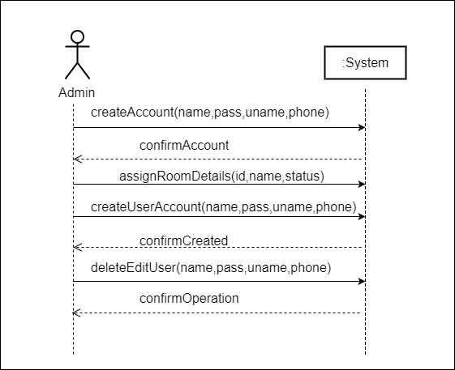

Figure: SSD to Manage User

### Make Reservation:

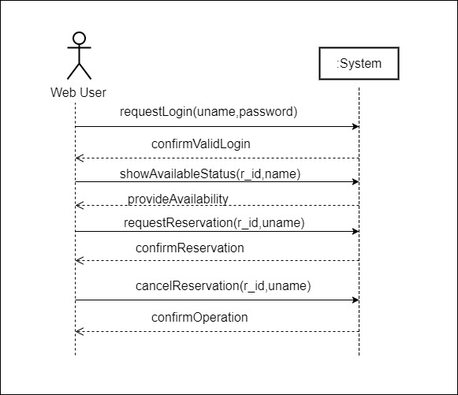

Figure: SSD to Make Reservation

## Domain/Conceptual Model

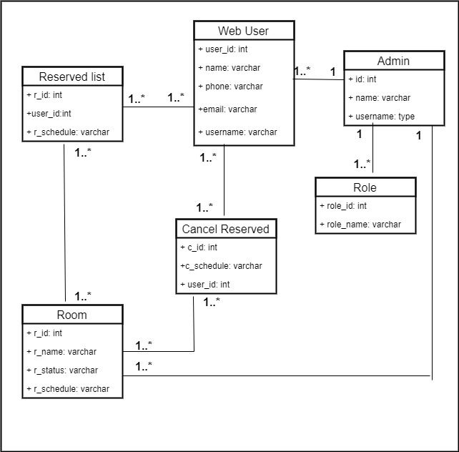

**Figure: System Domain Model**

## Activity diagram

Activity diagrams are graphical representations of workflows of stepwise activities and actions with support for choice, iteration and concurrency.

This whole process is shown in the below diagram.

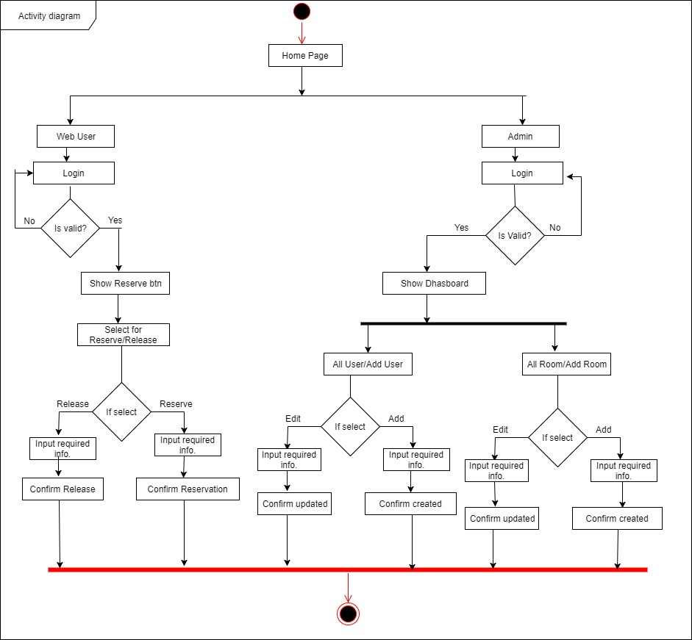

**Figure 2.18 Activity Diagram of the system**

Chapter 3

**System Design**

# System Design

## Sequence Diagrams

### Admin

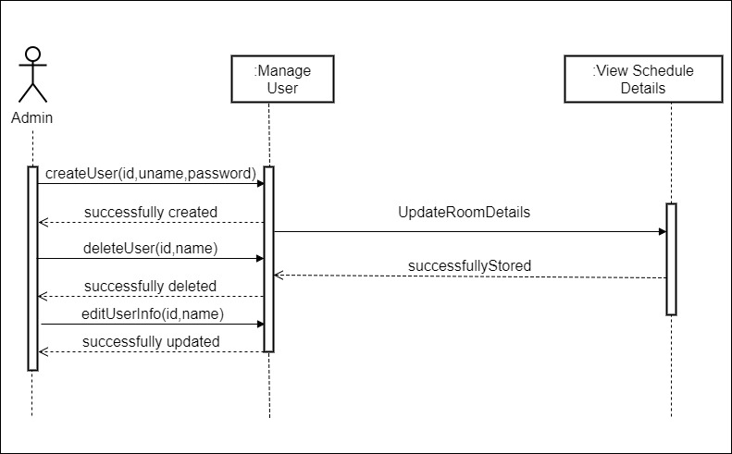

Figure 3.1 SD to Admin

### Web User

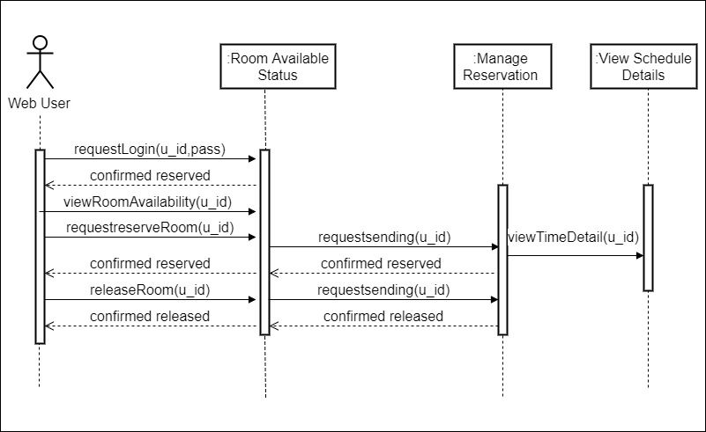

Figure 3.1 SD to Web User

## Class Diagram

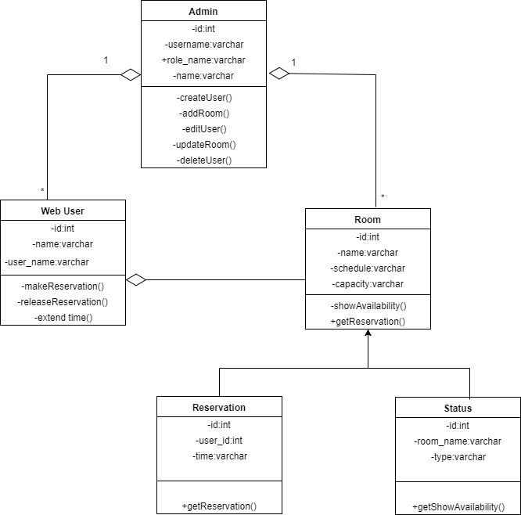

Figure 3.8 Class Diagram of System

## Entity Relationship Diagram

An entity-relationship model is an abstract and conceptual representation of data. Entity-relationship modeling is a database modeling method, used to produce a type of conceptual schema or semantic data model of a system, often a relational database, and its requirements in a top-down fashion. Diagrams created by this process are called Entity-Relationship Diagrams.

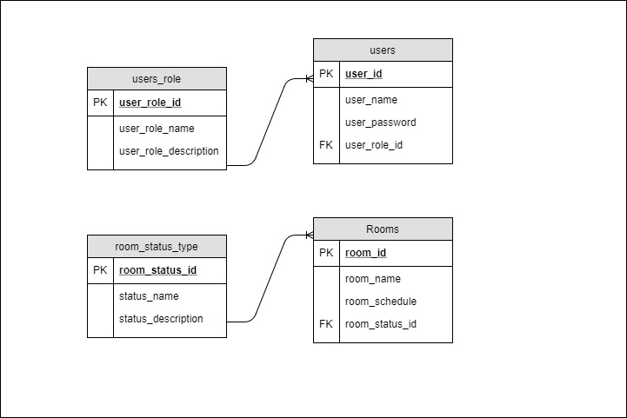

Figure 3.9 Entity Relationship Diagram

Chapter 4

**Implementation**

# Implementation

Implementation (software) perspective describes software implementations in a particular technology (such as PHP). In the UP, Implementation means programming and building the system, not deploying it.

In the implementation phase, the developer builds the components either from scratch or by composition given the architecture document from the design phase and the requirement document from the analysis phase. The architecture document should give guidance. Sometimes, this guidance is found in the requirement document. The implementation phase deals with issues of quality, performance and debugging. The end deliverable of implementation phase is the product itself.

## Tools &Technologies

Following are the tools and technologies used in development of this project:

Raw PHP

HTML5, CSS3, JavaScript, J-query, bootstrap

Server: Localhost (xampp)

Tool: draw.io

Chapter 5

**Conclusion**

# Conclusion

The name of the system is Room Management Appliance System (RMA), where web users can reserve their meeting or class or conference room for their purpose through the networked system.

## Good Features of the System

* Admin can easily edit or delete user.
* Admin can easily create a web user.

## Limitations of the System

* No register user can make any reservation.

**Github Link: https://github.com/rafikulislam/Object-Oriented-Software-Development**