**Design and Implementation of a Data Warehouse for a Retail Store with Store-level Data**

**Consulting Report-1**

*Requirements Gathering to Create Business Questions*

**George, Alpha**

**Rafi, Parvez**

**Shetty, Sharvil**

Table of Contents

1. Introduction 3

2. Details about the Data 4

2.1. Understanding of the data 4

2.2. Metadata description for all OLTP files 5

2.3. Entity-Relationship diagram 9

3. Domain Understanding 10

4. Business Questions 12

4.1. List of business questions and their analysis 12

4.1.1. Which stores are posting weak or stagnant revenue growth? 12

4.1.2. What is the trend of wine sales during Christmas holiday season? 14

4.1.3. Which stores have more popularity among kids and elderly groups? 16

4.1.4. Which stores attract people who earn below poverty line? 19

4.1.5. What is the effect of introducing coupons on total number of customer visits? 21

4.1.6. What is the trend of a product demand in different price-tiers? 23

4.1.7. What is the effect of different price promotional strategies on sales? 25

4.1.8. What is the percentage contribution of each bathroom product category towards sales? 27

4.1.9. What is the total share of products sold with different promotional strategies? 28

4.1.10. What share of the perishable or non-perishable products were shipped or warehoused? 30

4.2. Prioritization of Business Questions 32

5. References 34

# **Introduction**

Dominick’s was a retail store chain founded in 1918 and headquartered in Illinois. The data being analyzed in this report is from Dominick’s Fine Food's (DFF) database through Chicago Booth collected after both formed a partnership for store-level research into shelf management and pricing. The data encompasses 25 product categories sold at DFF’s 100 retail chain stores located in the Chicago metropolitan area over the years from 1989 to 1997. The research is of the data and developing a data warehouse on top it, would help DFF systematically analyze the factors that influence product sales. This project report aims at formulating business questions that aim to analyze these factors and help in solving key business problems such as follows.

1. **Proper shelf-management for sales growth.** The sales increase tactics can broadly be classified under two categories.
2. *Out-of-store tactics*- they include tactics to attract more consumers or retain existing ones against external competitors.
3. *In-store tactics*- it includes tactics to increase sales once consumers are inside the stores.

*Shelf-management* is an in-store tactic, which focuses on how retailers can boost sales through store-level shelf-management. The analysis of data through UPC scanners makes it *possible to understand* heterogeneity of local area demand. One of the challenges that DFF faces is how it should allocate shelf space to the multitude of products they sell across stores.

1. **Effect of consumer demographics on product sales.** Another key problem DFF needs to address is how distribution of consumer’s age, economic health, household sizes affects the sales across product categories. Answers to these problems would help DFF in targeted marketing.
2. **Impact of location of stores on sales.** DFF has more than 100 retail stores in Chicago. The store-level research on product sales also aims at answering how positioning of stores translates into revenue for DFF and what makes shoppers choose one store over another.
3. **Making pricing decisions based on seasons.** Retail stores usually see spikes in sales during vacation seasons such as Thanksgiving and Christmas. It is important for DFF to determine optimal prices of the products that would increase profit margin during these seasons.
4. **Effect of price promotions.** DFF has been rolling out coupons across product categories for promotions. They need to analyze whether price promotions through strategies like Coupons help any sales growth.

# Details about the Data

## Understanding of the data

As a part of the project, we are planning to do analysis on data collected from James M. Klits Center, University of Chicago Booth School of Business. Total size of this data adds up to 4.76 GB needs lot of changes to convert this dirty data to perform meaningful analysis. The data comprises of 9 years of store level data of more than 3500 UPCs, which were sold through around 100 stores across United States. Most of the Stores are located in Chicago area. We need to analyze the data from 1989-1994 for same number of stores. The complete product line is classified in to 29 different categories.

In total, there are four data files and they can be classified in to two categories namely General files and Category files. These four data files are available in .csv format for the analysis of the sales of Dominick’s FF.

1. **Customer Count Files**

* This file contains the information about in-store traffic of all the stores, which were compiled, on a weekly basis from scanners located at each store in DFF.
* This table contains the information about the sale information of each product categories of Beer, Meat, grocery and Diary etc. store wise on weekly basis.
* This file also contains the separate information of each above product purchased using Coupons at each store in DFF chain on weekly basis.

1. **Store-Specific Demographics**

* This file contains the store wise information of all the customers purchased the products from DFF on weekly and demography basis.
* Information present in this file is obtained by mapping the customer information with the Census information collected by US government for Chicago Metropolitan area.
* Various demography information available in this file include age groups, household income, number of dependent members, employment status, and retired status of every customer.
* Demographic information is the most important in later stages of the project for Data Warehousing and building different store wise strategies targeting different demography of people. This file has very importance in framing the questions in this phase of the project.

1. **UPC Files**

* As the name indicates UPC means Unique Product Code. Each Product is mapped to a UPC and other information related to that product.
* Complete mapping of UPC code to product is available in the *List of all UPCs in the category* table. This information can be used for product specific strategies for DFF.

1. **Movement Files**

* This file contains category wise weekly movement of each product in DFF.
* Information in this file give clear idea about profit margin on each product. This in turn will give idea about strategies need to be adopted by DFF to reduce losses and increase profit. This very important in Business point of view.
* If the Sale quantity is predictable after analyzing weekly sale data, it will give strategic advantage to the inventory department of DFF in preparing for peak and off seasons.

In addition to the above data sources, we have “Weeks Decode Table” which gives the week to date mappings useful for analysis. This is very useful in formulating different business strategies.

## Metadata description for all OLTP files

1. Please find below the description for each attribute in **ccount** file.

|  |  |  |  |
| --- | --- | --- | --- |
| **Variable** | **Description** | **Variable** | **Description** |
| DATE | Date of the Observation | FTGITAL | Food-to-Go Italian Sales in Dollars |
| Week | Week Number | GM | General Merchandise Sales in Dollars |
| Store | Store Code | GMCOUP | General Coupons Redeemed |
| BAKCOUP | Bakery Coupons Redeemed | GROCCOUP | Grocery Coupons Redeemed |
| BAKERY | Bakery Sales in Dollars | GROCERY | Grocery Sales in Dollars |
| BEER | Beer Sales in Dollars | HABA | Health and Beauty Aids Sales in Dollars |
| BOTTLE | Bottle Sales in Dollars | HABACOUP | Health and Beauty Aids Coupons Redeemed |
| BULK | Bulk Sales in Dollars | JEWELRY | Jewelry Sales in Dollars |
| BULKCOUP | Bulk Coupons Redeemed | LIQCOUP | Liquor Coupons Redeemed |
| CAMERA | Camera Sales in Dollars | MANCOUP | Manufacturer Coupons Redeemed |
| CHEESE | Cheese Sales in Dollars | MEAT | Meat Sales in Dollars |
| CONVFOOD | Conventional Foods Sales in Dollars | MEATCOUP | Meat Coupons Redeemed |
| COSMCOUP | Cosmetics Coupons Redeemed | MEATFROZ | Meat-Frozen Sales in Dollars |
| COSMETIC | Cosmetics Sales in Dollars | MISCSCP | Misc. Coupons Redeemed |
| CUSTCOUN | Customer Count | MVPCLUB | MVP |
| DAIRCOUP | Dairy Coupons Redeemed | PHARCOUP | Pharmacy Coupons Redeemed |
| DAIRY | Dairy Sales in Dollars | PHARMACY | Pharmacy Sales in Dollars |
| DELI | Deli Sales in Dollars | PHOTCOUP | Photo Coupons Redeemed |
| DELICOUP | Deli Coupons Redeemed | PHOTOFIN | Photo |
| DELIEXPR | Deli Express Sales in Dollars | PRODCOUP | Produce Coupons Redeemed |
| DELISELF | Deli Self Service Sales in Dollars | PRODUCE | Produce Sales in Dollars |
| FISH | Fish Sales in Dollars | PROMCOUP | Promotion Coupons Redeemed |
| FISHCOUP | Fish Coupons Redeemed | PROMO | Promotion Sales in Dollars |
| FLORAL | Floral Sales in Dollars | SALADBAR | Salad Bar Sales in Dollars |
| FLORCOUP | Floral Coupons Redeemed | SALCOUP | Salad Coupons Redeemed |
| FROZCOUP | Frozen Items Coupons Redeemed | SPIRITS | Spirits Sales in Dollars |
| FROZEN | Frozen Items Sales | SSDELICP | Self Service Deli Sales in Dollars |
| FTGCCOUP | Food-to-Go Coupons Redeemed | VIDCOUP | Video Coupons Redeemed |
| FTGCHIN | Food-to-Go Chinese Sales in Dollars | VIDEO | Video Sales in Dollars |
| FTGICOUP | Food-to-Go Coupons Redeemed | VIDEOREN | Video Rentals (Dollar Amounts) |

1. Please find below the description for each attribute in **Demography** file.

|  |  |  |  |
| --- | --- | --- | --- |
| **Variable** | **Description** | **Variable** | **Description** |
| age9 | % Population under age 9 | retired | % of Retired |
| age60 | % Population over age 60 | unemp | % of Unemployed |
| ethnic | % Blacks & Hispanics | wrkch5 | % of working women with children under 5 |
| educ | % College Graduates | wrkch17 | % of working women with children 6 - 17 |
| nocar | % With No Vehicles | nwrkch5 | % of non-working women with children under 5 |
| income | Log of Median Income | nwrkch17 | % of non-working women with children 6 - 17 |
| incsigma | Std dev of Income Distribution (Approximated) | wrkch | % of working women with children |
| hsizeavg | Average Household Size | nwrkch | % of non-working women with children |
| hsize1 | % of households with 1 person | wrkwch | % of working women with children under 5 |
| hsize2 | % of households with 2 persons | wrkwnch | % of working women with no children |
| hsize34 | % of households with 3 or 4 persons | telephn | % of households with telephones |
| hsize567 | % of households with 5 or more persons | mortgage | % of households with mortgages |
| hh3plus | % of households with 3 or more persons | nwhite | % of population that is non-white |
| hh4plus | % of households with 4 or more persons | poverty | % of population with income under $15,000 |
| hhsingle | % of households with 1 person | shopcons | % of Constrained Shoppers |
| hhlarge | % of households with 5 or more persons | shophurr | % of Hurried Shoppers |
| workwom | % Working Women with full-time jobs | shopavid | % of Avid Shoppers |
| sinhouse | % Detached Houses | shopstr | % of Shopping Stranges |
| density | Trading Area in Sq Miles per Capita | shopunft | % of Unfettered Shoppers |
| hval150 | % of Households with Value over $150,000 | shopbird | % of Shopper Birds |
| hval200 | % of Households with Value over $200,000 | shopindx | Ability to Shop (Car and Single Family House) |
| hvalmean | Mean Household Value (Approximated) | shpindx | Ability to Shop (Car and Single Family House) |
| single | % of Singles |  |  |

1. Please find below the description for each attribute in **UPC** file

|  |  |  |  |
| --- | --- | --- | --- |
| **Variable** | **Description** | **Variable** | **Description** |
| upc | UPC Number | descrip | Product Name |
| com_code | % Population over age 60 | size | Product Size |
| nitem | Dominick's item code | case | Number of items in a case |

1. Please find the description for each attribute in **Movement** file

|  |  |  |  |
| --- | --- | --- | --- |
| **Variable** | **Description** | **Variable** | **Description** |
| upc | UPC Number | qty | Number of item bundled together |
| store | Store Number | profit | Gross margin |
| week | Week Number | sale | Sale code (B, C, S) |
| move | Number of unit sold | ok | 1 for valid data, 0 for trash |
| price | Retail Price |  |  |

## Entity-Relationship diagram

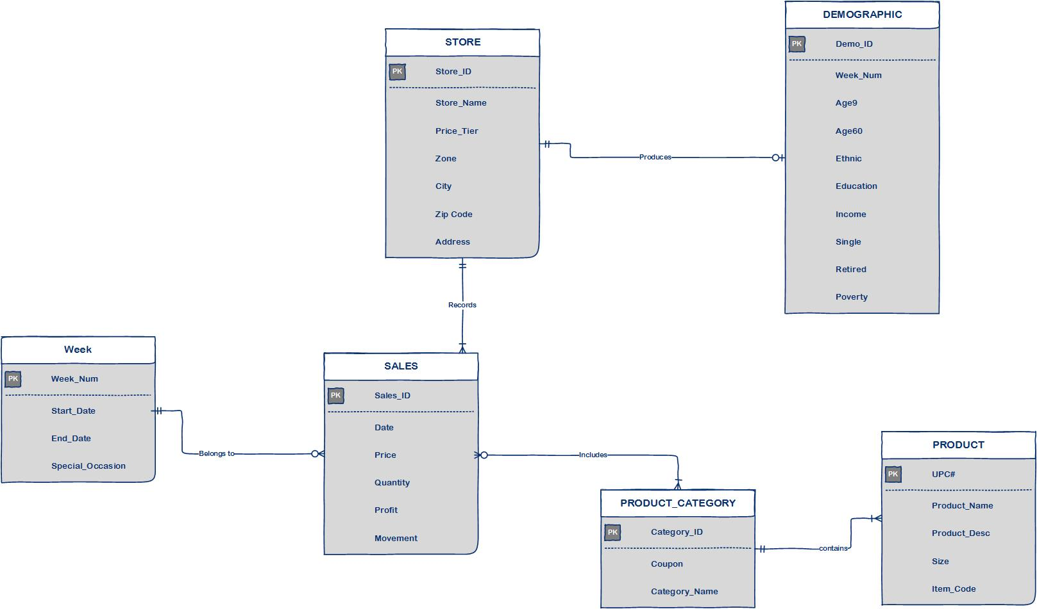

# Domain Understanding

We had a pool of research papers to understand how significant and relevant data can be derived from past sales data. Research papers also gave insight about methods by which we can build business strategies on top of the derived data. It was beyond the scope of the project to read and understand all the papers from the pool of research papers. From the complete list, we read three and understood the strategies adopted during the design and implementation of Data Warehousing. Please find our understandings about each paper detailed below.

1. **Nevo, Aviv and Catherine Wolfram,** [**"Why do Manufacturers Issue Coupons? An Empirical Analysis of Breakfast Cereals,"**](https://research.chicagobooth.edu/marketing/databases/dominicks/docs/2002_Why_Do_Manufacturers.pdf)***The RAND Journal of Economics*, 33 (Summer 2002): 319-339.**

The main objective of this research paper is to summarize the effect of Coupons in the increase or decrease in sales of any retail chain. This paper discusses the scenarios in which the coupons are introduced by a Manufacturers and the effect of it in detail. Paper also discusses that giving coupons is better than spending substantial amount in advertisements. This paper also explains how the price of commodities whose quality is not comparable to its competitors will decrease in long term .This is very important in formulating our strategies in later stages of the project for improving sales based on the meaningful data derived from data warehousing design methodologies.

This paper also discusses the different reasons behind a manufacturer introducing discount/coupon on a particular product. Firstly, it can be for introducing a new product. This will give a larger pool of customers a taste/experience of the new product. Secondly coupons are introduced to boost up sales of a particular product which is lagging behind its customers or if it is being perished in inventory. This is explained under the heading relationships between Coupons and Shelf price. In addition, the paper discusses how the perception of customer about a product can change if the coupons are made available continuously. Effects and correlation of price and coupons in different situations are derived and explained mathematically in the complete paper. This summarizes the complete project.

1. **Sivakumar, K.,**[**"Quality-Tier Competition and Optimal Pricing,"**](https://research.chicagobooth.edu/marketing/databases/dominicks/docs/1995-Quality-TierCompetition.pdf) **Journal of Business Research 33 (1995): 251-260.**

This research paper talks about implications of quality-tier competition by developing a conceptual framework to investigate how optimal pricing decisions can be done the level of brand quality to which it belongs. This paper explained how comparative study could be done on 2 different products about its pricing. It also discusses the implication of the framework introduced and steps involved in the implementation of the framework. This will be very helpful in adopting strategies for pricing the items in DFF considering the competition faced by the product after getting results from the data warehouse we are planning to design in the upcoming stages of the project.

This paper also gives insight about Customer decision model explaining what will be the possible decisions of a customer comparing the price and brand category of 2 products competing each other. This idea is very useful in determining what the possible price of each product is, considering the utilities derived from it. The framework described in this paper proposes the empirical distribution of possible prices for a product. It also describes the profit available from each price in the distribution and managerial implication of the same. In total, the paper draws a complete relation between the academic researches in marketing practices of pricing a product.

1. **Lira, Loreto,**[**"Why Do Some Prices in the Retail Sector Drop When Demand Rises? Evidence from the Chilean Case,"**](https://research.chicagobooth.edu/marketing/databases/dominicks/docs/2007-WhyDoSomePricesDrops.pdf)***Revista ABANTE* 10 (Octubre 2007): 151-168**

The primary objective of this research whether the prices in retail sector decrease when there is a positive demand in the product. This explained in the backdrop of countercyclical relationship of in Chile between cost and increased demand of set of retail products. This paper discusses about various theories analyzing the effect and cause of prices in each theory scenario. Author discusses theories effecting the prices at Producer/Supplier level and Retail level. For example, pro cyclical Price elasticity proposed by Warner Barsky states that Producer price could drop for products experiencing increase in the elasticity of demand. This can happen due to transferring of elasticity of demands to suppliers in periods of generalized shocks in demand. If similar situation arises for a product in DFF for a particular week DFF management transfer the benefit to customers by applying the same principle.

So similarly applying other theories in the paper, equations can be written for each product in DFF on weekly basis considering the changes in sales of the particular product in previous week. Even though applying equations for pricing on each product is not in the purview of the project even in later stages, we can apply these in one or two products if the time permits. The paper also says that above theories stand null and void when the demand of a product is artificially increased by applying coupons. All theories are explained with the variation in price of products in a retail chain at Chile. Results of the study proves that price of set of retail products fall when the demand increases, which is likely to be similar in case of DFF as the scenarios are same in both the cases.

# Business Questions

## List of business questions and their analysis

Based on our analysis of data, we came up with following 10 business questions pertaining to the business processes of Dominick’s Fine Food (DFF). The following sections also consist of our analysis of the given data which support these business questions.

### Which stores are posting weak or stagnant revenue growth?

**Entity-Relationship Diagram:**

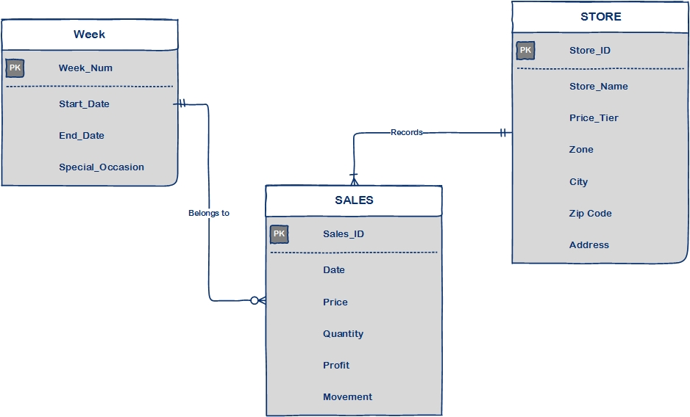

**Data Table:**

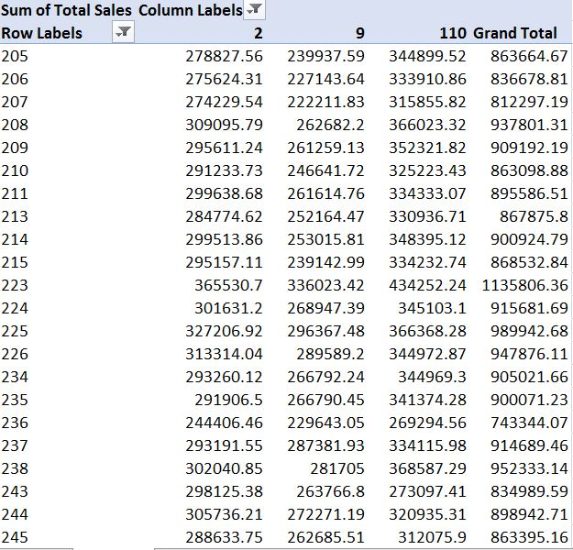

*Table.1. Weekly sales trends for stores 2,9 and 110. Leftmost column shows week numbers*

**Graphical Analysis:**

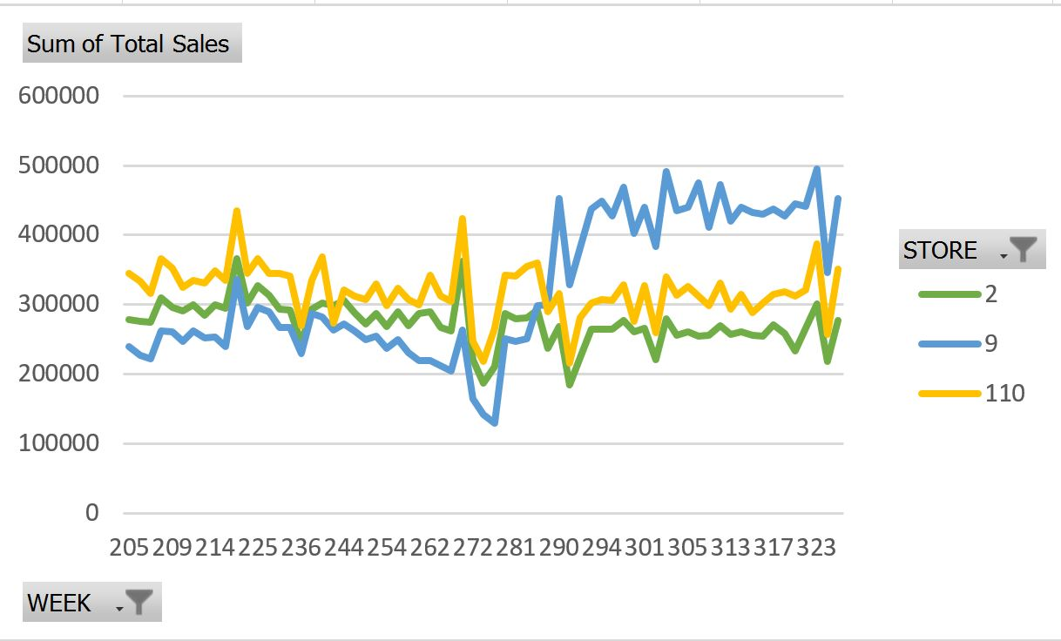

*Fig. 1. Graph showing weekly sales trends for stores 2,9 and 110*

**Explanation:**The line graph above shows weekly sales trends for stores Dominick 2, Dominick 9 and Dominick 110. The business question helps to analyze the sales trend across all the stores and then identify the stores which have been posting weak or stagnant growth. For example, stores Dominick 2 and Dominick 110 failed to register a growth as good as the store Dominick 9 during later phases of the observation. Such an analysis will help DFF to identify the stores that need special attention from DFF’s marketing team.

### What is the trend of wine sales during Christmas holiday season?

**Entity-Relationship Diagram:**

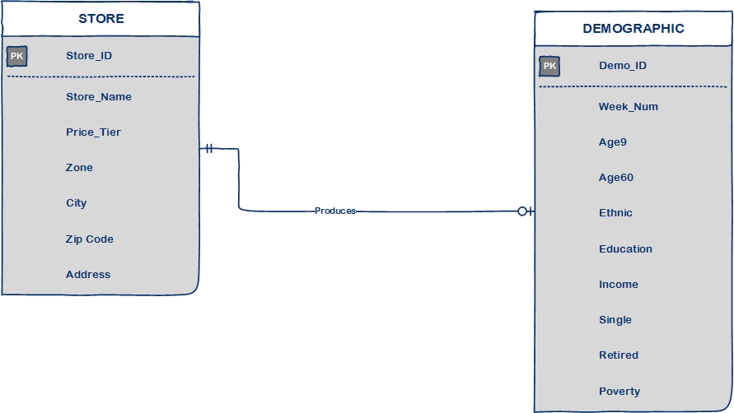

**Data Table:**

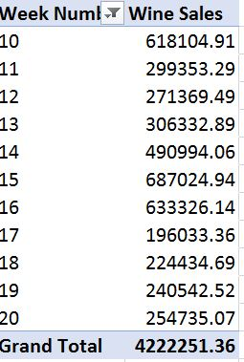

*Table.2. Weekly sales trends for wine around Christmas Week*

**Graphical Analysis:**

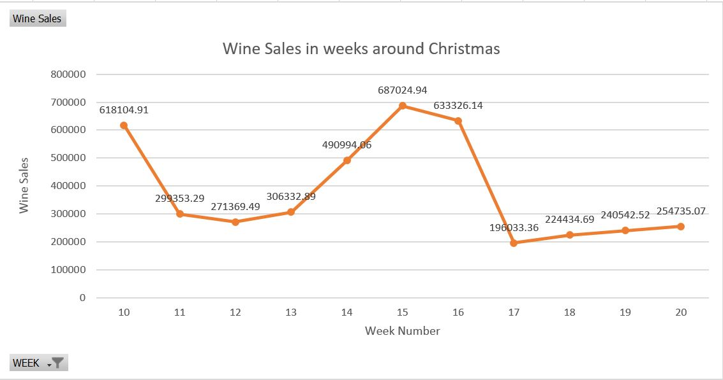

*Fig. 2. Weekly sales trends for wine around Christmas Week*

**Explanation:** Some products may see significant boost in sales during festive/vacation seasons. One such product is wine which saw sudden growth from week 13 through week 17 (Christmas through new year). Such an analysis will help DFF identify all the products which usually see seasonal growth in sales. The supplies of these products would need to be managed effectively during these seasons. Proper shelf-management has always been one of important concerns for retails businesses. This type of analysis would help in better management of the products that would feature on store shelves.

### Which stores have more popularity among kids and elderly groups?

**Entity-Relationship Diagram:**

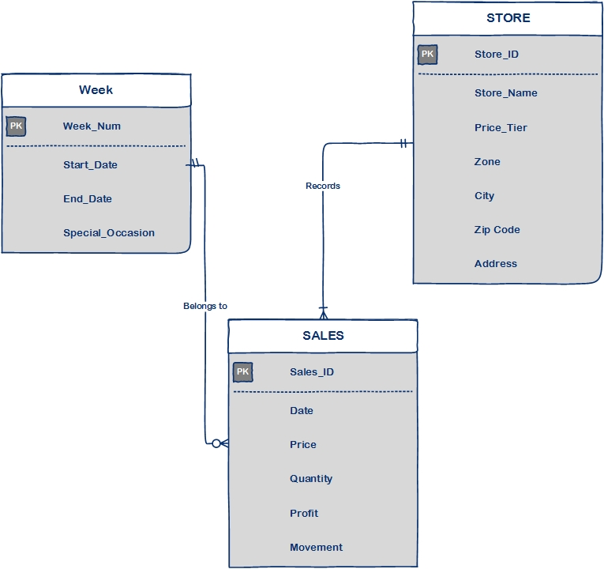

**Data Table:**

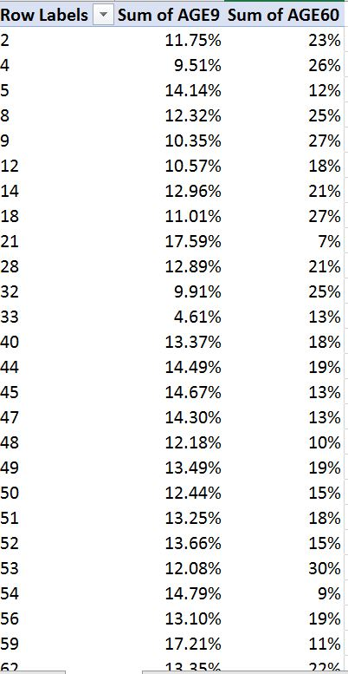

*Table. 3. Store-wise percentage visit of kids(age<9) and elderly people(age>60)*

**Graphical Analysis:**

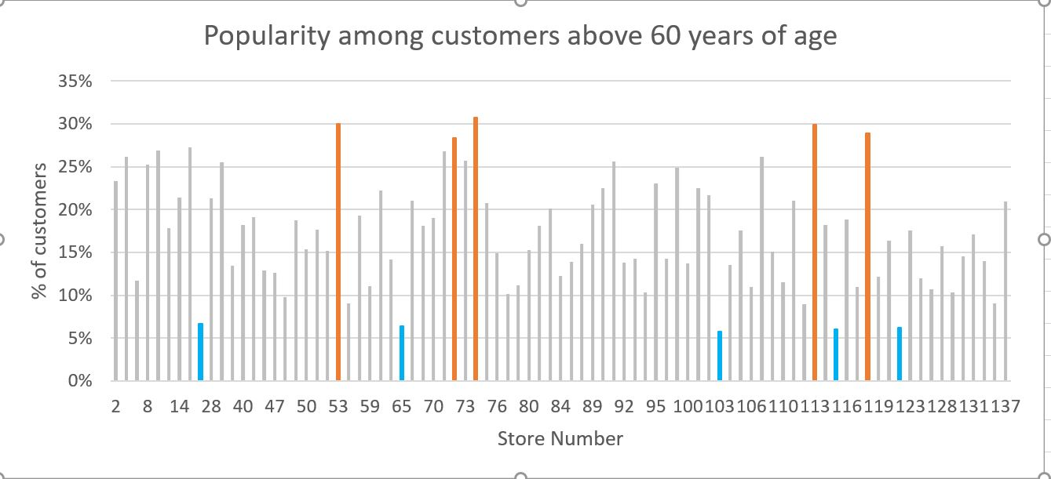

*Fig. 3.A. Store-wise percentage visit of elderly people(age>60)*

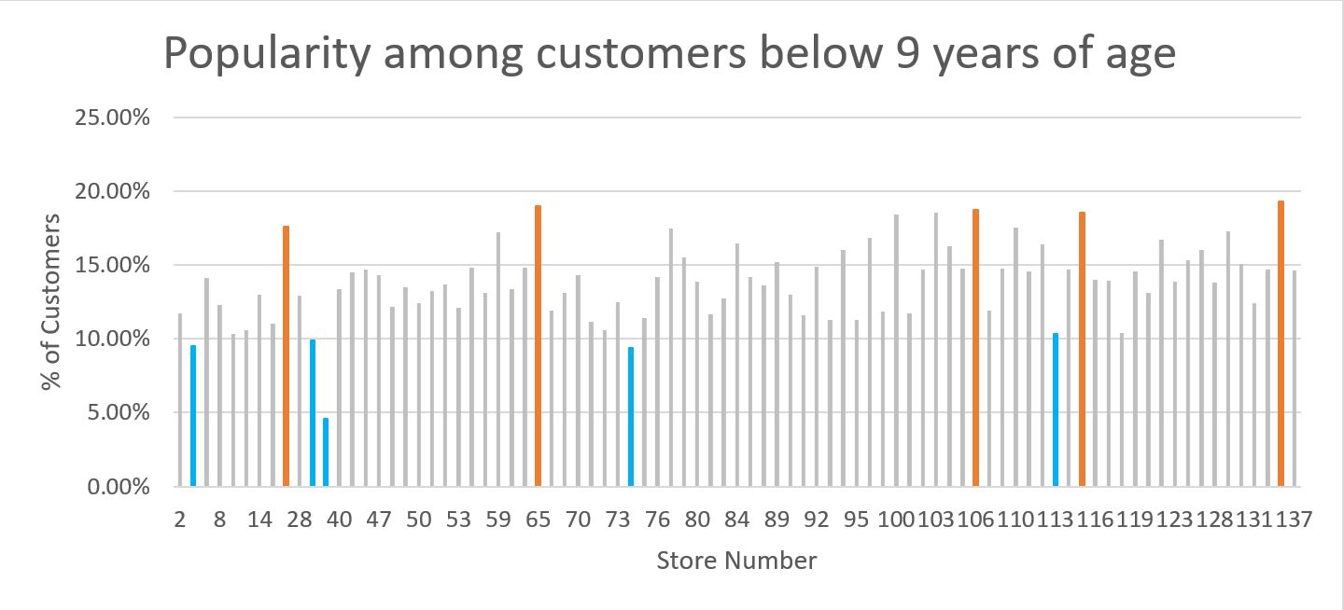

*Fig. 3.B. Store-wise percentage visit of kids(age<9)*

**Explanation:** The graphs above highlight the DFF stores which are most or least popular among kids and elderly group people. Retails companies require such analysis for targeted marketing and sales. For instance, the stores which are popular among kids may be supplied with more of young age merchandize. Similarly, the stores that are popular among elderly section may be supplied with merchandize that sell more to elderly people.

### Which stores attract people who earn below poverty line?

**Entity-Relationship Diagram:**



**Data Table:**

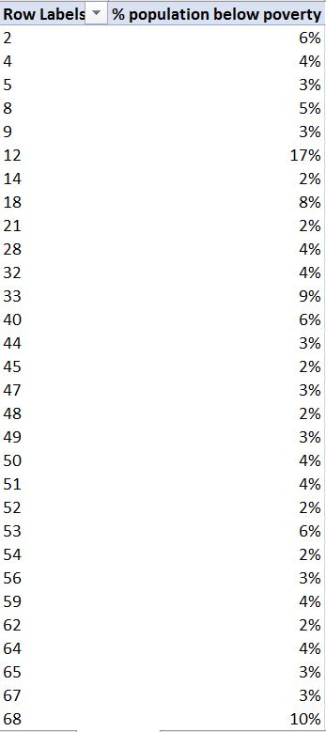

*Table. 4. Store-wise percentage of Poor People (annual salary<$15,000)*

**Graphical Analysis:**

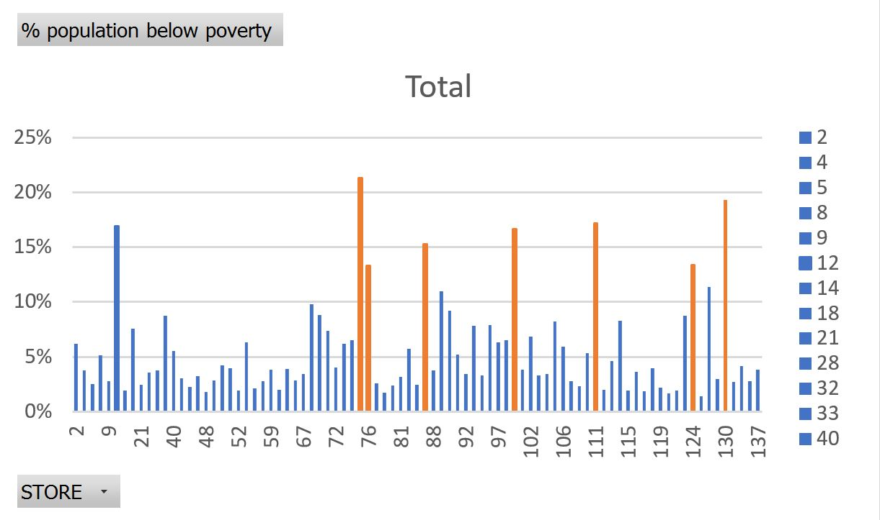

*Fig. 4. Store-wise percentage of Poor People (annual salary<$15,000)*

**Explanation:** The plot above shows percentage of people below poverty line (income less than $15,000) visiting stores of DFF. We realized that some of the stores were more popular among low income group people. Such an analysis is important for DFF for store-wide distribution of the stock which is usually consumed more by low-income group. For example, low income group usually consumes non-luxury goods more. If we can identify these stores, DFF would be able to make to distribute such goods more effectively.

### What is the effect of introducing coupons on total number of customer visits?

**Entity-Relationship Diagram:**

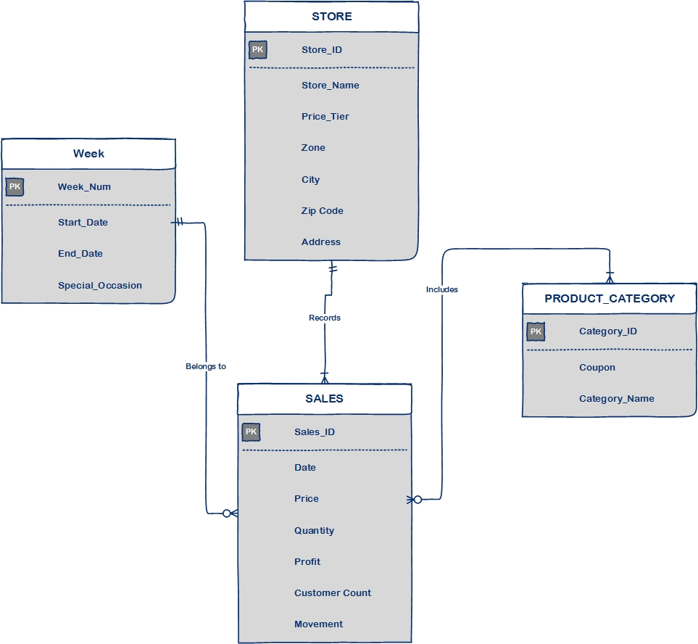

**Data Table:**

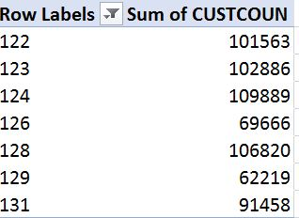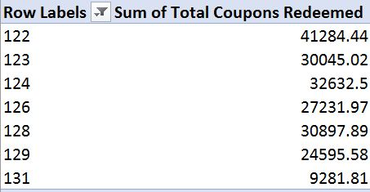

*Table. 5.A. Count of customers per week Table. 5.B. Count of Coupons used per week*

**Graphical Analysis:**

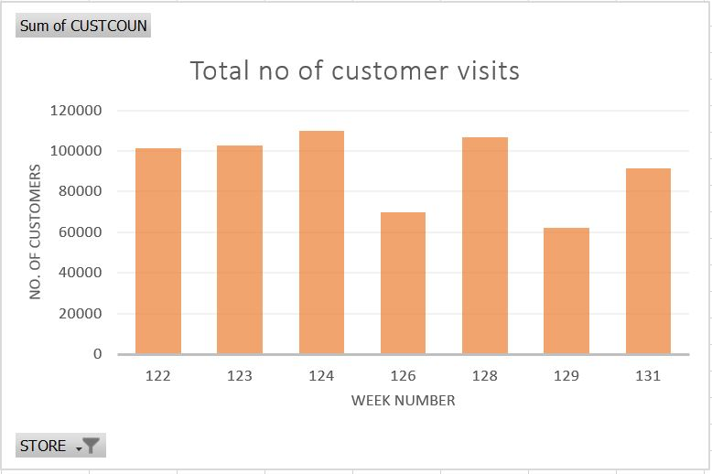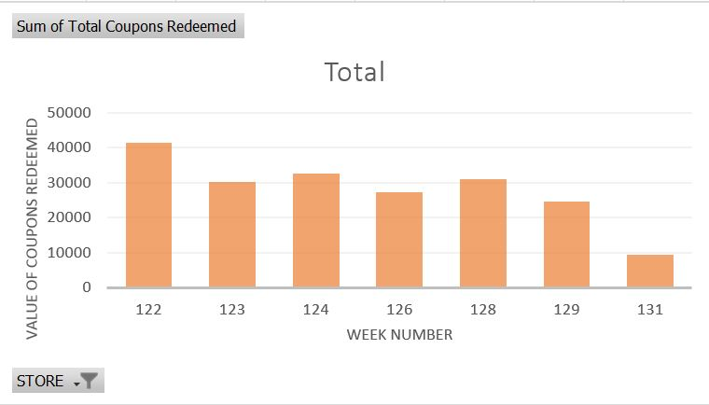

*Fig. 5.A. Count of customers per week Fig. 5.B. Count of Coupons used per week*

**Explanation:** With data and graph above help analyze the impact of coupons on count of customers who visited DFF stores over a certain period of observation. We assume that number of coupons that were redeemed is in proportion to the coupons launched. The analysis is needed to understand how customer footfall varied as DFF launched promotional strategies like announcing coupons. We can repeat similar exercise for other promotional strategies and see how each impacts the customer count. This will help identify the effectiveness of such promotional strategies. The analysis will also help to see one promotional strategy fares against other marketing forces in their effect on customer visits.

### What is the trend of a product demand in different price-tiers?

**Entity-Relationship Diagram:**

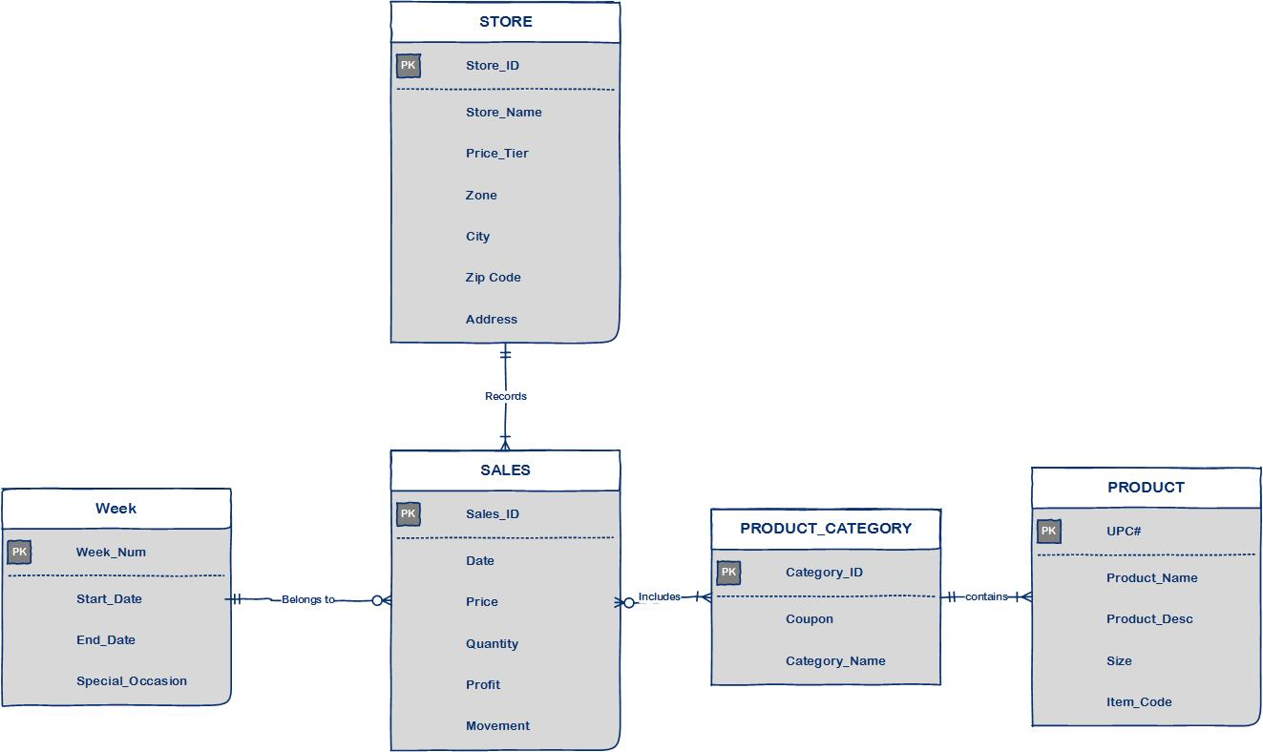

**Data Table:**

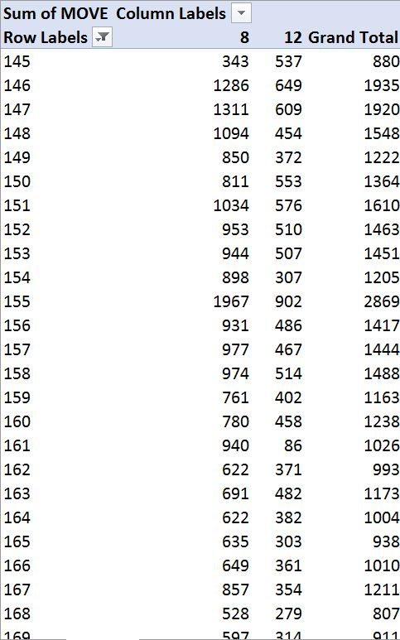

*Table. 6. Weekly sales of Cheese in store 8(medium-price tier) store 12(high-price tier)*

**Graphical Analysis:**

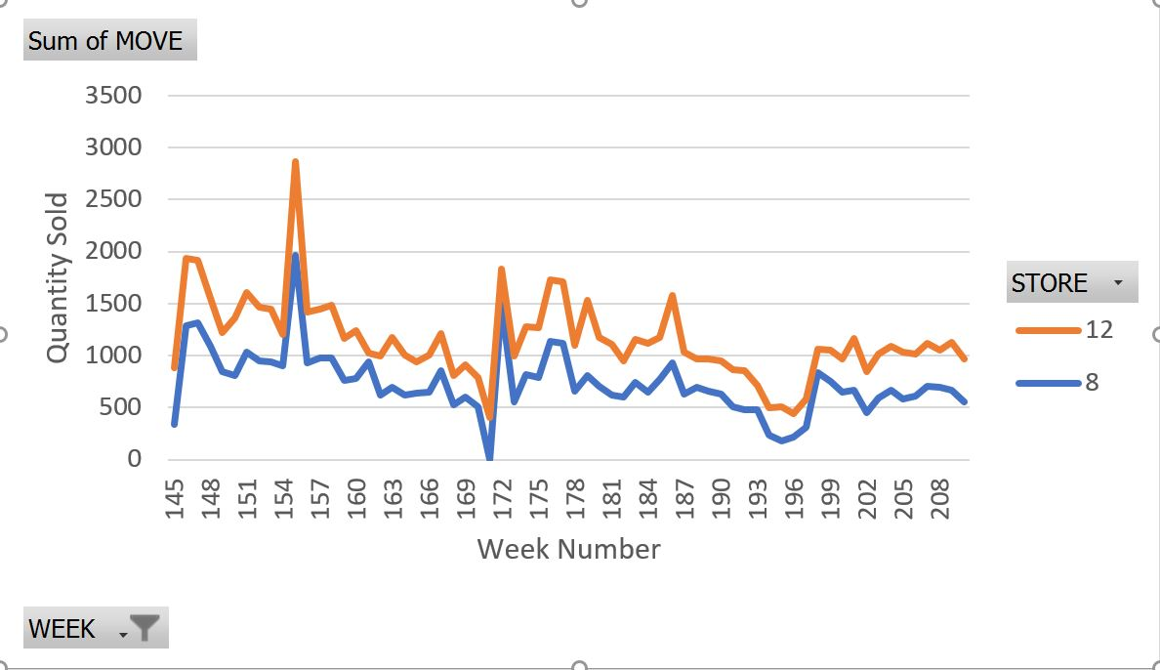

*Fig. 6. Weekly sales of Cheese in store 8(medium-price tier) store 12(high-price tier)*

**Explanation:** The plot above compares quantities of Cheese sold in two stores in difference price-tier zones. The store Dominick 12 is in high-price trier zone, while the store Dominick 8 is in low price tier zone. One possible explanation for the trend as above could be high-price zones being in rich neighborhoods where people can afford to buy more. Such an analysis is important in distributing merchandize based on price-tier zones. Out of 16 zones in which different stores are located, they can be divided into 4 price tiers viz. *CubFighter, Low, Medium, High*. In this analysis, we cover only medium-price and high-price tiers. Similar analysis may be expanded to other price tiers which would help in comparative study of the demand trends across these 4 price tiers.

### What is the effect of different price promotional strategies on sales?

**Entity-Relationship Diagram:**

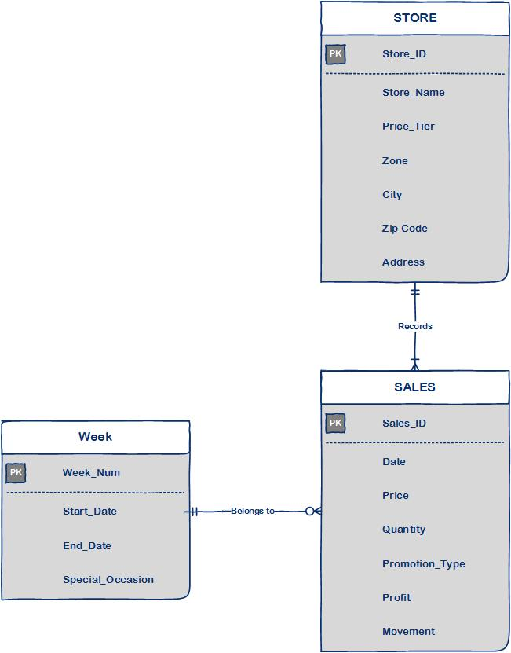

**Data Table:**

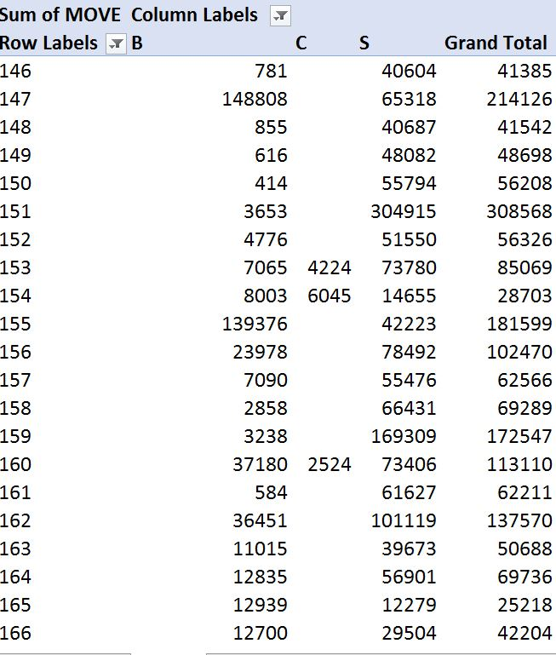

*Table. 7. Weekly sales of soft drinks categorized under B, C or S promotions*

**Graphical Analysis:**

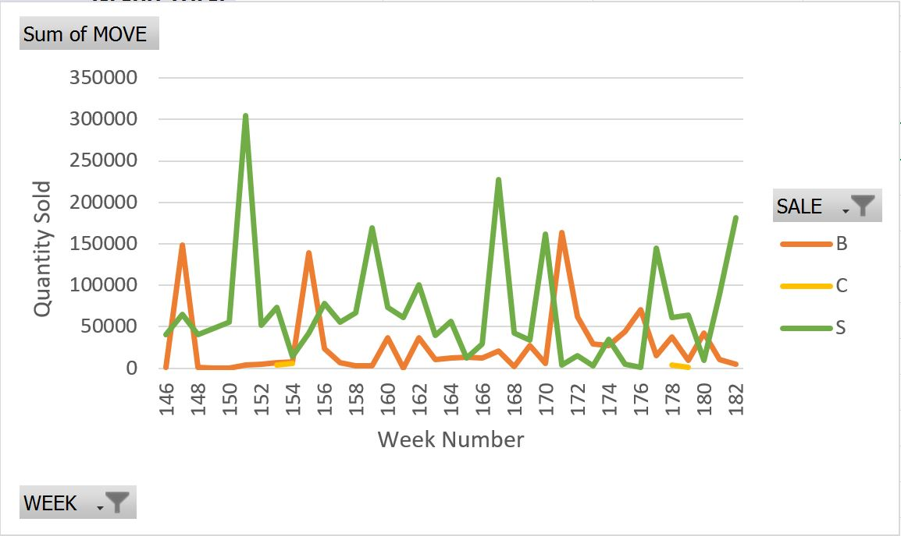

*Fig. 7. Weekly sales of soft drinks categorized under B, C or S promotions*

**Explanation:** This analysis aims at comparative impact of different promotional strategies on amount of specific product sold at stores. We picked the dataset on *soft drink*s category and plotted quantities sold for three different promotional strategies viz. *B: Bonus Buy, C: Coupon and S: Simple Price Reduction.* This analysis can be extended across other product categories too. This analysis is required for DFF to identify which promotional strategy works best for each product category.

### What is the percentage contribution of each bathroom product category towards sales?

**Entity-Relationship Diagram:**

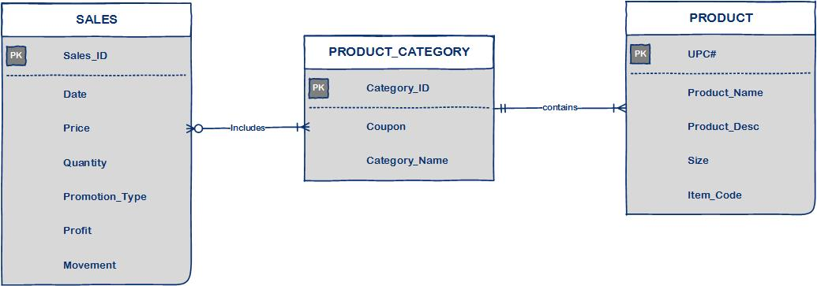

**Data Table:**



*Table. 8. Weekly sales of product categories of Dish Detergent, Laundry Detergent, Fabric*

**Graphical Analysis:**

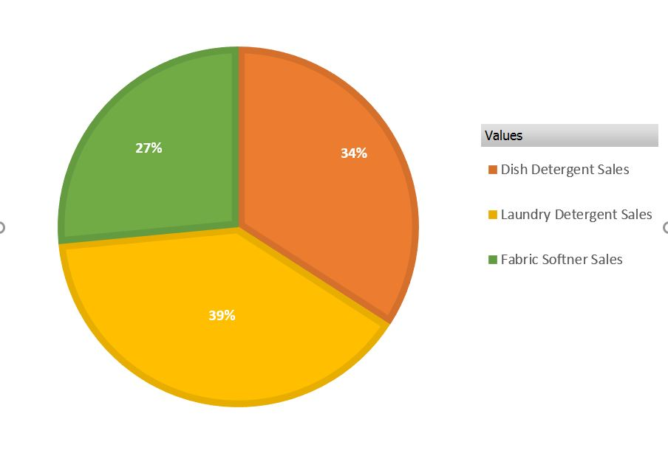

*Fig. 8. Total sales of product categories of Dish Detergent, Laundry Detergent, Fabric*

**Explanation:** Here we analyze the percentage share among three similar products that fall under bathroom category. Such analysis is important from the perspective of shelf-management. DFF needs this type of analysis to discover which products are doing good in long run. For example, the above pie-chart demonstrates *Laundry detergent* has contributed more in total sales compared to the other two products. This kind of stats would help DFF in taking strategic decisions for choosing the products which need less or more focus.

### What is the total share of products sold with different promotional strategies?

**Entity-Relationship Diagram:**



**Data Table:**

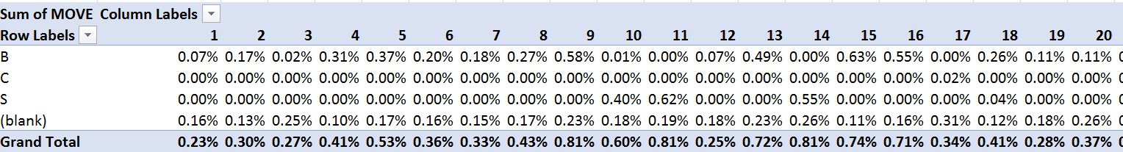

*Table. 9. Total share of products under B,C and S categories*

**Graphical Analysis:**

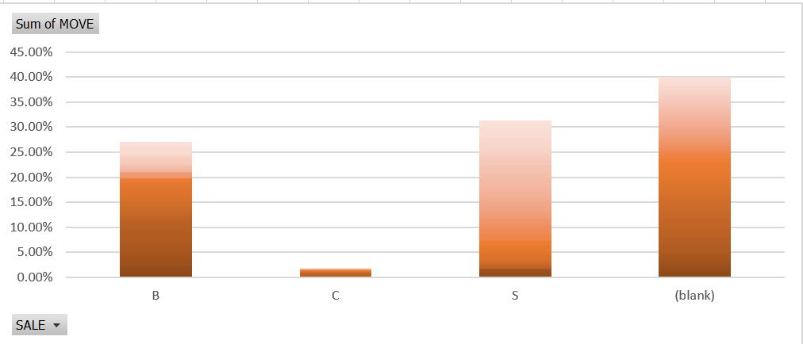

*Fig. 9. Total share of products under B,C and S categories*

**Explanation:** The plot above consolidates the impacts of different price promotion tactics and provides an overall picture of how DFF took decision on selling products with these promotions. Such an analysis will help DFF to introspect how their promotional strategies fared in long run. It will also help them to benchmark their strategies against other players in the industry. For, example from the graph above, we can infer that DFF made most of their sales from the price promotion category S (simple price reduction). (blank) demonstrates the sales that were posted without any price promotion. They may further compare these stats with profitability and see how good was their strategy to sell most of the products under S-type promotion.

### What share of the perishable or non-perishable products were shipped or warehoused?

**Entity-Relationship Diagram:**

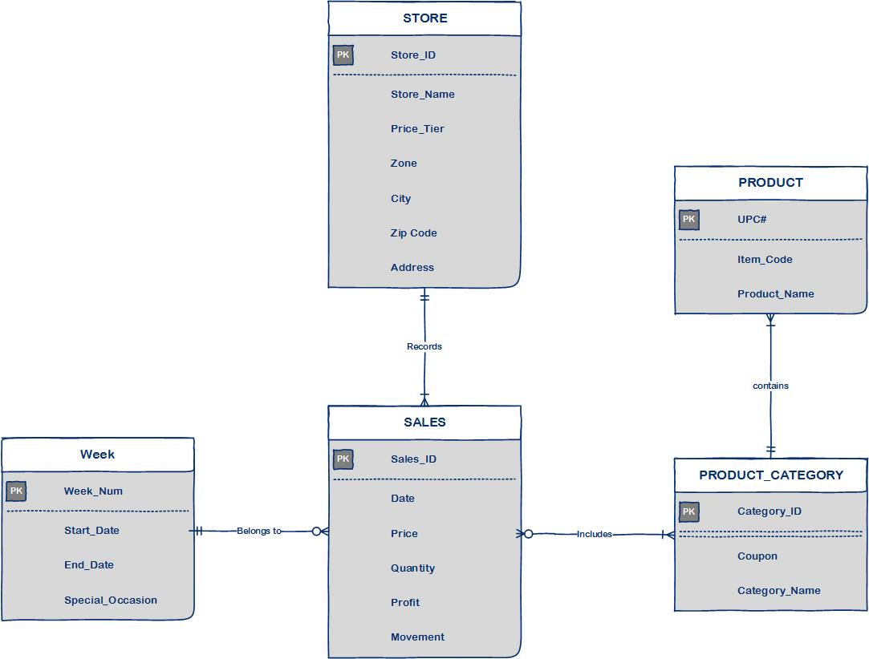

**Data Table:**

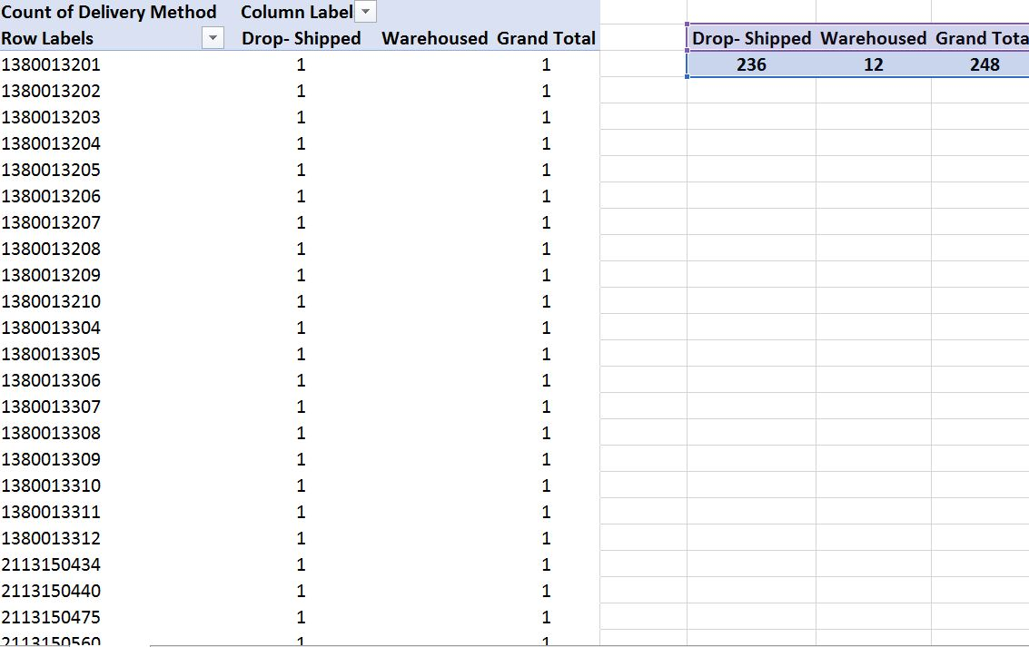

*Table. 10.A. Shipped vs Warehoused stock comparison for Frozen Dinner*

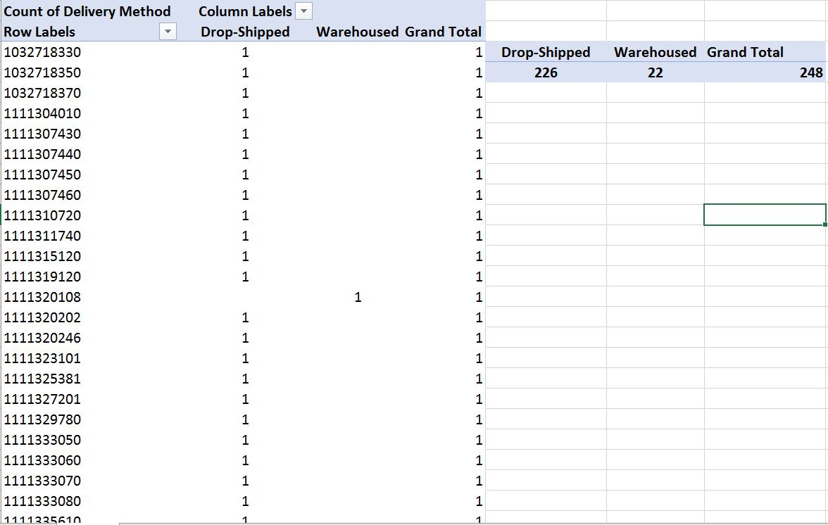

*Table. 10. B. Shipped vs Warehoused stock comparison for Toothpaste*

**Graphical Analysis:**

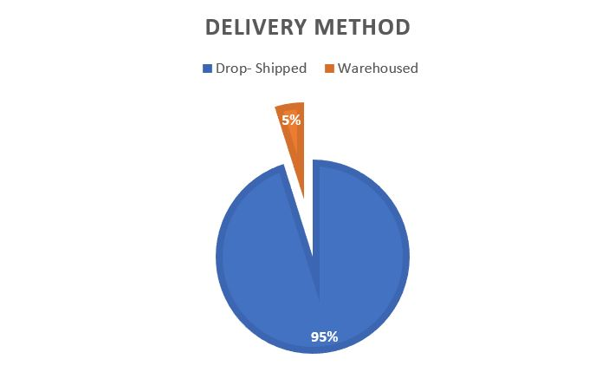

*Fig. 10.A. Drop-Shipped and Warehoused stock of Frozen Dinner*

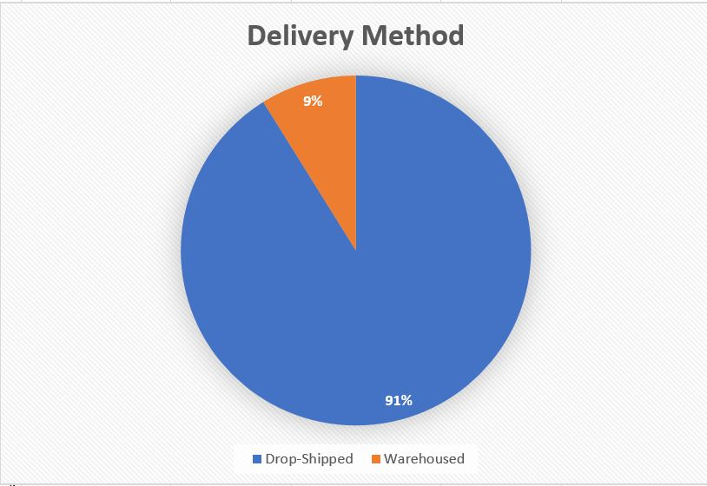

*Fig. 10.B. Drop-Shipped and Warehoused stock of Toothpaste*

**Explanation:** The data provides a comparison between one perishable and one non-perishable item in terms of what proportion of the stock that was drop-shipped or warehoused. We pulled this data from *itemcode* value for the products, where each item code suggested whether the item was shipped or warehoused based on last digit of the *itemcode*. In our case, we chose "toothpaste" as a non-perishable product and frozen dinner as a perishable product. Our intuition was that more number of perishable products should be directly shipped to the stores rather than being warehoused. We decided to validate our intuition with the data. The stated business question aims at analyzing the percentage of stock that was drop-shipped or warehoused. If perishable items are stored for longer, there are chances for them to spoiled. This analysis would help DFF business to prevent such storage losses by effective taking decisions around merchandised to be shipped.

## Prioritization of Business Questions

The answers to these 10 business questions can help DFF analyze product sales trends and can provide key insights in forecasting the impact of various in-store and out-store forces on sales. We also saw how some of the questions aim at analyzing the effect of several marketing strategies employed by DFF. In this section, we have prioritized these 10 question under 3 groups: *High Priority, Medium Priority and Low Priority*. This prioritization has been done based on how strongly DFF’s performance is correlated with the answers to the questions.

***High Priority:***

|  |  |
| --- | --- |
| 4.1.1. | Which stores are posting weak or stagnant revenue growth? |
| 4.1.6. | What is the trend of a product demand in different price-tiers? |
| 4.1.7. | What is the effect of different price promotional strategies on sales? |

***Medium Priority:***

|  |  |
| --- | --- |
| 4.1.3. | Which stores have more popularity among kids and elderly groups? |
| 4.1.4. | Which stores attract people who earn below poverty line? |
| 4.1.5. | What is the effect of introducing coupons on total number of customers visit? |

***Low Priority:***

|  |  |
| --- | --- |
| 4.1.2. | What is trend of wine sales during Christmas holiday season? |
| 4.1.8. | What is the percentage contribution of each bathroom product category towards sales? |
| 4.1.9. | What is the total share of products sold with different promotional strategies? |
| 4.1.10. | What share of the perishable or non-perishable products were shipped or warehoused? |

# **References**

1. <https://en.wikipedia.org/wiki/Dominick's>
2. <https://research.chicagobooth.edu/marketing/databases/dominicks/docs/1994-shelfmanagement.pdf>
3. Drèze, Xavier; Hoch, Stephen J.; Purk, Mary E. (1994): *Shelf Management and Space Elasticity*
4. <http://supreetnayak.com/img/portfolio/fullsize/DWReport.pdf>
5. <http://research.chicagobooth.edu/marketing/databases/dominicks/papers.aspx>
6. [www.chicagobooth.edu/research/kilts/marketing-databases/dominicks/demo](http://www.chicagobooth.edu/research/kilts/marketing-databases/dominicks/demo)
7. <https://research.chicagobooth.edu/marketing/databases/dominicks/docs/2002_Why_Do_Manufacturers.pdf>
8. <https://research.chicagobooth.edu/marketing/databases/dominicks/docs/1995-Quality-TierCompetition.pdf>
9. <https://research.chicagobooth.edu/marketing/databases/dominicks/docs/2007-WhyDoSomePricesDrops.pdf>