Demo.csv

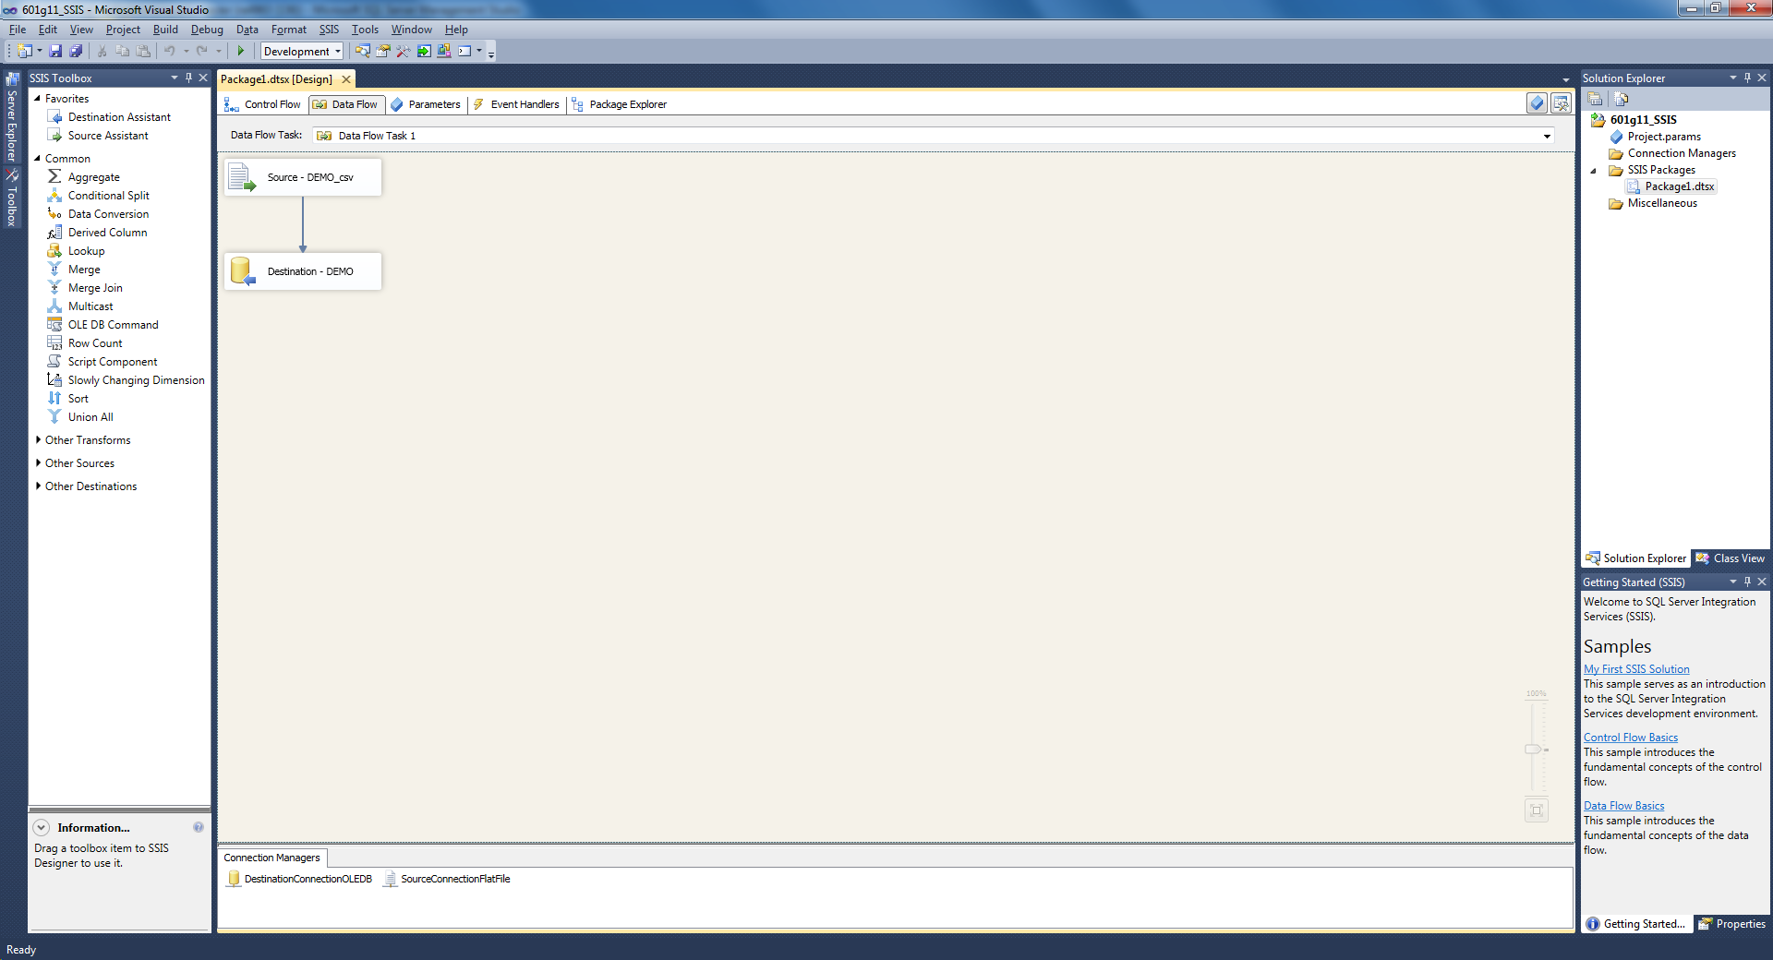

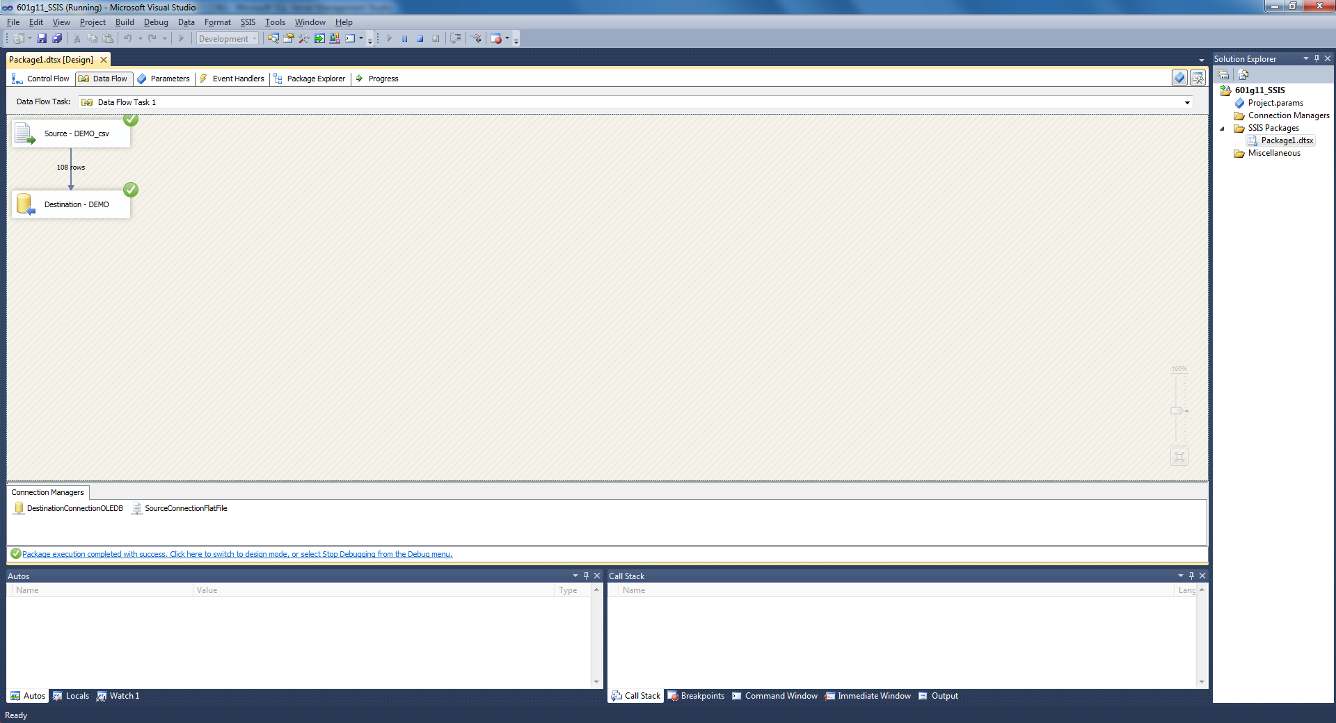

Time

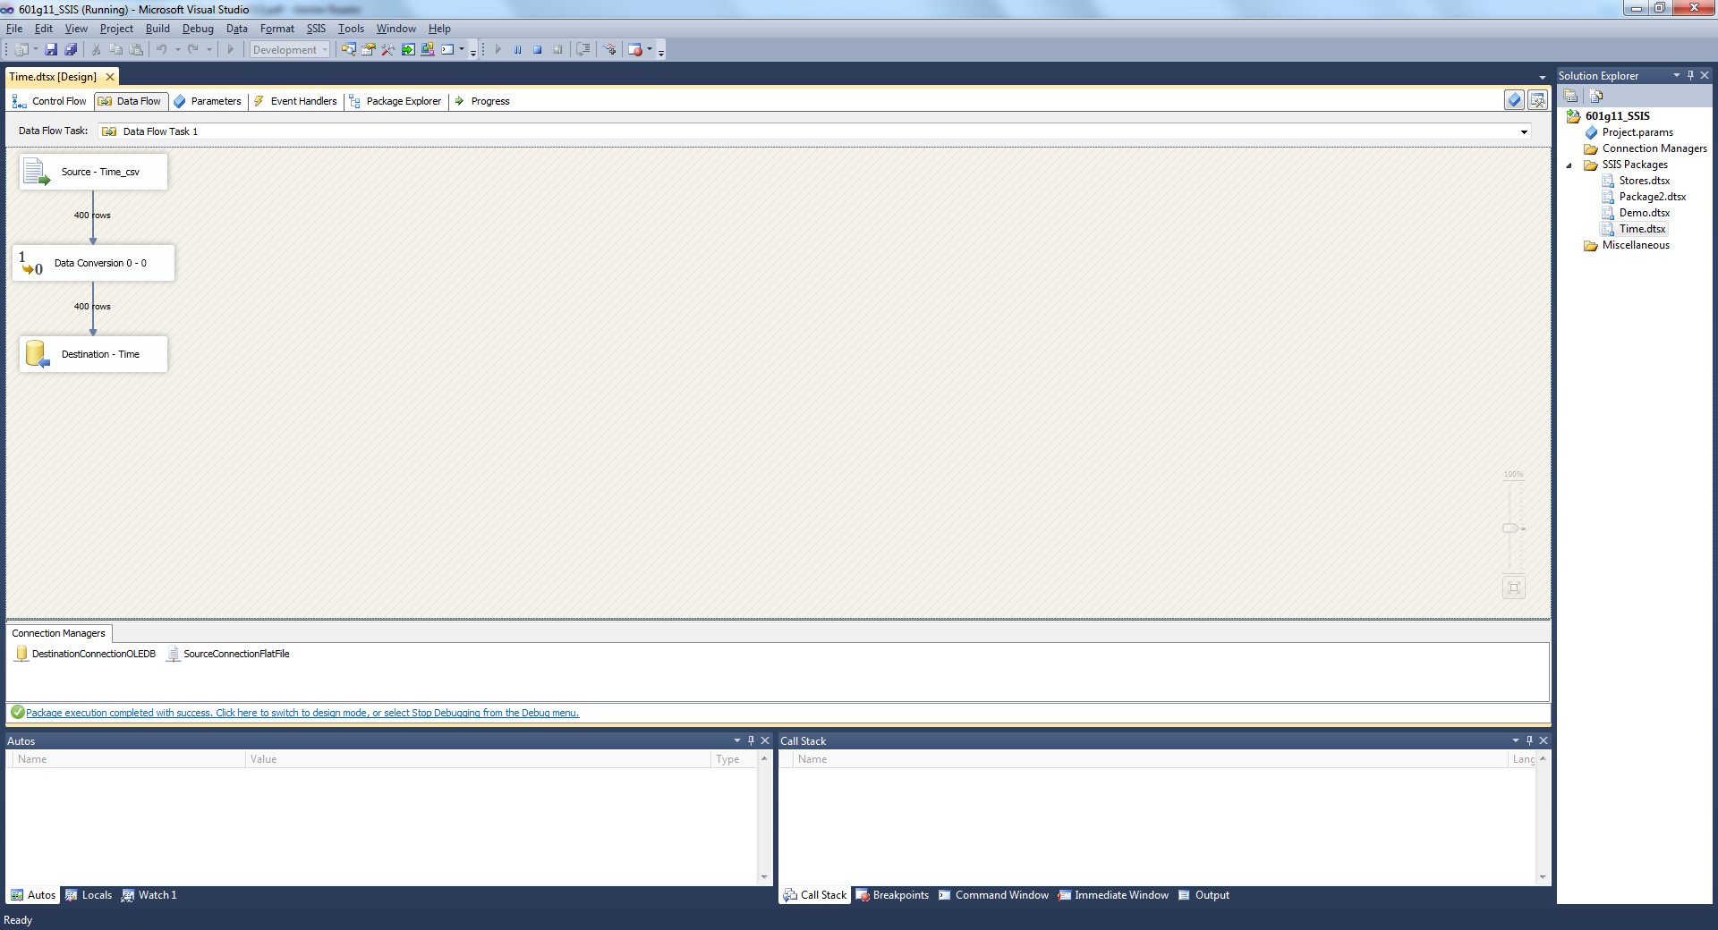

Stores:

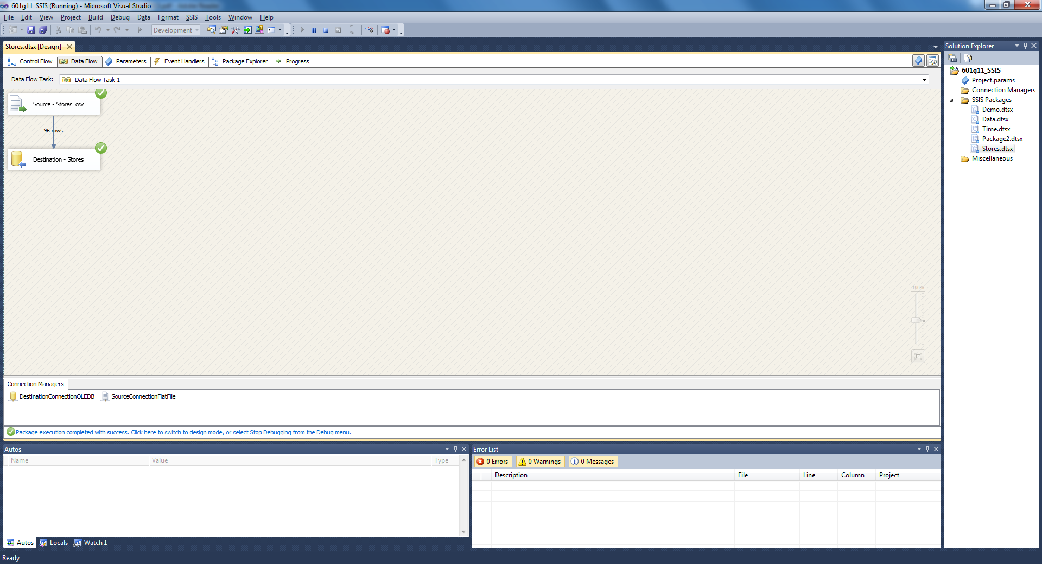

Cleaning DEMO file:

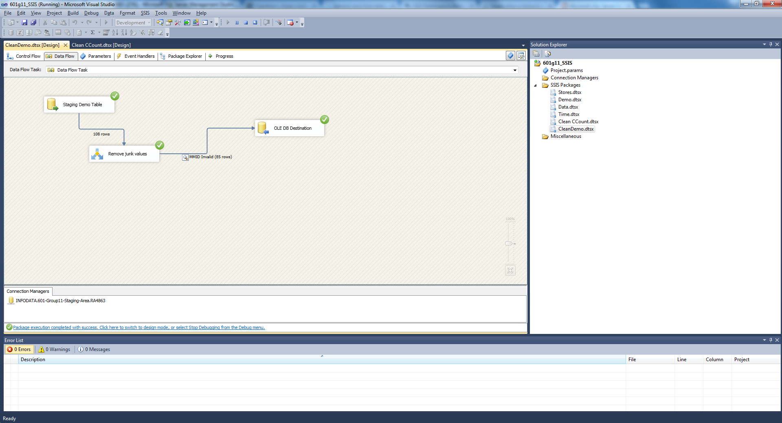

CCOunt clean:

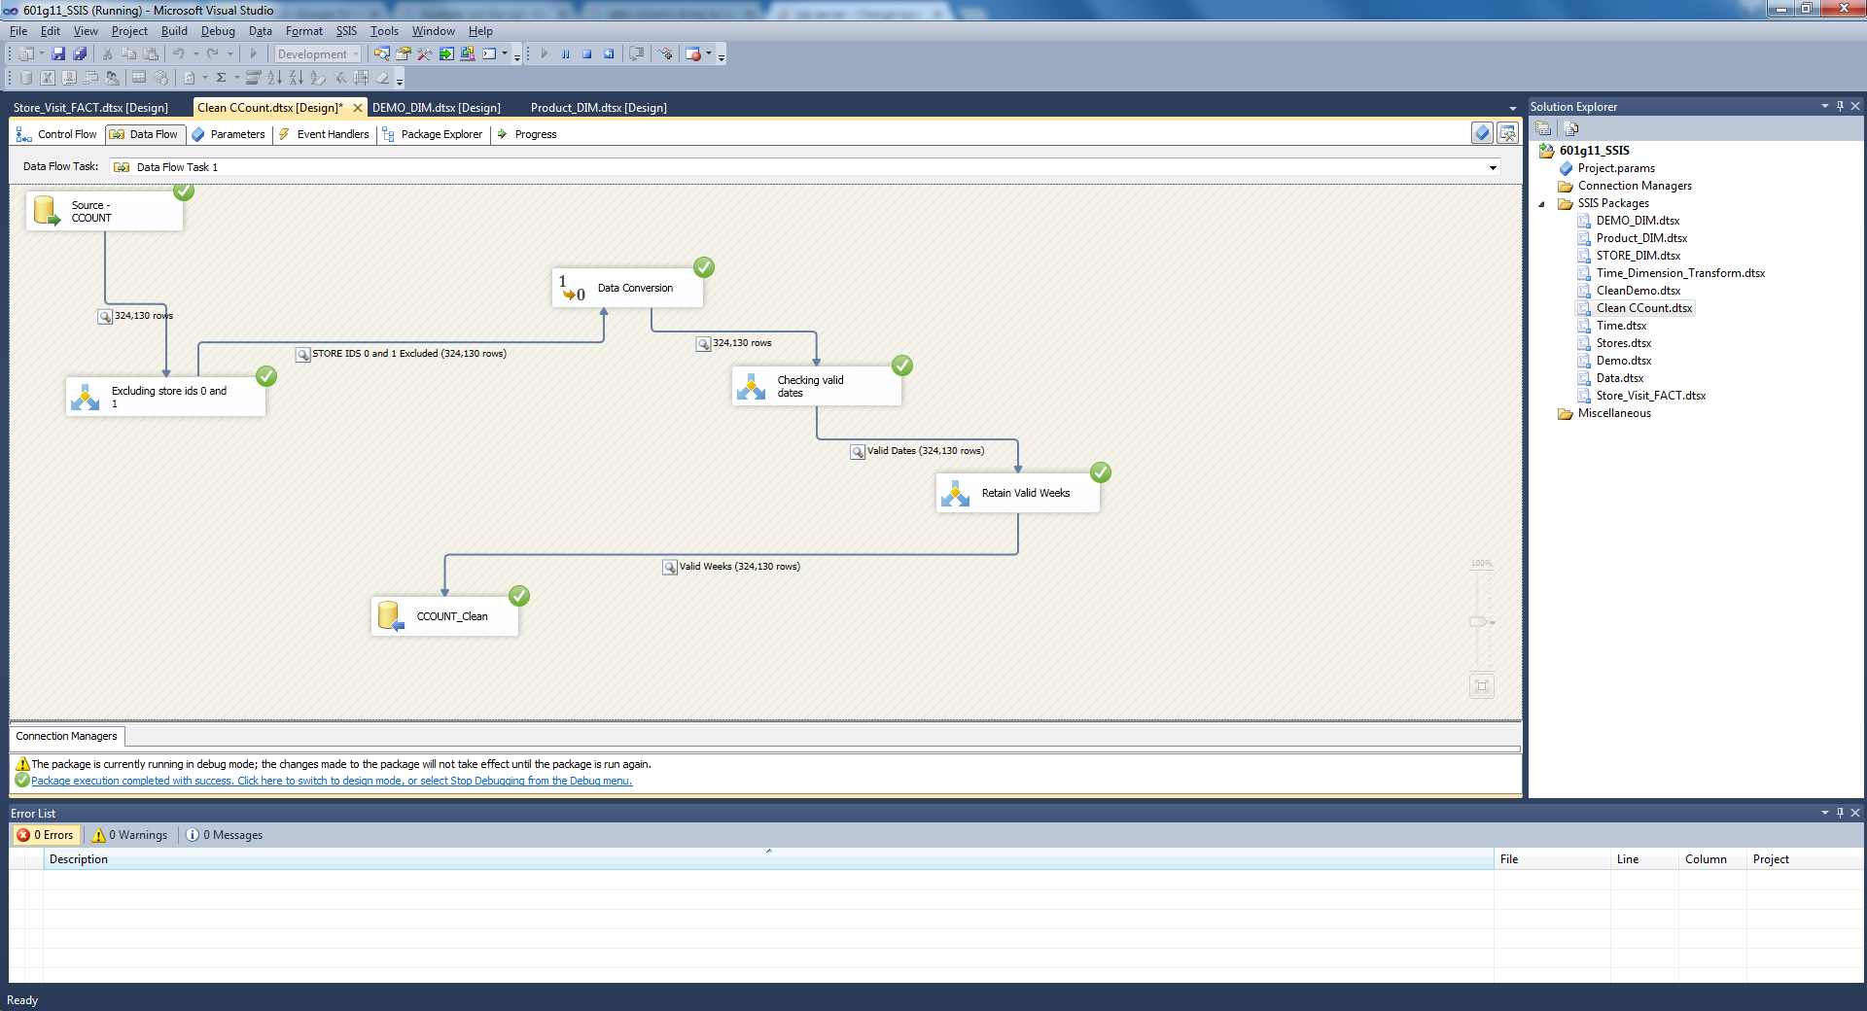

TIME_DIM

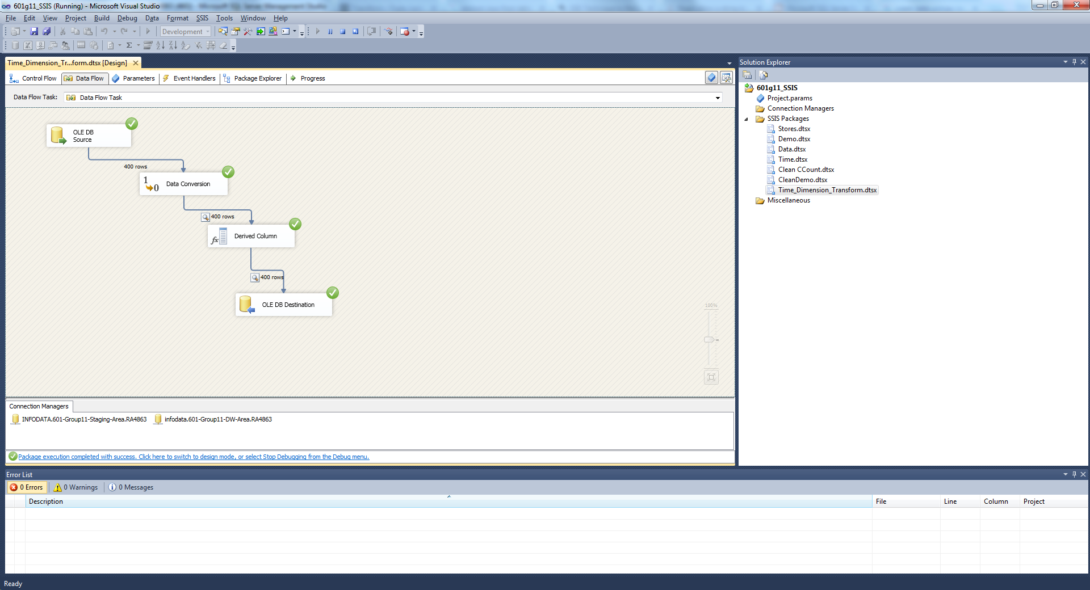

CREATE TABLE [dbo].[TIME_DIM](

[TIME_ID] [int] IDENTITY(1,1) NOT NULL,

[WEEK] [numeric](18, 0) NULL,

[MONTH] [int] NULL,

[YEAR] [int] NULL,

[EVENTS] [varchar](50) NULL,

PRIMARY KEY(TIME_ID)

)

STORE_DIM

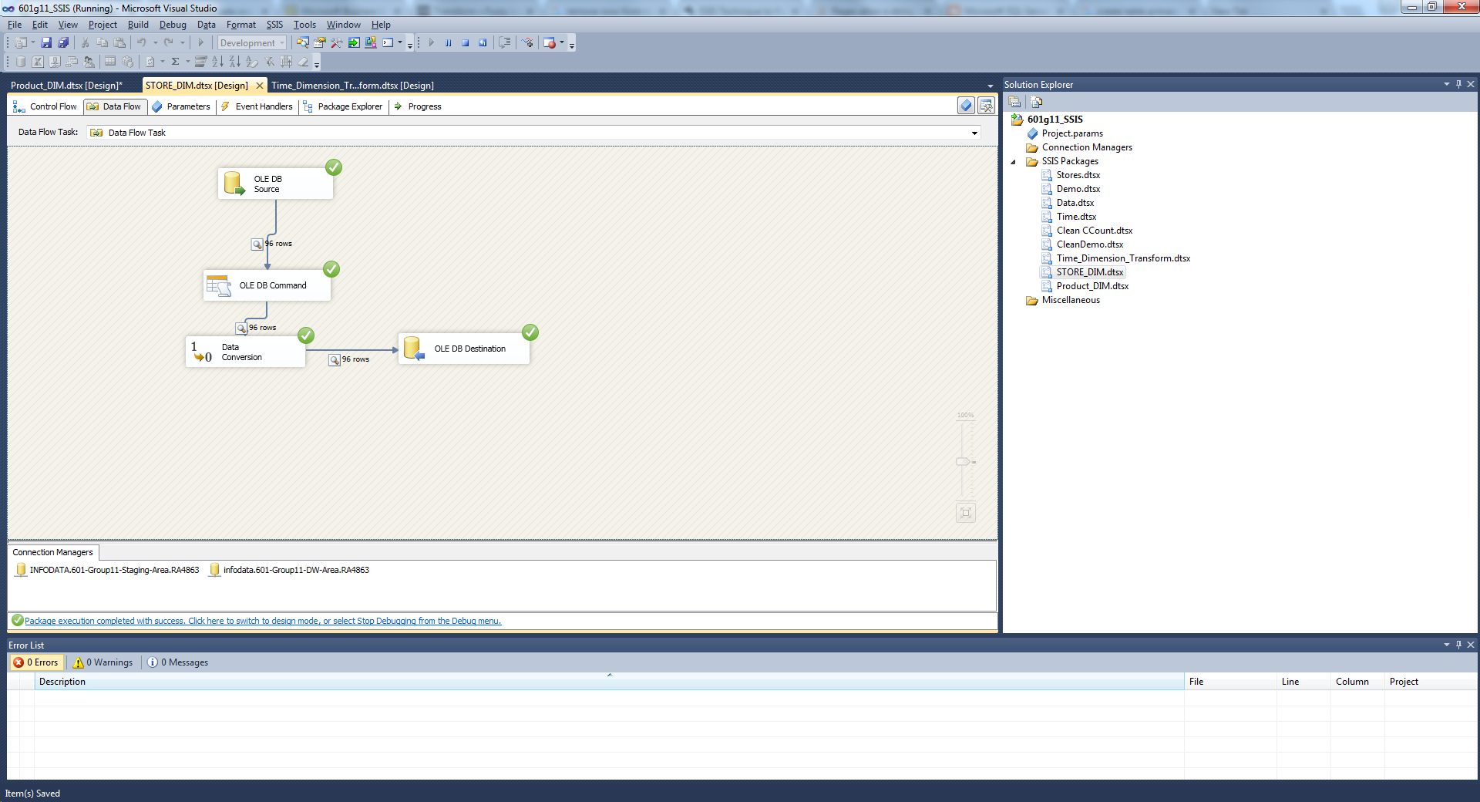

CREATE TABLE [STORE_DIM] (

[STORE_ID] int IDENTITY(1,1),

[STORE_NUMBER] int,

[PRICE_TIER] varchar(50),

[ZONE] int,

[CITY] varchar(50),

[ZIPCODE] varchar(50),

PRIMARY KEY (STORE_ID)

)

PRODUCT_DIM

SELECT TOP 1000 [PRODUCT_ID]

,[UPC_CODE]

,[PRODUCT_CATEGORY]

,[ITEM_CODE]

FROM [601-Group11-DW-Area].[dbo].[PRODUCT_DIM]

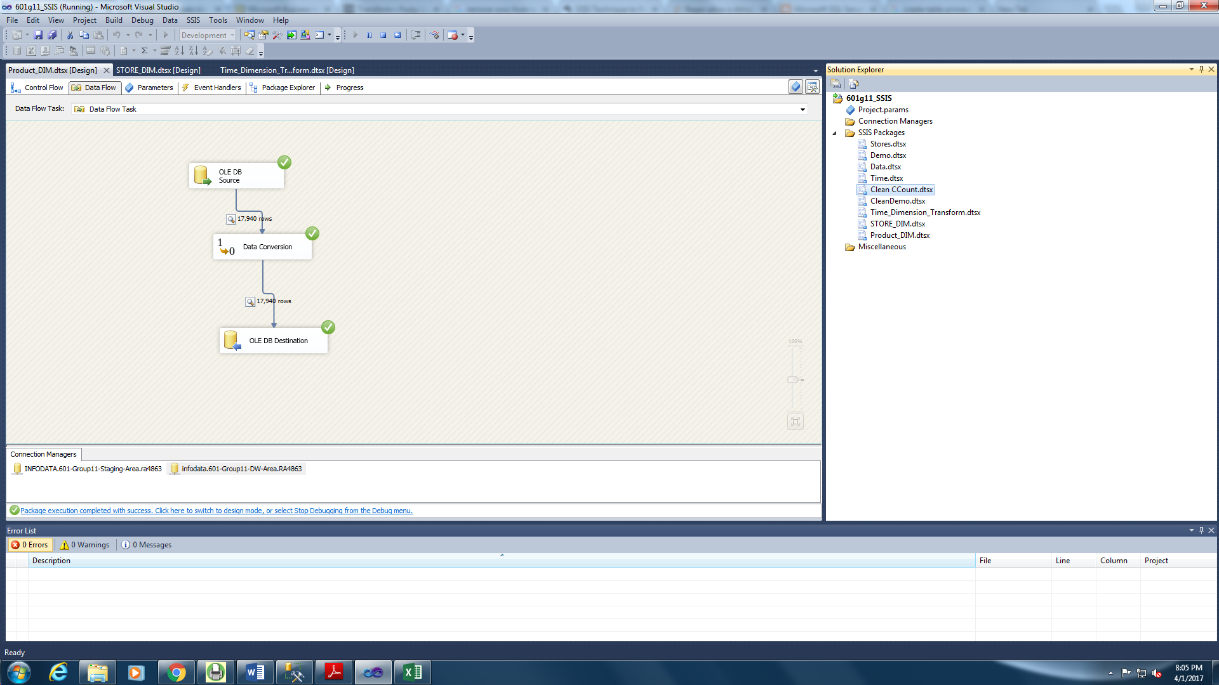

DEMO_DIM

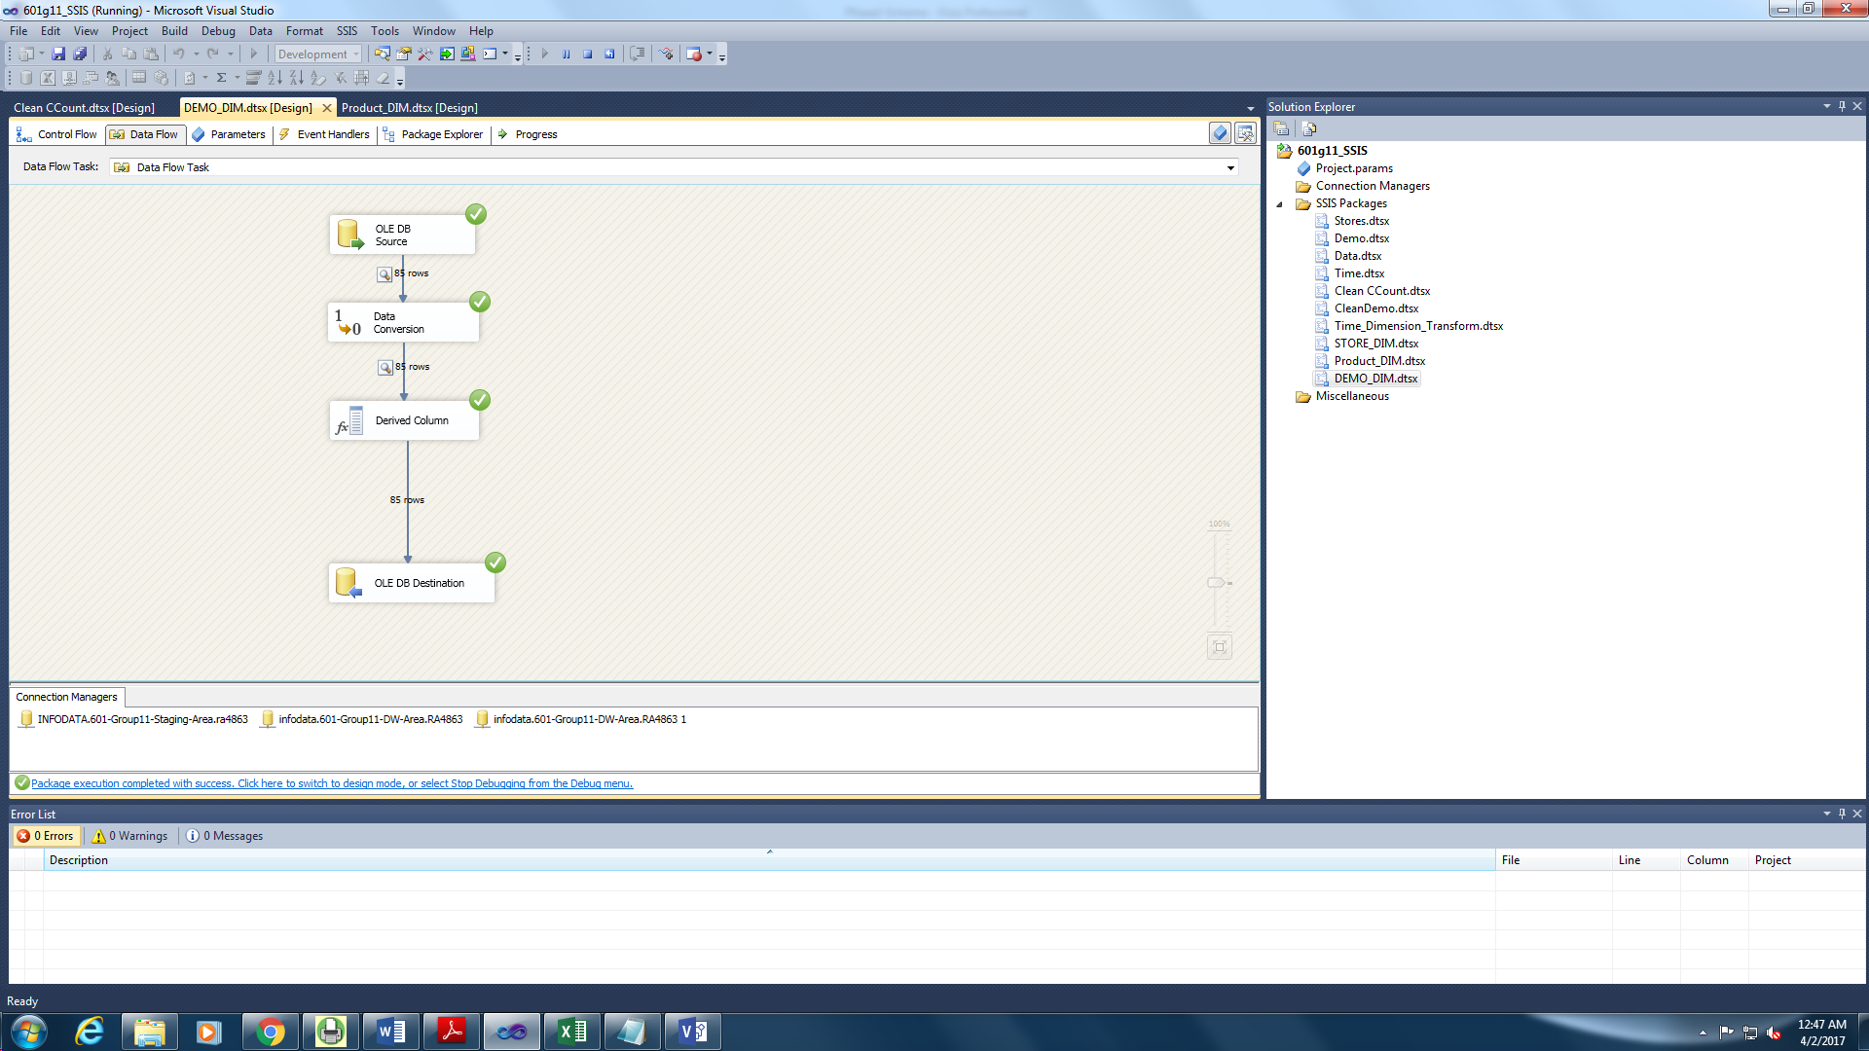

COUPON_DIM

