 **VARENDRA UNIVERSITY**

**Department of Computer Science &** **Engineering**

**Report**

Course Title: Software Development

Course Code: CSE-328

Assignment Topic: Paddy Business Management Application

|  |  |
| --- | --- |
| Submitted By | Submitted To |
| Name: Md Rafiqul Islam  Student ID: 183313013  Batch: 3rd  Semester: 8th  Section: A  Department: CSE  Phone: 01738979446 | **Faculty,**  **Arifa Ferdousi**  **Computer Science and Engineering,**  **Varendra University** |

rafiqul

Submission Date: **Signature**

# **Introduction**

I want create a webpage base Paddy Business Management Application. It will help to manage my Paddy business easily. The characteristic of my application:

1. will have cash-in option.
2. will have new customer registration option.
3. will have transaction option.
4. will have a paid option.
5. will have a repot to view all customer, all cash-in and all transaction list.
6. It will a search by mobile option.

My application minimum will have these facilities and many more as I improve this application.

# **Motivation**

In 2017 I used to buy and sell paddy in my home town but one day I had problem with daily calculation. I cannot find some expenses. So I had a loss about 30000tk.Then I thought that if I had an automated system that do daily expenses calculation for me. I am trying to build this web base application.

# Review of related work

# 1.Tali khata:

**Advantage:**

* Can be used for small business.
* Easy to use.
* Notification can be sent using SMS.

**Drawbacks:**

* Not business specific application.

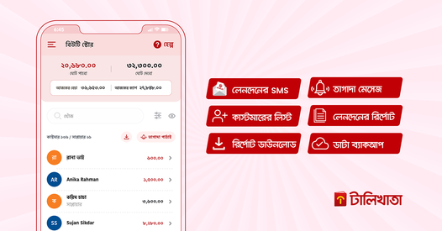

# 1. Khata Book:

Advantage:

* Add a customer to Khata Book
* Edit Customer Information
* Add Transaction done by Customer
* Edit old transactions of your hisab kitab app
* Delete Transaction from your account book

Drawbacks:

* Not business specific application.

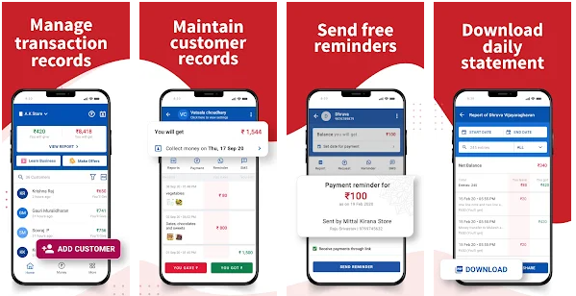

**3. Day-to-day Expenses:**

**Advantage**:

* Cash Book
* Share Cash Book
* Generate Report
* Search

**Drawbacks:**

* Not business specific application.

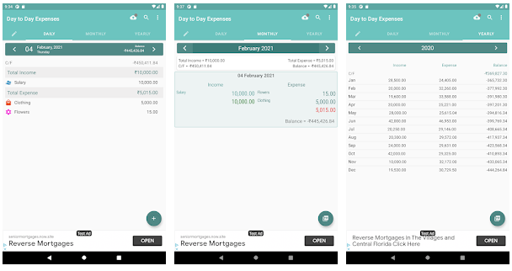

# Proposed model

I will work with **Waterfall models**

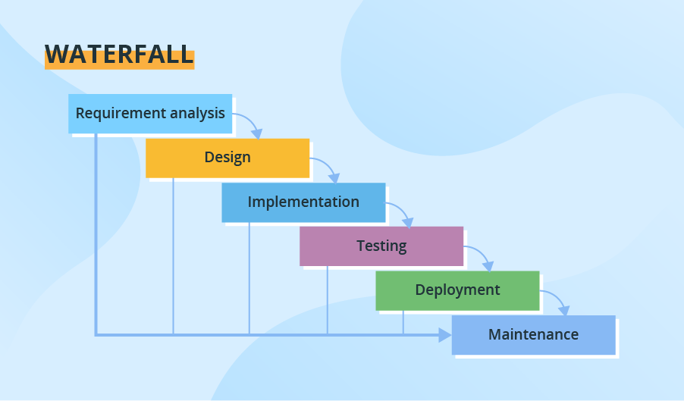

Through all development stages (analysis, design, coding, testing, deployment), the process moves in a cascade mode. Each stage has concrete deliverables and is strictly documented. The next stage cannot start before the previous one is fully completed. Thus, for example, software requirements cannot be re-evaluated further in development. There is also no ability to see and try software until the last development stage is finished, which results in high project risks and unpredictable project results. Testing is often rushed, and errors are costly to fix.

*Use cases:*

* *Simple small or mid-sized projects with clearly defined and unchanging requirements (small company website development).*
* *Projects with the need for stricter control, predictable budget and timelines (e.g., governmental projects).*
* *Projects that must adhere to multiple rules and regulations (healthcare projects).*
* *Projects where a well-known technology stack and tools are used.*

So, because it meets the needs of my development requirement. So, I will use this model to run my development.

**Implementation**

**Used Technology:**

* PHP
* PHP MyAddmin
* Java script
* HTML
* CSS
* Bootstrap

# **All Page DFD:**

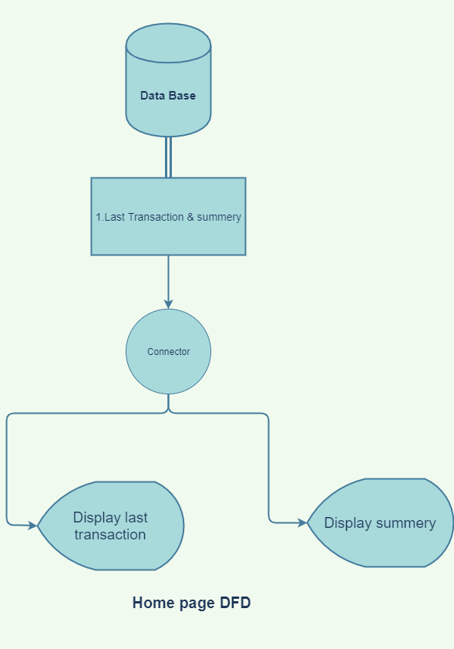

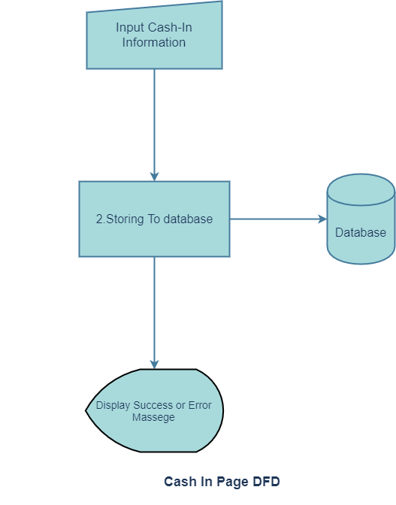

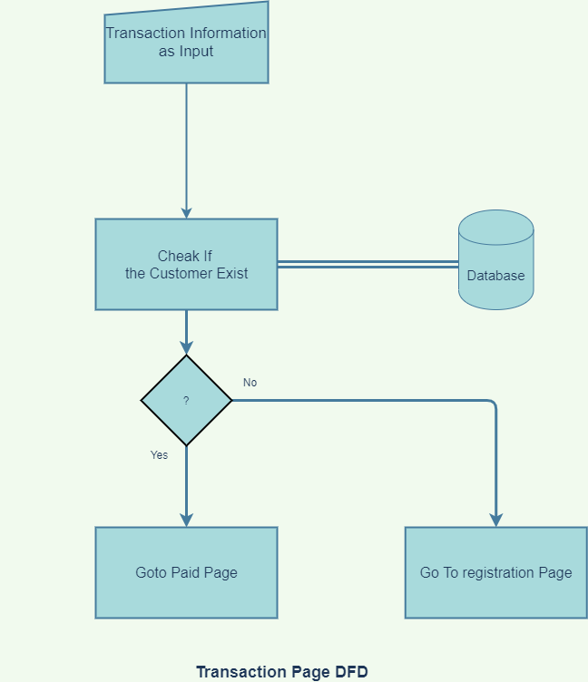

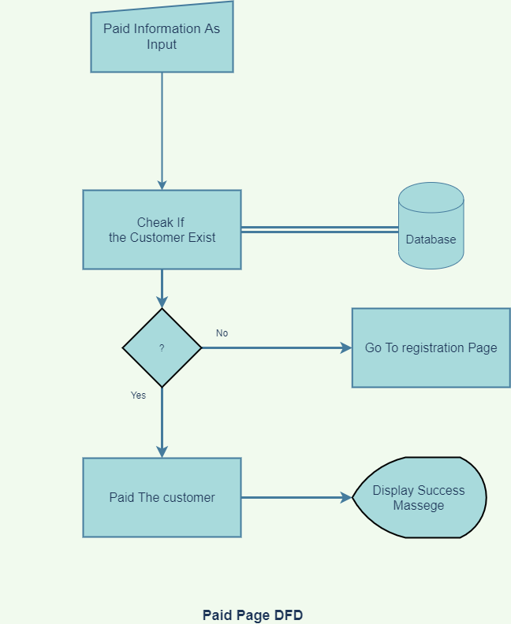

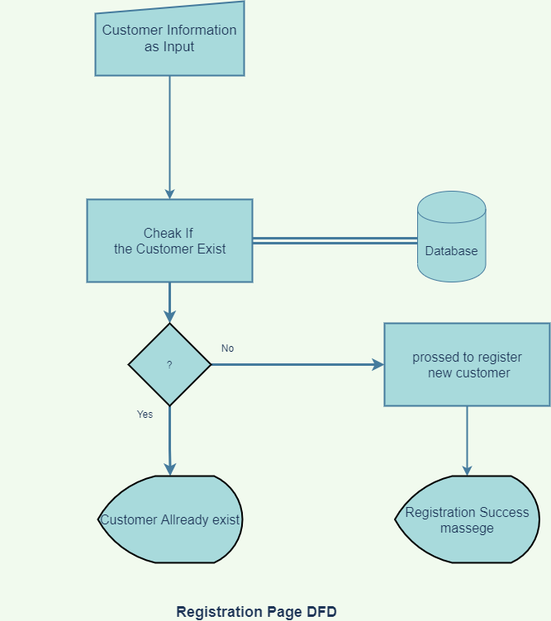

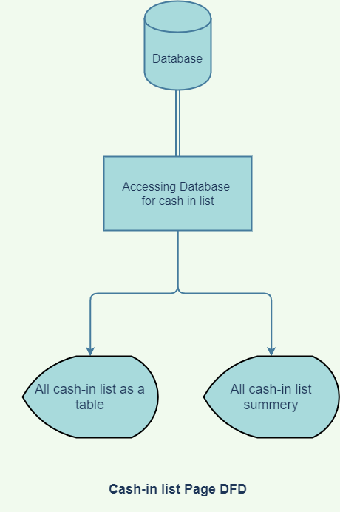

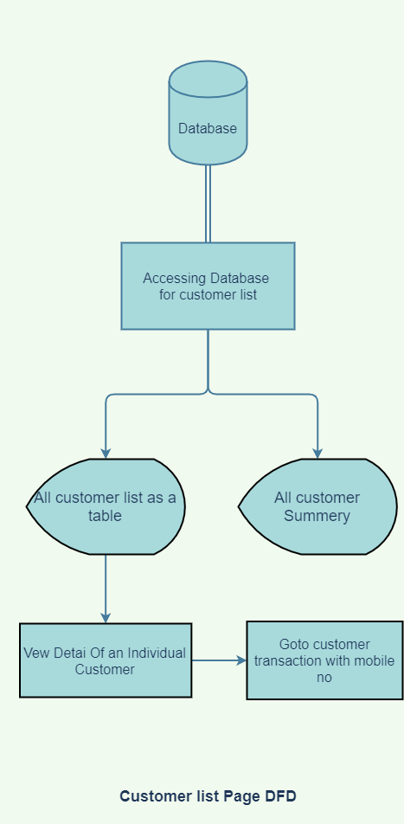

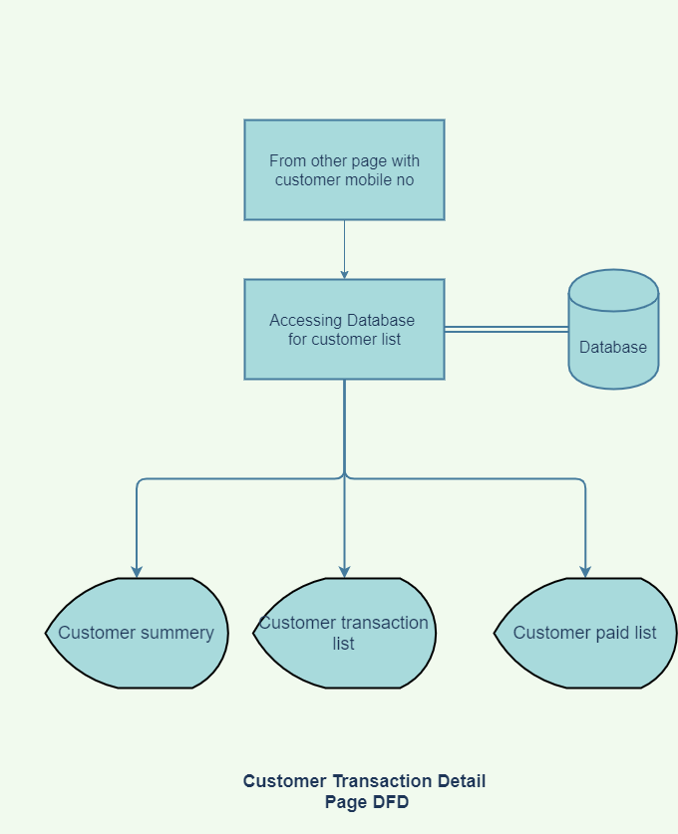

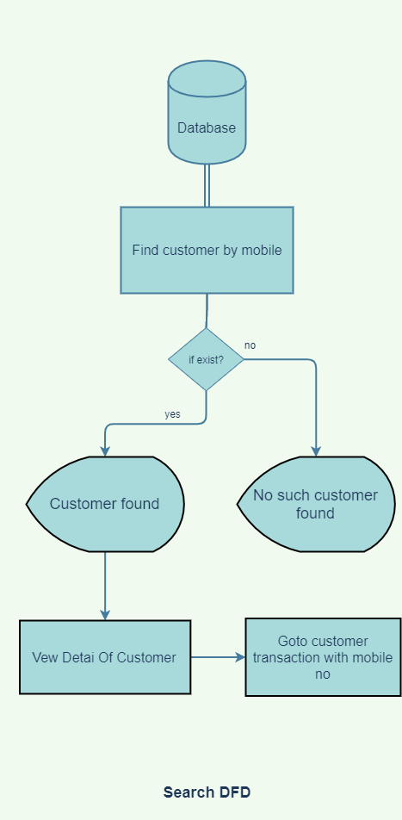

# **Data base table:**

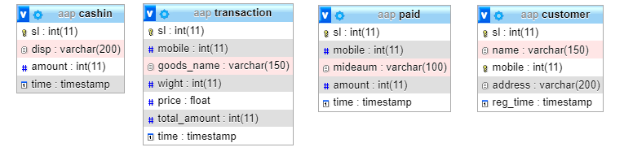

I have implemented these DFD and created data base table using given technology.

# **Result**

# Home Page

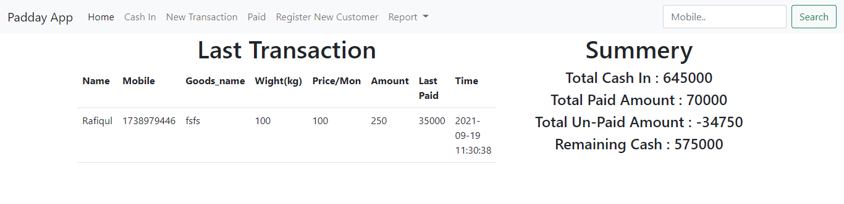

# Cash In Page

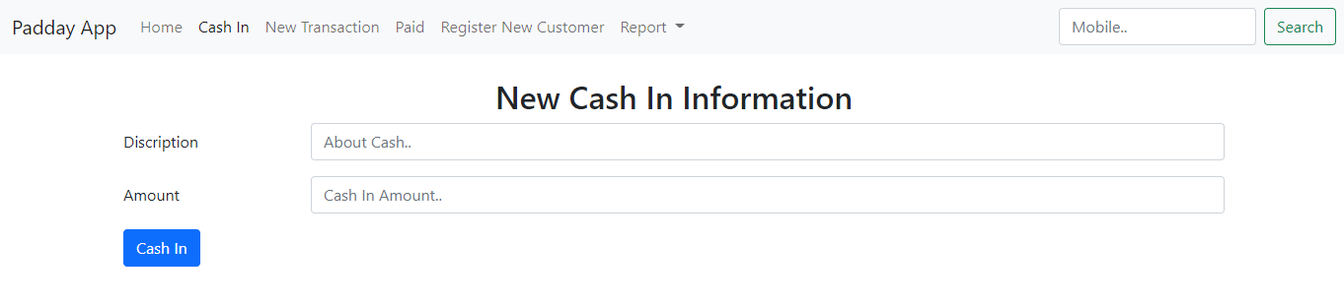

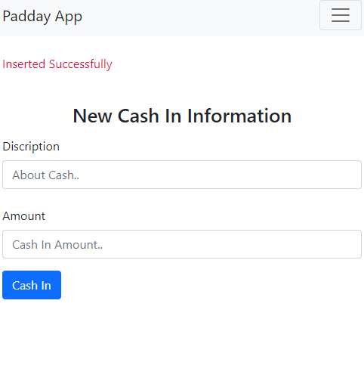

# Transaction Page

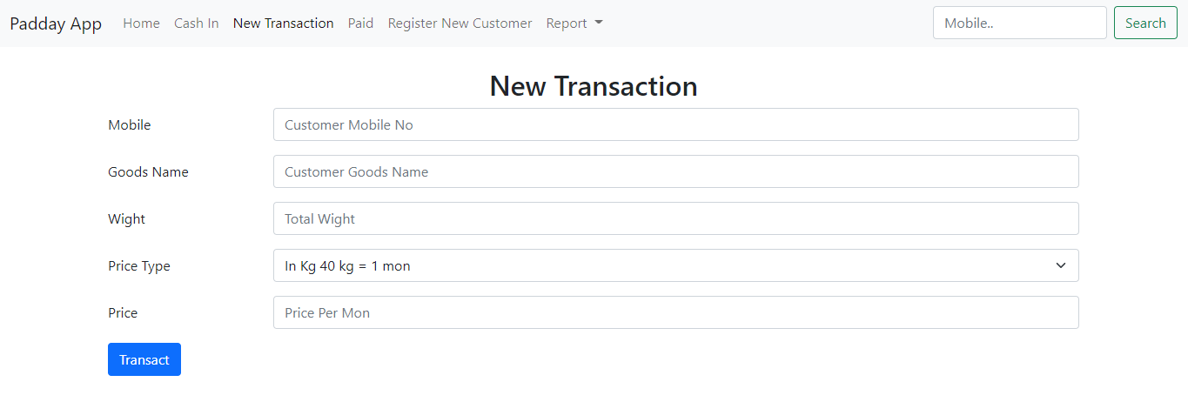

# Paid Page

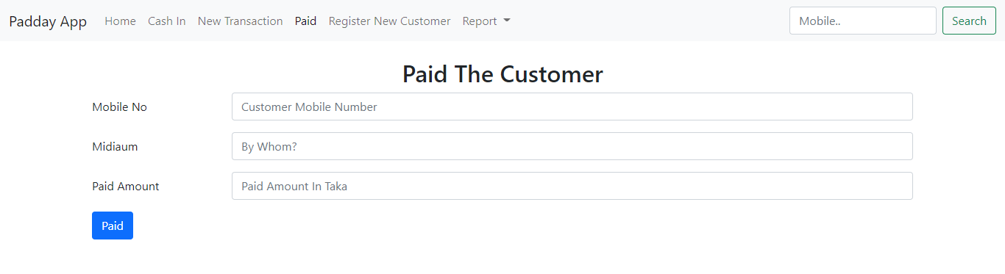

# Registration Page

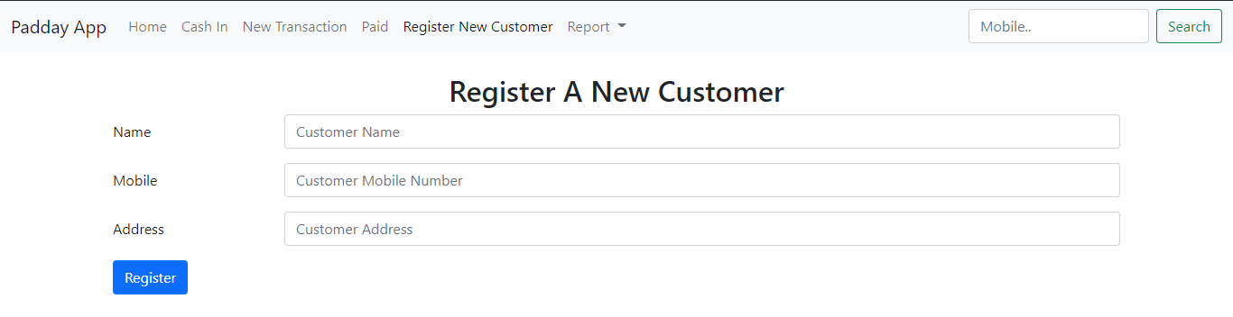

# Cash In list Page

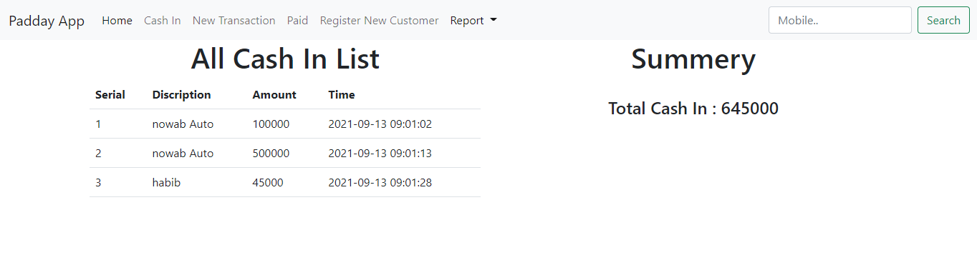

# Customer List Page

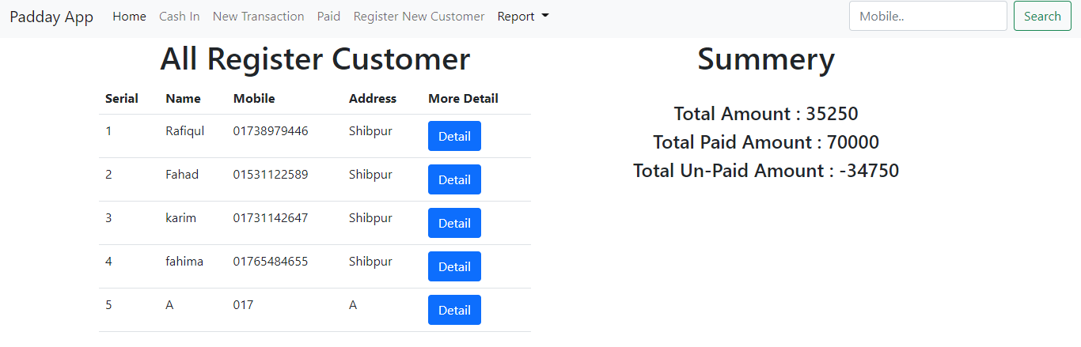

# Customer transaction list page

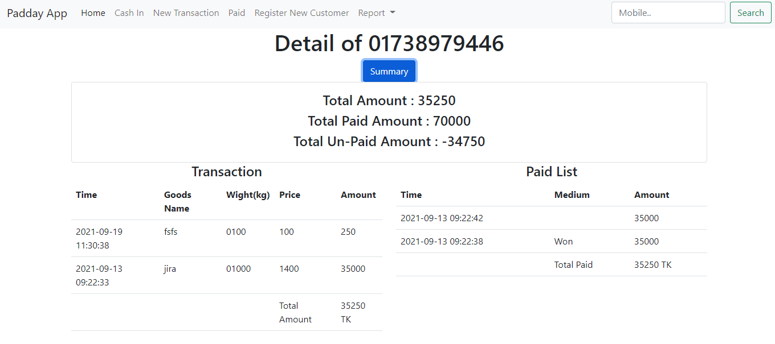

# Search page

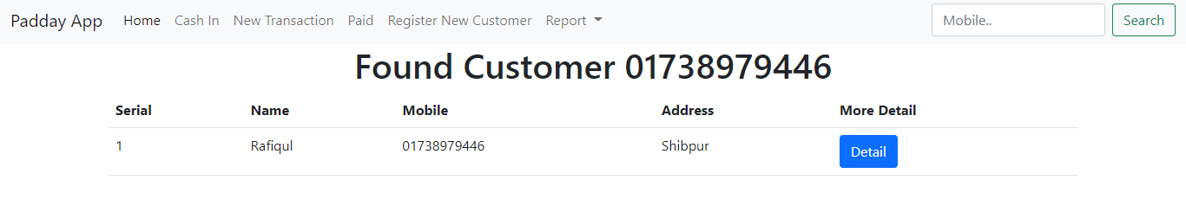

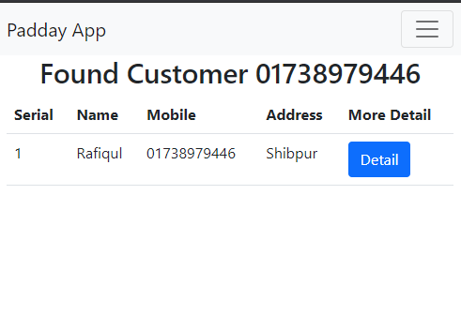

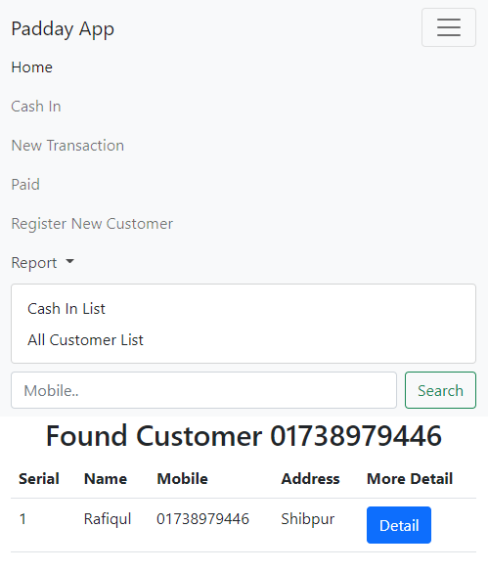

# **Discussion**

These are the graphical representation of the DFD and Database table.

Here, On Home page:

1.Show last transaction with Paid Amount.

2.Show Total Summery

Cash In page:

Able To insert new cash with some detail information which store in database.

Transaction Page:

1.Able to transact with register customer.

2.if customer is register send to paid page.

3.if customer in not register send to register page.

Paid Page:

1.Paid The customer If customer exist in database.

2.if not send to register page.

Register page:

1.register a new customer if customer does not exist in database.

Cash In List Page:

1.View All Cash in Information

2.View Cash in summery

Customer list page:

1.View All Customer with a detail link.

2.View Paid summery

Customer transaction List Page:

1.View This customer Summery.

2.View all transaction of this customer.

3.View All paid list of this Customer.

Search:

1.Searching By mobile No.

2.Exist in all Page at Navbar.

# **Conclusion:**

I have already implemented these on my application but I need to improve and add some more feature in this application. Such as printing transaction of a customer, sending massage via internet, Able to view weekly, monthly, yearly summery etc. And I want use this software for my won Paddy Business.

# Reference

Project GitHub Link:

<https://github.com/rafiq000/PBMS.git>

<https://github.com/rafiq000/paddy.git>

<https://github.com/rafiq000/paddy_app.git>

<https://github.com/rafiq000/Final_version.git>

Xampp Download Link:

<https://www.apachefriends.org/download.html>

Bootstrap Download Link:

<https://getbootstrap.com/>