

Technical Safety Concept Lane Assistance

**Document Version: 1.0**

**Template Version 1.0, Released on 2017-06-21**



# Document history

|  |  |  |  |
| --- | --- | --- | --- |
| Date | Version | Editor | Description |
| 6/4/2018 | 1.0 | Tariq Rafique | Final Version |
|  |  |  |  |
|  |  |  |  |
|  |  |  |  |
|  |  |  |  |

# Table of Contents

Document history

Table of Contents

Purpose of the Technical Safety Concept

Inputs to the Technical Safety Concept

Functional Safety Requirements

Refined System Architecture from Functional Safety Concept

Functional overview of architecture elements

Technical Safety Concept

Technical Safety Requirements

Refinement of the System Architecture

Allocation of Technical Safety Requirements to Architecture Elements

Warning and Degradation Concept

# Purpose of the Technical Safety Concept

The technical safety concept defines how the subsystem interact at the message level and describes how the ECUs communicate with each other. The technical safety concept is more detailed than a functional safety concept because it looks at the details of the various subsystems.

It involves turning functional safety requirements into technical safety requirement and allocating technical safety requirements to the system architecture

# Inputs to the Technical Safety Concept

## Functional Safety Requirements

|  |  |  |  |  |
| --- | --- | --- | --- | --- |
| **ID** | **Functional Safety Requirement** | **ASIL** | **Fault Tolerant Time Interval** | **Safe State** |
| Functional  Safety  Requirement  01-01 | The Lane Keeping item shall ensure that the lane departure oscillating torque amplitude is below Max_Torque_Amplitude | C | 50ms | Reduce torque amplitude to 0 |
| Functional  Safety  Requirement  01-02 | The lane keeping item shall ensure that the lane departure oscillating torque frequency is below Max_Torque_Frequency | C | 50ms | Reduce vibration frequency to 0 |
| Functional  Safety  Requirement  02-01 | The electronic power steering ECU shall ensure that the lane keeping assistance torque is applied for only Max_Duration | B | 500ms | Lane Keeping Assistance torque reduced to 0 |

## Refined System Architecture from Functional Safety Concept

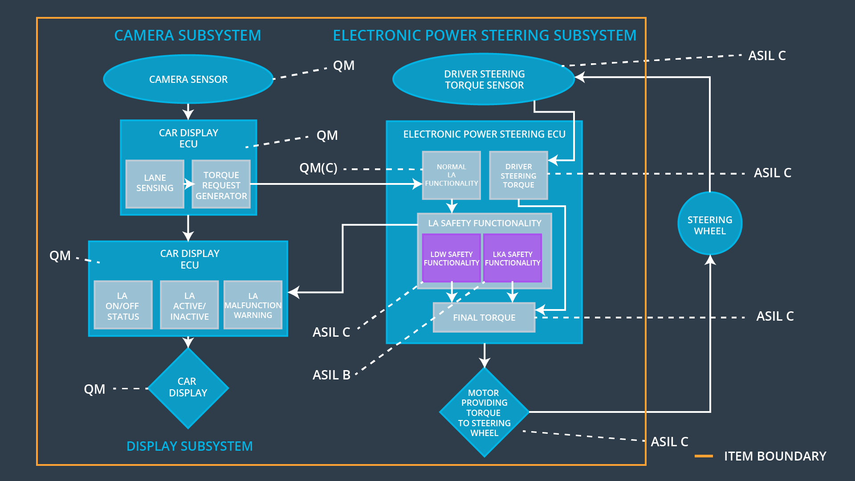

### 

### Functional overview of architecture elements

|  |  |
| --- | --- |
| **Element** | **Description** |
| Camera Sensor | The camera sensor reads in images from the front of the car and forwards them to the Camera ECU Lane Sensing |
| Camera Sensor ECU - Lane Sensing | Detects where the lane is in camera images and where the car is located within the lane |
| Camera Sensor ECU - Torque request generator | Creates a correct torque request based on where the vehicle is in the lane and where it needs to be |
| Car Display | Screen to show warning and information messages |
| Car Display ECU - Lane Assistance On/Off Status | Controls display of lane assistance status on the car display |
| Car Display ECU - Lane Assistant Active/Inactive | Controls display of lane assistance active/inactive status on the car display |
| Car Display ECU - Lane Assistance malfunction warning | Controls display of lane assistance malfunction warnings on the car display |
| Driver Steering Torque Sensor | Sensor that measures the amount and direction of torque applied by the driver to the steering wheel |
| Electronic Power Steering (EPS) ECU - Driver Steering Torque | Reads from sensor that measures the amount and direction of torque applied by the driver to the steering wheel |
| EPS ECU - Normal Lane Assistance Functionality | Implements LDW and LKA functionality. Received torque requests from the Camera ECU Torque request generator and generates sterring torque |
| EPS ECU - Lane Departure Warning Safety Functionality | Safety module to ensure that LDW torque doesn’t exceed maximum amplitude and frequency limits. |
| EPS ECU - Lane Keeping Assistant Safety Functionality | Safety module to ensure that the LKA functionality doesn’t stay activated longer than a maximum duration |
| EPS ECU - Final Torque | Reads in data from driver steering torque sensor and the LDW and LKA safety module to generate the final torque for the motor |
| Motor | Applies torque to the steering wheel |

# Technical Safety Concept

## Technical Safety Requirements

**Lane Departure Warning (LDW) Requirements:**

Functional Safety Requirement 01-01 with its associated system elements

(derived in the functional safety concept)

|  |  |  |  |  |
| --- | --- | --- | --- | --- |
| **ID** | **Functional Safety Requirement** | **Electronic Power Steering ECU** | **Camera ECU** | **Car Display ECU** |
| Functional  Safety  Requirement  01-01 | The lane keeping item shall ensure that the lane departure oscillating torque amplitude is below Max_Torque_Amplitude | X |  |  |

Technical Safety Requirements related to Functional Safety Requirement 01-01 are:

|  |  |  |  |  |  |
| --- | --- | --- | --- | --- | --- |
| **ID** | **Technical Safety Requirement** | **ASIL** | **Fault Tolerant Time Interval** | **Architecture Allocation** | **Safe State** |
| Technical  Safety  Requirement  01 | The LDW safety component shall ensure that the amplitude of the 'LDW_Torque_Request' sent to the 'Final electronic power steering Torque' component is below 'Max_Torque_Amplitude. | C | 50ms | LDW Safety | LDW_Torque_Request=0 |
| Technical  Safety  Requirement  02 | As soon as the LDW function deactivates the LDW feature, the 'LDW Safety' software block shall send a signal to the car display ECU to turn on a warning light. | C | 50ms | LDW Safety | LDW_Torque_Request=0 |
| Technical  Safety  Requirement  03 | As soon as a failure is detected by the LDW function, it shall deactivate the LDW feature and the 'LDW_Torque_Request' shall be set to zero. | C | 50ms | LDW Safety | LDW_Torque_Request=0 |
| Technical  Safety  Requirement  04 | The validity and integrity of the data transmission for 'LDW_Torque_Request' signal shall be ensured. | C | 50ms | Data Transmission Integrity Check | LDW_Torque_Request=0 |
| Technical  Safety  Requirement  05 | Memory test shall be conducted at start up of the EPS ECU to check for any faults in memory. | A | Ignition cycle | Safety Startup | LDW_Torque_Request=0 |

Functional Safety Requirement 01-2 with its associated system elements

(derived in the functional safety concept)

|  |  |  |  |  |
| --- | --- | --- | --- | --- |
| **ID** | **Functional Safety Requirement** | **Electronic Power Steering ECU** | **Camera ECU** | **Car Display ECU** |
| Functional  Safety  Requirement  01-02 | The lane keeping item shall ensure that the lane departure oscillating torque frequency is below Max_Torque_Frequency | X |  |  |

Technical Safety Requirements related to Functional Safety Requirement 01-02 are:

|  |  |  |  |  |  |
| --- | --- | --- | --- | --- | --- |
| **ID** | **Technical Safety Requirement** | **ASIL** | **Fault Tolerant Time Interval** | **Architecture Allocation** | **Safe State** |
| Technical  Safety  Requirement  01 | The LDW safety component shall ensure that the frequency of the 'LDW_Torque_Request' sent to the 'Final electronic power steering Torque' component is below 'Max_Torque_Frequency. | C | 50ms | LDW Safety | LDW_Torque_Request=0 |
| Technical  Safety  Requirement  02 | As soon as the LDW function deactivates the LDW feature, the 'LDW Safety' software block shall send a signal to the car display ECU to turn on a warning light. | C | 50ms | LDW Safety | LDW_Torque_Request=0 |
| Technical  Safety  Requirement  03 | As soon as a failure is detected by the LDW function, it shall deactivate the LDW feature and the 'LDW_Torque_Request' shall be set to zero. | C | 50ms | LDW Safety | LDW_Torque_Request=0 |
| Technical  Safety  Requirement  04 | The validity and integrity of the data transmission for 'LDW_Torque_Request' signal shall be ensured. | C | 50ms | Data Transmission Integrity Check | LDW_Torque_Request=0 |
| Technical  Safety  Requirement  05 | Memory test shall be conducted at start up of the EPS ECU to check for any faults in memory. | A | Ignition cycle | Safety Startup | LDW_Torque_Request=0 |

**Lane Keeping Assistance (LKA) Requirements:**

Functional Safety Requirement 02-1 with its associated system elements

(derived in the functional safety concept)

|  |  |  |  |  |
| --- | --- | --- | --- | --- |
| **ID** | **Functional Safety Requirement** | **Electronic Power Steering ECU** | **Camera ECU** | **Car Display ECU** |
| Functional  Safety  Requirement  02-01 | The lane keeping item shall ensure that the lane keeping assistance torque is applied for only Max_Duration | X |  |  |

Technical Safety Requirements related to Functional Safety Requirement 02-01 are:

|  |  |  |  |  |  |
| --- | --- | --- | --- | --- | --- |
| **ID** | **Technical Safety Requirement** | **ASIL** | **Fault Tolerant Time Interval** | **Allocation to Architecture** | **Safe State** |
| Technical  Safety  Requirement  01 | The LKA safety component shall ensure that the LKA Torque is only applied for Max_Duration time | B | 500ms | LKA Safety | LKA_Torque_Request=0 |
| Technical  Safety  Requirement  02 | As soon as the LKA function deactivates the LKA feature, the 'LKA Safety' software block shall send a signal to the car display ECU to turn on a warning light. | B | 500ms | LKA Safety | LKA_Torque_Request=0 |
| Technical  Safety  Requirement  03 | As soon as a failure is detected by the LKA function, it shall deactivate the LKA feature and the ‘LKA_Torque_Request' shall be set to zero. | B | 500ms | LKA Safety | LKA_Torque_Request=0 |
| Technical  Safety  Requirement  04 | The validity and integrity of the data transmission for 'LKA_Torque_Request' signal shall be ensured. | B | 500ms | Data Transmission Integrity Check | LKA_Torque_Request=0 |
| Technical  Safety  Requirement  05 | Memory test shall be conducted at start up of the EPS ECU to check for any faults in memory. | A | Ignition cycle | Safety Startup | LKA_Torque_Request=0 |

## Refinement of the System Architecture

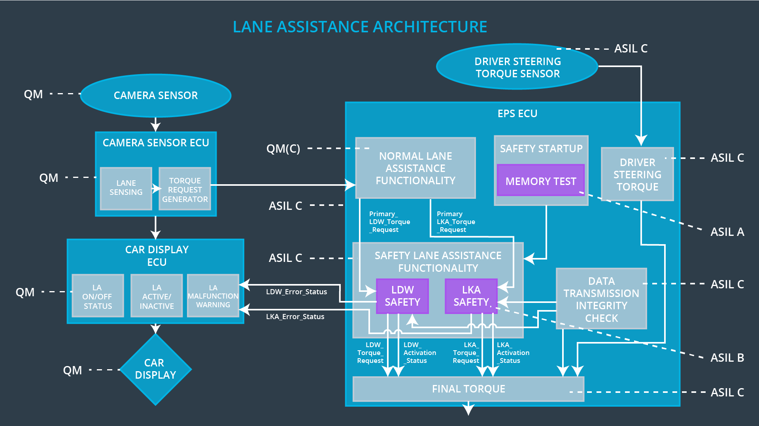

## Allocation of Technical Safety Requirements to Architecture Elements

All technical safety requirements are allocated to the Electronic Power Steering ECU

## Warning and Degradation Concept

|  |  |  |  |  |
| --- | --- | --- | --- | --- |
| **ID** | **Degradation Mode** | **Trigger for Degradation Mode** | **Safe State invoked?** | **Driver Warning** |
| WDC-01 | Turn off Lane Departure Warning function | Malfunction_01 Malfunction_02 | Yes | Warning light on dashboard |
| WDC-02 | Turn off Lane Keeping Assistance function | Malfunction_03 | Yes | Warning light on dashboard |