CampusEye: Single-Photograph Classroom Attendance Using Deep Face Embeddings with Roster-Based Absentee Resolution
Rafiqul Islam
ID 2122414642
rafiqul.islam12@northsouth.edu
Safayat Ibrahim
ID 2131174642
safayat.ibrahim@northsouth.edu
Department of Electrical & Computer Engineering, North South University, Dhaka, Bangladesh
Supervisor: Mohammad Shifat-E-Rabbi — CSE499A.15, Senior Design Project
Abstract—Manual roll call and RFID card systems remain the dominant methods of recording classroom attendance at many universities, yet both record a token rather than confirming that a specific individual is physically present. This paper presents CampusEye, an automated attendance system that marks an entire class from a single photograph using deep face embeddings. Faces are located by a YuNet convolutional detector and encoded by a FaceNet model into 128-dimensional vectors; identity is decided by cosine distance against per-student templates formed by averaging ten enrolment samples. The principal contribution is roster-based absentee resolution: because attendance is scoped to a course section with a known roster, students who are enrolled but not recognised are written to the register as absent, yielding a complete register from one photograph. Component testing recorded a correct identification at a cosine distance of 0.23 against a rejection threshold of 0.6, correct rejection of an unfamiliar face at 0.71, and a mean processing time of 0.8 s per frame. A milestone acceptance test on a thirty-student section produced five present and twenty-five absent records exactly as specified, and the implementation passes twenty-five automated tests. Large-scale accuracy benchmarking, live camera capture and encryption of stored biometric templates are identified as work for CSE499B.
Index Terms—attendance management, face recognition, FaceNet, convolutional neural network, cosine similarity, educational technology.

I. Introduction
Recording attendance is a routine administrative requirement in higher education, and the methods in common use have changed little in decades. At North South University the current mechanism is an RFID card scanned at a wall-mounted reader on entry to a classroom. Elsewhere the roll call persists. Both approaches share a structural weakness: they record the presentation of a token — a spoken response, or a plastic card — and infer presence from it, rather than establishing that a particular person is in the room.
The consequences follow directly from that weakness. A card can be handed to a classmate, and a name can be answered by someone else, so proxy attendance is neither difficult nor detectable. A card can be lost or forgotten, in which case a student who is genuinely present cannot be recorded. Readers placed at classroom entrances create queues at exactly the moment a class is trying to begin, and calling thirty to one hundred names consumes several minutes of every lecture. Across a semester this accumulates into a material loss of teaching time.
Face recognition offers a different basis for the decision. Rather than reading a token, the system observes the person. Contemporary deep embedding models map a face image into a vector space in which distance corresponds to identity, and do so with sufficient reliability that a photograph of an entire classroom can, in principle, resolve every student in it simultaneously. This makes attendance a passive act: the class is photographed once, and the register follows.
This paper reports the CSE499A phase of CampusEye, an attendance system built on that principle. The contributions of this phase are:
1) A complete single-photograph attendance pipeline combining a convolutional face detector, deep embedding extraction, and threshold-gated nearest-template matching, implemented as a deployable web application rather than a laboratory script.
2) Roster-based absentee resolution, in which attendance is scoped to a course section and students who are enrolled but not recognised are written to the register as absent. None of the five systems reviewed in Section II performs this step, and without it a recognition system can only ever produce a partial register.
3) A multi-tenant data model in which every student record, register and embedding cache is scoped to the account that owns it, with the isolation asserted by automated tests rather than assumed.
4) An audited implementation: twenty-five automated tests, and a documented review of the codebase whose findings and remedies are reported in Section VI rather than omitted.
The remainder of the paper is organised as follows. Section II reviews related work and identifies the research gap. Section III presents the system design and the methodology behind each decision. Section IV describes the implementation. Section V reports experimental results. Section VI discusses limitations, and Section VII concludes with the scope planned for CSE499B.

II. Related Work
Five studies of face-recognition attendance systems were reviewed during this phase. They fall into three groups, and the progression between those groups motivates the design adopted here.

A. Classical Feature-Based Approaches
Chakraborty [3] combines a Haar cascade detector with Principal Component Analysis, in the Eigenface formulation, and writes attendance to text files. The approach is computationally light and simple to deploy, but Eigenface representations are known to degrade under variation in illumination and pose, because the projection basis is derived from global pixel intensities rather than from features invariant to those changes.
Gomes et al. [4] substitute Local Binary Pattern Histograms for PCA, retaining the Haar detector. LBPH is more robust to monotonic illumination change than Eigenface and supports detection of several faces in one frame. The authors also introduce a secondary store for unrecognised faces, an idea adopted in the present work. Their own review nevertheless reports a materially lower accuracy ceiling for LBPH than for learned representations.
Abuazh et al. [2] take a different route, implementing pattern matching in LabVIEW and exporting attendance to spreadsheets, with an accompanying messaging subsystem. The reported accuracy is approximately 90 per cent, and the authors identify sensitivity to lighting as a principal limitation.

B. Deep Embedding Approaches
Oshin et al. [5] represent the current state of the reviewed set. Faces are encoded by InsightFace using the ArcFace loss into 512-dimensional embeddings, and identity is decided by cosine similarity, with a threshold of 0.5 reported as optimal for that embedding space. Embeddings are held in Redis and the interface is built in Streamlit. This is the closest architectural relative of the present work, and the embedding-plus-threshold formulation is adopted here directly.

C. Comparative Review
Budiman et al. [1] conduct a systematic review comparing LBPH against convolutional approaches across attendance systems and conclude in favour of the latter. Gomes et al. [4] report figures from the literature of approximately 95 per cent for convolutional methods against 70 to 90 per cent for Eigenface. Taken together these provide the evidence for selecting a learned embedding over a handcrafted feature space, and that conclusion is implemented rather than re-derived in the present work.

D. Research Gap
Three observations follow from the review. First, three of the five systems rely on classical feature extraction whose accuracy ceiling is well documented, and a deep embedding is the established remedy. Second, and more consequentially, every reviewed system records the students it recognises and stops there. None holds a course roster, and therefore none can state who was absent; the output is a list of attendees rather than a register. Third, attendance is written to text files or spreadsheets in four of the five, with no queryable multi-user store and no isolation between instructors.
A fourth gap is noted but not addressed in this phase: none of the reviewed systems defends against presentation attacks, such as a photograph held to the camera, nor detects the same identity appearing in two locations. Proxy attendance is named as a motivation in several of the papers but solved in none of them. That gap is scheduled for CSE499B and is discussed in Section VII.
The second gap is the one this work principally addresses. Marking students present is the simpler half of the problem; determining who is missing requires knowing who was expected, which in turn requires the system to model courses and rosters rather than only faces.

Table I
Summary of Reviewed Systems
Ref. | Method | Adopted here | Divergence
[1] 2023 | Systematic review, LBPH vs CNN | Evidence for a CNN backbone | A review; this work implements its conclusion
[2] 2020 | LabVIEW pattern matching, Excel logs | Timestamped logging of each mark | Relational store; no messaging subsystem
[3] 2020 | Haar cascade, PCA / Eigenface | Per-student enrolment sets | CNN embedding replaces PCA; YuNet replaces Haar
[4] 2020 | Haar cascade, LBPH, unknown store | Multi-face capture; unknown-face store | FaceNet embeddings replace LBPH
[5] 2025 | ArcFace 512-d, cosine at 0.5, Redis | Embedding with cosine threshold | FaceNet 128-d at 0.6; relational store

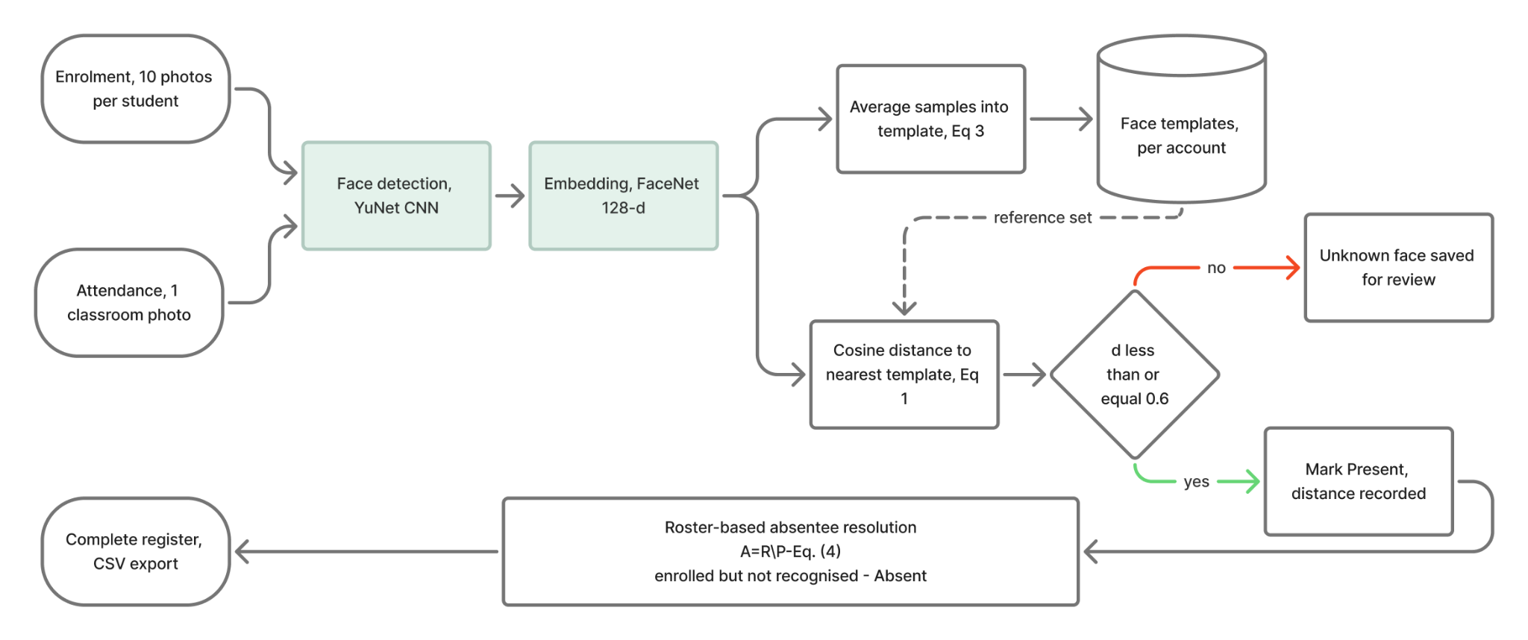
Fig. 1. CampusEye processing pipeline. Enrolment and attendance share the detection and embedding stages (shaded) and diverge only in the use made of the resulting vector: one path averages samples into a stored template, the other compares against every stored template and gates the decision on a cosine-distance threshold. The roster-difference stage converts a list of recognised students into a complete register.

III. System Design and Methodology

A. Pipeline Overview
Enrolment and attendance are two uses of one pipeline, shown in Fig. 1. Both detect faces in an image and convert each detected face into an embedding vector. They diverge only afterwards: enrolment averages the vectors from a student’s sample photographs into a single stored template, while attendance compares each vector from a classroom photograph against every stored template and applies a distance threshold. A practical consequence of this structure is that any improvement to detection or embedding benefits both operations simultaneously.

B. Face Detection
Faces are located using YuNet [8], a compact convolutional detector distributed in ONNX form and invoked through the OpenCV FaceDetectorYN interface [10]. YuNet was selected over the Haar cascade used in [3] and [4] because uploaded classroom photographs contain tilted heads, spectacles and uneven illumination, conditions under which cascade detectors are known to miss faces or emit false positives. A Haar cascade is retained in the codebase as a compatibility fallback for OpenCV builds in which the newer interface is unavailable, but it is not the primary detector.
Each detected region is expanded by a margin of 20 per cent before cropping, so that the embedding model receives the surrounding facial context rather than a tight box, and detections are returned in descending order of confidence.

C. Embedding Extraction
Each cropped face is converted into a 128-dimensional embedding by the FaceNet model [6], accessed through the DeepFace framework [9]. FaceNet is trained with a triplet loss that directly optimises for the property the application requires: that distances in the embedding space correspond to identity, so that two images of one person lie closer together than images of different people. The original work reports 99.63 per cent accuracy on the Labeled Faces in the Wild benchmark; that figure characterises the model on that dataset and is not a measurement of the present system.
Because the detector has already isolated the face, the embedding model’s internal detector is bypassed. Re-detecting an already-cropped region occasionally fails and would discard an otherwise usable sample.

D. Similarity Metric and Decision Rule
Two embeddings are compared by cosine distance, which measures the angle between the vectors and is therefore insensitive to their magnitude. For embeddings u and v,
d(u, v) = 1 − (u · v) / (‖u‖ ‖v‖)(1)
so that d = 0 denotes identical direction and larger values denote increasing dissimilarity. Cosine distance is adopted following [5], where it is used on ArcFace embeddings.
Given a probe embedding x and the set S of enrolled students with templates tₛ, the system selects the nearest template and accepts the match only if the distance falls at or below a threshold τ:
ŝ = arg min d(x, tₛ) for s ∈ S, accept iff d(x, tŝ) ≤ τ(2)
If the condition fails, the face is labelled unknown and the cropped region is retained for review rather than discarded. The threshold is set to τ = 0.6. This value is specific to the FaceNet embedding space and is not transferable from the 0.5 reported in [5], which was obtained for 512-dimensional ArcFace embeddings; thresholds calibrated in one embedding space carry no guarantee in another.

E. Enrolment and Template Construction
A student is enrolled from N = 10 photographs. Each is detected and embedded independently, and a photograph that yields no face, or more than one, is rejected with a specific reason so that the operator can replace it. The accepted embeddings are combined into a single template by taking their arithmetic mean:
tₛ = (1/N) Σ eᵢ , i = 1 … N(3)
Averaging several samples means that no single photograph — an unusual expression, an unfortunate angle — determines the stored identity. Oshin et al. [5] capture multiple samples for robustness but do not describe combining them into one template; the averaging step is an addition of the present work. Its limitations are discussed in Section VI.

F. Roster-Based Absentee Resolution
Recognition alone yields the set P of students identified in a photograph. A register, however, must also state who was absent, which requires knowing who was expected. CampusEye therefore models course sections, each holding a roster R of enrolled students, and scopes every attendance operation to one section. Recognition is restricted to that section’s roster, so a student can never be marked present in a course they are not taking. The absent set follows as the set difference
A = R \ P(4)
and every member of A is written to the register with status Absent. The register is therefore complete after a single photograph, with |R| = |P| + |A| records. Attendance coverage for a session is reported as
C = (|P| / |R|) × 100%(5)
Resolution is idempotent: rescanning a section does not duplicate rows, and a student recognised in a later scan is promoted from Absent to Present in place. This matters in practice, because latecomers are common and a register that could not be revised would be unusable.

G. Data Model and Multi-Tenancy
Records are held in a single relational database with five tables: accounts, students, course sections, section enrolments, and attendance. Every student, section and attendance row carries the identifier of the account that owns it, and every query is scoped by that identifier, as is the in-memory cache of embeddings used to avoid reloading templates on each request. Two instructors may therefore hold a student with the same institutional identifier without collision, and neither can observe the other’s records.
Attendance is unique on the combination of account, section, student and date. The inclusion of the section in that key is necessary rather than incidental: a student enrolled in two courses that meet on the same day must be able to hold two independent attendance records for that date.

IV. Implementation

A. Architecture
The system is implemented in Python and organised into four layers. A configuration module centralises every tunable parameter. A data layer manages the schema, its migrations, and all queries. A processing layer contains detection, embedding, recognition, enrolment and attendance logic. A web layer exposes server-rendered pages together with a JSON interface used by the browser client. Approximately 2,150 lines of Python and 4,650 lines of template, stylesheet and client script were written during this phase.

B. Web Application
The interface is built with Flask and comprises seven screens: an overview showing the current register and a fourteen-day trend, enrolment, attendance capture, course and roster management, a student directory, reports, and authentication. Rosters can be imported from a comma-separated file exported by the registrar, which allows a section to be prepared before any student has been photographed. Registers are exportable as CSV for institutional record-keeping.
The interface was rebuilt during this phase against accessibility requirements: every interactive control carries a visible keyboard focus indicator, all text was verified to meet a 4.5:1 contrast ratio against its background, motion is suppressed for users who request reduced motion, and the layout was verified free of horizontal overflow at viewport widths from 375 to 1440 pixels.

C. Configuration
Table II lists the parameters governing the pipeline. Each is defined in one place and imported by every module that depends on it, so that a change to the threshold or the sample count propagates consistently.

Table II
Pipeline Configuration Parameters
Parameter | Value | Governs
Embedding model | FaceNet | Vector representation
Embedding dimension | 128 | Template size
Detector | YuNet (ONNX) | Face localisation
Detector confidence | 0.60 | Detection sensitivity
Minimum face size | 30 × 30 px | Smallest usable face
Crop padding | 20 % | Context around a face
Distance metric | Cosine | Identity comparison
Match threshold τ | 0.60 | Accept / reject boundary
Enrolment samples N | 10 | Template robustness

V. Experimental Results
Results are reported at two stages: component tests conducted during development, and an end-to-end acceptance test of the completed milestone. All figures below are measurements taken from the implemented system. No accuracy figure is reported for a large-scale dataset, because no such evaluation has been performed; that work is scheduled for CSE499B and is stated as a limitation in Section VI.

A. Face Detection
A single-subject frame captured from a webcam produced one bounding box positioned on the face. A group photograph containing five faces produced five correct detections together with one false positive on a background object. Detection recall was therefore complete on this sample, with a false-positive rate acceptable for the prototype, since a spurious region yields no template match and is discarded as unknown rather than mis-attributed to a student.

B. Recognition
With five students enrolled, a probe image of a known student was matched to the correct template at a cosine distance of 0.23, comfortably below the 0.6 threshold. A probe of a person not enrolled in the system produced a nearest-template distance of 0.71, above the threshold, and was correctly classified as unknown. These two measurements are summarised in Table III. The separation between them — 0.23 against 0.71, with the decision boundary at 0.6 — indicates that the threshold sits in an appropriate region for this embedding space, though two probes are far too few to establish an operating characteristic.

C. Processing Time
End-to-end processing of a frame averaged 0.8 s. Profiling identified embedding extraction as the dominant cost; detection and database access were negligible by comparison. This is acceptable for single-photograph attendance, where the operation occurs once per class, but is the principal obstacle to the continuous video processing planned for CSE499B.

D. Roster Acceptance Test
The milestone acceptance criterion for the course and roster layer specified that, given a thirty-student section in which five students are recognised, the system should record five present and twenty-five absent. A section was created, a thirty-student roster imported from CSV, and five students recognised. The resulting register contained thirty records: five with status Present, each carrying the cosine distance that produced the match, and twenty-five with status Absent. Coverage by (5) was 16.7 per cent. Fig. 2 shows the resulting register. The test was executed through the application’s own HTTP interface rather than by calling internal functions, so the result exercises the full request path.

Table III
Summary of Measured Results
Test | Observed | Threshold | Outcome
Enrolled student probe | 0.23 | 0.60 | Correct
Unfamiliar face probe | 0.71 | 0.60 | Correct
Group photo, 5 faces | 5 detected | — | 1 false pos.
Mean frame time | 0.8 s | — | —
Roster acceptance, n = 30 | 5 P / 25 A | — | As specified
Automated test suite | 25 / 25 | — | Pass
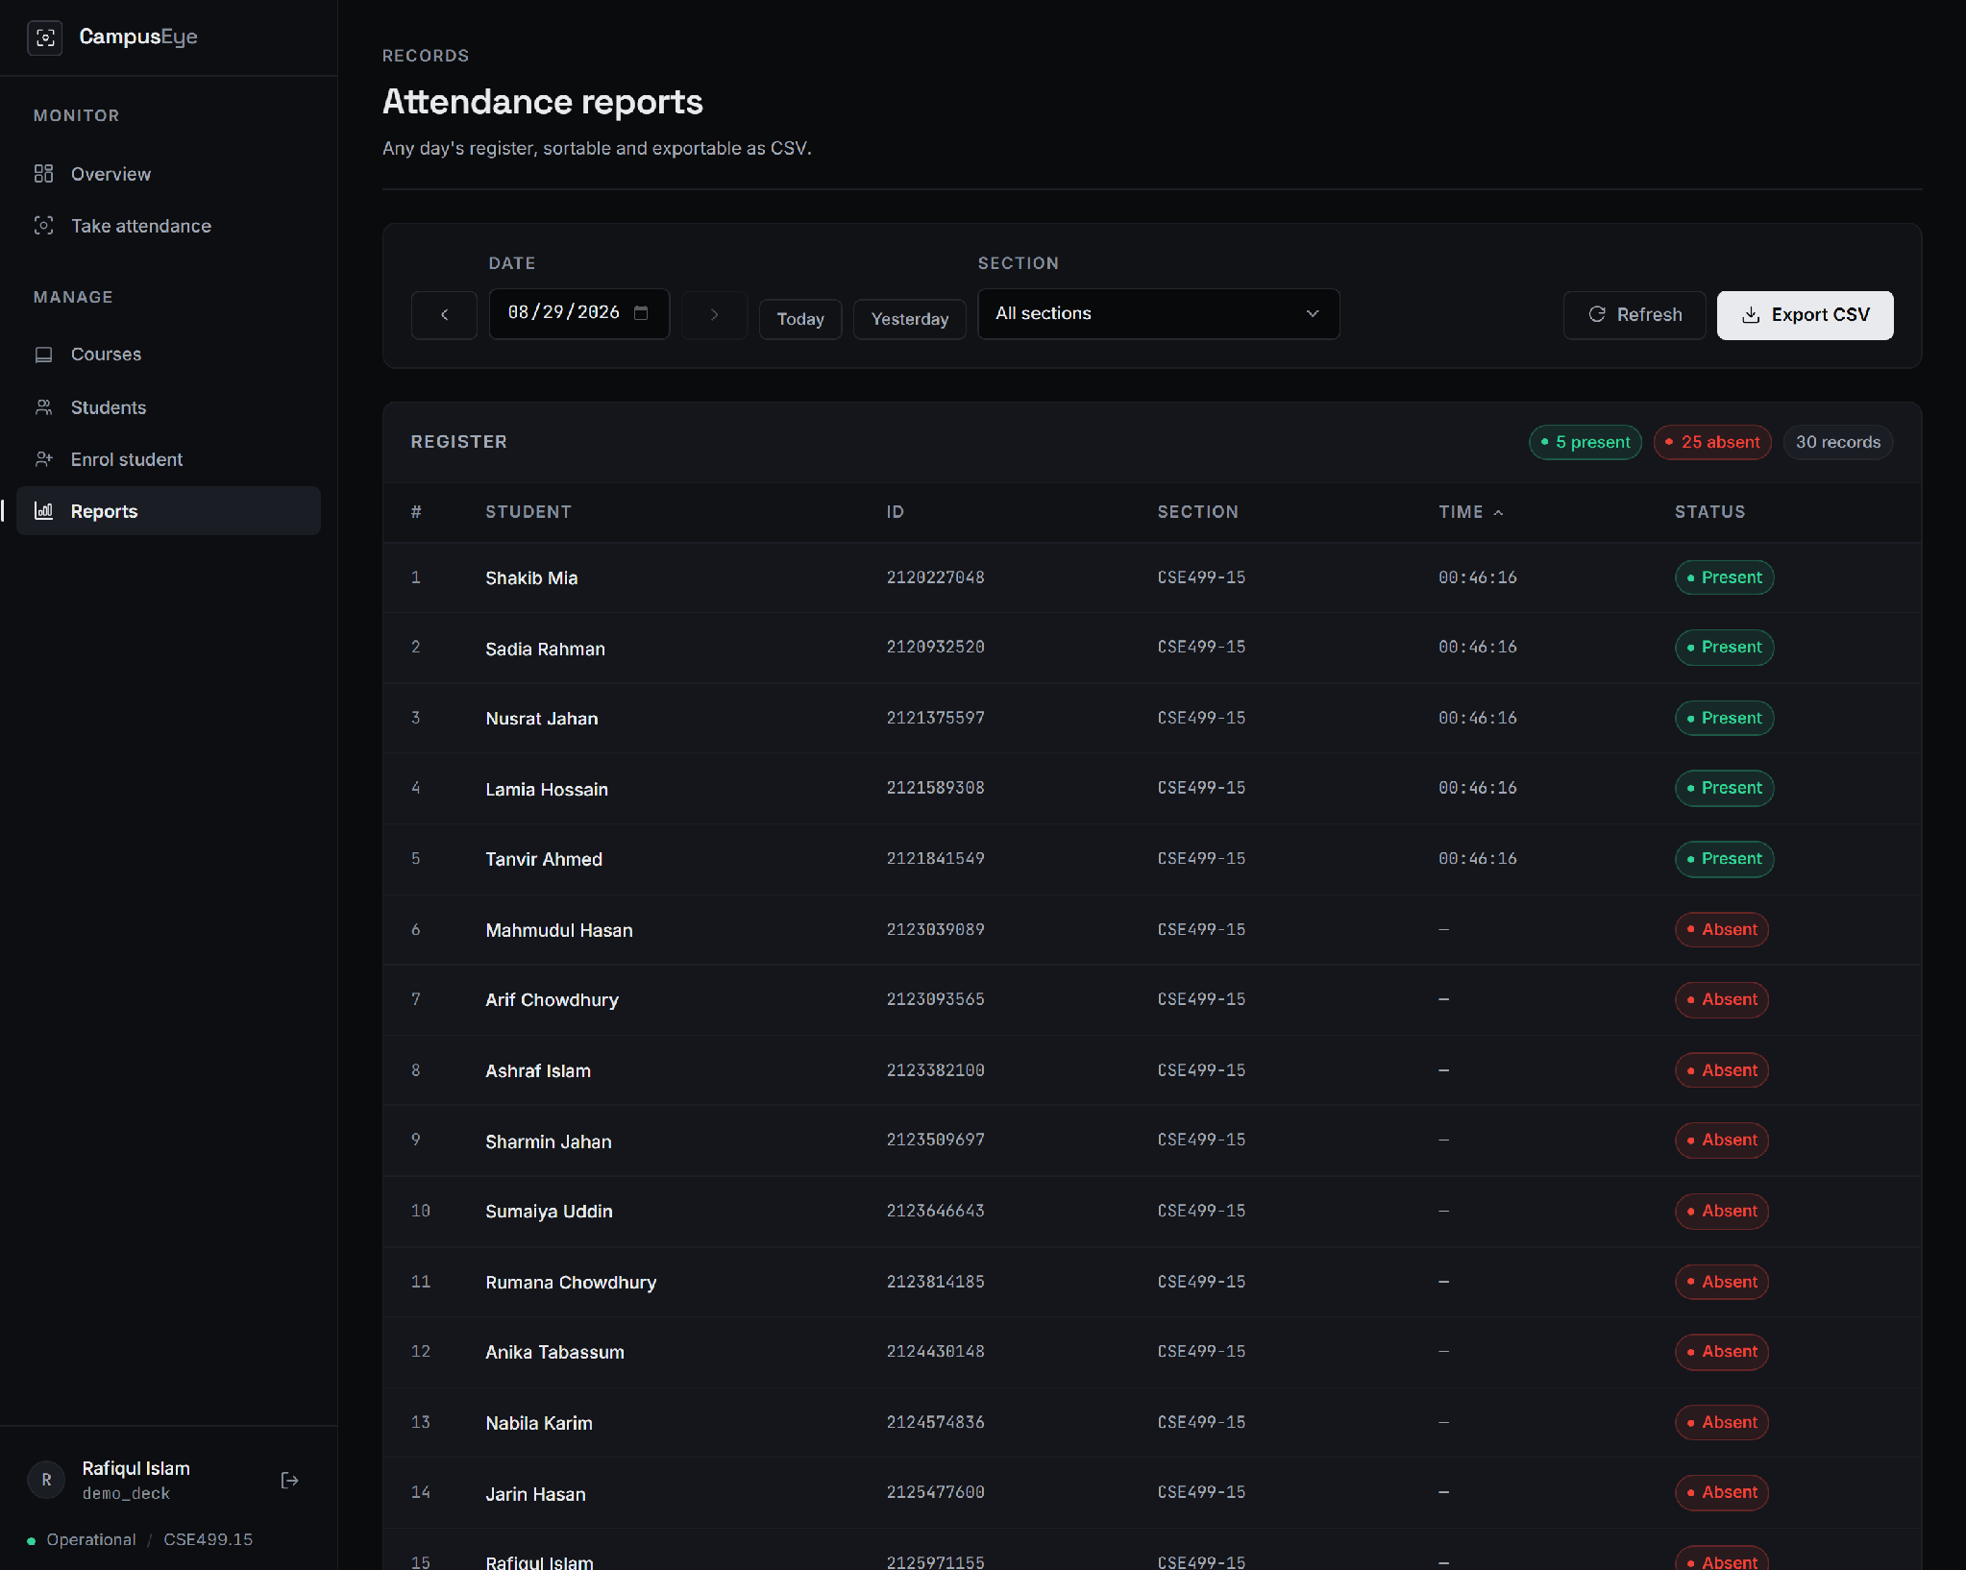
Fig. 2. Register produced by the roster acceptance test. Five students recognised from one photograph are recorded Present with the time of the scan; the remaining twenty-five members of the roster are resolved to Absent by (4). Names for students without a face profile are carried from the imported roster.

E. Automated Test Suite
Twenty-five automated tests pass. They cover account creation and password hashing, isolation of students, registers and embedding caches between accounts, course and roster management, the idempotence of absentee resolution, the ability of one student to hold separate records in two sections on the same date, and the in-place schema migration. The suite does not measure recognition accuracy; this is addressed in Section VI.

F. Software Quality Audit
A review of the codebase was conducted before submission, yielding eighteen findings. Six areas were examined and found sound: parameterised database queries throughout, escaping of all user-controlled values rendered in the browser, exclusion of biometric images and the database from version control, password hashing, account isolation, and the schema migration. Two defects were material. Two test modules wrote to the production database rather than a temporary one, so part of that database’s contents were residue from test runs. Separately, embedding extraction wrote each face crop to a single fixed temporary filename while the server was configured to handle requests concurrently, admitting a race between simultaneous scans. Both have identified remedies, and both are reported here rather than omitted because the audit is part of the engineering result.

VI. Discussion and Limitations
The results establish that the pipeline functions and that the roster mechanism produces a complete register, but they do not establish accuracy. Four limitations bound the claims of this phase.
• Accuracy is not measured. No evaluation has been performed on a large labelled dataset, and no receiver operating characteristic has been derived. The threshold of 0.6 is adopted from the literature and supported by two probe measurements, not tuned on classroom data. Any accuracy figure quoted for this system at this stage would be unsupported.
• The test set is small. Five enrolled students and a five-face group photograph are sufficient to demonstrate that the components work, and insufficient to characterise behaviour in a classroom of one hundred, where the probability of a near-collision between templates grows with the number enrolled.
• Templates are averaged without normalisation. Equation (3) takes the mean of raw embeddings, so samples of larger magnitude — often the brighter or closer photographs — exert more influence on the stored template than others. Normalising each sample to unit length before averaging is the standard remedy and is expected to improve consistency; the comparison is itself a worthwhile experiment.
• Input is a photograph, not a live scene. Attendance requires an image to be uploaded. Continuous capture from a camera, and the tracking and anti-spoofing that a live deployment would demand, are not implemented.
A further consideration is ethical rather than technical. The system stores biometric templates derived from students’ faces, and retains cropped images of unrecognised individuals for review. In the present implementation templates are stored without encryption and retained images are not subject to any retention limit. Both are addressed in the CSE499B plan, and neither should be regarded as acceptable in a deployment beyond a controlled prototype.

VII. Conclusion and Future Work
This paper has presented the CSE499A phase of CampusEye, an automated classroom attendance system that marks a class from a single photograph. Faces are detected by a convolutional detector, encoded as 128-dimensional embeddings, and matched against averaged per-student templates by cosine distance under a fixed threshold. The system’s distinguishing feature is that attendance is scoped to a course section, which allows absentees to be resolved as the difference between the roster and the recognised set and yields a complete register from one photograph — a step absent from all five reviewed systems.
Component testing recorded correct identification at a cosine distance of 0.23 and correct rejection at 0.71 against a threshold of 0.6, with a mean processing time of 0.8 s per frame. The roster milestone met its acceptance criterion exactly, producing five present and twenty-five absent records from a thirty-student section, and the implementation passes twenty-five automated tests.
Work planned for CSE499B follows the limitations identified above. Live camera capture will remove the upload step, accompanied by a dual-threshold review queue that routes borderline matches to the instructor rather than deciding them silently. Continuous ingestion from fixed cameras, with multi-object tracking to maintain identity across frames, extends the system from a per-class tool towards continuous monitoring. Anti-spoofing and impossible-travel detection address the proxy problem named in the literature but solved in none of it. Biometric templates will be encrypted at rest and retained images subjected to a fixed retention period. The phase concludes with large-scale benchmarking on a labelled classroom dataset, which is what will permit an accuracy claim to be made — and which this report deliberately does not anticipate.

References
[1] A. Budiman, Fabian, R. A. Yaputera, S. Achmad, and A. Kurniawan, “Student attendance with face recognition (LBPH or CNN): Systematic literature review,” Procedia Computer Science, Bina Nusantara University, 2023.
[2] R. Abuazh, A. Alharbi, and O. Alsaleh, “Face detection and recognition student attendance system,” College of Engineering technical report, 2020.
[3] P. Chakraborty, “Automatic student attendance system using face recognition,” Dept. of Computer Science and Engineering, Comilla University, Bangladesh, 2020.
[4] C. Gomes, S. Chanchal, T. Desai, and D. Jadhav, “Class attendance management system using facial recognition,” ITM Web of Conferences, 2020.
[5] O. Oshin, A. Adetiba, and E. Adetiba, “Class attendance system using facial recognition,” Dept. of Electrical and Information Engineering, Covenant University, Nigeria, 2025.
[6] F. Schroff, D. Kalenichenko, and J. Philbin, “FaceNet: A unified embedding for face recognition and clustering,” in Proc. IEEE Conf. Computer Vision and Pattern Recognition (CVPR), 2015, pp. 815–823.
[7] J. Deng, J. Guo, N. Xue, and S. Zafeiriou, “ArcFace: Additive angular margin loss for deep face recognition,” in Proc. IEEE/CVF Conf. Computer Vision and Pattern Recognition (CVPR), 2019, pp. 4690–4699.
[8] W. Wu, H. Peng, and S. Yu, “YuNet: A tiny millisecond-level face detector,” Machine Intelligence Research, vol. 20, no. 5, pp. 656–665, 2023.
[9] S. I. Serengil and A. Ozpinar, “LightFace: A hybrid deep face recognition framework,” in Proc. Innovations in Intelligent Systems and Applications Conf. (ASYU), 2020, pp. 1–5.
[10] G. Bradski, “The OpenCV library,” Dr. Dobb’s Journal of Software Tools, vol. 25, no. 11, pp. 120–125, 2000.
[11] Pallets Projects, “Flask documentation,” 2024. [Online]. Available: https://flask.palletsprojects.com
[12] SQLite Consortium, “SQLite database engine documentation,” 2024. [Online]. Available: https://sqlite.org/docs.html

