# Threat Modeling Report

Created on 2/28/2025 3:21:20 PM

**Threat Model Name:** Open Eclass 1.0

**Owner:** -

**Reviewer:** -

**Contributors:** -

**Description:** Παροχή διαδικτυακών εκπαιδευτικών υπηρεσιών σε φοιτητές και εκπαιδευτικούς. Οι φοιτητές μπορούν να εγγραφούν σε μαθήματα, να κατεβάζουν εκπαιδευτικό υλικό και να ανεβάζουν εργασίες. Οι εκπαιδευτικοί μπορούν να δημιουργούν/επεξεργάζονται μαθήματα, να ανεβάζουν σημειώσεις/διαφάνειες, να διαχειρίζονται βαθμολογίες και να βλέπουν αναφορές προόδου φοιτητών.

**Assumptions:** Διαχείριση Μαθημάτων: Ο εκπαιδευτικός δημιουργεί/διαχειρίζεται το μάθημα, ανεβάζει εκπαιδευτικό υλικό. Υποβολή Εργασιών: Ο φοιτητής ανεβάζει την εργασία του, και ο εκπαιδευτικός τη βαθμολογεί. Ενημέρωση & Συνεργασία: Ανακοινώσεις, δημοσίευση βαθμών.

**External Dependencies:** HTTPS / TLS: Απαιτείται κρυπτογραφημένη επικοινωνία μεταξύ browser και server. Web Server: Apache Firewall: Προστατεύει το εσωτερικό δίκτυο, φιλτράρει απροσδόκητα αιτήματα. Database (MySQL): Αποθήκευση δεδομένων χρηστών, μαθημάτων, βαθμολογιών. File Storage: Χώρος αποθήκευσης των αρχείων (σημειώσεις, διαφάνειες, εργασίες).

### Threat Model Summary:

|  |  |
| --- | --- |
| Not Started | 43 |
| Not Applicable | 0 |
| Needs Investigation | 0 |
| Mitigation Implemented | 0 |
| Total | 43 |
| Total Migrated | 0 |

## Diagram: High-Level-diagram

High-Level-diagram diagram screenshot
            

### High-Level-diagram Diagram Summary:

|  |  |
| --- | --- |
| Not Started | 43 |
| Not Applicable | 0 |
| Needs Investigation | 0 |
| Mitigation Implemented | 0 |
| Total | 43 |
| Total Migrated | 0 |

### Interaction: data

data interaction screenshot
      

#### 1. Web Server Process Memory Tampered  [State: Not Started]  [Priority: High]

|  |  |
| --- | --- |
| **Category:** | Tampering |
| **Description:** | If Web Server is given access to memory, such as shared memory or pointers, or is given the ability to control what Browser Client executes (for example, passing back a function pointer.), then Web Server can tamper with Browser Client. Consider if the function could work with less access to memory, such as passing data rather than pointers. Copy in data provided, and then validate it. |
| **Justification:** | <no mitigation provided> |

#### 2. Elevation Using Impersonation  [State: Not Started]  [Priority: High]

|  |  |
| --- | --- |
| **Category:** | Elevation Of Privilege |
| **Description:** | Browser Client may be able to impersonate the context of Web Server in order to gain additional privilege. |
| **Justification:** | <no mitigation provided> |

### Interaction: file request

file request interaction screenshot
      

#### 3. Spoofing the Web Server Process  [State: Not Started]  [Priority: High]

|  |  |
| --- | --- |
| **Category:** | Spoofing |
| **Description:** | Web Server may be spoofed by an attacker and this may lead to unauthorized access to File System. Consider using a standard authentication mechanism to identify the source process. |
| **Justification:** | <no mitigation provided> |

#### 4. Spoofing of Destination Data Store File System  [State: Not Started]  [Priority: High]

|  |  |
| --- | --- |
| **Category:** | Spoofing |
| **Description:** | File System may be spoofed by an attacker and this may lead to data being written to the attacker's target instead of File System. Consider using a standard authentication mechanism to identify the destination data store. |
| **Justification:** | <no mitigation provided> |

#### 5. The File System Data Store Could Be Corrupted  [State: Not Started]  [Priority: High]

|  |  |
| --- | --- |
| **Category:** | Tampering |
| **Description:** | Data flowing across file request may be tampered with by an attacker. This may lead to corruption of File System. Ensure the integrity of the data flow to the data store. |
| **Justification:** | <no mitigation provided> |

#### 6. Data Store Denies File System Potentially Writing Data  [State: Not Started]  [Priority: High]

|  |  |
| --- | --- |
| **Category:** | Repudiation |
| **Description:** | File System claims that it did not write data received from an entity on the other side of the trust boundary. Consider using logging or auditing to record the source, time, and summary of the received data. |
| **Justification:** | <no mitigation provided> |

#### 7. Potential Excessive Resource Consumption for Web Server or File System  [State: Not Started]  [Priority: High]

|  |  |
| --- | --- |
| **Category:** | Denial Of Service |
| **Description:** | Does Web Server or File System take explicit steps to control resource consumption? Resource consumption attacks can be hard to deal with, and there are times that it makes sense to let the OS do the job. Be careful that your resource requests don't deadlock, and that they do timeout. |
| **Justification:** | <no mitigation provided> |

#### 8. Data Flow HTTPS request Is Potentially Interrupted  [State: Not Started]  [Priority: High]

|  |  |
| --- | --- |
| **Category:** | Denial Of Service |
| **Description:** | An external agent interrupts data flowing across a trust boundary in either direction. |
| **Justification:** | <no mitigation provided> |

#### 9. Data Store Inaccessible  [State: Not Started]  [Priority: High]

|  |  |
| --- | --- |
| **Category:** | Denial Of Service |
| **Description:** | An external agent prevents access to a data store on the other side of the trust boundary. |
| **Justification:** | <no mitigation provided> |

### Interaction: file response

file response interaction screenshot
      

#### 10. Spoofing of Source Data Store File System  [State: Not Started]  [Priority: High]

|  |  |
| --- | --- |
| **Category:** | Spoofing |
| **Description:** | File System may be spoofed by an attacker and this may lead to incorrect data delivered to Web Server. Consider using a standard authentication mechanism to identify the source data store. |
| **Justification:** | <no mitigation provided> |

#### 11. Cross Site Scripting  [State: Not Started]  [Priority: High]

|  |  |
| --- | --- |
| **Category:** | Tampering |
| **Description:** | The web server 'Web Server' could be a subject to a cross-site scripting attack because it does not sanitize untrusted input. |
| **Justification:** | <no mitigation provided> |

#### 12. Persistent Cross Site Scripting  [State: Not Started]  [Priority: High]

|  |  |
| --- | --- |
| **Category:** | Tampering |
| **Description:** | The web server 'Web Server' could be a subject to a persistent cross-site scripting attack because it does not sanitize data store 'File System' inputs and output. |
| **Justification:** | <no mitigation provided> |

#### 13. Potential Data Repudiation by Web Server  [State: Not Started]  [Priority: High]

|  |  |
| --- | --- |
| **Category:** | Repudiation |
| **Description:** | Web Server claims that it did not receive data from a source outside the trust boundary. Consider using logging or auditing to record the source, time, and summary of the received data. |
| **Justification:** | <no mitigation provided> |

#### 14. Weak Access Control for a Resource  [State: Not Started]  [Priority: High]

|  |  |
| --- | --- |
| **Category:** | Information Disclosure |
| **Description:** | Improper data protection of File System can allow an attacker to read information not intended for disclosure. Review authorization settings. |
| **Justification:** | <no mitigation provided> |

#### 15. Potential Process Crash or Stop for Web Server  [State: Not Started]  [Priority: High]

|  |  |
| --- | --- |
| **Category:** | Denial Of Service |
| **Description:** | Web Server crashes, halts, stops or runs slowly; in all cases violating an availability metric. |
| **Justification:** | <no mitigation provided> |

#### 16. Data Flow HTTPS request Is Potentially Interrupted  [State: Not Started]  [Priority: High]

|  |  |
| --- | --- |
| **Category:** | Denial Of Service |
| **Description:** | An external agent interrupts data flowing across a trust boundary in either direction. |
| **Justification:** | <no mitigation provided> |

#### 17. Data Store Inaccessible  [State: Not Started]  [Priority: High]

|  |  |
| --- | --- |
| **Category:** | Denial Of Service |
| **Description:** | An external agent prevents access to a data store on the other side of the trust boundary. |
| **Justification:** | <no mitigation provided> |

#### 18. Web Server May be Subject to Elevation of Privilege Using Remote Code Execution  [State: Not Started]  [Priority: High]

|  |  |
| --- | --- |
| **Category:** | Elevation Of Privilege |
| **Description:** | File System may be able to remotely execute code for Web Server. |
| **Justification:** | <no mitigation provided> |

#### 19. Elevation by Changing the Execution Flow in Web Server  [State: Not Started]  [Priority: High]

|  |  |
| --- | --- |
| **Category:** | Elevation Of Privilege |
| **Description:** | An attacker may pass data into Web Server in order to change the flow of program execution within Web Server to the attacker's choosing. |
| **Justification:** | <no mitigation provided> |

### Interaction: HTTPS request

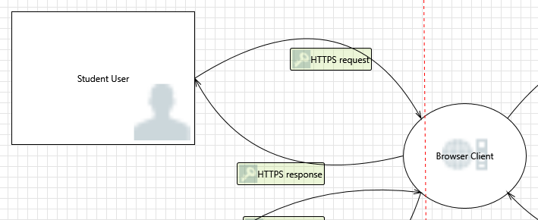

#### 20. Spoofing the Student/Teacher User External Entity  [State: Not Started]  [Priority: High]

|  |  |
| --- | --- |
| **Category:** | Spoofing |
| **Description:** | Student User may be spoofed by an attacker and this may lead to unauthorized access to Browser Client. Consider using a standard authentication mechanism to identify the external entity. |
| **Justification:** | <no mitigation provided> |

#### 21. Elevation Using Impersonation  [State: Not Started]  [Priority: High]

|  |  |
| --- | --- |
| **Category:** | Elevation Of Privilege |
| **Description:** | Browser Client may be able to impersonate the context of Student User in order to gain additional privilege. |
| **Justification:** | <no mitigation provided> |

### Interaction: HTTPS request

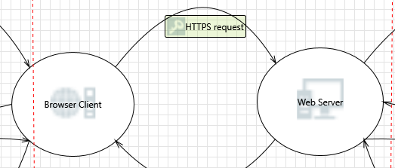

#### 22. Cross Site Scripting  [State: Not Started]  [Priority: High]

|  |  |
| --- | --- |
| **Category:** | Tampering |
| **Description:** | The web server 'Web Server' could be a subject to a cross-site scripting attack because it does not sanitize untrusted input. |
| **Justification:** | <no mitigation provided> |

#### 23. Elevation Using Impersonation  [State: Not Started]  [Priority: High]

|  |  |
| --- | --- |
| **Category:** | Elevation Of Privilege |
| **Description:** | Web Server may be able to impersonate the context of Browser Client in order to gain additional privilege. |
| **Justification:** | <no mitigation provided> |

### Interaction: HTTPS request

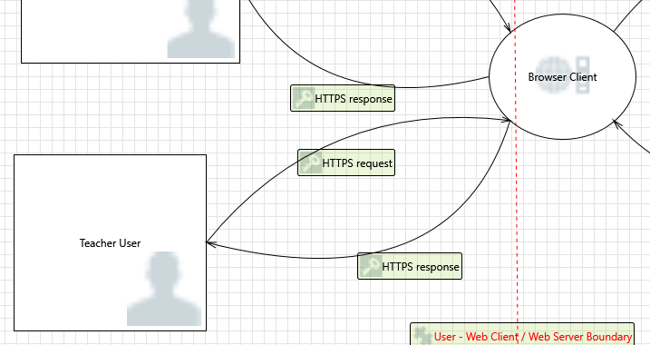

#### 24. Spoofing the Human User External Entity  [State: Not Started]  [Priority: High]

|  |  |
| --- | --- |
| **Category:** | Spoofing |
| **Description:** | Teacher User may be spoofed by an attacker and this may lead to unauthorized access to Browser Client. Consider using a standard authentication mechanism to identify the external entity. |
| **Justification:** | <no mitigation provided> |

#### 25. Elevation Using Impersonation  [State: Not Started]  [Priority: High]

|  |  |
| --- | --- |
| **Category:** | Elevation Of Privilege |
| **Description:** | Browser Client may be able to impersonate the context of Teacher User in order to gain additional privilege. |
| **Justification:** | <no mitigation provided> |

### Interaction: sql query

sql query interaction screenshot
      

#### 26. Spoofing the Web Server Process  [State: Not Started]  [Priority: High]

|  |  |
| --- | --- |
| **Category:** | Spoofing |
| **Description:** | Web Server may be spoofed by an attacker and this may lead to unauthorized access to SQL Database. Consider using a standard authentication mechanism to identify the source process. |
| **Justification:** | <no mitigation provided> |

#### 27. Spoofing of Destination Data Store SQL Database  [State: Not Started]  [Priority: High]

|  |  |
| --- | --- |
| **Category:** | Spoofing |
| **Description:** | SQL Database may be spoofed by an attacker and this may lead to data being written to the attacker's target instead of SQL Database. Consider using a standard authentication mechanism to identify the destination data store. |
| **Justification:** | <no mitigation provided> |

#### 28. Potential SQL Injection Vulnerability for SQL Database  [State: Not Started]  [Priority: High]

|  |  |
| --- | --- |
| **Category:** | Tampering |
| **Description:** | SQL injection is an attack in which malicious code is inserted into strings that are later passed to an instance of SQL Server for parsing and execution. Any procedure that constructs SQL statements should be reviewed for injection vulnerabilities because SQL Server will execute all syntactically valid queries that it receives. Even parameterized data can be manipulated by a skilled and determined attacker. |
| **Justification:** | <no mitigation provided> |

#### 29. The SQL Database Data Store Could Be Corrupted  [State: Not Started]  [Priority: High]

|  |  |
| --- | --- |
| **Category:** | Tampering |
| **Description:** | Data flowing across sql query may be tampered with by an attacker. This may lead to corruption of SQL Database. Ensure the integrity of the data flow to the data store. |
| **Justification:** | <no mitigation provided> |

#### 30. Data Store Denies SQL Database Potentially Writing Data  [State: Not Started]  [Priority: High]

|  |  |
| --- | --- |
| **Category:** | Repudiation |
| **Description:** | SQL Database claims that it did not write data received from an entity on the other side of the trust boundary. Consider using logging or auditing to record the source, time, and summary of the received data. |
| **Justification:** | <no mitigation provided> |

#### 31. Potential Excessive Resource Consumption for Web Server or SQL Database  [State: Not Started]  [Priority: High]

|  |  |
| --- | --- |
| **Category:** | Denial Of Service |
| **Description:** | Does Web Server or SQL Database take explicit steps to control resource consumption? Resource consumption attacks can be hard to deal with, and there are times that it makes sense to let the OS do the job. Be careful that your resource requests don't deadlock, and that they do timeout. |
| **Justification:** | <no mitigation provided> |

#### 32. Data Flow HTTPS request Is Potentially Interrupted  [State: Not Started]  [Priority: High]

|  |  |
| --- | --- |
| **Category:** | Denial Of Service |
| **Description:** | An external agent interrupts data flowing across a trust boundary in either direction. |
| **Justification:** | <no mitigation provided> |

#### 33. Data Store Inaccessible  [State: Not Started]  [Priority: High]

|  |  |
| --- | --- |
| **Category:** | Denial Of Service |
| **Description:** | An external agent prevents access to a data store on the other side of the trust boundary. |
| **Justification:** | <no mitigation provided> |

### Interaction: sql result

sql result interaction screenshot
      

#### 34. Spoofing of Source Data Store SQL Database  [State: Not Started]  [Priority: High]

|  |  |
| --- | --- |
| **Category:** | Spoofing |
| **Description:** | SQL Database may be spoofed by an attacker and this may lead to incorrect data delivered to Web Server. Consider using a standard authentication mechanism to identify the source data store. |
| **Justification:** | <no mitigation provided> |

#### 35. Cross Site Scripting  [State: Not Started]  [Priority: High]

|  |  |
| --- | --- |
| **Category:** | Tampering |
| **Description:** | The web server 'Web Server' could be a subject to a cross-site scripting attack because it does not sanitize untrusted input. |
| **Justification:** | <no mitigation provided> |

#### 36. Persistent Cross Site Scripting  [State: Not Started]  [Priority: High]

|  |  |
| --- | --- |
| **Category:** | Tampering |
| **Description:** | The web server 'Web Server' could be a subject to a persistent cross-site scripting attack because it does not sanitize data store 'SQL Database' inputs and output. |
| **Justification:** | <no mitigation provided> |

#### 37. Elevation by Changing the Execution Flow in Web Server  [State: Not Started]  [Priority: High]

|  |  |
| --- | --- |
| **Category:** | Elevation Of Privilege |
| **Description:** | An attacker may pass data into Web Server in order to change the flow of program execution within Web Server to the attacker's choosing. |
| **Justification:** | <no mitigation provided> |

#### 38. Weak Access Control for a Resource  [State: Not Started]  [Priority: High]

|  |  |
| --- | --- |
| **Category:** | Information Disclosure |
| **Description:** | Improper data protection of SQL Database can allow an attacker to read information not intended for disclosure. Review authorization settings. |
| **Justification:** | <no mitigation provided> |

#### 39. Web Server May be Subject to Elevation of Privilege Using Remote Code Execution  [State: Not Started]  [Priority: High]

|  |  |
| --- | --- |
| **Category:** | Elevation Of Privilege |
| **Description:** | SQL Database may be able to remotely execute code for Web Server. |
| **Justification:** | <no mitigation provided> |

#### 40. Data Store Inaccessible  [State: Not Started]  [Priority: High]

|  |  |
| --- | --- |
| **Category:** | Denial Of Service |
| **Description:** | An external agent prevents access to a data store on the other side of the trust boundary. |
| **Justification:** | <no mitigation provided> |

#### 41. Data Flow HTTPS request Is Potentially Interrupted  [State: Not Started]  [Priority: High]

|  |  |
| --- | --- |
| **Category:** | Denial Of Service |
| **Description:** | An external agent interrupts data flowing across a trust boundary in either direction. |
| **Justification:** | <no mitigation provided> |

#### 42. Potential Process Crash or Stop for Web Server  [State: Not Started]  [Priority: High]

|  |  |
| --- | --- |
| **Category:** | Denial Of Service |
| **Description:** | Web Server crashes, halts, stops or runs slowly; in all cases violating an availability metric. |
| **Justification:** | <no mitigation provided> |

#### 43. Potential Data Repudiation by Web Server  [State: Not Started]  [Priority: High]

|  |  |
| --- | --- |
| **Category:** | Repudiation |
| **Description:** | Web Server claims that it did not receive data from a source outside the trust boundary. Consider using logging or auditing to record the source, time, and summary of the received data. |
| **Justification:** | <no mitigation provided> |