

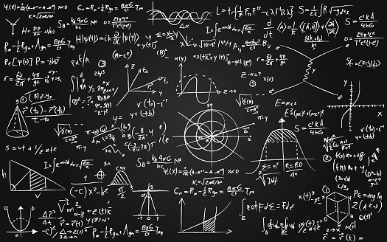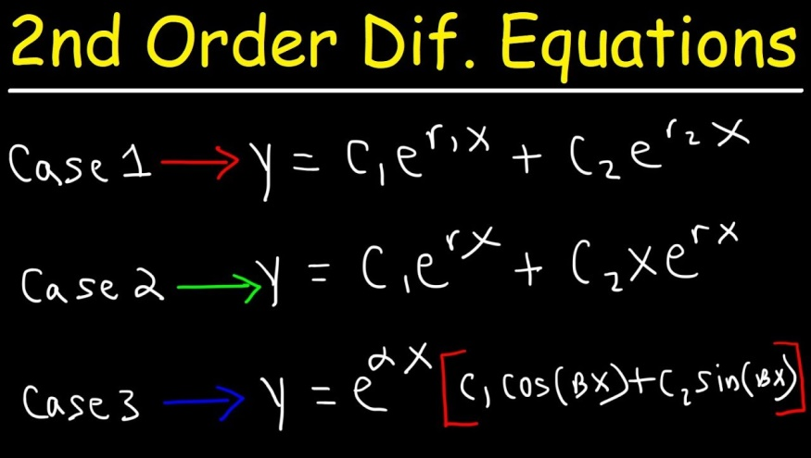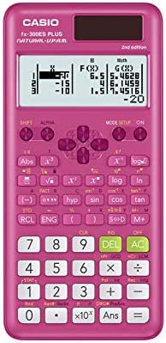

**ASSIGNMENT SUBMISSION**

ON

Second order of differentials equation

**Submitted to:**

Name :Md.Mashih Ibn Yasin Adan

Designation : Lecturer(SU)

Department : CS

**Submitted By:**

Name : Rafi Ahmed

ID : CSE-2202026150

Department : CSE

Email : smrafi120@gmail.com