**AMERICAN INTERNATIONAL UNIVERSITY BANGLADESH**

**Faculty of Engineering**

**Laboratory Report Cover Sheet**

***Students must complete all details except the faculty use part.***

Please submit all reports to your subject supervisor or the office of the concerned faculty.

Laboratory Title: 3 RGB LED controlled by transistor.

Experiment Number: Due Date: 13-05-2024 Semester: Spring

Subject Code: EEE 2104 Subject Name : Device Lab ________Section:_E___________

Course Instructor: **ABU HENA MD. SHATIL__________** Degree Program: _ CSE

**Declaration and Statement of Authorship:**  1. I/we hold a copy of this report, which can be produced if the original is lost/ damaged.

1. This report is my/our original work and no part of it has been copied from any other student’s work or from any other source except where due acknowledgement is made.
2. No part of this report has been written for me/us by any other person except where such collaboration has been authorized by the lecturer/teacher concerned and is clearly acknowledged in the report.
3. I/we have not previously submitted or currently submitting this work for any other course/unit.
4. This work may be reproduced, communicated, compared and archived for the purpose of detecting plagiarism.
5. I/we give permission for a copy of my/our marked work to be retained by the School for review and comparison, including review by external examiners.

# **I/we understand that**

1. Plagiarism is the presentation of the work, idea or creation of another person as though it is your own. It is a form of cheating and is a very serious academic offence that may lead to expulsion from the University. Plagiarized material can be drawn from, and presented in, written, graphic and visual form, including electronic data, and oral presentations. Plagiarism occurs when the origin of the material used is not appropriately cited.
2. Enabling plagiarism is the act of assisting or allowing another person to plagiarize or to copy your work



Group Number (if applicable): 04 Individual Submission Group Submission



|  |  |  |  |  |
| --- | --- | --- | --- | --- |
| **No.** | **Student Name** | **Student Number** | **Student Signature** | **Date** |
| **Submitted by:** | |  |  |  |
| **1** | MD RAFIT | 23-50418-1 |  |  |
| **Group Members:** | |  |  |  |
| **2** | MD.SIAM-UL-ISLAM | 22-49466-3 |  |  |
| **3** | Rakibul Hasan Shakil | 22-49462-3 |  |  |
| **4** | Sumaiya Akter Shimu | 22-48668-3 |  |  |
| **5** | Rakib Hossain | 22-48744-3 |  |  |

**Title**

3 RBG LEDs controlled by transistor.

**Abstract**

The objective of this experiment was to design and implement a circuit that efficiently controls three RGB LEDs using transistors. By varying the base voltage of the transistors, we achieved color mixing and brightness adjustment. The circuit was powered by a DC source.

**Objective**

The primary goal of this experiment was to demonstrate how NPN transistors can effectively control RGB LEDs, allowing for color variation and illumination control.

**Literature Review**

Transistors are semiconductor devices widely used in electronic circuits for amplification, switching, and signal processing. In LED applications, transistors act as switches or amplifiers to control the current flowing through the LEDs, thereby regulating their brightness. RGB LEDs consist of three individual LED chips (Red, Green, Blue) integrated into a single package, enabling the emission of a wide range of colors by varying the intensity of each chip.

The use of transistors in LED control circuits offers several advantages, including efficient current regulation, precise control over LED brightness, and compatibility with microcontroller-based systems for automation and programmability. Commonly used transistors for such applications include bipolar junction transistors (BJTs) and field-effect transistors (FETs).

Transistors play a crucial role in electronic circuits. In this experiment, we utilized NPN transistors (such as the commonly used 2N3904) to regulate the current flow through RGB LEDs. The base-emitter junction voltage determines whether the transistor is in an “on” or “off” state.

**Theory**

In this circuit, each RGB LED is connected to a transistor (either BJT or FET) acting as a switch. By varying the voltage applied to the base (for BJTs) or gate (for FETs) of the transistors, the collector (or drain) current can be controlled, thereby adjusting the brightness of the corresponding LED. By independently controlling the intensity of the Red, Green, and Blue LEDs, a wide spectrum of colors can be generated through additive color mixing.

**Figure: 1**

The RGB color model is based on the additive mixing of red, green, and blue light, where different combinations of these primary colors produce a variety of hues. By adjusting the relative intensities of each color channel, various colors can be achieved. For example, mixing equal intensities of red and green light produces yellow, while mixing red and blue produces magenta, and mixing green and blue produces.

The theory behind this experiment involves the behavior of NPN transistors. When a positive voltage is applied to the base (B) of the transistor, it allows current to flow from the collector © to the emitter (E). By controlling the base voltage, we can modulate the current through the RGB LEDs, resulting in different colors.

**Apparatus**

**The following components were used in this experiment:**

* **Three RGB LEDs (common cathode):** These LEDs emit red, green, and blue light.
* **NPN transistors:** These transistors act as switches to control the current flow.
* **Base resistors (5Ω):** These resistors limit the base current of each transistor.
* **Stabilizing capacitors (10μF):** These capacitors enhance circuit stability.
* **DC power supply (8V):** Provides the necessary voltage for the circuit.
* **Breadboard and jumper wires:** Used for circuit connections.

**Circuit Diagram**

**Figure: 2**

**Procedure**

1. Connect the cathode (common ground) of the RGB LEDs to the negative terminal of the DC power supply.
2. Connect the anodes of the RGB LEDs to the collectors © of the transistors (Q1, Q2, Q3).
3. Add a resistor (R1, R2, R3) in series with the base (B) of each transistor.
4. Connect the emitter (E) of each transistor to the ground.
5. Place capacitors (C1, C2, C3) in parallel with each RGB LED.
6. Apply a voltage to the base of each transistor to control the current flow through the LEDs.
7. Observe the color mixing and adjust the base voltage to achieve desired colors.

**Simulation:**

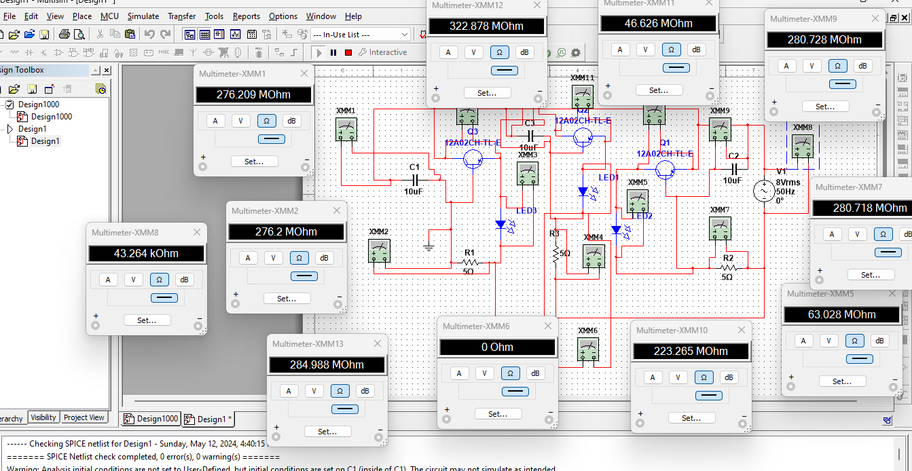

**Figure: 3**

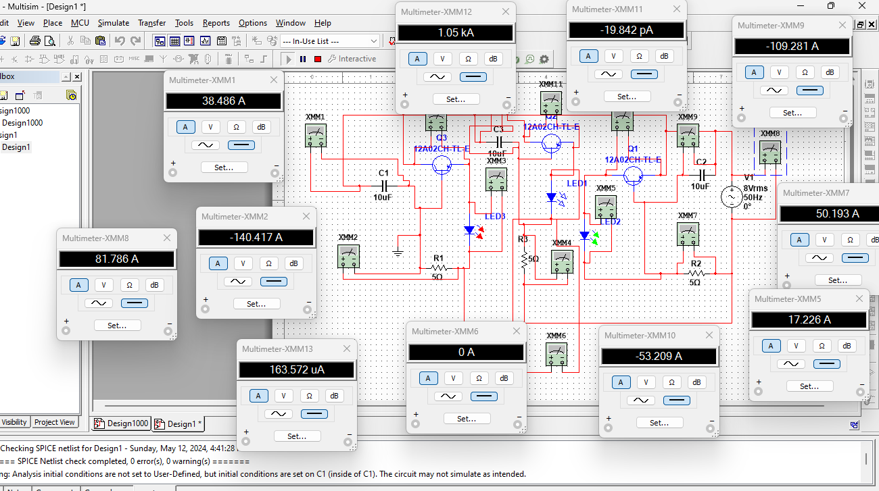

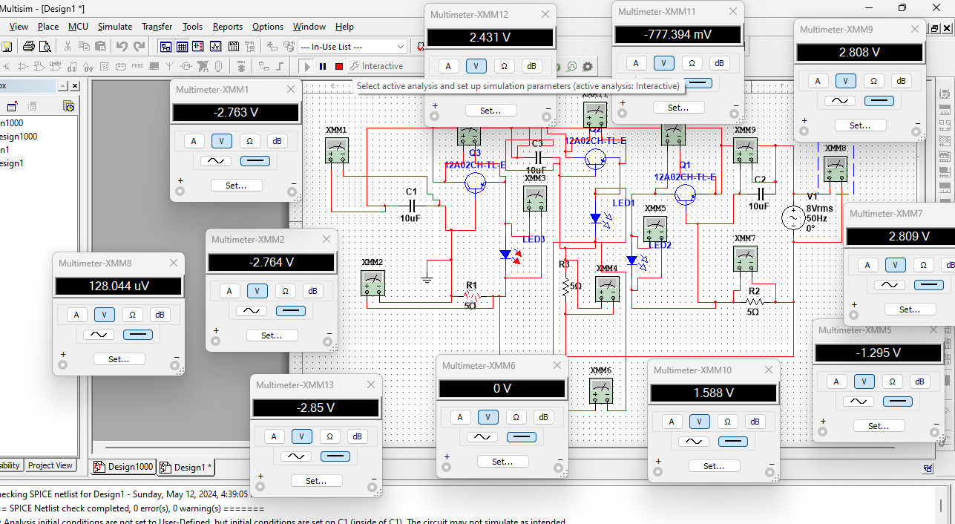**Figure: 4**

**Figure: 5**

**Discussion**

The circuit successfully controlled the RGB LEDs using transistors. By adjusting the base voltage, we could create various colors by mixing red, green, and blue light. The capacitors helped stabilize the circuit, preventing unwanted fluctuations.

**Conclusion**

Transistors are essential components for efficient LED control. This experiment demonstrated their application in RGB LED circuits. Future work could explore additional features, such as pulse-width modulation (PWM) for smoother color transitions.

**Reference**

1. American International University–Bangladesh (AIUB) Electronic Devices Lab Manual.
2. P. Horowitz, W. Hill, “The Art of Electronics,” Cambridge University Press (1989).