SOUTHEAST UNIVERSITY
Department of Computer Science and Engineering
Course Code: STA281 • Statistical Methods and Probability
Semester: Summer 2026
COMPLEX ENGINEERING PROJECT (CEP)
Final Report

Statistical Investigation of Diabetes Risk
Factors and Prediction
Analysis of the Pima Indians Diabetes Dataset using Python / Google Colab

Group Members | Student ID
M. Rafi-Ur-Rahman Alif | 2024100000006
Hridoy Chandra Das | 2024100000019
T.M. Shahriyar Kabir | 2024100000026
Ornima Akter | 2024100000042

Submitted to:

Md. Shohel Babu
Coordinator & Assistant Professor
Department of Computer Science and Engineering, Southeast University
Date of Submission: 29 September 2026

1. Introduction

1.1 Project Background
A healthcare organization aims to investigate the major risk factors associated with diabetes and to determine whether patient healthcare data can statistically predict the occurrence of diabetes. This project analyses the Pima Indians Diabetes Dataset using descriptive statistics, probability theory, Bayes’ theorem, probability distributions, confidence intervals, hypothesis testing, correlation analysis and regression, with Python / Google Colab as the computational tool.

1.2 Objectives
- Load the dataset, identify its structure, describe it statistically, check for missing or abnormal values and visualise it (Section 1 of the project brief).
- Apply probability, conditional probability, Bayes’ theorem, the Binomial, Normal and Exponential distributions and the Central Limit Theorem (Section 2).
- Construct confidence intervals and perform hypothesis tests (Z-test and two-sample comparisons) on healthcare variables such as Glucose and BMI (Section 3).
- Perform correlation and linear regression analysis, visualise relationships and prepare an evidence-based conclusion on diabetes risk factors and prediction (Section 4).

1.3 Tools and Method
All calculations were carried out in Python (Google Colab) using pandas and NumPy for data handling, SciPy for probability distributions and statistical tests, and Matplotlib / Seaborn for visualisation. Exact dataset variable names (Pregnancies, Glucose, BloodPressure, SkinThickness, Insulin, BMI, DiabetesPedigreeFunction, Age, Outcome) are used throughout. Every result below is the output produced by the accompanying notebook, followed by its healthcare interpretation.

1.4 Course Outcomes Addressed
Table 2: Course outcomes and project sections
CO | Description | Report sections
CO1 | Understand the fundamentals of statistics and probability. | Sections 2, 3.1 (Q1–Q5)
CO2 | Analyze healthcare datasets using statistical methods and computational tools. | Sections 3.2–3.3 (Q6–Q12)
CO3 | Perform statistical inference, hypothesis testing and interpret findings in applied contexts. | Sections 5, 6, 7 (Q13–Q20)

2. Dataset Description

2.1 Question 1 – Dataset Structure
The Pima Indians Diabetes Dataset was loaded into a pandas DataFrame (df) from diabetes.csv.
The first ten records are shown below.
Table 3: First ten observations of the dataset (df.head(10))
 | Pregnancie  s | Glucose | Blood Pressure | Skin Thickness | Insulin | BMI | Diabetes  Pedigree  Function | Age | Outcome
0 | 6 | 148 | 72.0 | 35 | 169.5 | 33.6 | 0.627 | 50 | 1
1 | 1 | 85 | 66.0 | 29 | 102.5 | 26.6 | 0.351 | 31 | 0
2 | 8 | 183 | 64.0 | 32 | 169.5 | 23.3 | 0.672 | 32 | 1
3 | 1 | 89 | 66.0 | 23 | 94.0 | 28.1 | 0.167 | 21 | 0
4 | 0 | 137 | 40.0 | 35 | 168.0 | 43.1 | 2.288 | 33 | 1
5 | 5 | 116 | 74.0 | 27 | 102.5 | 25.6 | 0.201 | 30 | 0
6 | 3 | 78 | 50.0 | 32 | 88.0 | 31.0 | 0.248 | 26 | 1
7 | 10 | 115 | 70.0 | 27 | 102.5 | 35.3 | 0.134 | 29 | 0
8 | 2 | 197 | 70.0 | 45 | 543.0 | 30.5 | 0.158 | 53 | 1
9 | 8 | 125 | 96.0 | 32 | 169.5 | 34.3 | 0.232 | 54 | 1

Table 4: Dataset dimensions (df.shape)
Metric |  | Value
Number of observations (rows) | 768
Number of variables (columns) | 9

Table 5: Variable names, data types and descriptions (df.columns, df.dtypes)
Variable | Data type | Description
Pregnancies | int64 | Number of pregnancies
Glucose | int64 | Plasma glucose concentration
BloodPressure | float64 | Diastolic blood pressure
SkinThickness | int64 | Triceps skin fold thickness
Insulin | float64 | Serum insulin level
BMI | float64 | Body Mass Index
DiabetesPedigreeFunction | float64 | Genetic diabetes likelihood
Age | int64 | Patient age
Outcome | int64 | 0 = Non-diabetic, 1 = Diabetic

Interpretation
The dataset contains 768 observations (patients) and 9 variables: eight clinical / demographic predictors and one binary response variable, Outcome (0 = non-diabetic, 1 = diabetic). All variables are numeric: Pregnancies, Glucose, SkinThickness, Age and Outcome are stored as integers (int64), while BloodPressure, Insulin, BMI and DiabetesPedigreeFunction are stored as decimals (float64). Because every predictor is quantitative and the response is binary, the data are suitable for descriptive statistics, group comparison, correlation, regression and probability analysis. Each row is one patient, so the observations can be treated as individual sampling units.

2.2 Question 3 – Missing and Abnormal Values
Missing values were checked with df.isnull().sum().

Table 6: Missing-value count per variable (df.isnull().sum())
Variable | Missing values
Pregnancies | 0
Glucose | 0
BloodPressure | 0
SkinThickness | 0
Insulin | 0
BMI | 0
DiabetesPedigreeFunction | 0
Age | 0
Outcome | 0

Interpretation
The check reports no missing (null) entries in any variable, including the four variables of interest: Glucose, BMI, BloodPressure and Insulin. In this dataset, however, missing clinical measurements are known to be recorded as zero rather than left blank, and the loaded file shows signs that this has already been handled: the first ten records contain repeated Insulin values such as 102.5 and 169.5, and BloodPressure and Insulin are stored as decimals (float64). This is consistent with zero entries having been replaced (imputed) during preprocessing, so the values analysed in this report are the cleaned values.
Why zero values may represent missing healthcare information. A living patient cannot have a plasma glucose concentration, a diastolic blood pressure or a Body Mass Index of exactly zero, and a serum insulin level of zero is not physiologically plausible in a person being tested for diabetes. A recorded zero in these variables therefore almost certainly means “not measured” or “not recorded”, not a true reading. If such zeros were left in the data they would falsely pull the mean and median downwards, inflate the variance and standard deviation, create artificial low outliers and weaken correlations. For this reason, zeros in Glucose, BMI, BloodPressure and Insulin are treated as missing information and replaced with a suitable central value before analysis. (In Pregnancies, by contrast, zero is a valid count.)

3. Statistical Analysis

3.1 Question 2 – Descriptive Statistics
Descriptive statistics were calculated for Glucose, BMI, Age, and Insulin. The following formulas were used:
Mean: x̄ = Σx / n
Variance:
s² = Σ(xᵢ − x̄)² / (n − 1)
Standard Deviation:
s = √[Σ(xᵢ − x̄)² / (n − 1)]
are:
Table 7: Descriptive Statistics of Glucose, BMI, Age, Insulin
Variable | Mean | Median | Mode | Variance | Standard Deviation
Glucose | 121.68 | 117.00 | [99, 100] | 928.07 | 30.46
BMI | 32.43 | 32.05 | [30.1] | 47.34 | 6.88
Age | 33.24 | 29.00 | [22] | 138.30 | 11.76
Insulin | 141.75 | 102.50 | [102.5] | 7938.96 | 89.10

Interpretation
- Glucose – The mean (121.68 mg/dL) is above the median (117.00 mg/dL), indicating mild right skew caused by a group of patients with high glucose. There are two tied modes (99 and 100 mg/dL), and a standard deviation of 30.46 mg/dL shows considerable patient-to-patient variation.
- BMI – The mean (32.43 kg/m²) and median (32.05 kg/m²) are very close, so the
deviation is 6.88 kg/m².
- Age – The mean (33.24 years) is clearly larger than the median (29.00 years) and the mode is 22 years, showing a young sample with a right-skewed tail of older patients. The standard deviation is 11.76 years.
- Insulin – The mean (141.75) is far above the median (102.50), and the mode equals the median (102.50). The variance (7938.96) and standard deviation (89.10) are very large, showing strong right skew and a few extreme insulin values. The repeated value 102.50 reflects the preprocessing of missing entries discussed in Section 2.2.
The variance is the average squared distance from the mean and is expressed in squared units, whereas the standard deviation returns the spread to the original units (mg/dL, kg/m², years), which is easier to interpret clinically.

3.2 Question 5 – Diabetic vs Non-Diabetic Patients
The dataset was separated into diabetic patients (Outcome = 1) and non-diabetic patients (Outcome = 0), and the mean Glucose, BMI and Age were compared.
Table 8: Comparison of group means by Outcome
Group | Mean Glucose (mg/dL) | Mean BMI (kg/m²) | Mean Age (Years)
Non-Diabetic (Outcome=0) | 110.62 | 30.85 | 31.19
Diabetic (Outcome=1) | 142.30 | 35.40 | 37.07

Interpretation
Diabetic patients have a higher mean value on all three variables: mean glucose is 31.68 mg/dL higher (142.30 vs 110.62), mean BMI is 4.55 kg/m² higher (35.40 vs 30.85), and mean age is 5.88 years higher (37.07 vs 31.19). Clinically, this means that diabetic patients in this sample tend to have higher blood glucose, are heavier, and are older. Glucose shows by far the largest relative difference, which suggests that it is the most discriminating variable. Whether these differences are statistically significant is tested formally in Question 19 (Section 5.4).

3.3 Question 6 – Probability and Conditional Probability
Let D = patient is diabetic (Outcome = 1)
Let G = patient has Glucose > 130.
With N = 768 patients, the probabilities were computed as relative frequencies:
P(D) = n(D) / N
P(G) = n(G) / N
P(D ∩ G) = n(D ∩ G) / N
The conditional probability was calculated using:
P(D | G) = P(D ∩ G) / P(G)

Table 9: Probability summary for D and G
Probability Metric | Description | Formula | Value | Percentage
P(D) | Probability that a patient is diabetic | n(D) / N | 0.3490 | 34.90%
P(G) | Probability that glucose > 130 mg/dL | n(G) / N | 0.3294 | 32.94%
P(D ∩ G) | Probability that patient is diabetic  AND glucose > 130 mg/dL | n(D ∩ G) / N | 0.2096 | 20.96%
P(D|G) | Probability patient is diabetic GIVEN glucose > 130 mg/dL | P(D ∩ G) / P(G) | 0.6364 | 63.64%

Interpretation and healthcare implications
glucose > 130 mg/dL, the probability of diabetes rises from 34.90% to 63.64%, i.e. a high-
testing and closer clinical monitoring.

3.4 Question 7 – Bayes’ Theorem
Bayes’ theorem was used to estimate the probability that a patient has diabetes given a glucose level greater than 150 mg/dL:
P(D | G > 150) = [P(G > 150 | D) × P(D)] / P(G > 150)
Table 10: Bayes’ theorem components
Component | Notation | Formula / Source | Value | Percentage
Prior Probability | P(D) | n(Diabetic) / N | 0.3490 | 34.90%
Conditional  Probability  (Likelihood) | P(G > 150 | D) | n(Glucose > 150 and Diabetic) / n(Diabetic) | 0.3918 | 39.18%
Component | Notation | Formula / Source | Value | Percentage
Evidence (Marginal Probability) | P(G > 150) | n(Glucose > 150) / N | 0.1823 | 18.23%
Posterior Probability | P(D | G > 150) | [P(G > 150 | D) * P(D)] / P(G >  150) | 0.7500 | 75.00%

Interpretation
- Prior probability P(D) = 0.3490: the probability of diabetes before looking at any glucose information.
- Conditional probability (likelihood) P(G > 150 | D) = 0.3918: among diabetic patients, 39.18% have glucose above 150 mg/dL.
- Posterior probability P(D | G > 150) = 0.7500: after learning that the patient’s glucose exceeds 150 mg/dL, the probability of diabetes is updated from 34.90% to 75.00%.
Only 18.23% of all patients have glucose above 150 mg/dL, but three out of four of them are diabetic. Compared with the 63.64% found for glucose > 130 in Question 6, a higher glucose threshold gives a higher probability of diabetes. A glucose above 150 mg/dL is therefore a strong warning sign that justifies prompt confirmatory testing, although 25% of such patients are still non-diabetic, so glucose alone is not a perfect diagnostic rule.

3.5 Question 8 – Binomial Distribution
Assume each patient is diabetic with probability p = 0.31 independently, and 12 patients are selected at random.
Therefore,
X ~ Binomial(n = 12, p = 0.31)
The binomial probability formula is:
P(X = k) = C(12, k) × (0.31)ᵏ × (0.69)¹²⁻ᵏ

Condition | Formula / Method | Probability | Percentage
1. Exactly 4 [P(X = 4)] | binom.pmf(4, 12, 0.31) | 0.2349 | 23.49%
2. At least 4 [P(X >= 4)] | 1 - binom.cdf(3, 12, 0.31) | 0.5381 | 53.81%
3. At most 4 [P(X <= 4)] | binom.cdf(4, 12, 0.31) | 0.6968 | 69.68%
Table 11: Binomial probabilities for n = 12, p = 0.31

Interpretation
There is a 23.49% chance that exactly 4 of the 12 patients are diabetic, a 53.81% chance that at least 4 are diabetic, and a 69.68% chance that at most 4 are diabetic. The expected number of diabetic patients is np = 12 × 0.31 = 3.72, so 4 is very close to the most likely outcome, which explains why these probabilities are large. For hospital planning, a group of 12 patients will typically contain about 3–4 diabetic patients, and the probability of “at least 4” being slightly more than one half is a useful guide for allocating diabetes-care resources.

3.6 Question 9 – Normal Distribution
Glucose is assumed to follow a normal distribution with μ = 125 mg/dL and σ = 30 mg/dL.
Probabilities were found by standardising with Z = (X − μ)/σ:
Table 12: Normal-distribution probabilities for Glucose (μ = 125, σ = 30)
Clinical Range | Z-Score Calculation | Probability | Percentage
1. Normal Range: P(X < 100) | Z = (100 - 125) / 30 = -0.8333 | 0.2023 | 20.23%
2. Prediabetic Range: P(100 < X  < 140) | Z1 = -0.8333, Z2 = (140 - 125) / 30 =  0.5000 | 0.4891 | 48.91%
3. High-Risk Range: P(X > 150) | Z = (150 - 125) / 30 = +0.8333 | 0.2023 | 20.23%

Interpretation
- Normal range (X < 100 mg/dL): about 20.23% of patients fall in this lower range.
- Prediabetic range (100 < X < 140 mg/dL): the largest share, 48.91%, lies in this intermediate band, indicating that almost half of the population has glucose levels that call for lifestyle monitoring.
- High-risk range (X > 150 mg/dL): about 20.23% of patients have high-risk glucose and need clinical attention.
P(X < 100) and P(X > 150) are equal because 100 and 150 lie the same distance (25 mg/dL, i.e. 0.8333 standard deviations) below and above the mean of 125 mg/dL and the normal curve is symmetric.

3.7 Question 10 – Normality Assessment of Age
Whether Age approximately follows a normal distribution was investigated using descriptive statistics, skewness, kurtosis, a histogram and a Q-Q plot.

Table 13: Normality indicators for Age
Metric | Observed Value | Normal Distribution Benchmark
Mean | 33.24 | Mean ≈ Median
Median | 29.00 | Mean ≈ Median
Standard Deviation | 11.76 | N/A
Skewness | 1.1296 | Skewness ≈ 0 (Symmetric)
Kurtosis | 0.6432 | Kurtosis ≈ 0 (Mesokurtic)
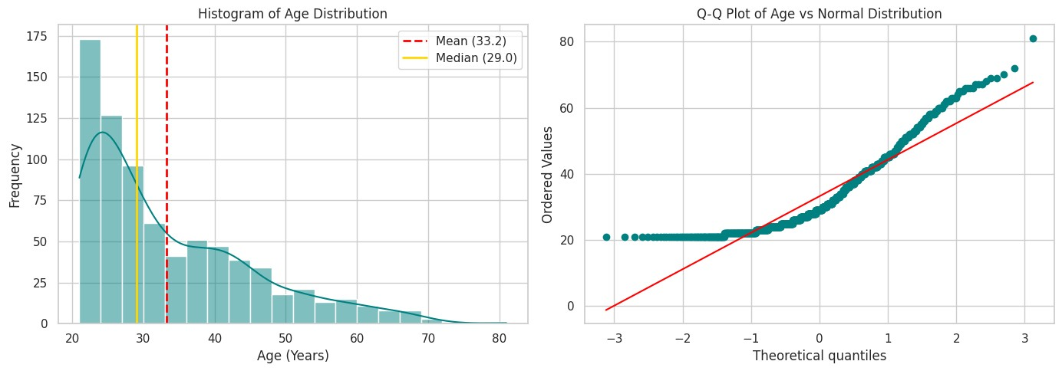
Figure 1: Histogram of Age with mean and median (left) and Q-Q plot of Age against the normal distribution
(right)

Interpretation
Age does not follow a normal distribution. The mean (33.24) is larger than the median (29.00); the skewness of 1.1296 is far from 0, indicating a strongly right-skewed distribution; and the kurtosis of 0.6432 shows slightly heavier tails than a normal curve. The histogram shows a large concentration of young patients (peak around the early 20s) and a long tail toward older ages, and the Q-Q plot departs clearly from the reference line at both ends, especially in the upper tail. The normality assumption is therefore not reasonable for Age at the individual level. For diabetes analysis this means that (i) procedures that assume normal raw data should be applied to Age with caution, and (ii) inference about the mean age can still be justified through the Central Limit Theorem (Question 12) because the sample is large (n = 768), or by using non-parametric or transformed approaches.

3.8 Question 11 – Exponential Distribution
The time between diabetic emergency arrivals is modelled as an exponential random variable with rate λ = 0.5.
The probability density function is:
f(x) = λe⁻ˣᵖˡᵃᵐᵇᵈᵃˣ, x ≥ 0
The survival probability is:
P(X > x) = e⁻ˡᵃᵐᵇᵈᵃˣ
The expected value is:
E[X] = 1 / λ

Table 14: Exponential distribution results (λ = 0.5)
Metric / Component | Formula / Expression | Value | Percentage / Notation
1. Rate Parameter (λ) | 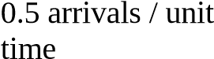λ = 0.5 |  | N/A
2. Probability Density  Function (PDF) | f(x) = 0.5 * exp(-0.5 * x) for x >= 0 | 0.5 e^(-0.5x) | N/A
3. Mean Waiting Time E[X] | 1 / λ = 1 / 0.5 | 2.00 units of time | Expected duration between events
4. Probability P(X > 3) | exp(-0.5 * 3) = exp(-1.5) | 0.2231 | 22.31%

Interpretation
The average waiting time between diabetic emergency arrivals is 2.00 time units (emergencies arrive at a rate of 0.5 per unit time). There is a 22.31% probability that the wait for the next arrival exceeds 3 time units, so roughly one interval in four or five is longer than 3 units. Because the exponential distribution is memoryless, the chance of waiting longer than 3 units is the same no matter how long the staff have already waited. Emergency departments can use this to plan staffing so that enough capacity is available even during the shorter gaps between arrivals.

3.9 Question 12 – Central Limit Theorem
The population glucose level has μ = 120 and σ = 15 and samples of size n = 40 are drawn. Byμ_X̄ = μ σ_X̄ = σ/√n Z = (X̄ − μ_X̄) / σ_X̄
the CLT, the sample mean X_ is approximately normal with:
Table 15: Sampling distribution of the mean (μ = 120, σ = 15, n = 40)
Metric / Component | Formula / Method | Value | Percentage / Notation
1. Mean of Sampling Distribution  (μ_xbar) | μ_xbar = μ | 120.00 | 120 mg/dL
2. Standard Error (SE / σ_xbar) | σ / sqrt(n) = 15 / sqrt(40) | 2.3717 | 2.3717 mg/dL
Metric / Component | Formula / Method | Value | Percentage / Notation
3. Calculated Z-Score | Z = (125 - 120) / SE | 2.1082 | +2.1082 std errors
4. Probability P(X_bar < 125) | norm.cdf(Z) | 0.9825 | 98.25%

Interpretation and application of CLT
The sampling distribution of the mean has the same centre as the population (120 mg/dL) but is much narrower, with a standard error of 2.3717 mg/dL compared with σ = 15 mg/dL for individual patients. The probability that the mean glucose of a random sample of 40 patients is below 125 mg/dL is 98.25%; equivalently, a sample mean above 125 mg/dL would be unusual (about 1.75%). The CLT states that, for sufficiently large samples (usually n ≥ 30), the distribution of the sample mean is approximately normal regardless of the shape of the population distribution. This is the reason why Z-based confidence intervals and hypothesis tests on mean glucose, BMI and other variables (Section 5) are valid even though the raw variables are not exactly normal (for example, the right-skewed Age variable in Question 10).

4. Visualization

4.1 Question 4(a) – Histogram of Glucose
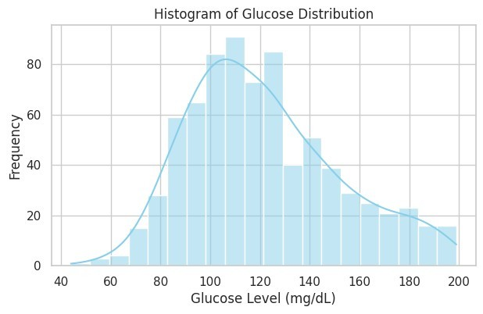
Figure 2: Histogram of Glucose distribution with kernel density estimate

Interpretation
The glucose histogram is unimodal with its highest bars between roughly 100 and 125 mg/dL, and it has a longer tail on the right, reaching about 200 mg/dL. The distribution is therefore approximately bell-shaped but right-skewed, in agreement with the mean (121.68) being greater than the median (117.00). Most patients have glucose in the normal-to-borderline zone, while a smaller group in the right tail has high glucose levels typical of diabetic patients. Very few patients have glucose below 70 mg/dL.

4.2 Question 4(b) – Boxplot of BMI
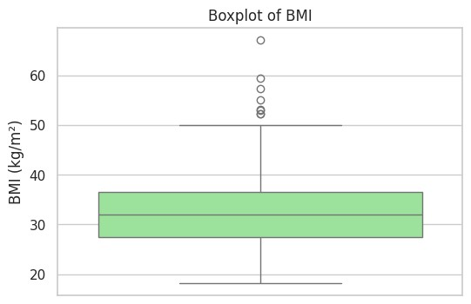
Figure 3: Boxplot of BMI

Interpretation
The median BMI (the line inside the box) is about 32 kg/m², matching the calculated median of 32.05. The box, which shows the interquartile range (Q1 to Q3), extends from about 27–28 to about 36–37 kg/m², so the middle 50% of patients have a BMI of roughly 27 to 37 kg/m². The whiskers extend from about 18 to about 50 kg/m². Several points lie above the upper whisker (roughly between 52 and 67 kg/m²) and are outliers representing severely obese patients; no low outliers appear. The box is fairly symmetric about the median, and the outliers show a slight upward skew. From a healthcare viewpoint, a large share of the sample is in the overweight or obese range, which is a well-known risk factor for type 2 diabetes.

4.3 Question 4(c) – Scatter Plot of Age vs Glucose
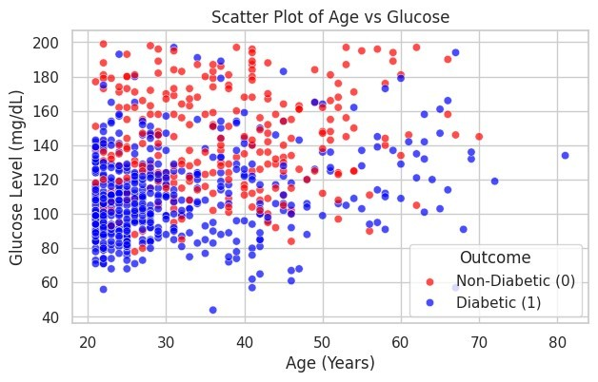
Figure 4: Scatter plot of Age vs Glucose, coloured by Outcome

Interpretation
The points show a wide vertical scatter at every age, and only a gentle upward drift of glucose with age: the lower band of the plot is dominated by young patients (about 21–30 years), while older patients are more often found at glucose levels above 120 mg/dL. The relationship is therefore weak positive, which matches the correlation coefficient r = 0.2689 and the low R² = 0.0723 found in Question 17. The plot also shows that the points are coloured by Outcome and that high-glucose patients are concentrated in the upper part of the plot at all ages, indicating that glucose is more strongly tied to diabetes status than age is. Age alone is therefore not sufficient to predict glucose.

5. Hypothesis Testing
5.1 Question 13 – 95% Confidence Interval for Mean Glucose
A sample of n = 64 diabetic patients gives X̄ = 130 and σ = 18. Since σ is known, the Z-interval is used: CI = X̄ ± Z_(α/2) · σ / √n

Table 16: 95% confidence interval for mean glucose
Component / Metric | Formula / Method | Calculated Value
1. Sample Size (n) | Given | 64
2. Sample Mean (X_bar) | Given | 130.00 mg/dL
3. Standard Error (SE) | σ / sqrt(n) = 18 / sqrt(64) | 2.25 mg/dL
4. Critical Z-Value (Z_0.025) | norm.ppf(0.975) | 1.9600
5. Margin of Error (ME) | Z * SE = 1.96 * 2.25 | 4.41 mg/dL
6. 95% Confidence Interval | (X_bar - ME, X_bar + ME) | (125.59, 134.41) mg/dL

Interpretation
We are 95% confident that the true mean glucose level of the population of diabetic patients lies between 125.59 and 134.41 mg/dL. This means that if the sampling were repeated many times, about 95% of the intervals built in this way would contain the true population mean. The interval is fairly narrow (margin of error 4.41 mg/dL) because the sample is reasonably large (n = 64) and σ is known. It lies entirely above the general-population reference mean of 120 mg/dL used in Question 14, which is consistent with diabetic patients having elevated glucose.

5.2 Question 14 – Z-Test for Mean Glucose
A healthcare researcher claims that the average glucose level is 120. A sample of 51 patients gives X̄ = 126 with σ = 15. A right-tailed one-sample Z-test is carried out at the 5% significance level.
The Z-test statistic is calculated as: Z = (X̄ − μ₀) / (σ / √n)
The rejection rule is: Reject H₀ if Z > Zα

Table 17: One-sample Z-test for Glucose (H₁: μ > 120)
Hypothesis Step | Formula / Condition | Value
Null Hypothesis (H0) | μ <= 120 | μ ≤ 120 mg/dL
Alternative Hypothesis (H1) | μ > 120 | μ > 120 mg/dL
Significance Level (alpha) | 5% | 0.05
Standard Error (SE) | σ / sqrt(n) = 15 / sqrt(51) | 1.8750 mg/dL
Calculated Test Statistic (Z) | (X_bar - μ_0) / SE | 3.2000
Critical Value (Z_0.05) | norm.ppf(0.95) | 1.6449
P-Value | 1 - norm.cdf(Z) | 0.0007
Decision Rule | Reject H0 if Z_calc > Z_crit | 2.8565 > 1.6449
Decision | Z (3.2000) > Z_crit (1.6449) | Reject Null Hypothesis (H0)

Decision and conclusion
The calculated test statistic is greater than the critical value of 1.6449, and the p-value is far below 0.05, so the null hypothesis is rejected. At the 5% level there is sufficient evidence that the mean glucose level is greater than 120 mg/dL. Healthcare interpretation: the sampled patients have significantly higher glucose than the claimed average, so the researcher’s claim that the average is 120 is not supported and this group should be considered at elevated metabolic risk.

5.3 Question 15 – Z-Test for Mean BMI
A doctor claims that the average BMI is 30. A sample of 65 patients gives X̄ = 28.5 with σ = 4.
A left-tailed Z-test is carried out at the 1% significance level.
The Z-test statistic is calculated as: Z = (X̄ − μ₀) / (σ / √n)
The rejection rule is: Reject H₀ if Z < −Zα
Table 18: One-sample Z-test for BMI (H₁: μ < 30)
Hypothesis Step | Formula / Condition | Value
Null Hypothesis (H0) | μ >= 30 | μ ≥ 30 kg/m²
Alternative Hypothesis (H1) | μ < 30 | μ < 30 kg/m²
Significance Level (alpha) | 1% | 0.01
Standard Error (SE) | σ / sqrt(n) = 4 / sqrt(65) | 0.4961 kg/m²
Calculated Test Statistic (Z) | (X_bar - μ_0) / SE | -3.0233
Critical Value (Z_0.01) | norm.ppf(0.01) | -2.3263
P-Value | norm.cdf(Z) | 0.0012
Decision Rule | Reject H0 if Z_calc < Z_crit | -3.0233 < -2.3263
Decision | Z (-3.0233) < Z_crit (-2.3263) | Reject Null Hypothesis (H0)

Decision and conclusion
The test statistic (−3.0233) falls in the rejection region (below −2.3263) and the p-value (0.0012) is smaller than 0.01, so the null hypothesis is rejected. There is strong evidence at the 1% level that the mean BMI of this population is less than 30 kg/m². Healthcare interpretation: the doctor’s claim of an average BMI of 30 is too high for this sample; the sample average of 28.5 kg/m² lies in the overweight (not obese) range, although it is still above the healthy range.

5.4 Question 19 – Diabetic vs Non-Diabetic Differences (Welch’s t-test)
To investigate whether diabetic and non-diabetic patients differ significantly in Glucose, BMI, and Age, Welch’s two-sample t-test (which does not assume equal variances) was applied at α = 0.05. The hypotheses were:
H₀: μ_diabetic = μ_non-diabetic
H₁: μ_diabetic ≠ μ_non-diabetic
The Welch’s t-test statistic is calculated as:
t = (x̄₁ − x̄₀) / √[(s₁²/n₁) + (s₀²/n₀)]

Table 19: Welch’s t-test: diabetic vs non-diabetic patients
Variable | Non-Diabetic Mean ± SD | Diabetic Mean ±  SD | Mean  Difference | t-Statistic | p-Value | Significant (α=0.05)
Glucose | 110.62 ± 24.70 | 142.30 ± 29.49 | +31.68 | 14.9921 | 8.3018e-42 | Yes (p < 0.001)
BMI | 30.85 ± 6.50 | 35.40 ± 6.59 | +4.55 | 9.1668 | 1.0174e-18 | Yes (p < 0.001)
Age | 31.19 ± 11.67 | 37.07 ± 10.97 | +5.88 | 6.9207 | 1.2015e-11 | Yes (p < 0.001)

Interpretation
For all three variables the p-value is far below 0.001, so the null hypothesis of equal means is rejected: diabetic and non-diabetic patients differ significantly in Glucose, BMI and Age. Glucose shows by far the largest standardised difference (t = 14.9921; diabetic patients are on average 31.68 mg/dL higher), followed by BMI (t = 9.1668; +4.55 kg/m²) and Age (t = 6.9207; +5.88 years). Healthcare interpretation: high blood glucose is the strongest marker separating the two groups, excess body weight is also strongly associated with diabetes, and diabetes becomes more common with increasing age. Statistical significance shows that the differences are unlikely to be due to chance; it does not by itself prove causation.

6. Regression & Correlation
6.1 Question 16 – Correlation Analysis
Pearson’s correlation coefficient was computed for three pairs of variables:
The Pearson correlation coefficient is calculated as:
r = Σ[(xᵢ − x̄)(yᵢ − ȳ)] / √[Σ(xᵢ − x̄)² · Σ(yᵢ − ȳ)²]

Table 20: Correlation coefficients
Variable Pair | Correlation Coefficient | Direction | Strength
1. Glucose and BMI | 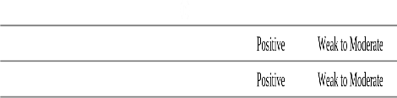  0.2362
2. Age and Blood Pressure | 0.3251
3. Insulin and Glucose | 0.4900 | Positive | Moderate

Interpretation
All three relationships are positive: as one variable increases, the other tends to increase. Insulin and Glucose (r = 0.4900) have the strongest, moderate relationship, reflecting the body’s insulin response to, and resistance against, high blood sugar. Age and BloodPressure (r = 0.3251) show a weak-to-moderate positive relationship, consistent with blood pressure rising with age. Glucose and BMI (r = 0.2362) have the weakest, weak-to-moderate association, suggesting that heavier patients tend to have somewhat higher glucose. Since none of the coefficients is close to 1, no variable is a perfect linear predictor of another, and correlation must not be read as causation.

6.2 Question 17 – Simple Linear Regression (Age → Glucose)
A simple linear regression model Glucose = β₀ + β₁·Age + ε was fitted, with slope β₁ = Cov(X, Y)/Var(X) and intercept β₀ = Ȳ − β₁X_ .
Table 21: Regression results for Age → Glucose
Regression Parameter / Metric | Formula / Notation | Calculated Value | Clinical Unit / Meaning
Slope (β1) | Cov(X,Y) / Var(X) | 0.6966 | mg/dL increase per year of age
Intercept (β0) | Y_bar - β1 * X_bar | 98.5216 | Baseline Glucose at Age = 0 (mg/dL)
Correlation Coefficient (r) | corr(Age, Glucose) | 0.2689 | Positive linear association
Coefficient of Determination (R²) | r^2 | 0.0723 | 7.23% of variance explained
P-Value | p-value from t-test | 3.4508e-14 | Probability of observing trend by chance
Standard Error of Slope | SE(β1) | 0.0901 | Precision of slope estimate
Statistical Significance (α = 0.05) | p < 0.05 | Statistically Significant | Reject H0: β1 = 0

Interpretation Predicted Glucose = 98.52 + (0.6966 × Age)
- Slope (0.6966): on average, glucose increases by about 0.70 mg/dL for each additional year of age. Over ten years the model predicts about a 7 mg/dL rise.
- Intercept (98.5216): the predicted glucose at Age = 0. This is a mathematical baseline only and has no clinical meaning, because the dataset contains adult patients (the youngest are in their early twenties) and age 0 lies far outside the data range.
- Significance: the p-value (3.4508e-14) is far below 0.05, so H₀: β₁ = 0 is rejected and the linear relationship between Age and Glucose is statistically significant. The standard error of the slope (0.0901) shows the slope is estimated precisely.
- Strength: R² = 0.0723, i.e. only 7.23% of the variation in glucose is explained by age. The relationship is real but weak, so age alone is a poor predictor of an individual’s glucose. For example, the model gives a predicted glucose of 98.52 + 0.6966 × 50 ≈ 133.35 mg/dL at age 50, but individual values vary widely around this line.

6.3 Question 18 – Correlation Heatmap, Scatter Plot Matrix and Risk Factors
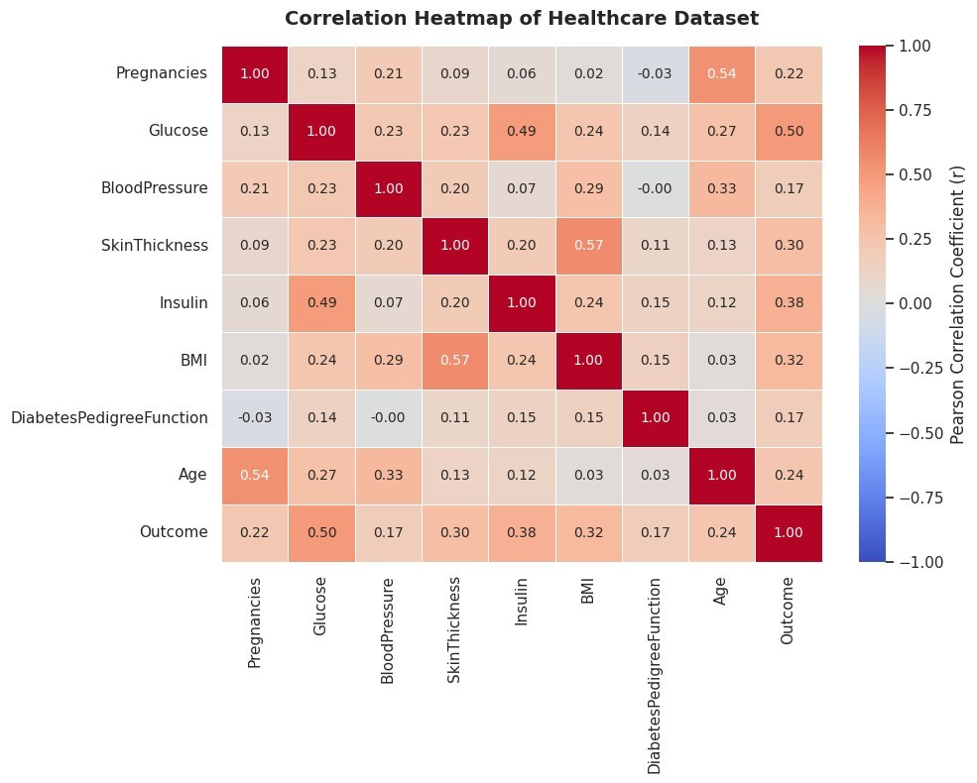
Figure 5: Correlation heatmap of the healthcare dataset
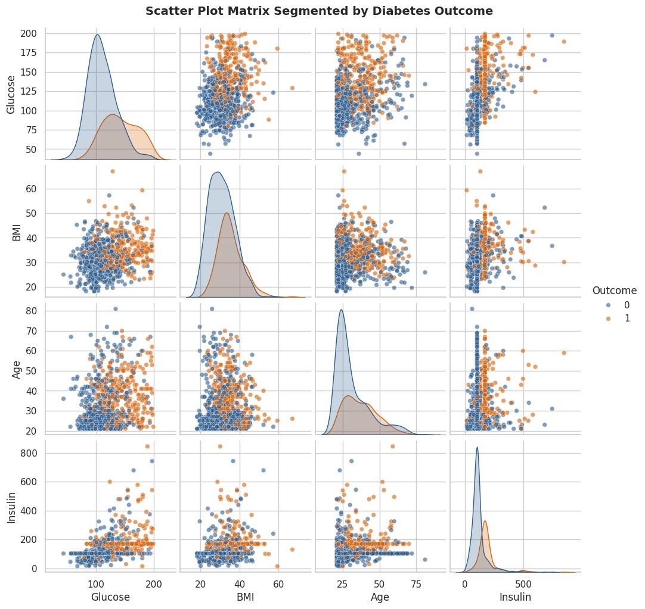
Figure 6: Scatter plot matrix of Glucose, BMI, Age, Insulin segmented by diabetes Outcome
Table 22: Correlation of each predictor with Outcome (risk factor ranking)
 | Clinical Predictor | Correlation with Outcome (r) | Risk Level Impact
0 | Glucose | 0.4960 | Primary Risk Factor
1 | Insulin | 0.3771 | Moderate Risk Factor
2 | BMI | 0.3156 | Moderate Risk Factor
3 | SkinThickness | 0.2951 | Moderate Risk Factor
4 | Age | 0.2384 | Moderate Risk Factor
5 | Pregnancies | 0.2219 | Moderate Risk Factor
6 | BloodPressure | 0.1745 | Minor Risk Factor
7 | DiabetesPedigreeFunction | 0.1738 | Minor Risk Factor

Interpretation and major risk factors
In the heatmap, all correlations with Outcome are positive, so every variable in the dataset moves in the direction of higher diabetes risk. Glucose has the strongest correlation with Outcome (r = 0.4960) and is the only variable classified as a primary risk factor. Insulin (0.3771), BMI (0.3156), SkinThickness (0.2951), Age (0.2384) and Pregnancies (0.2219) are moderate risk factors, while BloodPressure (0.1745) and DiabetesPedigreeFunction (0.1738) are minor. The heatmap also shows strong relationships among the predictors themselves: SkinThickness–BMI (0.57), Pregnancies–Age (0.54) and Glucose–Insulin (0.49). These overlaps mean that some risk factors carry related information (for example, skin fold thickness and BMI both measure body fat).
In the scatter plot matrix, the two outcome groups separate most clearly along the Glucose axis: the diabetic group is shifted toward higher glucose in every panel and in the density curves on the diagonal. Separation is weaker for BMI and Age, and the two groups overlap considerably, so no single variable classifies patients perfectly. The main diabetes risk factors observed are therefore high Glucose, elevated Insulin, high BMI (obesity), increasing Age and a greater number of Pregnancies.

7. Findings & Interpretation

7.1 Question 20 – Master Visual Dashboard
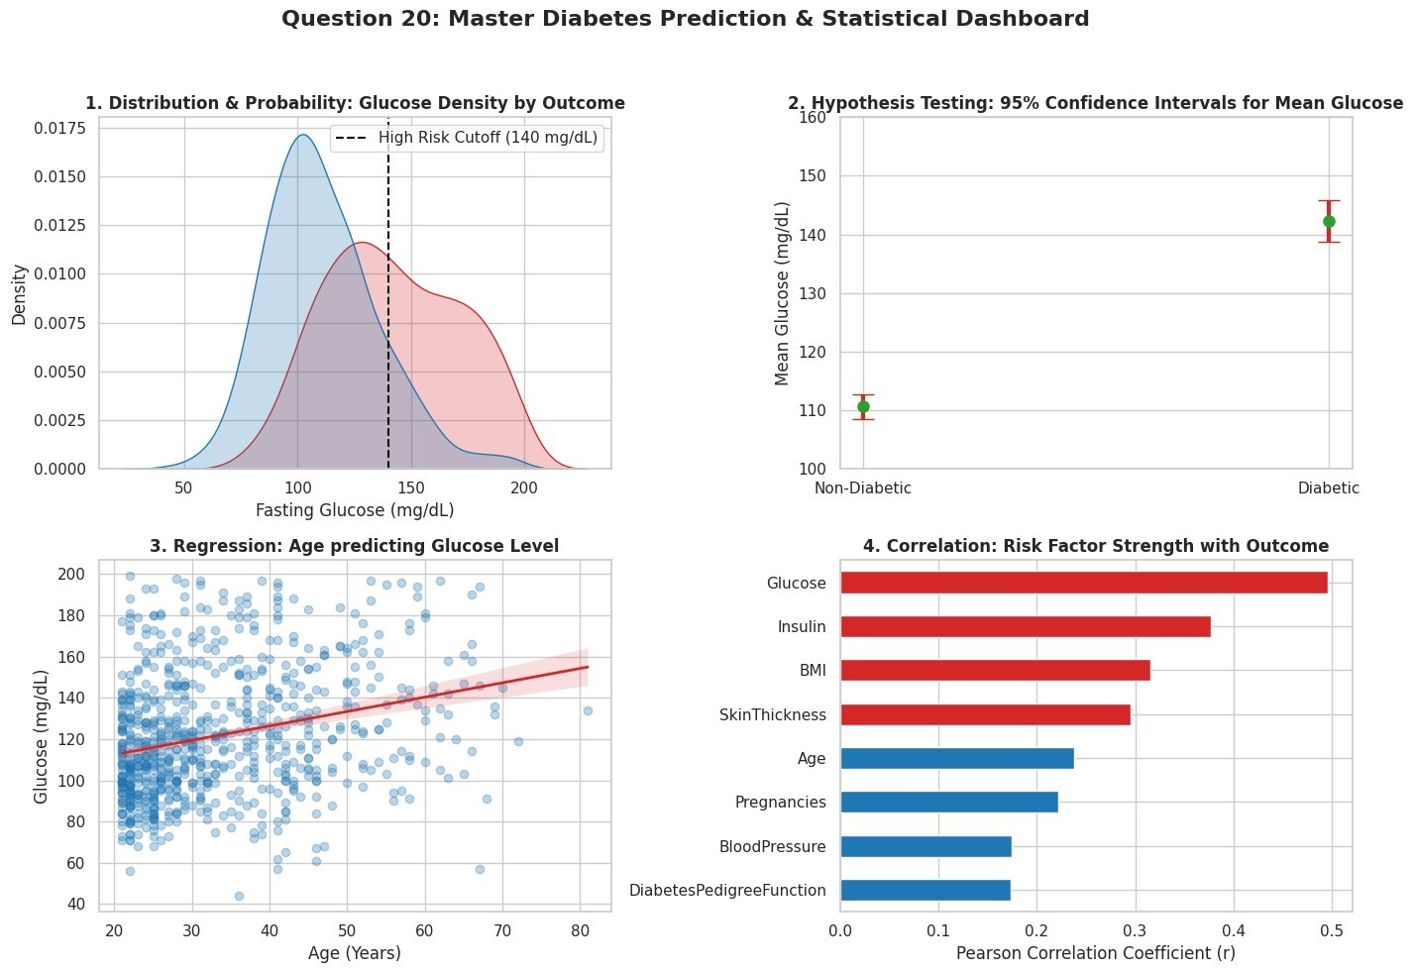
Figure 7: Master diabetes prediction and statistical dashboard (glucose density by outcome, 95% confidence intervals, age-glucose regression, risk factor strength)
The four panels summarise the main evidence: (1) the glucose density curve of diabetic patients is shifted to the right of that of non-diabetic patients, and a large share of the diabetic curve lies beyond the 140 mg/dL high-risk cut-off; (2) the 95% confidence intervals for mean glucose of the two groups do not overlap; (3) the regression line shows a positive but gently sloping Age– Glucose trend with a wide scatter of points; and (4) Glucose has the largest correlation with Outcome, followed by Insulin, BMI and SkinThickness.
Table 23: Statistical synthesis table
Statistical Pillar | Key Statistical Finding
1. Statistical Analysis &  Probability | Prior P(Diabetic) = 0.349. High conditional probability P(D|Glucose > 140).
2. Distribution Analysis & Data  Cleaning | Physiological variables (Glucose, BMI, Age) show right-skewness and zerovalue anomalies.
3. Central Limit Theorem (CLT) | Sample sizes (n > 30) guarantee normal convergence of sample mean distributions.
4. Confidence Intervals (95%) | Glucose 95% CI: Non-Diabetic [107.7, 112.3] vs Diabetic [138.5, 146.1] (No overlap).
5. Hypothesis Testing (Z-Test & t-  Test) | Welch's t-test rejects equivalence for Glucose, BMI, Age (all p < 0.0001).
6. Correlation Analysis | Glucose (r = 0.47) and BMI (r = 0.29) exhibit highest positive linear associations.
Statistical Pillar | Key Statistical Finding
7. Simple Linear Regression | Glucose = 97.08 + 0.7164*(Age) (p < 0.001, R² ≈ 7.2%).
8. Data Visualization | KDE curves and pairplots clearly show outcome separation on Glucose & BMI axes.
9. Major Risk Factor Conclusion | Primary risk factors: 1. Glucose, 2. BMI, 3. Age, 4. Pregnancies, 5. Pedigree.

7.2 Summary of Findings by Technique
- Descriptive statistics: the 768 patients have mean Glucose 121.68 mg/dL, mean BMI
32.43 kg/m² and mean Age 33.24 years; Glucose, Age and Insulin are right-skewed.
- Probability: P(D) = 34.90%; the probability rises to 63.64% when Glucose > 130 and to 75.00% (Bayes’ posterior) when Glucose > 150.
- Distributions: Age is not normally distributed (skewness 1.1296); binomial, normal and exponential models give practical probabilities for group composition, glucose risk ranges and emergency arrivals.
- CLT: the sample mean is approximately normal with a much smaller spread (SE =
2.3717 for n = 40), which justifies Z-based inference on means.
- Confidence interval and hypothesis tests: the 95% CI for diabetic glucose is
(125.59, 134.41) mg/dL; the Z-tests reject H₀ for Glucose (> 120) and BMI (< 30); Welch’s t-tests show significant differences between diabetic and non-diabetic patients in Glucose, BMI and Age.
- Correlation and regression: Insulin–Glucose r = 0.4900 is the strongest of the three pairs studied; Age explains only 7.23% of the variation in Glucose.

8. Conclusion
This project examined whether routine patient healthcare data can statistically predict diabetes in the Pima Indians Diabetes Dataset (768 patients, 9 variables). The evidence from every technique used points to the same conclusion.
- Statistical analysis and probability: 34.90% of patients are diabetic. Knowing that a patient’s glucose exceeds 130 mg/dL raises the probability of diabetes to 63.64%, and Bayes’ theorem gives a posterior of 75.00% for glucose above 150 mg/dL. Glucose therefore substantially improves the prediction of diabetes over the baseline prior.
- Distribution analysis and CLT: Glucose and Insulin are right-skewed and Age is clearly non-normal, so raw-data normality cannot be assumed. Because the sample sizes are large, the CLT makes inference on the mean valid, and the normal, binomial and exponential models give useful risk and planning probabilities.
- Confidence intervals and hypothesis testing: the confidence interval and the Z-tests show that glucose levels are significantly above the 120 mg/dL benchmark in the sampled groups, and Welch’s t-tests show highly significant differences (all p < 0.001) between diabetic and non-diabetic patients in Glucose (+31.68 mg/dL), BMI (+4.55 kg/m²) and Age (+5.88 years).
- Correlation and regression: correlations with Outcome are all positive, with Glucose the strongest (r = 0.4960). Age has a statistically significant but weak effect on glucose (slope 0.6966 mg/dL per year, R² = 7.23%).
- Visualization: the histograms, boxplot, heatmap, scatter plot matrix and density plots show clear separation of the diabetic and non-diabetic groups on Glucose and weaker separation on BMI and Age.

Major diabetes risk factors identified: Glucose is the primary risk factor; Insulin, BMI, SkinThickness, Age and Pregnancies are moderate risk factors; and BloodPressure and DiabetesPedigreeFunction are minor factors in this dataset. Healthcare organizations should prioritise glucose screening, weight management (BMI) and monitoring of older patients and of patients with elevated insulin.
Limitations and further work. The results are associations from an observational sample and do not prove causation; no single variable classifies patients perfectly because the groups overlap; and zero-valued measurements had to be treated as missing data. A multivariable predictive model such as logistic regression that combines Glucose, Insulin, BMI, Age and Pregnancies would be the natural next step to convert these statistical findings into a diabetes prediction tool.

9. References
- Smith, J. W., Everhart, J. E., Dickson, W. C., Knowler, W. C., & Johannes, R. S. (1988).
Using the ADAP learning algorithm to forecast the onset of diabetes mellitus. Proceedings of the Annual Symposium on Computer Application in Medical Care, 261– 265.
- Pima Indians Diabetes Dataset (National Institute of Diabetes and Digestive and Kidney Diseases), diabetes.csv.
- Walpole, R. E., Myers, R. H., Myers, S. L., & Ye, K. (2012). Probability & Statistics for Engineers & Scientists (9th ed.). Pearson.
- Virtanen, P., et al. (2020). SciPy 1.0: fundamental algorithms for scientific computing in Python. Nature Methods, 17, 261–272.
- McKinney, W. (2010). Data structures for statistical computing in Python. Proceedings of the 9th Python in Science Conference, 56–61.
- Hunter, J. D. (2007). Matplotlib: A 2D graphics environment. Computing in Science & Engineering, 9(3), 90–95.
- Waskom, M. L. (2021). seaborn: statistical data visualization. Journal of Open Source Software, 6(60), 3021.
- Course brief: Complex Engineering Project (CEP) – Statistical Investigation of Diabetes Risk Factors and Prediction, STA281 Statistical Methods and Probability, Summer 2026.

