|  |
| --- |
|  |

|  |
| --- |
|  |
| ASEAN QUIZ 2014 (MALAYSIA) QUIZ USER MANUAL |
| logo penerangandownload.jpgQuiz User Manual |

Table of Contents

1 Student Quiz Module 3

1.1 URL 3

1.2 Login 3

1.3 Type of question 4

1.4 Main screen 4

1.5 Skip Question 5

1.6 Remaining Time 5

1.7 Slogan 5

1.8 Logout 5

Table of Figures

Figure 1‑1 Student quiz login view 3

Figure 1‑2 Student main screen 4

1‑3 Logout screen 6

# Student Quiz Module

## URL

Website of Quiz Module is accessible at http://asean.inform.gov.my/kpn-quiz-hub/

## Login

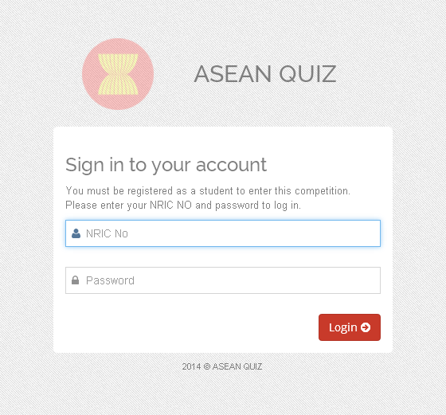

Figure 1‑1 Student quiz login view

|  |  |
| --- | --- |
| Field | Default value |
| Username | Student NRIC number |
| Password | First 6 digit of student NRIC |
| Login | Login button |

## Type of question

Quiz has 3 type of question

1. Multiple choices : 40
2. True and False : 10
3. Slogan : 1

Total question: 51

## Main screen

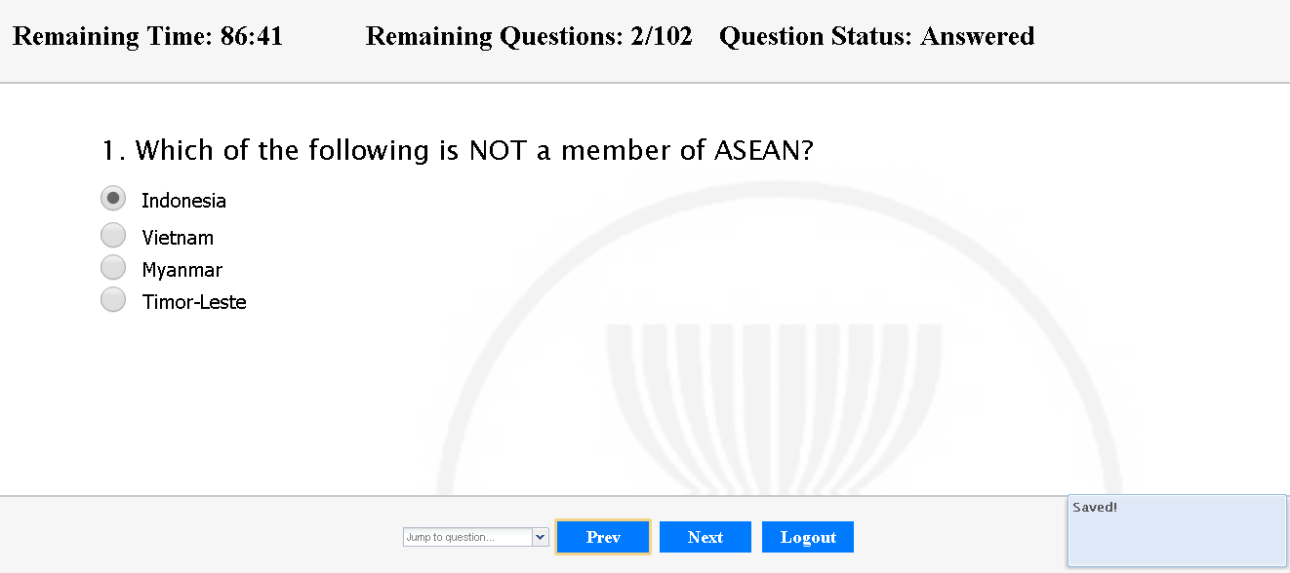

8

2

4

3

9

7

6

5

1

Figure ‑ Student main screen

|  |  |
| --- | --- |
| Item | Description |
| 1 | Remaining time before quiz ended |
| 2 | Remaining question ( total answered of total question ) |
| 3 | Question status (answered or unanswered ) |
| 4 | Current question |
| 5 | Question list |
| 6 | Move to previous question |
| 7 | Move to next question |
| 8 | Logout button |
| 9 | Popup message |

## Skip Question

1. Click on Question List (item 5 in Figure 1‑2 Student main screen).
2. Dropdown lists as following appear.

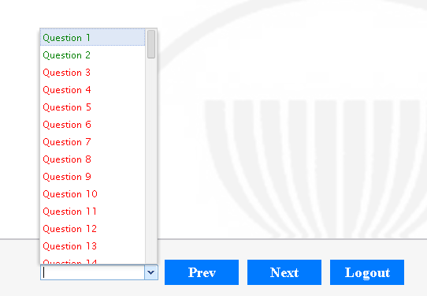

1. Question in red indicated, an unanswered question and green mean it’s answered question
2. Click on Question number to view question details
3. Current question answer will be save automatically
4. Popup message as in (item 9 Figure 1‑2 Student main screen) will be appeared
5. You’re allowed to move next or previous question without answering current question

## Remaining Time

1. The remaining time text colour will change to red when 10 minute left
2. When time out, current question answer will be saved and you’ll be force to logout

## Slogan

1. Participants need to complete the slogan given in not more in 25 words

## Logout

1. Click on logout after you finished answer all question given
2. The following page will be appear
3. Click Logout again to completely logout

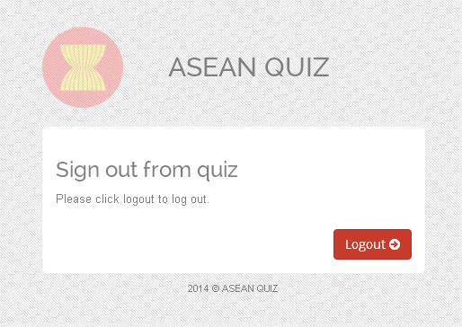

‑ Logout screen