1️⃣ CLone keep dari git & Masuk ke folder repo Keep
git clone https://github.com/keephq/keep.git
cd /home/rafli/keep

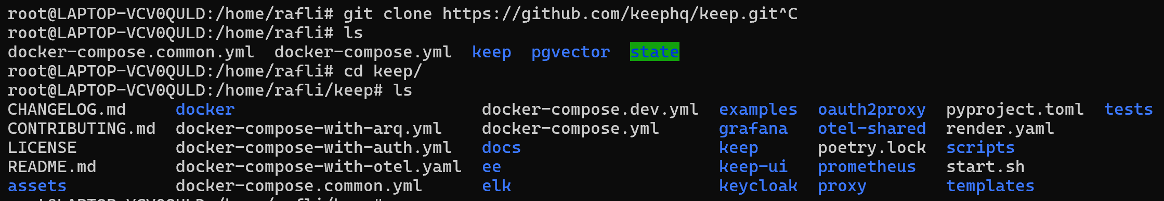

2️⃣ Pastikan Docker Compose v2
docker compose version

Docker Compose version v2.25.0

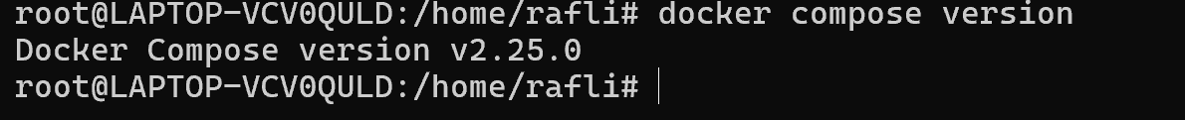

3️⃣ Jalankan Keep (SESUAI DOCS)
Edit docker-compose.common.yml:
services:
keep-frontend-common:
ports:
- "3000:3000"
environment:
- NEXTAUTH_SECRET=secret
- NEXTAUTH_URL=http://192.168.9.100:3000
- NEXT_PUBLIC_API_URL=http://192.168.9.100:8080
- POSTHOG_KEY=phc_muk9qE3TfZsX3SZ9XxX52kCGJBclrjhkP9JxAQcm1PZ
- POSTHOG_HOST=https://ingest.keephq.dev
- NEXT_PUBLIC_SENTRY_DSN=https://0d4d59e3105ffe8afa27dcb95a222009@o4505515398922240.ingest.us.sentry.io/4508258058764288
- PUSHER_HOST=localhost
- PUSHER_PORT=6001
- PUSHER_APP_KEY=keepappkey

keep-backend-common:
ports:
- "8080:8080"
environment:
- PORT=8080
- SECRET_MANAGER_TYPE=FILE
- SECRET_MANAGER_DIRECTORY=/state
- DATABASE_CONNECTION_STRING=postgresql://keep_rw:P@ssw0rd#keep_rw@192.168.9.212:6432/keepdb
- OPENAI_API_KEY=disable
- PUSHER_APP_ID=1
- PUSHER_APP_KEY=keepappkey
- PUSHER_APP_SECRET=keepappsecret
- PUSHER_HOST=keep-websocket-server
- PUSHER_PORT=6001
- USE_NGROK=false

keep-websocket-server-common:
image: quay.io/soketi/soketi:1.4-16-debian
ports:
- "6001:6001"
- "9601:9601"
environment:
- SOKETI_USER_AUTHENTICATION_TIMEOUT=3000
- SOKETI_DEBUG=1
- SOKETI_DEFAULT_APP_ID=1
- SOKETI_DEFAULT_APP_KEY=keepappkey
- SOKETI_DEFAULT_APP_SECRET=keepappsecret

Edit docker-compose.yml :
services:
keep-frontend:
extends:
file: docker-compose.common.yml
service: keep-frontend-common
image: us-central1-docker.pkg.dev/keephq/keep/keep-ui
environment:
- AUTH_TYPE=NO_AUTH
- API_URL=http://192.168.9.100:8080
volumes:
- ./state:/state
depends_on:
- keep-backend

keep-backend:
extends:
file: docker-compose.common.yml
service: keep-backend-common
image: us-central1-docker.pkg.dev/keephq/keep/keep-api
environment:
- AUTH_TYPE=NO_AUTH
- PROMETHEUS_MULTIPROC_DIR=/tmp/prometheus
- KEEP_METRICS=true
volumes:
- ./state:/state

keep-websocket-server:
extends:
file: docker-compose.common.yml
service: keep-websocket-server-common

grafana:
image: grafana/grafana:latest
profiles:
- grafana
ports:
- "3001:3000"
volumes:
- ./grafana:/var/lib/grafana
- ./grafana/provisioning:/etc/grafana/provisioning
- ./grafana/dashboards:/etc/grafana/dashboards
environment:
- GF_SECURITY_ADMIN_USER=admin
- GF_SECURITY_ADMIN_PASSWORD=admin
- GF_USERS_ALLOW_SIGN_UP=false
depends_on:
- prometheus

prometheus:
image: prom/prometheus:latest
profiles:
- grafana
ports:
- "9090:9090"
volumes:
- ./prometheus/prometheus.yml:/etc/prometheus/prometheus.yml
command:
- "--config.file=/etc/prometheus/prometheus.yml"
depends_on:
- keep-backend

docker compose up -d

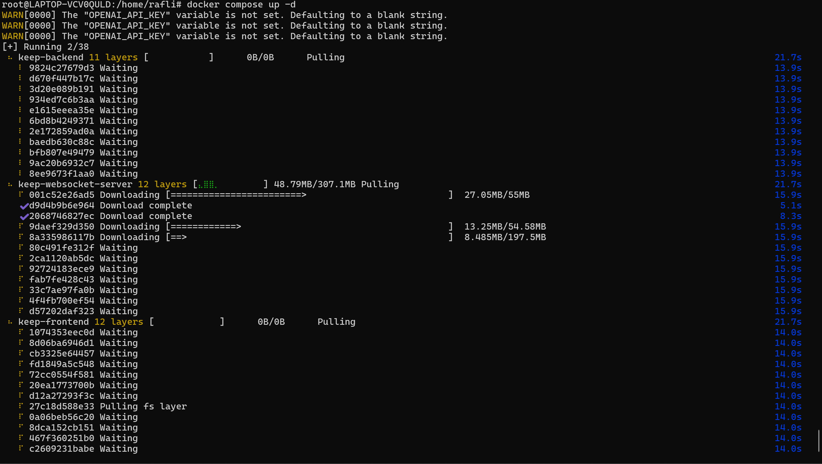

4️⃣ Cek container
docker ps
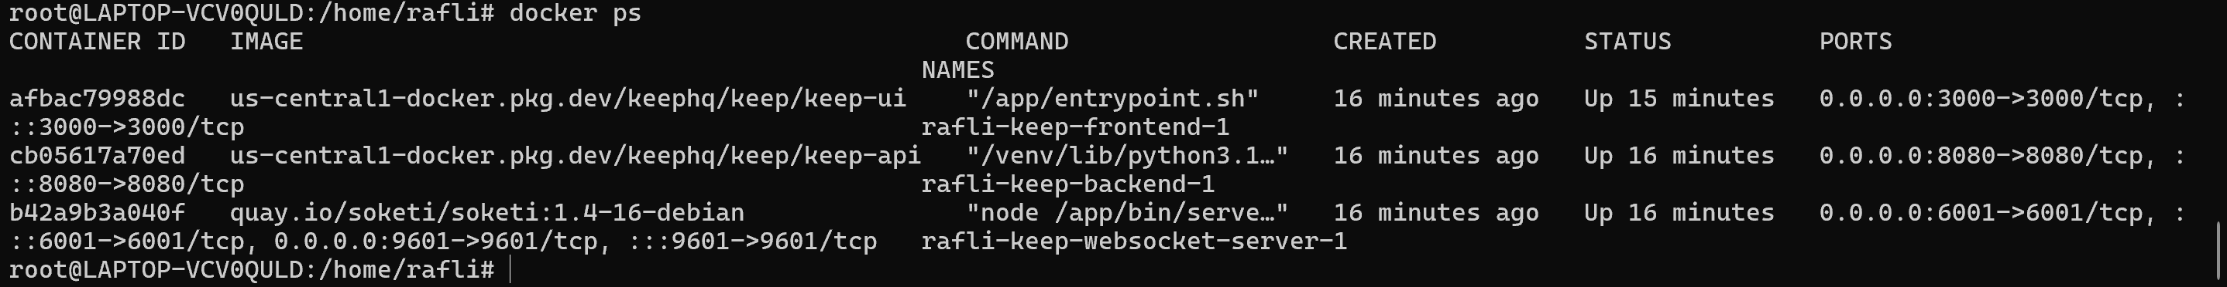

5️⃣ Akses UI
http://localhost:3000

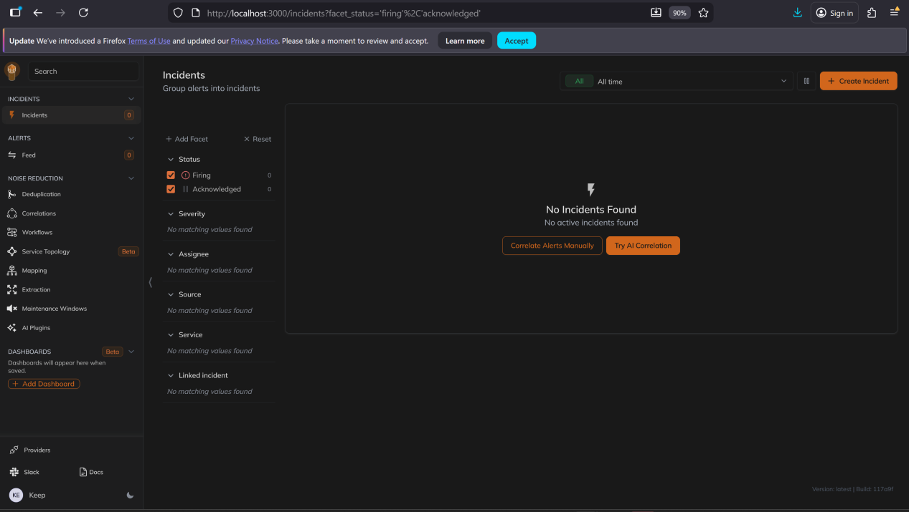

📦 Install PostgreSQL via Docker

1. Buat folder
mkdir -p /opt/postgres
cd /opt/postgres

Buat docker-compose.yml
version: "3.9"
services:
postgres:
image: postgres:16
container_name: postgres
restart: unless-stopped
ports:
- "5432:5432"
environment:
POSTGRES_DB: appdb
POSTGRES_USER: postgres
POSTGRES_PASSWORD: strongpassword
volumes:
- pgdata:/var/lib/postgresql/data

volumes:
pgdata:

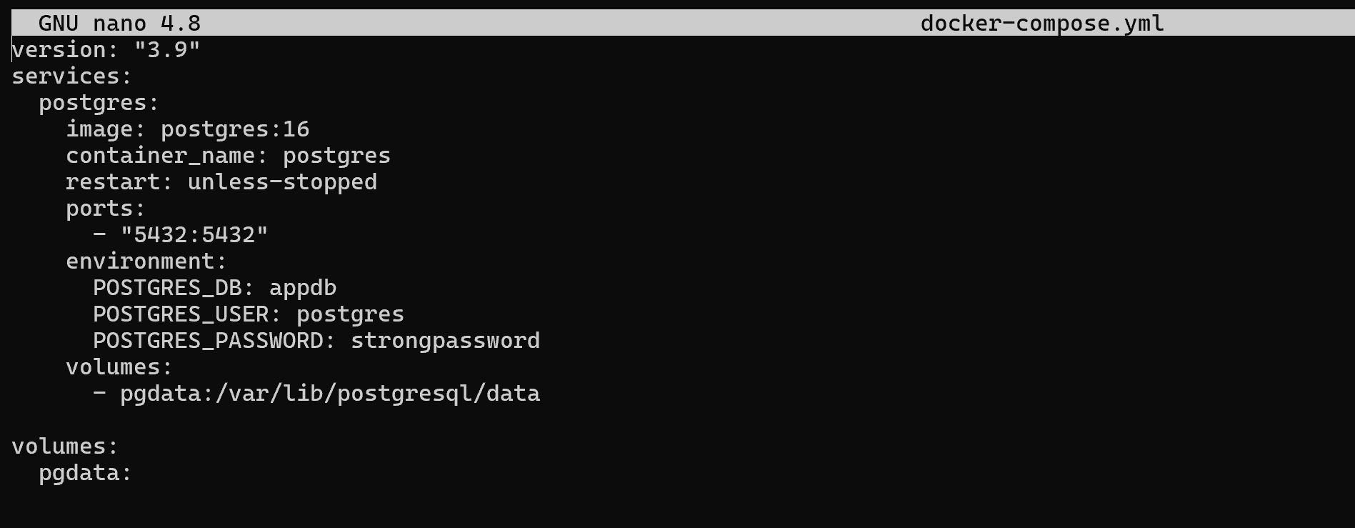

3. Jalankan
docker compose up -d

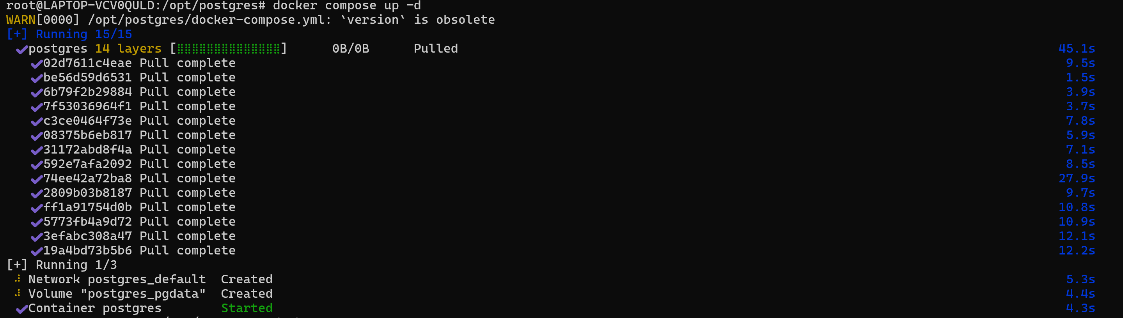

4. Test
docker ps
psql -h localhost -U postgres -d appdb
docker exec -it postgres psql -U postgres -d appdb

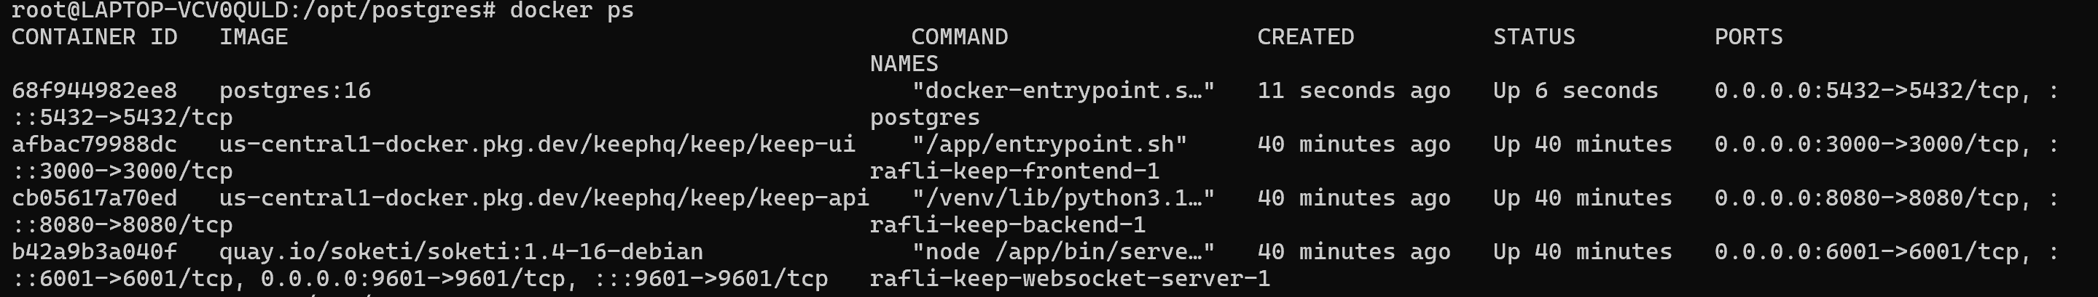
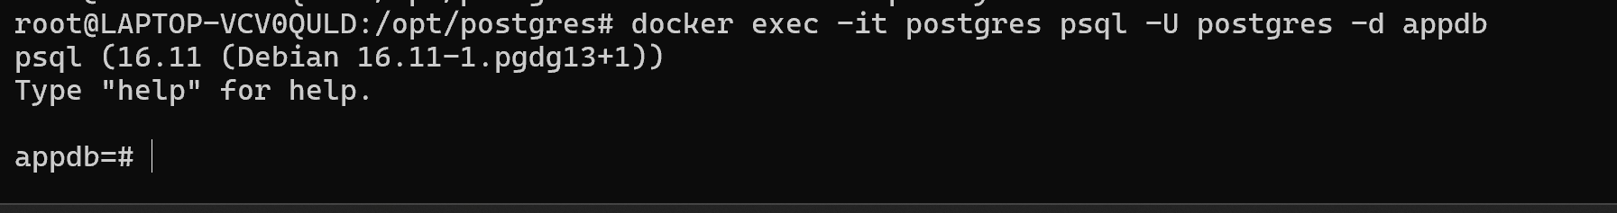

Cara connect keep dengan postgresql

BUAT USER KHUSUS UNTUK KEEP (WAJIB)
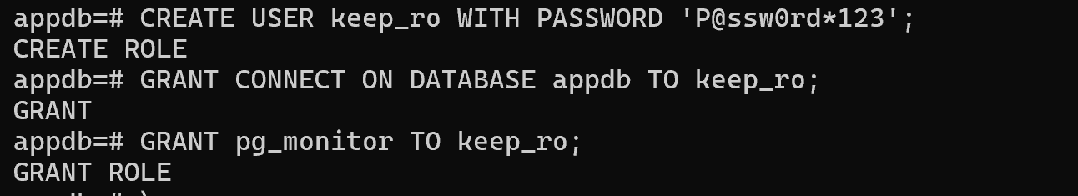
CREATE USER keep_ro WITH PASSWORD 'KeepStrongPass!';
GRANT CONNECT ON DATABASE appdb TO keep_ro;
GRANT pg_monitor TO keep_ro;

(Optional, kalau nanti ada tabel)
GRANT USAGE ON SCHEMA public TO keep_ro;
GRANT SELECT ON ALL TABLES IN SCHEMA public TO keep_ro;

Connect dari web ui keep
Settings → Providers → PostgreSQL → Add
Isi:
Host: postgres (jika satu docker network)
Port: 5432 (sesuaikan)
Database: appdb (sesuaikan)
User: keep_ro (sesuaikan)
Password: KeepStrongPass! (sesuaikan)

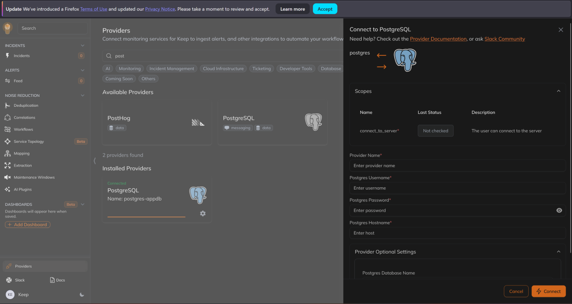

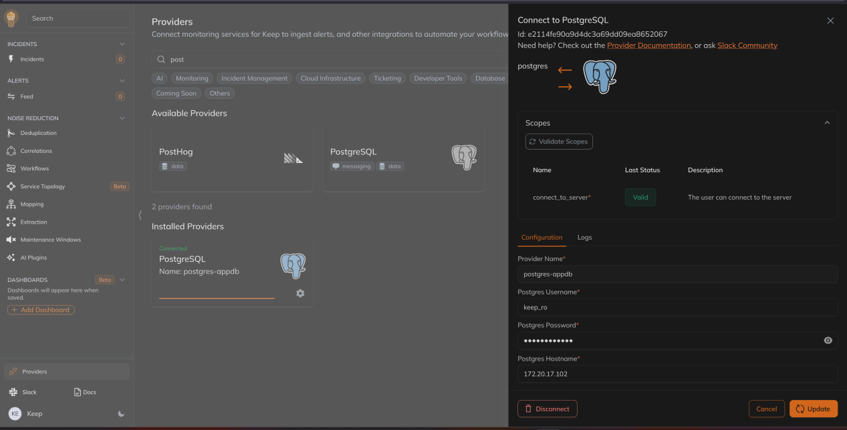

🧩 PRASYARAT YANG SUDAH ADA
✅ PostgreSQL via Docker
✅ Keep UI & backend running
✅ Provider PostgreSQL SUDAH CONNECT

🎯 TARGET AKHIR:
1️⃣ Alert max_connections > 80%
2️⃣ Root cause analysis: kenapa timeout (active vs idle)
3️⃣ Report harian kesehatan database (disk, connection, size)
4️⃣ Notifikasi otomatis (Slack / Telegram)

1️⃣ ALERT: MAX CONNECTION > 80%

🔍 QUERY (Keep akan jalankan ini)
SELECT
current_setting('max_connections')::int AS max_conn,
count(*) AS used_conn,
round((count(*)::numeric / current_setting('max_connections')::numeric) * 100, 2) AS usage_percent
FROM pg_stat_activity;

⚙️ DI KEEP (Workflow)
Step:
Workflows → Create Workflow
Trigger
Type: PostgreSQL
Provider: postgres-appdb
Query: (query di atas)
Interval: 1 minute

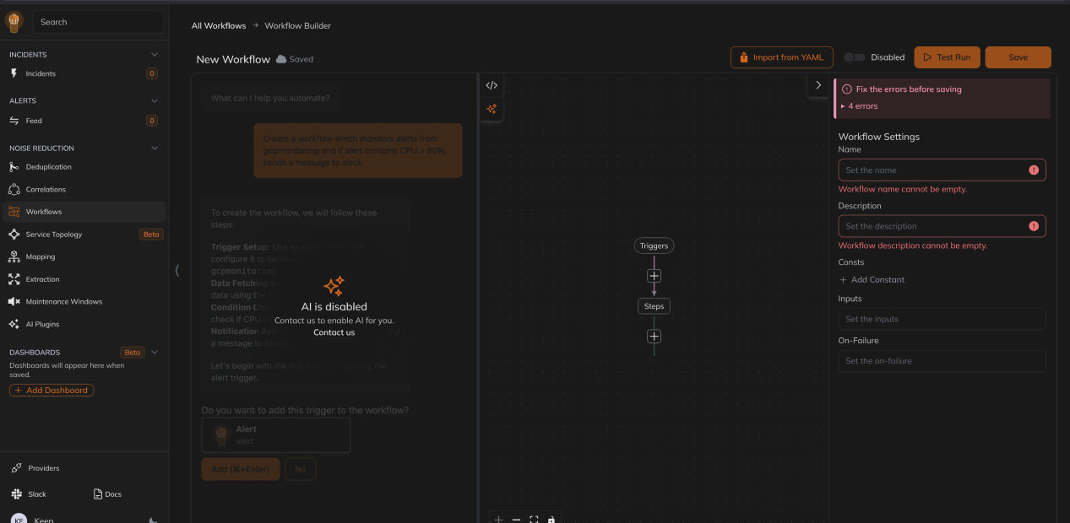

✅ LANGKAH 1 — PILIH TRIGGER: INTERVAL
Every: 1
Unit: Minute

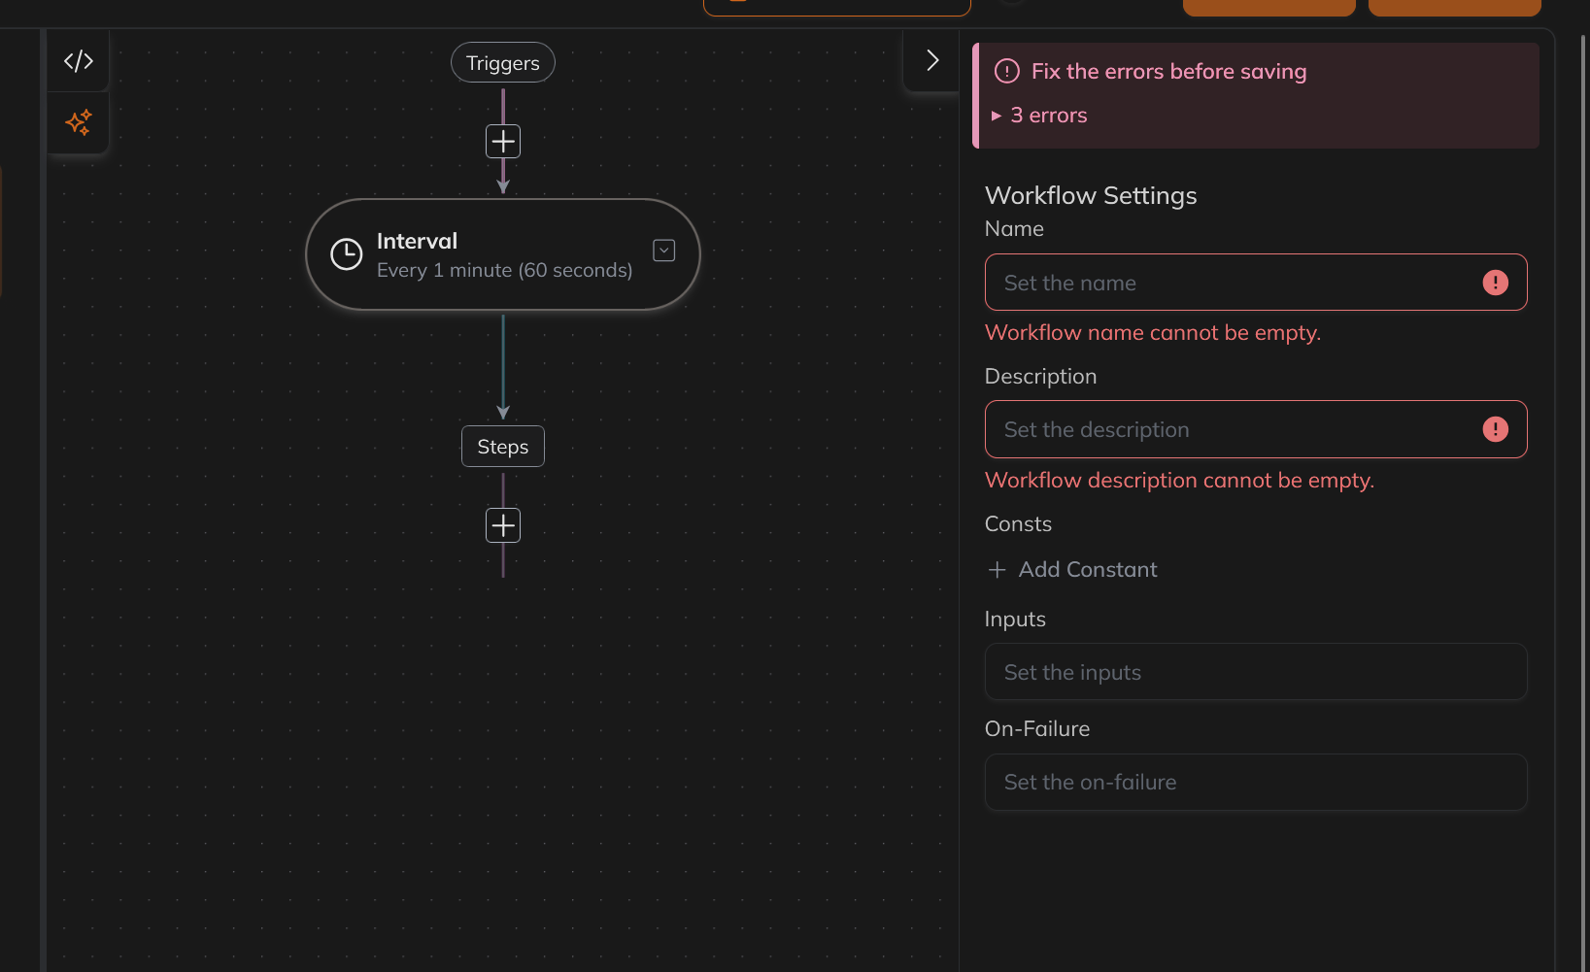

✅ LANGKAH 2 — TAMBAH STEP: DATABASE QUERY
Sekarang fokus ke Steps (bawah)
👉 Klik ➕ di bawah Steps

Cari dan pilih:
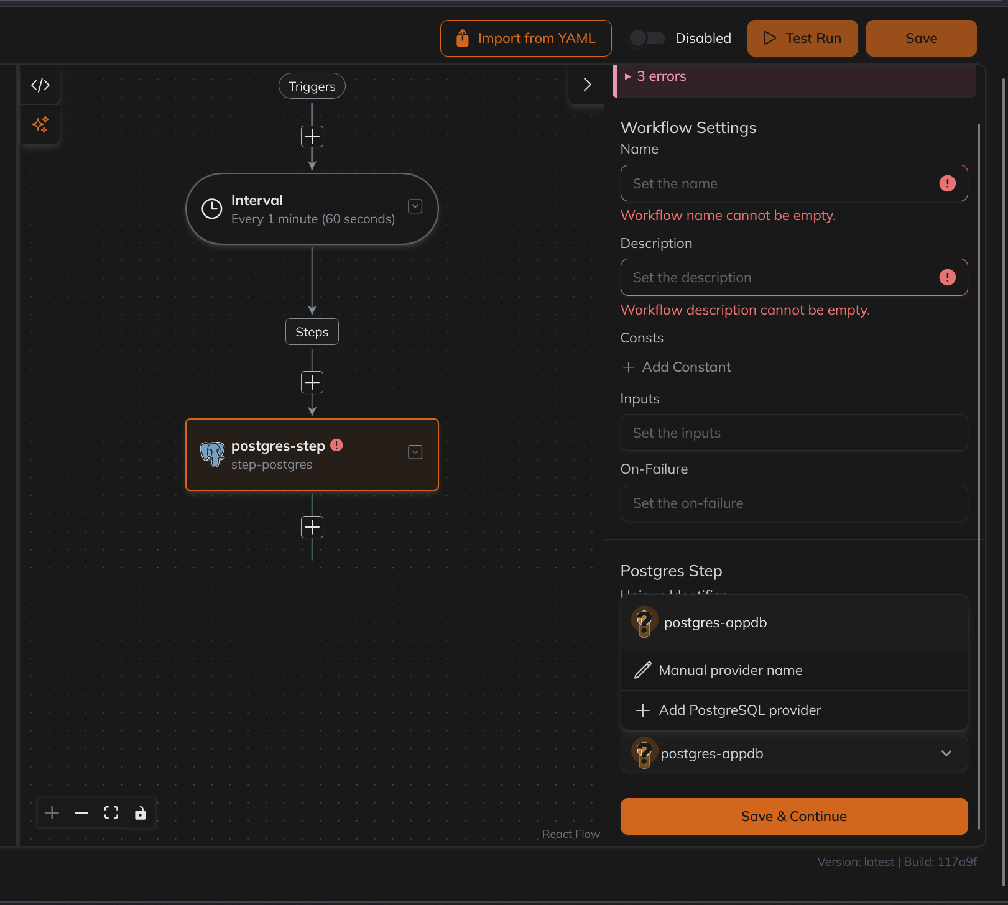

✅ LANGKAH 2 — Pilih configure tambahkan query lalu save dan test
SELECT
current_setting('max_connections')::int AS max_conn,
count(*) AS used_conn,
round(
(count(*)::numeric / current_setting('max_connections')::numeric) * 100,
2
) AS usage_percent
FROM pg_stat_activity;

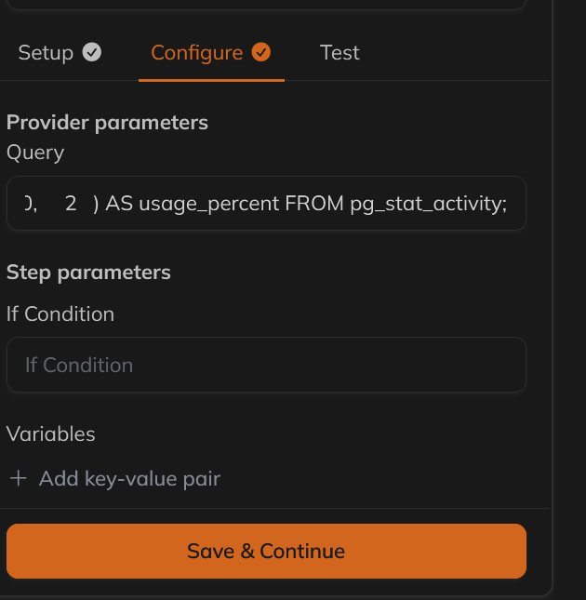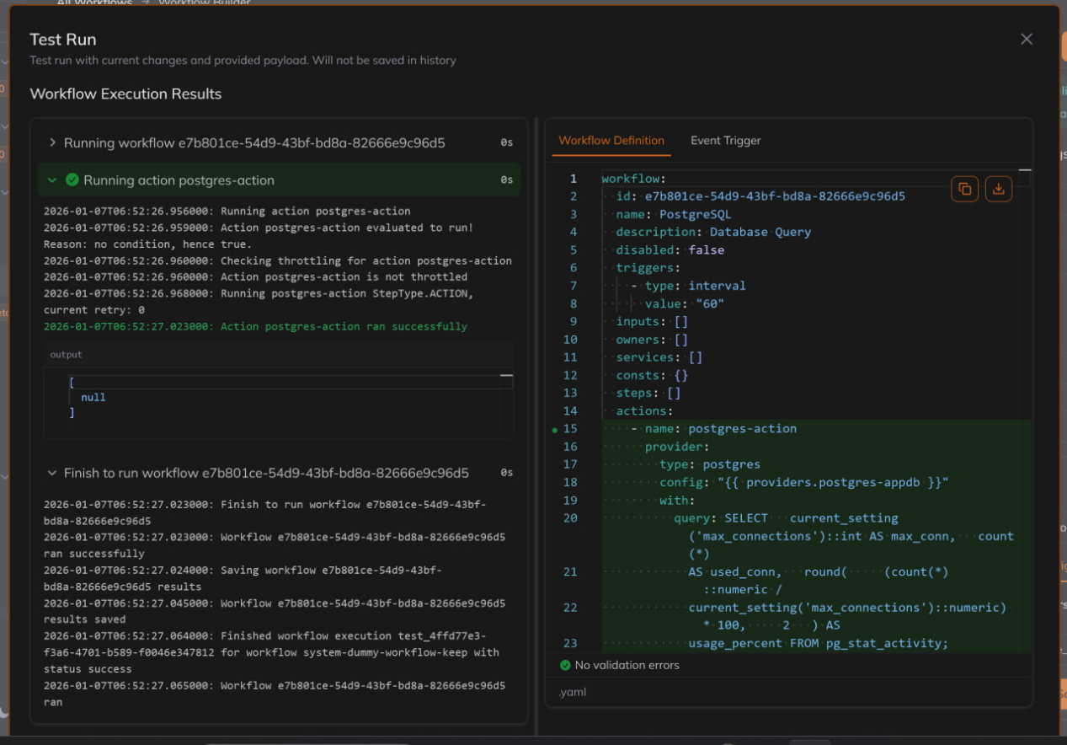

==================================================================================
Output kolom:
should_alert (boolean)
message (text)

Keluar alert hanya kalau:
Blocking > 0 ✅
Total connections > 100 ✅
Ada Long query detail (pid + user) ✅
===================================================================================
WITH
conn AS (
SELECT
count(*) AS total,
count(*) FILTER (WHERE state='active') AS active,
count(*) FILTER (WHERE state='idle') AS idle,
count(*) FILTER (WHERE state='idle in transaction') AS idle_trx
FROM pg_stat_activity
WHERE datname = current_database()
),
blocking AS (
SELECT count(*) AS cnt
FROM pg_stat_activity blocked
JOIN pg_locks bl
ON bl.pid = blocked.pid AND NOT bl.granted
JOIN pg_locks bk
ON bk.locktype = bl.locktype
AND bk.pid <> bl.pid
WHERE blocked.datname = current_database()
),
longq AS (
SELECT
pid,
usename,
now() - query_start AS dur,
regexp_replace(left(query, 120), E'[\\n\\r\\t]+', ' ', 'g') AS q
FROM pg_stat_activity
WHERE datname = current_database()
AND query_start IS NOT NULL
AND state <> 'idle'
AND now() - query_start > interval '5 minutes'
ORDER BY dur DESC
LIMIT 5
),
longq_text AS (
SELECT COALESCE(
string_agg(
E' • pid=' || pid || E' user=' || usename ||
E' dur=' || to_char(dur, 'HH24:MI:SS') ||
E' q=' || q,
E'\n'
),
E' • (none)'
) AS txt
FROM longq
),
dbsize AS (
SELECT pg_size_pretty(pg_database_size(current_database())) AS pretty
),
flags AS (
SELECT
(SELECT cnt FROM blocking) AS blocking_cnt,
(SELECT total FROM conn) AS total_conn,
((SELECT cnt FROM blocking) > 0 OR (SELECT total FROM conn) > 100) AS should_alert
)
SELECT
should_alert,
CASE
WHEN should_alert THEN
E'🗓 ' || to_char(now(), 'Dy, YYYY-MM-DD HH24:MI:SS') || E'\n\n' ||

E'📌 *Labels*\n' ||
E'- Notification : KeepDB Monitoring\n' ||
E'- Alert Type : PostgreSQL Health Check\n' ||
E'- Severity : ' ||
CASE
WHEN (SELECT blocking_cnt FROM flags) > 0 AND (SELECT total_conn FROM flags) > 100 THEN 'Major'
WHEN (SELECT blocking_cnt FROM flags) > 0 THEN 'Major'
WHEN (SELECT total_conn FROM flags) > 100 THEN 'Warning'
ELSE 'Info'
END || E'\n\n' ||

E'🔔 *Annotation*\n' ||
E'- Instance ➞ 192.168.9.212:6432\n' ||
E'- Database ➞ ' || current_database() || E'\n\n' ||

E'📊 *Metrics*\n' ||
E'- DB Size ➞ ' || (SELECT pretty FROM dbsize) || E'\n\n' ||

E'- Connections :\n' ||
E' • Total connections ➞ ' || (SELECT total FROM conn) || E'\n' ||
E' • Active connections ➞ ' || (SELECT active FROM conn) || E'\n' ||
E' • Idle connections ➞ ' || (SELECT idle FROM conn) || E'\n' ||
E' • Idle in transaction ➞ ' || (SELECT idle_trx FROM conn) || E'\n\n' ||

E'- Blocking ➞ ' || (SELECT blocking_cnt FROM flags) || E'\n' ||
E'- Long Query (>5m) details:\n' || (SELECT txt FROM longq_text)
ELSE
NULL
END AS message
FROM flags;

===================================================================================
🗓 Tue, 2026-02-03 13:55:50 (date)
Menampilkan alert telergram
- Instance ➞ Ip server
- Database ➞ Nama database
- DB Size ➞ size db
- Connections ➞ (Total connections, active connections, Idle connections, Idle in transaction)
- Long Query >5m ➞ (query panjang yg running lebih dari 5 menit{waktu yg ditentukan})
- Blocking ➞ Jika ada blocking query
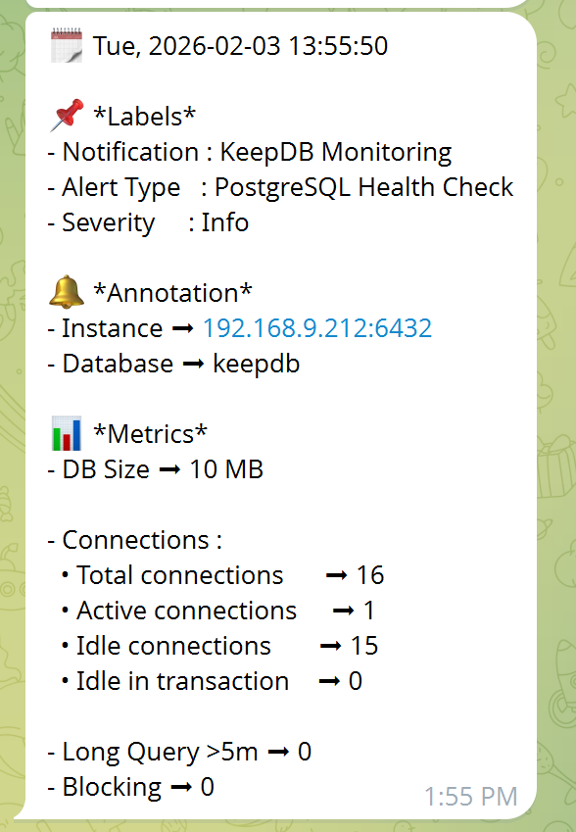
SELECT
E'🗓 ' || to_char(now(), 'Dy, YYYY-MM-DD HH24:MI:SS') || E'\n\n' ||

E'📌 *Labels*\n' ||
E'- Notification : KeepDB Monitoring\n' ||
E'- Alert Type : PostgreSQL Health Check\n' ||
E'- Severity : Info\n\n' ||

E'🔔 *Annotation*\n' ||
E'- Instance ➞ 192.168.9.212:6432\n' ||
E'- Database ➞ keepdb\n\n' ||

E'📊 *Metrics*\n' ||
E'- DB Size ➞ ' ||
pg_size_pretty(pg_database_size(current_database())) || E'\n\n' ||

E'- Connections :\n' ||
E' • Total connections ➞ ' ||
(SELECT count(*) FROM pg_stat_activity WHERE datname=current_database()) || E'\n' ||
E' • Active connections ➞ ' ||
(SELECT count(*) FROM pg_stat_activity WHERE datname=current_database() AND state='active') || E'\n' ||
E' • Idle connections ➞ ' ||
(SELECT count(*) FROM pg_stat_activity WHERE datname=current_database() AND state='idle') || E'\n' ||
E' • Idle in transaction ➞ ' ||
(SELECT count(*) FROM pg_stat_activity WHERE datname=current_database() AND state='idle in transaction') || E'\n\n' ||

E'- Long Query >5m ➞ ' ||
(SELECT count(*)
FROM pg_stat_activity
WHERE datname=current_database()
AND state <> 'idle'
AND now() - query_start > interval '5 minutes') || E'\n' ||

E'- Blocking ➞ ' ||
(SELECT count(*)
FROM pg_stat_activity blocked
JOIN pg_locks bl ON bl.pid = blocked.pid AND NOT bl.granted
JOIN pg_locks bk ON bk.locktype = bl.locktype AND bk.pid <> bl.pid
WHERE blocked.datname=current_database()
)
AS message;

=======monitoring cluster postgress===================
Yg mau di monitoring
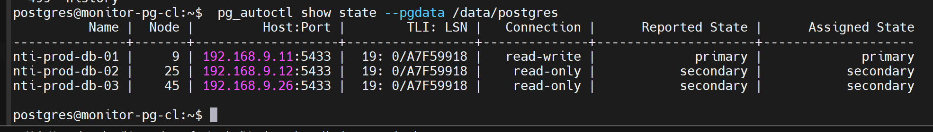
Di pg_autoctl show state --pgdata /data/postgres

Monitoring di keephq
Query di builder postgres step
WITH nodes AS ( SELECT nodename AS node, nodehost AS host, nodeport AS port, reportedstate AS current_state, goalstate AS target_state, reportedpgisrunning AS pg_up, health, (now() - reporttime) AS report_lag, CASE WHEN reportedstate = 'primary' THEN 'read-write' ELSE 'read-only' END AS connection FROM pgautofailover.node ORDER BY nodename ), node_blocks AS ( SELECT string_agg( E'• *Node* ➞ `' || node || E'`\n' || E' - Host ➞ `' || host || E':' || port || E'`\n' || E' - Connection ➞ *' || connection || E'*\n' || E' - State ➞ `' || current_state || E' → ' || target_state || E'`\n' || E' - PG Up ➞ `' || pg_up || E'`\n' || E' - Health ➞ `' || health || E'`\n' || E' - Lag ➞ `' || to_char(report_lag, 'HH24:MI:SS') || E'`', E'\n\n' ) AS blocks FROM nodes ), summary AS ( SELECT COUNT(*) AS total_nodes, SUM(CASE WHEN current_state <> target_state THEN 1 ELSE 0 END) AS mismatch, SUM(CASE WHEN pg_up IS DISTINCT FROM true THEN 1 ELSE 0 END) AS pg_down, SUM(CASE WHEN health IS DISTINCT FROM 1 THEN 1 ELSE 0 END) AS bad_health FROM nodes ) SELECT E'🗓 ' || to_char(now(), 'Dy, YYYY-MM-DD HH24:MI:SS') || E'\n\n' || E'📌 *Labels*\n' || E'- Notification : PG AutoFailover Monitoring\n' || E'- Alert Type : PG AutoFailover State Report\n' || E'- Severity : Info\n\n' || E'🔔 *Annotation*\n' || E'- Cluster ➞ nti-prod\n' || E'- Source ➞ pgautofailover.node\n\n' || E'📊 *Metrics*\n' || E'- Total Nodes ➞ ' || (SELECT total_nodes FROM summary) || E'\n' || E'- Mismatch (state) ➞ ' || (SELECT mismatch FROM summary) || E'\n' || E'- PG Down ➞ ' || (SELECT pg_down FROM summary) || E'\n' || E'- Bad Health ➞ ' || (SELECT bad_health FROM summary) || E'\n\n' || E'🧾 *Nodes*\n' || (SELECT blocks FROM node_blocks) AS message;
output :
