Env
Git options
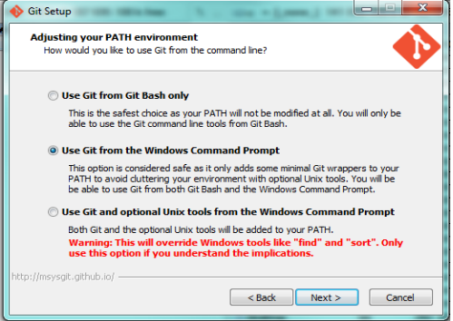

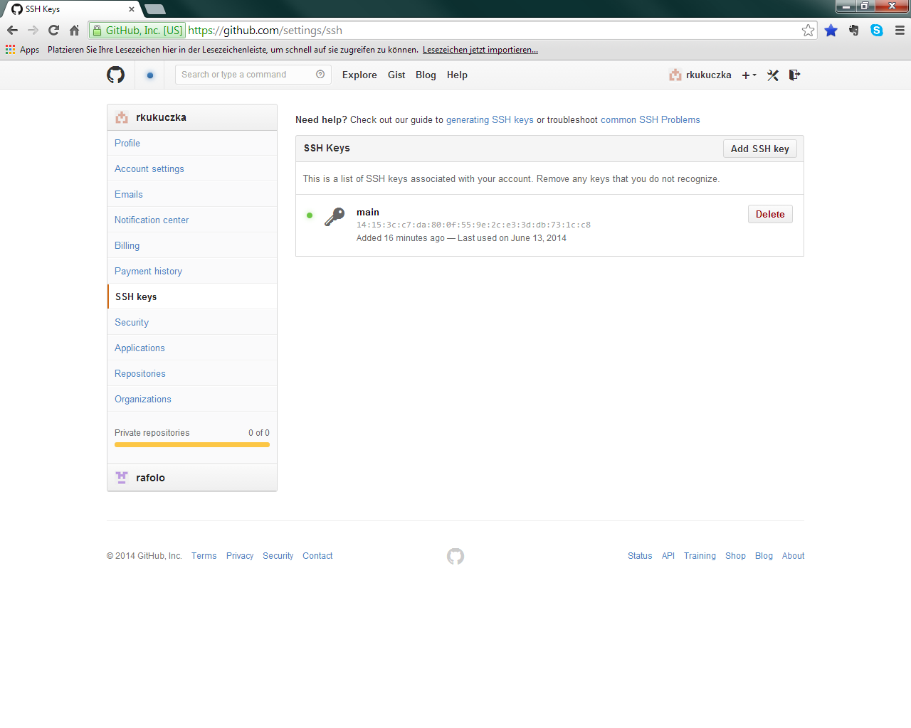

ssh-keygen -t rsa -C "your_email@example.com"
# Creates a new ssh key, using the provided email as a label
# Generating public/private rsa key pair.
# Enter file in which to save the key (/c/Users/you/.ssh/id_rsa): [Press enter]
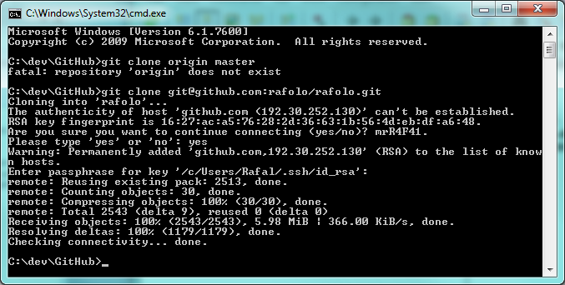
https://help.github.com/articles/generating-ssh-keys
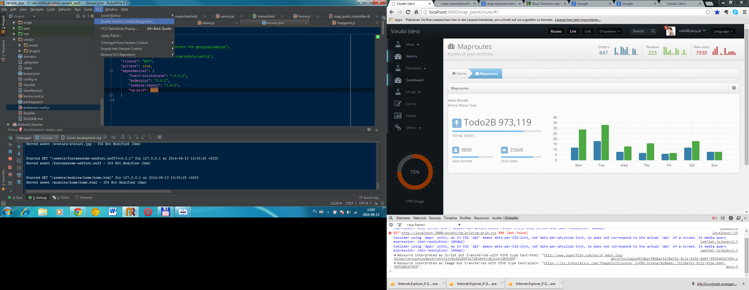

node.js (konfig w package.js)

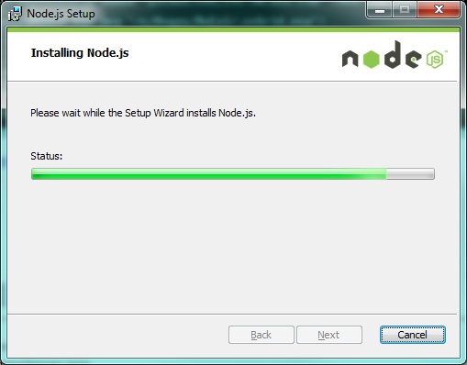
Istall Karma

Bower uzywa bower.json
Karma to karma
Protractor to testy funkcjonalne, Karma unity

Instttt
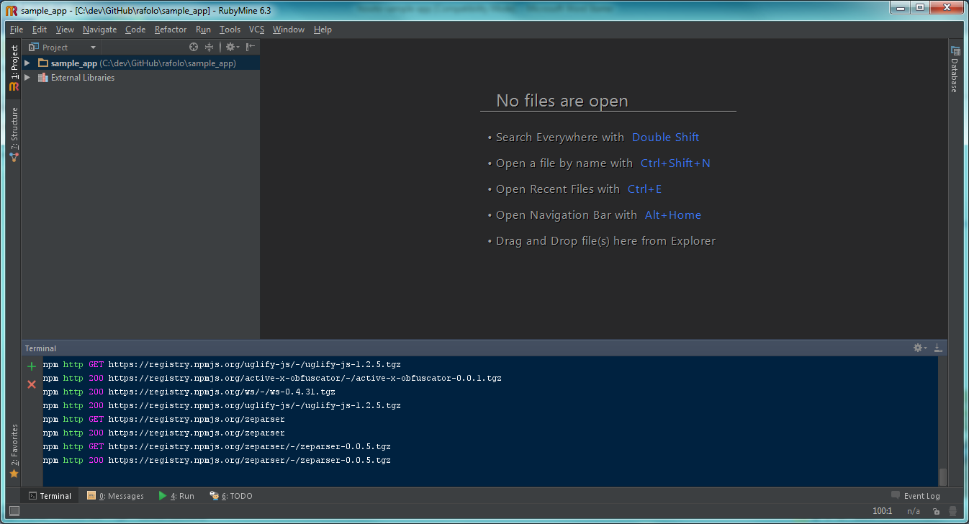
Bower install
Run ~$ npm install ~$ bower install
Karma install
~$ npm install -g karma
~$ npm install -g karma-cli
Protractor install
~$ npm install -g protractor
Tests
Run ~$ karma start
A potem

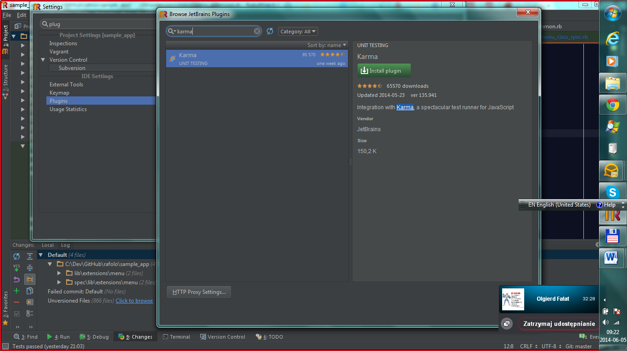

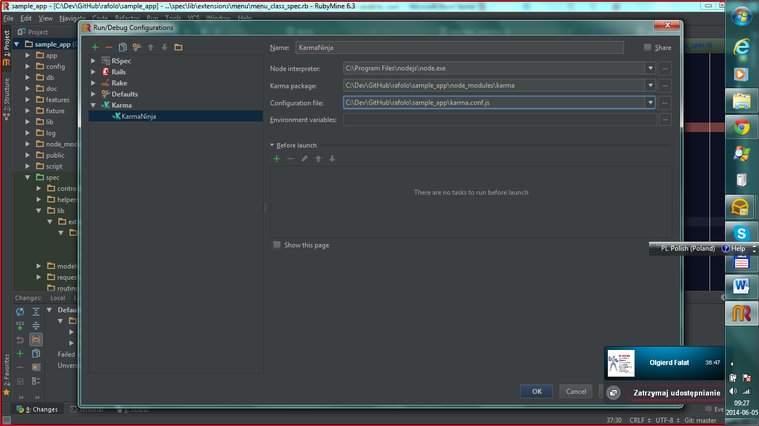

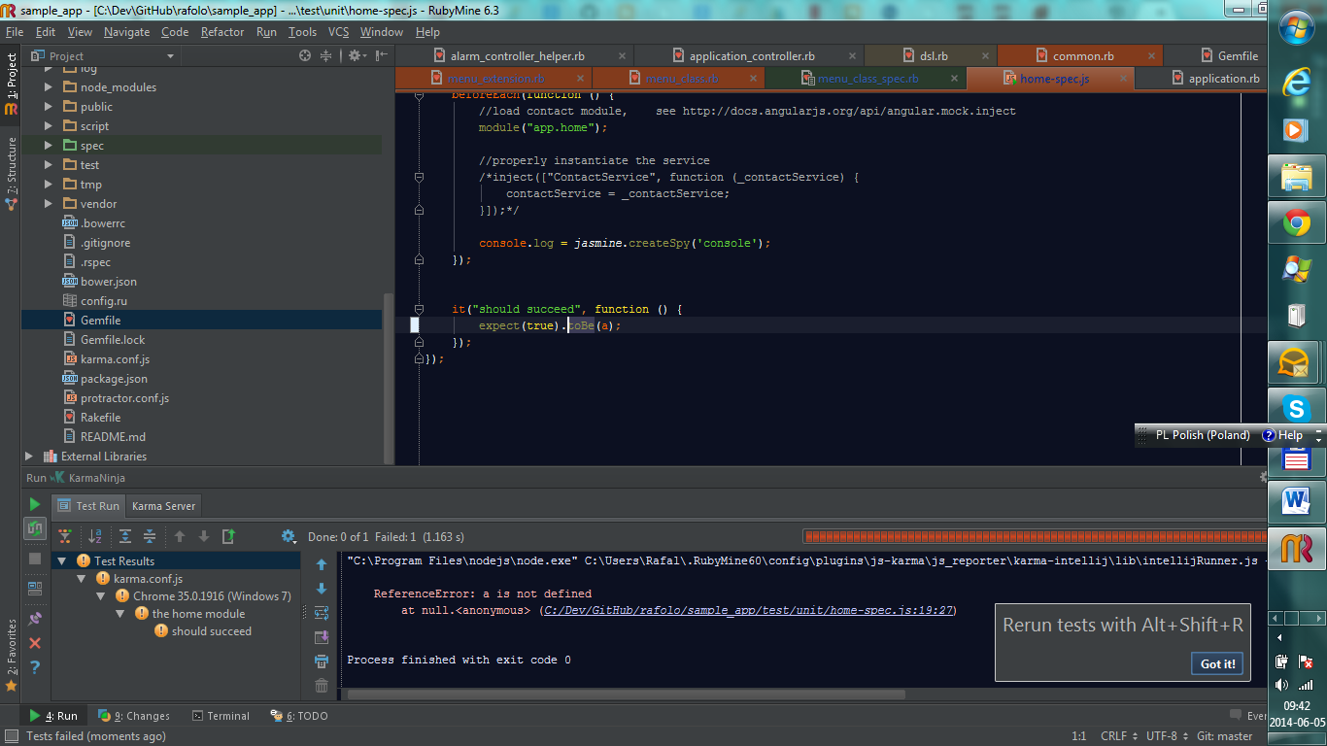

Own Rake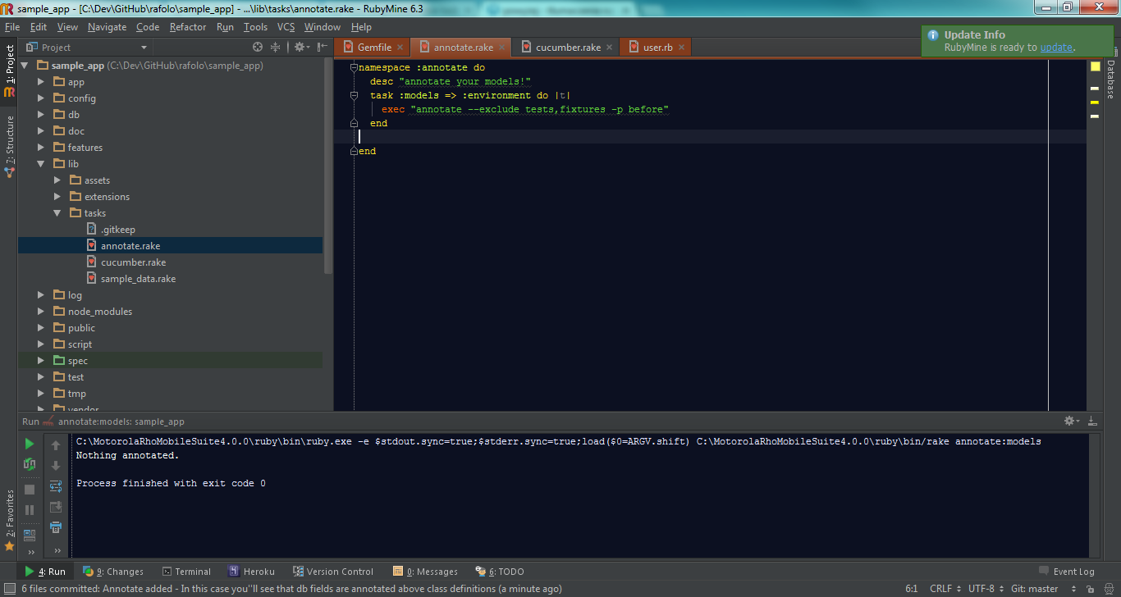

namespace :annotate do
desc "annotate your models!"
task :models => :environment do |t|
exec "annotate --exclude tests,fixtures -p before"
end

end

Javascript debug
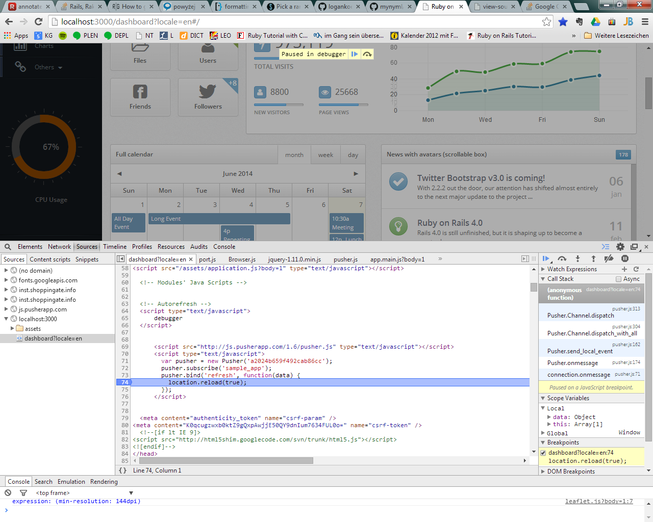

<!-- Autorefresh -->
<script type="text/javascript">
debugger
</script>

Confiig watcher and autorefresh
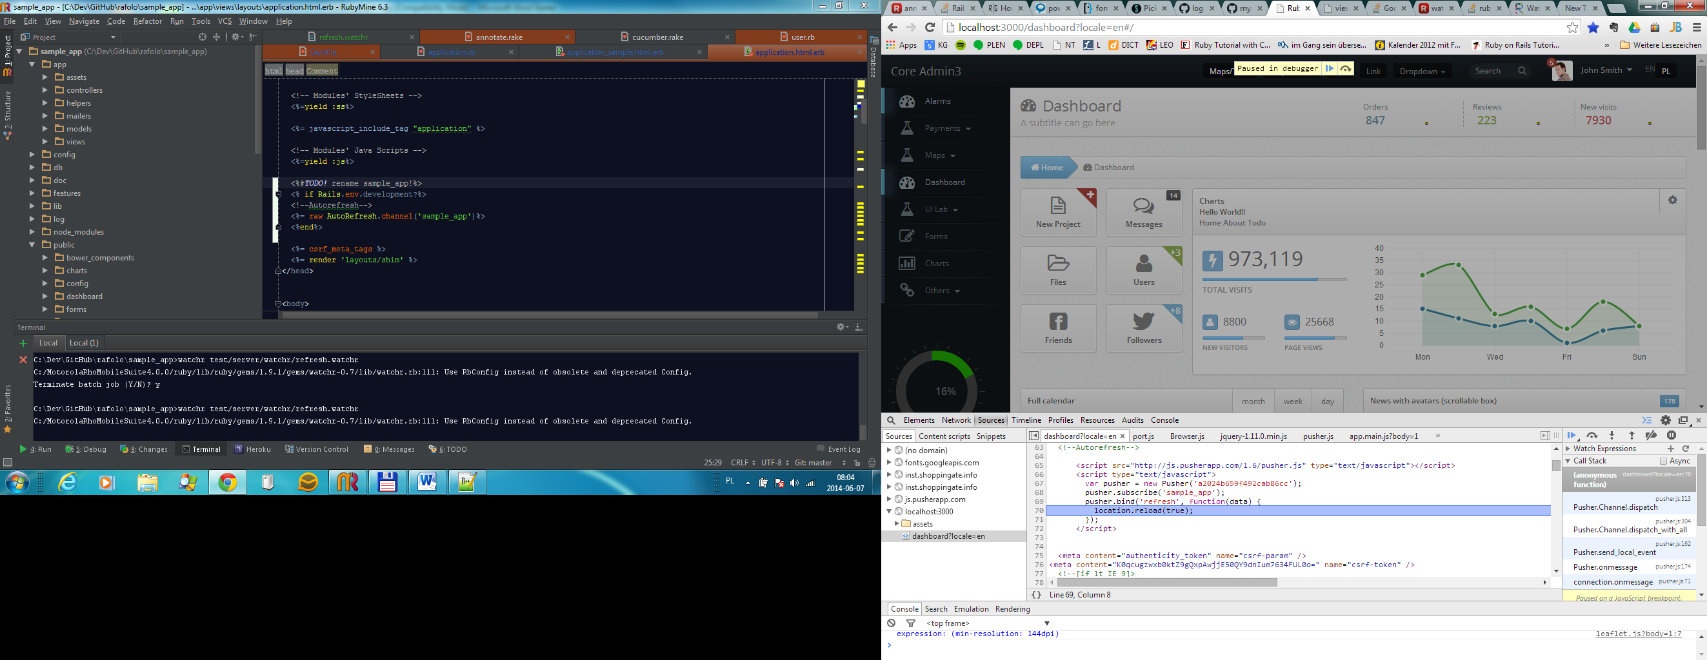

https://github.com/mynyml/watchr
https://github.com/logankoester/autorefresh

config
watch( 'app/views/.*\.erb' ) { |m| system('autorefresh sample_app') }
see gems
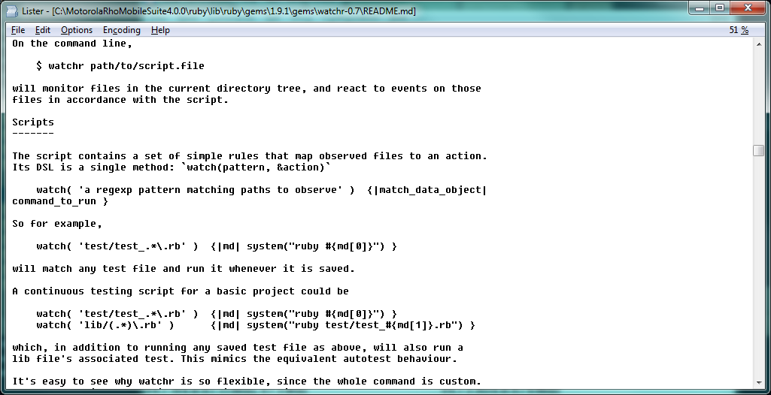

Javascript bower integration
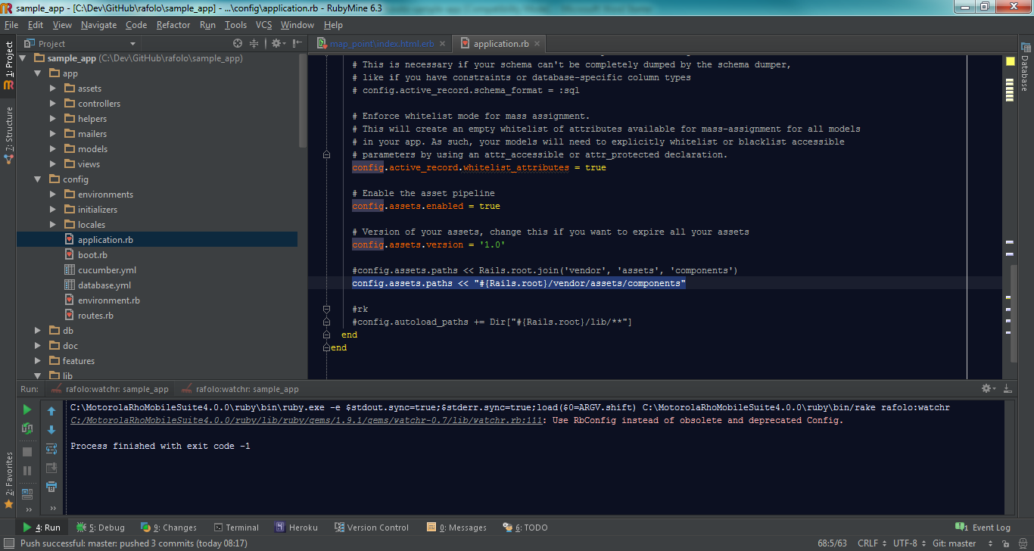

http://www.iconoclastlabs.com/blog/bower-and-rails-4
Javascript autorefresh
http://www.livejs.com/
https://github.com/mynyml/watchr
rake rafolo:watchr (libs/tasks/…) and change a html, js, css, erb file

Annotate
Rake annotate adds comments to models

Rails
Rake annotate adds comments to models
ActionController::ForceSSL::ClassMethods.module_eval do
def forest(options = {})
User.new.toglle!(:admin) #change prop

end
end
end

Git
- Git reflog
8eb5ada HEAD@{0}: reset: moving to 8eb5ada
f6ab295 HEAD@{1}: commit: Modernizr dependency check
cc30bbd HEAD@{2}: commit: Combo localizator
d66b1c0 HEAD@{3}: commit: show_examples config added - remove the invalid link with grace
0dfa5e3 HEAD@{4}: commit: Sole configs added
8eb5ada HEAD@{5}: commit: Livejs, watchr integrated
e498d84 HEAD@{6}: commit: Layoput added - that not hatches
git reset --hard 0dfa5e3
and back…
git reset –hard f6ab295

Install Middleman
gem install middleman, middleman init boom, middleman server
http://12devs.co.uk/articles/204/

Samples

Sample code
ActionController::ForceSSL::ClassMethods.module_eval do
def force_ssl(options = {})
config = Rails.application.config

return unless config.use_ssl # <= this is new

end
end
end

