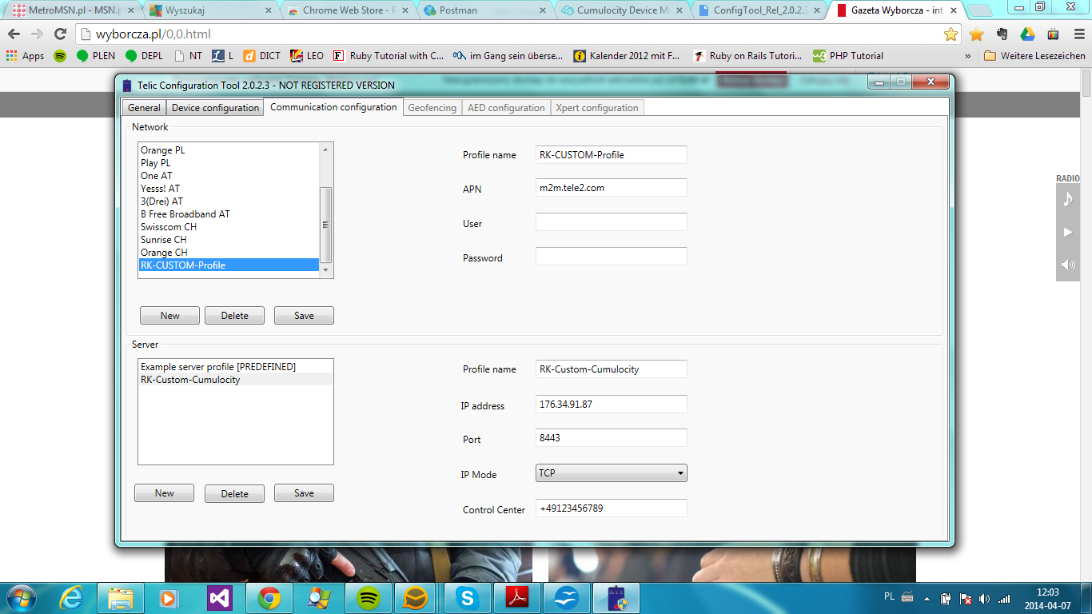
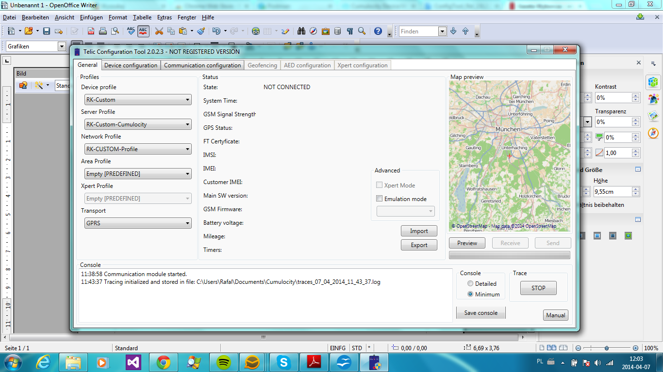

176.34.91.87
https://pkey.cumulocity.com
admin/PyfXNp_6kL6D
https://pkey.cumulocity.com/inventory/managedObjects?fragmentType=c8y_Position

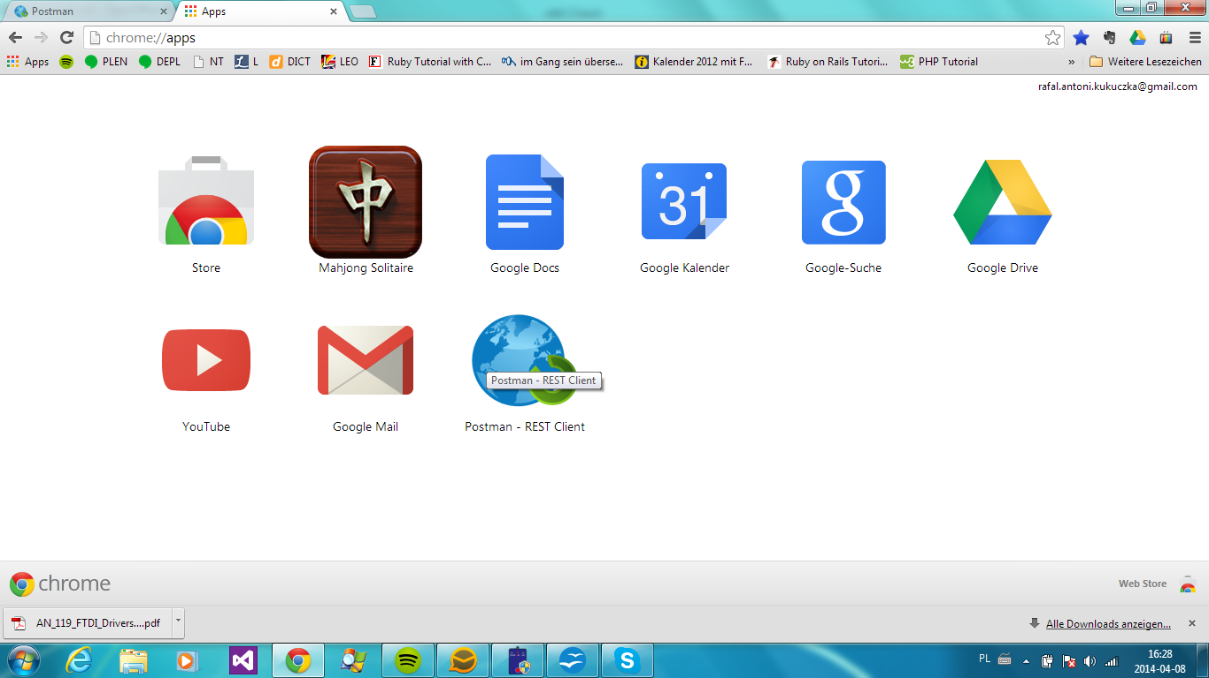

Leaflet

IMEI –mobilny MAC
CELLID – MAC dla Simmcard
ICCID – numer BS

Certificates:
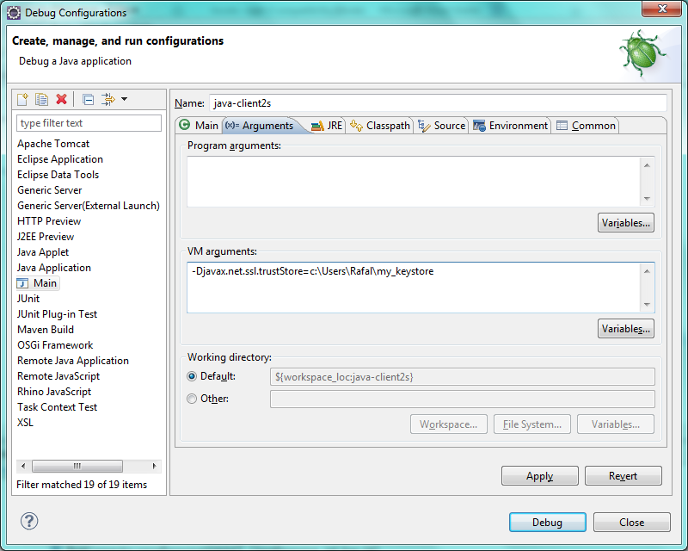

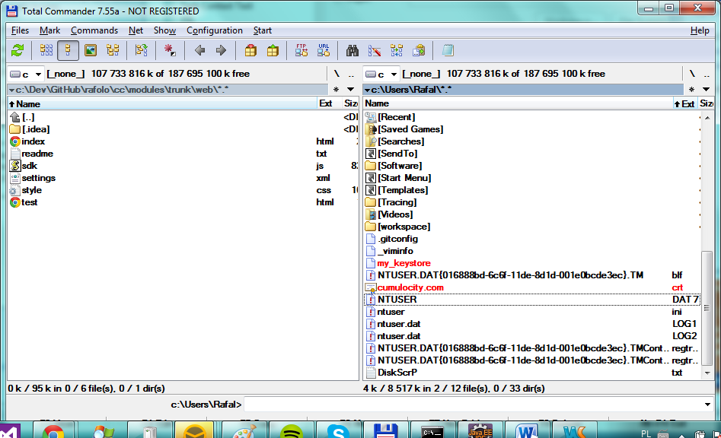

C:\Users\Rafal>keytool -genkey -keystore my_keystore -alias keystore -storepass
123123 -dname "CN=dstore server, OU=division, O=company, L=city, ST=state, C=co
ntry"
Enter key password for <keystore>
(RETURN if same as keystore password):
Re-enter new password:

C:\Users\Rafal>keytool -import -alias cumulocity -file cumulocity.com.crt -keys
ore my_keystore
Enter keystore password:
Owner: CN=*.cumulocity.com, OU=Domain Control Validated
Issuer: CN=Go Daddy Secure Certificate Authority - G2, OU=http://certs.godaddy.
om/repository/, O="GoDaddy.com, Inc.", L=Scottsdale, ST=Arizona, C=US
Serial number: 45bf1ddfdab8a
Valid from: Fri Apr 11 15:36:08 CEST 2014 until: Sun Sep 14 14:02:04 CEST 2014
Certificate fingerprints:
MD5: 96:8C:35:81:59:A4:D6:DB:B3:AB:D8:E0:37:29:41:C2
SHA1: A8:B7:C4:D6:58:7D:A9:3B:E4:37:BD:F8:E9:A6:6C:86:CB:5C:F0:40
SHA256: 34:BA:A2:A7:E0:92:9D:91:59:DA:6C:26:A7:D8:38:46:A7:9D:27:E5:3D
23:A4:76:A0:55:D8:DF:BF:60:5A:6D
Signature algorithm name: SHA256withRSA
Version: 3

Extensions:

#1: ObjectId: 1.3.6.1.5.5.7.1.1 Criticality=false
AuthorityInfoAccess [
[
accessMethod: ocsp
accessLocation: URIName: http://ocsp.godaddy.com/
,
accessMethod: caIssuers
accessLocation: URIName: http://certificates.godaddy.com/repository/gdig2.cr

]
]

#2: ObjectId: 2.5.29.35 Criticality=false
AuthorityKeyIdentifier [
KeyIdentifier [
0000: 40 C2 BD 27 8E CC 34 83 30 A2 33 D7 FB 6C B3 F0 @..'..4.0.3..l..
0010: B4 2C 80 CE .,..
]
]

#3: ObjectId: 2.5.29.19 Criticality=true
BasicConstraints:[
CA:false
PathLen:2147483647
]

#4: ObjectId: 2.5.29.31 Criticality=false
CRLDistributionPoints [
[DistributionPoint:
[URIName: http://crl.godaddy.com/gdig2s1-40.crl]
]]

#5: ObjectId: 2.5.29.32 Criticality=false
CertificatePolicies [
[CertificatePolicyId: [2.16.840.1.114413.1.7.23.1]
[PolicyQualifierInfo: [
qualifierID: 1.3.6.1.5.5.7.2.1
qualifier: 0000: 16 2B 68 74 74 70 3A 2F 2F 63 65 72 74 69 66 69 .+http://
ertifi
0010: 63 61 74 65 73 2E 67 6F 64 61 64 64 79 2E 63 6F cates.godaddy.co
0020: 6D 2F 72 65 70 6F 73 69 74 6F 72 79 2F m/repository/

]] ]
]

#6: ObjectId: 2.5.29.37 Criticality=false
ExtendedKeyUsages [
serverAuth
clientAuth
]

#7: ObjectId: 2.5.29.15 Criticality=true
KeyUsage [
DigitalSignature
Key_Encipherment
]

#8: ObjectId: 2.5.29.17 Criticality=false
SubjectAlternativeName [
DNSName: *.cumulocity.com
DNSName: cumulocity.com
]

#9: ObjectId: 2.5.29.14 Criticality=false
SubjectKeyIdentifier [
KeyIdentifier [
0000: 20 21 E7 70 13 48 2F 10 9A 85 88 F6 C3 59 28 47 !.p.H/......Y(G
0010: F9 B3 D3 CE ....
]
]

Trust this certificate? [no]: yes
Certificate was added to keystore

C:\Users\Rafal>keytool -list -v -keystore my_keystore
Enter keystore password:

Keystore type: JKS
Keystore provider: SUN

Your keystore contains 2 entries

Alias name: cumulocity
Creation date: 2014-05-05
Entry type: trustedCertEntry

Owner: CN=*.cumulocity.com, OU=Domain Control Validated
Issuer: CN=Go Daddy Secure Certificate Authority - G2, OU=http://certs.godaddy.
om/repository/, O="GoDaddy.com, Inc.", L=Scottsdale, ST=Arizona, C=US
Serial number: 45bf1ddfdab8a
Valid from: Fri Apr 11 15:36:08 CEST 2014 until: Sun Sep 14 14:02:04 CEST 2014
Certificate fingerprints:
MD5: 96:8C:35:81:59:A4:D6:DB:B3:AB:D8:E0:37:29:41:C2
SHA1: A8:B7:C4:D6:58:7D:A9:3B:E4:37:BD:F8:E9:A6:6C:86:CB:5C:F0:40
SHA256: 34:BA:A2:A7:E0:92:9D:91:59:DA:6C:26:A7:D8:38:46:A7:9D:27:E5:3D
23:A4:76:A0:55:D8:DF:BF:60:5A:6D
Signature algorithm name: SHA256withRSA
Version: 3

Extensions:

#1: ObjectId: 1.3.6.1.5.5.7.1.1 Criticality=false
AuthorityInfoAccess [
[
accessMethod: ocsp
accessLocation: URIName: http://ocsp.godaddy.com/
,
accessMethod: caIssuers
accessLocation: URIName: http://certificates.godaddy.com/repository/gdig2.cr

]
]

#2: ObjectId: 2.5.29.35 Criticality=false
AuthorityKeyIdentifier [
KeyIdentifier [
0000: 40 C2 BD 27 8E CC 34 83 30 A2 33 D7 FB 6C B3 F0 @..'..4.0.3..l..
0010: B4 2C 80 CE .,..
]
]

#3: ObjectId: 2.5.29.19 Criticality=true
BasicConstraints:[
CA:false
PathLen:2147483647
]

#4: ObjectId: 2.5.29.31 Criticality=false
CRLDistributionPoints [
[DistributionPoint:
[URIName: http://crl.godaddy.com/gdig2s1-40.crl]
]]

#5: ObjectId: 2.5.29.32 Criticality=false
CertificatePolicies [
[CertificatePolicyId: [2.16.840.1.114413.1.7.23.1]
[PolicyQualifierInfo: [
qualifierID: 1.3.6.1.5.5.7.2.1
qualifier: 0000: 16 2B 68 74 74 70 3A 2F 2F 63 65 72 74 69 66 69 .+http://
ertifi
0010: 63 61 74 65 73 2E 67 6F 64 61 64 64 79 2E 63 6F cates.godaddy.co
0020: 6D 2F 72 65 70 6F 73 69 74 6F 72 79 2F m/repository/

]] ]
]

#6: ObjectId: 2.5.29.37 Criticality=false
ExtendedKeyUsages [
serverAuth
clientAuth
]

#7: ObjectId: 2.5.29.15 Criticality=true
KeyUsage [
DigitalSignature
Key_Encipherment
]

#8: ObjectId: 2.5.29.17 Criticality=false
SubjectAlternativeName [
DNSName: *.cumulocity.com
DNSName: cumulocity.com
]

#9: ObjectId: 2.5.29.14 Criticality=false
SubjectKeyIdentifier [
KeyIdentifier [
0000: 20 21 E7 70 13 48 2F 10 9A 85 88 F6 C3 59 28 47 !.p.H/......Y(G
0010: F9 B3 D3 CE ....
]
]

*******************************************
*******************************************

Alias name: keystore
Creation date: 2014-05-05
Entry type: PrivateKeyEntry
Certificate chain length: 1
Certificate[1]:
Owner: CN=dstore server, OU=division, O=company, L=city, ST=state, C=country
Issuer: CN=dstore server, OU=division, O=company, L=city, ST=state, C=country
Serial number: 3a5069e8
Valid from: Mon May 05 14:13:35 CEST 2014 until: Sun Aug 03 14:13:35 CEST 2014
Certificate fingerprints:
MD5: D1:50:CC:EB:EB:F4:03:6C:04:72:65:26:69:4A:4D:45
SHA1: 79:57:0A:68:D2:C5:35:0B:10:B5:9D:5A:AB:3B:10:C0:64:E3:6D:BE
SHA256: C6:BC:AC:85:A2:F5:CA:E8:91:84:14:93:8C:F2:C5:24:22:14:7D:BC:CF
24:BE:B2:B8:3B:C1:08:C7:86:E2:99
Signature algorithm name: SHA1withDSA
Version: 3

Extensions:

#1: ObjectId: 2.5.29.14 Criticality=false
SubjectKeyIdentifier [
KeyIdentifier [
0000: 0E 01 93 62 22 82 EF A5 5E F7 E5 38 DF 08 6E 11 ...b"...^..8..n.
0010: 23 60 F2 6B #`.k
]
]

*******************************************
*******************************************

C:\Users\Rafal>

WebApp:
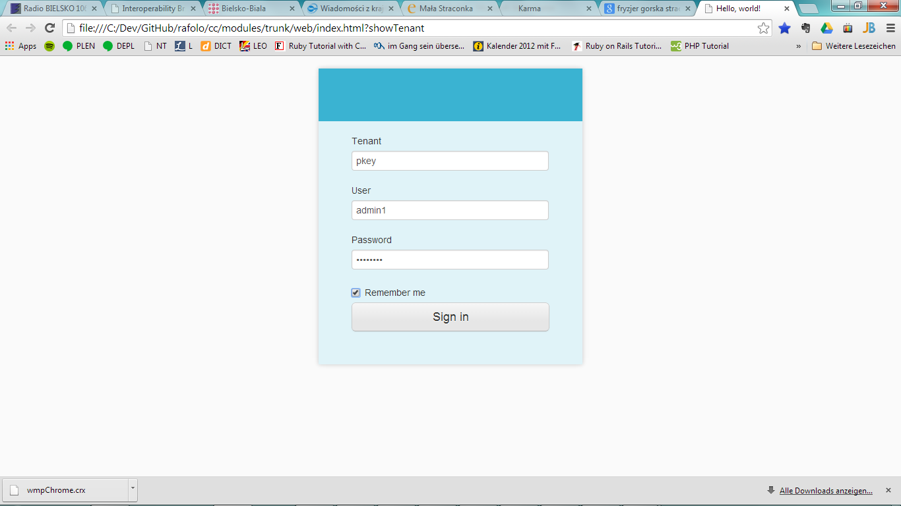

"admin1", "Im1gbqiM"

