Survey-Weighted Machine Learning for Prospective Stratification of High-Cost Patients: A Design-Based Pipeline with External Temporal Validation, Decision-Curve Analysis, and Subgroup Calibration in a Nationally Representative U.S. Cohort
Rafael Alexandre dos Reis
Independent Researcher, Curitiba, Brazil | Corresponding author: Rafael Alexandre dos Reis, rafreis2@gmail.com
Funding: None. Conflicts of interest: The author declares no competing interests.

Abstract
Background. A small minority of patients accounts for most healthcare spending, so identifying them prospectively from routinely available data is central to precision-medicine care management. Existing high-cost prediction models are frequently at high risk of bias: they treat complex population samples as if simple random, are seldom validated externally, and rarely audit equity. These shortcomings matter because cost-based targeting can reproduce structural bias.^{1,2}
Methods. In the Medical Expenditure Panel Survey (MEPS) two-year longitudinal panels, we predicted membership in the population-weighted top decile of year-2 total expenditure from year-1 features only. The complex survey design (longitudinal weights, strata, primary sampling units) was carried through every step. Predictors were chosen by a fully design-based pipeline: weighted filters, a Rao–Scott Wald screen, and a survey-weighted LASSO, yielding 62 features. A survey-weighted gradient-boosted model was developed on panels 21–23 (2016–2019) and validated on non-overlapping panels 26–27 (2021–2023), with the COVID-disrupted intervening panels excluded. We assessed discrimination (design-based cluster-bootstrap confidence intervals), calibration, SHAP explanations, decision-curve analysis against a prior-year-cost benchmark, subgroup calibration by income and race/ethnicity, and concordance with preventable (AHRQ Prevention Quality Indicator) hospitalizations.
Results. Development and validation cohorts comprised 44,225 and 15,033 persons (weighted average-annual populations 330 and 338 million). External discrimination was strong and temporally stable (weighted AUC 0.857, 95% CI 0.842–0.869; panel 26, 0.856; panel 27, 0.857), exceeding XGBoost (0.851), survey logistic regression (0.846), and prior-year cost (0.813); calibration was close to ideal (slope 0.93). Flagging the top decile of predicted risk captured 48.9% of future high-cost patients. Net benefit exceeded the prior-cost benchmark across the actionable threshold range (paired difference at a 10% threshold, 0.0089; 95% CI 0.0067–0.0111). Subgroup calibration was broadly stable, with predicted risks close to observed in every group, while discrimination varied modestly (AUC 0.84–0.91 across income; 0.84–0.89 across race/ethnicity). Two-thirds of preventable heart-failure or COPD hospitalizations occurred in the top-cost decile (risk ratio 17.6); among persons not previously high-cost, discrimination for incident high-cost was 0.80.
Conclusions. A transparent, externally validated, survey-weighted model stratifies high-cost patients with strong discrimination, stable subgroup calibration, and demonstrable clinical utility, supporting design-aware precision-medicine prediction.
Keywords: precision medicine; patient stratification; high-cost patients; machine learning; complex survey data; decision curve analysis

1. Introduction
Healthcare expenditure is highly concentrated: across health systems the costliest decile of patients typically accounts for roughly half of all spending.³ Because that spending is dominated by a small, identifiable group, prospectively flagging high-cost, high-need individuals before costs accrue is a foundational task for precision-medicine care management, which allows scarce, personalized interventions such as intensive case management, medication reconciliation, transitional care, and targeted prevention to be directed to the patients most likely to benefit.⁴ The operational value of such stratification depends on more than discrimination alone. A deployable model must be well calibrated so that individual risks can be trusted, must demonstrate decision-analytic benefit over the simple heuristics a health system already uses, and must perform equitably across the sociodemographic groups it serves.
Machine-learning models for high-cost prediction have proliferated, but their translational credibility is limited by recurrent methodological weaknesses. A systematic review of prediction models for future high-need high-cost care found that a large majority were at high risk of bias, with common deficiencies in sample handling, validation, and reporting.¹ Three gaps are especially consequential for population data. First, surveys such as MEPS arise from a complex sample design, with unequal selection probabilities, stratification, and clustering, that must be propagated through estimation to recover population-representative risks; ignoring the design inflates apparent performance and biases the estimand, and the problem is not resolved simply by using a flexible learner.^{5,6} Second, many models report only internally cross-validated performance, which does not establish transportability to a later period or setting; contemporary guidance treats a dedicated external validation as a distinct and essential study.⁷ Third, equity is rarely examined, despite the demonstration that an algorithm using cost as a label can systematically under-serve Black patients because cost is an imperfect proxy for need.² A cost-targeting model that is not audited for subgroup calibration risks encoding this bias.
The estimand itself has direct precedent. Fleishman and Cohen used the MEPS two-year panels to predict membership in the upper expenditure decile in year 2 from year-1 information, with an earlier development cohort and a later validation cohort, using logistic regression with diagnostic cost-group risk scores.⁸ Our contribution lies in how that task is estimated and evaluated: design-consistent survey-weighted machine learning in place of unweighted logistic regression; an external validation conducted as a distinct study across the COVID-19 shock rather than a later split of the same era; decision-curve analysis against the prior-cost heuristic; and subgroup calibration reported as a primary output rather than a post hoc check. Recent ensemble-ML work has begun to pair high-usage prediction with temporal validation and economic-impact analysis under TRIPOD+AI, which signals that clinical-utility framing is now expected in this space, although that study used a disease-registry cohort and did not perform decision-curve analysis.⁹
We therefore address these gaps in a single, reproducible study designed around the survey structure rather than ignoring it. Using the MEPS two-year longitudinal panels, we predict membership in the population-weighted top decile of next-year total expenditure from year-1 features alone, carrying the longitudinal weight, strata, and primary sampling units through feature selection, model training, calibration, uncertainty quantification, and every subgroup estimate. We validate on non-overlapping, post-pandemic panels; benchmark decision-analytic utility against prior-year cost; audit discrimination and calibration across income and race/ethnicity; and, as a clinically anchored secondary analysis, test whether the high-cost group concentrates ambulatory-care-sensitive hospitalizations. Reporting follows TRIPOD+AI.¹⁰

2. Methods

2.1 Data source and study design
MEPS is a nationally representative survey of the U.S. civilian non-institutionalized population conducted by the Agency for Healthcare Research and Quality; each two-year longitudinal panel follows a cohort across five interview rounds and is released with a single longitudinal weight linking both calendar years.¹¹ The model was developed on panels 21–23 (2016–2019) and validated on panels 26–27 (2021–2023). Panels 24 and 25 (extended by AHRQ to four years because of pandemic-related field disruptions) occupy the gap between the development and validation windows and were excluded, producing a clean, non-overlapping temporal split that also straddles the COVID-19 shock as a stringent test of transportability. We used the two-year Panel 23 file rather than its four-year extension, whose longitudinal weight targets a different population.

2.2 Estimand, outcome, and leakage control
The target estimand is population-level: membership in the survey-weighted 90th percentile of year-2 total expenditure. We estimated the threshold separately within each panel using the design-based weighted quantile,¹² so that secular growth in healthcare prices does not distort the meaning of the top decile across a seven-year span; by construction the weighted event rate was 10.0% in every panel. All predictors were drawn from year 1, and an automated firewall excluded any variable derived from year 2, including year-2 expenditure, from the feature set, enforcing strict temporal separation between predictors and outcome.

2.3 Carrying the survey design through the pipeline
Every estimate used the longitudinal person weight with the variance stratum and primary sampling unit via Taylor-series linearization. Rather than treating the design as a nuisance, we integrated it into each analytic step. This choice is grounded in two literatures: weighted (design-consistent) estimation targets the finite-population risk and, for tree ensembles specifically, unweighted fitting has been shown to inflate performance relative to the population model;^{5,13} and recent syntheses of tree-based methods for survey data motivate weighted splitting, design-aware resampling, and cluster-respecting validation as the appropriate defaults.⁶

2.4 Design-based feature selection
From 685 year-1 variables common to all five panels we applied a pre-specified, transparent selection pipeline. A structural exclusion first removed identifiers, edit and imputation flags, source-of-payment decompositions of prior spending, month-by-payer coverage cells, and disaggregated income items, while an allowlist admitted round-1 and round-2 self-reported health and functional-limitation constructs (their round-3 to round-5 counterparts were excluded because they postdate the predictor year), leaving 176 candidates. Weighted filters (missingness ≤40%, weighted near-zero variance, and pairwise |ρ|≤0.90) reduced these to 79; a design-based Rao–Scott Wald screen removed variables without a weighted univariable association (p≥0.157),^{14,15} leaving 72; and a survey-weighted LASSO with design-based cross-validation produced the final set of 62 features.¹⁶ We did not use Boruta as the primary selector because its permutation test presumes independent observations and is not valid under stratified, clustered, weighted sampling; it was retained only as a labelled sensitivity analysis.¹⁷

2.5 Model development and comparators
The primary learner was a gradient-boosted decision-tree model (LightGBM) with the longitudinal weight supplied as the per-observation weight; the algorithm accommodates missing values natively, avoiding imputation of the tree inputs.¹⁸ The number of boosting rounds was selected by five-fold cross-validation in which whole primary sampling units were assigned to folds, preventing leakage of clustered observations across the split. The frozen model was then applied, unchanged, to the external panels. Three comparators contextualize performance: a survey-weighted XGBoost,¹⁹ a survey-weighted logistic regression fitted to the same 62 features, and a parsimonious model of the outcome on log prior-year expenditure alone.

2.6 Performance, calibration, and uncertainty
Discrimination was the survey-weighted area under the ROC curve, reported overall and by validation panel. Confidence intervals (95%) were obtained from a design-based bootstrap that resampled primary sampling units within strata (400 replicates), which respects clustering where closed-form variance is not established. Calibration was summarized by the weighted calibration slope, calibration-in-the-large, the Brier score, and a decile-binned weighted reliability curve with bootstrap intervals.²⁰ We additionally report the operating characteristics of a top-decile targeting rule (weighted sensitivity, specificity, and positive predictive value at the 90th predicted-risk percentile), the quantity most relevant to a fixed-capacity care-management program.

2.7 Explainability, clinical utility, and equity
Feature contributions used TreeSHAP, with population importance summarized as the weighted mean absolute SHAP value; we interpret these as associational contributions to the model rather than causal effects, consistent with cautions about over-reading additive attributions.^{21,22,23} Clinical utility used decision-curve analysis: we computed weighted net benefit across threshold probabilities and compared the model with the prior-year-cost benchmark and the treat-all and treat-none references.²⁴ Because both curves are estimated on the same persons, we report the paired difference in net benefit with cluster-bootstrap intervals, which is the appropriate comparison, alongside the marginal intervals for each curve.²⁵ Motivated by evidence that cost-based algorithms can be inequitable,² we audited weighted discrimination and calibration within income (poverty category) and race/ethnicity strata; subgroup calibration is the property most directly protective against the failure mode of interest.^{26,27,28}

2.8 Secondary concordance, sensitivity, and reproducibility
As a clinically anchored secondary analysis we linked year-2 hospital inpatient stays to conditions (via the event–condition link files) and flagged admissions for heart failure (ICD-10-CM I50) or COPD (J40–J44, age ≥40), approximating AHRQ Prevention Quality Indicators #08 and #05.²⁹ Because MEPS public files provide only three-digit ICD-10-CM codes and no principal-diagnosis ranking, this is a documented proxy rather than the exact specification. In a transition sensitivity analysis we restricted to persons not in the year-1 top decile and re-evaluated discrimination for incident high-cost status. Non-tree comparators handled missingness under design-based multiple-imputation principles.^{30,31} Analyses used R 4.5 (survey, srvyr, lightgbm, xgboost, svyVarSel, shapviz), with the environment pinned via renv.³²
Ethics. This study analyzed only publicly available, de-identified MEPS data and was exempt from institutional review board approval; no informed consent was required.

3. Results

3.1 Cohort characteristics
The development and validation cohorts comprised 44,225 and 15,033 persons, representing weighted average-annual populations of 330 and 338 million (Table 1). The cohorts were demographically similar and consistent with national benchmarks (validation: 50.6% female; 19.4% Hispanic, 57.7% non-Hispanic White, 12.4% non-Hispanic Black; 6.8% uninsured; 66.7% and 64.7% with any private coverage), and both carried the constructed 10.0% weighted top-decile rate. Median prior-year expenditure was modest ($1,095 and $1,392), so the outcome is not trivially recoverable from a high baseline in most persons.
Characteristic | Training (P21–23, 2016–19) | Validation (P26–27, 2021–23)
Persons, n (unweighted) | 44,225 | 15,033
Weighted population (avg. annual) | 329.7 million | 337.8 million
Top-decile (high-cost) rate | 10.0% | 10.0%
Age, mean (years) | 38.6 | 39.4
Female | 51.0% | 50.6%
Hispanic | 18.4% | 19.4%
Non-Hispanic White | 59.8% | 57.7%
Non-Hispanic Black | 12.3% | 12.4%
Non-Hispanic Asian | 5.9% | 6.3%
Any private insurance | 66.7% | 64.7%
Public coverage only | 26.3% | 28.5%
Uninsured | 7.0% | 6.8%
Poor / near-poor | 17.3% | 16.3%
High income | 39.8% | 42.8%
Prior-year total expenditure, median | $1,095 | $1,392
Prior-year prescription fills, mean | 9.5 | 8.4
Table 1. Survey-weighted characteristics of the development and external-validation cohorts. Populations are averaged over the panels pooled in each cohort.

3.2 Feature selection
The design-based pipeline reduced 685 candidate year-1 variables to a final set of 62 features (685 to 176 after structural exclusion and the round-based allowlist; 79 after weighted filtering; 72 after the Rao–Scott screen; 62 after the survey-weighted LASSO). The retained features spanned prior spending and utilization, self-reported physical and mental health, functional limitation, chronic-condition diagnoses, and sociodemographic and insurance characteristics, and were applied identically across all five panels.

3.3 Discrimination, operating characteristics, and calibration
In external temporal validation the model achieved a weighted AUC of 0.857 (95% CI 0.842–0.869), with essentially identical performance in the two validation panels a year apart (panel 26, 0.856; panel 27, 0.857), indicating temporal stability across the pandemic period. Discrimination exceeded survey-weighted XGBoost (0.851), survey logistic regression (0.846), and the prior-year-cost model (0.813) (Table 2). At a fixed-capacity operating point that flags the top decile of predicted risk, the model captured 48.9% of persons who became high-cost the following year, at a positive predictive value of 48.9% and an approximately five-fold enrichment over the 10% base rate. Sensitivity and positive predictive value coincide here because the flag rate (the top decile) equals the event rate (10%); this is an arithmetic consequence of the operating point, not a coincidence. Calibration was close to ideal (slope 0.93; mean predicted 0.106 vs. observed 0.100; Brier 0.068), with predicted and observed risks tracking the identity line across the full range (Figure 1).
Model / metric | Value
LightGBM AUC (95% CI) | 0.857 (0.842–0.869)
AUC, panel 26 / panel 27 | 0.856 / 0.857
XGBoost AUC | 0.851
Survey logistic regression AUC | 0.846
Prior-year cost only AUC | 0.813
Calibration slope | 0.93
Calibration-in-the-large (pred / obs) | 0.106 / 0.100
Brier score | 0.068
Sensitivity at top-decile flag | 48.9%
Specificity at top-decile flag | 94.3%
Positive predictive value | 48.9%
Table 2. External-validation performance (survey-weighted). Confidence interval from a design-based cluster bootstrap over primary sampling units (400 replicates). The operating point flags the top decile of predicted risk; sensitivity and positive predictive value coincide because the flag rate equals the event rate.
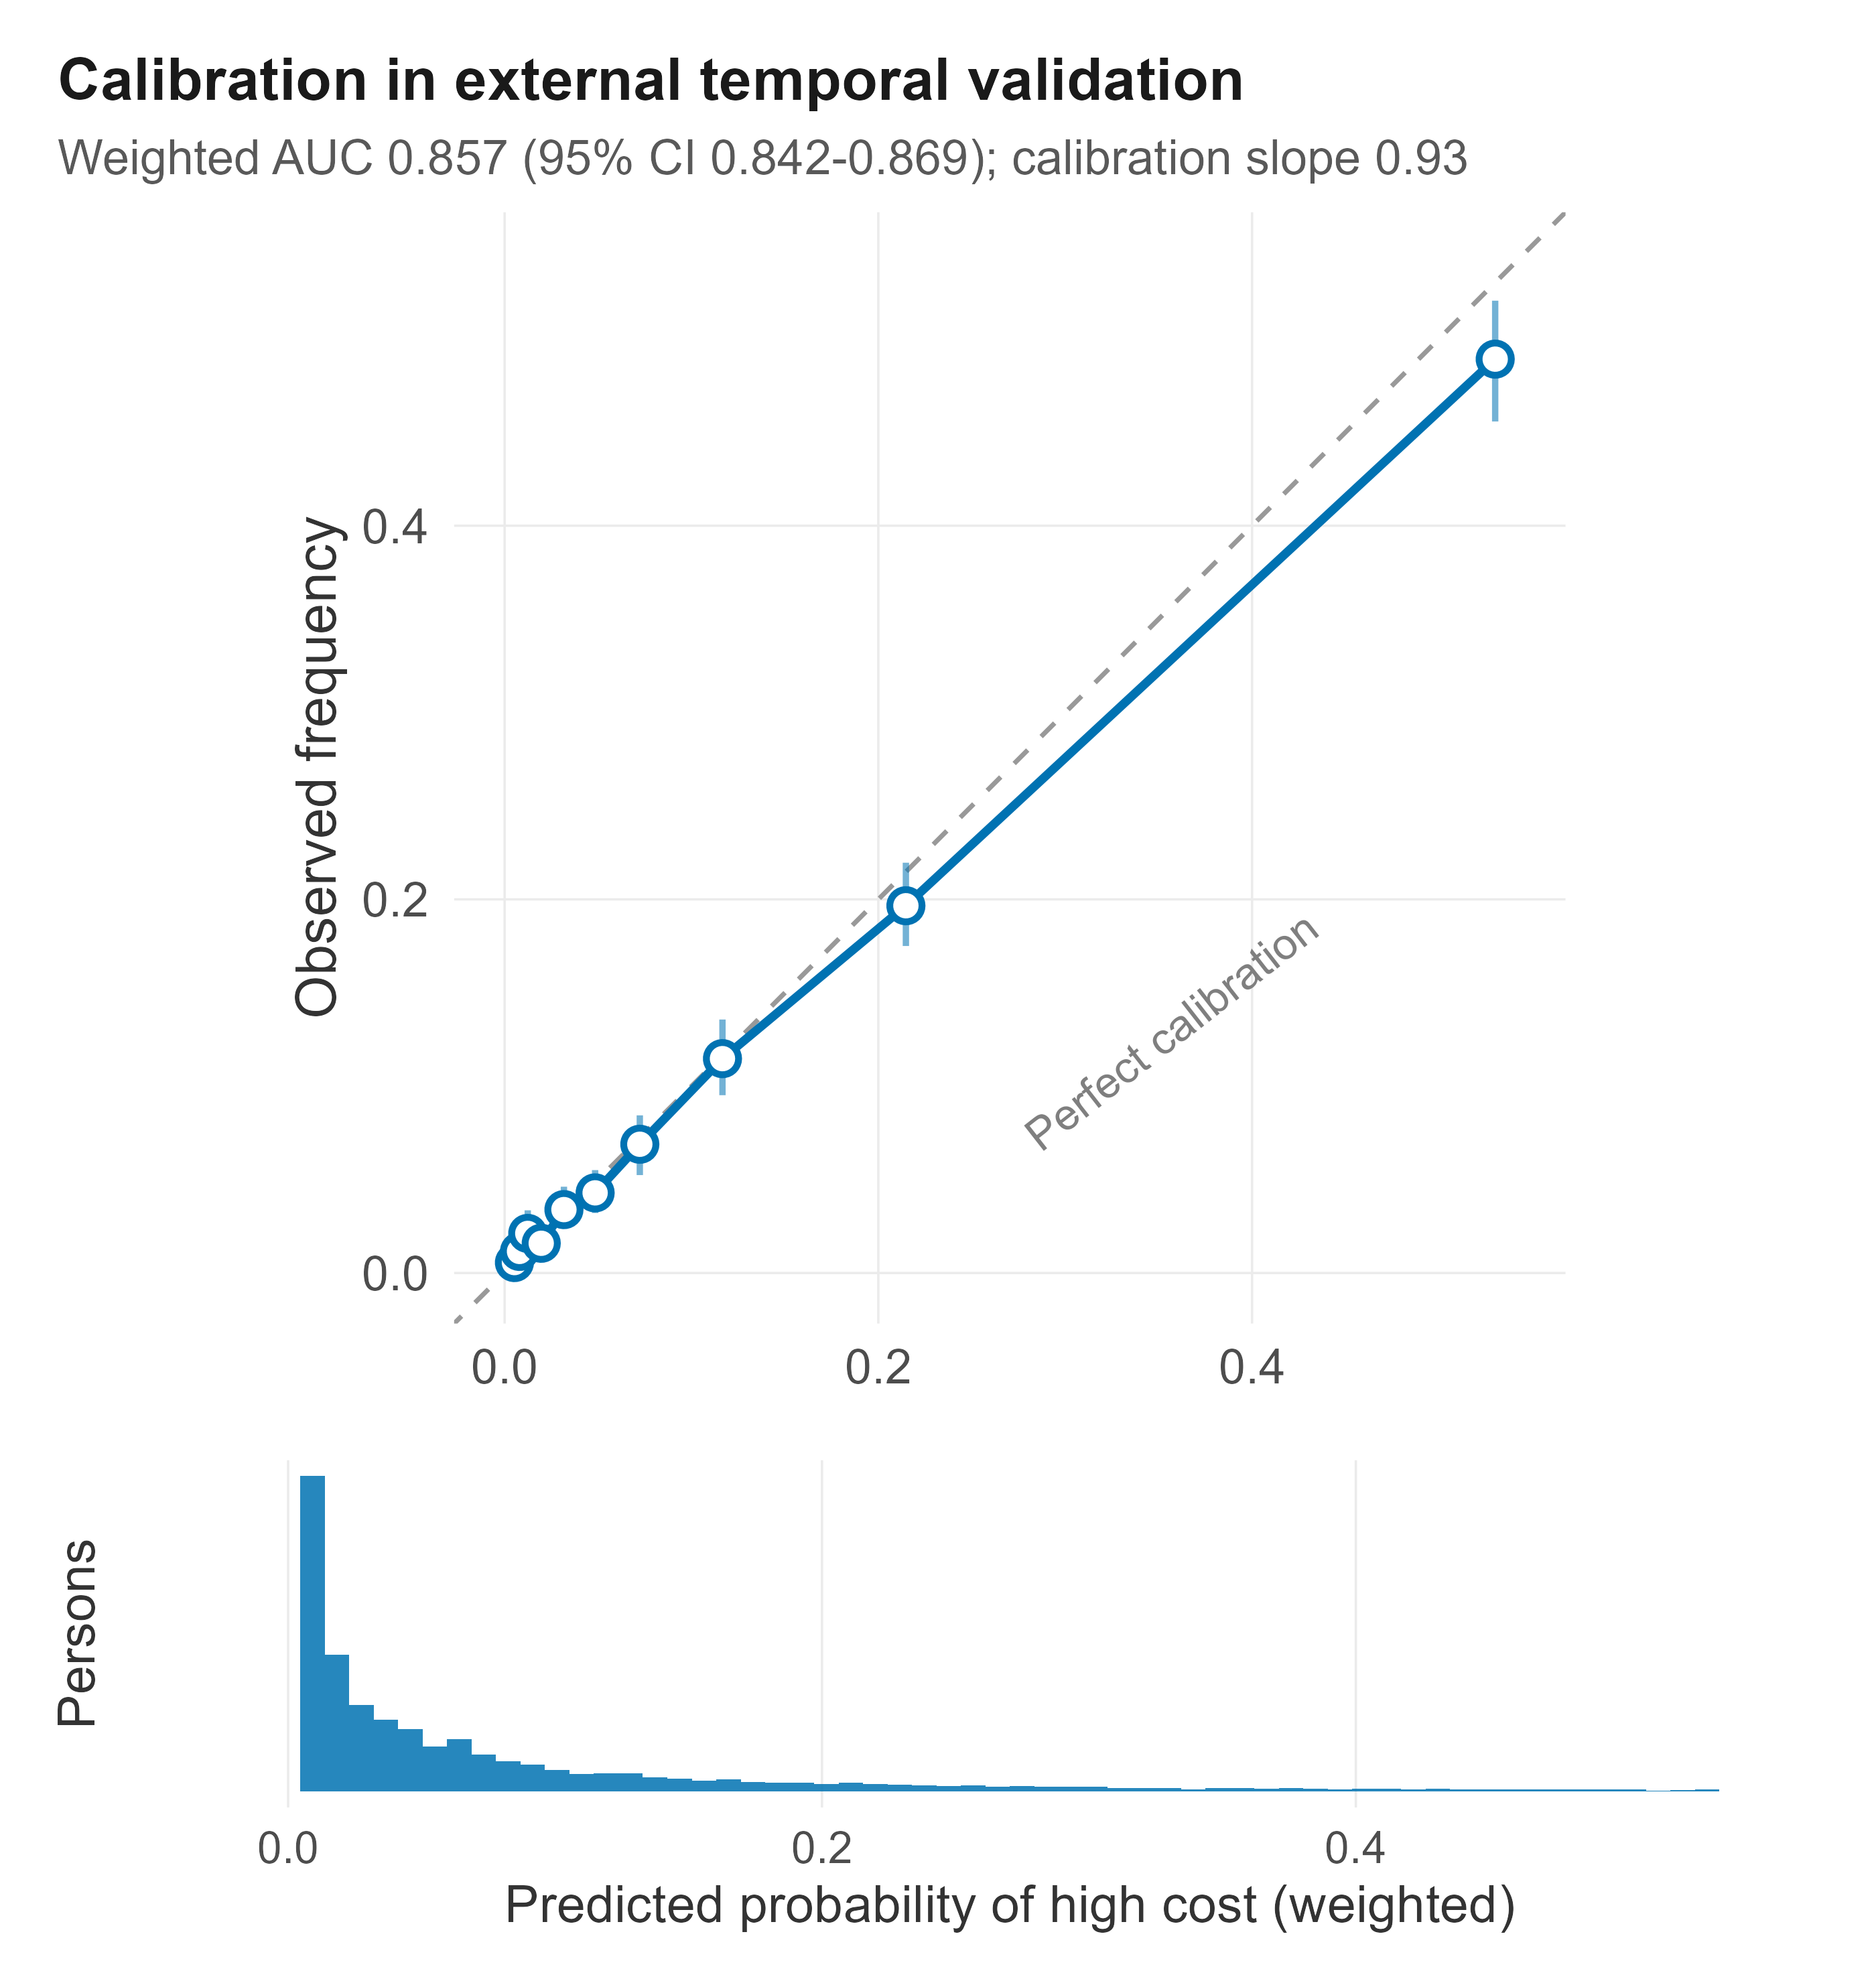
Figure 1. Survey-weighted reliability curve in external temporal validation (panels 26–27; n = 15,033). Points are decile bins of predicted risk with 95% cluster-bootstrap intervals; the dashed line denotes perfect calibration. The lower panel shows the weighted distribution of predicted risk.

3.4 Feature contributions
Prior-year total expenditure was the dominant contributor, followed by prescription-fill count, age, family size, ambulatory-visit count, out-of-pocket spending, and self-reported physical health (Figure 2). The importance profile is clinically coherent: prior utilization and health status, not identifiers or payment artifacts, drive predictions, and it is consistent with the leakage controls and structural exclusions imposed during selection.
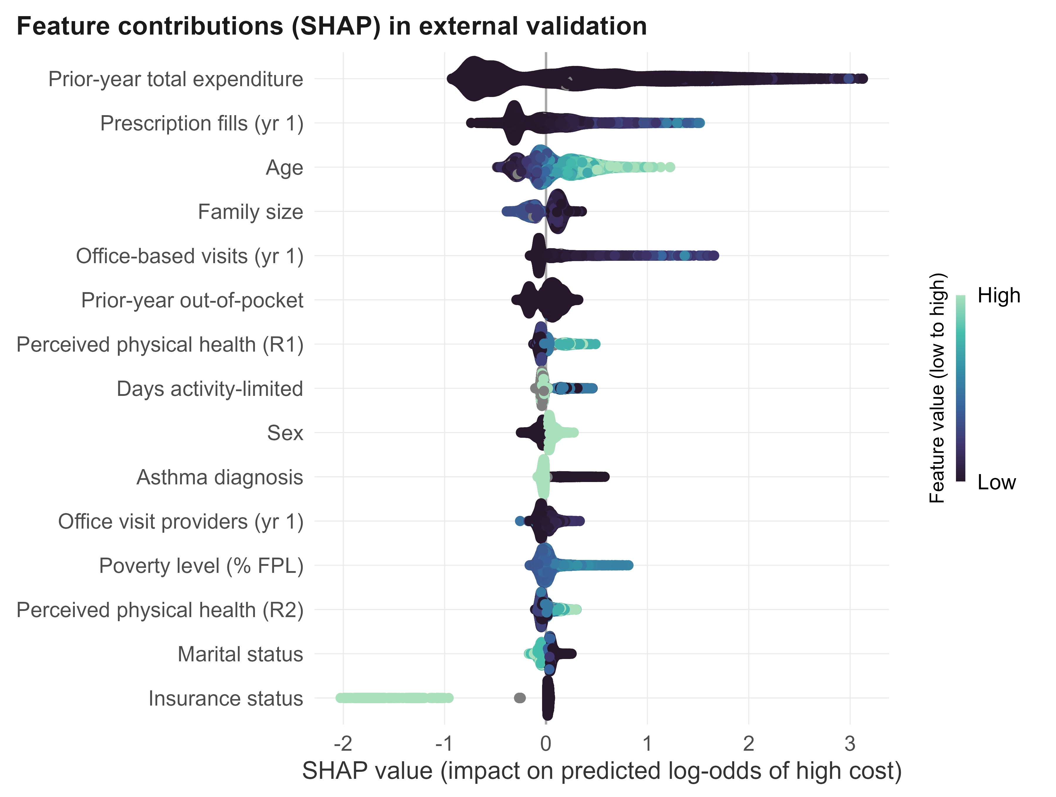
Figure 2. SHAP beeswarm in external validation (n = 15,033; the 15 most important features, ordered by mean absolute SHAP value). Each point is a validation participant; horizontal position is the feature’s SHAP contribution to the predicted log-odds of high cost, and colour encodes the feature value from low to high.

3.5 Clinical utility
Across the actionable range of threshold probabilities the model produced higher weighted net benefit than the prior-year-cost benchmark and the treat-all and treat-none strategies (Figure 3). At a 10% threshold, net benefit was 0.0561 (95% CI 0.0505–0.0616) for the model and 0.0472 (0.0415–0.0527) for prior-year cost; because both are estimated on the same persons, the paired difference is the appropriate comparison, and it was 0.0089 (95% CI 0.0067–0.0111), with the model superior in every bootstrap replicate. The paired advantage excluded zero at every threshold from 5% to 30% (minimum difference 0.0066). In practical terms this is the additional future high-cost patients identified at no additional false-positive cost, the decision-analytic quantity most relevant to allocating a fixed care-management capacity.²⁴
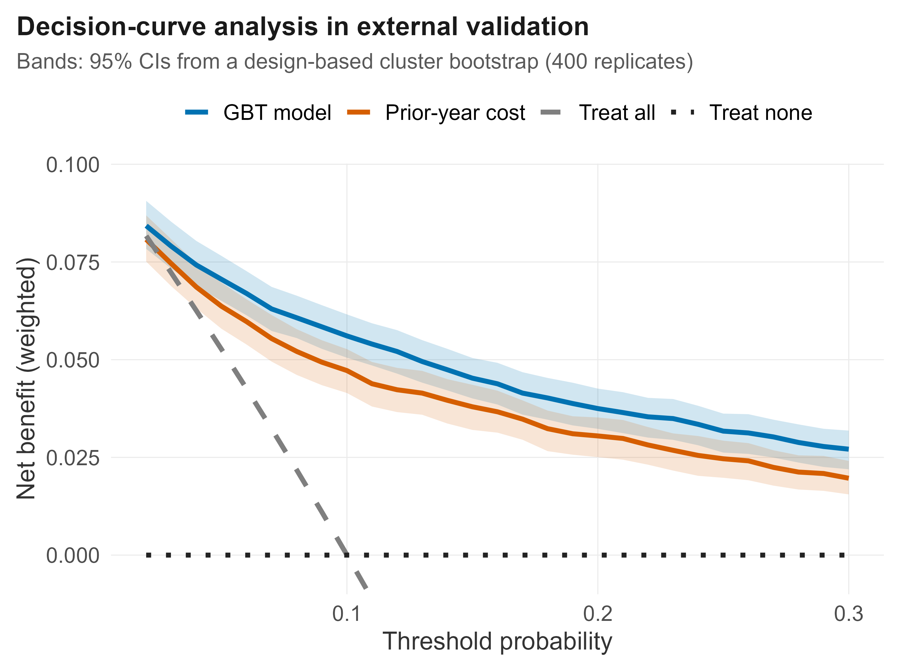
Figure 3. Decision-curve analysis in external validation. Weighted net benefit for the model, the prior-year-cost benchmark, and the treat-all and treat-none references, clipped to the actionable threshold range. Bands are 95% confidence intervals from a design-based cluster bootstrap (400 replicates).

3.6 Subgroup calibration and equity
Calibration was broadly stable across income and race/ethnicity strata, with predicted risks close to observed rates in every group (Table 3). Discrimination varied modestly, from 0.84 to 0.91 across income categories and 0.84 to 0.89 across race/ethnicity, a between-group range of about 0.05 that we do not regard as negligible. Calibration also held in the lowest-observed-rate stratum (Hispanic persons: predicted 5.9% vs. observed 4.6%), the configuration in which cost-based targeting is most prone to systematic error.² A small group of 119 validation participants (0.8%) had missing or unclassified income; they are reported as a separate row, and their subgroup AUC is not estimable with reliability given the few events.
Subgroup | n | Observed | Predicted | AUC
Income – poor/negative | 2,215 | 9.9% | 11.0% | 0.886
Income – near poor | 734 | 14.0% | 12.8% | 0.912
Income – low | 2,028 | 10.7% | 10.3% | 0.865
Income – middle | 4,124 | 9.2% | 9.4% | 0.864
Income – high | 5,813 | 10.1% | 11.2% | 0.838
Income – missing/unclassified | 119 | 7.6% | 6.8% | not estimable
Race/eth – Hispanic | 3,106 | 4.6% | 5.9% | 0.891
Race/eth – NH White | 8,396 | 12.5% | 13.1% | 0.839
Race/eth – NH Black | 2,120 | 9.5% | 8.9% | 0.863
Race/eth – NH Asian | 838 | 6.7% | 7.2% | 0.840
Race/eth – Other | 573 | 6.7% | 8.3% | 0.860
Table 3. Weighted subgroup performance in external validation by income (poverty category) and race/ethnicity. Both stratifications use the same denominator and now sum to the full validation cohort (n = 15,033); income includes a missing/unclassified row, whereas race/ethnicity has no missing values.

3.7 Preventable hospitalizations and transition analysis
Hospitalizations approximating AHRQ Prevention Quality Indicators for heart failure and COPD were rare (53 in validation; weighted prevalence 0.30%). Two-thirds (66%) nevertheless occurred within the observed top-cost decile, only a tenth of the population, corresponding to a weighted risk ratio of 17.6 (1.98% vs. 0.11%), and the model’s predicted high-cost group captured 59% of them prospectively (risk ratio 13.1). In the transition analysis, 6.3% of persons not in the year-1 top decile became high-cost the following year, and the model discriminated these incident cases with a weighted AUC of 0.80, evidence that predictions reflect emerging need rather than the mechanical persistence of prior spending.

4. Discussion
In a nationally representative U.S. cohort, a survey-weighted gradient-boosted model stratified high-cost patients with strong external discrimination (AUC 0.857), calibration close to ideal, and a decision-analytic advantage over a prior-year-cost heuristic that was consistent across the actionable threshold range. Because the complex design was carried through feature selection, training, calibration, and every subgroup estimate, the risks are population-representative rather than artifacts of sample composition, and the external, post-pandemic validation, performed as a distinct study consistent with current guidance,⁷ supports temporal transportability.
The task is not new: Fleishman and Cohen established this estimand and the train-early, validate-later design in MEPS.⁸ What we add is design-consistent estimation, an external validation that spans a health-system shock, formal decision-analytic comparison against the heuristic that a payer would otherwise use, and equity reported as a primary result. These are the properties that determine whether a stratification model is fit for precision-medicine care management, and they are where the systematic review of high-need high-cost models found most work wanting: sample handling, validation, and transparent reporting.¹ Our discrimination is competitive with the strongest claims-based high-cost models, which report random-forest AUC of 0.883 in commercial claims data, while being estimated on population-representative survey data with the design carried throughout;^{33,34} and the concordance of the high-cost group with heart-failure and COPD admissions connects the statistical target to the same acute, ambulatory-care-sensitive events that cost-prediction models are increasingly used to anticipate.³⁵
The equity findings address a central concern in healthcare AI. A widely used algorithm was shown to under-serve Black patients because it predicted cost as a proxy for need,² so any cost-targeting model warrants explicit subgroup scrutiny.^{26,27} We found broadly stable calibration across income and race/ethnicity, including in the lowest-cost stratum, so that, at a given predicted risk, expected high-cost status is similar across groups. Discrimination was not identical: a range of about 0.05 across groups is modest but not nothing, and we lean the equity claim on calibration, which is the property that governs whether a risk threshold means the same thing in each group. Even stable calibration does not guarantee equitable outcomes, since cost remains an imperfect proxy for need, but it is a necessary condition and a concrete, reportable safeguard for resource-constrained deployment.²⁸
Methodologically, the study offers an end-to-end, design-aware approach: design-consistent variable selection^{15,16} and weighted risk estimation with cluster-aware resampling,⁶ in place of the more common practice of applying a flexible learner to survey data as though it were a simple random sample. The transition analysis further shows the model identifies emerging need, which addresses the frequent criticism that high-cost prediction merely re-detects the already-expensive.

4.1 Limitations
Several limitations temper interpretation. The AHRQ-PQI secondary endpoint is a three-digit-ICD proxy without principal-diagnosis ranking, and the number of qualifying admissions was small, so those estimates are illustrative. MEPS excludes institutionalized and active-duty military populations and lacks laboratory, imaging, and detailed clinical data that could improve prediction. Design-consistent closed-form variance for composite quantities such as net benefit and weighted SHAP summaries is an area of active methodological development; we therefore used cluster resampling for the AUC, calibration and net-benefit intervals and report point estimates for the SHAP summaries.²⁵ SHAP values are associational and inherit known caveats for correlated predictors.²³ Finally, expenditure is nominal; the per-panel threshold mitigates but does not eliminate this, and external validity beyond the U.S. non-institutionalized population is not established.

4.2 Conclusion
A transparent, reproducible, and externally validated survey-weighted machine-learning model stratifies high-cost patients with strong discrimination, stable subgroup calibration, and clinical utility exceeding the prior-cost heuristic. Designing around the population sampling structure and validating across a disrupted temporal window yields risks suitable for equitable precision-medicine care management, and the same approach transfers to other prediction problems built on complex survey data.

Declarations
Data availability. All data are public MEPS Household Component files (longitudinal panels HC-202, HC-210, HC-217, HC-244, HC-252 and the linked 2022/2023 event files) available from AHRQ at https://meps.ahrq.gov.
Code availability. The complete analysis code, including the design-based selection pipeline, the validation invariants, and all figure scripts, is openly available at https://github.com/rafreis/meps-highcost and archived on Zenodo (DOI: [TO BE INSERTED ON RELEASE]). Public MEPS data are not redistributed; the pipeline downloads them from AHRQ.
Use of artificial intelligence. The author used an AI coding assistant (Claude, Anthropic) to help write and debug analysis code; all data handling, analyses, results, and interpretations were specified and verified by the author, who takes full responsibility for the content.
Reporting. Reported in accordance with TRIPOD+AI; a completed checklist is provided as a supplementary file.

References
- de Ruijter UW, Kaplan ZLR, Bramer WM, Eijkenaar F, Nieboer D, van der Heide A, et al. Prediction models for future high-need high-cost healthcare use: a systematic review. J Gen Intern Med. 2022;37(7):1763-1770. doi:10.1007/s11606-021-07333-z
- Obermeyer Z, Powers B, Vogeli C, Mullainathan S. Dissecting racial bias in an algorithm used to manage the health of populations. Science. 2019;366(6464):447-453. doi:10.1126/science.aax2342
- Fan Q, Wang J, Nicholas S, Maitland E. High-cost users: drivers of inpatient healthcare expenditure concentration in urban China. BMC Health Serv Res. 2022;22(1):1348. doi:10.1186/s12913-022-08775-9
- Topol EJ. High-performance medicine: the convergence of human and artificial intelligence. Nat Med. 2019;25(1):44-56. doi:10.1038/s41591-018-0300-7
- MacNell N, Feinstein L, Wilkerson J, Salo PM, Molsberry SA, Fessler MB, et al. Implementing machine learning methods with complex survey data: lessons learned on the impacts of accounting sampling weights in gradient boosting. PLoS One. 2023;18(1):e0280387. doi:10.1371/journal.pone.0280387
- Bhaduri D, Toth D, Holan SH. A review of tree-based methods for analyzing survey data. WIREs Comput Stat. 2025;17(1):e70010. doi:10.1002/wics.70010
- Riley RD, Archer L, Snell KIE, Ensor J, Dhiman P, Martin GP, et al. Evaluation of clinical prediction models (part 2): how to undertake an external validation study. BMJ. 2024;384:e074820. doi:10.1136/bmj-2023-074820
- Fleishman JA, Cohen JW. Using information on clinical conditions to predict high-cost patients. Health Serv Res. 2010;45(2):532-552. PMID: 20132341
- Tan JK, Quan L, Tan HY, Goh SY, Thumboo J, Au M, et al. Ensemble machine learning models for predicting patients with high usage: model validation and economic impact analysis. JMIR Med Inform. 2026;14:e77202. doi:10.2196/77202
- Collins GS, Moons KGM, Dhiman P, Riley RD, Beam AL, Van Calster B, et al. TRIPOD+AI statement: updated guidance for reporting clinical prediction models that use regression or machine learning methods. BMJ. 2024;385:e078378. doi:10.1136/bmj-2023-078378
- Agency for Healthcare Research and Quality. Medical Expenditure Panel Survey (MEPS): Household Component. Rockville, MD: AHRQ. Accessed July 2026. https://meps.ahrq.gov
- Francisco CA, Fuller WA. Quantile estimation with a complex survey design. Ann Stat. 1991;19(1):454-469. doi:10.1214/aos/1176347993
- Wooldridge JM. Inverse probability weighted M-estimators for sample selection, attrition, and stratification. Port Econ J. 2002;1(2):117-139. doi:10.1007/s10258-002-0008-x
- Rao JNK, Scott AJ. On chi-squared tests for multiway contingency tables with cell proportions estimated from survey data. Ann Stat. 1984;12(1):46-60. doi:10.1214/aos/1176346391
- Lumley T, Scott A. AIC and BIC for modelling with complex survey data. J Surv Stat Methodol. 2015;3(1):1-18. doi:10.1093/jssam/smu022
- Iparragirre A, Lumley T, Barrio I, Arostegui I. Variable selection with LASSO regression for complex survey data. Stat. 2023;12(1):e578. doi:10.1002/sta4.578
- Kursa MB, Rudnicki WR. Feature selection with the Boruta package. J Stat Softw. 2010;36(11):1-13. doi:10.18637/jss.v036.i11
- Ke G, Meng Q, Finley T, Wang T, Chen W, Ma W, et al. LightGBM: a highly efficient gradient boosting decision tree. Adv Neural Inf Process Syst. 2017;30:3146-3154.
- Chen T, Guestrin C. XGBoost: a scalable tree boosting system. In: Proceedings of the 22nd ACM SIGKDD International Conference on Knowledge Discovery and Data Mining. New York: ACM; 2016:785-794. doi:10.1145/2939672.2939785
- Van Calster B, McLernon DJ, van Smeden M, Wynants L, Steyerberg EW. Calibration: the Achilles heel of predictive analytics. BMC Med. 2019;17(1):230. doi:10.1186/s12916-019-1466-7
- Lundberg SM, Lee SI. A unified approach to interpreting model predictions. Adv Neural Inf Process Syst. 2017;30:4765-4774.
- Lundberg SM, Erion G, Chen H, DeGrave A, Prutkin JM, Nair B, et al. From local explanations to global understanding with explainable AI for trees. Nat Mach Intell. 2020;2(1):56-67. doi:10.1038/s42256-019-0138-9
- Salih AM, Raisi-Estabragh Z, Boscolo Galazzo I, Radeva P, Petersen SE, Lekadir K, et al. A perspective on explainable artificial intelligence methods: SHAP and LIME. Adv Intell Syst. 2025;7(6):2400304. doi:10.1002/aisy.202400304
- Vickers AJ, Elkin EB. Decision curve analysis: a novel method for evaluating prediction models. Med Decis Making. 2006;26(6):565-574. doi:10.1177/0272989X06295361
- Vickers AJ, van Calster B, Wynants L, Steyerberg EW. Decision curve analysis: confidence intervals and hypothesis testing for net benefit. Diagn Progn Res. 2023;7(1):11. doi:10.1186/s41512-023-00148-y
- Yang Y, Lin M, Zhao H, Peng Y, Huang F, Lu Z. A survey of recent methods for addressing AI fairness and bias in biomedicine. J Biomed Inform. 2024;154:104646. doi:10.1016/j.jbi.2024.104646
- Chakradeo K, Huynh I, Balaganeshan SB, et al. Navigating fairness aspects of clinical prediction models. BMC Med. 2025;23(1):567. doi:10.1186/s12916-025-04340-3
- Meerwijk EL, McElfresh DC, Martins S, et al. Evaluating accuracy and fairness of clinical decision support algorithms when health care resources are limited. J Biomed Inform. 2024;156:104664. doi:10.1016/j.jbi.2024.104664
- Agency for Healthcare Research and Quality. Prevention Quality Indicators Technical Specifications, Version v2024. Rockville, MD: AHRQ; 2024.
- Rubin DB. Multiple Imputation for Nonresponse in Surveys. New York: Wiley; 1987.
- Groenwold RHH, White IR, Donders ART, Carpenter JR, Altman DG, Moons KGM. Missing covariate data in clinical research: when and when not to use the missing-indicator method for analysis. CMAJ. 2012;184(11):1265-1269. doi:10.1503/cmaj.110977
- Lumley T. Analysis of complex survey samples. J Stat Softw. 2004;9(1):1-19. doi:10.18637/jss.v009.i08
- Langenberger B, Schulte T, Groene O. The application of machine learning to predict high-cost patients: a performance-comparison of different models using healthcare claims data. PLoS One. 2023;18(1):e0279540. doi:10.1371/journal.pone.0279540
- Holster T, Ji S, Marttinen P. Risk adjustment for regional healthcare funding allocations with ensemble methods: an empirical study and interpretation. Eur J Health Econ. 2024;25(7):1117-1131. doi:10.1007/s10198-023-01656-w
- Arnold M, Liou L, Boland MR. Development, evaluation and comparison of machine learning algorithms for predicting in-hospital patient charges for congestive heart failure exacerbations, chronic obstructive pulmonary disease exacerbations and diabetic ketoacidosis. BioData Min. 2024;17(1):35. doi:10.1186/s13040-024-00387-9

