Windows Sandbox Tool

# User Manual

**Requirements:**

Before installing the Sandbox Tool, ensure that your system meets the following requirements:

* **Operating System:** Windows 10 or Windows 11 (Note that Windows Sandbox Tool is not available on the Home version of the windows)
* .**NET Framework:** Installed (.NET managed code system)
* Sufficient disk space for installation and operation
* Open the PowerShell in administrative Mode.
* To set the execution policy to Remote Signed, type Set-ExecutionPolicy RemoteSigned and press Enter.

Following these steps prepares the system to execute the sandbox script.

**Interactive Environment**

This mode allows the user to pass parameters via PowerShell to execute the intended script in the sandbox. Follow these steps:

1. Go to the directory containing **GUI.ps1** within the assignment folder.
2. Launch PowerShell by typing powershell into the File Explorer address bar.
3. Next, specify the name of the sandbox script, which is **./GUI.ps1**, followed by the sandbox configuration parameters:

a. -hostfolder: The name of the folder containing the executable binary. If the binary is located in the C directory, PowerShell must be run in administrative mode. However, for this assignment, the C# executable file is in the same folder, so provide the path to this folder.

The name of the .exe file. I have compiled the C# code name Hello.exe. For example: -file: "Hello.exe"

b. -sandboxfolder: The file location within the sandbox directory. Since the sandbox has only one directory, C: you can specify any folder within it. For example: -sandboxfolder "C:\SandboxFolder"

c. Remaining parameters are the permissions for the executable file within the sandbox. These permissions can be set to On or Off:

* -readonly On
* -vGPU On
* -network Off
* -audio Off
* -protected On

Complete PowerShell Interactive command:

./GuI.ps1 -hostfolder "Path\To\HostFolder" -sandboxfolder "C:\SandboxFolder" -readonly On -vGPU On -network Off -audio Off -protected On

The PowerShell script is set up to generate a sandbox.wsb file in the same directory as the GUI.ps1 script. You will find the sandbox.wsb file in desktop folder.

**Executing Programs**

To execute programs using the Sandbox Tool, follow these steps:

* Open the Sandbox Tool application.
* Navigate to the "Execute" tab or section within the application.
* Specify the program file (.exe) you wish to run within the sandbox environment.
* Optionally, configure any additional parameters or restrictions for the sandbox execution.
* Click on the "Execute" button to initiate the execution process.
* Monitor the execution process and review any output or results generated by the program.

**Graphical User Interface (GUI):**

If the user does not supply parameters to the ./GUI.ps1 command in PowerShell, a graphical user interface (GUI) will open, allowing the user to input all the sandbox configuration options. Also I shared all off way how to run it properly.

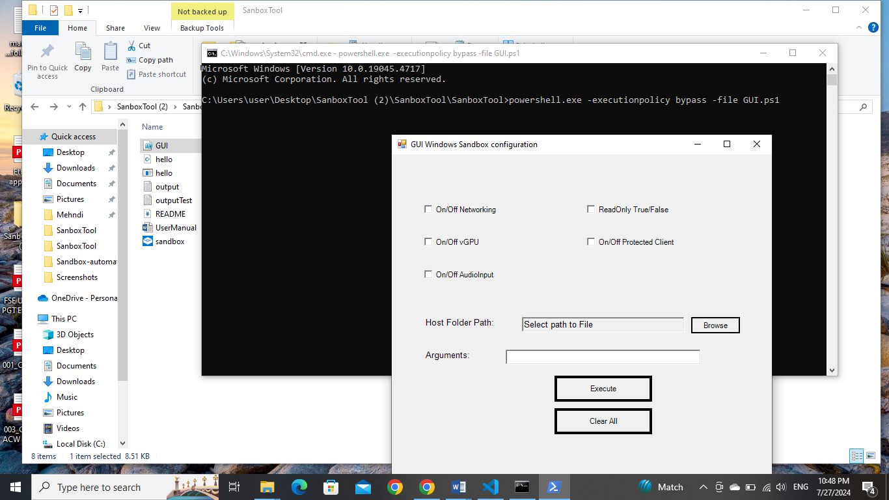

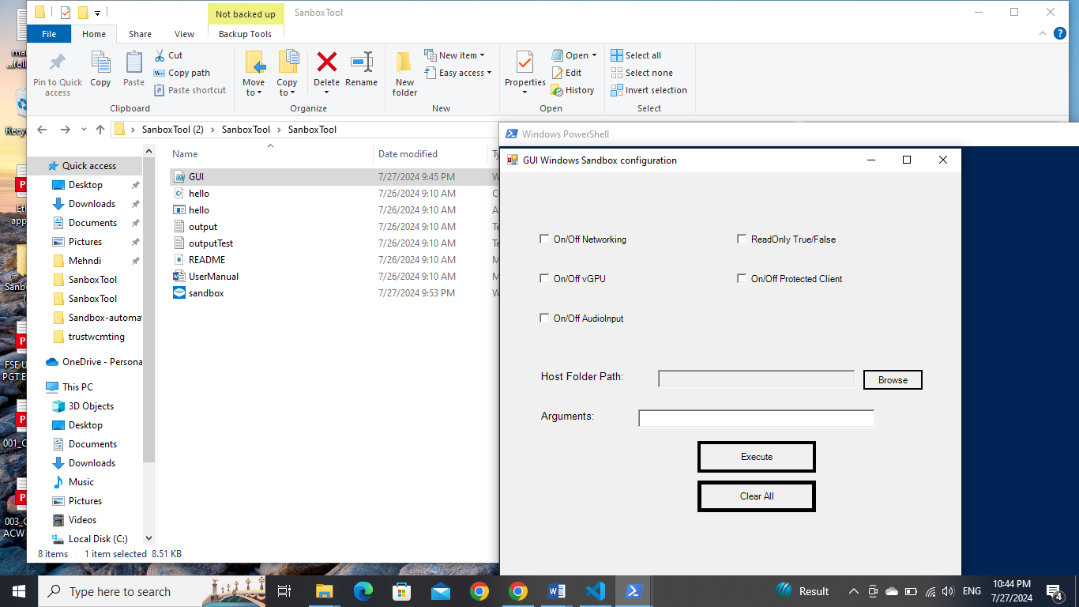

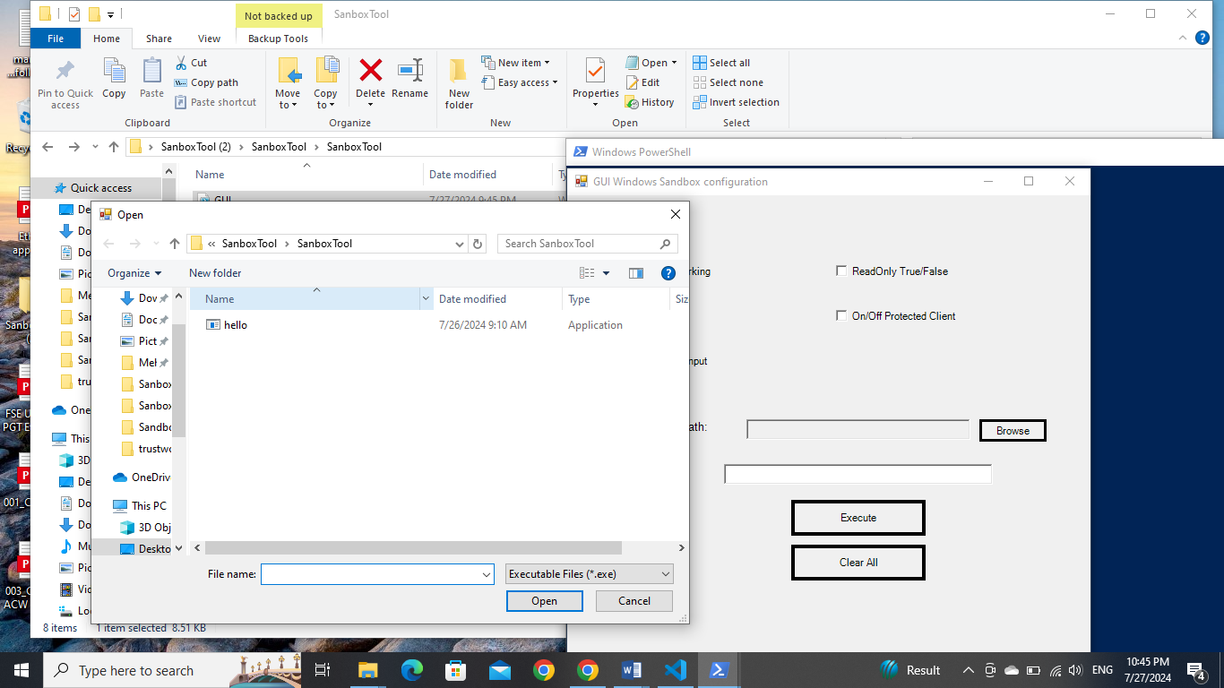

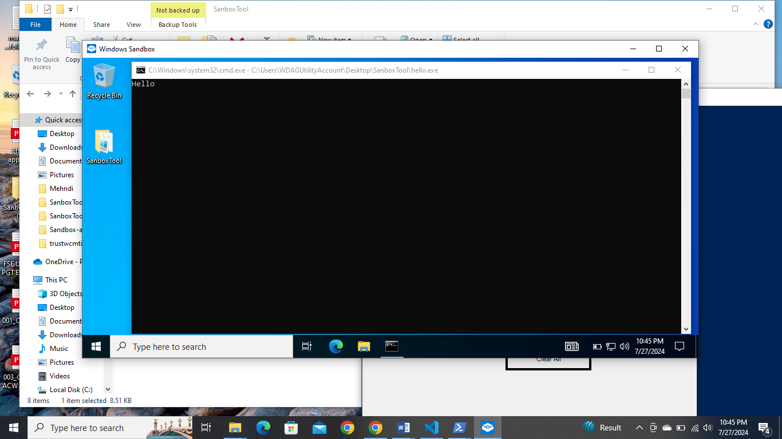

The GUI allows the user to set executable permissions within the sandbox using checkboxes. If a checkbox is checked, the respective permission is On; if unchecked, it is Off.

Use the Host Folder Path option to browse and select the folder that contains the executable to be execute .exe file inside the container.

The final options require the name of the executable and the sandbox folder:

* -file: Enter the name of the executable stored in the Host Folder Path.