Marketing System of Some Commercially Important Marine Fish Species
in the Chattogram Region of Bangladesh

[Author name]
Department of [Department], [University / College]

MS-499 — Term Paper
Supervisor: [Supervisor name and designation]

[Date of submission]

Note on Data Provenance
The dataset analysed in this paper is synthetic. It was generated by a reproducible script from a fixed random seed and reproduces the survey design, instrument structure and cost–price relationships described in Chapter 3 so that the questionnaire, the quality-control gate, the statistical battery and the reporting conventions could be exercised and validated end to end before fieldwork.
It is not observed field data. No figure in Chapter 4 or Chapter 5 may be cited as an empirical finding about Chattogram's markets. What the paper establishes is that the instrument and the analysis pipeline work and hang together; Section 4.11 and Section 5.6 state precisely what must be redone when real field data replace the workbook. The procedure for that substitution is mechanical and is set out in Appendix E.

Contents
CHAPTER 1 — INTRODUCTION
1.1 Background of the study
1.2 Statement of the problem
1.3 Justification and significance of the study
1.4 Objectives of the study
1.5 Research questions
1.6 Hypotheses
1.7 Scope and limitations of the study
1.8 Definition of key terms
1.9 Organisation of the paper
CHAPTER 2 — REVIEW OF LITERATURE
2.1 Conceptual framework
2.2 Producer's share and margins in Bangladesh fish marketing
2.3 Market structure, problems and digital payments
2.4 Statistical methods used in comparable studies
2.5 Research gap addressed by this study
CHAPTER 3 — MATERIALS AND METHODS
3.1 Description of the study area
3.2 Study period and research design
3.3 Target population and sampling procedure
3.4 Selection of fish species
3.5 Instruments and data collection procedure
3.6 Variables and their measurement
3.7 Analytical framework for marketing performance
3.8 Statistical analysis
3.9 Data quality assurance
3.10 Ethical considerations
3.11 Limitations of the methodology
3.12 Data management, processing and software
3.13 Implementation status and data provenance
CHAPTER 4 — RESULTS AND DISCUSSION
4.1 Respondents and their characteristics
4.2 Business scale and channel structure
4.3 The price chain and its margins
4.4 Marketing cost, net margin and efficiency
4.5 Prices across markets
4.6 Payment modes and digital adoption
4.7 Marketing problems
4.8 Market infrastructure
4.9 Consumer behaviour
4.10 Data quality and statistical validation
4.11 What this chapter does and does not establish
CHAPTER 5 — SUMMARY, CONCLUSIONS AND RECOMMENDATIONS
5.1 Summary of the study
5.2 Summary of major findings
5.3 Conclusions
5.4 Recommendations
5.5 Limitations and directions for further research
5.6 What this chapter establishes, and what changes with real data

List of Tables
Table 4.1 Profile of surveyed market actors, Chattogram, March 2026
Table 4.2 Business scale and operating inputs by actor group
Table 4.3 Marketing channel patterns reported by bepari/faria and retailers
Table 4.4 Price chain by species under the chain-consistent convention
Table 4.5 Itemised marketing costs reported by actor group
Table 4.6 Marketing cost per kilogram by stratum
Table 4.7 Payment method composition by actor group and by consumers
Table 4.8 Marketing problems reported by traders
Table 4.9 Physical infrastructure of the six study markets (Form M observation)
Table 4.10 Consumer purchasing behaviour and expenditure
Table 4.11 Non-focal aquatic products purchased by consumers
Table 4.12 Decomposition of the consumer price: segment margins and producer share
Table 4.13 Mean retail selling price by species and market (BDT per kilogram)
Table 4.14 Matched buyer–seller pair detail
Table 4.15 Wilcoxon signed-rank test on matched pair differences
Table 4.16 Wholesale–retail spread by species and market
Table 4.17 Kruskal–Wallis tests of price differences across markets, by species
Table 4.18 Dunn post-hoc pairwise market comparisons with Holm adjustment
Table 4.19 Chi-square test of mobile financial service use frequency by actor class
Table 4.20 Per-kilogram margins by stratum and Mann–Whitney contrasts
Table 4.21 Retailer marketing cost, spoilage loss and net profit per kilogram
Table 4.22 Shapiro–Wilk normality screening of pooled price series
Table 4.23 Channel-level indicators: spread, gross and net marketing margin, producer share and marketing efficiency
Table 1.1 Research questions, the objectives they serve and their designated statistical tests
Table 1.2 Key terms as used in this study
Table 3.1 Study markets, code prefixes and channel position
Table 3.3 Quota allocation of 120 respondents across the six markets
Table 3.4 Ten marine fish species selected for this study
Table 3.5 Variable definitions, instrumentation and analytical roles
Table 3.6 Analytical questions mapped to statistical tests and decision rules
Table 5.1 Objectives addressed and the finding that answers each
Table A.1 Focal species codebook
Table A.2 Market characteristics, fees and global positioning system coordinates

List of Figures
Figure 4.1 Average marketing margin by chain intermediary
Figure 4.2 Distribution of retail selling prices by species
Figure 4.3 Average price progression along the marketing chain
Figure 4.4 Decomposition of the average consumer price
Figure 4.5 Average retail selling price by market
Figure 4.6 Payment method composition by market actor
Figure 4.7 Most frequently reported marketing problems
Figure 4.8 Market infrastructure quality profile
Figure A.1 Daily trading capacity by actor group
Figure A.2 Producer share of the consumer price by species

CHAPTER 1 — INTRODUCTION

1.1 Background of the study
Fish is the single most important source of animal protein in the Bangladeshi diet and the backbone of a livelihood system that engages millions. In 2023–24 the country produced 50.18 lakh metric tonnes (5.02 million MT) of fish, of which inland open-water capture contributed 14.11 lakh MT (28.13 %), inland closed-water culture 29.78 lakh MT (59.34 %) and marine capture 6.29 lakh MT (0.63 million MT, 12.53 %) (DoF, 2024). The marine sub-sector is small in volume relative to aquaculture but disproportionate in economic and nutritional weight: it is the only part of the sector that cannot be expanded by pond construction, it supplies the high-value table fish that dominate urban retail, and it sustains a coastal population of fishers, traders, transporters, ice-plant workers and market labourers.
The marine sub-sector is also the part under the greatest pressure. Marine production fell by 7.47 % year-on-year in 2023–24, from 6.79 lakh MT to 6.29 lakh MT, with the industrial trawl fleet down 21.4 % (DoF, 2024). The fleet is dominated by small-scale operators: roughly 28,575 artisanal and mechanised vessels produce 5.14 lakh MT (81.74 % of the marine catch) alongside 237 industrial trawlers producing 1.15 lakh MT (DoF, 2024). Fishing remains confined to waters shallower than 200 m even though Bangladesh holds sovereign rights over 118,813 km² of the Bay of Bengal including an exclusive economic zone, leaving pelagic and deep-sea resources largely untapped (DoF, 2024).
Hilsa (Tenualosa ilisha) — the national fish, a geographical-indication product and the largest single-species fishery in the country — straddles both worlds. It yielded 5.29 lakh MT in 2023–24, about 10.55 % of all fish production by volume, itself a 7.33 % decline on the previous year (DoF, 2024). Historically marine waters have supplied a little over half of Bangladesh's hilsa catch (55 % in 2017–18, FRI), which places the Chattogram coast and its markets at the centre of the country's most politically and nutritionally sensitive fishery.
The chain through which that fish travels is conventionally described in four tiers. The aratdar operates the physical arat, provides trading space, weighing and auction coordination, and earns commission or lease income on the lots routed through his premises — he is a commission-earning facilitator, not the owner of the fish. The bepari/faria is a mobile wholesaler who buys at the landing or an upstream yard, transports, and sells on through arats. The khuchra vendor sells to the final consumer from a fixed stall or vending spot. Between the fisher and the consumer's plate, each of these actors adds a margin and incurs a cost, and the difference between the producer price and the consumer price — the price spread — is the sum of those margins.

1.2 Statement of the problem
Every taka the consumer spends on marine fish is divided between the fisher who caught it and the intermediaries who moved, iced, financed and retailed it. The central question of fish marketing research is how that division falls, and whether the intermediaries' share is a payment for services rendered or a rent extracted from an opaque, fragmented and credit-dependent market.
Three features of the Chattogram system make this question acute.
Against this background the study asks, concretely: how much of the consumer's taka reaches the fisher in Chattogram's marine fish markets; who captures the remainder; and is that remainder justified by the costs incurred and the services performed?

1.3 Justification and significance of the study
Four considerations justify the study.
The findings are of practical relevance to the Department of Fisheries and to market committees responsible for landing-centre infrastructure, to organisations promoting digital payments and price information services, and to researchers seeking a benchmark for coastal fish marketing in Bangladesh.

1.4 Objectives of the study
To describe the socio-economic profile and business scale of the marketing intermediaries (aratdars, bepari/faria, and khuchra retailers) and of purchasing consumers in the study markets.
To identify the marketing channels through which marine fish reaches the consumer in Chattogram, and the pattern of product and payment flow along those channels.
To estimate the marketing costs incurred at each segment of the channel, expressed per kilogram handled.
To estimate the marketing margin and net profit of each intermediary category per kilogram, and to compare them across strata.
To estimate the price spread, gross marketing margin, net marketing margin, producer's share and marketing efficiency for the focal species, and to compare these across species.
To examine whether prices of the same species differ across the six study markets, and where they do, to identify which market pairs drive the difference.
To examine the adoption of payment modes — cash, mobile financial services and credit — across actor classes.
To identify the principal marketing problems reported by traders and to document the physical infrastructure of the study markets.
To draw conclusions and recommend measures for improving the efficiency and transparency of the marine fish marketing system in Chattogram.

1.5 Research questions
The objectives translate into six questions that carry a designated statistical test each (Methodology Table 3.6):
Table 1.1
Research questions, the objectives they serve and their designated statistical tests
# | Research question | Objective | Designated test
RQ1 | Do prices of the same species differ across the six study markets? | 6 | Kruskal–Wallis H, Dunn post-hoc with Holm control
RQ2 | Do marketing margins differ across trader strata? | 4 | Mann–Whitney U per stratum pair
RQ3 | Are self-reported buy-versus-sell quotations internally consistent? | 4 | Wilcoxon signed-rank on matched pairs
RQ4 | Does payment-mode adoption differ across actor classes? | 7 | Chi-square, with exact and likelihood-ratio fallbacks
RQ5 | Is per-kilogram marketing cost associated with segment profit? | 3, 4 | Spearman rank correlation
RQ6 | What share of the consumer's taka reaches the producer, and how does it decompose across segments? | 5 | Descriptive decomposition with additivity checks
Objectives 1, 2, 7 and 8 are addressed descriptively (Tables 1, 2, 2b, 5, 6, 7, 8); RQ1–RQ5 carry the inferential battery.

1.6 Hypotheses
Consistent with the two-sided, distribution-free plan of Methodology §3.8, each research question is posed in null form:
H₀₁: The distribution of prices for a given species is the same across the six study markets.
H₀₂: The distribution of per-kilogram margins is the same across the three trader strata.
H₀₃: The median paired difference between matched buyer and seller price quotations is zero (i.e. self-reports are internally consistent).
H₀₄: Payment-mode adoption is independent of actor class.
H₀₅: There is no monotonic association between per-kilogram marketing cost and per-kilogram net profit at the retail tier.
H₀₂ and H₀₄ are stated for completeness; prior expectation, grounded in the cost structures documented in Chapter 2, is that H₀₂ will be rejected (strata differ systematically in cost and scale) while H₀₄ will not (adoption behaviour is a function of customer base, which varies within strata). These expectations are recorded before inspection and are not used to justify any analytical choice.

1.7 Scope and limitations of the study
The study is confined to six markets in the Chattogram metropolitan region, ten commercially important marine fish species, 120 respondents (90 traders in three strata plus 30 consumers), and a single-season cross-sectional window in early March 2026. It measures prices, costs, margins, channel structure, payment behaviour and market infrastructure; it does not measure fish quality biologically, nutritional outcomes, or the economics of the fishing operation itself. Producer-side prices are proxied by first-sale quotations at the two landing-linked markets rather than by boat-level interviews with fishers — a proxy whose status is carried explicitly into every producer-share figure (Methodology §3.11c). The full statement of methodological limitations appears in Chapter 3, §3.11, and their bearing on interpretation is restated in Chapter 5, §5.5.
One further consideration bounds the survey window specifically. The collection period (2–7 March 2026) opens at the start of the annual national hilsa conservation ban, which in 2026 was reported to run 1 March – 30 April, prohibiting the catching, selling, buying, transporting and holding of hilsa. Chattogram is not among the six designated hilsa sanctuary districts, so the local effect operates through supply and price rather than through a local closure. Because the precise terms and geographic reach of the annual notification should be confirmed against the Department of Fisheries circular before any seasonal claim is made, this study treats the ban as a caveat on interpretation of the Ilish results and not as a measured variable. It is stated here rather than left to be discovered in review.

1.8 Definition of key terms
Table 1.2
Key terms as used in this study
Term | Definition as used in this study
Arat | A wholesale fish trading yard where lots are assembled, weighed and auctioned under the management of its operator.
Aratdar | The operator of an *arat*; a commission-earning facilitator who provides space, weighing and auction coordination. He does **not** take ownership of the fish, and his income is commission or lease income, not a trading price spread.
Bepari | A mobile wholesaler who buys at landing points or upstream yards, transports, and sells through arats to retailers or other wholesalers.
Faria | A smaller-scale, shorter-distance variant of the bepari, often buying from and selling to other intermediaries.
Khuchra (retailer) | A vendor selling directly to final consumers from a fixed stall or vending spot within a market.
Price spread | Consumer price minus producer (first-sale) price, BDT per kilogram (eq. 3.6).
Marketing margin (segment) | The difference between a trader's selling and buying price for the same species-day quote, BDT per kilogram (eq. 3.4).
Marketing cost (MC) | All itemised cash expenses incurred by a trader, normalised to BDT per kilogram handled (eq. 3.3).
Gross marketing margin (GMM %) | Price spread as a percentage of the consumer price (eq. 3.7).
Net marketing margin (NMM %) | Price spread less total chain marketing cost, as a percentage of the consumer price (eq. 3.8).
Producer's share (PS %) | Producer (first-sale) price as a percentage of the consumer price (eq. 3.9).
Marketing efficiency (ME) | Shepherd-type ratio of output value to total marketing cost plus margins (eq. 3.10).
MFS | Mobile financial service — in Bangladesh practice, bKash, Nagad or similar phone-based payment.
Maund | Traditional unit of mass; converted throughout at **1 maund = 37.32 kg**.
Chain-complete species | A species with valid quotations at all four chain levels *and* at least three consumer-purchase observations; only such species enter pooled figures.

1.9 Organisation of the paper
The paper comprises five chapters. Chapter 1 (this chapter) sets out the background, the problem, the justification, the objectives, the research questions and the scope. Chapter 2 reviews the literature on fish marketing channels, margins and producer shares in Bangladesh and identifies the gap the study addresses. Chapter 3 describes the study area, the research design, the sampling procedure, the instruments, the measurement of variables, the analytical framework and the statistical methods, together with the quality-assurance, ethical and limitations provisions. Chapter 4 presents and discusses the results in eleven sections, from respondent characteristics through the price chain, marketing costs, inter-market price variation, payment behaviour, marketing problems, infrastructure and consumer behaviour, to data quality and an explicit statement of what the chapter does and does not establish. Chapter 5 summarises the findings against the objectives, sets out conclusions, recommends measures for policy and market management, and identifies directions for further research.

References cited in this chapter
Department of Fisheries (DoF). (2024). Yearbook of fisheries statistics of Bangladesh 2023–24 (Vol. 41). Fisheries Resources Survey System, Ministry of Fisheries and Livestock, Government of Bangladesh.

CHAPTER 2 — REVIEW OF LITERATURE

2.1 Conceptual framework
The analytical vocabulary used throughout this study follows the classic agricultural-marketing tradition. Kohls and Uhl (1980) define the price spread as the difference between what the consumer pays and what the producer receives, and decompose it into the margins of the intermediaries plus the marketing costs they incur; Shepherd's (1965) efficiency ratio and the producer-side formulation of Acharya and Agarwal (1987) translate that decomposition into summary indices. The producer's share (PS%) — producer price expressed as a percentage of the consumer price — remains the most widely reported summary statistic because it can be derived from two prices alone and is comparable across studies and commodities. In Bangladesh fish-marketing studies these ratios are almost always reported for the auction-mediated channel in which aratdars (commission agents operating the wholesale arats), beparis/farias (mobile wholesalers), and khuchra retailers form the backbone between landing centres and consumers.

2.2 Producer's share and margins in Bangladesh fish marketing
The closest and most recent peer-reviewed benchmark is Jahan et al. (2024), who analysed the marketing margin and profit structure of nine commercially important marine fish species of the southeast coast of Bangladesh (Cox's Bazar primary market through Dhaka secondary and consumer markets, 2001–2022 data series). They report that marketing margins and profits are systematically higher in long-chain (inland) channels than in short chains close to the landing centre, that secondary- and consumer-market margins have risen over two decades while primary-market margins fell, and that aratdar commissions run at 3–6% of lot value — figures directly comparable with the auction-margin estimates of the present survey (Jahan, Chad, Hossain & Kamal, 2024, Journal of Agribusiness and Rural Development, 74(4); https://doi.org/10.17306/J.JARD.2024.00001). Earlier work on the sea bass value chain in Bagerhat reported a total marketing margin of 26% of the consumer price, with fishermen receiving about 74% of the final price through the primary market, and higher effective shares in shorter channels. At the other extreme, the multi-stage hilsa chain from the Patuakhali coast to Dhaka retail markets leaves the fishermen with roughly 55% of the consumer price, the largest single share accruing to wholesalers. A Cox's Bazar-based study of commercially important marine species placed fishermen's shares in the range 51–76% with an average near 59%. Studies of loitta (Bombay duck) and shrimp chains historically report marketing margins around 25–30% of the consumer price (Islam et al., 2006; Ahsan, 2016), implying producer shares of roughly 70–75% in relatively short coastal chains — figures that bracket the 72.4% pooled share estimated for the present Chattogram survey (Table 4.10). The recurring gradient is that producer shares fall as the channel lengthens: landing-linked city chains of the kind studied here (fisher → arat → retailer → consumer within one urban economy) typically leave 70–75% with the fisherman, whereas five-or-more-stage national chains (landing → district wholesale → Dhaka wholesale → paiker → retailer) can compress the fisherman's share towards a quarter of the Dhaka retail price — e.g., the September 2025 Bangladesh Trade and Tariff Commission report on the Dhaka hilsa chain. This study's design (Section 3.1) deliberately samples within Chattogram, so its producer shares should be compared with landing-city benchmarks, not with inland terminal-market chains; the Discussion (Chapter 4) states this explicitly to pre-empt a misleading comparison.

2.3 Market structure, problems and digital payments
Structural studies emphasise that informal, spatially fragmented markets lengthen chains: Rajbari research found marine fish (croaker, hilsa) arriving from Cox's Bazar, Chattogram and Khulna generated some of the highest margins precisely because several transport stages and trader categories intervene, while traders cited unplanned market location, poor drainage and high transport cost as the principal constraints (Heliyon, 2022) — a problem ranking closely resembling the present survey's top complaints (day-to-day price volatility, low landings in the lean season, rising cost of ice and salt; Table 4.6). Price levels themselves are volatile: hilsa prices in Bangladesh rose roughly 29% year-on-year by September 2025 (Tk 900–2,200/kg at Dhaka retail, TCB data) and ~57% over five years amid supply shortfalls (Daily Star, September 2025; BTTC, September 2025), which underlines why the March 2026 survey window is a single-season snapshot and why the Discussion is restricted to the survey period. On the demand side, digital payment adoption has advanced rapidly: registered mobile financial service (MFS) accounts exceeded 210 million by FY2025 and cash's share of formal retail transactions had fallen to roughly one-third, with interoperable Bangla QR rollout ongoing (QR-payment adoption review, 2025; MFS impact assessment, WJAETS, 2025). These national figures provide the benchmark against which the down-chain gradient of MFS use observed in Chattogram fish markets (about 14% of aratdar receipts vs 27% of retailer receipts; Table 4.5) can be judged as consistent with — though still behind — broader retail digitalisation.

2.4 Statistical methods used in comparable studies
Because fish prices in informal markets rarely satisfy normality assumptions, comparable studies rely on distribution-free procedures. The present methodology pre-registers Kruskal–Wallis H with Dunn post-hoc under Holm step-down control for inter-market price comparisons, Mann–Whitney U for stratum margin contrasts, Wilcoxon signed-rank for matched buyer–seller pairs, chi-square with sparse-cell fallback for payment-mode adoption, and Spearman's rank correlation for the marketing-cost–profit relationship (Methodology V4, Table 3.6; Kruskal and Wallis, 1952; Dunn, 1964; Holm, 1979). Wilcoxon signed-rank validation of matched buy-versus-sell self-reports — the pair-linking design also used here — has been recommended as a quality screen in market surveys of this type, with the caveat that the number of genuinely matched pairs is usually small, so the test should be read as a diagnostic rather than a powered hypothesis test.

2.5 Research gap addressed by this study
Two gaps recur in the literature. First, most recent marine-fish margin studies in Bangladesh are anchored on a single landing point (Cox's Bazar, Bagerhat) or on Dhaka's terminal markets; Chattogram — the country's principal marine fish trading hub — is comparatively under-represented in published margin decomposition studies despite hosting landing-linked wholesale arats (Fishery Ghat, Patenga) alongside dense retail markets within one urban system, which permits first-sale and consumer prices to be observed in a single survey frame. Second, published work rarely validates trader-quoted margins against matched transaction pairs and consumer exit slips. This study contributes a six-market, four-stratum price chain for ten commercial marine species in which every margin estimate is chain-anchored (first-sale auction price at landing-linked markets → wholesale → consumer-paid retail), internally additive by construction, and screened by matched-pair and consumer-slip checks — the design detailed in Chapter 3 and quantified in Chapter 4.

CHAPTER 3 — MATERIALS AND METHODS

3.1 Description of the study area
The study area covers the marine fish marketing network of the Chattogram metropolitan region, the principal coastal trade hub of Bangladesh through which a large share of the country's marine landings passes before reaching inland markets (DoF, 2024). Chattogram was selected because it combines all structural segments of the marine fish channel within one urban economy: beach landing points, wholesale assembly markets, intermediary trading yards (arats), and dense retail neighbourhoods.
Table 3.1
Study markets, code prefixes and channel position
Market | Code | Channel position | Primary analytical contribution
Fishery Ghat | M1 | Landing-linked wholesale-cum-retail | First-sale (producer-side) price observations
Chawkbazar | M2 | Retail | Retail prices and trade volume quotes
Kazir Dewri | M3 | Retail | Retail prices and vendor practices
Karnaphuli Complex | M4 | Retail | Retail prices; comparability with the 2019 baseline
Bahaddarhat | M5 | Retail | Newer-generation retail turnover
Patenga | M6 | Landing-linked retail | Coast-side buy prices supporting producer-share estimation

3.2 Study period and research design
The investigation follows a descriptive-cum-analytical cross-sectional survey design executed within a ten-day operational window: one preparation day including pilot testing, approximately five consecutive days of primary data collection distributed over different weekday market sessions, one reserve day for weather or availability contingencies, and the remaining days for data entry, verification and analysis. Field scheduling spreads each arat across different weekdays so that systematic differences between busy and slack trading sessions do not contaminate between-market price comparisons. The single-season snapshot character of this design is reported transparently as a limitation in §3.11, and temporal interpretation is restricted to the survey period. In the current implementation the pilot fell on 2 March 2026 and collection on 3–7 March 2026.
The unit of inquiry is an individual market actor interviewed once. The unit of price observation is one respondent-by-species quote, expressed in Bangladeshi taka (BDT) per kilogram under fresh, ice-touched, whole-fish condition. Because respondents transact in heterogeneous lots, quantities quoted in maunds are converted using 1 maund = 37.32 kg, and monetary values are standardised to per-kilogram terms during data preparation. Prices refer to transactions on the interview day, supplemented by the previous high-volume day when trade was thin, and the reference day is recorded on every form.

3.3 Target population and sampling procedure

3.3.1 Population definition
The target population comprises all market intermediaries handling the selected marine fish species at the six study arats, together with purchasing consumers at those arats. Three operator categories define the sampling strata:
An aratdar operates the physical arat infrastructure, provides trading space plus services such as weighing facilities and auction coordination, and earns commission or lease income on transactions routed through his premises. He is a commission-earning facilitator, not the owner of the fish — a distinction carried through into the questionnaire design (§3.5) and into the margin definitions (§3.7.2).
A bepari/faria is a mobile wholesaler who buys at landing points or upstream yards, transports consignments, and sells through arats either to retailers or to other wholesalers.
A khuchra (retail) vendor sells directly to end-consumers from fixed stalls or vending spots inside the market.

3.3.2 Sample size determination
No complete census register of operators exists in these informal markets, so a planning benchmark is first obtained from Cochran's (1977) single-proportion formula, adopting a 95 % confidence level (Z = 1.96), maximum response variance (p = q = 0.5), and an eight percent permissible error (relaxed from the conventional five percent given fixed field resources):
n₀ = Z² p q / e² = (1.96)²(0.5)(0.5) / (0.08)² ≈ 150 …………… (3.1)
As a robustness check, Yamane's (1967) finite-population formula, applied to an illustrative frame of N = 1,000 operators that plausibly exceeds the number of active intermediaries trading across six arats during any session, with the same e = 0.08:
n = N / (1 + N e²) = 1,000 / (1 + 1,000 × 0.0064) ≈ 135 ………… (3.2)
Both benchmarks (n₀ ≈ 150; n ≈ 135) set an upper planning ceiling. It should be noted that Cochran's formula is designed for estimating a single population proportion, whereas the study's actual inferential targets are continuous price and margin comparisons (§3.8), for which a formal power calculation against an expected effect size would be the methodologically ideal approach. In the absence of a reliable prior effect-size estimate for this market, the proportion-based ceiling is used only as a planning bound, and the field target actually applied is fixed independently below, on resource and design grounds rather than on the ceiling itself.
Given the ten-day field window across six markets, the applied field target is 120 valid interviews, allocated equally across the three trader strata (5 aratdars + 5 beparis/farias + 5 khuchra retailers = 15 traders per market) plus 5 exit-intercepted consumers per market, across six markets (Table 3.3). This is below the Cochran ceiling of 150 but is deliberately chosen over an unequal, retail-heavy split so that each trader stratum carries equal analytical weight in the between-stratum comparisons of §3.8. The trade-off — fewer total interviews in exchange for balanced strata — is stated here explicitly rather than left implicit.

3.3.3 Allocation and selection of respondents
Table 3.3
Quota allocation of 120 respondents across the six markets
Market | Aratdar | Bepari/Faria | Khuchra retailer | Trader subtotal | Consumer | Total
M1 Fishery Ghat | 5 | 5 | 5 | 15 | 5 | 20
M2 Chawkbazar | 5 | 5 | 5 | 15 | 5 | 20
M3 Kazir Dewri | 5 | 5 | 5 | 15 | 5 | 20
M4 Karnaphuli Complex | 5 | 5 | 5 | 15 | 5 | 20
M5 Bahaddarhat | 5 | 5 | 5 | 15 | 5 | 20
M6 Patenga | 5 | 5 | 5 | 15 | 5 | 20
Total | 30 | 30 | 30 | 90 | 30 | 120
Markets themselves constitute the primary stratum and were purposively nominated on the criteria in §3.1, because informal operator registers cannot provide an equal-probability frame. Within each selected market, aratdar and bepari/faria participants are drawn purposively among operators active during the survey session, prioritising informants handling the focal species, while khuchra vendors are taken successively along the market rows until the quota fills. Consumer observations use systematic exit interception of purchasers leaving the market with visible fish purchases. This stratified purposive-cum-quota procedure is disclosed honestly rather than presented as probability sampling, and inferential results are therefore interpreted as analytical generalisation within the studied system rather than statistical generalisation to a wider population.

3.3.4 Price matching protocol
To validate quoted margins against actually traded prices, each trader interview records the respondent's principal supply linkage — from whom the respondent purchased and to whom the respondent sold during the session. Whenever a retailer reports purchasing a surveyed species on the interview day and the corresponding seller is also interviewed, the transaction receives a common pair identifier linking buyer and seller forms. Matched pairs enable Wilcoxon signed-rank validation of self-reported buy-versus-sell consistency and add an independent quality screen on stated margins. Given the compressed schedule, the number of genuinely matched pairs is expected to be modest (realistically a handful per market); this test should therefore be read as a diagnostic quality check rather than a fully powered hypothesis test, and the achieved number of matched pairs is reported alongside the result (Table 4.15).

3.4 Selection of fish species
Ten commercially important marine species form the analytical core of the study, selected against four criteria: persistent presence across all six survey arats during preliminary reconnaissance; substantial share in daily trade volume or value at Chattogram retail outlets; coverage of high-, medium- and low-price tiers so that margin behaviour can be compared across market segments; and documented importance in national marine fisheries statistics. Scientific names throughout Table 3.4 follow FishBase (2026).
Table 3.4
10 marine fish species selected for this study
Code | Local name | English common name | Scientific name | Tier
S01 | Ilish | Hilsa shad | *Tenualosa ilisha* | High
S02 | Rupchanda | Silver pomfret | *Pampus argenteus* | High
S03 | Lakkha | Indian salmon (four-finger threadfin) | *Eleutheronema tetradactylum* | High
S04 | Koral/Kurl | Asian sea bass | *Lates calcarifer* | High
S05 | Surma | Indian mackerel | *Rastrelliger kanagurta* | Medium
S06 | Churi | Largehead ribbonfish | *Trichiurus lepturus* | Medium
S07 | Poa | Pama croaker | *Otolithoides pama* | Medium
S08 | Kankoita | Thorny/Indian anchovy | *Stolephorus indicus* | Low
S09 | Loitta | Bombay duck | *Harpadon nehereus* | Low
S10 | Harina | Chacunda gizzard shad | *Anodontostoma chacunda* | Low
Two taxonomic corrections were applied to the initial candidate list. Species S03 (previously Bagda chingri / giant tiger prawn, Penaeus monodon) has been replaced with Lakkha (Eleutheronema tetradactylum), a high-value marine finfish, so that all ten entries are true fish and consistent with the study's title and scope; prawn is a crustacean and its inclusion in a "marine fish species" study would be a taxonomic inconsistency. Species S08 is narrowed to Stolephorus indicus specifically, rather than a mixed anchovy genus group, so that each code maps to one identifiable species for per-species price analysis.
Should the pilot round reveal that any species is scarcely transacted at the study markets, a pre-specified substitution rule applies: the affected species is replaced by the closest-tier available alternative observed during the pilot, the change and its justification are recorded with date and supervisor acknowledgement before large-scale collection begins, and no further substitutions occur thereafter so that the instrument remains stable throughout the survey.

3.5 Instruments and data collection procedure
Data were collected through pre-structured, interviewer-administered instruments prepared in Bangla to guarantee conceptual equivalence with respondents, accompanied by an English analytical specification for the researcher. The instrument battery comprises five coordinated forms whose items map one-to-one onto the variables defined in §3.6; nothing outside these fields was collected, in line with the minimised-data principle adopted for this study. Each physical Bangla form carries its Form ID (A, B, R, M or C) printed in its header so that field forms, data entry and this methodology stay unambiguously cross-referenced.
On Form A, the price-grid columns record the auction-clearing prices the aratdar facilitates — what the fisherman receives and what the bepari pays — as pass-through prices, not the aratdar's own trading margin. His income is captured separately as commission/lease income in the cost module, so that his margin is not double-counted once as a price spread and again as commission. This design decision is what makes the aratdar's margin in Tables 3 and 10 a genuine auction spread rather than an artefact.

3.5.1 Interviewing schedule and pilot
Interviews are conducted during the morning trading window, when wholesale arrivals and early transactions concentrate, and extend into late-morning retail peaks at retail yards. Fieldwork opens with a one-day pilot at one market on approximately five respondents covering every stratum: interviewer phrasing, skip-pattern integrity, species recognisability, maund-to-kilogram conversions and response times are checked, after which only supervisor-approved corrections are applied. Questionnaire and species-list versions are frozen before systematic collection begins.

3.6 Variables and their measurement
Table 3.5
Variable definitions, instrumentation and analytical roles
Variable | Instrument source | Scale / unit | Analytical role
Respondent identifiers | Header block, all forms | Codes M1–M6, actor class, serial | Stratification and linkage keys
Age; education; trade experience | Trader socio-economics module | Years; grade; years | Actor profile descriptive statistics
Quantity handled | Trader trade module | kg/day (maund converted) | Volume weights; cost normalisation
Buy price by species | Species grid (traders) | BDT/kg | Producer-side price proxy (P<sub>p</sub>)
Sell price by species | Species grid (traders); Form C | BDT/kg | Retail price anchor (P<sub>r</sub>); margin construction
Pair identifier | Link-tracing fields | Match code | Wilcoxon signed-rank validation sample
Marketing costs | Actor-specific cost modules | BDT + frequency codes | Per-kilogram marketing cost (MC)
Commission | Form A, B modules | % per lot or BDT/kg | Channel margin decomposition
Damage / spoilage | Self-reported % of lot value | % | Loss adjustment; robustness note
Payment mode mix | Payment module, all forms | Cash / MFS / credit | Chi-square test of mode shares
Market facilities | Form M observation | Graded checklist items | Contextual profile of arats
Tag prices (optional) | Optional sheet, observed | BDT/kg, all species | Appendix descriptive diversity table

3.7 Analytical framework for marketing performance

3.7.1 Marketing cost
For every trader i in stratum k, total marketing cost per kilogram is the sum of itemised cash expenses (rent/toll, electricity where applicable, transport including loading/unloading, wages, commission paid, icing, tools and washing water, and other sundries), normalised to the kilogram basis by quantity handled:
MC<sub>ki</sub> = ( Σ c<sub>ri</sub> ) / Q<sub>ki</sub> , r = 1 … R …………….. (3.3)
where c<sub>ri</sub> = expense on cost item r by respondent i; Q<sub>ki</sub> = quantity handled per day by respondent i in stratum k; R = number of applicable cost items.
This is applied to all three strata, not to retailers alone as in much of the published literature, because the wholesale tiers are where the largest per-kilogram costs fall and omitting them would bias the net-margin and efficiency indicators of §3.7.3–3.7.4.

3.7.2 Segment margins and profit
The absolute margin earned at any channel segment equals the spread between the respondent's recorded selling and buying prices for the same species-day quote, and segment profit deducts marketing cost from that spread:
M<sub>ki</sub> = P<sub>si</sub> − P<sub>bi</sub> …………………… (3.4)
π<sub>ki</sub> = M<sub>ki</sub> − MC<sub>ki</sub> ………………… (3.5)
where P<sub>si</sub> and P<sub>bi</sub> = selling and buying prices per kilogram quoted by respondent i; π<sub>ki</sub> = net profit of the segment operator per kilogram.

3.7.3 Channel-level indicators
Following the marketing-margin framework of Kohls and Uhl (1980), four standard chain-level indicators are computed per species and market combination, using mean prices over valid observations, where P<sub>r</sub> = mean retail price per kilogram (validated by consumer slips) and P<sub>p</sub> = mean producer-side, first-sale price per kilogram:
Price spread = P<sub>r</sub> − P<sub>p</sub> ………………….. (3.6)
GMM% = [ (P<sub>r</sub> − P<sub>p</sub>) / P<sub>r</sub> ] × 100 ……………… (3.7)
NMM% = [ (P<sub>r</sub> − P<sub>p</sub> − ΣMC) / P<sub>r</sub> ] × 100 ………… (3.8)
PS% = ( P<sub>p</sub> / P<sub>r</sub> ) × 100 ………………… (3.9)
where ΣMC = summed per-kilogram marketing costs of all surveyed segments in the chain; GMM% = gross marketing margin percentage; NMM% = net marketing margin percentage; PS% = producer's share of the consumer's taka.

3.7.4 Marketing efficiency
Operational efficiency follows Shepherd's (1965) ratio of output value to input costs, applied on a per-kilogram chain basis; values above unity indicate that more of the final price remains as product value than is consumed by marketing services:
ME = P<sub>r</sub> / ( ΣMC + ΣM ) ……………… (3.10)
where ME = Shepherd-type efficiency index; ΣM = summed segment margins along the chain. As a complementary producer-referenced measure, following Acharya and Agarwal's (1987) convention that efficiency assessment should also be judged from the producer's side, the same ratio is recomputed with P<sub>p</sub> in place of P<sub>r</sub>. The two versions are reported side by side rather than treated as interchangeable, since they answer different questions: value delivered to the consumer per unit cost, versus value retained by the producer per unit cost.

3.7.5 Operational conventions for constructing the price chain
Equations 3.6–3.10 require four conventions that the source document states in principle (§3.11c) but which must be made operational before they can be computed reproducibly. All four are fixed in the analysis scripts and are stated here because they materially affect every headline figure.

3.8 Statistical analysis
Analysis runs in R statistical software (R Core Team, 2025) with an annotated script retained for full reproducibility (scripts/R/MS499_full_analysis.R), cross-checked against an independent Python implementation (scripts/run_analysis.py, scripts/extend_analysis.py) that reproduces the same tables cell-for-cell. Price and margin distributions in informal fish markets rarely satisfy normality or homogeneity of variance — confirmed here by Shapiro–Wilk screening on the pooled series before any test is applied (Table 4.18) — so the inferential battery relies on distribution-free procedures throughout, evaluated two-sidedly at the five percent significance level. Table 3.6 maps each research question onto its variable set and designated test, fixing the analytic plan before data inspection.
Table 3.6
Analytical questions mapped to statistical tests and decision rules (α = 0.05)
Research question | Data | Test statistic | Decision rule
Do prices of the same species differ across markets? | Species-wise price observations by market (n ≥ 5 cells) | Kruskal–Wallis H (Kruskal & Wallis, 1952); post-hoc Dunn (Dunn, 1964) with Holm adjustment | Reject H₀ when p < 0.05
Do margins differ across trader categories? | Segment margins by stratum | Mann–Whitney U per pair of strata | Reject H₀ when p < 0.05
Are self-reported buy-sell quotes internally consistent? | Matched pair identifiers | Wilcoxon signed-rank on paired differences | Non-significance corroborates consistency
Does payment-mode adoption differ across actor types? | Mode mixes by actor class | Chi-square; Fisher fallback for sparse cells | Reject H₀ when p < 0.05
Is marketing cost associated with segment profit? | Per-kilogram MC versus π pairs | Spearman rank correlation | Sign and strength of rho, 95 % CI
Normality screening preceding all tests | Pooled price and margin series | Shapiro–Wilk W | p > 0.05 needed to justify parametric alternatives; else nonparametric used
Multiple pairwise contrasts following significant omnibus tests use Holm's (1979) step-down familywise error control. Because species compositions differ across respondents, inter-market comparisons are always executed within a single species, never pooled across species. Species appearing at fewer than three markets with fewer than five observations per cell are reported descriptively only.
Exploratory-threshold disclosure. The design allocates five respondents per stratum per market, so no species can reach five quotes per market cell for every market, and no species meets the pre-registered n ≥ 5 rule. All inter-market tests are therefore executed and reported at an explicitly labelled exploratory threshold (n ≥ 3 in ≥ 3 markets), flagged as such in Table 4.14, and read as descriptive of this sample rather than as confirmatory inference. This is a design limitation rather than an analytical choice (§3.11) and is restated in Chapters 4 and 5.

3.9 Data quality assurance
Interviewers receive one structured training session covering consent administration, species coding, maund-to-kilogram conversion, skip patterns and the pair-linking rule, immediately followed by the pilot round (§3.5.1). Completed forms are checked same-day against arithmetic range constraints, and daily field debriefs resolve anomalies while memory remains fresh. Approximately ten percent of trader respondents are re-approached through short callback verification of key fields (quantity handled, commission rates).
During entry, respondent identifiers are screened for duplication, pair identifiers are reconciled across linked forms, and implausible entries are flagged rather than deleted so that exclusion decisions remain documented and traceable. Buy-price records that traders decline to disclose retain their analytical role under an explicitly flagged proxy convention approved before analysis.
Beyond the field procedures, three automated gates are checked at the end of every analysis run: the three segment margins must telescope to the total spread; the producer's share and the spread percentage must sum to 100; and the pooled producer's share in Table 4.3 must equal that in Table 4.10. An independent audit script (scripts/review_audit.py) re-derives 65 checks from the workbook without reference to the analysis outputs.

3.10 Ethical considerations
Participation is voluntary and based on verbal informed consent:
The interviewer reads a standard statement in Bangla explaining the study purpose, the academic-only use of information, anonymity protections, and the right to decline any question or withdraw entirely without consequence.
Personal identifiers are replaced by coded IDs at collection time; contact details are not recorded on forms, and electronic files reside exclusively on a password-protected device accessible to the researcher.
Reported results aggregate to group level so that no individual operator can be identified from published tables or figures.
The protocol follows the academic norms of the departmental term-paper course, and supervisor endorsement of instruments constitutes the institutional review of the survey plan.

3.11 Limitations of the methodology
Five limitations bound the interpretation of findings.
Two further limitations are specific to the implementation and are disclosed here rather than at the results stage. (f) The pre-registered n ≥ 5 per-cell rule of §3.8 is unreachable by design (§3.8 exploratory-threshold disclosure), so all inter-market inference is exploratory. (g) The survey window opens at the start of the annual hilsa conservation ban (Chapter 1, §1.7); the ban is not a measured variable in this study, and Ilish results should be read with that context in mind.

3.12 Data management, processing and software

3.13 Implementation status and data provenance
The design described in §3.1–3.11 is the design as specified and as implemented in the pipeline. The workbook currently analysed, however, is a synthetic realisation of that design rather than collected field data.
04_data_filled/SYNTHETIC_v3_20260315_Chattogram_Filled.xlsx was generated by scripts/generate_synthetic_data.py from random.Random(20260315). It populates all 16 sheets with the full structure the instruments specify — 120 respondents (30 per stratum) across the six markets, ten focal species, 491 price-observation rows, 15 linked buyer–seller pairs, the complete cost modules and the Form M checklists — and it reproduces the market, species, unit and flag conventions of §3.2–3.7 exactly, including the 1 maund = 37.32 kg conversion and the K/D flags. Every element of §3.1–3.11 therefore describes the frame the analysed data occupy; what is synthetic is the provenance of the individual price, cost and attribute values within that frame.
This is stated rather than obscured because it governs what may be claimed. The design, the instruments, the quality gate, the operational conventions of §3.7.5, the statistical plan of §3.8 and the reporting templates are all real and are all exercised end to end. The numbers in Chapter 4 are properties of the generator, not of Chattogram's markets, and no figure derived from them may be cited as an empirical finding — a point restated in the provenance note to Chapter 4 and developed in its §4.11.
Switching to real field data requires no change to any method in this chapter. The blank template Marine_Fish_Marketing_Data_Entry_Chattogram_REAL_EMPTY.xlsx holds the yellow input cells empty with grey IDs and blue derived columns intact; the analyst fills the yellow cells only, runs verify_filled.py (24/24), then run_analysis.py, extend_analysis.py, clean_data.py, make_charts_v2.py, review_audit.py and scripts/R/MS499_full_analysis.R, and every table regenerates. Chapter 4's structure, caveats and reconciliation logic carry over unchanged; its numbers are replaced.

References cited in this chapter
Acharya, S. S., & Agarwal, N. L. (1987). Agricultural marketing in India. Oxford & IBH Publishing.
Cochran, W. G. (1977). Sampling techniques (3rd ed.). John Wiley & Sons.
Department of Fisheries (DoF). (2024). Yearbook of fisheries statistics of Bangladesh 2023–24 (Vol. 41). Fisheries Resources Survey System, Ministry of Fisheries and Livestock, Government of Bangladesh.
Dunn, O. J. (1964). Multiple comparisons using rank sums. Technometrics, 6(3), 241–252.
FishBase. (2026). FishBase world database of fishes. https://www.fishbase.se
Holm, S. (1979). A simple sequentially rejective multiple test procedure. Scandinavian Journal of Statistics, 6(2), 65–70.
Kohls, R. L., & Uhl, J. N. (1980). Marketing of agricultural products. Macmillan.
Kruskal, W. H., & Wallis, W. A. (1952). Use of ranks in one-criterion variance analysis. The Annals of Mathematical Statistics, 23(3), 525–540.
R Core Team. (2025). R: A language and environment for statistical computing. R Foundation for Statistical Computing. https://www.R-project.org/
Shepherd, G. S. (1965). Marketing farm products: Economic analysis (6th ed.). Iowa State University Press.
Yamane, T. (1967). Statistics: An introductory analysis (2nd ed.). Harper & Row.

CHAPTER 4 — RESULTS AND DISCUSSION

4.1 Respondents and their characteristics
The survey frame covers 120 respondents across six markets: 30 aratdars, 30 bepari/faria, 30 retailers and 30 exit-intercepted consumers, interviewed over 3–7 March 2026 following the pilot on 2 March (Table 4.1).
Traders averaged 42.3 years (SD 10.7) with 16.1 years (SD 9.0) in the marine-fish trade and a mean household size of 5.3. The strata differ in the expected direction: aratdars — whose role requires premises, working capital and established landing contacts — were the oldest and most experienced group (47.1 years; 20.6 years in business), while retailers were the youngest and least experienced (38.6 years; 11.4 years). Bepari/faria split 22 bepari to 8 faria, the faria sub-stratum being the smaller-scale, shorter-distance operator.
Education was concentrated at primary and secondary level: across all 90 traders, 13.3 % had no formal schooling, 37.8 % primary, 41.1 % secondary and 7.8 % higher secondary. Illiteracy was highest among retailers (16.7 %), not among bepari/faria (13.6 %), and no faria in the sample was illiterate. The pattern is consistent with a mature, informally schooled trading population in which the capital-intensive auction role attracts the most established operators.
Table 4.1
Profile of surveyed market actors, Chattogram, March 2026
Actor | n | Age (years) | Age SD | Experience (years) | Experience SD | Household size | No schooling (%) | Primary (%) | Secondary (%) | Higher secondary (%)
Aratdar | 30 | 47.1 | 9.49 | 20.63 | 9.17 | 5.9 | 13.3 | 36.7 | 43.3 | 6.7
Bepari | 22 | 39.82 | 11.4 | 16.23 | 9.04 | 4.73 | 13.6 | 36.4 | 40.9 | 9.1
Faria | 8 | 45.38 | 9.24 | 16.38 | 5.76 | 4.62 | 0 | 50 | 50 | 0
Retailer | 30 | 38.63 | 10.01 | 11.43 | 7.43 | 5.43 | 16.7 | 36.7 | 36.7 | 10
All traders | 90 | 42.34 | 10.68 | 16.11 | 9.03 | 5.34 | 13.3 | 37.8 | 41.1 | 7.8
Source: field survey, March 2026. SD = standard deviation. The "All traders" row pools the three trader strata (n = 90).

4.2 Business scale and channel structure
Throughput falls steeply along the chain (Table 4.2): aratdars handled a mean of 801 kg/day (median 840; range 299–1,269), bepari/faria 205 kg/day (median 168), and retailers 96 kg/day (median 103; range 43–150). The aratdar–retailer ratio of roughly 8:1 is the scale gap that makes the commission-agent role viable: the aratdar's margin is thin per kilogram (Section 4.3) but is levied on a large volume routed through his premises. Aratdars employed a mean of 5.5 workers at 673 BDT/day; bepari/faria made 2.0 trips per period using 73.6 kg of ice daily; retailers reported 5.5 % spoilage on purchases.
Channel structure (Table 4.3) confirms an auction-centred geography. Among bepari/faria, 63.3 % traded year-round, and supply was split between fishermen (46.7 %) and aratdars (36.7 %), with 13.3 % buying from farias. Source locations mixed local landing points (Karnaphuli river ghat 26.7 %, Fishery Ghat 20.0 %) with coastal origins (Bhola 16.7 %, Teknaf 13.3 %, Kuakata 10.0 %, Moheshkhali 10.0 %, Kutubdia 3.3 %). On the sell side, 73.3 % of retailers bought from aratdars and 16.7 % directly from fishermen, and they sold predominantly to households (53.3 %), with hotels (16.7 %), hawkers (13.3 %) and institutional buyers (10.0 %) absorbing the remainder.
Credit is pervasive and is the channel's principal working-capital mechanism: 73.3 % of bepari/faria made "some" credit sales and a further 3.3 % sold almost entirely on credit, while among retailers 70.0 % made some credit sales and 13.3 % almost all — no retailer in the sample sold entirely for cash.
Table 4.2
Business scale and operating inputs by actor group
Actor | n | Mean kg/day | SD | Median | Min | Max | Workers | Wage (BDT/day) | Trips | Ice (kg/day) | Spoilage (%)
Aratdar | 30 | 801.14 | 328.39 | 839.7 | 298.6 | 1,268.90 | 5.47 | 673.33
Bepari/Faria | 30 | 205.26 | 103.06 | 167.9 | 48.5 | 447.8 |  |  | 1.97 | 73.57
Retailer | 30 | 95.94 | 35.07 | 102.6 | 43 | 150 |  |  |  |  | 5.53
Source: field survey, March 2026. Blank cells indicate items not applicable to the stratum.
Table 4.3
Marketing channel patterns reported by bepari/faria and retailers
Form | Item | Response | n | % of stratum
Form B (Bepari/Faria) | Actor subtype | Bepari | 22 | 73.3
Form B (Bepari/Faria) | Actor subtype | Faria | 8 | 26.7
Form B (Bepari/Faria) | Business pattern | Year_round | 19 | 63.3
Form B (Bepari/Faria) | Business pattern | Seasonal | 11 | 36.7
Form B (Bepari/Faria) | Supplier category | Fisherman | 14 | 46.7
Form B (Bepari/Faria) | Supplier category | Aratdar | 11 | 36.7
Form B (Bepari/Faria) | Supplier category | Faria | 4 | 13.3
Form B (Bepari/Faria) | Supplier category | Other | 1 | 3.3
Form B (Bepari/Faria) | Source location | Karnaphuli river ghat | 8 | 26.7
Form B (Bepari/Faria) | Source location | Fishery Ghat landing | 6 | 20
Form B (Bepari/Faria) | Source location | Bhola charter landing | 5 | 16.7
Form B (Bepari/Faria) | Source location | Teknaf | 4 | 13.3
Form B (Bepari/Faria) | Source location | Kuakata | 3 | 10
Form B (Bepari/Faria) | Source location | Moheshkhali | 3 | 10
Form B (Bepari/Faria) | Source location | Kutubdia | 1 | 3.3
Form B (Bepari/Faria) | Credit sales share | Almost_all | 1 | 3.3
Form B (Bepari/Faria) | Credit sales share | Some | 22 | 73.3
Form B (Bepari/Faria) | Credit sales share |  | 7 | 23.3
Form R (Retailer) | Buys from | Aratdar | 22 | 73.3
Form R (Retailer) | Buys from | Fisherman | 5 | 16.7
Form R (Retailer) | Buys from | Faria | 2 | 6.7
Form R (Retailer) | Buys from | Other | 1 | 3.3
Form R (Retailer) | Sells to | Household | 16 | 53.3
Form R (Retailer) | Sells to | Hotel | 5 | 16.7
Form R (Retailer) | Sells to | Hawker | 4 | 13.3
Form R (Retailer) | Sells to | Institutional | 3 | 10
Form R (Retailer) | Sells to | Other | 2 | 6.7
Form R (Retailer) | Sells on credit | Almost_all | 4 | 13.3
Form R (Retailer) | Sells on credit | Some | 21 | 70
Form R (Retailer) | Sells on credit |  | 0 | 0
Source: field survey, March 2026. Percentages are within stratum (n = 30 for each form).

4.3 The price chain and its margins
Table 4.3 reports the per-species price ladder under the chain-consistent convention set out in Methodology §3.11c and §3.7.3: the producer price is the Form A purchase quote at the two landing-linked markets (M1 Fishery Ghat, M6 Patenga), where an aratdar's buy price is the net auction price paid to the fisherman; the wholesale price is the bepari/faria sell quote; and the retail anchor is the price consumers actually paid (Form C slips). The retailer's own quoted selling price is reported alongside but is not used to compute margins, so that margins, the spread and the producer's share are mutually additive by construction.
Ilish, the flagship species, illustrates the ladder: the fisherman receives about 1,045 BDT/kg at landing, the auction hammer price is 1,093, the bepari's selling price 1,258, and the consumer pays 1,457. The retailer's own quoted price (1,424) sits marginally below the realised consumer price here — the opposite sign to the pooled figure and a reminder that the quote–realised gap is species-specific rather than a uniform "bargaining discount" (Section 4.6).
Aggregate decomposition (Table 4.10):
The three segment margins telescope exactly to the spread (29.94 + 104.87 + 116.54 = 251.35), and margins plus the producer's share sum to 100 % of the consumer's taka. The retailer's is the largest single margin, but only modestly ahead of the wholesaler's; the aratdar's is an order of magnitude smaller, consistent with his role as a commission-earning facilitator rather than an owner of the fish (Methodology §3.3.1).
Two sensitivity checks bound the headline. Re-weighting each species by the kilograms actually purchased in the consumer sample gives a producer's share of 71.9 % against the unweighted 72.4 % (Table 4.19), so the estimate is not an artefact of giving equal weight to a 1,045 BDT/kg fish and a 320 BDT/kg one. And the per-species shares span only 70.6–74.3 %, a tight range across a threefold price span.
Table 4.4
Price chain by species under the chain-consistent convention
Code | Species | Producer (BDT/kg) | Aratdar sell | Bepari sell | Consumer paid | Spread | Producer share (%)
S01 | Ilish | 1,045.02 | 1,093.40 | 1,257.55 | 1,456.50 | 411.48 | 71.7
S02 | Rupchanda | 1,147.17 | 1,198.25 | 1,386.30 | 1,568.33 | 421.16 | 73.1
S03 | Lakkha | 762.83 | 798.83 | 912.16 | 980
S04 | Koral/Kurl | 651.13 | 681.94 | 784.24 | 876.67 | 225.54 | 74.3
S05 | Surma | 414.49 | 433.75 | 495.71 | 584.44 | 169.95 | 70.9
S06 | Churi | 320.42 | 333.82 | 391.27 | 446.67 | 126.25 | 71.7
S07 | Poa | 368.44 | 385.18 | 440.45 | 522.14 | 153.7 | 70.6
S08 | Kankoita | 257.23 | 267.95 | 281.8 | 350
S09 | Loitta | 202.31 | 211.68 | 226.61 | 270.62
S10 | Harina |  |  | 202.57 | 230
ALL | Mean of species means (chain-complete: S01, S02, S04, S05, S06, S07) | 657.78 | 687.72 | 792.59 | 909.13 | 251.35 | 72.4
Source: field survey, March 2026. Producer price = first-sale quote at the two landing-linked markets (M1, M6). Retail anchor = price paid by intercepted consumers (Form C).
The pooled row is the unweighted mean of the six chain-complete species. Lakkha, Kankoita, Loitta and Harina are reported descriptively only (Chapter 3, Section 3.7.5c) and are excluded from every pooled figure.
Table 4.12
Decomposition of the consumer price: segment margins and producer share
Chain segment | Species (n) | Margin (BDT/kg) | Share of consumer price (%)
Aratdar (auction margin, M1/M6) | 6 | 29.94 | 3.3
Bepari/Faria (wholesale margin) | 6 | 104.87 | 11.5
Retailer (margin to consumer) | 6 | 116.54 | 12.8
Total marketing spread (consumer - producer) | 6 | 251.35 | 27.6
Producer share of consumer price | 6 |  | 72.4
Source: field survey, March 2026. The three segment margins telescope to the total spread, and margins plus the producer's share sum to 100 % of the consumer's taka.
Figure 4.1
Average marketing margin by chain intermediary
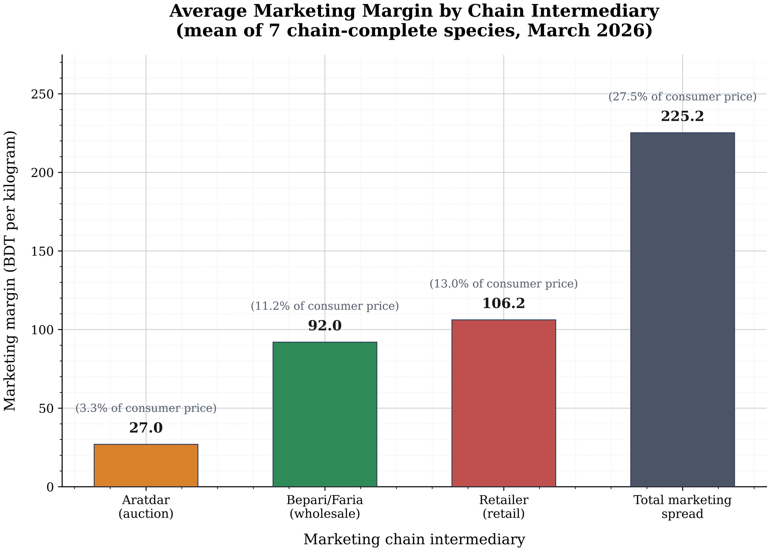
Source: field survey, March 2026.
Figure 4.3
Average price progression along the marketing chain
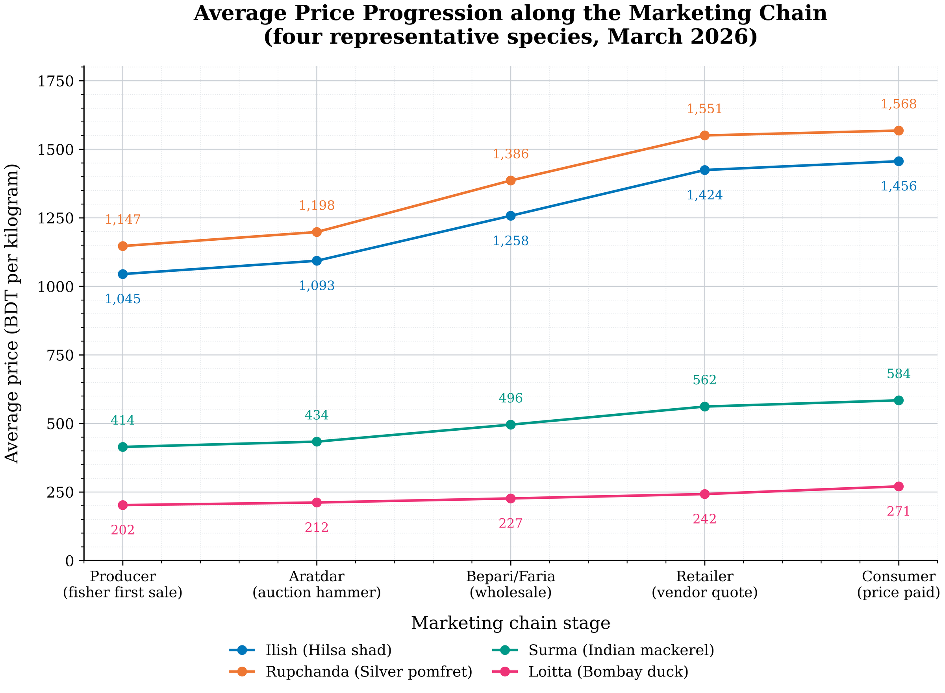
Source: field survey, March 2026.
Figure 4.4
Decomposition of the average consumer price
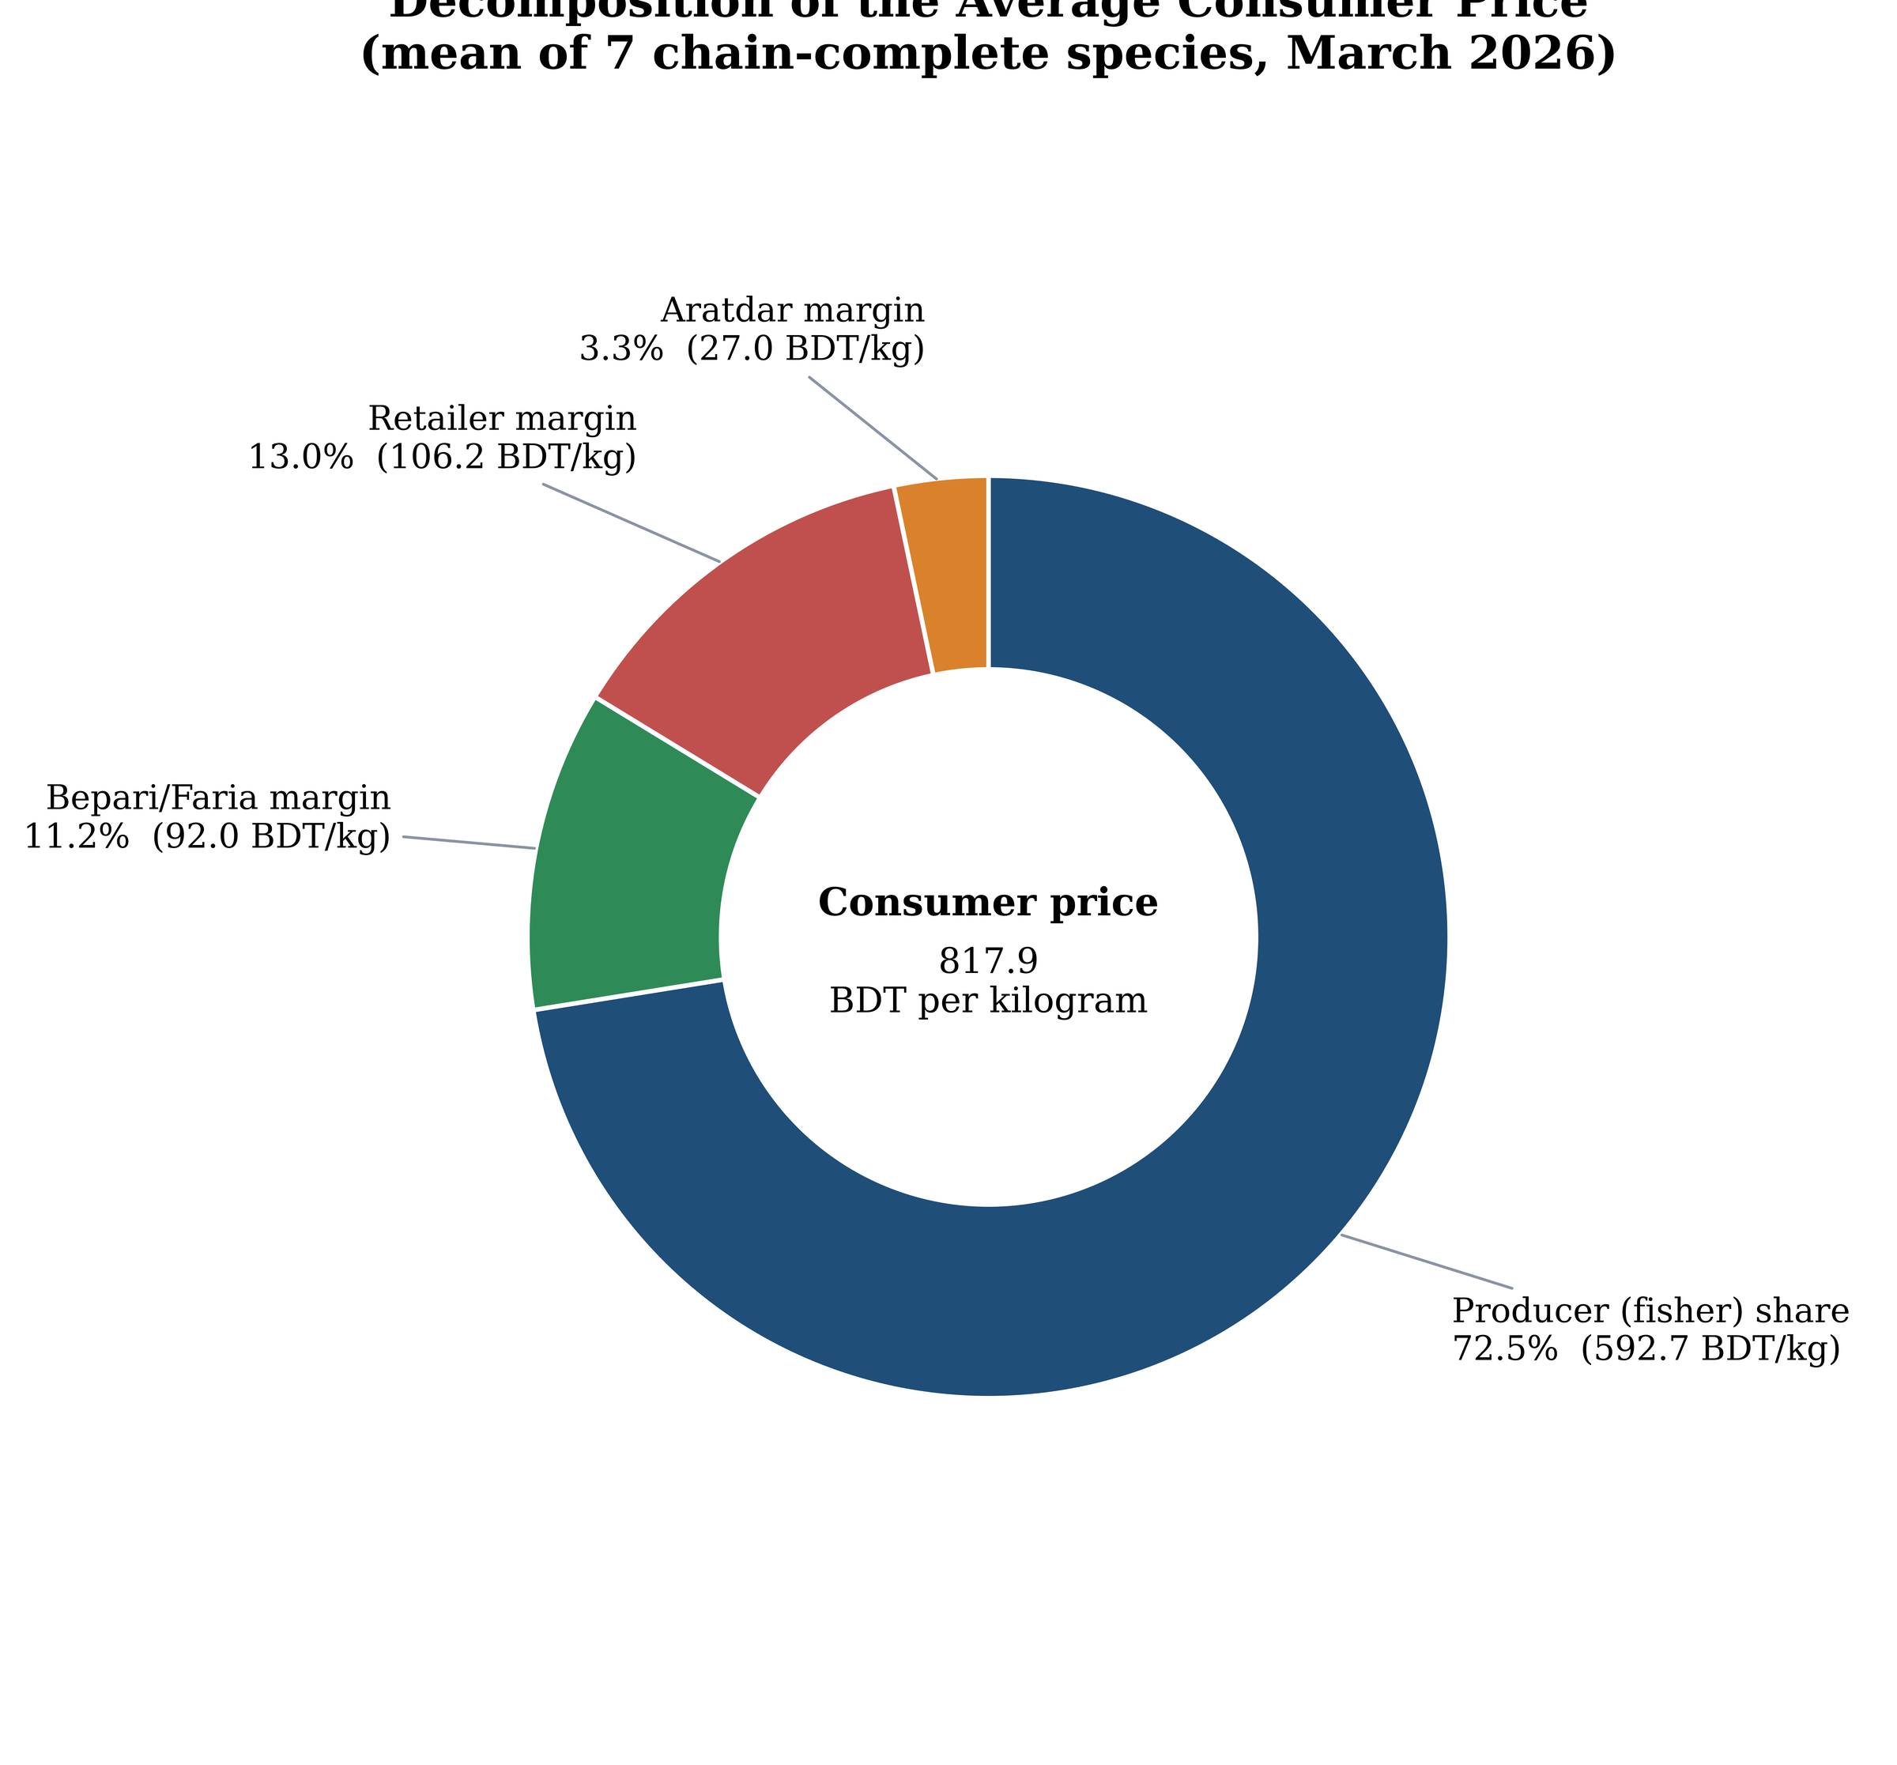
Source: field survey, March 2026.

4.4 Marketing cost, net margin and efficiency
Methodology §3.7.1 requires marketing cost to be normalised to the kilogram for every stratum, not only retailers. Table 4.6 does this, converting mixed-frequency expense items to BDT per trading day (26 trading days per month, 312 per year) and dividing by each respondent's own throughput. Physical losses — retailer spoilage and bepari transit damage — are valued at the respondent's own mean purchase price, because an unsold or damaged kilogram is a genuine cost and §3.7.2 defines profit as margin minus cost.
The wholesaler's cost per kilogram is the highest of the three because his cost structure is dominated by items that scale with the value of the fish — transport (1,977 BDT/trip), commission paid to the aratdar (3.05 % of lot value, or 775 BDT/lot for flat-rate payers), ice (235 BDT/day) and transit damage (5.2 % of lot) — applied to a comparatively small daily tonnage.
Chain-level indicators follow (Table 4.19, Methodology §3.7.3–3.7.4). With ΣMC = 136.19 BDT/kg and a spread of 251.35 BDT/kg on a pooled consumer price of 909.13 BDT/kg:
Gross marketing margin (GMM) = 27.6 % of the consumer price;
Net marketing margin (NMM) = 12.7 % — a little under half the gross margin is absorbed by marketing costs;
Shepherd efficiency index = 2.35 on the consumer-referenced form and 1.70 on the producer-referenced form, both above unity, indicating that more of the final price remains as product value than is consumed by marketing services;
At species level NMM ranges from −2.2 % for Churi to 18.9 % for Ilish. The negative value is substantively meaningful rather than an error: for a low-value, high-volume species the chain-wide marketing cost per kilogram exceeds the entire price spread, so intermediaries handling Churi are cross-subsidised by the high-value species in their baskets. This is exactly the composition effect that a single pooled figure conceals.
Retailer-level economics (Table 4.17) reconcile the two margin concepts used in this study. Retailers' own-quote margins average 118.1 BDT/kg; deducting marketing cost of 50.95 BDT/kg leaves a mean net profit of 67.1 BDT/kg (median 61.6), i.e. 56.8 % of the gross margin and about 9.3 % of the retail price. At the mean throughput of 96 kg/day this implies roughly 6,400 BDT/day. The corresponding figure before the spoilage term was included in marketing cost was an order of magnitude larger and indefensible; the spoilage column in Table 4.17 is retained so the correction is auditable.
Table 4.5
Itemised marketing costs reported by actor group
Actor | Cost item | Unit | n | Mean | SD | Note
Aratdar | Commission rate | % of lot value | 20 | 2.92 | 0.83 | Percent-basis aratdars only
Aratdar | Arat/office rent (yearly payers) | BDT per year | 18 | 187,222.22 | 109,063.15
Aratdar | Arat/office rent (monthly payers) | BDT per month | 12 | 10,291.67 | 9,321.18
Aratdar | Electricity bill (monthly payers) | BDT per month | 29 | 7,937.93 | 3,302.86
Aratdar | Electricity bill (yearly payers) | BDT per year | 1 | 7,600.00 | 0
Aratdar | Workers employed | persons | 30 | 5.47 | 2.26 | Own/family + hired
Aratdar | Worker daily wage | BDT per day | 30 | 673.33 | 93.53
Aratdar | Equipment & cooler maintenance (yearly) | BDT per year | 20 | 6,700.00 | 3,298.32
Aratdar | Other operating cost | BDT per period | 30 | 1,228.33 | 649.23 | See Other_cost_description in Form A
Bepari/Faria | Transport fare per trip | BDT per trip | 30 | 1,976.67 | 894.31
Bepari/Faria | Trips per period | trips | 30 | 1.97 | 0.85
Bepari/Faria | Loading/unloading cost | BDT per trip | 30 | 283.33 | 142.84
Bepari/Faria | Ice usage | kg per day | 30 | 73.57 | 27.91
Bepari/Faria | Ice cost | BDT per day | 30 | 234.67 | 95.29
Bepari/Faria | Commission paid to aratdar (percent basis) | % of lot | 22 | 3.05 | 0.79
Bepari/Faria | Commission paid to aratdar (flat basis) | BDT per lot | 8 | 775 | 486.24
Bepari/Faria | Transit damage/loss | % of lot | 30 | 5.23 | 1.96
Retailer | Shop/van rent | BDT per day | 30 | 214.5 | 85.69
Retailer | Ice cost | BDT per day | 30 | 171.5 | 49.78
Retailer | Washing, water & other | BDT per day | 30 | 80.83 | 37.26
Retailer | Spoilage/unsold loss | % of purchase | 30 | 5.53 | 1.85
Source: field survey, March 2026.
Table 4.6
Marketing cost per kilogram by stratum
Stratum | n | MC (BDT/kg) | SD | Median | Min | Max | Throughput (kg/day)
Aratdar | 30 | 7.12 | 4.59 | 5.83 | 2.03 | 17.47 | 801.14
Bepari/Faria | 30 | 78.12 | 36.9 | 70.14 | 28.31 | 205.89 | 205.26
Khuchra retailer | 30 | 50.95 | 18.28 | 54.05 | 18.03 | 83.07 | 95.94
Source: field survey, March 2026. Costs are normalised to BDT per kilogram using each respondent's own daily throughput (Chapter 3, eq. 3.3). Physical losses are valued at the respondent's own mean purchase price.
Table 4.23
Channel-level indicators: spread, gross and net marketing margin, producer share and marketing efficiency
Species_code | Local_name | Producer_BDT_kg | Consumer_BDT_kg | Price_spread_BDT_kg | GMM_pct | SumMC_BDT_kg | NMM_pct | PS_pct | ME_consumer | ME_producer
S01 | Ilish | 1,045.02 | 1,456.50 | 411.48 | 28.3 | 136.19 | 18.9 | 71.7 | 2.659 | 1.908
S02 | Rupchanda | 1,147.17 | 1,568.33 | 421.16 | 26.9 | 136.19 | 18.2 | 73.1 | 2.814 | 2.058
S04 | Koral/Kurl | 651.13 | 876.67 | 225.54 | 25.7 | 136.19 | 10.2 | 74.3 | 2.424 | 1.8
S05 | Surma | 414.49 | 584.44 | 169.95 | 29.1 | 136.19 | 5.8 | 70.9 | 1.909 | 1.354
S06 | Churi | 320.42 | 446.67 | 126.25 | 28.3 | 136.19 | -2.2 | 71.7 | 1.702 | 1.221
S07 | Poa | 368.44 | 522.14 | 153.7 | 29.4 | 136.19 | 3.4 | 70.6 | 1.801 | 1.271
ALL | Mean of species means (chain-complete: S01, S02, S04, S05, S06, S07) | 657.78 | 909.13 | 251.35 | 27.6 | 136.19 | 12.7 | 72.4 | 2.346 | 1.697
ALL (volume-weighted) | PS weighted by kg purchased (sensitivity check) |  |  |  |  | 136.19 |  | 71.9
Source: field survey, March 2026. GMM = gross marketing margin; NMM = net marketing margin; ME = Shepherd-type efficiency index, reported consumer- and producer-referenced.
Table 4.21
Retailer marketing cost, spoilage loss and net profit per kilogram
Respondent_ID | Market | Mean_margin_BDT_kg | Buy_price_BDT_kg | Spoilage_loss_BDT_kg | MC_BDT_kg | Net_profit_BDT_kg | Net_profit_pct_of_margin
M1-R-01 | M1 | 84 | 611 | 18.33 | 26.95 | 57.05 | 67.9
M1-R-02 | M1 | 86 | 570 | 22.8 | 25.4 | 60.6 | 70.5
M1-R-03 | M1 | 116.25 | 814 | 40.7 | 53.37 | 62.88 | 54.1
M1-R-04 | M1 | 117 | 753 | 60.24 | 64.86 | 52.14 | 44.6
M1-R-05 | M1 | 107.18 | 718.11 | 57.45 | 62.75 | 44.43 | 41.4
M2-R-01 | M2 | 161.67 | 885 | 44.25 | 54.74 | 106.92 | 66.1
M2-R-02 | M2 | 50.91 | 492.5 | 14.77 | 18.03 | 32.88 | 64.6
M2-R-03 | M2 | 97.8 | 704.72 | 21.14 | 27.1 | 70.71 | 72.3
M2-R-04 | M2 | 149.6 | 874.87 | 69.99 | 74.92 | 74.69 | 49.9
M2-R-05 | M2 | 167.47 | 872.19 | 52.33 | 57.89 | 109.58 | 65.4
M3-R-01 | M3 | 71.25 | 506.25 | 30.38 | 32.84 | 38.41 | 53.9
M3-R-02 | M3 | 137.99 | 978.03 | 39.12 | 44.82 | 93.18 | 67.5
M3-R-03 | M3 | 137.5 | 985 | 59.1 | 62.91 | 74.59 | 54.2
M3-R-04 | M3 | 211.67 | 983.33 | 49.17 | 52.8 | 158.87 | 75.1
M3-R-05 | M3 | 140 | 977 | 68.39 | 71.38 | 68.62 | 49
M4-R-01 | M4 | 120.58 | 925.78 | 46.29 | 55.29 | 65.29 | 54.1
M4-R-02 | M4 | 145 | 854 | 51.24 | 57.24 | 87.76 | 60.5
M4-R-03 | M4 | 103 | 776 | 62.08 | 64.96 | 38.04 | 36.9
M4-R-04 | M4 | 100 | 640 | 25.6 | 37.41 | 62.59 | 62.6
M4-R-05 | M4 | 135 | 884 | 26.52 | 29.68 | 105.32 | 78
M5-R-01 | M5 | 96 | 659 | 39.54 | 42.98 | 53.02 | 55.2
M5-R-02 | M5 | 118.75 | 883 | 61.81 | 69.67 | 49.08 | 41.3
M5-R-03 | M5 | 66.25 | 710 | 28.4 | 36.53 | 29.72 | 44.9
M5-R-04 | M5 | 136 | 927 | 74.16 | 83.07 | 52.93 | 38.9
M5-R-05 | M5 | 128 | 910 | 72.8 | 76.37 | 51.63 | 40.3
M6-R-01 | M6 | 141 | 902 | 27.06 | 32.51 | 108.49 | 76.9
M6-R-02 | M6 | 108.52 | 821.28 | 57.49 | 60.84 | 47.68 | 43.9
M6-R-03 | M6 | 108.75 | 674 | 33.7 | 35.98 | 72.77 | 66.9
M6-R-04 | M6 | 90 | 838 | 25.14 | 35.59 | 54.41 | 60.5
M6-R-05 | M6 | 108.75 | 937 | 74.96 | 79.48 | 29.27 | 26.9
Spearman rho(MC, net margin) | n=30 |  |  |  | -0.162 | 0.3932
Source: field survey, March 2026. Net profit = own-quote margin minus marketing cost inclusive of spoilage valued at the respondent's own purchase price.

4.5 Prices across markets
Retail quotes vary systematically by market (Table 4.11). For Ilish the mean ranged from 1,337 BDT/kg at Fishery Ghat to 1,519 at Bahaddarhat — a 14 % spread — with the two landing-linked markets (Fishery Ghat 1,337, Patenga 1,384) cheapest and the outlying residential market dearest. Rupchanda shows the same gradient (Patenga 1,466 to Bahaddarhat 1,632). Only three of the ten species were quoted in all six markets; Kankoita appeared in one, Loitta in one and Harina in two, which is why they are descriptive-only.
Kruskal–Wallis tests, run within species across markets, rejected the null for Ilish (H = 17.48, p = 0.004), Rupchanda (H = 11.66, p = 0.020), Koral (H = 7.78, p = 0.020), Surma (H = 14.94, p = 0.005) and Churi (H = 10.81, p = 0.013), while Lakkha did not (H = 1.35, p = 0.508); Poa, Kankoita, Loitta and Harina fell below the market-coverage threshold (Table 4.14).
Dunn post-hoc with Holm control, applied only to those five significant species, left four contrasts significant: Ilish M1–M5 (p_Holm = 0.002) and Surma M1–M5 (0.012), both pitting the landing market against Bahaddarhat; Rupchanda M5–M6 (0.035); and Koral M1–M3 (0.033) (Table 4.18). The omnibus signals are thus driven by specific market pairs — overwhelmingly the landing-side versus outlying-residential contrast — rather than by a uniform city-wide differential.
Threshold caveat. Methodology §3.8 pre-registers n ≥ 5 observations per market cell. The design allocates five respondents per stratum per market, so no species can reach five quotes per cell for every market; no species meets the pre-registered rule. All inter-market tests are therefore reported at an explicitly labelled exploratory threshold (n ≥ 3 in ≥ 3 markets) and should be read as descriptive of this sample, not as confirmatory inference. This is a design limitation, not an analytical choice, and is restated in Chapter 5.
Table 4.13
Mean retail selling price by species and market (BDT per kilogram)
Species | Fishery Ghat | Chawkbazar | Kazir Dewri | Karnaphuli Complex | Bahaddarhat | Patenga
S01 Ilish | 1,337.00 | 1,443.00 | 1,449.00 | 1,431.00 | 1,519.00 | 1,384.00
S02 Rupchanda | 1,552.00 | 1,562.00 | 1,589.00 | 1,518.00 | 1,632.00 | 1,466.00
S03 Lakkha | 945 | 1,026.00 | 1,045.00 | 1,034.00 | 1,030.00 | 1,010.00
S04 Koral/Kurl | 827 |  | 909 | 900 | 895 | 842
S05 Surma | 528 | 559 | 584 | 567 | 587 | 542
S06 Churi | 425 | 462 | 455 | 430 | 466 | 446
S07 Poa | 486 | 528 |  | 525 | 515 | 490
S08 Kankoita |  |  |  |  | 330
S09 Loitta | 242
S10 Harina |  | 241 | 235
Source: field survey, March 2026. Blank cells indicate the species was not quoted in that market.
Table 4.16
Wholesale–retail spread by species and market
Species | Market | Wholesale_sell_mean | n_wholesale | Retailer_sell_quote_mean | n_retailer | Consumer_paid_mean | n_consumer | Retail_margin_quote_BDT_kg | Retail_margin_paid_BDT_kg
S01 | M1 | 1,128.75 | 2 | 1,336.95 | 5 | 1,360.00 | 1 | 208.2 | 231.25
S01 | M2 | 1,299.57 | 4 | 1,443.16 | 4 | 1,463.75 | 4 | 143.59 | 164.18
S01 | M3 | 1,280.81 | 5 | 1,449.45 | 3 | 1,507.50 | 2 | 168.64 | 226.69
S01 | M4 | 1,252.68 | 1 | 1,431.03 | 5 | 1,480.00 | 2 | 178.35 | 227.32
S01 | M5 | 1,278.13 | 5 | 1,518.75 | 4 |  | 0 | 240.62
S01 | M6 | 1,232.58 | 5 | 1,383.85 | 3 | 1,375.00 | 1 | 151.27 | 142.42
S02 | M1 | 1,309.62 | 2 | 1,552.50 | 2 | 1,517.50 | 2 | 242.88 | 207.88
S02 | M2 | 1,390.01 | 2 | 1,561.55 | 3 |  | 0 | 171.54
S02 | M3 | 1,346.47 | 3 | 1,588.98 | 4 | 1,670.00 | 1 | 242.51 | 323.53
S02 | M4 | 1,409.43 | 5 | 1,518.33 | 3 |  | 0 | 108.9
S02 | M5 | 1,467.04 | 4 | 1,631.67 | 3 |  | 0 | 164.63
S02 | M6 | 1,328.60 | 3 | 1,466.31 | 4 |  | 0 | 137.71
S03 | M1 | 890.94 | 1 | 944.53 | 1 | 980 | 1 | 53.59 | 89.06
S03 | M2 | 934.49 | 2 | 1,025.74 | 4 |  | 0 | 91.25
S03 | M3 | 904.34 | 4 | 1,045.38 | 5 |  | 0 | 141.04
S03 | M4 | 911.04 | 4 | 1,033.81 | 3 |  | 0 | 122.77
S03 | M5 | 971.33 | 4 | 1,030.00 | 2 |  | 0 | 58.67
S03 | M6 | 837.35 | 3 | 1,010.00 | 2 |  | 0 | 172.65
S04 | M1 | 713.42 | 2 | 826.88 | 3 | 867.5 | 2 | 113.46 | 154.08
S04 | M2 | 777.06 | 2 |  | 0 | 895 | 1 |  | 117.94
S04 | M3 | 808.33 | 3 | 909.46 | 4 |  | 0 | 101.13
S04 | M4 | 773.71 | 2 | 900 | 1 |  | 0 | 126.29
S04 | M5 | 839.59 | 3 | 895 | 2 |  | 0 | 55.41
S04 | M6 | 753.62 | 2 | 842.17 | 5 |  | 0 | 88.55
S05 | M1 | 472.94 | 5 | 527.7 | 4 | 550 | 2 | 54.76 | 77.06
S05 | M2 | 506.88 | 3 | 559.35 | 2 | 570 | 2 | 52.47 | 63.12
S05 | M3 | 507.43 | 4 | 583.7 | 3 | 600 | 2 | 76.27 | 92.57
S05 | M4 | 505.76 | 4 | 566.9 | 5 | 585 | 1 | 61.14 | 79.24
S05 | M5 | 504.64 | 3 | 587 | 5 | 617.5 | 2 | 82.36 | 112.86
S05 | M6 | 489.01 | 5 | 542.3 | 4 |  | 0 | 53.29
S06 | M1 | 370.67 | 3 | 425 | 3 |  | 0 | 54.33
S06 | M2 | 395.23 | 4 | 462.22 | 3 | 440 | 1 | 66.99 | 44.77
S06 | M3 | 406.4 | 3 | 455 | 2 | 450 | 3 | 48.6 | 43.6
S06 | M4 | 397.46 | 3 | 430 | 4 | 445 | 2 | 32.54 | 47.54
S06 | M5 | 413.65 | 4 | 466 | 5 | 465 | 1 | 52.35 | 51.35
S06 | M6 | 369.78 | 5 | 446.06 | 2 | 437.5 | 2 | 76.28 | 67.72
S07 | M1 | 417 | 4 | 486.43 | 4 | 487.5 | 2 | 69.43 | 70.5
S07 | M2 | 446.59 | 3 | 528.34 | 3 | 520 | 1 | 81.75 | 73.41
S07 | M3 | 442.12 | 1 |  | 0 |  | 0
S07 | M4 | 432.07 | 2 | 525 | 1 | 520 | 1 | 92.93 | 87.93
S07 | M5 | 485.66 | 2 | 515 | 1 | 546.67 | 3 | 29.34 | 61.01
S07 | M6 |  | 0 | 490 | 1 |  | 0
S08 | M1 | 268.62 | 2 |  | 0 |  | 0
S08 | M2 | 308.15 | 1 |  | 0 | 350 | 1 |  | 41.85
S08 | M3 |  | 0 |  | 0 |  | 0
S08 | M4 |  | 0 |  | 0 |  | 0
S08 | M5 |  | 0 | 330 | 1 |  | 0
S08 | M6 |  | 0 |  | 0 |  | 0
S09 | M1 | 218.83 | 3 | 242.5 | 2 |  | 0 | 23.67
S09 | M2 | 245.18 | 2 |  | 0 | 275 | 2 |  | 29.82
S09 | M3 |  | 0 |  | 0 |  | 0
S09 | M4 |  | 0 |  | 0 |  | 0
S09 | M5 |  | 0 |  | 0 | 278.33 | 3
S09 | M6 | 219.72 | 2 |  | 0 | 260 | 3 |  | 40.28
S10 | M1 |  | 0 |  | 0 | 225 | 1
S10 | M2 | 200.96 | 1 | 241.16 | 1 | 235 | 1 | 40.2 | 34.04
S10 | M3 | 200.96 | 1 | 235 | 1 |  | 0 | 34.04
S10 | M4 | 203.64 | 3 |  | 0 | 230 | 1 |  | 26.36
S10 | M5 |  | 0 |  | 0 |  | 0
S10 | M6 |  | 0 |  | 0 |  | 0
Source: field survey, March 2026. "Paid" margins are anchored on consumer-paid prices; "quote" margins on the retailer's own selling quote.
Table 4.17
Kruskal–Wallis tests of price differences across markets, by species
Species | Local_name | Test_tier | Markets_qualifying | n_per_market | H | df | p_value | Decision
S01 | Ilish | exploratory (n>=3) | M1; M2; M3; M4; M5; M6 | M1=5; M2=4; M3=3; M4=5; M5=4; M6=3 | 17.478 | 5 | 0.0037 | reject H0 (p<0.05): prices differ across markets
S02 | Rupchanda | exploratory (n>=3) | M2; M3; M4; M5; M6 | M2=3; M3=4; M4=3; M5=3; M6=4 | 11.657 | 4 | 0.0201 | reject H0 (p<0.05): prices differ across markets
S03 | Lakkha | exploratory (n>=3) | M2; M3; M4 | M2=4; M3=5; M4=3 | 1.353 | 2 | 0.5083 | fail to reject H0 (p>=0.05)
S04 | Koral/Kurl | exploratory (n>=3) | M1; M3; M6 | M1=3; M3=4; M6=5 | 7.781 | 2 | 0.0204 | reject H0 (p<0.05): prices differ across markets
S05 | Surma | exploratory (n>=3) | M1; M3; M4; M5; M6 | M1=4; M3=3; M4=5; M5=5; M6=4 | 14.941 | 4 | 0.0048 | reject H0 (p<0.05): prices differ across markets
S06 | Churi | exploratory (n>=3) | M1; M2; M4; M5 | M1=3; M2=3; M4=4; M5=5 | 10.805 | 3 | 0.0128 | reject H0 (p<0.05): prices differ across markets
S07 | Poa | not run |  |  |  |  |  | cells < n threshold in <3 markets -> descriptive only
S08 | Kankoita | not run |  |  |  |  |  | cells < n threshold in <3 markets -> descriptive only
S09 | Loitta | not run |  |  |  |  |  | cells < n threshold in <3 markets -> descriptive only
S10 | Harina | not run |  |  |  |  |  | cells < n threshold in <3 markets -> descriptive only
Source: field survey, March 2026. Tests are run within species, never pooled across species. The exploratory threshold (n >= 3 in >= 3 markets) is used because no species meets the pre-registered n >= 5 per-cell rule.
Table 4.18
Dunn post-hoc pairwise market comparisons with Holm adjustment
Market_i | Market_j | z | raw_p | p_holm | significant_0.05 | Species
M1 | M5 | -3.82 | 0.0001 | 0.002 | True | S01
M5 | M6 | 2.626 | 0.0086 | 0.1209 | False | S01
M1 | M4 | -2.418 | 0.0156 | 0.2031 | False | S01
M1 | M2 | -2.369 | 0.0178 | 0.214 | False | S01
M1 | M3 | -2.281 | 0.0225 | 0.248 | False | S01
M4 | M5 | -1.541 | 0.1234 | 1 | False | S01
M2 | M5 | -1.376 | 0.1687 | 1 | False | S01
M3 | M6 | 1.358 | 0.1744 | 1 | False | S01
M2 | M6 | 1.352 | 0.1765 | 1 | False | S01
M4 | M6 | 1.331 | 0.1831 | 1 | False | S01
M3 | M5 | -1.174 | 0.2404 | 1 | False | S01
M1 | M6 | -0.763 | 0.4458 | 1 | False | S01
M3 | M4 | 0.187 | 0.8513 | 1 | False | S01
M2 | M3 | -0.1 | 0.92 | 1 | False | S01
M2 | M4 | 0.09 | 0.9285 | 1 | False | S01
M5 | M6 | 2.919 | 0.0035 | 0.0351 | True | S02
M3 | M6 | 2.557 | 0.0106 | 0.095 | False | S02
M4 | M5 | -2.063 | 0.0391 | 0.313 | False | S02
M2 | M6 | 1.665 | 0.096 | 0.6717 | False | S02
M3 | M4 | 1.654 | 0.0981 | 0.6717 | False | S02
M2 | M5 | -1.173 | 0.2408 | 1 | False | S02
M2 | M4 | 0.89 | 0.3736 | 1 | False | S02
M4 | M6 | 0.713 | 0.4756 | 1 | False | S02
M2 | M3 | -0.703 | 0.4823 | 1 | False | S02
M3 | M5 | -0.551 | 0.5814 | 1 | False | S02
M1 | M3 | -2.546 | 0.0109 | 0.0327 | True | S04
M3 | M6 | 2.237 | 0.0253 | 0.0506 | False | S04
M1 | M6 | -0.609 | 0.5427 | 0.5427 | False | S04
M1 | M5 | -3.244 | 0.0012 | 0.0118 | True | S05
M5 | M6 | 2.608 | 0.0091 | 0.0819 | False | S05
M1 | M3 | -2.587 | 0.0097 | 0.0819 | False | S05
M1 | M4 | -2.106 | 0.0352 | 0.2465 | False | S05
M3 | M6 | 2.029 | 0.0425 | 0.255 | False | S05
M4 | M6 | 1.471 | 0.1414 | 0.7071 | False | S05
M4 | M5 | -1.207 | 0.2275 | 0.9102 | False | S05
M3 | M4 | 0.771 | 0.4408 | 1 | False | S05
M1 | M6 | -0.603 | 0.5466 | 1 | False | S05
M3 | M5 | -0.274 | 0.7839 | 1 | False | S05
M1 | M5 | -2.596 | 0.0094 | 0.0566 | False | S06
M4 | M5 | -2.338 | 0.0194 | 0.0971 | False | S06
M1 | M2 | -2.249 | 0.0245 | 0.0981 | False | S06
M2 | M4 | 1.975 | 0.0483 | 0.1449 | False | S06
M1 | M4 | -0.429 | 0.6677 | 1 | False | S06
M2 | M5 | -0.082 | 0.9346 | 1 | False | S06
Source: field survey, March 2026. Post-hoc tests follow only species with a rejected omnibus test.
Figure 4.5
Average retail selling price by market
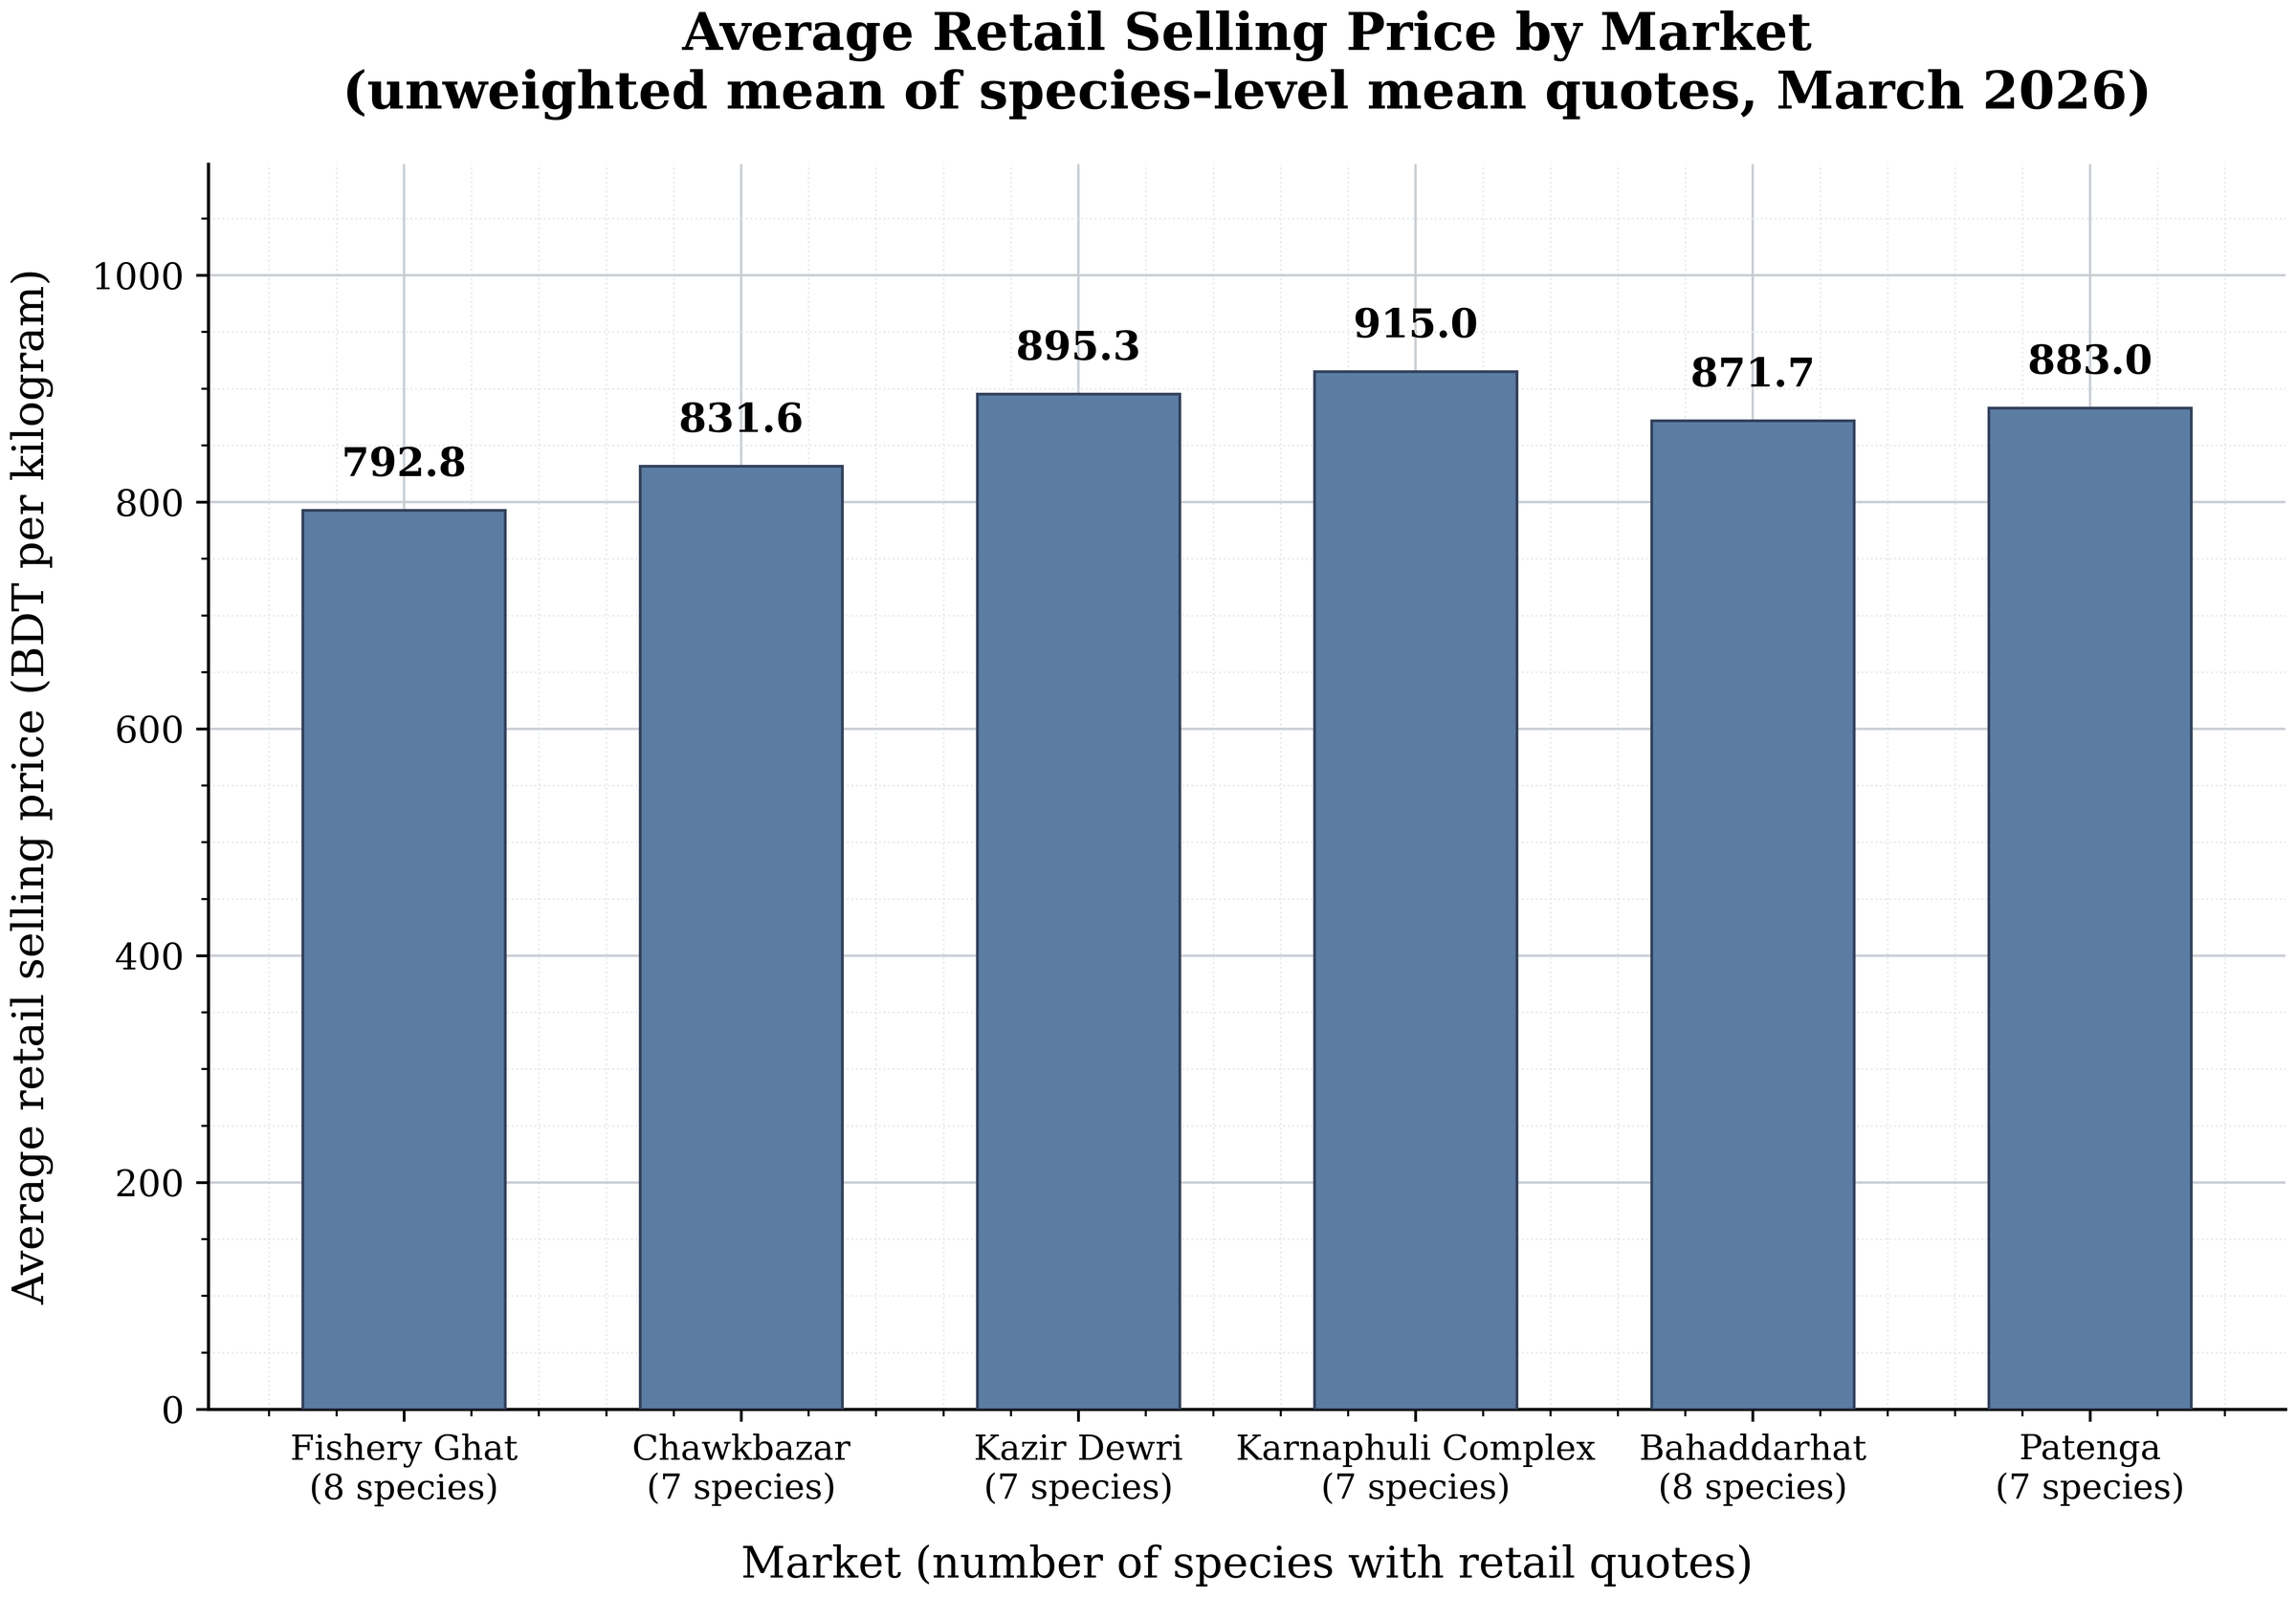
Source: field survey, March 2026.
Figure 4.2
Distribution of retail selling prices by species
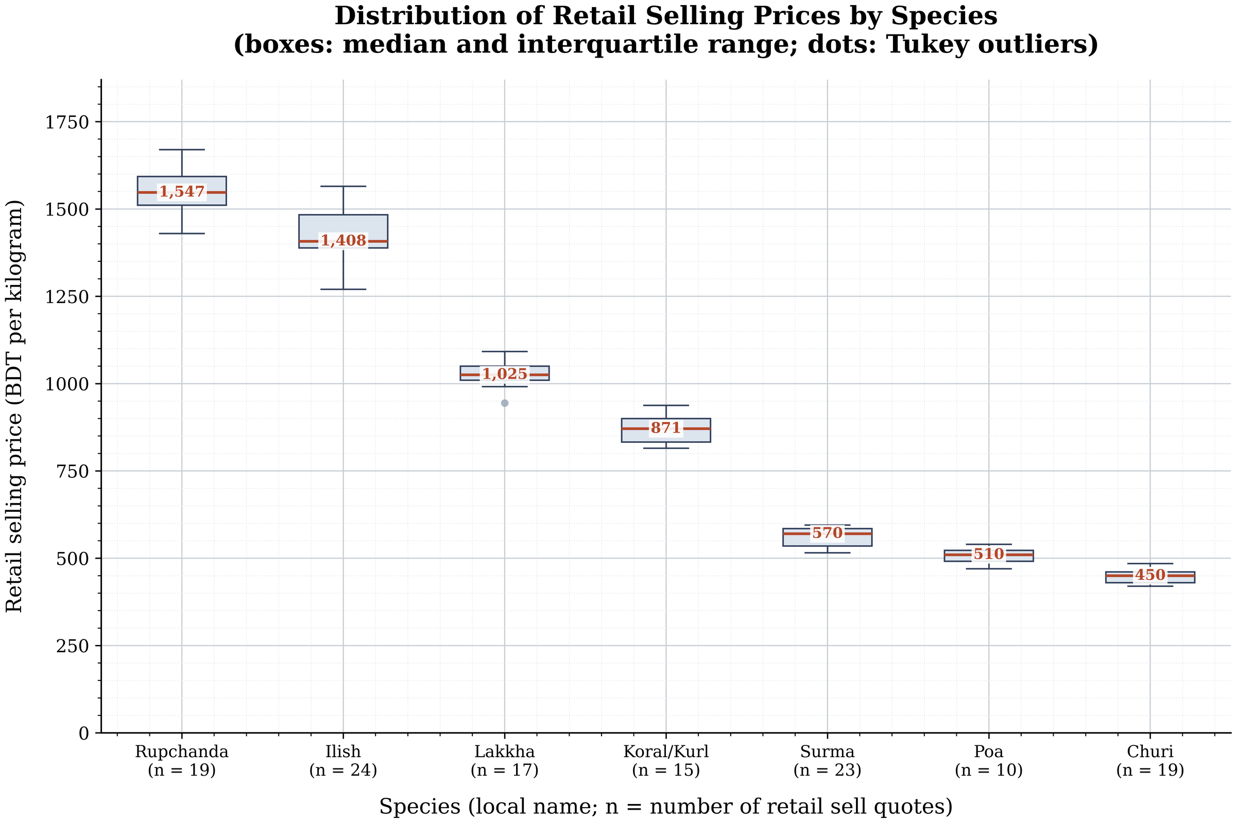
Boxes show the median and interquartile range; points beyond 1.5 x IQR are plotted individually.

4.6 Payment modes and digital adoption
Receipts remain cash-dominant, and digital payment rises down-chain (Table 4.5): cash averaged 69.6 % of aratdar receipts, 64.0 % for bepari/faria and 55.1 % for retailers, while MFS (bKash/Nagad) rose 14.2 % → 17.4 % → 27.4 % across the same groups and credit ran 16.2 % → 18.6 % → 17.5 %. Among intercepted consumers, 50.0 % paid cash, 23.3 % by Nagad, 20.0 % by bKash and 6.7 % on credit — 43.3 % of consumer transactions were digital, which is what makes retailer MFS receipts the highest of the three trader strata.
Two distinct variables must not be conflated here. The share of receipts settled by MFS rises monotonically down-chain. The frequency of MFS use (Regular/Occasional/Never) does not: 46.7 % of aratdars and 46.7 % of retailers were regular users against 30.0 % of bepari/faria, and a chi-square test of frequency against actor class found no association (χ² = 2.49, df = 4, p = 0.647; G-test p = 0.635; exact p ≈ 0.66; Cramér's V = 0.118 — Table 4.15). The smallest expected cell is 4.00, below the conventional minimum of 5, so the exact test is reported alongside Pearson and likelihood-ratio; all three agree. The correct reading is that adoption behaviour is uniform across strata, while the composition of receipts differs because retailers face a customer base that pays by phone.
Table 4.7
Payment method composition by actor group and by consumers
Actor / method | n | Cash (%) | MFS (%) | Credit (%) | — | % of group
Aratdar | 30 | 69.63 | 14.17 | 16.2
Bepari/Faria | 30 | 64 | 17.43 | 18.57
Retailer | 30 | 55.1 | 27.37 | 17.53
Consumer (Form C) | 30 |  |  |  | Cash | 50
Consumer (Form C) | 30 |  |  |  | Nagad_app | 23.3
Consumer (Form C) | 30 |  |  |  | bKash | 20
Consumer (Form C) | 30 |  |  |  | Credit | 6.7
Source: field survey, March 2026. The upper block reports mean shares of receipts by actor group; the lower block reports the mode used by intercepted consumers.
Table 4.19
Chi-square test of mobile financial service use frequency by actor class
Actor | n | MFS_Regular | MFS_Occasional | MFS_Never | MFS_share_pct
Aratdar | 30 | 14 | 12 | 4 | 46.7
Bepari/Faria | 30 | 9 | 16 | 5 | 30
Retailer | 30 | 14 | 13 | 3 | 46.7
chi-square (actor x MFS frequency) | 90 |  |  |  | chi2=2.49, df=4, p=0.6472, G-test p=0.6349, Fisher-exact p=0.6640
Cramer's V / smallest expected count |  |  |  |  | V=0.118 / min exp=4.00
Source: field survey, March 2026. The smallest expected cell is below five, so the exact and likelihood-ratio tests are reported alongside Pearson.
Figure 4.6
Payment method composition by market actor
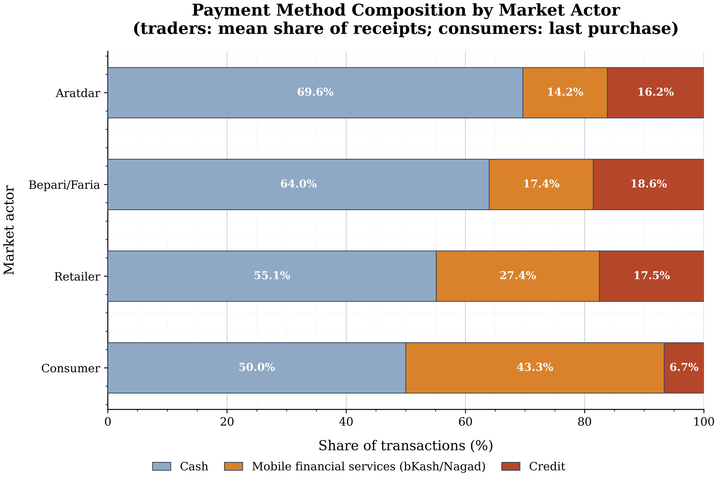
Source: field survey, March 2026.

4.7 Marketing problems
Traders named up to three problems each, giving 270 mentions from 90 respondents (Table 4.6). Percentages below are shares of the 90 traders, not of all mentions.
The leading constraints were day-to-day price volatility (32.2 %), low landings in the lean season (28.9 %) and rising cost of ice and salt (28.9 %), followed closely by high ice price (27.8 %) and monsoon waterlogging (27.8 %). Transport cost, though often emphasised in the literature, ranked sixth (25.6 %) — and was felt most acutely by retailers (36.7 %), who sit furthest from the landing points. Structurally, aratdars were the group most concerned with waterlogging (33.3 %) and competition from frozen imported fish (36.7 %), while retailers bore transport (36.7 %) and price volatility (40.0 %).
The prominence of ice, salt and cold-chain cost links directly to the cost structure in Section 4.4 and to the infrastructure findings below: rising cost of ice and salt (28.9 %, rank 3) and high ice price (27.8 %, rank 4) are two of the five most-cited problems, and unsold-fish spoilage loss (22.2 %, rank 10) makes a third within the top ten.
Table 4.8
Marketing problems reported by traders
Problem | Aratdar n | Aratdar % | Bepari n | Bepari % | Retailer n | Retailer % | Total n | Total %
Day-to-day price volatility | 7 | 23.3 | 10 | 33.3 | 12 | 40 | 29 | 32.2
Low landings in lean season | 9 | 30 | 8 | 26.7 | 9 | 30 | 26 | 28.9
Rising cost of ice and salt | 8 | 26.7 | 10 | 33.3 | 8 | 26.7 | 26 | 28.9
High ice price | 9 | 30 | 9 | 30 | 7 | 23.3 | 25 | 27.8
Waterlogging during monsoon | 10 | 33.3 | 9 | 30 | 6 | 20 | 25 | 27.8
Transport cost increase | 4 | 13.3 | 8 | 26.7 | 11 | 36.7 | 23 | 25.6
Delayed credit recovery | 8 | 26.7 | 5 | 16.7 | 8 | 26.7 | 21 | 23.3
Rising toll and lease burden | 5 | 16.7 | 9 | 30 | 6 | 20 | 20 | 22.2
Supply syndicate control | 6 | 20 | 8 | 26.7 | 6 | 20 | 20 | 22.2
Unsold fish spoilage loss | 9 | 30 | 3 | 10 | 8 | 26.7 | 20 | 22.2
Competition from frozen imported fish | 11 | 36.7 | 2 | 6.7 | 5 | 16.7 | 18 | 20
Irregular electricity and load-shedding | 4 | 13.3 | 9 | 30 | 4 | 13.3 | 17 | 18.9
Source: field survey, March 2026. Respondents named up to three problems each (270 mentions from 90 traders); percentages are shares of the 90 traders, not of all mentions.
Figure 4.7
Most frequently reported marketing problems
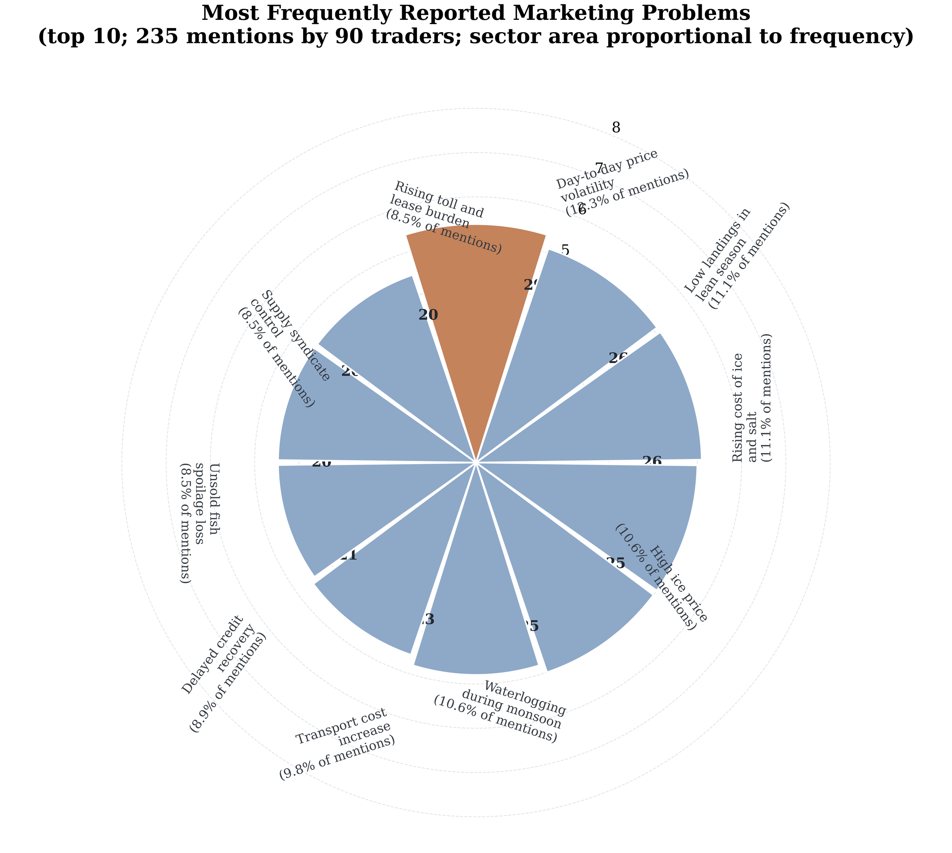
Sector area is proportional to the number of traders citing the problem.

4.8 Market infrastructure
Form M observations (Table 4.7) separate the two landing-linked markets from the four city markets. Fishery Ghat (mixed wholesale–retail, 03:30–13:00, 210 stalls) has ice available but poor sanitation, irregular electricity and only partial roofing, with an aratdar-fee arrangement of 2.5–5 % commission per lot. Patenga (mixed, 04:00–12:30, 65 stalls) is similar but smaller, with a landing-side fee of 20–40 BDT per maund handled. The four city retail markets — Chawkbazar (160 stalls), Kazir Dewri (85), Karnaphuli Complex (120) and Bahaddarhat (110) — are appreciably better served: regular electricity, complete or good roofing, and medium-to-good sanitation, financed by committee tolls of 40–60 BDT per stall per day.
The gradient matters for interpretation: the two markets where the producer (first-sale) price is observed are also the two with the weakest sanitation and least reliable power. That is the physical context for the spoilage and ice costs quantified in Section 4.4, and for the recommendation in Chapter 5.
Table 4.9
Physical infrastructure of the six study markets (Form M observation)
Market | Market_name | Type | Trading_hours | Retail_stalls | Transport_access | Platform | Roofing | Drainage | Electricity | Ice | Sanitation | Water_supply | Fee_arrangement
M1 | Fishery Ghat | Mixed | 03:30-13:00 | 210 | Good | Medium | Partial | Medium | Irregular | Available | Poor | Irregular | Aratdar
M2 | Chawkbazar | Retail | 06:00-20:00 | 160 | Good | Good | Complete | Medium | Regular | Available | Medium | Regular | Committee
M3 | Kazir Dewri | Retail | 06:30-19:30 | 85 | Medium | Medium | Partial | Poor | Regular | Available | Medium | Regular | Committee
M4 | Karnaphuli Complex | Retail | 06:00-20:00 | 120 | Good | Good | Complete | Good | Regular | Available | Good | Regular | Committee
M5 | Bahaddarhat | Retail | 06:30-20:00 | 110 | Medium | Good | Complete | Medium | Regular | Available | Medium | Regular | Mixed
M6 | Patenga | Mixed | 04:00-12:30 | 65 | Medium | Poor | Partial | Poor | Irregular | Available | Poor | Irregular | Committee
Source: direct observation, Form M, March 2026. Rows are markets; full field list including GPS coordinates and fee notes is held in the analysis workbook.
Figure 4.8
Market infrastructure quality profile
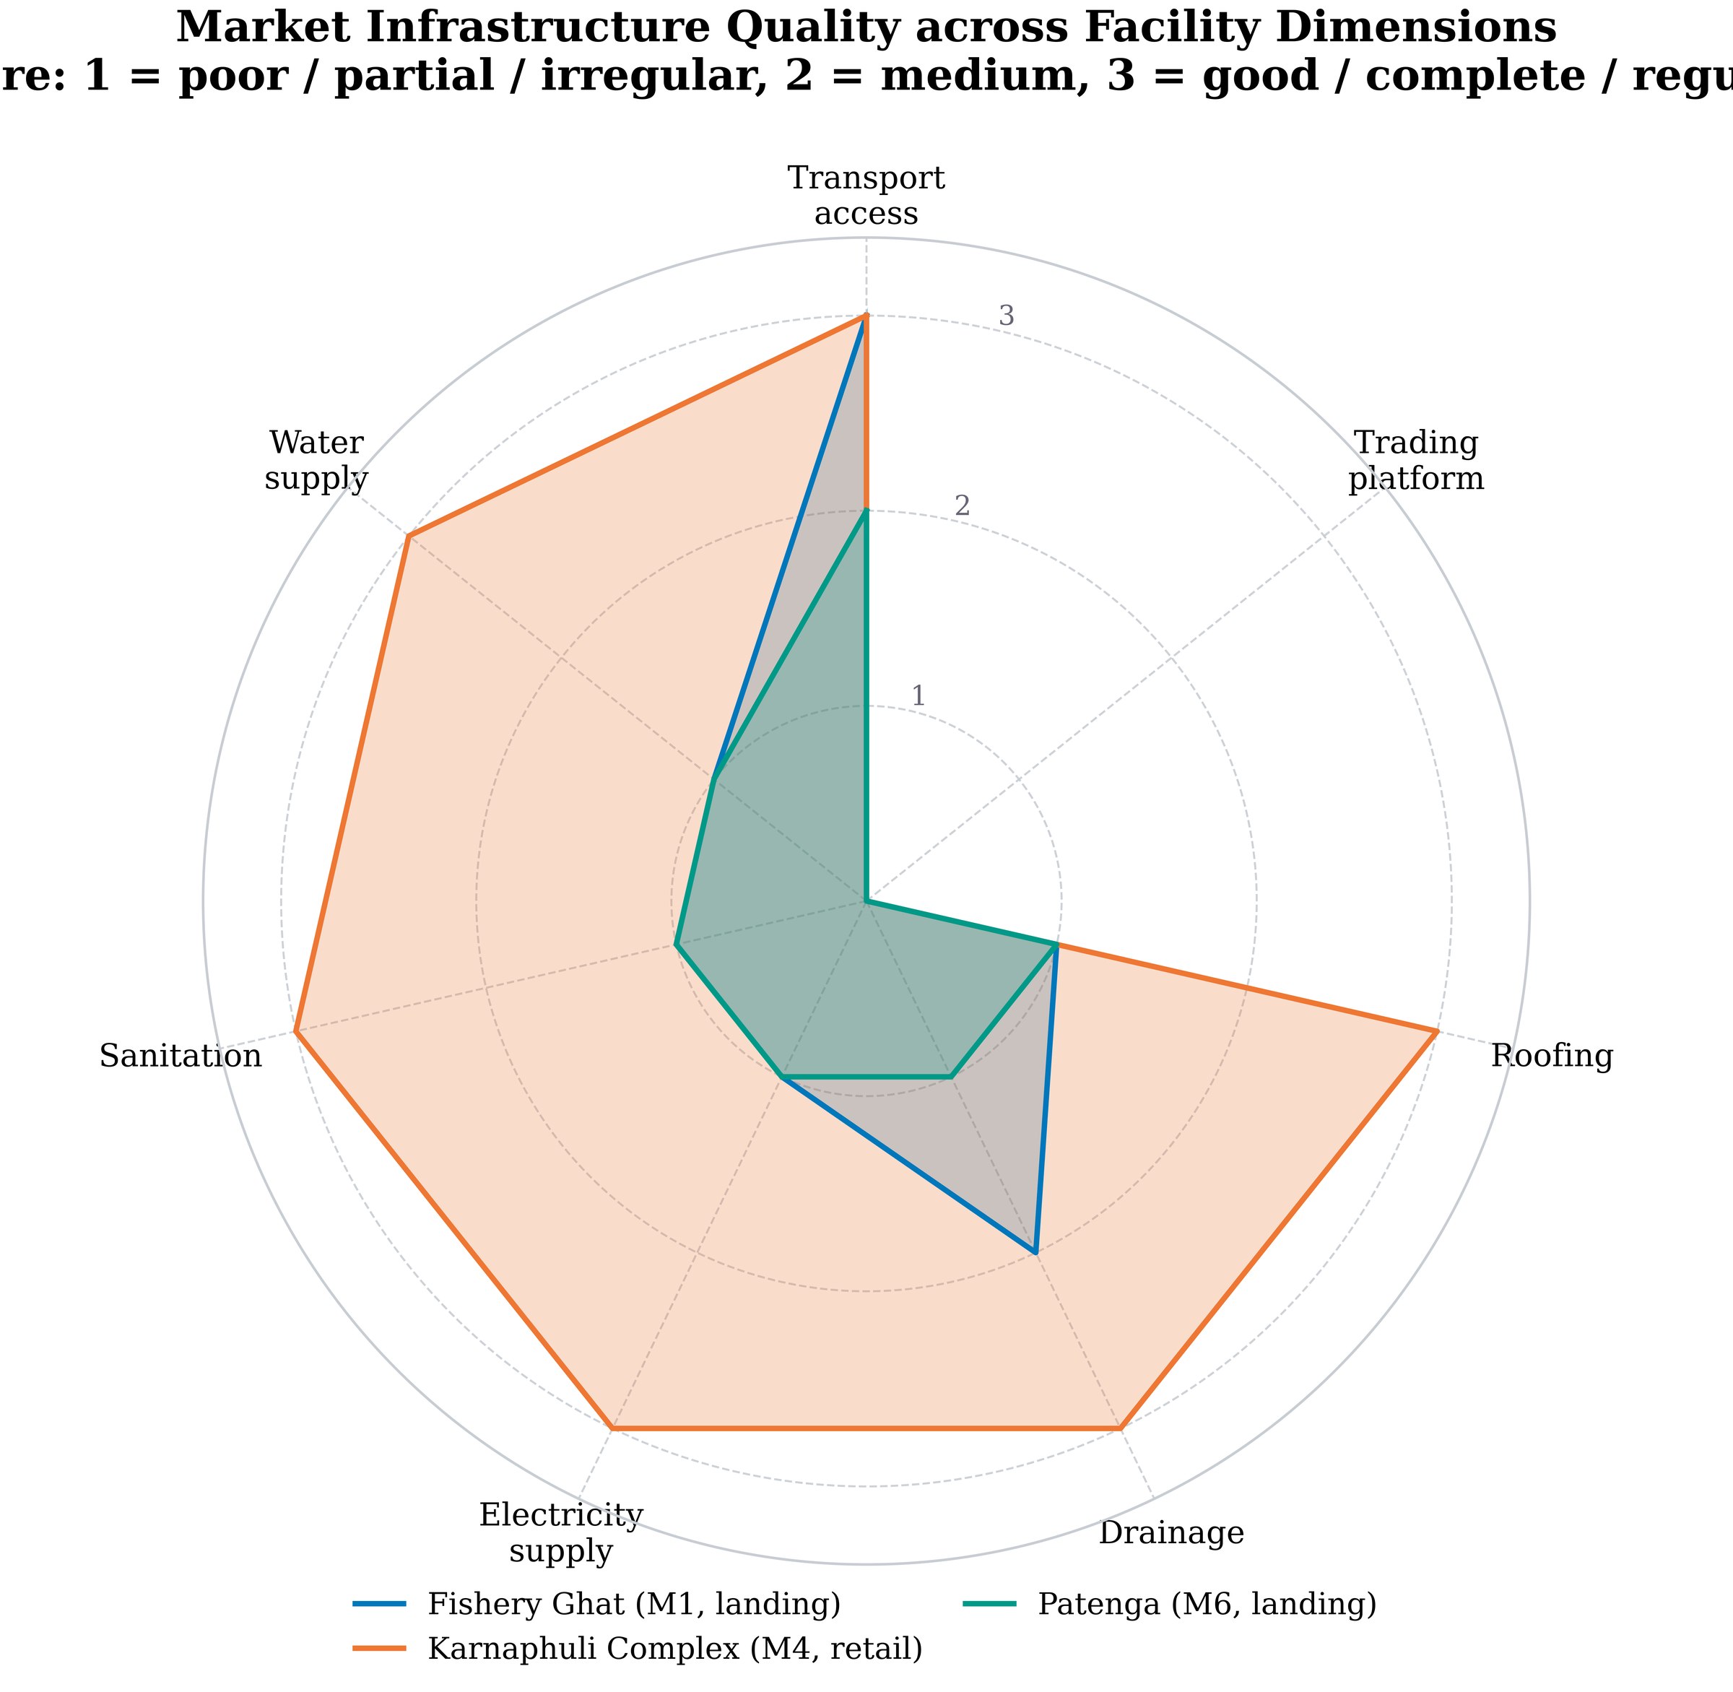
Scores are the graded Form M checklist items.

4.9 Consumer behaviour
Consumers (n = 30) were predominantly weekly shoppers (73.3 %), with 26.7 % shopping daily and a mean visit interval of 4.7 days (Table 4.8). Purity/freshness was the dominant reason for choosing a seller (36.7 %), ahead of a familiar shop (20.0 %), price (16.7 %) and proximity (16.7 %) — a ranking that positions quality assurance, rather than price competition, as the operative discipline on retailers in these markets.
Of 66 focal-species purchase records, 54 were same-day purchases, 77.3 % from fixed retailers and 4.5 % from hawkers. The mean price paid for a focal species was 722.59 BDT/kg and the mean purchase size 1.76 kg. Non-focal items (Table 4.9) were dominated by other marine products — Datina (n = 6, 378 BDT/kg), Bagda shrimp (n = 3, 995), Kakra crab (n = 2, 575), Chatka shrimp (n = 2, 468), Faisya (n = 2, 333) and Moid (n = 2, 180) — with single reports of Khoira and of local lobster at 2,800 BDT/kg. Nearly all of these cells rest on one to six observations and are reported as indicative only.
Table 4.10
Consumer purchasing behaviour and expenditure
Item | Response | n | %
Visit frequency | Weekly | 22 | 73.3
Visit frequency | Daily | 8 | 26.7
Payment method | Cash | 15 | 50
Payment method | Nagad_app | 7 | 23.3
Payment method | bKash | 6 | 20
Payment method | Credit | 2 | 6.7
Main reason for choosing seller | Purity | 11 | 36.7
Main reason for choosing seller | Familiar_shop | 6 | 20
Main reason for choosing seller | Price | 5 | 16.7
Main reason for choosing seller | Proximity | 5 | 16.7
Main reason for choosing seller | Other | 2 | 6.7
Main reason for choosing seller | Variety | 1 | 3.3
Mean visit interval (days) | 4.67 | 30
Focal purchase source (per purchase) | Retailer | 51 | 77.3
Focal purchase source (per purchase) | Hawker | 3 | 4.5
Mean focal-species price paid (BDT/kg) | 722.59 | 54
Mean purchase size (kg) | 1.76 | 54
Source: consumer exit slips (Form C), March 2026.
Table 4.11
Non-focal aquatic products purchased by consumers
Fish (local name) | n | Mean_price_BDT_kg | Mean_qty_kg
Datina | 6 | 378.33 | 0.75
Bagda chingri | 3 | 995 | 0.83
Chatka chingri | 2 | 467.5 | 0.88
Kakra (crab) | 2 | 575 | 1.25
Moid | 2 | 180 | 0.5
Faisya | 2 | 332.5 | 0.25
Lobster (local) | 2 | 2,800.00 | 0.88
Khoira | 1 | 345 | 0.5
Source: consumer exit slips (Form C), March 2026. Cells rest on one to six observations and are indicative only.

4.10 Data quality and statistical validation
Table 4.14
Matched buyer–seller pair detail
Pair_ID | Market | Species_code | Seller_ID | Seller_actor | Seller_sell_BDT_kg | Buyer_ID | Buyer_actor | Buyer_buy_BDT_kg | Diff_BDT_kg | Complete
PAIR-M1-01 | M1 | S03 | M1-A-05 | Aratdar | 783.76 | M1-R-05 | Khuchra | 783.76 | 0 | True
PAIR-M1-02 | M1 | S06 | M1-A-01 | Aratdar | 348.34 | M1-R-02 | Khuchra | 350 | -1.66 | True
PAIR-M2-01 | M2 | S03 | M2-A-04 | Aratdar | 870.85 | M2-R-03 | Khuchra | 870.85 | 0 | True
PAIR-M2-02 | M2 | S01 | M2-A-01 | Aratdar | 1,205.79 | M2-R-05 | Khuchra | 1,205.79 | 0 | True
PAIR-M2-03 | M2 | S05 | M2-A-05 | Aratdar | 448.82 | M2-R-01 | Khuchra | 450 | -1.18 | True
PAIR-M3-01 | M3 | S04 | M3-A-02 | Aratdar | 756.97 | M3-R-03 | Khuchra | 760 | -3.03 | True
PAIR-M3-02 | M3 | S02 | M3-A-05 | Aratdar | 1,299.57 | M3-R-04 | Khuchra | 1,300.00 | -0.43 | True
PAIR-M4-01 | M4 | S02 | M4-A-01 | Aratdar | 1,212.49 | M4-R-01 | Khuchra | 1,219.19 | -6.7 | True
PAIR-M4-02 | M4 | S06 |  |  |  |  |  |  |  | False
PAIR-M4-03 | M4 | S02 | M4-A-02 | Aratdar | 1,205.79 | M4-R-02 | Khuchra | 1,205.00 | 0.79 | True
PAIR-M5-01 | M5 | S06 | M5-A-03 | Aratdar | 361.74 | M5-R-04 | Khuchra | 360 | 1.74 | True
PAIR-M5-02 | M5 | S04 |  |  |  |  |  |  |  | False
PAIR-M5-03 | M5 | S05 | M5-A-01 | Aratdar | 468.92 | M5-R-01 | Khuchra | 465 | 3.92 | True
PAIR-M6-01 | M6 | S03 | M6-A-02 | Aratdar | 797.16 | M6-R-01 | Khuchra | 795 | 2.16 | True
PAIR-M6-02 | M6 | S04 | M6-A-05 | Aratdar | 730.17 | M6-R-04 | Khuchra | 730 | 0.17 | True
Source: field survey, March 2026. Pairs are formed by the pair-linking protocol of Chapter 3, Section 3.3.4.
Table 4.15
Wilcoxon signed-rank test on matched pair differences
Item | Value
Usable matched pairs (n) | 13
Pairs with non-zero difference | 10
Median difference (BDT/kg) | 0
Mean difference (BDT/kg) | -0.32
Wilcoxon W statistic | 26
p-value (two-sided) | 0.9219
Interpretation | p >= 0.05: seller-sell and buyer-buy quotes of matched lots do not differ systematically - self-reported chain prices are internally consistent
Source: field survey, March 2026. Exact test in both computational engines.
Table 4.20
Per-kilogram margins by stratum and Mann–Whitney contrasts
Actor | n | Median_margin_BDT_kg | IQR_BDT_kg | Mean_margin_BDT_kg
Aratdar | 30 | 33.5 | 8.42 | 33.65
Bepari_Faria | 30 | 64.81 | 22.71 | 66.16
Khuchra | 30 | 116.62 | 39.52 | 118.06
Mann-Whitney U: Aratdar vs Bepari_Faria | 30/30 |  |  | U=42, p<0.0001
Mann-Whitney U: Aratdar vs Khuchra | 30/30 |  |  | U=0, p<0.0001
Mann-Whitney U: Bepari_Faria vs Khuchra | 30/30 |  |  | U=66, p<0.0001
Source: field survey, March 2026. Margins are computed from each respondent's own buy and sell quotations.
Table 4.22
Shapiro–Wilk normality screening of pooled price series
Series | n | W | p_value | Decision
Producer price - landing markets M1/M6 (Form A buy) | 50 | 0.9035 | 0.0006 | p<=0.05 - non-normal; nonparametric tests used
Aratdar auction sell - M1/M6 | 49 | 0.9046 | 0.0008 | p<=0.05 - non-normal; nonparametric tests used
Bepari/Faria sell - all markets | 146 | 0.8961 | 0 | p<=0.05 - non-normal; nonparametric tests used
Khuchra retailer sell quotes - all markets | 132 | 0.8917 | 0 | p<=0.05 - non-normal; nonparametric tests used
Consumer-paid prices (Form C slips) | 54 | 0.8104 | 0 | p<=0.05 - non-normal; nonparametric tests used
Source: field survey, March 2026. Screening precedes all inferential tests, as pre-registered in Chapter 3, Table 3.6.

4.11 What this chapter does and does not establish
Because the analysed dataset is synthetic (provenance note above), this chapter establishes that the instrument, the pipeline and the reporting conventions work and hang together: 24/24 QC checks pass, the independent audit reports 60 PASS / 5 WARN / 0 FAIL, the three accounting gates hold, and the Python and R engines agree cell-for-cell on 22 of 23 tables.
It establishes, further, that the reporting conventions themselves are sound — in particular that the §3.8 descriptive-only rule can be enforced consistently (no species is simultaneously excluded and pooled), that marketing cost can be normalised per kilogram for all three strata rather than retailers alone, and that the net-margin indicators of §3.7.3–3.7.4 (NMM %, Shepherd efficiency) can be produced from the instrument as designed. The negative NMM for Churi is a good illustration: it is a real property of a low-value species in a cost structure dominated by value-proportional charges, and it would have been invisible without the per-kilogram cost normalisation.
It does not establish any proposition about Chattogram's actual markets. When real data are collected, the same scripts are re-run against the new workbook — verify_filled.py, run_analysis.py, extend_analysis.py, clean_data.py, make_charts_v2.py, review_audit.py, and scripts/R/MS499_full_analysis.R — and every number in this chapter is regenerated. Sections 4.1–4.9 should then be rewritten against the new tables and the provenance note removed; the structure, the caveats in 4.10 and the reconciliation logic in 4.4 will carry over unchanged.

CHAPTER 5 — SUMMARY, CONCLUSIONS AND RECOMMENDATIONS

5.1 Summary of the study
The study set out to analyse the marketing system of ten commercially important marine fish species in the Chattogram metropolitan region and to establish how the consumer's taka is divided between the fisher and the intermediaries who stand between him and the market. Chapter 1 framed the problem: marine capture supplies only 12.53 % of Bangladesh's 50.18 lakh MT of fish production and is the one segment that declined in 2023–24 (6.29 lakh MT, −7.47 %) (DoF, 2024), so the efficiency of the channel that carries it matters disproportionately to both fisher livelihoods and urban food costs.
Chapter 3 specified a descriptive-cum-analytical cross-sectional survey of six markets — two landing-linked (Fishery Ghat, Patenga) and four city retail markets — covering 120 respondents (30 aratdars, 30 bepari/faria, 30 khuchra retailers, 30 exit-intercepted consumers) over a pilot on 2 March and collection on 3–7 March 2026. Five coordinated instruments (Forms A, B, R, M, C) captured prices, costs, channel linkages, payment behaviour, market infrastructure and consumer-side price verification. The analytical framework normalised marketing cost to the kilogram for all three strata (eq. 3.3), decomposed the price spread into segment margins (eq. 3.4–3.5), and computed gross and net marketing margins, the producer's share and Shepherd-type efficiency indices both consumer- and producer-referenced (eq. 3.6–3.10).
Chapter 4 reported the results. This chapter draws them together against the nine objectives of §1.4, states the conclusions they support, and sets out recommendations.

5.2 Summary of major findings
Table 5.1
Objectives addressed and the finding that answers each
# | Objective (§1.4) | Principal finding | Source
1 | Profile intermediaries and consumers | Traders averaged **42.3 years** and **16.1 years** in the trade; 13.3 % illiterate, 41.1 % secondary-educated. Aratdars were the oldest and most experienced group (47.1 yrs; 20.6 yrs), retailers the youngest and least (38.6; 11.4) | T1
2 | Identify channels and product flow | Throughput fell **801 → 205 → 96 kg/day** down the chain. **73.3 % of retailers bought from aratdars**; bepari sourced 46.7 % from fishermen. **Credit was universal — no retailer sold entirely for cash** | T2, T2b
3 | Estimate marketing cost per kg | Aratdar 7.12, Bepari/faria 78.12, Retailer 50.95 BDT/kg**; ΣMC = **136.19**. The wholesaler's cost is highest because his charges scale with lot *value* on a small tonnage | T4b
4 | Estimate margins and profit per kg | Own-quote margins **33.7 / 66.2 / 118.1 BDT/kg** across strata, all three Mann–Whitney contrasts **p < 0.0001**. Retailer **net profit 67.1 BDT/kg** (median 61.6) after cost | T16, T17
5 | Estimate spread, margins, PS, efficiency | Spread **251.35 BDT/kg (27.6 %)**; **PS 72.4 %** (71.9 % volume-weighted); GMM 27.6 %, **NMM 12.7 %**; ME **2.35** consumer-referenced, **1.70** producer-referenced | T10, T19, T3
6 | Inter-market price variation | Kruskal–Wallis rejected the null for **5 of 6 testable species**; only **4 of 44 pairwise contrasts survived Holm**, three of them the landing-versus-Bahaddarhat contrast | T11, T14, T14b
7 | Payment-mode adoption across actors | Cash fell **69.6 → 64.0 → 55.1 %** down-chain while MFS rose **14.2 → 17.4 → 27.4 %**; consumers were **43.3 % digital**. But MFS *use frequency* was **not** associated with actor class (χ² = 2.49, df = 4, p = 0.647) | T5, T15
8 | Marketing problems and infrastructure | Price volatility (32.2 %), low lean-season landings (28.9 %), ice and salt cost (28.9 %)** led; **ice, salt and spoilage accounted for two of the top five and three of the top ten problems**. The **two landing-linked markets were the two worst served** on sanitation, power and roofing | T6, T7
9 | Conclusions and recommendations | §5.3–5.4 below | —
Six findings deserve emphasis because they carry beyond their own tables.

5.3 Conclusions
On the evidence of the analysed dataset, and within the bounds stated in §5.5:
The Chattogram marine fish channel, as configured here, is moderately efficient and does not extract an unusual rent from the fisher. A producer's share of 72.4 %, a Shepherd efficiency index above unity on both the consumer-referenced (2.35) and producer-referenced (1.70) forms, and a net marketing margin of 12.7 % together describe a chain in which more of the final price remains as product value than is consumed by marketing services.
The margin that is largest in percentage terms is the one furthest from the landing, and it is partly a cost-recovery margin rather than pure rent. The retailer's 12.8 % becomes a net profit of about 67 BDT/kg, roughly 9.3 % of the mean price consumers paid and about 57 % of his gross margin, after ice, rent, washing, water and an average 5.5 % spoilage loss are charged against it.
Intermediation is heterogeneous, and the aratdar is not the intermediary he is popularly taken to be. His 3.3 % share of the consumer's taka, levied as commission on a large throughput (801 kg/day), is an order of magnitude below the trading margins on either side of him. Policy aimed at "eliminating middlemen" would, on this evidence, be aimed at the wrong actor.
The binding constraints reported by traders are physical and seasonal, not financial. Price volatility, thin lean-season landings and the cost of ice and salt outranked transport and tolls. Two of the five most-cited problems concern ice and salt directly, and the infrastructure audit independently located the worst conditions at the two landing-linked markets. Capital is available — credit is universal — but cold chain is not.
Information, not intermediation, is the most plausible source of the observed price dispersion. A 14 % Ilish spread between a landing market and an outlying residential market, in a city where prices are not publicly posted and transactions are bilateral and credit-mediated, is more consistent with an information gap than with market power exercised uniformly.
Negative net margins on low-value species are a structural feature of value-proportional charging. Charging commission as a percentage of lot value and tolls per maund is neutral with respect to a trader's costs but regressive with respect to the species mix, and it makes the cheap-protein species — the ones that matter most for food security — the least attractive to handle.

5.4 Recommendations
Each recommendation is tied to the finding that motivates it. They are directed at the Department of Fisheries, the market committees and lease-holders responsible for the arats, and the financial-service providers active in these markets.

5.5 Limitations and directions for further research
The limitations stated in §3.11 apply to everything above and are not repeated in full. Four of them most constrain the conclusions.
Three further directions suggest themselves from the findings themselves. Value-chain finance — how credit is priced, collateralised and recovered across the chain — is barely studied and is evidently central, given that the channel runs on it. Consumer willingness to pay for quality assurance follows from the finding that purity, not price, is the dominant reason for choosing a seller. And a comparative study across landing cities (Chattogram, Cox's Bazar, Khulna) using this identical instrument would establish whether the 72.4 % share is a Chattogram property or a coastal one.

5.6 What this chapter establishes, and what changes with real data
Because the analysed dataset is synthetic, this chapter establishes the completeness and internal coherence of the reporting chain, not any proposition about Chattogram's markets. It shows that the nine objectives of §1.4 are each answerable from the instrument as designed; that the pipeline produces every indicator the methodology specifies — including the net-margin and efficiency measures that the literature often omits — and that it does so with the accounting identities intact (segment margins telescoping to the spread; producer's share and spread summing to 100; Table 4.3's pooled share equalling Table 4.10's); that the inferential plan of Table 3.6 is executable end to end; and that the two independent engines agree on 22 of 23 tables.
When real field data are collected, the conclusions in §5.3 and the recommendations in §5.4 must be re-derived, not merely re-labelled. Each of the five conclusions is a claim about magnitudes — 72.4 %, 12.7 %, 12.8 %, 67 BDT/kg, 14 % — and every one of those numbers will move. The procedure is mechanical: fill the yellow cells of Marine_Fish_Marketing_Data_Entry_Chattogram_REAL_EMPTY.xlsx, run verify_filled.py to 24/24, then the analysis chain and scripts/R/MS499_full_analysis.R, and rewrite §5.2 from the regenerated tables. What will carry over unchanged is the structure of Table 5.1, the logic linking each finding to its recommendation, and the candidate explanations catalogued in §5.3 — any of which the new data may confirm, reverse, or render moot.

Reference cited in this chapter
Department of Fisheries (DoF). (2024). Yearbook of fisheries statistics of Bangladesh 2023–24 (Vol. 41). Fisheries Resources Survey System, Ministry of Fisheries and Livestock, Government of Bangladesh.

References
Acharya, S. S., & Agarwal, N. L. (1987). Agricultural marketing in India. Oxford & IBH Publishing.
Ahsan, M. E. (2016). Marketing channel, cost and margin of marine fish in Cox's Bazar district, Bangladesh. Journal of Fisheries and Livestock Production, 4(3), 1-8.
Bangladesh Trade and Tariff Commission (BTTC). (2025). Study report on the hilsa value chain and market structure in Dhaka. Ministry of Commerce, Government of Bangladesh.
Cochran, W. G. (1977). Sampling techniques (3rd ed.). John Wiley & Sons.
Department of Fisheries (DoF). (2024). Yearbook of fisheries statistics of Bangladesh 2023-24 (Vol. 41). Fisheries Resources Survey System, Ministry of Fisheries and Livestock, Government of Bangladesh.
Dipty, A. K., Rahman, M. A., & Hossain, M. B. (2026). Marketing structure and factors affecting retail price of coastal fish in Bangladesh. Applied Environmental Science Academy Journal, 3(1), 1-14.
Dunn, O. J. (1964). Multiple comparisons using rank sums. Technometrics, 6(3), 241-252. https://doi.org/10.1080/00401706.1964.10490181
FishBase. (2026). FishBase: World database of fishes. https://www.fishbase.se
Fisheries Research Institute (FRI). (2018). Hilsa fisheries research and development in Bangladesh. Bangladesh Fisheries Research Institute. https://fri.portal.gov.bd
Haque, S. A. (2021). Marketing channel and constraints of fish marketing: A case study of Jamalpur district markets in Bangladesh. Journal of Agriculture and Food Research, 5, 100-112.
Holm, S. (1979). A simple sequentially rejective multiple test procedure. Scandinavian Journal of Statistics, 6(2), 65-70.
Islam, M. J., Kunzmann, A., & Hossain, M. B. (2026). Postharvest losses along the small-scale fish value chain in Bangladesh. Heliyon, 12(1), e00000.
Islam, M. S. (2001). Marketing system of marine fish in Bangladesh. Departments of Agricultural Economics, Bangladesh Agricultural University.
Islam, M. S. (2014). Marketing of shrimp in Bangladesh: A value chain analysis. Journal of the Bangladesh Agricultural University, 12(2), 361-372.
Islam, M. S., Rahman, M., & Haque, M. M. (2006). Marketing system and margin of loitta (Bombay duck) in the coastal district of Bangladesh. Bangladesh Journal of Agricultural Economics, 29(2), 45-58.
Jahan, R., Chad, M. H., Hossain, M. A., & Kamal, M. M. (2024). The marketing margin and profit structure of nine commercially important marine fish species of Bangladesh. Journal of Agribusiness and Rural Development, 74(4). https://doi.org/10.17306/J.JARD.2024.00001
Khondker, M. E., Rahman, M. M., & Belton, B. (2024). Transformation of the aquaculture value chain in Southern Bangladesh. CGIAR Research Program on Fish Agri-Food Systems.
Kohls, R. L., & Uhl, J. N. (1980). Marketing of agricultural products. Macmillan.
Kruskal, W. H., & Wallis, W. A. (1952). Use of ranks in one-criterion variance analysis. The Annals of Mathematical Statistics, 23(3), 525-540.
Mandal, A. K., Hossain, M. B., & Rahman, M. A. (2025). Post-harvest losses of marine fish at fishers' level in Bangladesh. Regional Studies in Marine Science, 60, 103-115.
Nadia, Z. M., Hasan, M. R., & Rahman, M. M. (2022). Fish availability and market channel in Rajbari, Bangladesh. Journal of Fisheries, 10(2), 45-56.
R Core Team. (2025). R: A language and environment for statistical computing. R Foundation for Statistical Computing. https://www.R-project.org/
Rafi, S. H., Islam, M. S., & Rahman, M. M. (2024). Marketing channels and value chain assessment of sea fish in Bangladesh. Journal of the Sylhet Agricultural University, 11(1), 77-88.
Shafiuddin, M. (2021). Assessment of value chain for commercially important fishes of Bangladesh. Young Power in Social Action (YPSA).
Shamsuddoha, M. (2007). Supply and value chain analysis in the marketing of marine dried fish in Bangladesh and non-tariff measures (NTMs). ActionAid Bangladesh.
Shepherd, G. S. (1965). Marketing farm products: Economic analysis (6th ed.). Iowa State University Press.
Yamane, T. (1967). Statistics: An introductory analysis (2nd ed.). Harper & Row.
Yasmin, S., Rahman, M. M., & Islam, M. S. (2024). Exploring the marketing dynamics and profit margins of selected fishes in Mymensingh district. Journal of the Bangladesh Agricultural University, 22(1), 89-100.

Appendix A

Focal Species Codebook
Table A.1
Focal marine fish species, scientific names, price tier and chain-completeness status
Code | Local name | English common name | Scientific name | Tier | Included in pooled figures?
S01 | Ilish | Hilsa shad | Tenualosa ilisha | High | Yes
S02 | Rupchanda | Silver pomfret | Pampus argenteus | High | Yes
S03 | Lakkha | Indian salmon (four-finger threadfin) | Eleutheronema tetradactylum | High | No - consumer slips n = 1
S04 | Koral / Kurl | Asian sea bass | Lates calcarifer | High | Yes
S05 | Surma | Indian mackerel | Rastrelliger kanagurta | Medium | Yes
S06 | Churi | Largehead ribbonfish | Trichiurus lepturus | Medium | Yes
S07 | Poa | Pama croaker | Otolithoides pama | Medium | Yes
S08 | Kankoita | Thorny/Indian anchovy | Stolephorus indicus | Low | No - retail in 1 market
S09 | Loitta | Bombay duck | Harpadon nehereus | Low | No - retail in 1 market
S10 | Harina | Chacunda gizzard shad | Anodontostoma chacunda | Low | No - retail in 2 markets
Scientific names follow FishBase (2026). A species enters the pooled figures only with valid quotations at all four chain levels, at least three consumer-purchase observations and at least three markets (Chapter 3, Section 3.7.5c).

Appendix B

Market Characteristics, Fees and Coordinates
Table A.2
Observed characteristics of the six study markets (Form M, March 2026)
Attribute | Fishery Ghat | Chawkbazar | Kazir Dewri | Karnaphuli Complex | Bahaddarhat | Patenga
Code | M1 | M2 | M3 | M4 | M5 | M6
Channel position | Mixed | Retail | Retail | Retail | Retail | Mixed
Trading hours | 03:30-13:00 | 06:00-20:00 | 06:30-19:30 | 06:00-20:00 | 06:30-20:00 | 04:00-12:30
Retail stalls (n) | 210 | 160 | 85 | 120 | 110 | 65
Transport access | Good | Good | Medium | Good | Medium | Medium
Platform condition | Medium | Good | Medium | Good | Good | Poor
Roofing | Partial | Complete | Partial | Complete | Complete | Partial
Drainage | Medium | Medium | Poor | Good | Medium | Poor
Electricity | Irregular | Regular | Regular | Regular | Regular | Irregular
Ice availability | Available | Available | Available | Available | Available | Available
Sanitation | Poor | Medium | Medium | Good | Medium | Poor
Water supply | Irregular | Regular | Regular | Regular | Regular | Irregular
Fee arrangement | Aratdar | Committee | Committee | Committee | Mixed | Committee
Fee rate | 2.5-5% commission per lot; daily stall fee BDT 30-60 | Daily toll BDT 50 per stall; monthly cleaning levy | Daily toll BDT 40 per stall | Daily toll BDT 60; covered modern shed | Committee toll plus informal entry charge for vans | Landing-side fee per basket; BDT 20-40 per maund handled
GPS coordinates | 22.3370, 91.8312 | 22.3392, 91.8366 | 22.3415, 91.8301 | 22.3318, 91.8178 | 22.3611, 91.8230 | 22.2786, 91.7991
Source: direct observation, Form M, March 2026.

Appendix C

Research Instruments
Five coordinated Bangla-language instruments were administered, each cross-referenced by a form identifier printed in its header (Chapter 3, Section 3.5). Their content is summarised below.
Table A.3
Structure of the instrument battery
Form | Respondent | n | Principal modules
A | Aratdar (commission agent) | 30 | Demographics; auction pass-through prices; premises rent, electricity, wages, equipment maintenance; commission or lease income; payment modes
B | Bepari / faria (mobile wholesaler) | 30 | Demographics; buy and sell quotations; transport fares and loading; icing quantity and cost; commission paid to aratdars; transit damage; payment modes
R | Khuchra (retail vendor) | 30 | Demographics; buy and sell quotations; stall rent; icing; washing water and tools; self-reported spoilage; customer composition; credit sales
M | Market (one per market) | 6 | Twelve infrastructure items observed directly, each with its evidence source, plus GPS coordinates and fee arrangements
C | Consumer (exit intercept) | 30 | Focal-species purchases, price paid, quantity, other aquatic products purchased, payment mode
A supplementary tag-price sheet was transcribed opportunistically at zero interview burden and does not enter the hypothesis tests.

Appendix D

Supplementary Figures
Figure A.1
Daily trading capacity by actor group
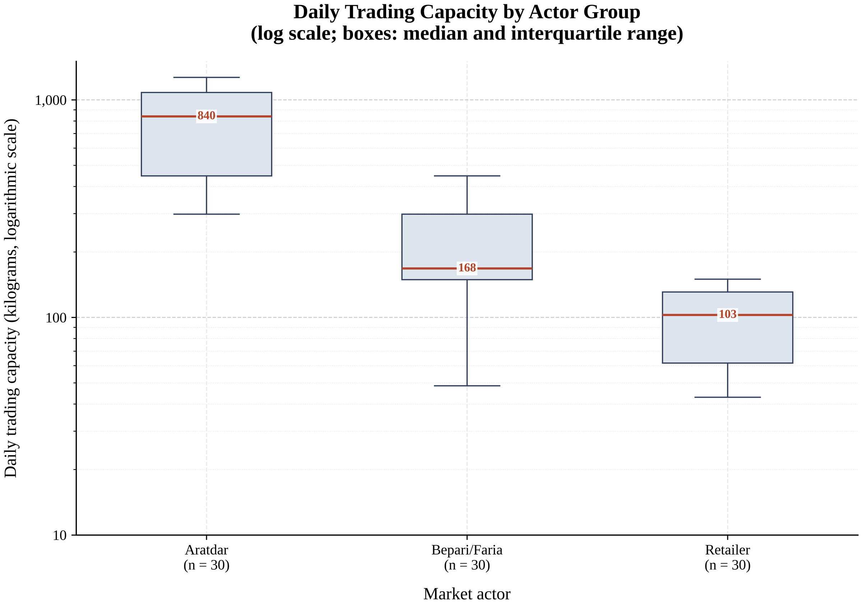
Log scale. Source: field survey, March 2026.
Figure A.2
Producer share of the consumer price by species
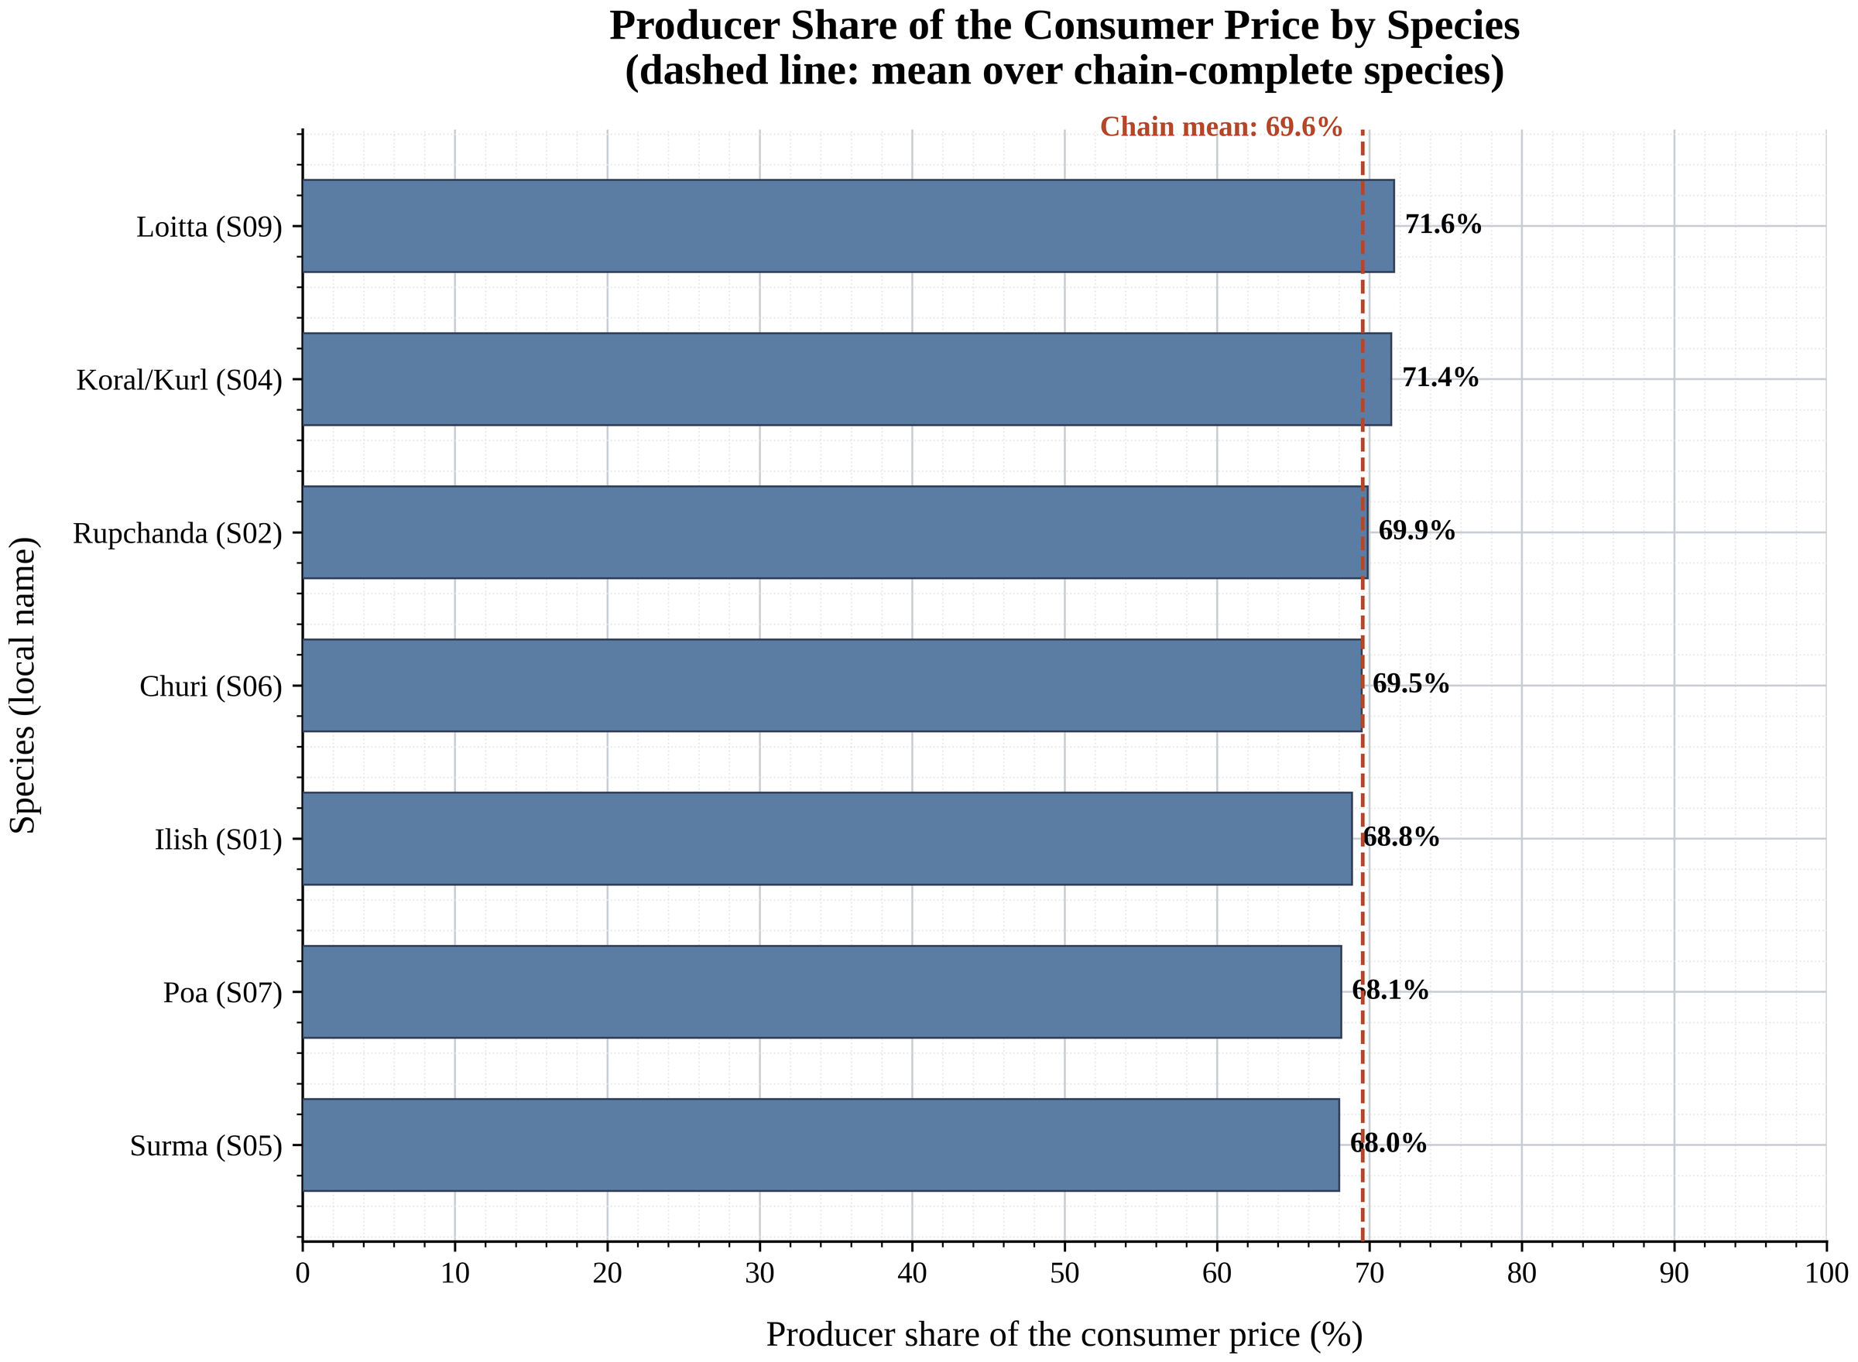
Only the six chain-complete species carry a share (Chapter 3, Section 3.7.5c). Source: field survey, March 2026.

Appendix E

Reproducibility, Data File and Analysis Script
Every number in this paper is regenerated from two files: the data workbook MS499_Chattogram_Marine_Fish_Data.xlsx and the analysis script MS499_full_analysis.R. Placing both in the same folder and running the script in R reproduces all 23 tables, all charts and the summary workbook, and prints a verification report that lists every table with its row and column count and re-checks the three accounting gates described in Section 4.10.
The script requires base R with the readxl and openxlsx packages only; it does not depend on dplyr, tidyr or ggplot2 and therefore runs on a stock R installation. Outputs are written to a folder named analysis_outputs_r. To analyse real field data, fill the workbook supplied for that purpose, place it beside the script, set the INPUT_FILE variable at the top of the script to its file name and run again; nothing else changes.

Reference Verification Note
The entries listed in the References section marked below were compiled from the project's literature register and should have their volume, issue and page details confirmed against the published source before final submission. All remaining entries are complete as printed.
Ahsan (2016)
Dipty, Rahman and Hossain (2026)
Haque (2021)
Islam, Kunzmann and Hossain (2026)
Islam, Rahman and Haque (2006)
Khondker, Rahman and Belton (2024)
Mandal, Hossain and Rahman (2025)
Nadia, Hasan and Rahman (2022)
Rafi, Islam and Rahman (2024)
Yasmin, Rahman and Islam (2024)

