Rafsan Raiyan  Full-Stack Web Developer · E-commerce Specialist · SEO & Growth  rafsanraiyan00@gmail.com ☎ +880 1601415105  in LinkedIn ⌨ GitHub 🌐 Portfolio  Dhaka, Bangladesh (UTC+6) · Open to remote & relocation | 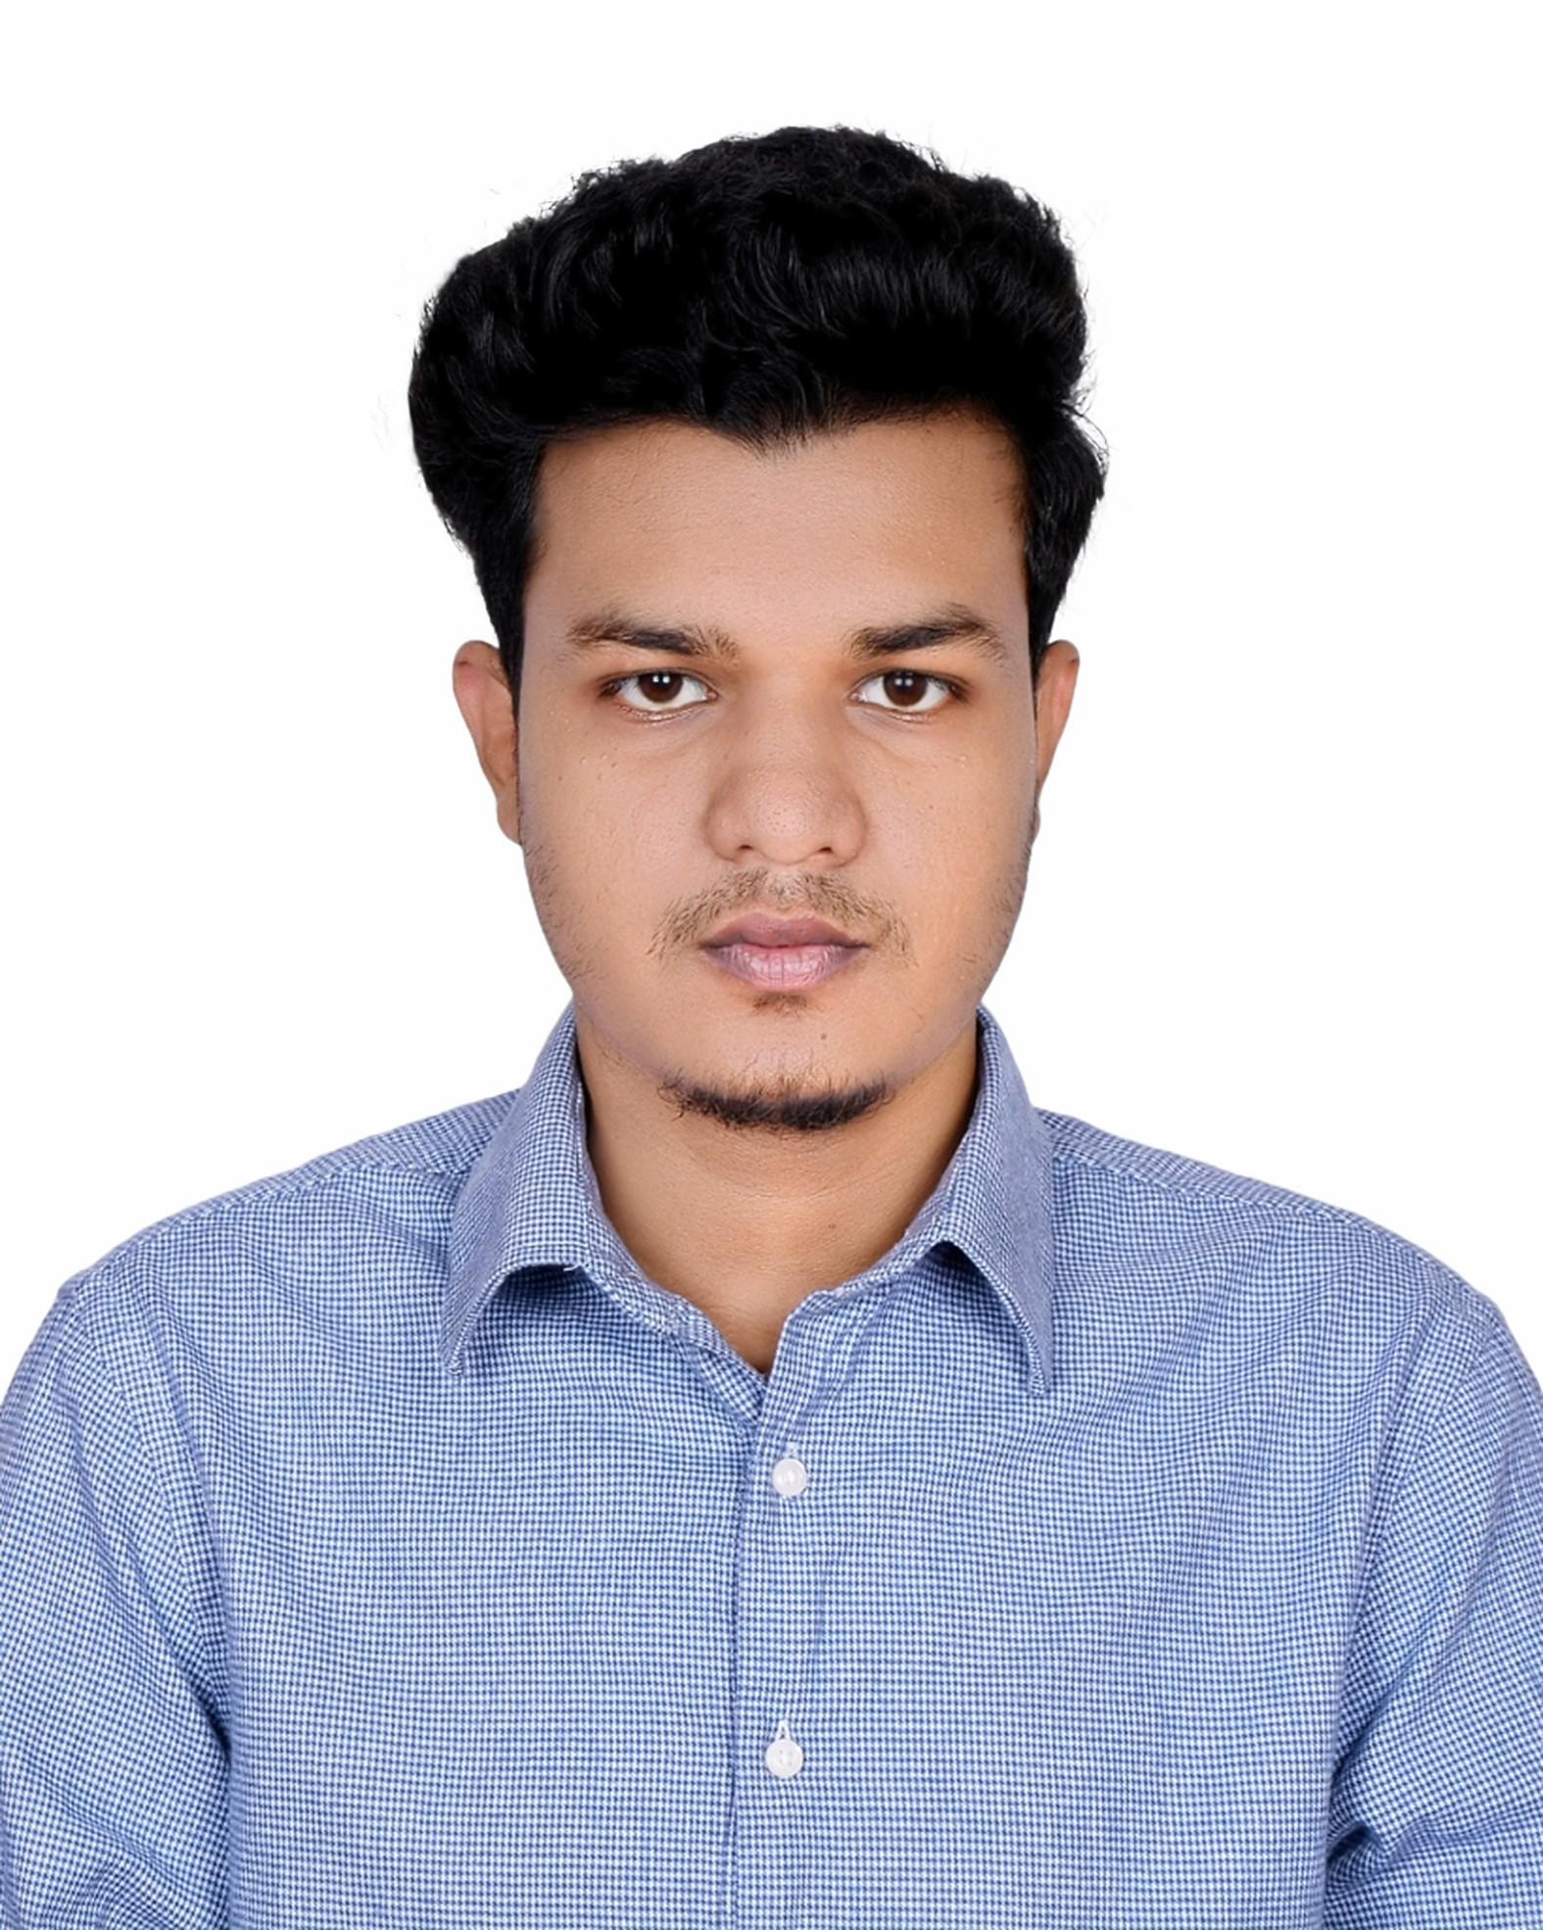

Summary
Full Stack Developer and Head of E-Commerce with 3+ years of experience architecting and shipping production e-commerce platforms across WordPress/WooCommerce and Shopify, backed by strong full-stack engineering (Laravel, Next.js, Django) and measurable growth outcomes. A full-stack builder at the core, now leading e-commerce operations end-to-end from writing the code to running the department while driving 65% organic traffic growth, 30% conversion rate uplift, and 45% Core Web Vitals improvement at a live production store. Combines hands-on full-stack development with technical SEO, CRO, and growth strategy to own the full cycle from deployment to revenue impact. Available for remote and international roles.
Professional Experience

01/2025 – Present  Dhaka, Bangladesh | Go Go Gorgeous · Full Stack Developer |Head of E-Commerce  - Managed and optimized the WooCommerce e-commerce platform, improving overall user experience and contributing to a 30% increase in conversion rate through website enhancements and checkout optimization  - Boosted Core Web Vitals scores by 45% (LCP, CLS, INP) via asset minification, lazy loading, CDN setup, and critical CSS delivery, cutting bounce rate by 18%  - Increased Average Order Value (AOV) by 20% through strategic product merchandising, cross-selling initiatives, wishlist implementation, and personalized product recommendations  - Directed day-to-day digital operations - overseeing site management, campaign execution, and cross-team coordination across design, marketing, and fulfillment to keep operations running at scale.  - Collaborated with the marketing team to build seasonal campaign pages and banners, raising CTR by 22%  - Researched, tested, and implemented new e-commerce tools, features, and website improvements to support business growth and conversion optimization.

11/2023 – 12/2024  Dhaka, Bangladesh | Quantanite Bangladesh · Data Analyst & Automation Specialist  - Automated 8 reporting pipelines with Google Sheets Apps Script, reducing cycle time by 20% and eliminating manual errors  - Validated and transformed 500K+ structured records, achieving 99.8% data integrity across client deliverables  - Deployed 5 interactive KPI dashboards, charts, trend lines, and drill-down filters that accelerated leadership decisions  - Operated across BD–UK time zones through async-first communication, consistently meeting international deadlines

06/2023 – 11/2023  Dhaka, Bangladesh | Appnap Technologies Limited · Web Developer Intern  - Delivered 4 cross-browser responsive web applications in Laravel, HTML5, CSS3, and Bootstrap  - Built 6 custom Laravel modules and integrated 3 third-party REST APIs (payment, SMS, mapping), cutting manual overhead by 35%  - Completed BCC EDGE certification in PHP & Laravel managed by IIT, University of Dhaka
Key Projects

Next.js · React Tailwind · | Deshi-Bideshi Kitchen — Full Stack Food Platform  - Built an SSR-optimized food ordering platform with dynamic menu, image gallery, mobile-first layout - scoring 95+ on Lighthouse with sub-1.5s load time

React Tailwind · | R3 Studio— Digital Growth Agency Platform  - Built and launched a digital growth agency platform offering web development, SEO, Meta Ads, and mobile app services featuring an interactive investment estimator, client project showcase, and WhatsApp-integrated lead capture, scaling to 20+ delivered client projects

Laravel · MySQL  Bootstrap · ORM | E-LECTRONIX — Full Stack E-Commerce Store  - Architected a full store role-based auth, product catalog, cart, order tracking, payment integration, and an admin dashboard

PHP · MySQL Role-Based  Access | Student Enrollment System — Academic Management System  - Developed an enrollment platform with graph analytics and interactive dashboards to support data-driven institutional planning

PHP · MySQL Transaction  Reports | Post Office Management System — Operations Management System  - Designed a postal operations system featuring role-based login, file management, and transaction visualizations to streamline daily workflows
Technical Skills

Languages PHP · JavaScript ES6+ · Python · HTML5 · CSS3 · SQL
Front-End Next.js · React · Tailwind CSS · Bootstrap · Responsive Design
Back-End Laravel · Django · REST API · JWT · OAuth · Eloquent ORM · Composer · Webhooks
WordPress & Shopify Custom Theme Design · Plugin Development · WooCommerce · Shopify · Elementor
Database MySQL · Supabase · Query Optimization · Indexing · Migrations · Relational Design
SEO & Growth Technical SEO · On-Page SEO · Core Web Vitals · Schema Markup · RankMath · YouTube SEO · CRO · A/B Testing
Analytics Google Analytics 4 · Search Console · Google Tag Manager · Funnel Analysis · Power BI · Apps Script
DevOps & Tools Git · GitHub · Vercel · Linux CLI · cPanel · VS Code · Figma · Canva · Slack
Soft Skills Cross-functional Collaboration · Async Remote Work · Stakeholder Communication · Data-Driven Decision Making · Agile/Scrum
Education

2019 – 2023  Dhaka, Bangladesh | B.Sc. in Computer Science & Engineering, Independent University, Bangladesh

2016 – 2018  Khulna, Bangladesh | Higher Secondary Certificate (HSC) - Science, Bangladesh Navy School & College

2009 – 2016  Pirojpur, Bangladesh | Secondary School Certificate (SSC) - Science, Pirojpur Govt. High School
Research & Certification

2023  IEEE CS Publication | AI Chatbot: An Interactive Model for Human-Robot Interaction  Undergraduate NLP and conversational AI research. Published under IEEE Computer Society academic activities.  Supervised by Asst. Prof. AKM Mahbubur Rahman, Dept. of CSE, IUB.

Jun – Sep 2023  BCC EDGE / IIT, Univ. of Dhaka | Web Development with PHP & Laravel  ICT Division, Bangladesh Computer Council (BCC) EDGE - Hire and Train Program. Organised by Appnap Technologies  Limited.
Additional

Languages: Bangla (Native) · English (Professional - reading, writing, spoken)
Memberships: IEEE Computer Society - General Member
Activities: AmariSchool Campus Ambassador - student outreach and community engagement
References

AKM Mahbubur Rahman
Assistant Professor, Dept. of Computer Science & Engineering, Independent University, Bangladesh  akmmrahman@iub.edu.bd

