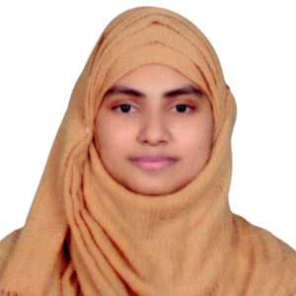
aseta.akter.piro@gmail.com
Seeking a challenging position in a recognized organization where creativity, sincerity, skill and performance are at the heart of one’s appraisal and recognition.

CAREER
Name | : | Aseta Akter
Date Of Birth | : | 15 March 1996
Present Address | : | CI Para Road, Pirojpur Sadar, Pirojpur
Theological Identity | : | Muslim
Nationality | : | Bangladeshi
Marital Status | : | Married

Authenticity Declaration
I do hereby declare that all the information provided above is true. Certificates or other documents can be provided if needed.
Personal Information
Aseta Akter

Master of Social Science
Political Science
Suhrawardy Govt. College, Pirojpur
National University
3.05 out of 4.00
Completed on: 2022
Bachelor of Social Science
Political Science
2.88 out of 4.00
Completed on: 2017
Higher Secondary Certificate (HSC)
Humanities
4.10 out of 5
Pirojpur Govt. Girls’ College
Completed on: 2013
Higher Secondary Certificate (HSC)
Humanities
4.10 out of 5
Pirojpur Govt. Girls’ College
Completed on: 2013
Secondary School Certificate (SSC)
Humanities
4.4 out of 5
Darul Quran Mahila Dakhil Madrasa, Pirojpur
Completed on: 2011
Available on Request
REFERENCES
- Bangla: Native Language
- English: Good Communication
Language Proficiency

SKILLS

Field Officer 09/2020 – 04/2024
Dak Diya Jai
Worked as a team player at different locations. Helped team to achieve goals for different assignments.
- Loan Disbursement
- Receive Instalment for Loan
- Data Entry
- Reporting

Operating System: Microsoft Windows 7 and Windows 10
Microsoft Office: Microsoft Word & Excel
General: Internet Sufing

Field Officer

ACADEMIC QUALIFICATIONS
Aseta Akter



CI Para Road, Pirojpur Sadar, Pirojpur

PROFILE

+880 1841 132 830




