Project Proposal

Student Marketplace

**Rafsun Masud Prince**

1831505042

rafsun.prince@northsouth.edu

**Khalid Bin Shafiq**

1911342642

**Mahmudul Hasan**

1813416642

# Project Name

Student Marketplace

# Project Information

In this project we shall build a website for university students who need help in making progress toward their enrolled courses. Student Marketplace is an E-commerce website where students can buy and sell tuition, books, notes, accessories etc.

# Technology Stack

* HTML
* CSS
* JavaScript
* PHP
* SQL

# Scope

**General**

|  |  |
| --- | --- |
| User type | There are three types of users: buyers, sellers and admins. |
| User Registration | User must be registered with name, phone no. and address, the type of account and password.  Note: Admin account can only be created by the database administrator. |
| Item category | Items can be categorized as follows: tuitions, old books, notes, accessories, sample questions, exercise solutions or others. |
| Item properties | Items are stored with the following information: title, description, image (optional), price and category. |

**Buyer**

|  |  |
| --- | --- |
| Operations | Byers can search, filter, browse, buy, review, report items. Cannot sell. |
| Cart | When a buyer desires to buy an item, system shall stack it into the cart. |
| Payment | User shall pay all items of the cart to complete a payment. |
| Review | User shall post reviews on an item. The system shall verify whether the user actually purchased the item. |
| Report | User can post reports on an item if the item has defects. |

**Seller**

|  |  |
| --- | --- |
| Operations | Sellers can publish item, see list of his published items, modify them and mange earned money. Cannot buy. |
| Approval | After registration, an admin must approve a seller account. Until then, the account will be inactive. |
| Publish | In order to publish an item, a seller must provide all information (properties) of the item. Then, the item is queued for moderator review before it is published. |
| Update | Seller can update or delete a published item. |
| Wallet | Money earned by selling items are stored in a virtual wallet. Money can be withdrawn from this wallet using bank account. |

**Admin**

|  |  |
| --- | --- |
| Operations | Admins approve seller accounts and items posted by sellers, delete items and see reports created by buyers. Cannot buy or sell. |
| Featuring | Admins can set certain items as featured so that they are displayed to the most buyers. |

# ER Diagram

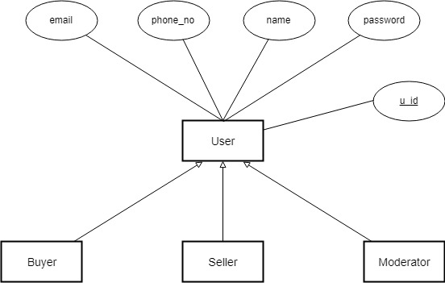

User types

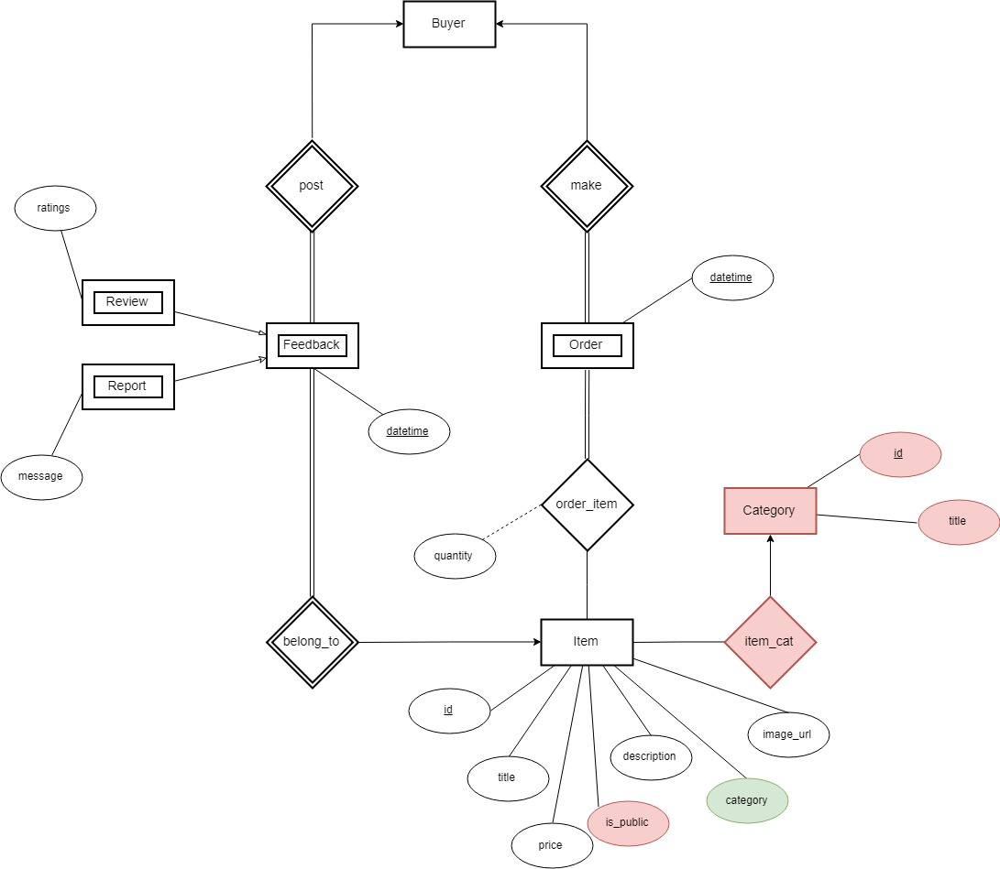

Buyer

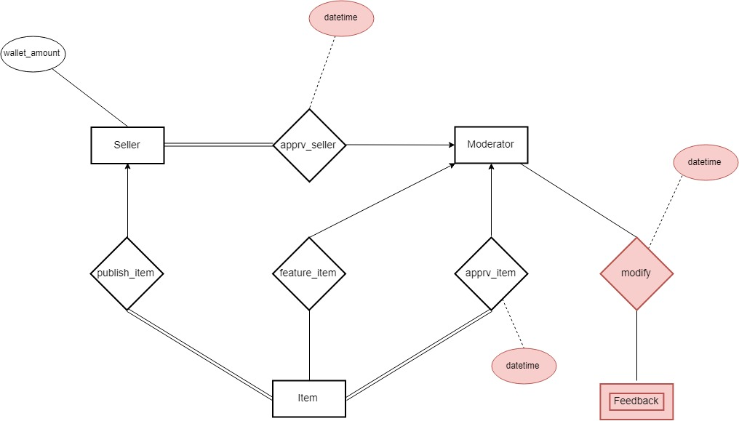

Seller and Moderator