Summary of latest THE results

* The University of Newcastle has moved from 251-300 to 201-250 (ranking increase of one band or ~50 ranks). See **Figure 1**.
* The pillar scores for Teaching, Research and Citations have increased since the 2022 release driving the ranking increase. See **Figure 2.**
* The pillar scores are normalised with respect to the size of the institution.
* Research and Teaching scores have been rising from 2018-2019 (although remain relatively low on the world stage after the size of the institution has been considered). See **Figure 2.**
* Citations is the highest performing pillar with a weight of 30% and has increased slightly from 2022 to 2023. See **Figure 2.**
* All of the University of Newcastle’s score remain above the sector median when compared to all Universities in the world. See **Figure 3 (Top)**
* When compared with only AU universities The University of Newcastle performs close the middle of the pack.
* Further sector data to be released shortly and deeper analysis to follow.

**Figure 1:** Rank for the University of Newcastle in the THE World University Rankings.

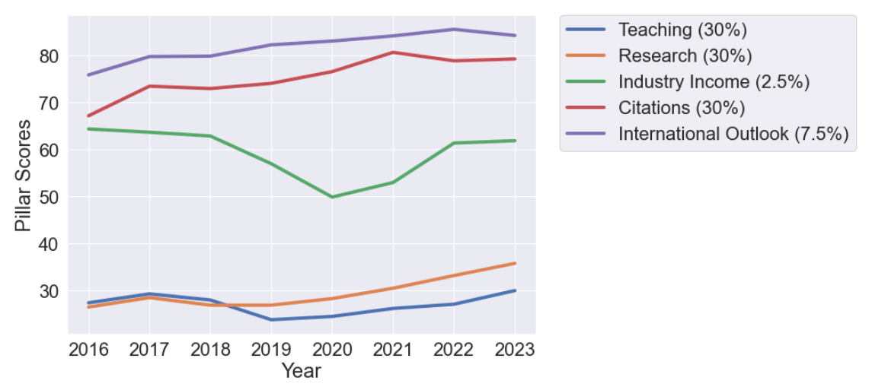

**Figure 2:** The scores for each of the pillars that combine (weighting in the legend) to for the final score and rank.

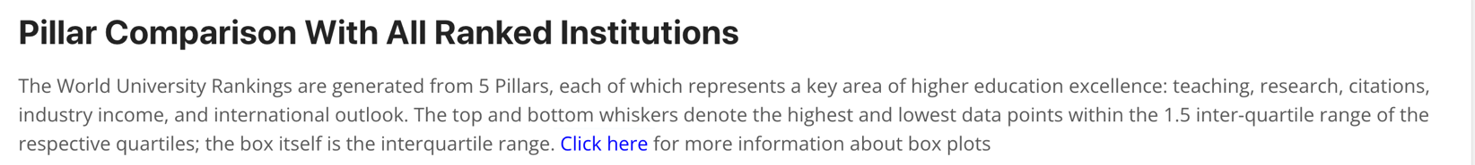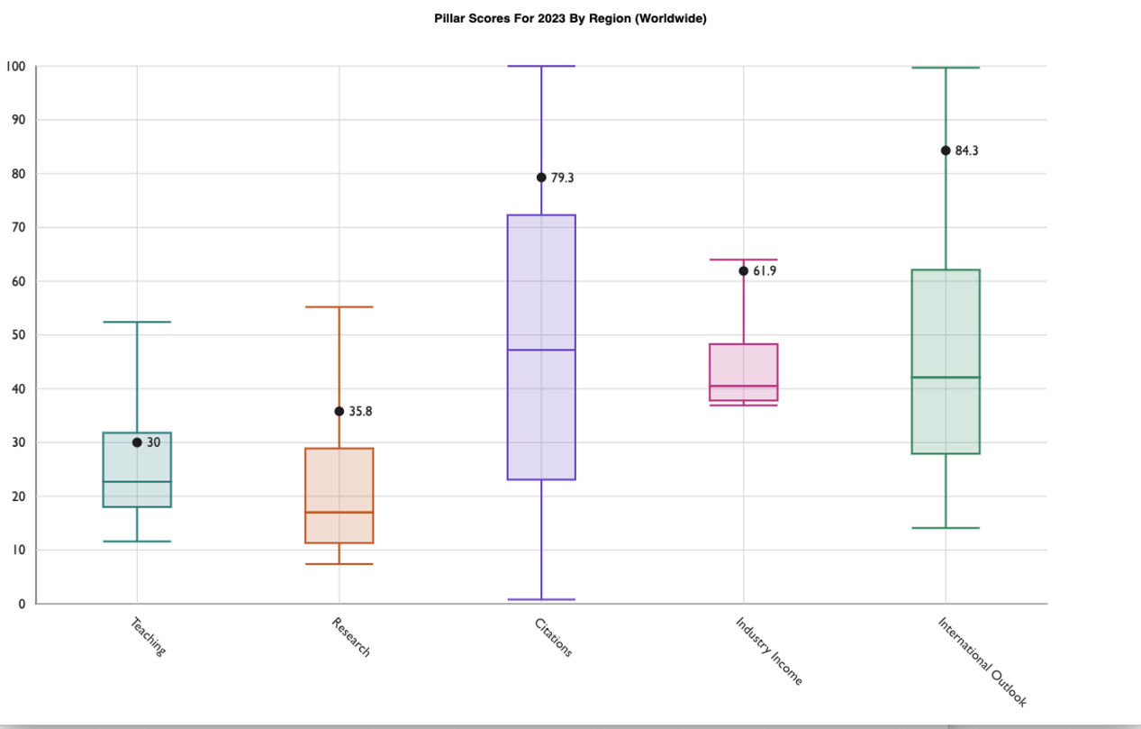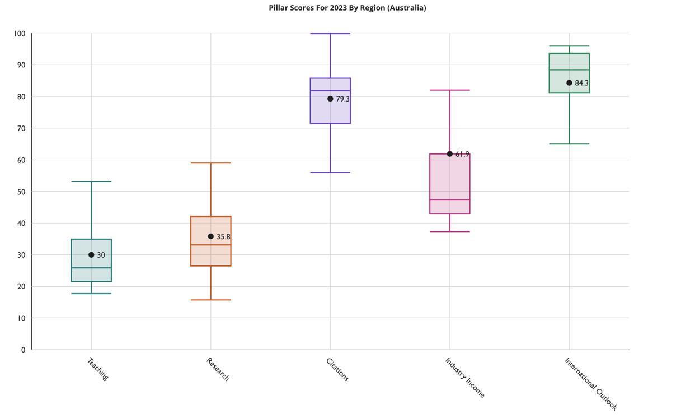

**Figure 3:** (Top) Pillar Scores benchmarked against all Universities in the world. (Bottom) the same benchmark with only AU universities.

