**Dot point summary of 2023 results:**

* The University of Newcastle has moved from 251-300 to 201-250 (ranking increase of one band or ~50 ranks). See **Figure 1**.
* The pillar scores for Teaching, Research and Citations have increased since the 2022 release driving the ranking increase. See **Figure 2.**
* The pillar scores are normalised with respect to the size of the institution.
* Research and Teaching scores have been rising from 2018-2019 (although remain relatively low on the world stage after the size of the institution has been considered). See **Figure 2.**
* Citations is the highest performing pillar with a weight of 30% and has increased slightly from 2022 to 2023. See **Figure 2.**

Figure 1. University of Newcastle ranking (2016-2023)

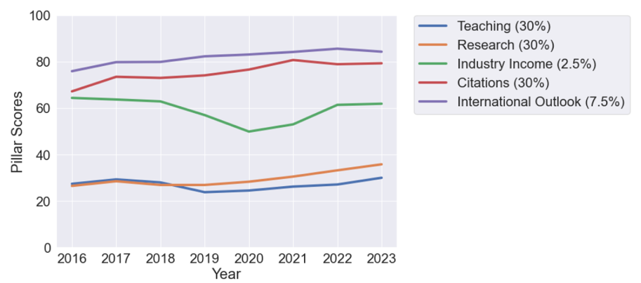

Figure 2: The scores for each of the pillars that combine (weighting in the legend) to for the final score and rank.

**Methodology:** Add details of methodology from Neil’s paper.

**Statistical exploration of 2023 results**

Why do THE release ranking bands? The major reason THE release ranking bands for University’s lower down the ranking is that they do want users of the data to over interpret the results. The score and rank of the high-performing universities fluctuate a very small amount year to year, whereas it is common for universities lower down the ranking to move around more over the years.

The simple reason for this is, for example, is that the high performing universities can often produce orders of magnitude more papers than those further down the ranking [Can try to prove this if we need]. This means that small variations in outputs does not influence the scores and subsequent ranking. Whereas universities further down ranking are very much more closely packed together in terms of outputs and metrics and hence see increased volatility i.e. they are fighting it out for their spots in the ranking. The worry is that when a university ranked at 1000, for example, sees a rise of 75 ranks it over-capitalises on the marketing of that increase, when the change is not significant. Therefore, THE and other rankings prefer to give ranking bands rather than exact values.

**A simple question to ask, therefore, is: what is the expected volatility for a given University in the THE WUR?**

Although THE release ranking bands, they do release the scores for each of the pillars. We have scraped all data from the THE webpages, over all pillars, for all years to 2017-2023 (prior to which there was a major methodology change). Using these values, we can re-create a derived rank for each of the Universities (to a certain point – below a rank of 1000 the THE start to give score bands for the pillars). From this we can examine the typical variability (or standard deviation) for a particular university over the years 2017-2023. Figure 3 below shows the expected variation in a universities rank (y-axis) as a function of rank (x-axis). The y-axis essentially gives the typical change to be expected given a particular rank (or average rank). The University of Newcastle has an average rank of 280 (from 2017-2023) and the expected variation around this value (using the red best fit line in the Figure) is 41 ranks. In comparison, a university with a rank of 30 (e.g. Melbourne University) would only change ranks by around 3 ranks per year.

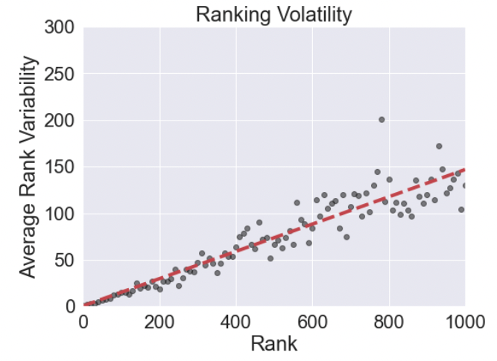

Figure 3: The y-axis shows the typical volatility expected from a university at a given rank. The University of Newcastle is at an average rank of 280, therefore it is expected to vary by plus or minus 41 ranks. The red dashed line shows the best fit to the data.

In Figure 4 below, we plot the derived rank for Newcastle from 2017-2022 with the mean value (280 orange line) and expected volatility (). Although four consecutive rises in rank have been observed the variations are in-line with the expected volatility at this rank.

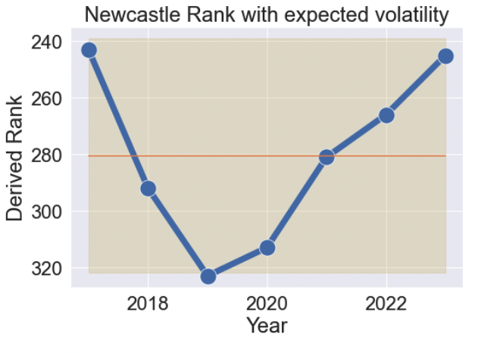

Figure 4: Derived rank and time-series for the University of Newcastle. The shaded region shows the expected volatility given the average rank.

Using an Augmented Dickey-Fuller ([ADF](https://www.machinelearningplus.com/time-series/augmented-dickey-fuller-test/)) test shows that the time-series in stationary from 2017-2022, but *non-stationary* i.e. statistically on the move over 2017-2023.

**How do Universities significantly change their ranking?**

Using the methodology above we can filter universities that changed above and beyond the expected volatility with significant linear increase in rank. The Figures below show (on the left) the overall rank, including a best fit to the data (green line), the average rank (dashed line) and the expected volatility (shaded region). On the right the pillar scores are shown, including the weighting (in the caption). The largest driving factor of the significant increase in ranking is citations, and there were many more examples of this trend across all 2000 universities. The citations pillar does not have any subsidiary metrics and is defined as: “the average number of times a university’s published work is cited by scholars globally” and “The data are normalised to reflect variations in citation volume between different subject areas. This means that institutions with high levels of research activity in subjects with traditionally high citation counts do not gain an unfair advantage.”

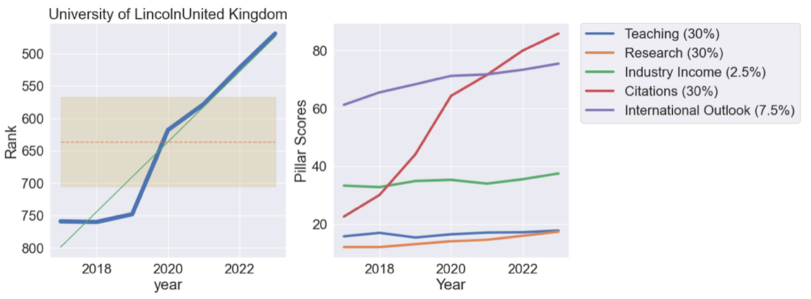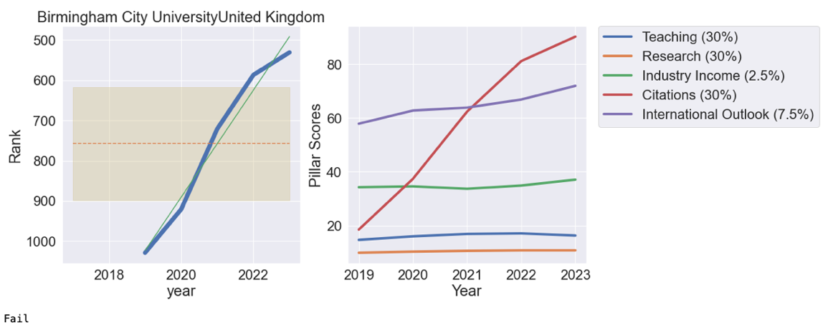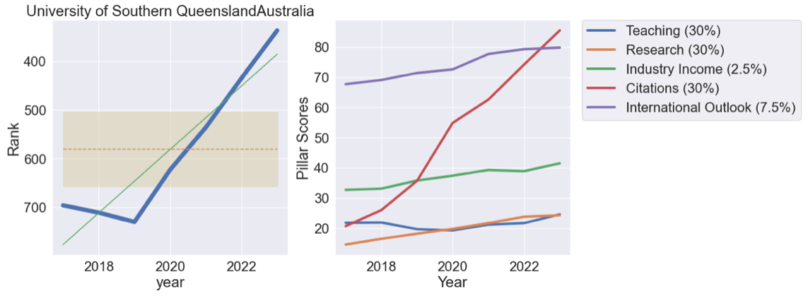

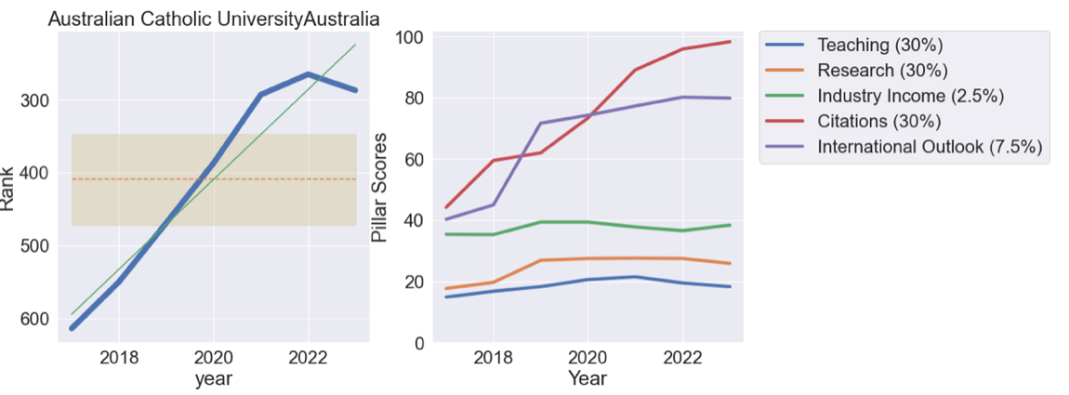

Both ACU and USQ have seen significant movement in ranking (insert rankings gains) driven by a large increase in citations. Is this driven by a small number of highly citation researchers (and possible new hires)?

**How much do the scores change across all of the pillars?**

The plots below show how much the score for a particular university has changed from 2017-2023 (i.e. the variance or volatility on the y-axis averaged across all 2000 universities) with average score. Noting that a top university will have a score of 100, the way to read this plot is (looking at the score plot first), the universities with very high score see smaller changes in that score over time i.e. if you are Oxford you probably get a score of 98 plus or minus 1 each year. As you move to lower scores the variation increases until around a score of 40 with volatility +/- 4, after which THE start to give score bands and the variation decreases (same as ranking analysis above).

The main takeaway here is that the teaching and research scores see fairly constant volatility across the score range, whereas citations (as discussed above) sees up to +/- 10 score variation at a mean score of 50. Industry Income is interesting as well and the big tail is probably not a feature, but this pillar only contributes 2.5% to the overall score so will not drive any major shifts.

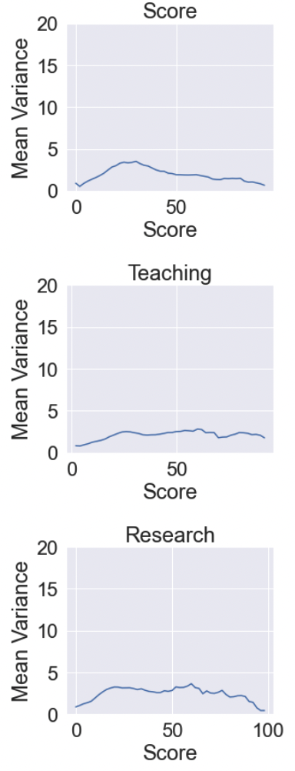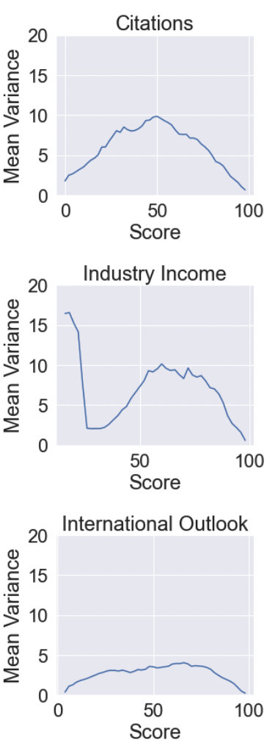

**Metric analysis:**

Each year we can choose a number of peers from which we can access much deeper metric and raw scores. Looking further into ACU (see Figures below) for which we have this analysis. It can be seen that Citations (30%), Publications per staff (6%), Proportion of international academic staff (2.5%) are among the metrics with significant upward change.



Figure : Rank and Pillar Scores for ACU.

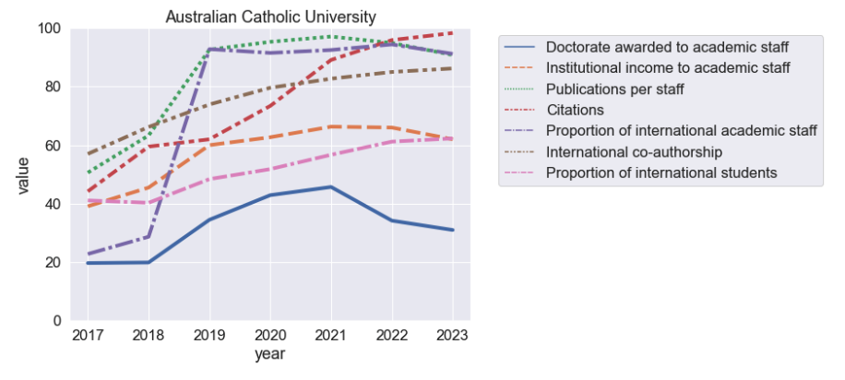

Figure : Metric scores with change > 20 points for ACU (other metrics have been removed for clarity)

Further analysis of all the selected peers and filtering on metrics that have changed by greater than 20 points gives the following result (Figure x). Institutional income to academic had the highest frequency of increase across all the peers, although this weighted at 2.5%. This is followed by publications per staff (xx %) and then Doctorate awarded to academic staff (). Citations has the next largest change and is worth 30% of the score. Teaching reputation features the lowest amount and is worth 15%. Likewise, research reputation does not feature and is worth 18%. The reputation surveys are worth a significant amount of the final scores and have a decent headroom for improvement. [Add more here and get input from Yik].

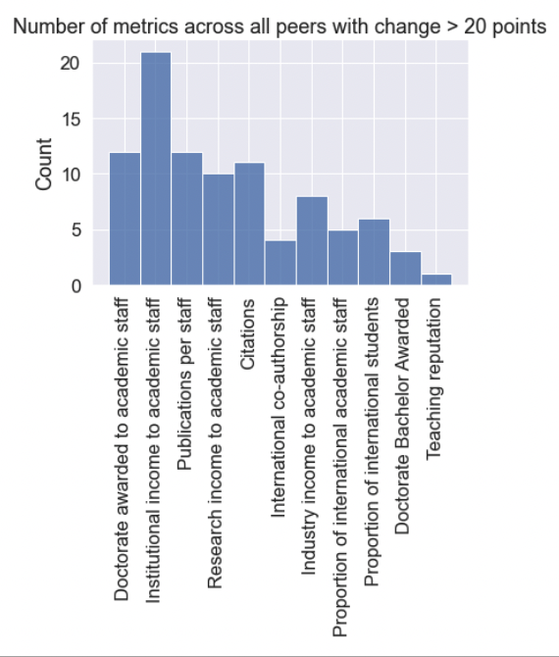

**Changes to the 2024 ranking**

A change in methodology will take place in the 2024 ranking.

**What next and open questions?**

* I could try and track down if the citation increases in USQ and ACU is because of key HiCis or some other shift in their pub strategy.
* I wanted to take a deeper look at the teaching and research scores and how they break down into the metrics. For example, do we see large changes in reputation, or is it sticky? The only way I can do this is through datapoints for our selected peers. But taking a look yesterday I could see that the peers we select each year are set in stone (is this correct?). So, if we choose all AU universities in 2017, I am stuck with them. I couldn’t change to say Birmingham City University (featured above) and get a full five years of full data, which is what I would need to see how the metrics have moved for these Unis.
* In the full EC paper, I don’t think we should focus analysis on AU (or international) unis that haven’t significantly moved. So, in the main body we only include a table of changes for unis that have moved a significant amount. We can add the usual reporting table in the appendix with full details, but I think we need to focus in on the key movers.
* Let me know how we travel with the stats above. I imagine EC will not want all the details and we can break this down to “a statistical analysis shows that Universities x,y and z have made significant gains this year”.
* **Recommendations: Reiterate a need for focus on HiCis and open access (plus any other scheme we can add) combined with a holistic approach to pushing every dial as much as we can.**