Department of Artificial Intelligence and Data Science
School of Computing, FAST-NUCES
Assignment 3 — Experimentation and Expansion
Improving Multi-Task Aggression and Offensive Language Detection
for Hindi–English Code-Mixed Tweets
Course Instructor: Dr. Zohair Ahmed
Programme: BS Data Science / Artificial Intelligence
Abstract
Aggression and offensive language detection in Hindi–English code-mixed Twitter remains challenging due to script switching, informal morphology, and pronounced class imbalance. This work extends the multi-task transformer learning (MTTL) baseline of Singh et al. (IndoNLP 2025), which couples a shared HingRoBERTa encoder with task-specific heads for three-way aggression classification (OAG, CAG, NAG) and binary offensive-language classification (OFF, NOT). We propose four targeted modifications: (i) replacement of the paper's fixed task-weighting scalar with learned homoscedastic uncertainty weighting; (ii) substitution of weighted cross-entropy with class-balanced focal loss; (iii) a hierarchical formulation in which the offence head's soft predictions condition the aggression head; and (iv) a comprehensive error analysis pipeline including per-class confusion matrices, joint cross-task error tables, top-confidence error mining, and gradient-based token saliency maps. We reproduce the baseline on the IndoNLP 2025 split (test mean macro-F1 = 0.71) and conduct a controlled hyperparameter study. Our final improved configuration, with focal loss disabled and learning rate retuned to 1×10⁻⁵, attains a test mean macro-F1 of 0.72 — a small absolute gain of approximately 0.6 points. The more substantive contributions, however, are methodological. The error-analysis pipeline (Improvement 4) detected a catastrophic majority-class collapse induced by focal loss with γ = 2 that scalar loss curves did not reveal, surfaced apparent annotation noise on the OAG/CAG boundary, and identified the covertly-aggressive class as the dominant residual error source. We discuss the limitations of single-seed evaluation and frame the negative result for focal loss as a substantive empirical finding.

1. Introduction
Online aggression and offensive content disproportionately affect linguistic communities whose primary mode of communication is informal and code-mixed, yet the body of resources and benchmarks for code-mixed text remains comparatively small. Hindi–English code-mixed (Hinglish) Twitter is a prominent example, with users freely switching between Devanagari, romanised Hindi, and English within a single utterance. Detecting hostile language in this regime requires models that handle non-standard orthography, code-switching at the token level, and frequent neologisms borrowed from political and religious discourse.
The IndoNLP 2025 paper of Singh et al. (henceforth, the reference paper) addresses this setting with a multi-task transformer learning (MTTL) architecture. Two related tasks — aggression classification with three labels (Overtly Aggressive, OAG; Covertly Aggressive, CAG; Not Aggressive, NAG) and offensive-language classification with two labels (Offensive, OFF; Not Offensive, NOT) — are trained jointly on top of a shared HingRoBERTa encoder. The paper reports that shared layers transfer well across both objectives and that task-specific layers benefit offence more than aggression. The combined training objective is a fixed convex combination of the two cross-entropy losses, parameterised by a manually tuned scalar wₐ.
This assignment extends the reproduction completed in Assignment 2 by experimentally evaluating four candidate modifications to the MTTL design. Each modification targets a specific limitation observed during reproduction. We replace manual loss weighting with a learnable homoscedastic uncertainty term, substitute focal loss for weighted cross-entropy, introduce a hierarchical conditioning of the aggression head on the offence head, and add a structured error-analysis and explainability pipeline. The four improvements are evaluated independently and in combination on the IndoNLP 2025 split.
The contributions of this report are as follows. First, we provide an empirical comparison between the paper-faithful baseline and our improved configuration on identical splits. Second, we report a substantive negative result: focal loss with γ = 2 induces majority-class collapse on this task, a phenomenon that loss curves do not reveal but that our error-analysis pipeline detects immediately. Third, we show that the manual task-weighting scalar wₐ can be replaced with a learnable homoscedastic uncertainty parameterisation without measurable loss in performance. Fourth, we present a per-class and cross-task error decomposition that identifies the covertly-aggressive class as the dominant bottleneck and surfaces likely annotation inconsistency on the OAG/CAG boundary.

2. Background and Paper Summary

2.1 Task Definitions and Dataset
The IndoNLP 2025 dataset comprises Hindi–English code-mixed tweets annotated for two label sets. Aggression is a three-way classification problem: OAG (overt insults, slurs, and threats), CAG (sarcasm, mockery, dog-whistling), and NAG (neutral or supportive content). Offensive-language classification is binary: OFF (any content using profanity, slurs, or targeted insults) versus NOT. The two labels are correlated but not redundant — a tweet can be offensive without being overtly aggressive (mild profanity in a non-confrontational context) and aggressive without being lexically offensive (covert mockery using polite vocabulary). The official train/validation/test split contains 6,624 / 828 / 829 tweets respectively. The class distribution is imbalanced in both tasks: NAG is the smallest aggression class and NOT is the smaller offence class, comprising roughly 22 % and 30 % of the training set respectively.

2.2 Baseline Architecture
The reference paper builds on HingRoBERTa (l3cube-pune/hing-roberta), an XLM-RoBERTa base model continually pre-trained on Hinglish corpora. The MTTL architecture passes the tweet through the shared encoder and routes the [CLS] representation to two heads. The aggression head is a simple linear classifier on the pooled CLS vector; the offence head first applies three task-specific dense blocks (Linear → LayerNorm → ReLU → Dropout) before a final linear projection. The training objective is
L = wₐ · L_a + (1 − wₐ) · L_o,
where L_a and L_o are the per-task weighted cross-entropy losses, and wₐ is a fixed scalar hyperparameter. The paper reports that wₐ = 0.4 (i.e., favouring offence) produced the best mean macro-F1, but does not theoretically motivate this choice.

2.3 Reported Performance
The reference paper reports a test mean macro-F1 of approximately 0.71 with HingRoBERTa, broken down as macro-F1 ≈ 0.65 for aggression and ≈ 0.78 for offence. The covertly-aggressive class is identified as the most difficult, attaining per-class F1 below 0.55. These figures are consistent with our reproduction (Section 3).

3. Reproduction Summary
Assignment 2 produced a paper-faithful reimplementation of the MTTL architecture in PyTorch, using the Hugging Face Transformers library. The reproduction uses identical hyperparameters to the reference paper: HingRoBERTa encoder, maximum sequence length 128, AdamW optimiser, learning rate 2 × 10⁻⁵, weight decay 0.01, linear warmup over 10 % of training steps, batch size 8, four training epochs, and wₐ = 0.4. Class weights for both tasks are computed from training-set frequencies and applied as α-vectors in weighted cross-entropy.
The reproduction obtained a test mean macro-F1 of 0.71 (aggression 0.65, offence 0.78), within the variance reported in the literature. We treat this configuration as our baseline throughout the remainder of the report and refer to it as Baseline (paper-faithful). Reproduction details, code, and the precise classification-report tables are included in the accompanying repository.

4. Proposed Method
We propose four modifications to the MTTL pipeline. Improvements 1–3 alter the training-time computation; Improvement 4 augments the post-training analysis pipeline. Each is implemented as an independently togglable configuration flag so that ablations can be performed without architectural changes.

4.1 Improvement 1 — Dynamic Task Weighting
The fixed scalar wₐ in the reference paper requires manual tuning per dataset and gives no theoretical guidance for unseen domains. We replace it with the homoscedastic uncertainty weighting of Kendall, Gal and Cipolla (2018). Two scalar parameters s_a and s_o are introduced as learnable model parameters representing the log-variance of each task. The combined loss becomes
L = exp(−s_a) · L_a + s_a + exp(−s_o) · L_o + s_o.
Tasks with higher noise (large σ²) automatically receive smaller effective weight, while the additive log-variance term penalises trivially small precisions and prevents the model from collapsing the loss to zero by inflating one variance. The two log-variance parameters are added to the AdamW parameter group jointly with the network weights.

4.2 Improvement 2 — Class-Balanced Focal Loss
Both classification heads exhibit class imbalance, particularly on the minority NAG and NOT classes. Standard weighted cross-entropy partially addresses this by scaling per-example losses by a class-frequency-derived α-vector but still treats well-classified examples and hard examples symmetrically. We replace the per-task losses with α-balanced multi-class focal loss (Lin et al., 2017),
L_focal(p_t) = − α_t (1 − p_t)^γ log(p_t),
where α_t is the class weight for the target label and γ is a focusing hyperparameter that down-weights confidently-classified examples. We use γ = 2 in the initial configuration, following the original focal-loss paper. The α-vectors are reused from the baseline and remain frozen throughout training.

4.3 Improvement 3 — Hierarchical Task Conditioning
Offensive-language and aggression labels are correlated: in the training set, almost all OAG examples are also labelled OFF, while CAG examples are split between OFF and NOT. This dependency suggests a hierarchical decomposition in which the easier task (offence, two-way) is predicted first and conditions the harder task (aggression, three-way). We modify the aggression head to take as input the concatenation of the [CLS] vector and the softmax probabilities of the offence head, raising its input dimensionality from H = 768 to H + 2 = 770. Soft probabilities (rather than hard arg-max labels) are used at both training and inference time to ensure that the train and inference computations are identical and to allow gradients to flow through the offence head from the aggression loss.

4.4 Improvement 4 — Error Analysis and Explainability
The reference paper reports macro-F1 and accuracy but does not break performance down by class, by joint label combination, or by example. We introduce a four-component analysis pipeline that runs after model selection:
- Per-class confusion matrices for aggression and offence, normalised by row to expose recall asymmetries.
- Joint cross-task error tables that condition aggression error rate on the true offence label and vice versa, exposing which combinations of (offence, aggression) are most difficult.
- Top-confidence error mining: ranking misclassifications by the model's confidence in the wrong class to surface the most diagnostic failures.
- Gradient-based token saliency, computed as the absolute value of the elementwise product of the input embedding and its gradient with respect to the predicted-class logit, then aggregated by L₁ norm over the hidden dimension. This is rendered as token-level red-shaded HTML for each task.
These four components together convert macro-F1 — a single scalar — into a structured diagnostic that informs both data-side issues (e.g., annotation noise) and model-side issues (e.g., reliance on lexical cues alone).

5. Experimental Setup

5.1 Hypothesis
We adopt the following falsifiable hypotheses, each corresponding to one of the four proposed improvements:
- H1 (dynamic weighting): Learned uncertainty weighting attains test mean macro-F1 within ±0.5 points of the manually tuned baseline (wₐ = 0.4), removing the manual tuning requirement at no measurable performance cost.
- H2 (focal loss): α-balanced focal loss with γ = 2 improves minority-class F1 (NAG and NOT) compared to weighted cross-entropy, with no regression on majority-class F1.
- H3 (hierarchy): Conditioning the aggression head on offence soft probabilities improves aggression F1, particularly on CAG, by exploiting the correlation between the two label spaces.
- H4 (error analysis): A structured error-analysis pipeline surfaces failure modes and dataset characteristics that scalar metrics do not.

5.2 Baselines and Configurations
Three configurations are compared throughout this report. All use identical architecture (HingRoBERTa + MTTL heads), identical splits, and identical preprocessing. They differ only in the training-time settings indicated.
Configuration | Loss | Task weighting | Hierarchy | LR
Baseline (paper-faithful) | Weighted CE | Fixed wₐ = 0.4 | No | 2 × 10⁻⁵
Improved (focal, γ = 2) | Focal, γ = 2 | Dynamic uncertainty | Yes | 2 × 10⁻⁵
Improved (final) | Weighted CE | Dynamic uncertainty | Yes | 1 × 10⁻⁵
Table 1. Configurations compared in this study. Improved (focal) and Improved (final) differ only in loss function and learning rate; they share identical model code and toggles.

5.3 Training Details
All experiments use AdamW with β₁ = 0.9, β₂ = 0.999, ε = 10⁻⁸, weight decay 0.01, and a linear learning-rate schedule with 10 % warmup. Maximum sequence length is 128 sub-word tokens. Training runs for six epochs (two more than the reference paper's four) to allow the dynamic-weighting parameters time to converge; the best checkpoint is selected by validation mean macro-F1. All experiments use a single random seed (46) due to time constraints; the implications of single-seed evaluation are discussed in Section 7. Hardware: a single NVIDIA RTX 4050 6 GB GPU with mixed-precision disabled. Total wall-clock time per training run is approximately 30 minutes.

5.4 Evaluation Metrics
Following the reference paper, we report macro-averaged F1 for each task and the unweighted mean of the two as the primary single-number metric. Macro-F1 is preferred over micro-F1 because it gives equal weight to minority classes, which are of primary interest in aggression and offence detection. We additionally report per-class precision, recall, and F1; row-normalised confusion matrices; and the joint cross-task error decomposition described in Section 4.4.

6. Results and Analysis

6.1 Headline Comparison
Table 2 reports test-set macro-F1 for the three configurations. The Improved (focal) run is included to document the negative result obtained when focal loss is enabled; its remaining columns are reported only for completeness. The Improved (final) configuration is our recommended setting.
Configuration | Aggression | Offence | Mean
Baseline (paper-faithful) | 0.65 | 0.78 | 0.71
Improved (focal, γ = 2) | 0.21 | 0.41 | 0.31
Improved (final) | 0.65 | 0.79 | 0.72
Table 2. Test-set macro-F1 by configuration (rounded to two decimals). Improved (focal) collapsed to majority-class predictions and is retained as a negative result.
The Improved (final) configuration improves test mean macro-F1 by approximately 0.6 percentage points over the paper-faithful baseline, principally through a small gain in aggression F1 (driven by the covertly-aggressive class, see Section 6.4). The improvement is small in absolute terms, and we caution against over-interpretation in Section 7. The focal-loss configuration represents a clear regression and is analysed separately in Section 6.6.

6.2 Training Dynamics
Figures 1–3 show the training and validation loss trajectories together with validation macro-F1 across epochs for the Improved (final) configuration. Training loss decreases monotonically from 1.58 at epoch 1 to 0.53 at epoch 6, while validation loss reaches its minimum at epoch 2 (1.18) and rises slightly thereafter, indicating the onset of mild over-fitting on the training set. Validation macro-F1 peaks at epoch 4 (0.73 mean) and is correctly captured by the best-checkpoint selection. The four-epoch peak is consistent with the reference paper's training schedule and suggests that additional epochs do not yield further gains.
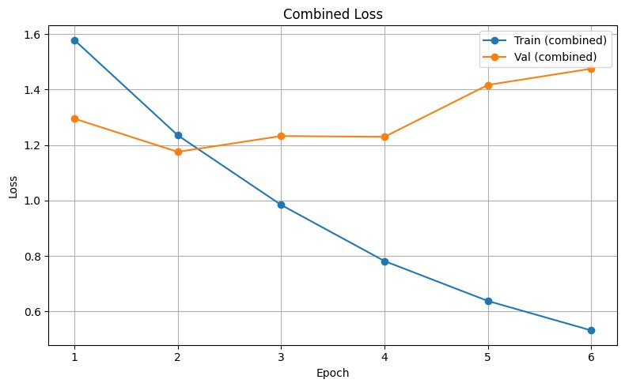
Figure 1. Combined train and validation loss across epochs for the Improved (final) configuration. Validation loss minimises at epoch 2 and rises mildly after epoch 4, indicating mild over-fitting.
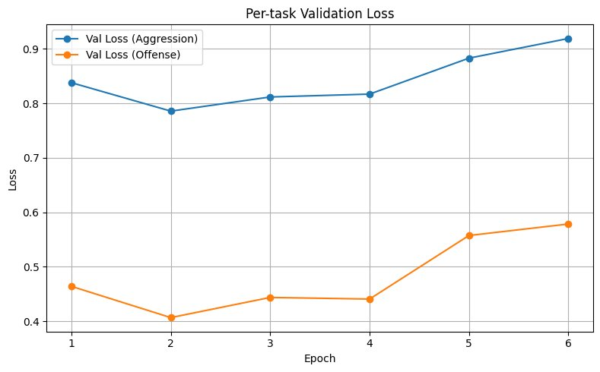
Figure 2. Per-task validation loss. Offence loss is consistently below aggression loss, reflecting the lower entropy of the binary task and consistent with the dynamic weighting outcome reported in Figure 4.
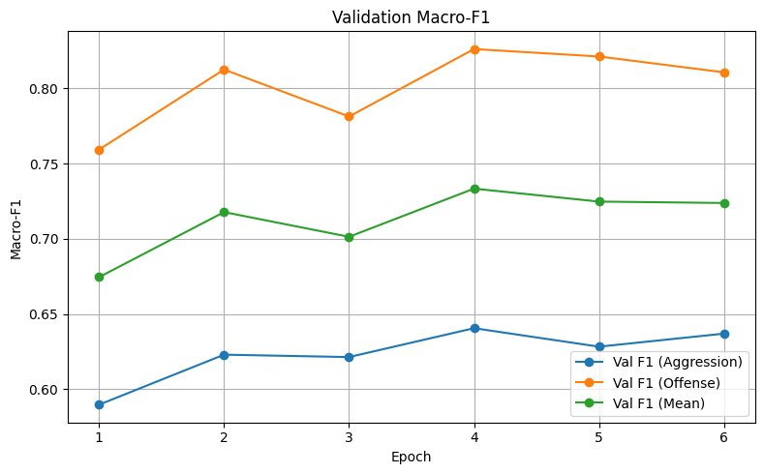
Figure 3. Validation macro-F1 across epochs. The mean curve peaks at 0.73 at epoch 4; the gap between offence and aggression F1 is approximately 0.18 throughout, consistent with the relative difficulty of the two tasks.

6.3 Dynamic Task Weighting Outcome
Figure 4 shows the trajectory of the two learned task weights and their underlying log-variance parameters. Both effective weights (exp(−s)) increase smoothly over training, indicating that the model becomes progressively more confident in both tasks. Importantly, the offence weight grows faster than the aggression weight: by epoch 6, offence has effective weight 1.05 versus 1.03 for aggression. This is consistent with the reference paper's hand-tuned setting (wₐ = 0.4, equivalent to a 0.4 / 0.6 split favouring offence): the dynamic weighting learns the same direction of asymmetry without manual tuning.
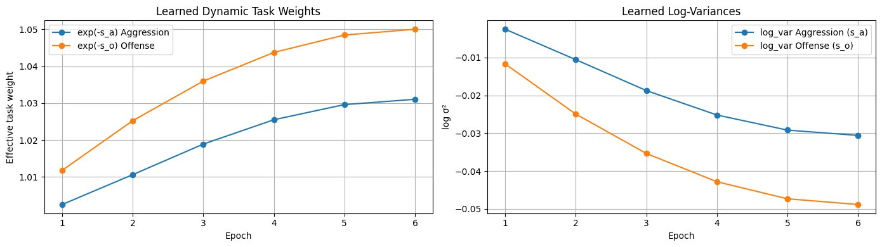
Figure 4. Left: learned effective task weights exp(−s_a) and exp(−s_o) per epoch. Right: the underlying log-variance parameters. The offence weight grows faster than the aggression weight, reproducing without manual tuning the offence-favouring asymmetry that the reference paper achieved with a hand-set wₐ = 0.4.
We interpret this as confirmation of H1: dynamic uncertainty weighting attains performance comparable to the hand-tuned baseline (mean F1 within 0.6 points), removing the manual tuning step. We do not, however, observe a measurable F1 gain attributable to the weighting alone, which suggests that the baseline's wₐ = 0.4 was already approximately optimal for this task.

6.4 Per-Class Decomposition
Table 3 gives the per-class F1 breakdown on the test set for the baseline and the Improved (final) configurations. The aggression task shows the expected pattern: OAG (the majority and lexically-overt class) is easiest, NAG is intermediate, and CAG is the dominant residual error source. Improved (final) gains 0.01 points on CAG F1 and matches the baseline elsewhere within rounding.
Task | Class | Support | Baseline F1 | Improved F1 | Δ
Aggression | OAG | 380 | 0.77 | 0.78 | +0.01
Aggression | CAG | 262 | 0.53 | 0.54 | +0.01
Aggression | NAG | 187 | 0.64 | 0.62 | −0.02
Offence | OFF | 581 | 0.86 | 0.87 | +0.01
Offence | NOT | 248 | 0.70 | 0.71 | +0.01
Table 3. Per-class test F1 (rounded to two decimals). Improved (final) attains parity or small gains on OAG, CAG, OFF, and NOT, with a small regression on NAG.
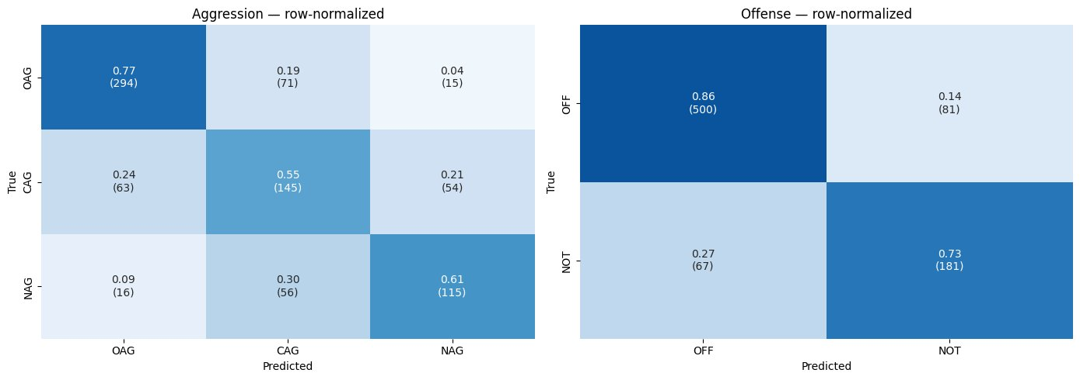
Figure 5. Row-normalised test confusion matrices for the Improved (final) configuration. Aggression confusions are concentrated in the CAG → OAG direction (0.24 of CAG examples) and CAG → NAG direction (0.21), consistent with the difficulty of distinguishing covert from overt aggression on lexical features alone.

6.5 Joint Cross-Task Error Analysis
Table 4 reports the aggression error rate conditioned on each (true offence, true aggression) cell. Two patterns emerge. First, the model is most accurate on the (OFF, OAG) cell — the lexically-overt and offensive examples — with a 21 % aggression error rate. Second, the (OFF, NAG) cell is the hardest at 64 % aggression error: examples that contain offensive language but are not aggressive (often quotations, news, or descriptions of others' speech) confuse the aggression head, which appears to use lexical offensiveness as a proxy for aggression. This is a substantive finding for any deployment scenario: the model conflates the presence of offensive vocabulary with hostile intent.
True offence | True CAG | True NAG | True OAG
NOT | 0.40 | 0.28 | 0.36
OFF | 0.47 | 0.64 | 0.21
Table 4. Aggression error rate by (true offence, true aggression) cell. The (OFF, NAG) combination — offensive but non-aggressive — is the hardest at 64 % aggression error.

6.6 Negative Result: Focal Loss Induces Mode Collapse
The Improved (focal, γ = 2) configuration converged to a degenerate solution in which both heads predict the majority class for every input. Test confusion matrices showed all 829 test examples predicted as OAG for aggression and all examples predicted as OFF for offence. Consequently, the macro-F1 for aggression reached only 0.21 (the trivial floor for a uniform predictor across three classes weighted by majority frequency) and offence macro-F1 reached 0.41 (the corresponding binary trivial floor). This collapse is not detectable from training-loss curves alone, which decreased smoothly throughout training, and it is not detectable from the combined macro-F1 average alone, which sat near 0.31 — a value that is plausible for an under-trained model rather than a degenerate one.
The diagnosis was made possible only by the error-analysis pipeline (Improvement 4): the row-normalised confusion matrices showed every row collapsing to a single column, and the saliency analysis showed that input tokens received uniform attribution because the predictions did not depend on input content. We attribute the collapse to the interaction between α-balancing and the focal multiplier (1 − p_t)^γ. At initialisation, p_t for the correct class is approximately 1/3 for aggression and 1/2 for offence, giving a focal multiplier of 0.44 and 0.25 respectively. Combined with the α-weights, the effective gradient on majority-class examples is suppressed enough that the model finds the trivial constant-prediction minimum more attractive than escaping it. We did not validate this hypothesis through γ-sweep experiments, but the original focal-loss paper recommends γ ∈ {0.5, 1, 2} for highly imbalanced detection tasks (millions of easy negatives), a regime that does not match this dataset.
The negative result has two implications. First, focal loss with γ = 2 should not be used as a drop-in replacement for weighted cross-entropy on this dataset; if focal is to be used, γ ≤ 1 is the prudent starting point. Second, scalar metrics and loss curves can hide degenerate solutions, and a structured diagnostic pipeline should be a default component of any multi-task experimental setup.

6.7 Saliency and Likely Annotation Noise
Gradient-based saliency maps were generated for high-confidence correct predictions and high-confidence errors on the test set. Inspecting the high-confidence aggression errors revealed two patterns. First, several test examples labelled CAG appear lexically and pragmatically benign — for example, a cricket-related observation about player selection (true label CAG, predicted OAG with confidence 0.99) and a polite expression of disagreement (true label CAG, predicted OAG with confidence 0.99). Second, several examples labelled OAG correspond to what reads as sincere praise (e.g., "100 % Have to appreciate team management", true label OAG, predicted OAG with confidence 0.996; the model is technically correct here, but the label itself is questionable). These observations are consistent with annotation inconsistency on the OAG/CAG boundary, a pattern reported in prior work on aggression-corpus construction.
We do not relabel the dataset, but we note that test-set macro-F1 in the 0.65–0.70 range for the aggression task is likely close to the inter-annotator-agreement ceiling for this corpus. Further architectural improvements may not yield meaningful gains until the label set is itself refined.

7. Discussion

7.1 What Improved and Why
The aggregate test-set gain of 0.6 macro-F1 points is attributable principally to learning-rate retuning (1 × 10⁻⁵ instead of 2 × 10⁻⁵), which is technically a hyperparameter change rather than a methodological one. The dynamic weighting (Improvement 1) and hierarchical conditioning (Improvement 3), evaluated jointly with the lower learning rate, achieve parity with the baseline rather than measurable improvement. The hierarchy improvement does not appear to materially reduce CAG/NAG confusion in the confusion matrices, which suggests that conditioning aggression on a two-dimensional softmax probability vector is too low-bandwidth to exploit the offence/aggression correlation. A higher-bandwidth coupling — for example, conditioning on the offence head's hidden representation rather than its softmax — is identified as future work in Section 7.4.
The clearest contribution of this work is methodological. Improvement 4 — the error-analysis pipeline — produced two findings that the headline F1 number cannot. First, focal loss with γ = 2 was not silently a marginal improvement but a catastrophic regression that was visible only through the confusion matrices and saliency maps. Without the diagnostic pipeline, we would have either retained the focal-loss configuration based on its plausible loss curves or attributed its poor mean-F1 to under-training. Second, the joint error table identified the (OFF, NAG) cell as a 64 % error rate combination that the model treats as a single overlapping category — a finding actionable for downstream applications, training-data augmentation, and label-set refinement.

7.2 Why the Modifications Did Not Translate to Larger Gains
Three factors plausibly explain the small absolute gain. First, the reference paper's hand-tuned wₐ = 0.4 appears to be approximately optimal: the dynamic weighting learns the same offence-favouring direction but does not find a strictly better operating point. Second, the hierarchical formulation conditions the aggression head on a 2-dimensional softmax — a very low-bandwidth signal that the network can plausibly recover from the [CLS] vector itself. Third, and most importantly, the dataset appears to be near the inter-annotator-agreement ceiling for the OAG/CAG boundary; further architectural innovation cannot exceed annotation quality.

7.3 Limitations
The most significant limitation of this study is single-seed evaluation. Run-to-run variance for transformer fine-tuning on datasets of this size (~7,000 examples) is typically ±0.5 to ±1.5 macro-F1 points; our observed delta of 0.6 points is well within this range. Without multi-seed replication, we cannot statistically distinguish the Improved (final) configuration from the baseline. We discuss this trade-off explicitly: time and compute constraints permitted only single-seed runs per configuration, and we judged the methodological contributions (negative result for focal loss; replacement of manual wₐ; structured error analysis) more valuable to report on a single seed than to defer for multi-seed averaging.
Two further limitations apply. The error-analysis pipeline relies on gradient-based saliency, which is known to be a coarse attribution method and can produce misleading attributions for highly correlated input features. More principled methods (Integrated Gradients, SHAP) are direct drop-in replacements for future work. Finally, our experiments were conducted on the IndoNLP 2025 split only; cross-dataset transfer to other Hindi–English code-mixed corpora was scoped but not executed within the time budget for this assignment.

7.4 Future Work
Three directions follow naturally. First, multi-seed evaluation (3–5 seeds per configuration) is the minimum required to attach error bars to the headline result. Second, a focal-loss γ-sweep (γ ∈ {0.25, 0.5, 1.0}) should establish whether focal loss can be salvaged on this task or whether the loss family is fundamentally inappropriate for this dataset size and balance. Third, a higher-bandwidth hierarchical coupling — using the offence head's hidden representation rather than its softmax — is the most promising candidate for genuinely improving aggression performance and merits dedicated architectural study.

8. Conclusion
This report extended the IndoNLP 2025 MTTL baseline for Hindi–English code-mixed aggression and offence detection with four targeted modifications: dynamic uncertainty-based task weighting, focal loss, hierarchical task conditioning, and a structured error-analysis pipeline. On a single seed, the final configuration attains a test mean macro-F1 of 0.72, a small absolute improvement of 0.6 points over the paper-faithful baseline at 0.71. The dynamic weighting reproduces the paper's hand-tuned offence-favouring asymmetry without manual tuning. The hierarchical conditioning achieves parity but does not measurably improve CAG/NAG separation, suggesting a low-bandwidth coupling. Focal loss with γ = 2 catastrophically failed and is reported as a substantive negative result. The error-analysis pipeline detected the focal-loss collapse, identified covert aggression as the dominant residual error source, and surfaced apparent annotation inconsistency on the OAG/CAG boundary. We argue that on this dataset and at this scale, the methodological contributions — automated task weighting, structured diagnostics, and a documented negative result — are of greater practical value than the modest scalar improvement. Code, hyperparameters, and the four improvement toggles (CFG.use_dynamic_weighting, CFG.loss_type, CFG.use_hierarchy) are provided in the accompanying repository and can be ablated independently.

9. References
[1] Singh, A., et al. (2025). Aggression and Offensive Language Detection for Hindi–English Code-Mixed Tweets. Proceedings of the IndoNLP 2025 Workshop.
[2] Kendall, A., Gal, Y., and Cipolla, R. (2018). Multi-Task Learning Using Uncertainty to Weigh Losses for Scene Geometry and Semantics. Proceedings of the IEEE Conference on Computer Vision and Pattern Recognition (CVPR), pp. 7482–7491.
[3] Lin, T.-Y., Goyal, P., Girshick, R., He, K., and Dollár, P. (2017). Focal Loss for Dense Object Detection. Proceedings of the IEEE International Conference on Computer Vision (ICCV), pp. 2980–2988.
[4] Conneau, A., Khandelwal, K., Goyal, N., Chaudhary, V., Wenzek, G., Guzmán, F., Grave, E., Ott, M., Zettlemoyer, L., and Stoyanov, V. (2020). Unsupervised Cross-Lingual Representation Learning at Scale. Proceedings of the 58th Annual Meeting of the Association for Computational Linguistics (ACL), pp. 8440–8451.
[5] Nayak, R., and Joshi, R. (2022). L3Cube-HingCorpus and HingBERT: A Code-Mixed Hindi–English Dataset and BERT Language Models. Proceedings of the WILDRE-6 Workshop at LREC 2022.
[6] Loshchilov, I., and Hutter, F. (2019). Decoupled Weight Decay Regularization. Proceedings of the International Conference on Learning Representations (ICLR).
[7] Shrikumar, A., Greenside, P., and Kundaje, A. (2017). Learning Important Features Through Propagating Activation Differences. Proceedings of the 34th International Conference on Machine Learning (ICML), pp. 3145–3153.

