βExchange Software Design Specification

Matthew Gilligan

Randy Arruda

…

Section 1: Introduction

* 1. Describe the purpose of this document

Record all the design process and results.

* 1. Describe the scope of this document

System design specification and database design and web design.

* 1. Describe this document's intended audience

Software developer and programmers.

* 1. Identify the system/product using any applicable names and/or version numbers.

none

1.5 Provide references for any other pertinent documents such as:

• Related and/or companion documents

***Software requirement specification***

• Prerequisite documents

***Software requirement specification***

• Documents which provide background and/or context for this document

***Software requirement specification***

• Documents that result from this document (e.g. a test plan or a development plan)

***System implementation - Codes***

* 1. Define any important terms, acronyms, or abbreviations

***βExchange means book exchange in CSULA***

Section 2: System Overview

Provide a general description of the software system including its functionality and matters related to the overall system and its design.

***βExchange system will provide a web-based platform for students to exchange books. Students can register into the system and post the books they want to sell or exchange. Students can also browse available books. The system can display the picture of the books. The administrator can view and delete the users.***

Section 3: Design Considerations

3.1 Assumptions and Dependencies

***βExchange will run on Apache, PHP, MySQL platform. MySQL’s Version is above 5.0***

3.2 General Constraints

***The βExchange system will need Chrome browser. βExchange runs on Windows and Linux machines.***

3.3 Goals and Guidelines

***βExchange must be easy to learn for new users.***

3.4 Development Methods

***Agile method was used to develop the βExchange system.***

Section 4: ArchitecturaI Strategies

4.1 Use of a particular type of product (programming language, database, library, etc.)

***PHP***

***MySQL***

***CSS***

***HTML***

4.2 Reuse of existing software components to implement various parts/features of the system

***n/a***

4.3 Future plans for extending or enhancing the software

***//examples***

* ***Include credit card payment***
* ***Include paypal payment***
* ***Include system chatting, allow users to chat about he books.***

4.4 User interface paradigms (or system input and output models)

* ***Web based system***
  + ***Apache Web Server***
  + ***Chrome browser***
* ***HTML, CSS***

4.5 Hardware and/or software interface paradigms

* ***Web server Apache is used to support βExchange***
* ***HTTP is used as the protocol***
* ***Standard SQL is used to operate the database.***

4.6 Error detection and recovery

***If input user id and password do not match the system, the system will reject the access request.***

4.7 External databases and/or data storage management and persistence

* ***MySQL***

4.8 Distributed data or control over a network

* ***Web based system***

4.9 Concurrency and synchronization

* ***βExchange web based system use database to synchronize books’ and users’ information. This information is updated automatically when user post new books or change book’s information.***

4.10 Communication mechanisms

* ***http protocol***
* ***web based system***

Section 5: System Architecture

This section should provide a high-level overview of how the functionality and responsibilities of the system were partitioned and then assigned to subsystems or components.

5.1 ***User Register Subsystem***

This subsystem allows a new user to register to the system by using name and email address.

5.2 ***User login subsystem***

This subsystem allows an existing user to login to the system by using name and email address. If the user is not registered, the request will be rejected and the system will allow the user to re-try. The re-try times are unlimited

5.3 ***Book Selling Subsystem***

This subsystem allows a user to register a book to the system by using their name and email address, the books title, a description of the book, and a picture of the book.

5.4 ***Book Buying Subsystem***

This subsystem allows the user to see all the books stored in the system. The user is allowed to see the title, the name of the user that posted the book, the time the book was posted, and the book picture

5.5 ***User Forum Subsystem***

This subsystem allows the user to post a message that is stored in the system. The subsystem also allows the user to see messages posted by other users posted in stored in the system.

.

.

.

5.n component-n (subsystem-n) name or description

Section 6: Detailed System Design

6.1 ***User Register System***

• Definition

***This subsystem allows a new user to register to the system by using name and email address.***

• Responsibilities

***This subsystem allows a new user to provide their name and email address to the system and store them into the database.***

• Constraints

***This subsystem does not check the format of the email address and password. There is no limitation to the name and email address.***

• Uses/Interactions

***This subsystem provides the name and email address to database***

• Resources

***This subsystem interacts with database.***

• Processing

***This subsystem displays a web based form. After user inputs his/her name and email address, the user can click the submit button to submit the information to backend PHP program UserInsert.php. The UserInsert.php receives all the data: name and email address from the webpage and inserts all of them into database table: user.***

• Interface/Exports

***User information includes:***

* ***name***
* ***email address***

6.2 ***User Login System***

* Definition

***This subsystem allows an existing user to login to the system by using their name and email address.***

* Responsibilities

***This subsystem allows a user to provide name and email address to the system and checks if they are in the database***

* Constraints

***The name and email address must exactly match what is in the database. There is no limitation to how many times an incorrect name or email can be submitted.***

* Uses/Interactions

***This subsystem compares the inputted name and email address to the database.***

* Resources

***This subsystem interacts with the database.***

* Processing

***This subdivision displays a web based form. After user inputs their name and email address, the user can click the submit button to submit the information to the backend PHP program Login.php. The Login.php receives all the data: name and email address from the webpage and compares it to the database table: user. The user can also click the “New User to Enroll” button to be redirected to the user register subsystem.***

* Interface/Exports

***User information includes:***

* ***name***
* ***email address***

6.3 ***Book Selling System***

* Definition

***This subsystem allows a user to register a book into the system.***

* Responsibilities

***This subsystem allows a user to provide the books title, a description of the book, and a picture of the book to the system and store them into the database***

* Constraints

***This subsystem does not check the format of the title, description, or picture.***

* Uses/Interactions

***This subsystem provides the user’s name and email address, the title, description, book picture, and post time to the database.***

* Resources

***This subsystem interacts with the database.***

* Processing

***This subdivision displays a web based form. After user inputs their name and email address, the title, description, book picture, and post time, the user can click the submit button to submit the information to the backend PHP program sellingInsert.php. The sellingInsert.php receives all the data: name, email address, title, description, book picture, and post time from the webpage and submits it to the database table: books.***

* Interface/Exports

***User information includes:***

* ***name***
* ***email address***
* ***title***
* ***description***
* ***book picture***
* ***post time***

6.4 ***Book Shopping System***

* Definition

***This subsystem allows a user to view the books registered in the system.***

* Responsibilities

***This subsystem displays in a table the title, user name, post time, and book picture for every book in the database.***

* Constraints

***There are no constraints to this subsystem***

* Uses/Interactions

***This subsystem displays in a table the title, user name, post time, and book picture for every book in the database.***

* Resources

***This subsystem interacts with the data base***

* Processing

***This system displays a table of book titles, user names, post times, and book pictures. It takes no user input.***

* Interface/Exports

***n/a***

6.5 ***User Forum System***

* Definition

***This subsystem allows a user to post a message to a forum that all the users can see***

* Responsibilities

***This subsystem allows a new user to provide a message to the system and store it in the database.***

* Constraints

***This subsystem does not check if the name is in the database, what is being said in the message, or if there is anything in the message.***

* Uses/Interactions

***This subsystem provides the name, message, and post time to the database***

* Resources

***This subsystem interacts with the database***

* Processing

***This subsystem displays a web based form. After user inputs their message, the user can click the submit button to submit the information to backend PHP program forumInsert.php. The forumInsert.php receives all the data: name, message, and post time from the webpage and inserts all of them into database table: forum.***

* Interface/Exports

***User information includes:***

* ***name***
* ***message***
* ***post time***

***…***

6.n

* Definition
* Responsibilities
* Constraints
* Uses/Interactions
* Resources
* Processing
* Interface/Exports

Section 7: GraphicaI User Interface Design

7.1 ***User Register System***

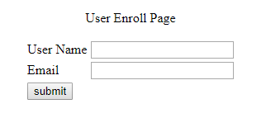

7.2 ***User Login System***

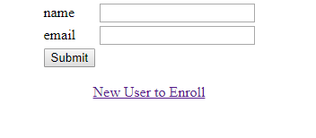

7.3 ***Book Selling System***

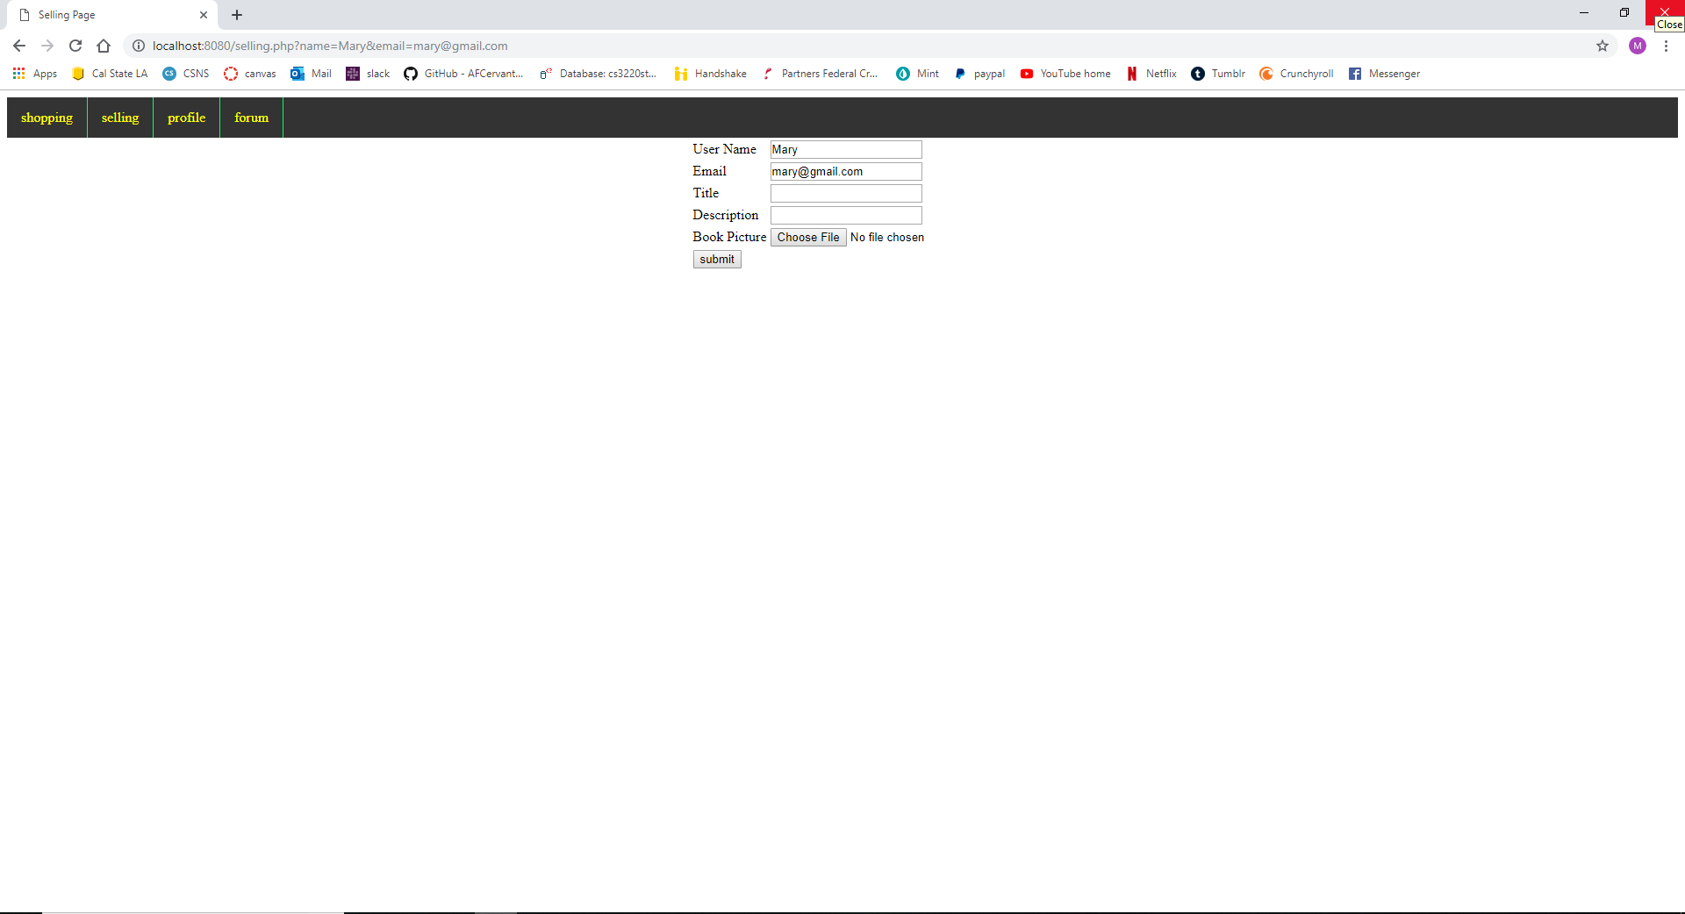

7.4 ***Book Shopping System***

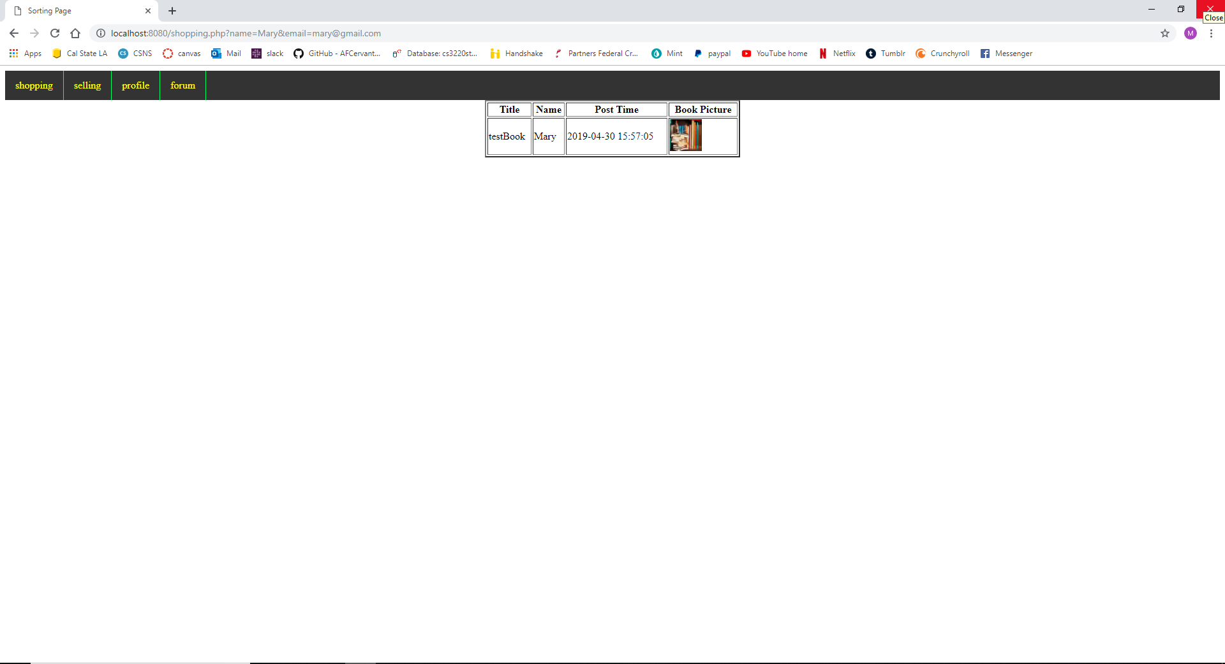

7.5 ***User Forum System***

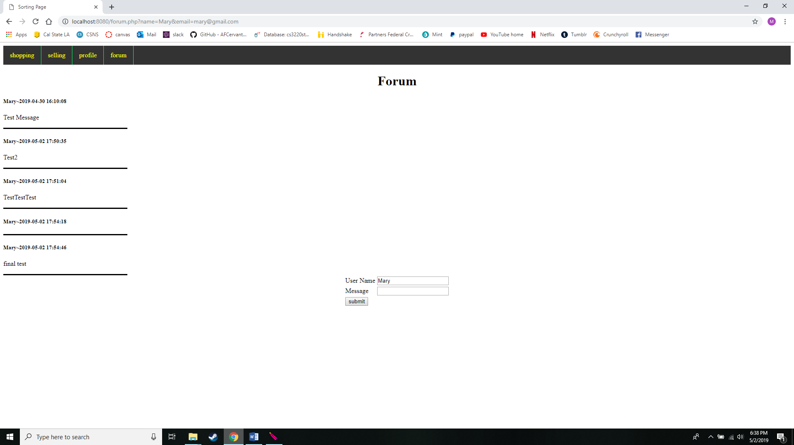

…

7.n

Section 8: Data Base Design

8.1 Table User

|  |  |
| --- | --- |
| Email_address | VarChar(100) |
| Password | VarChar(100) |

8.2 Table Books

|  |  |
| --- | --- |
| bookId | Int(11) |
| Name | Varchar(100) |
| Email | Varchar(100) |
| Title | Varchar(100) |
| Description | Varchar(100) |
| Posttime | Varchar(100) |

8.3 Table Forum

|  |  |
| --- | --- |
| name | Varchar(100) |
| message | Varchar(500) |
| posttime | datetime |

…

8.n

Section 9: GIossary

An ordered list of defined terms and concepts used throughout the document.